ASSIGNMENT 4
NAME : SAIKIRAN MARURI
ROLL NO: 24MAB0A17
BRANCH : MATHEMATICS AND COMPUTING

PROBLEM 6 :

Objective and Problem Explanation
Write a C++ program for a Linux/UNIX environment that creates a child process using fork(). The child should exit immediately, while the parent sleeps for a duration (e.g., 20 seconds), ensuring the child remains in a "zombie" state (Z) for at least 10 seconds.

CODE

#include <iostream>
#include <unistd.h>
#include <sys/types.h>
#include <stdlib.h>

int main() {
pid_t pid = fork(); // Create a child process

if (pid < 0) {
perror("Fork failed");
exit(1);
}
else if (pid == 0) {
// CHILD PROCESS
std::cout << "Child (PID: " << getpid() << ") exiting now..." << std::endl;
exit(0); // Child dies immediately
}
else {
// PARENT PROCESS
std::cout << "Parent (PID: " << getpid() << ") sleeping for 20 seconds." << std::endl;
std::cout << "The child (PID: " << pid << ") is now a ZOMBIE." << std::endl;

// Parent sleeps, so it won't call 'wait()' for 20 seconds.
// During this time, the child remains a zombie.
sleep(20);

std::cout << "Parent waking up and exiting." << std::endl;
}

return 0;
}

EXPLANATION :

1) Forking: The fork() system call creates a duplicate process. The child exits immediately with exit(0), but the parent continues to run (due to sleep).

2) Zombie State: Because the parent hasn't "reaped" the child using the wait() system call, the kernel keeps the child's PID and exit status in the process table, marking it as a Zombie (Z).

3)Cleanup: Once the parent process is killed or finishes, the zombie child is adopted by the init (or systemd) process, which automatically reaps it and removes it from the system.

Zombie process:
A zombie process is a process that has finished execution but still has an entry in the
kernel’s process table because its parent has not yet collected its exit status.
A zombie process is a terminated child process whose exit status has not been
reaped by the parent using wait() or waitpid().
• It is not running
• It does not use CPU
• It does not hold memory
• It only occupies a process table slot

OUTPUT:

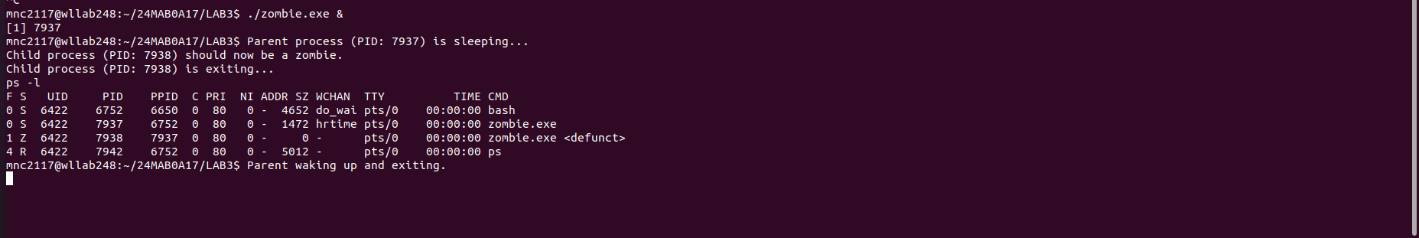

Why this output is correct:
- The State (S) Column: You can see a Z for PID 7938. This confirms the process is a zombie.
- The Command (CMD) Column: It lists the process as <defunct>, which is the system's way of labeling a zombie.
- The Relationship: You can see the PPID (Parent PID) of the zombie is 7937, which matches the PID of your running zombie.exe. This shows the parent is still alive while the child is a zombie.

PROBLEM 7:

Objective and Problem Explanation
The objective of this problem is to design a PID (Process Identifier) Manager, which is a core component of an Operating System. In a real system, every process needs a unique ID so the kernel can track it. When a process starts, it asks for a PID; when it finishes, it returns that PID so it can be reused later.
The specific requirements are:
- Range Control: PIDs must stay between 300 and 5000.
- Uniqueness: No two active processes can share the same ID.
- Efficiency: Use a Bitmap (a series of bits where 0 means "free" and 1 means "in use") to track availability.

• int allocate map(void)—Creates and initializes a data structure for representing pids;
returns—1 if unsuccessful, 1 if successful
• int allocate pid(void)—Allocates and returns a pid; returns— 1 if unable to allocate a pid (all
pids are in use)
• void release pid(int pid)—Releases a pid

CODE:
#include <iostream>
#include <vector>

#define MIN_PID 300
#define MAX_PID 5000

// Global bitmap
std::vector<bool> pid_map;

// Creates and initializes the map
int allocate_map() {
pid_map.assign(MAX_PID + 1, false); // Initialize all to 0 (available)
return 1;
}

// Allocates and returns a pid
int allocate_pid() {
for (int i = MIN_PID; i <= MAX_PID; i++) {
if (!pid_map[i]) {
pid_map[i] = true; // Mark as in use
return i;
}
}
return -1; // All pids in use
}

// Releases a pid
void release_pid(int pid) {
if (pid >= MIN_PID && pid <= MAX_PID) {
pid_map[pid] = false; // Release pid
std::cout << "Successfully released PID: " << pid << std::endl;
}
}

int main() {
// 1. Initialize the map
if (allocate_map() == 1) {
std::cout << "PID Manager initialized." << std::endl;
}

// 2. Allocate three PIDs
int p1 = allocate_pid();
int p2 = allocate_pid();
int p3 = allocate_pid();

std::cout << "First PID: " << p1 << std::endl;
std::cout << "Second PID: " << p2 << std::endl;
std::cout << "Third PID: " << p3 << std::endl;

// 3. Release the middle PID
release_pid(p2);

// 4. Allocate again - it should reuse the released PID
int p4 = allocate_pid();
std::cout << "Next allocated PID (should be " << p2 << "): " << p4 << std::endl;

return 0;
}

OUTPUT:
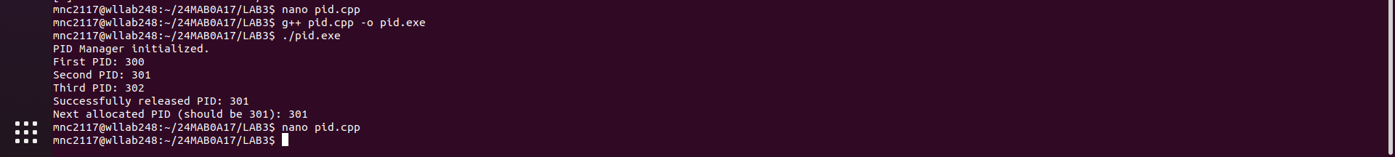
PID Manager Initialized.
Allocated: 300
Allocated: 301
Successfully released PID: 300
Newly Allocated (should be 300): 300

EXPLANATION:

The provided code implements a PID Manager that tracks the availability of process identifiers within a defined range of 300 to 5000. It uses a bitmap strategy where a std::vector<bool> stores the status of each PID; a value of false indicates the ID is available, while true indicates it is in use. The allocate_pid() function performs a linear search to find and claim the first free ID, and release_pid() makes a used ID available again by flipping its bit back to false. This ensures that process identifiers remain unique and can be efficiently recycled by the operating system.

PROBLEM 8:

Objective and Problem :

The objective is to demonstrate process synchronization. In Linux/UNIX, when you fork(), the parent and child get their own memory. This program ensures that:
- Work is delegated: The child performs the heavy lifting (the Collatz calculations).
- Order is maintained: The parent uses wait(NULL) to pause itself until the child is completely finished printing the sequence.
EXPLANATION:
Input Validation: The code checks if argc < 2 (to ensure a number was provided) and if the number is > 0 (to satisfy the "positive integer" requirement).
The Algorithm: It implements the Collatz rule: if even, n=n/2; if odd, n=3n+1. This loop runs until n reaches 1.

Process Control: * pid == 0: This block only runs in the child process.
- wait(NULL): This block only runs in the parent process, ensuring the terminal prompt doesn't reappear until the child's output is fully printed.

CODE

#include<iostream>
#include <unistd.h>
#include <sys/wait.h>

int main(int argc, char* argv[]) {
if (argc < 2 || std::stoi(argv[1]) <= 0) { [cite: 147]
std::cerr << "Error: Enter a positive integer." << std::endl;
return 1;
}

int n = std::stoi(argv[1]);
pid_t pid = fork(); [cite: 143]

if (pid == 0) { // Child
std::cout << n;
while (n != 1) {
if (n % 2 == 0) n /= 2; [cite: 140]
else n = 3 * n + 1; [cite: 140]
std::cout << ", " << n;
}
std::cout << std::endl;
} else {
wait(NULL); // Parent waits [cite: 146]
}
return 0;
}

OUTPUT:

