NAME : SAIKIRAN .

M BRANCH : MATHEMATICS AND COMPUTING

ASSIGNMENT 7

ROLLNO : 24MAB0A17

BOUNDED BUFFER METHOD

Working of Semaphore
A semaphore works by maintaining a counter that controls access to a specific resource, ensuring that no more than the allowed number of processes access the resource at the same time.
To achieve synchronization, every critical section of code is surrounded by two operations- Wait (P operation) and Signal (V operation) that are discussed above.
Example: Let’s consider two processes P1 and P2 sharing a semaphore S, initialized to 1:
- State 1: Both processes are in their non-critical sections, and S = 1.
- State 2: P1 enters the critical section. It performs wait(S), so S = 0. P2 continues in the non-critical section.
- State 3: If P2 now wants to enter, it cannot proceed since S = 0. It must wait until S > 0.
- State 4: When P1 finishes, it performs signal(S), making S = 1. Now P2 can enter its critical section and again sets S = 0.

Limitations of Semaphores
- Priority Inversion: A low-priority process holding a semaphore can block a high-priority one.
- Deadlock: Processes may wait on each other’s semaphores in a cycle, causing indefinite blocking.
- Complex to Manage: The OS must carefully track wait and signal calls; misuse can cause errors.
- Busy Waiting: In basic implementations, processes may keep checking the semaphore value, wasting CPU time.

The Analogy: The Pizza Window
- The Buffer: A warming shelf that can only hold 5 pizza boxes (this is N=5).
- The Producer: The Chef making the pizzas.
- The Consumer: The Delivery Driver picking them up.
- The Semaphores:
  - Empty: The number of empty spots on the shelf (starts at 5).
  - Full: The number of pizzas ready to go (starts at 0).
  - Mutex: The "Golden Key" to the shelf door. Only one person can open the door at a time.

Scenario 1: The Chef (Producer)
The Chef finishes a pizza. Before they can put it on the shelf, they follow your steps:
- wait(empty): The Chef looks at the shelf. "Is there an empty spot?" If the shelf is full of pizzas, the Chef must wait and can't make more yet.
- wait(mutex): The Chef grabs the Golden Key. Now, even if a driver arrives, the driver can't touch the shelf because the Chef has the key.
- Add Item: The Chef puts the pizza on the shelf.
- signal(mutex): The Chef puts the Golden Key back on the hook.
- signal(full): The Chef presses a buzzer that tells the drivers, "Hey, there's one more hot pizza ready!" (Increments the full count).

Scenario 2: The Driver (Consumer)
A Delivery Driver pulls up. They follow your steps:
- wait(full): The Driver looks at the shelf. "Is there at least one pizza here?" If the shelf is empty, the Driver must wait (maybe they take a nap in their car).
- wait(mutex): The Driver grabs the Golden Key. The Chef now has to wait if they finish another pizza because the Driver is currently using the shelf.
- Remove Item: The Driver takes a pizza box.
- signal(mutex): The Driver puts the Golden Key back on the hook.
- signal(empty): The Driver sends a text to the Chef: "Hey, I just freed up a spot on the shelf!" (Increments the empty count).

Why the order of "Waits" matters
Imagine if the Chef did wait(mutex) before wait(empty):
- The Chef grabs the key (locks the door).
- Then they realize the shelf is full (wait(empty) blocks them).
- The Chef is now asleep at the shelf holding the key.
- The Driver arrives, wants to take a pizza to free up space, but can't get the key.
This is a Deadlock. This is why we always check if there is space (or an item) before we grab the lock.

CODE

#include <iostream>
#include <queue>
#include <thread>
#include <semaphore.h>
#include <unistd.h>

#define BUFFER_SIZE 5
#define TOTAL_ITEMS 10 // Limit the loop

std::queue<int> buffer;
sem_t mtx, empty, full;

void producer() {
for (int i = 0; i < TOTAL_ITEMS; ++i) {
int item = rand() % 100;

sem_wait(&empty);
sem_wait(&mtx);

buffer.push(item);
std::cout << "[P] Produced: " << item << " | Size: " << buffer.size() << std::endl;

sem_post(&mtx);
sem_post(&full);

std::this_thread::sleep_for(std::chrono::milliseconds(200));
}
}

void consumer() {
for (int i = 0; i < TOTAL_ITEMS; ++i) {
sem_wait(&full);
sem_wait(&mtx);

int item = buffer.front();
buffer.pop();
std::cout << "[C] Consumed: " << item << " | Size: " << buffer.size() << std::endl;

sem_post(&mtx);
sem_post(&empty);

std::this_thread::sleep_for(std::chrono::milliseconds(400));
}
}

int main() {
sem_init(&mtx, 0, 1);
sem_init(&empty, 0, BUFFER_SIZE);
sem_init(&full, 0, 0);

std::thread p(producer);
std::thread c(consumer);

p.join();
c.join();

sem_destroy(&mtx);
sem_destroy(&empty);
sem_destroy(&full);

std::cout << "Done! All items processed." << std::endl;
return 0;
}

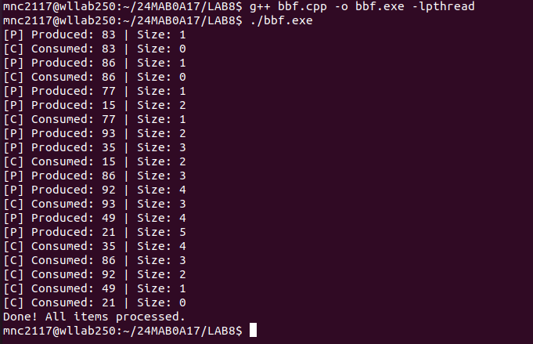
OUTPUT:

MULTILEVEL FEED BACK QUEUE(MLFQ)

CODE :
#include <iostream>
#include <vector>
#include <queue>
#include <algorithm>
#include <iomanip>

using namespace std;

struct Process {
string id;
int arrivalTime;
int burstTime;
int remainingTime;
int completionTime;
int turnAroundTime;
int waitingTime;
int lastServedTime; // For aging logic
int queueLevel; // 1, 2, or 3
};

void calculateMetrics(vector<Process>& processes) {
float totalWT = 0, totalTAT = 0;
cout << "\nTable Results:\n";
cout << "ID\tAT\tBT\tCT\tTAT\tWT\n";
for (auto& p : processes) {
p.turnAroundTime = p.completionTime - p.arrivalTime;
p.waitingTime = p.turnAroundTime - p.burstTime;
totalWT += p.waitingTime;
totalTAT += p.turnAroundTime;
cout << p.id << "\t" << p.arrivalTime << "\t" << p.burstTime << "\t"
<< p.completionTime << "\t" << p.turnAroundTime << "\t" << p.waitingTime << endl;
}
cout << fixed << setprecision(2);
cout << "\nAverage Waiting Time: " << totalWT / processes.size() << " ms";
cout << "\nAverage Turnaround Time: " << totalTAT / processes.size() << " ms\n";
}

int main() {
int n;
cout << "Enter number of processes: ";
cin >> n;

vector<Process> processes(n);
vector<Process*> completed;
queue<Process*> q1, q2, q3;

for (int i = 0; i < n; i++) {
cout << "Enter ID, Arrival Time, Burst Time for P" << i+1 << ": ";
cin >> processes[i].id >> processes[i].arrivalTime >> processes[i].burstTime;
processes[i].remainingTime = processes[i].burstTime;
processes[i].queueLevel = 1;
processes[i].lastServedTime = processes[i].arrivalTime;
}

// Sort by arrival time initially
sort(processes.begin(), processes.end(), [](Process a, Process b) {
return a.arrivalTime < b.arrivalTime;
});

int currentTime = 0;
int completedCount = 0;
vector<pair<string, pair<int, int>>> gantt;

while (completedCount < n) {
// 1. Move arriving processes to Q1
for (int i = 0; i < n; i++) {
if (processes[i].arrivalTime <= currentTime && processes[i].remainingTime > 0) {
bool alreadyInQueue = false;
// Check if already in one of the queues
// (In a real system, this is handled by state flags)
}
}

// Push newly arrived processes to Q1
static int lastIn = 0;
while(lastIn < n && processes[lastIn].arrivalTime <= currentTime) {
q1.push(&processes[lastIn]);
lastIn++;
}

// 2. Aging Mechanism (Every cycle, check Q2 and Q3)
// Check Q2 for promotion to Q1
int q2_size = q2.size();
for(int i=0; i<q2_size; i++) {
Process* p = q2.front(); q2.pop();
if (currentTime - p->lastServedTime >= 20) {
p->queueLevel = 1;
q1.push(p);
} else {
q2.push(p);
}
}
// Check Q3 for promotion to Q2
int q3_size = q3.size();
for(int i=0; i<q3_size; i++) {
Process* p = q3.front(); q3.pop();
if (currentTime - p->lastServedTime >= 20) {
p->queueLevel = 2;
q2.push(p);
} else {
q3.push(p);
}
}

// 3. Scheduling Execution
Process* current = nullptr;
int timeLimit = 0;

if (!q1.empty()) {
current = q1.front(); q1.pop();
timeLimit = 4;
} else if (!q2.empty()) {
current = q2.front(); q2.pop();
timeLimit = 8;
} else if (!q3.empty()) {
current = q3.front(); q3.pop();
timeLimit = current->remainingTime; // FCFS
} else {
currentTime++; // Idle
continue;
}

// Execute process
int executionTime = min(current->remainingTime, timeLimit);

// Handle preemption if in Q2/Q3 (Check if high priority arrives during execution)
// Simplified for this simulation: we execute the quantum or until arrival
int actualExec = 0;
for(int i=0; i<executionTime; i++) {
actualExec++;
current->remainingTime--;
currentTime++;

// Check for new arrivals in Q1 that would preempt Q2 or Q3
if (current->queueLevel > 1) {
bool higherArrival = false;
for(int j=lastIn; j<n; j++) {
if(processes[j].arrivalTime <= currentTime) {
higherArrival = true;
break;
}
}
if(higherArrival) break;
}
}

gantt.push_back({current->id, {currentTime - actualExec, currentTime}});
current->lastServedTime = currentTime;

if (current->remainingTime == 0) {
current->completionTime = currentTime;
completedCount++;
} else {
// Move down levels if quantum exceeded
if (current->queueLevel == 1 && actualExec == 4) current->queueLevel = 2, q2.push(current);
else if (current->queueLevel == 2 && actualExec == 8) current->queueLevel = 3, q3.push(current);
else if (current->queueLevel == 1) q1.push(current);
else if (current->queueLevel == 2) q2.push(current);
else q3.push(current);
}
}

// Output Gantt Chart
cout << "\nGantt Chart:\n|";
for (auto g : gantt) cout << " " << g.first << " |";
cout << "\n0";
for (auto g : gantt) cout << setw(7) << g.second.second;
cout << "\n";

calculateMetrics(processes);

return 0;
}

OUTPUT:
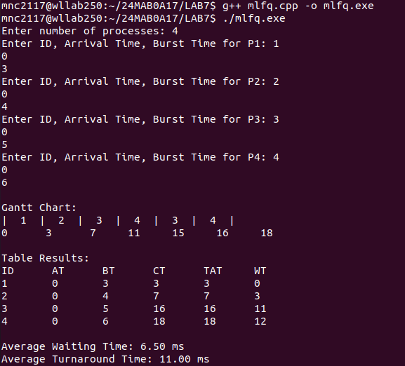
EXPLANATION:
Key Components of the Design:
- Queues: I used three pointers-based queues (q1, q2, q3) to represent the different priority levels.
- The "Fall-Through" Logic:
  - If a process uses its full 4ms in Q1, it is pushed to Q2.
  - If it uses its full 8ms in Q2, it is pushed to Q3.
- The "Promotion" Logic (Aging): Before selecting a process to run, the code iterates through lower queues. If a process has been waiting for more than 20ms since its lastServedTime, it is moved up one level.
- Preemption: The loop inside the execution block checks if a process with a higher priority (Queue level 1) has arrived while a lower-priority process is currently running. If so, it stops and yields.

