ASSIGNMENT 5

NAME : SAIKIRAN
ROLL NO : 24MAB0A17

BRANCH : MATHEMATICS AND COMPUTING

FCFS : (FIRST COME FIRST SERVE)

CODE :
#include <iostream>
#include <vector>
#include <algorithm>
#include <iomanip>

using namespace std;

struct Process {
string id;
int bt, at, ct, tat, wt;
};

int main() {

vector<Process> p = {
{"P1", 10, 0}, {"P6", 13, 1}, {"P2", 5, 2}, {"P9", 2, 3},
{"P3", 8, 4}, {"P4", 6, 6}, {"P8", 9, 7}, {"P7", 7, 9},
{"P5", 10, 10}, {"P10", 8, 12}
};

// Sort by Arrival Time
sort(p.begin(), p.end(), [](Process a, Process b) {
return a.at < b.at;
});

int currentTime = 0;
vector<pair<string, int>> gantt;

for (int i = 0; i < p.size(); i++) {
if (currentTime < p[i].at) currentTime = p[i].at;
currentTime += p[i].bt;
p[i].ct = currentTime;
p[i].tat = p[i].ct - p[i].at;
p[i].wt = p[i].tat - p[i].bt;
gantt.push_back({p[i].id, currentTime});
}

// Output Table and Gantt Chart
cout << "--- FCFS SCHEDULING ---\nID\tAT\tBT\tCT\tTAT\tWT\n";
float sumWT = 0, sumTAT = 0;
for (auto x : p) {
sumWT += x.wt; sumTAT += x.tat;
cout << x.id << "\t" << x.at << "\t" << x.bt << "\t" << x.ct << "\t" << x.tat << "\t" << x.wt << endl;
}
cout << "\nAverage WT: " << sumWT/10 << "\nAverage TAT: " << sumTAT/10 << endl;
return 0;
}

EXPLANATION:

The First-Come, First-Served (FCFS) algorithm operates on a simple "queue" logic: the process that arrives at the CPU first is executed first until it finishes. In the code, this is achieved by sorting the process list by Arrival Time (AT). A currentTime tracker moves forward as each process runs; if a process arrives after the CPU is free, the clock "jumps" to its arrival time. The code then calculates Completion Time (CT) by adding the burst time to the start time, and determines Turnaround Time (TAT) and Waiting Time (WT) using standard OS formulas (TAT=CT−AT and WT=TAT−BT). It is a non-preemptive algorithm, meaning once a process like P1 starts, it cannot be interrupted by P6 or P2 until it is completely done.

OUTPUT:

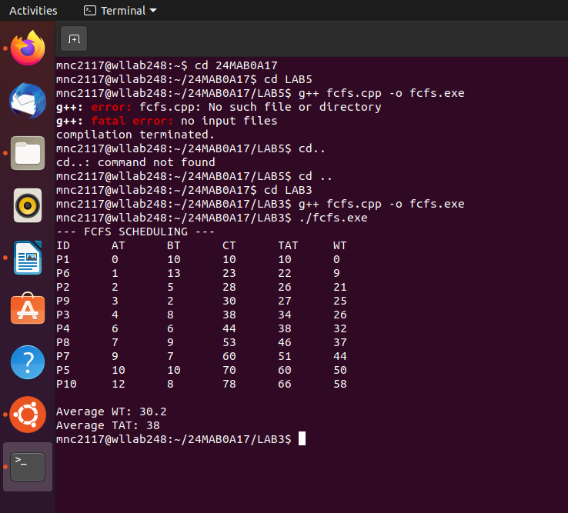

SJF : (SHORTEST JOB FIRST)

CODE :
#include <iostream>
#include <vector>
#include <iomanip>
#include <climits>

using namespace std;

struct Process {
string id;
int bt, at, ct, tat, wt;
bool isCompleted = false;
};

int main() {
// Hardcoded data from your table
vector<Process> p = {
{"P1", 10, 0}, {"P2", 5, 2}, {"P3", 8, 4}, {"P4", 6, 6}, {"P5", 10, 10},
{"P6", 13, 1}, {"P7", 7, 9}, {"P8", 9, 7}, {"P9", 2, 3}, {"P10", 8, 12}
};

int n = 10, completed = 0, currentTime = 0;
float totalWT = 0, totalTAT = 0;

cout << "--- SJF (Non-Preemptive) Scheduling ---" << endl;

while (completed < n) {
int idx = -1;
int minBT = INT_MAX;

// 1. Search for the shortest job that has already arrived
for (int i = 0; i < n; i++) {
if (p[i].at <= currentTime && !p[i].isCompleted) {
if (p[i].bt < minBT) {
minBT = p[i].bt;
idx = i;
}
}
}

// 2. If a process is found, execute it
if (idx != -1) {
currentTime += p[idx].bt;
p[idx].ct = currentTime;
p[idx].tat = p[idx].ct - p[idx].at;
p[idx].wt = p[idx].tat - p[idx].bt;
p[idx].isCompleted = true;
completed++;

totalWT += p[idx].wt;
totalTAT += p[idx].tat;
} else {
// If no process has arrived yet, move time forward
currentTime++;
}
}

// 3. Print Results
cout << "ID\tAT\tBT\tCT\tTAT\tWT\n";
for (int i = 0; i < n; i++) {
cout << p[i].id << "\t" << p[i].at << "\t" << p[i].bt << "\t"
<< p[i].ct << "\t" << p[i].tat << "\t" << p[i].wt << endl;
}

cout << fixed << setprecision(2);
cout << "\nAverage Waiting Time: " << totalWT / n << " ms";
cout << "\nAverage Turnaround Time: " << totalTAT / n << " ms" << endl;

return 0;
}

EXPLANATION

The Shortest Job First (SJF) Non-Preemptive algorithm prioritizes efficiency by selecting the process with the smallest Burst Time (BT) from the pool of processes that have already arrived. Unlike FCFS, which follows arrival order, the while loop in this code constantly scans the ready queue (using the condition p[i].at <= currentTime) to find the task that can be finished the fastest. Once a process is chosen, it is non-preemptive, meaning it runs to completion even if a shorter job arrives during its execution. By picking the shortest tasks first, the algorithm minimizes the time other processes spend waiting in the queue, effectively lowering the overall Average Waiting Time.

OUTPUT:

