A Multi-Modal AI Proctoring System For Online Exams Using YOLOv8, MediaPipe FaceMesh, And Rule-Based Behaviour Detection
Deepthi A¹, Marushka Rachelle Dsilva², Saniha K³, and Musaib Ahmed⁴

¹²³⁴ Department of Computer Science And Engineering (Artificial Intelligence and Machine Learning), Mangalore Institute of Technology and Engineering (MITE), Moodbidri, India Email:
¹ deepthia312@gmail.com
² marushkarachelledsilva@gmail.com
³ ksaniha18@gmail.com
⁴ musaibahmed0409@gmail.com

Faculty Guide
Mr. Srivatsa Upadhya P
Assistant Professor,
Department of Artificial Intelligence and Machine Learning ,
Mangalore Institute of Technology and Engineering (MITE), Moodbidri, India
srivatsa@mite.ac.in

Abstract— Maintaining academic integrity and guaranteeing secure evaluations have become more difficult due to the quick rise of online learning and remote testing. The scalability of traditional proctoring techniques is constrained, and they frequently fail to detect changing cheating tendencies [1], [5]. Real-time behavioral and gaze-based cheating detection is made possible by automated proctoring systems that use deep learning architectures like CNNs and YOLO, made possible by advancements in computer vision and artificial intelligence [8], [12], and [15]. These systems use head pose estimation, gaze tracking, and facial recognition to identify abnormalities during exams [6, 17, 19]. While addressing privacy and user-experience concerns, recent multimodal techniques that include behavioral and visual cues have demonstrated enhanced detection accuracy [9], [13]. Online proctoring's data security and trust are further improved by blockchain based systems [16]. Nonetheless, there are still issues with effective edge deployment, dataset variety, and low-light performance [10], [18]. In order to support exam integrity with fairness and usability, this study proposes an online proctoring platform for real-time gaze estimation and facial behavior analysis that is based on CNN and OpenCV. For reliable and moral online evaluation systems, future research will focus on multimodal fusion, lightweight, explainable models, and privacy preserving AI.
Keywords— Online proctoring, cheating detection, deep learning, CNN, YOLO, gaze tracking, blockchain, computer vision, edge AI, academic integrity.

INTRODUCTION
In the age of remote learning, when it is more difficult to guarantee fair assessment procedures due to the lack of traditional in-person invigilation, academic dishonesty in online exams has become a significant problem. There is an urgent demand for dependable and scalable cheating detection solutions for educators and policymakers because this problem jeopardizes the authenticity of student assessments as well as the reputation of academic institutions.
The suggested idea uses computer vision and voice analysis to develop a gaze-based cheating detection system that uses real-time video monitoring. The system Uses the technologies like MediaPipe , Yolo models, and OpenCV to automatically track face landmarks, head motions, gaze direction.

In order to identify abnormalities in gaze and head posture, detect facial and eye locations, and flag suspect activity like speaking or leaving the frame during the test, the framework analyzes live webcam feeds. Every occurrence that is detected is automatically recorded for evaluation by the examiner.

This strategy expands and improves on existing work in automated proctoring, which has demonstrated potential in detecting cheating tendencies through the use of techniques including gaze estimation, iris monitoring, face detection, and behavioral analytics. Monitoring staged exam sessions, documenting event triggers from visual and auditory abnormalities, and computing suspicion rates and accuracy metrics are all used in the evaluation process.

The findings show a notable improvement in identifying different types of wrongdoing while lowering the need for manual supervision. By surpassing conventional anomaly detection methods, the incorporation of gaze and speech analytics into the monitoring process significantly improves the integrity of virtual assessments.

The key contributions of this project include:

  - The fusion of multimodal vision and audio models for real-time cheating detection.

  - The development of an automated event logging backend for secure monitoring.

  - The demonstration of practical and reproducible techniques for robust academic proctoring in remote settings.

1

LITERATURE SURVEY
There are now more options for flexible learning thanks to the growing trend of online learning and remote testing, but there are also major obstacles to upholding academic integrity. Online proctoring solutions are now crucial for maintaining cybersecurity and avoiding cheating, as noted by Slusky [1], despite ongoing privacy and dependability issues.
The increasing application of machine learning models to improve online learning and assessment systems, especially for identifying behavioral and environmental anomalies, is highlighted by research by Kaddoura et al. [3]. In a systematic analysis of online exam cheating activities, Chuang et al. [5] found that visual and behavioral clues such head movement, eye gazing, and device usage are powerful markers of misconduct.
Similar to this, Galil et al. [6] investigated the connection between cheating conduct and gaze allocation, demonstrating that eye movement patterns can reveal social awareness and attention levels. Together, these results highlight the significance of AI driven surveillance in education, spurring the creation of systems that combine computer vision, object recognition, and facial tracking to effectively and morally preserve exam integrity.
To stop cheating, current online exam systems usually include rule-based notifications, browser lockout mechanisms, or manual invigilation. However, these methods are constrained by human error, scaling problems, and their incapacity to identify nuanced behavioral patterns, as mentioned by Mohite et al. [12] . When applicants utilize cell phones, earbuds, or get outside help off-screen, traditional methods are unable to detect this. While some AI-based frameworks, such those put forth by Shinde and Badgujar [11], have combined machine learning with facial recognition, they frequently have trouble with multi-person identification and real-time processing.
Research such as that conducted by Oeding et al. [20] also shows conflicting findings on students' perceptions of privacy and user experience, suggesting the need for more accurate, transparent, and non-intrusive models. Overall, the suggested approach seeks to close the gap left by existing solutions' lack of the multi-modal intelligence needed to integrate object identification, head pose estimation, and gaze tracking all at once.

SYSTEM DESIGN

In Fig.1 The candidate's client machine and a centralized processing server make up the two main subsystems of the overall design. The onboard webcam on the client device records live video, which is then processed by an OpenCV-based preprocessing module that does basic frame normalization, noise reduction, and scaling. After processing, the frames are sent to the server for further examination.

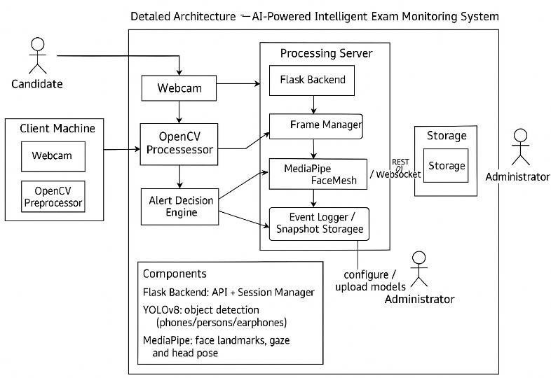

Fig 1. System Architecture Diagram

A Flask-based backend that manages APIs, handles sessions, and coordinates communications is hosted by the Processing Server. Incoming frames are distributed to two main detecting components by a Frame Manager. In order to identify attention deviations or face absence, the first component, MediaPipe FaceMesh, extracts 3D facial landmarks to assess gaze direction, facial orientation, and head attitude. The OpenCV pipeline's second component, YOLOv8, identifies forbidden items like cell phones, extra people, and earphones.

An Event Logger receives all detection outputs, logs suspicious activity with timestamps in the system's storage module. In addition to configuring system parameters and uploading new detection models, administrators can access alerts and evidence via WebSocket or REST APIs. The scalable, accurate, and real time monitoring of the candidate's behavior during online exams is guaranteed by this modular design.
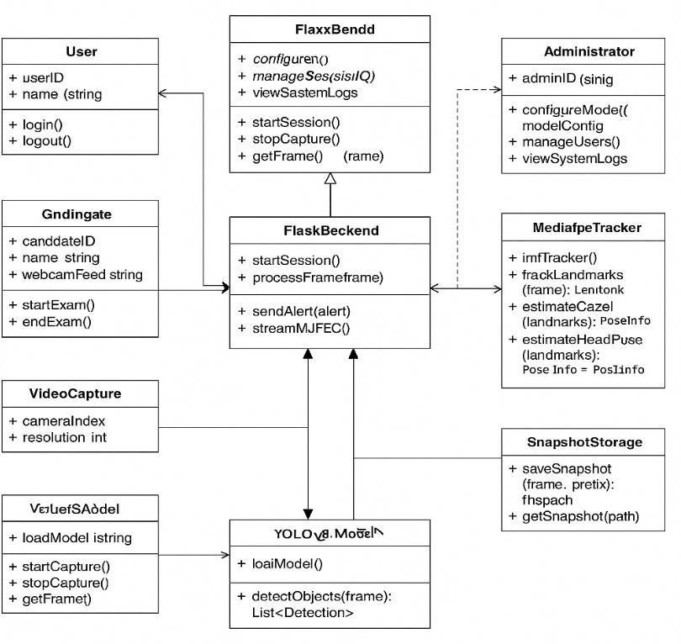

Fig 2. Class Diagram

In Fig.2 The main elements of the design are shown in the class diagram, which simulates the software structure of the suggested proctoring system. As the main controller, the Flask Backend manages frame acquisition. The Flask Backend receives their outputs and uses them for decision-making and fusion. Evidence snapshots created during suspicious occurrences are saved and retrieved via the SnapshotStorage class. The User and Gndingate classes, which describe candidate login actions and exam control functions, handle user management and session initialization. The Administrator and FlaxxBend (server management) classes offer administrative control, enabling system-level updates, model configuration, and log monitoring. All things considered, the class relationships establish an expandable and modular software structure that is in line with the system architecture, allowing for the clear division of administrative, storage, session management, and detection functions.
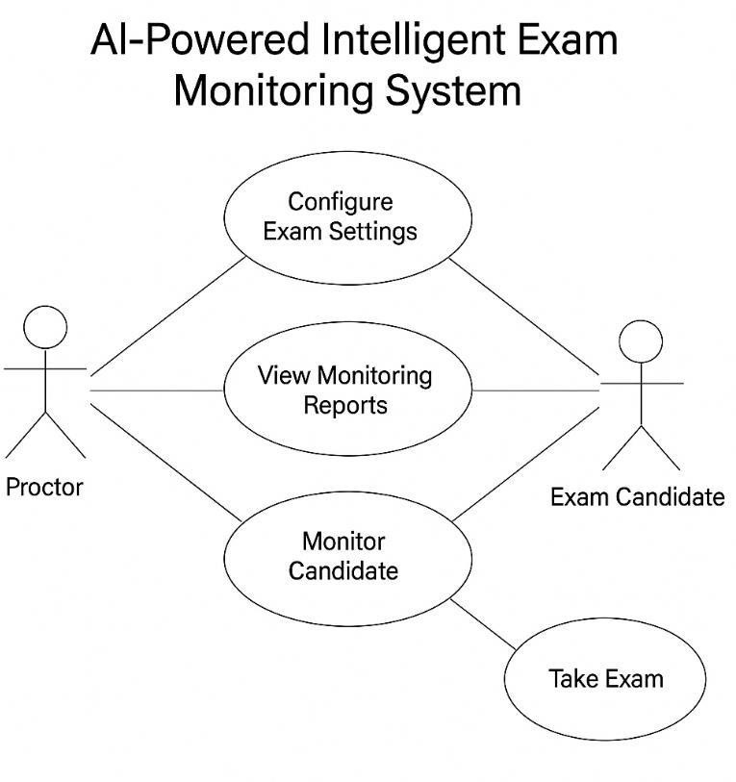
Fig 3. Use Case Diagram

In Fig.3 The main exchanges between the proctor and the exam candidate in the online proctoring system are depicted in the use case diagram. The proctor is in charge of setting up the exam parameters, starting the monitoring process, and then going over the monitoring reports that the system produces. The Exam Candidate primarily engages with the system by taking the test, while the system keeps an eye on their behavior throughout. The "Monitor Candidate" use case, which represents the real-time surveillance and event detection procedures that function during the exam, is linked to both actors. The flow of duties and the key features needed for safe and monitored online exams are shown in this diagram.

METHODOLOGY
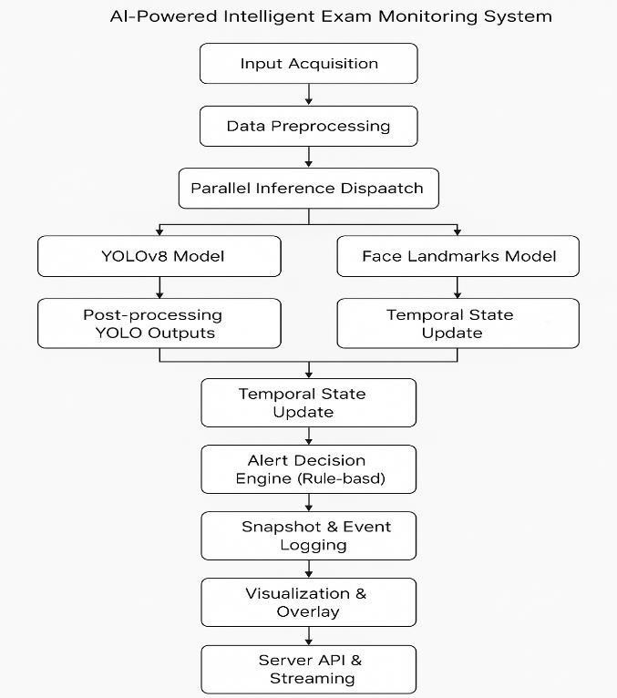

Fig 4. Data Flow Diagram

In Fig.4 The suggested AI-powered intelligent test monitoring system uses a multi-stage pipeline intended for high-accuracy proctoring to process real-time video data. Following input acquisition and preprocessing, the system sends the video frames in parallel to two inference modules: a face-landmark model that analyzes facial orientation and behavior and an object detection model based on YOLOv8 that detects actions associated to cheating. A temporal state updating system that monitors events across time integrates the results from both models. These states are then assessed by a rule-based alert decision engine to identify questionable activity. Events that are detected cause snapshots to be taken, logged, and then visualized and overlaid for examiner examination. Ultimately, a server API that supports real-time streaming is used to transmit the processed results.

Classification Loss (Binary Cross-Entropy):

Used to check how accurate anticipated class labels are:

L_cls=−[ylog(p)+(1−y)log(1−p)] (1)

Where y is the true class (0 or 1) and p is the predicted probability.

Bounding Box Regression Loss (CIoU Loss)

Used to refine the accuracy of predicted bounding boxes:
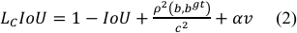

This captures overlap, center distance, and aspect-ratio consistency between predicted and ground-truth boxes.

Objectness Loss (Binary Cross-Entropy)

Used to determine whether an object exists in a predicted region:

Where yo=1 if an object is present, and po is the predicted objectness confidence.

EXPERIMENTAL ANALYSIS

Dataset Preparation And Preprocessing
848 photos selected for mobile-phone object detection tasks make up the mobile_phone_detector_final dataset. A total of 907 annotated bounding boxes from three classes are included in the dataset; phones make up the largest class (902 instances), followed by a very tiny number of people and one other minor class. 99.4% of the photos in the sample are exactly square, with an average resolution of 0.41 megapixels and a median size of 640 x 640. There are nine null cases in the dataset, however there are no missing annotations.

In accordance with normal machine-learning procedure, the dataset is split into three parts: 10% testing (85 photos), 20% validation (169 images), and 70% training (594 images). The aspect ratio distribution reveals that 99.4% of photos are square, with only a few wide or extra-wide examples, and nearly all photographs fall into the "large" size category (843 images). The histogram of object counts confirms that most photos have a single bounding box and that annotation density is modest, with an average of 1.1 items per image.

Mobile-phone instances exist uniformly throughout the middle and mid-frame regions, according to dimension and annotation heatmap analysis. All photos were automatically orientated and enlarged using a "Stretch to 640×640" normalization to make them compatible with YOLO-based detection models, but no data augmentations were used in the preprocessing procedure. All things considered, the dataset is lightweight, clean, and ideal for training mobile phone detection models in controlled settings.
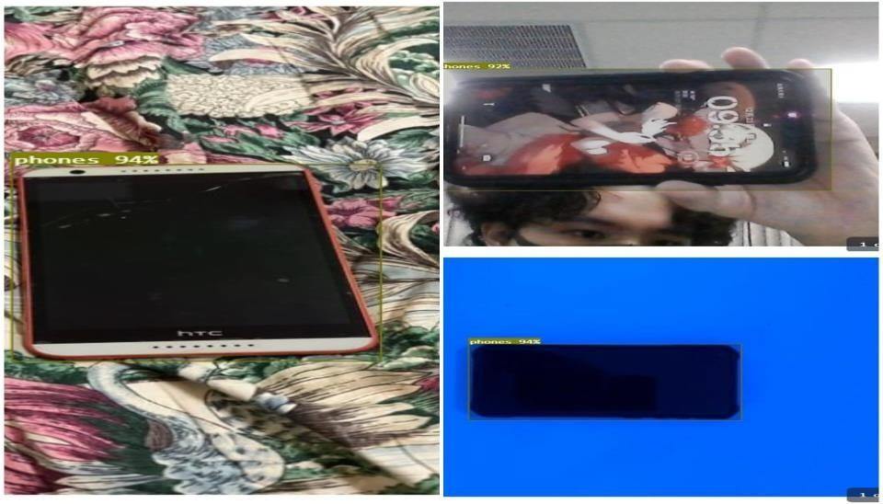
Fig 5. Model Training Logs

Development And Training
Two essential AI components—MediaPipe FaceMesh for gaze and head-pose estimation and Yolov8 for object detection— are integrated into a single real-time monitoring pipeline during the model development process. After capturing and pre-processing the webcam feed with OpenCV, each frame is concurrently run through MediaPipe to extract head- orientation angles, iris positions, and facial landmarks, and YOLOv8 to detect people, cell phones, and earphones. After that, a rule-based decision engine combines the outputs from both models and assesses object presence, gaze deviation, head turns, and face absence to see if any suspicious activity has taken place. The frontend shows the results in real time, while the Flask backend handles model loading, inference, and alert generation.ecise, quick, and ongoing monitoring.

Backend Integration Using Flask
The Flask framework, which serves as the primary communication layer between the AI models and the frontend interface, is used to develop the system's backend. Flask handles every incoming video frame, controls the initialization and operation of YOLOv8 and MediaPipe FaceMesh, and processes model outputs like absence status, gaze direction, head-pose angles, and object detections. In addition to supporting routes for live video streaming, snapshot viewing, and start/stop control of the monitoring process, it exposes RESTful API endpoints to the frontend for the real-time delivery of alert data, logs, and session status. To guarantee low- latency communication, Flask additionally handles error handling, lightweight event logging, and multi-threaded inference.Smooth monitoring during the exam session is ensured by this integration, which permits smooth, real time data flow between the detection modules and the React-based dashboard.

RESULTS AND DESCRIPTION
The system was tested under normal indoor conditions to evaluate its accuracy, responsiveness, and ability to detect suspicious activities during an online examination. The findings demonstrated that YOLOv8 could consistently identify prohibited items like cell phones, earbuds, and other people. Additionally, MediaPipe FaceMesh demonstrated dependability by identifying changes in head posture, gaze direction, and facial landmarks even when the candidate moved naturally throughout the session. The rule-based alert engine was able to generate timely warnings for events like gaze deviation, face absence, and abnormal head movements by combining the outputs from both models.

The system maintained steady frame processing, low latency, and continuous video streaming through the Flask backend throughout the evaluation. The detection pipeline and backend logic were successfully integrated, as evidenced by the instantaneous generation of alerts and their display on the frontend interface. All things considered, the findings show that the system offers reliable and effective monitoring capabilities, making it a workable way to improve the integrity of online tests.

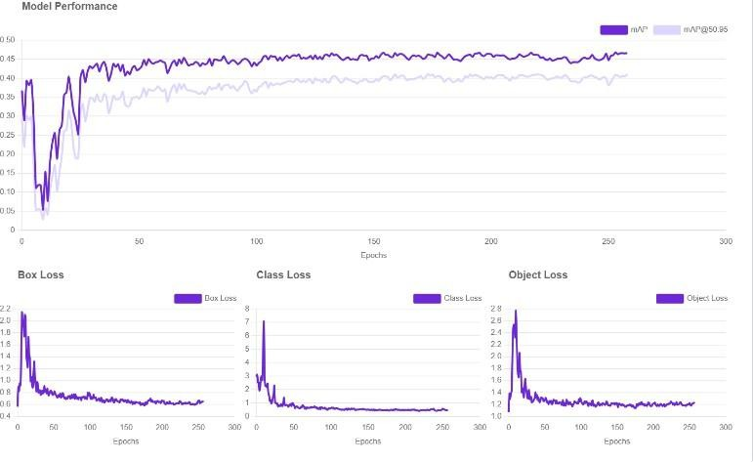
Fig 6. Model Training Logs

ACKNOWLEDGEMENT
The authors would like to thank Mangalore Institute Of Technology And Engineering , Mangalore, Karnataka for providing research infrastructure to conduct experiments at MITE Research center

REFERENCES
- L. Slusky, “Cybersecurity of Online Proctoring Systems,” Journal of International Technology and Information Management, vol. 29, no. 1, pp. 56–83, Jan. 2020, doi: https://doi.org/10.58729/1941-6679.1445.
- A. Tatnall, “Editorial for EAIT issue 6, 2022,” Education and Information Technologies, vol. 27, no. 6, pp. 7381–7394, Jul. 2022, doi: https://doi.org/10.1007/s10639-022-11228-9 .

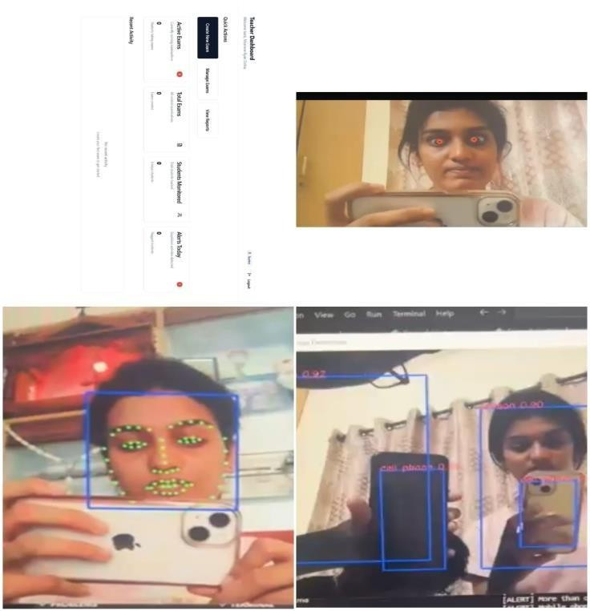

Fig 7. System Output

CONCLUSION

The created system effectively monitors candidates during online tests by combining MediaPipe FaceMesh and YOLOv8 object detection. The findings demonstrate that it is capable of accurately identifying cell phones, earbuds, gaze deviation, face absence, and other questionable behaviors in real time. During testing, the e ntire pipeline—from frame capture to alert generation operated without hiccups and consistently delivered results. This proves that the system works well and is useful for enhancing the safety and reliability of online tests.
- S. Kaddoura, D. E. Popescu, and J. D. Hemanth, “A systematic review on machine learning models for online learning and examination systems,” PeerJ Computer Science, vol. 8, p. e986, May 2022, doi: https://doi.org/10.7717/peerj-cs.986.

- Wei, N. Saab, and W. Admiraal, “Assessment of cognitive, behavioral, and affective learning outcomes in massive open online courses: A systematic literature review,” Computers & Education, vol. 163, p. 104097, Apr. 2021, doi:
https://doi.org/10.1016/j.compedu.2020.104 097.

- C. Y. Chuang, S. D. F. Noorbehbahani, A. Mohammadi, and
M. Aminazadeh, “A systematic review of research on cheating in online exams from 2010 to 2021,” Education and Information Technologies, vol. 27, Mar. 2022, doi: https://doi.org/10.1007/s10639-022-10927-7 v.

- A. Galil, J. Yarmolovsky, M. Gidron, and R. Geva, “Cheating behavior in children: Integrating gaze allocation and social awareness,” Journal of Experimental Child Psychology, vol. 178,
pp. 405–416, Feb. 2019, doi:
https://doi.org/10.1016/j.jecp.2018.08.013.

- J. Rudolph, S. Tan, and S. Tan, “ChatGPT: Bullshit Spewer or the End of Traditional Assessments in Higher education?,” Journal of Applied Learning & Teaching, vol. 6, no. 1, pp. 342–363, Jan. 2023, doi: https://doi.org/10.37074/jalt.2023.6.1.9.

- S. Kaddoura and A. Gumaei, “Towards Effective and Efficient Online Exam Systems using Deep Learning-based Cheating Detection Approach,” Intelligent Systems with Applications, vol. 16, p. 200153, 2022, DOI:
https://doi.org/10.1016/j.iswa.2022.200153.

- S. Mukherjee, B. Rohles, V. Distler, G. Lenzini, and V. Koenig, “The Effects of Privacy-Non Invasive Interventions on Cheating Prevention and User Experience in Unproctored Online Assessments: An Empirical Study,” Computers & Education, vol. 207, p. 104925, 2023, DOI:
https://doi.org/10.1016/j.compedu.2023.104 925.

- U. Gawande, K. Hajari, and Y. Golhar, “Real-Time Deep Learning Approach for Pedestrian Detection and Suspicious Activity Recognition,” Procedia Computer Science, vol. 218, pp. 2438 2447, 2023, DOI:
https://doi.org/10.1016/j.procs.2023.01.219.

- K. Shinde and V. S. Badgujar, “AI-ML Based Smart Online Examination Framework,” in Proc. Int. Conf. Machine Learning Applications (ICMLA), Jan. 2022, DOI: https://doi.org/10.1007/978-3-030-98531.

12] P. Mohite, R. Patil, V. Borhude, and A. Pawar, “Proctored Online Examination System Using Deep Learning and Computer Vision,” Int. J. Sci. Res. Sci. Technol., vol. 8, no. 2, pp. 510–514, 20 Apr. 2021. DOI: https://doi.org/10.32628/IJSRST218282.

- F. Noorbehbahani, A. Mohammadi, and M. Aminazadeh, “A Systematic Review of Research on Cheating in Online Exams from 2010 to 2021,” Education and Information Technologies, vol. 27, pp. 8413–8460, 2022. DOI:
https://doi.org/10.1007/s10639-022-10927-7

- L. C. O. Tiong and H. J. Lee, “E-cheating Prevention Measures: Detection of Cheating at Online Examinations Using Deep Learning Approach - A Case Study,” J. LaTeX Class Files, vol.XX, no. XX, Jan. 2021. DOI:
https://doi.org/arXiv:2101.09841..

- T. Singha, R. R. Nair, T. Babu, and P. Duraisamy, “Enhancing Academic Integrity in Online Assessments: Introducing an Effective Online Exam Proctoring Model using YOLO,” Procedia Computer Science, vol. 235, pp. 1399–1408, 2024. DOI: https://doi.org/10.1016/j.procs.2024.04.131.

- M. R. I. Sattar, M. T. B. H. Efty, T. S. Rafa, T. Das, M. S.
Samad, A. Pathak, M. U. Khandaker, and M. H. Ullah, “An Advanced and Secure Framework for Conducting Online Examination Using Blockchain Method,” Cyber Security and Applications, vol. 1, p. 100005, 2023. DOI: https://doi.org/10.1016/j.csa.2022.100005.

- J. Liu, Q. Li, M. Liu, and T. Wei, “CP-GAN: A cross-pose profile face frontalization boosting pose-invariant face recognition,” IEEE Access, vol. 8, pp. 198659–198667, 2020.

- Q. Yuankai, Z. Shengping, J. Feng, Z. Huiyu, T. Dacheng, and
L. Xuelong, “Siamese local and global networks for robust face tracking,” IEEE Trans. Image Process., vol. 29, pp. 4375943774, 2020.

- L. Jianwen, C. Xiaoxu, D. Junyu, and Y. Hui, “Real-time 3D facial tracking via cascaded compositional learning,” IEEE Trans. Image Process., vol. 30, p. 202, 2020.

- J. Oeding, T. Gunn, and J. Seitz, “The Mixed-Bag Impact of Online Proctoring Software in Undergraduate Courses,” Open Praxis, vol. 16, no. 1, pp. 82–93, Jan. 2024, doi:
https://doi.org/10.55982/openpraxis.16.1.58 5.

