HTML guide

**Introduction**

1. HTML-development is carried out according to the design (use figma “page menu” to look for different screens): <https://www.figma.com/file/E1r0QNn7rhTCGzxfq2hcgzyk/Beacon?node-id=1561%3A0>.
2. Actual style and sizing (such as paddings, margins, elements width and height) you can find in **Basic design principles** of the app: <https://www.figma.com/file/0mkKFZTUkFxFIZNmwZ8n1S/Basic-design-principles?node-id=0%3A1>
3. For successful and smooth HTML-development process implementation with the simultaneous engagement of two teams (XB and DTA) it is required for DTA to create a separate one .css file, for example: dta_style.css, which DTA team will start to work with.

**How to work in the app for html-development**

1. Cobra pages for HTML-development are located inside **iframes**. So that to start HTML-development you should find the page config. The path to required **iframe** you can find by opening “DevTools” 🡪 "Elements” tab or by selecting “View Page source” in context menu.
2. All HTML-development is built using Webix framework. Detailed information about framework is here: <https://docs.webix.com> .
3. So that to stylize some element, firstly you should check the app and try to find the same element on other pages that have been already prepared. Almost all designed elements already styled in the app (see **Basic design principles** for the help).
   1. If there is no such styled element, write down your style into file dta_style.css.

**NOTE:** Do not change file style.css, on the opposite - your changes would not be applied during merge. Also, be careful about redefining existing styles in your dta_style.css, they can affect other elements except those you are styling.

1. Do not forget set height for datatable’s header and rows. All actual cases are in the **Basic design principles**.
2. Some pages include popups inside.

To find a file with config of specific popup you should go to the file with page config, then find active element which shows popup (e.g. button), and find function being called by this element. As a rule, files with such functions are located in the same directory as the config of the page, in folder “scripts”.

Please, see the example of the points described above:

1. Open the page that you need to HTML-develop in the Cobra:

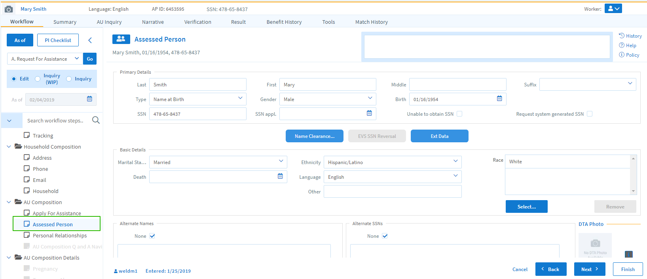

1. Find the file with page config using DevTools:

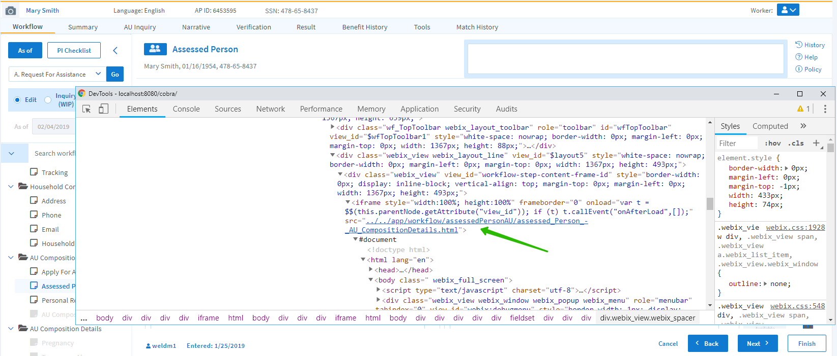

1. Find similar elements on other pages:

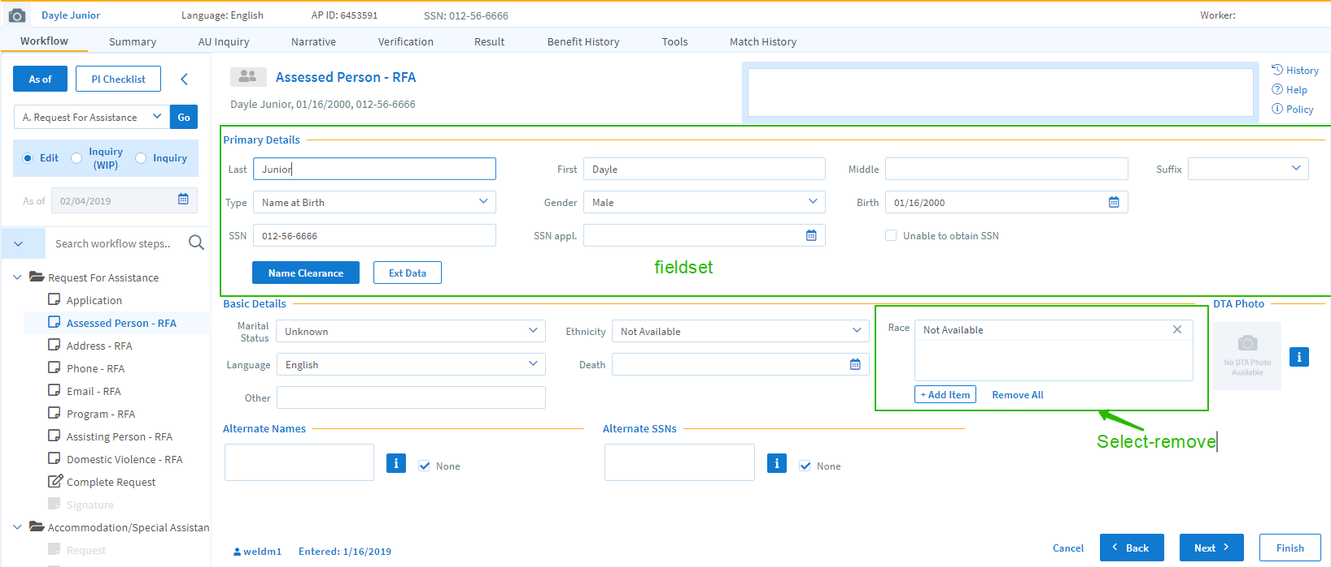

1. Then look through the config file of existing HTML-developed page and follow the pattern on the new one.