NyayBot – Project Development Report
(Multilingual Legal Document Simplification System)
NyayBot is designed to solve a problem affecting over 800 million Indians who struggle to understand legal documents due to language and complexity barriers.
- Introduction :
When I first started thinking about this project with my team, we noticed something very common around us. Many people, including our own family members, struggle to understand legal documents. Things like rental agreements, court notices, FIRs, or loan papers are usually written in very complicated language.
Even when I tried reading some of these documents myself, I realized how difficult they are to understand. And if it is hard for us as students, it is even more difficult for people from rural areas or those who are not comfortable with English.
Many people end up depending on lawyers just to understand basic information, which can be costly and sometimes confusing. That’s when me and my team thought what if we could make legal documents simple for everyone?
That idea led to the creation of NyayBot.
2. Problem Statement
From what we observed, the problem is not that people don’t have access to legal documents the real issue is that they can’t understand them properly.
Some key problems we identified were:
· Legal language is too complex
· Documents are not in familiar languages
· Legal help is expensive
· People can easily be misled

3. Proposed Solution
We decided to build a system that makes legal documents easy to understand in just a few steps.

With NyayBot, users can:
· Upload a legal document
· Extract text from it
· Get a simple summary
· Translate it into their preferred language
. Additional Feature: Risk Identification
We designed a feature to identify important or risky clauses in legal documents.
The goal is to:
· Highlight critical conditions
· Indicate possible risks
· Help users make safer decisions

- Our main idea was very simple:
Upload → Choose language → Understand instantly
- Example of Simplification
Original Legal Text:
“Tenant shall vacate the premises within 30 days upon notice from the landlord.”
Simplified Output:
“You must leave the house within 30 days if the owner asks you.”
This shows how the system converts complex legal language into simple, understandable sentences.

4. Technology Stack
While building this project, we used:
· React JS and JavaScript for the frontend
· pyPDF is used to extract text from the pdf uploaded
· Python (FastAPI) for the backend
· Grok API for AI-based summarization and translation
· OCR integrated through FastAPI for text extraction
5. System Architecture :-
-The system is designed to process documents step-by-step to ensure accurate and understandable results.
Flow:
User → Upload → OCR → Text Extraction → Chunking → Processing → Summarization → Translation → Output
Refer to system architecture diagram below:
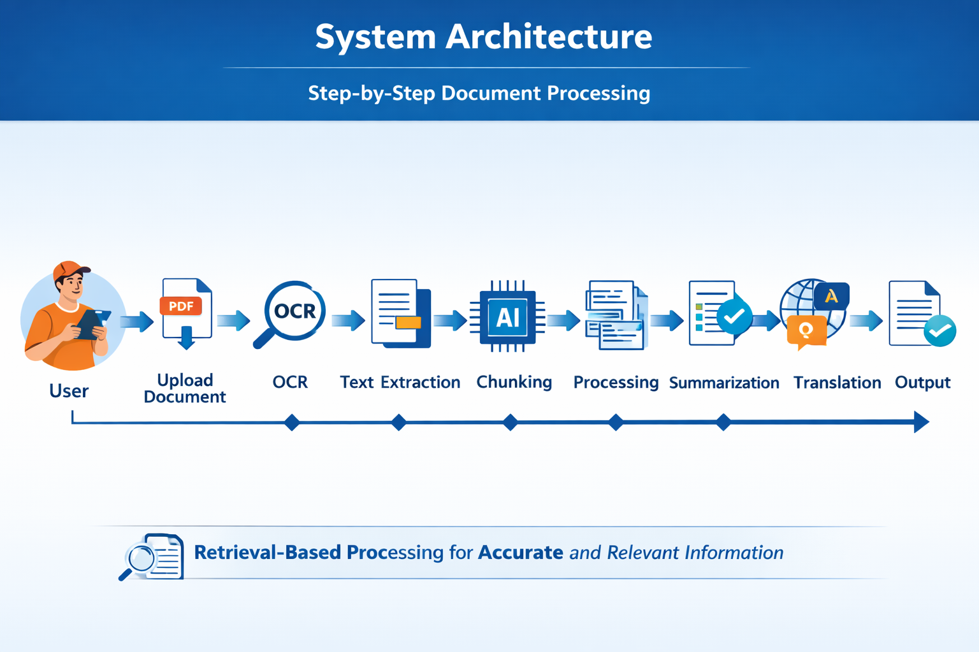
-To improve accuracy, the system processes only relevant parts of the document while generating responses. This helps reduce incorrect or misleading outputs and ensures better understanding.
-The system uses a retrieval-based approach to process only relevant parts of the document, improving accuracy and reducing incorrect outputs.

6. Development Journey

Iteration 1: Starting Simple

Upload → summarize → translate

Problems we faced:
· The summaries were not very clear
· Translations sounded unnatural
· OCR didn’t always extract correct text
· API usage cost was high

What we improved:
· Better prompts
· Structured pipeline
· Reduced API calls

Iteration 2: Making It Simpler

Problems:
· Output still felt like legal language
· Users didn’t fully trust the results
· UI was confusing

Improvements:
· Simplified language
· Added disclaimers
· Improved UI

Iteration 3: Adding Languages
Problems:
· Translation accuracy issues
· Performance slow
· File handling issues

Improvements:
· Optimized processing
· Limited file size
· Better prompts

Iteration 4: Making It Practical
Documents are processed temporarily and not stored
Problems:
- API cost major issue
- Privacy concerns
- Edge cases

Improvements:
- Cost optimization
- Privacy measures
- Strong disclaimers
- Documents are processed temporarily and not stored

Iteration 5: Authentication (Failed / Skipped)
We initially planned to implement user authentication with:
· Google account login
· Phone number OTP (2-step verification)

Problems we faced:
· Integration complexity with backend (FastAPI)
· Time constraints during development
· Difficulty handling OTP verification securely
· Managing session/state across frontend and backend
Decision Taken:
Due to these challenges and limited time, we decided to skip authentication in the current version and focus on core functionality.

Future Plan:
· Implement secure Google authentication
· Add phone OTP login
· Enable user-specific document history

Iteration 6: UI Flow Improvement

We observed a small issue in the user interface during testing.
Problem we noticed:
- When the user uploads a PDF and clicks on “Summarize”,
- The system redirects to another section called Simplifier
- At the same time, there is already a Summarizer section visible on top
- Chatbot placement initially created confusion for users about where to ask questions

This created confusion because:
- Users expected the result to appear that the summary of the document
- It is directly showing the simplifier section which presents under the summary section
- The flow felt slightly confusing
What we improved:
- Fixed the navigation so the result appears in the same section
- Removed confusion between “Summarizer” and “Simplifier”
- Made the flow simple and continuous
- Improved placement of chatbot for better usability

Result:
- Better user experience
- Clear and smooth flow
- Reduced confusion
- More professional interface

- User Flow (Demo Scenario)
- User opens the application
- Uploads a legal document
- System extracts text
- User selects preferred language
- System generates a simplified summary
- User reads the output
- User can ask questions for better understanding
The goal is to make the entire process simple and complete within a short time.
This improvement helped us understand that even small UI issues can affect user trust, especially in applications dealing with important documents.

7. Major Challenges
· API cost
· OCR accuracy
· Multilingual handling
- Performance
- Authentication implementation difficulty
- Ensuring accurate understanding without hallucination was a key challenge.

Why Not Use Existing AI Tools?
General AI tools are powerful, but they are not designed specifically for this use case.
Some limitations of existing tools:
· Mostly English-focused
· Not designed for common users
· Provide complex or technical outputs
· Do not focus on legal simplification
NyayBot focuses on:
· Simple language explanations
· Regional language support
· Easy-to-use interface
· Practical understanding instead of technical output
NyayBot is not just providing answers, it is designed to help users understand the consequences of legal documents.

8. Key Learnings
· Prompt engineering is important
· Simplicity is powerful
· Cost matters
· Trust is important
· UX is critical
· Not all planned features can be completed, prioritization is key
Performance Goals:
· Processing time: under 30–40 seconds
· Simple understanding within 1 minute
· Supports multiple Indian languages
9. Conclusion
Through NyayBot, we attempted to solve a real-world problem that affects millions of people. Our goal was to make legal documents simple and understandable for everyone, regardless of their language or background.
Even though we faced challenges and could not implement all planned features, we successfully built a working system that simplifies and translates legal documents.
NyayBot is not just a technical solution ,it is a step toward making legal understanding accessible, affordable, and usable for every individual.
This solution has the potential to scale and impact millions of users across India.

