INDEX
S.No | Date | Title of the Exercise | Page No. | Signature
1 |  | Introduction to Agentic AI: Campus Query Router Agent | 2
2 |  | Basic Tool Use and Function Calling: Student Helper Agent | 5
3 |  | LangChain Basics: Simple Retrieval Agent | 9
4 |  | LangGraph Basics: Self-Correction Coding Agent | 12
5 |  | Agentic RAG with Structured Retrieval: Campus Information RAG Agent | 18
6 |  | Multi-Agent Collaboration: Research Agent and Refiner Agent | 22
7 |  | API-Enabled Agent for External Automation: Weather Lookup Agent | 25
8 |  | Deploying and Evaluating an Agent: Query Router as a FastAPI Service | 30

1. Introduction to Agentic AI: Campus Query Router Agent
AIM
To build a Python agent that takes a campus query, uses an LLM to classify its intent as Academic, Exam or General, calls the matching stub function and prints the tool response.
DESCRIPTION
A chatbot only replies to what it is asked. An agent has a goal: it observes its input, decides what to do, acts through tools and then repeats. This observe, decide, act loop is what separates an agent from a plain question and answer program. In agentic AI the LLM is the decision maker and ordinary Python functions are the tools it can trigger.
Intent classification is the simplest form of this decision. The LLM reads the query with a routing prompt and returns one label, and the program maps that label to a function (action selection). The routing prompt asks for JSON containing a short thought and the intent, so every run follows the ReAct pattern of Thought, Action and Observation. The limitations of such a basic agent are that it makes a single decision, has no memory, uses stub tools and can send a query to the wrong desk if the label is wrong. An unexpected label is therefore replaced by General.
ALGORITHM
1. Load the Groq API key from the .env file and create the client.
2. Read the student's query from the console.
3. Send the routing prompt and the query to the LLM and receive JSON with a thought and an intent.
4. Check the intent; if it is not Academic, Exam or General, use General.
5. Look up the stub function for the intent in the TOOLS dictionary and call it.
6. Print the Thought, Action and Observation and repeat until the user types exit.
PROGRAM
query_router.py
"""
Exercise 1 - Campus Query Router Agent

Takes a student's question, asks the LLM to classify it as Academic / Exam / General,
then calls the matching stub function and prints what it returns.
"""
import json
import os

from dotenv import load_dotenv
from groq import Groq

load_dotenv() # reads GROQ_API_KEY from a .env file (this folder or any parent folder)
client = Groq(api_key=os.getenv("GROQ_API_KEY"))
MODEL = "openai/gpt-oss-20b"

ROUTER_PROMPT = """You are the query router of a college helpdesk.
Classify the student's question into exactly one intent:
- Academic: courses, syllabus, subjects, faculty, timetable, registration, attendance
- Exam: exam dates, hall tickets, results, revaluation, exam rules
- General: hostel, fees, library, transport, canteen, anything else

Reply with JSON only, like this:
{"thought": "<one short sentence of reasoning>", "intent": "Academic" or "Exam" or "General"}"""

# ---- stub tools (one per intent) ----
def academic_tool(query):
return f"[Academic Office] Your question '{query}' has been forwarded to the syllabus and course registration desk."

def exam_tool(query):
return f"[Exam Cell] Your question '{query}' has been forwarded to the timetable and hall ticket desk."

def general_tool(query):
return f"[General Helpdesk] Your question '{query}' has been forwarded to the campus information desk."

TOOLS = {
"Academic": academic_tool,
"Exam": exam_tool,
"General": general_tool,
}

def classify(query):
response = client.chat.completions.create(
model=MODEL,
messages=[
{"role": "system", "content": ROUTER_PROMPT},
{"role": "user", "content": query},
],
temperature=0,
response_format={"type": "json_object"},
)
try:
data = json.loads(response.choices[0].message.content)
except json.JSONDecodeError:
data = {}
thought = data.get("thought", "")
intent = data.get("intent", "General")
if intent not in TOOLS:
intent = "General"
return thought, intent

def run_agent(query):
# ReAct style: Thought -> Action -> Observation
thought, intent = classify(query)
print(f"Thought: {thought}")
print(f"Action: {intent.lower()}_tool")
observation = TOOLS[intent](query)
print(f"Observation: {observation}")

def main():
print("Campus Query Router Agent (type 'exit' to quit)\n")
while True:
query = input("Student: ").strip()
if query.lower() == "exit":
break
if not query:
continue
try:
run_agent(query)
except Exception as e:
print(f"Something went wrong: {e}")
print()

if __name__ == "__main__":
main()
OUTPUT
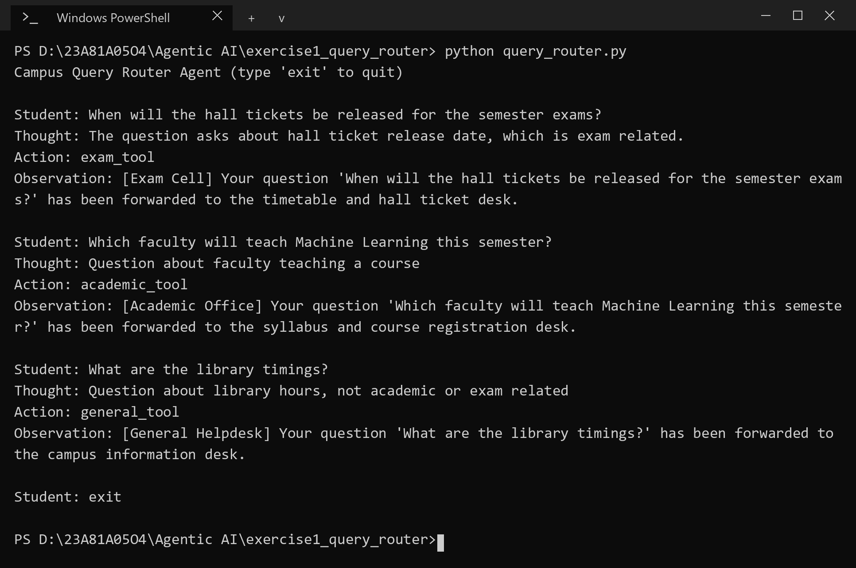
RESULT
The agent classified the hall ticket question as Exam, the faculty question as Academic and the library question as General, and called the matching function for each query.

2. Basic Tool Use and Function Calling: Student Helper Agent
AIM
To build a Student Helper Agent in which an LLM decides whether a query needs the math, python_help or english_grammar tool, and the response of the selected tool is printed.
DESCRIPTION
Function calling lets an LLM choose an action instead of only writing text. Each capability is wrapped as an ordinary Python function (a tool) and described to the model. The model replies with the name of the tool and the input for it, and the program executes the call. This is the reason to action flow of a ReAct agent: Thought (why this tool), Action (which tool and input) and Observation (what the tool returned).
A rule based router needs keyword lists for every topic and fails on a query such as 25% of 480 plus 17, which must first be turned into 0.25 * 480 + 17 before it can be calculated. An LLM driven router handles such wording and also extracts the input for the tool. Tools must be error safe: the math tool evaluates only plain arithmetic through the ast module instead of eval(), and every call is wrapped in try and except so that a failing tool returns a message instead of crashing the agent. When no tool fits, the agent says that it can only help with math, Python and English grammar.
ALGORITHM
1. Load the API key and create the Groq client.
2. Read the student's query from the console.
3. Ask the LLM, using a routing prompt, to return JSON with thought, action (math, python_help, english_grammar or none) and action_input.
4. If the action is none or unknown, print the fallback message.
5. Otherwise call the chosen tool function inside try and except.
6. Print the Thought, Action and Observation and repeat until the user types exit.
PROGRAM
student_helper.py
"""
Exercise 2 - Student Helper Agent

The LLM reads the student's query and decides which tool to use
(math, python_help or english_grammar). We call that tool and print its response.
"""
import ast
import json
import operator
import os

from dotenv import load_dotenv
from groq import Groq

load_dotenv()
client = Groq(api_key=os.getenv("GROQ_API_KEY"))
MODEL = "openai/gpt-oss-20b"

ROUTER_PROMPT = """You are a student helper. For each request, choose one action:
- math: arithmetic. action_input must be a plain arithmetic expression, e.g. "25% of 480" becomes "0.25 * 480"
- python_help: questions about Python syntax or errors. action_input is the question.
- english_grammar: correct an English sentence. action_input is the sentence.
- none: anything else.

Reply with JSON only:
{"thought": "<one short sentence>", "action": "math" or "python_help" or "english_grammar" or "none", "action_input": "<input>"}"""

def ask_llm(system, user, json_mode=False):
kwargs = {"response_format": {"type": "json_object"}} if json_mode else {}
response = client.chat.completions.create(
model=MODEL,
messages=[
{"role": "system", "content": system},
{"role": "user", "content": user},
],
temperature=0,
**kwargs,
)
return response.choices[0].message.content.strip()

# ---- tools ----
OPS = {
ast.Add: operator.add,
ast.Sub: operator.sub,
ast.Mult: operator.mul,
ast.Div: operator.truediv,
ast.FloorDiv: operator.floordiv,
ast.Mod: operator.mod,
ast.Pow: operator.pow,
}

def _eval(node):
if isinstance(node, ast.Constant) and isinstance(node.value, (int, float)):
return node.value
if isinstance(node, ast.BinOp) and type(node.op) in OPS:
return OPS[type(node.op)](_eval(node.left), _eval(node.right))
if isinstance(node, ast.UnaryOp) and isinstance(node.op, ast.USub):
return -_eval(node.operand)
raise ValueError("unsupported expression")

def math_tool(expression):
# only plain arithmetic is allowed, no eval()
result = _eval(ast.parse(expression, mode="eval").body)
return f"{expression} = {result}"

def python_help_tool(question):
return ask_llm(
"You are a Python tutor. Answer in at most 4 short lines and include a tiny code example if useful.",
question,
)

def english_grammar_tool(sentence):
corrected = ask_llm(
"Correct the grammar of the user's text. Reply with only the corrected text.",
sentence,
)
return f"Corrected: {corrected}"

TOOLS = {
"math": math_tool,
"python_help": python_help_tool,
"english_grammar": english_grammar_tool,
}

def decide(query):
reply = ask_llm(ROUTER_PROMPT, query, json_mode=True)
try:
data = json.loads(reply)
except json.JSONDecodeError:
return "", "none", query
return data.get("thought", ""), data.get("action", "none"), data.get("action_input", query)

def run_agent(query):
thought, tool, tool_input = decide(query)
print(f"Thought: {thought}")

if tool not in TOOLS:
print("Action: none")
print("Observation: I can only help with math, Python and English grammar.")
return

print(f"Action: {tool}({tool_input!r})")
try:
observation = TOOLS[tool](tool_input)
except Exception as e:
observation = f"The {tool} tool failed: {e}"
print(f"Observation: {observation}")

def main():
print("Student Helper Agent - math / Python help / English grammar (type 'exit' to quit)\n")
while True:
query = input("Student: ").strip()
if query.lower() == "exit":
break
if not query:
continue
try:
run_agent(query)
except Exception as e:
print(f"Something went wrong: {e}")
print()

if __name__ == "__main__":
main()
OUTPUT
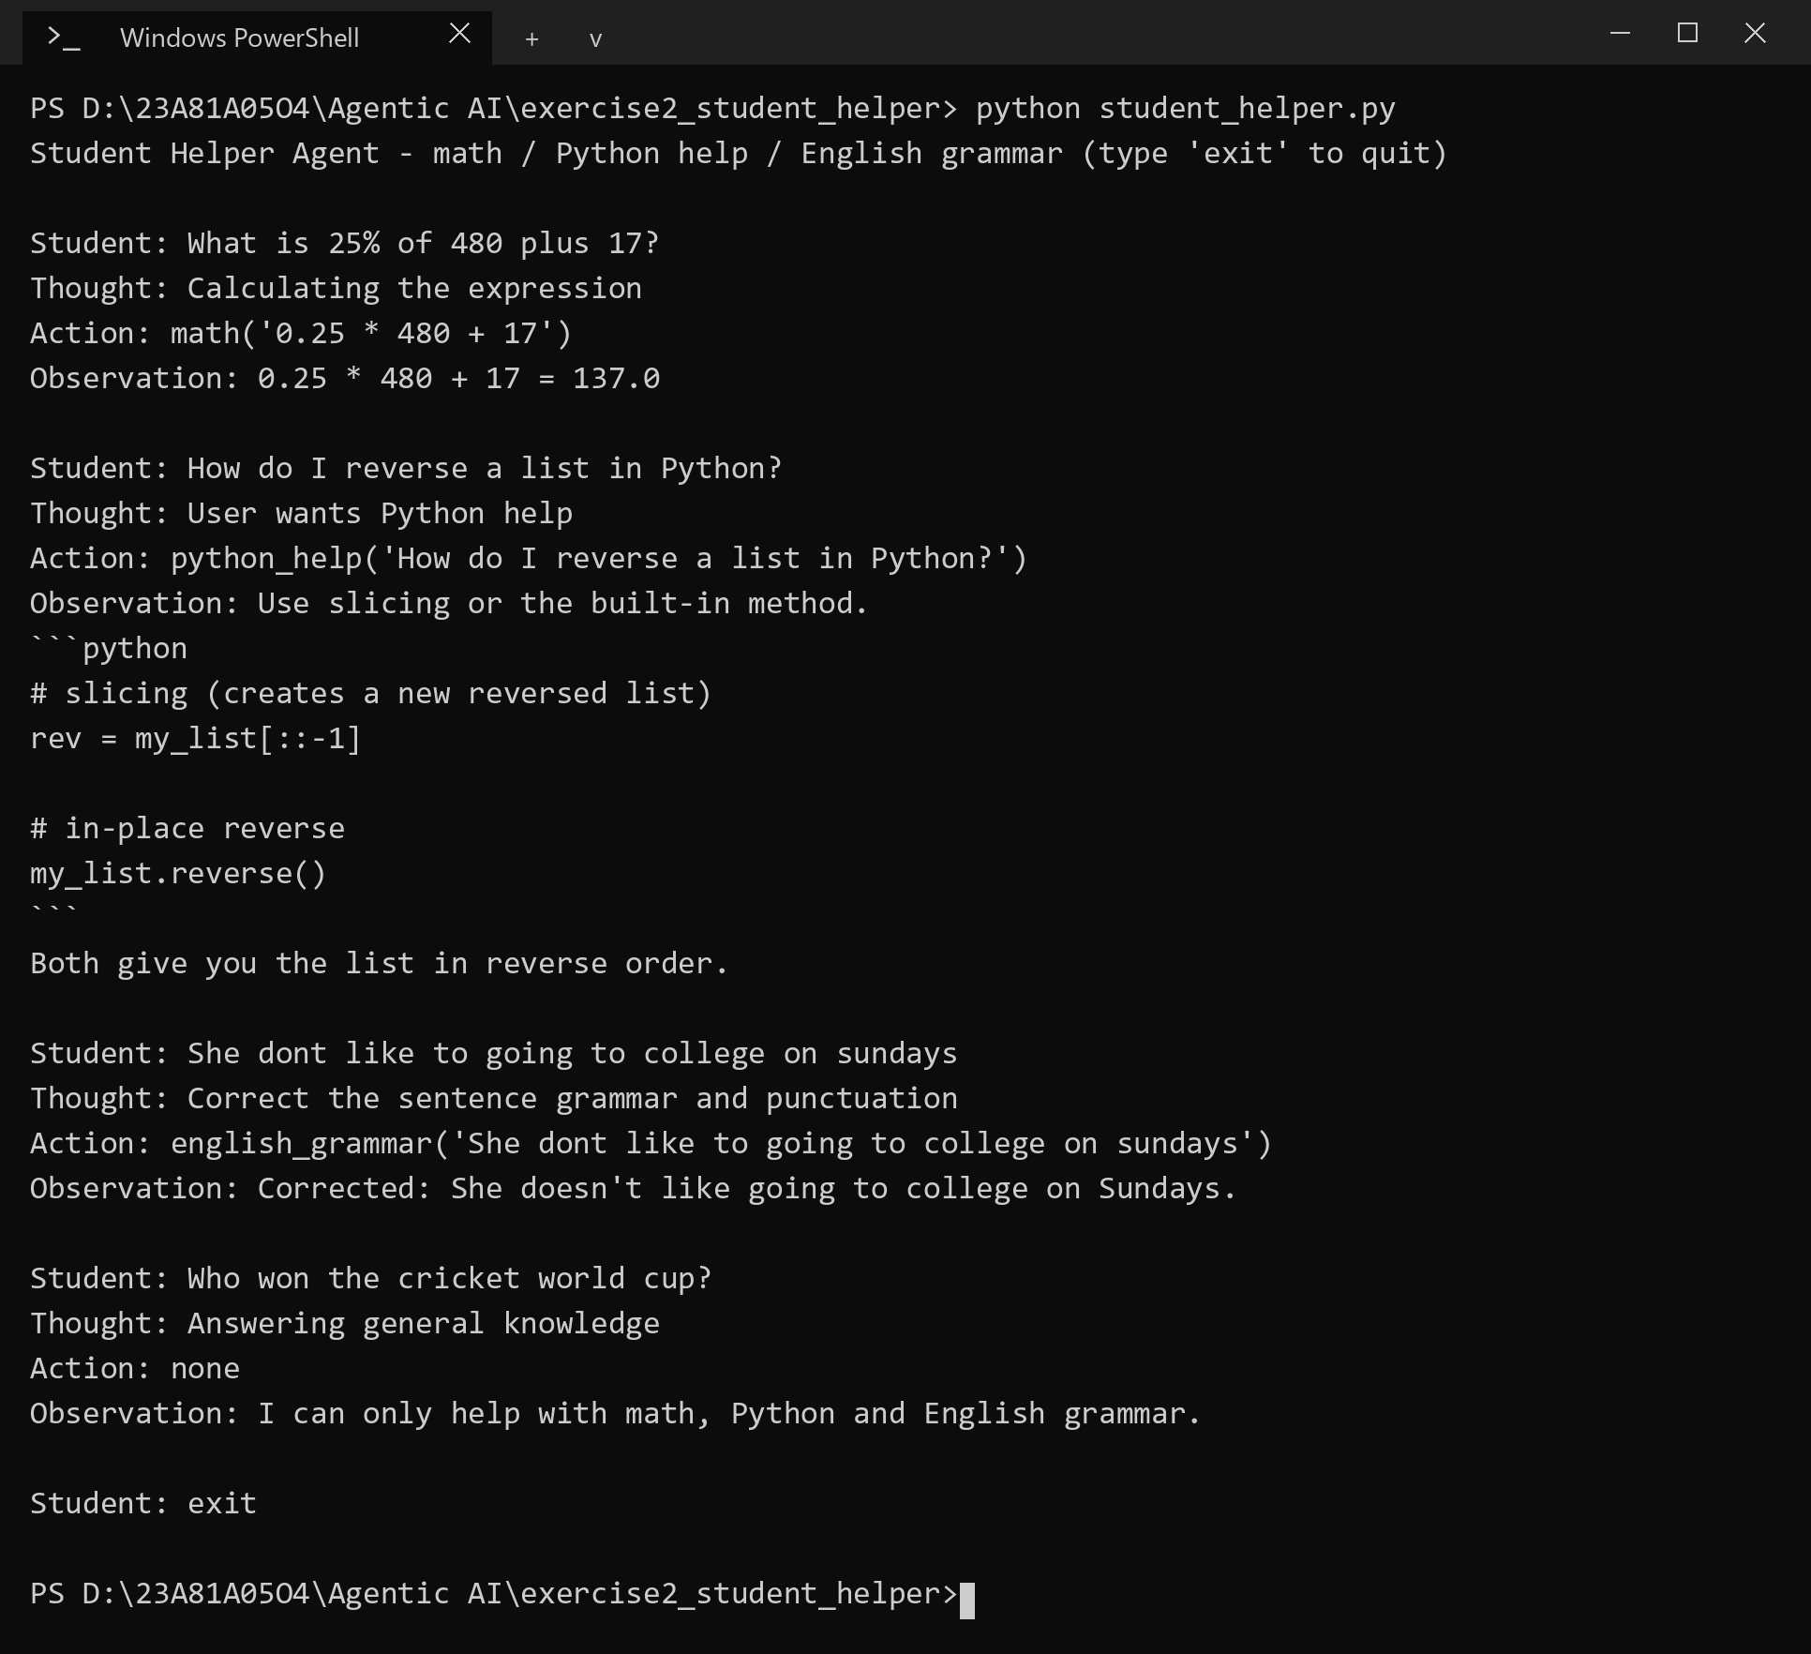
RESULT
The LLM selected math for the percentage question, python_help for the list question and english_grammar for the faulty sentence. It answered none for the cricket question, which is outside the three tools.

3. LangChain Basics: Simple Retrieval Agent
AIM
To build a LangChain agent that loads a campus rules document, splits it into chunks, stores their embeddings in Chroma, retrieves the most relevant chunks for a question and generates an answer from them.
DESCRIPTION
LangChain provides building blocks for LLM applications: prompt templates, models, output parsers and retrievers, which are joined into a chain with the | operator. Retrieval augmented generation (RAG) gives the model facts it was never trained on. The document is read and split into small overlapping chunks (500 characters with an overlap of 50, using RecursiveCharacterTextSplitter), and each chunk is converted into an embedding, a vector of numbers that places text of similar meaning close together.
The vectors are kept in Chroma, a vector database. The question is embedded in the same way and the nearest chunks are returned by similarity search together with a distance score, where a lower score means a closer match. The chunks are placed in a PromptTemplate and the chain PromptTemplate | ChatGroq | StrOutputParser writes the answer using only that context, so the model says it does not know when the document does not cover the question. The printed scores are a simple evaluation of retrieval: the answerable questions had a best score below 0.8, while the unrelated question scored about 2.0 on every chunk.
ALGORITHM
1. Read campus_rules.txt and wrap it in a LangChain Document.
2. Split the document with RecursiveCharacterTextSplitter (chunk size 500, overlap 50).
3. Embed every chunk with the local MiniLM model and store the chunks in Chroma.
4. Read the student's question and run a similarity search for the top 2 chunks.
5. Print the retrieved chunks with their scores.
6. Pass the chunks and the question to the chain (prompt, LLM, output parser) and print the answer.
PROGRAM
retrieval_agent.py
"""
Exercise 3 - Simple Retrieval Agent with LangChain

campus_rules.txt -> split into chunks -> embed -> Chroma vector store
question -> retrieve the most relevant chunks -> LLM answers from those chunks
"""
from pathlib import Path

from chromadb.utils.embedding_functions import DefaultEmbeddingFunction
from dotenv import load_dotenv
from langchain_chroma import Chroma
from langchain_core.documents import Document
from langchain_core.embeddings import Embeddings
from langchain_core.output_parsers import StrOutputParser
from langchain_core.prompts import PromptTemplate
from langchain_groq import ChatGroq
from langchain_text_splitters import RecursiveCharacterTextSplitter

load_dotenv() # ChatGroq picks up GROQ_API_KEY from the environment

DOC_PATH = Path(__file__).parent / "campus_rules.txt"
TOP_K = 2

class LocalEmbeddings(Embeddings):
"""Small MiniLM model that ships with chromadb, runs locally, no extra API key."""

def __init__(self):
self.model = DefaultEmbeddingFunction()

def embed_documents(self, texts):
return [[float(x) for x in vec] for vec in self.model(texts)]

def embed_query(self, text):
return self.embed_documents([text])[0]

def build_vector_store():
text = DOC_PATH.read_text(encoding="utf-8")
docs = [Document(page_content=text, metadata={"source": DOC_PATH.name})]

splitter = RecursiveCharacterTextSplitter(chunk_size=500, chunk_overlap=50)
chunks = splitter.split_documents(docs)
print(f"Loaded {DOC_PATH.name}: {len(chunks)} chunks")

return Chroma.from_documents(chunks, LocalEmbeddings())

prompt = PromptTemplate.from_template(
"""You are a helpful assistant for college students.
Answer the question using only the context below. If the answer is not in the context, say you don't know.

Context:
{context}

Question: {question}

Answer:"""
)
llm = ChatGroq(model="openai/gpt-oss-20b", temperature=0)
chain = prompt | llm | StrOutputParser()

def answer_question(store, question):
results = store.similarity_search_with_score(question, k=TOP_K)

print("\nRetrieved chunks (lower score = closer match):")
for doc, score in results:
preview = doc.page_content.replace("\n", " ")[:150]
print(f" [{score:.3f}] {preview}...")

context = "\n\n".join(doc.page_content for doc, _ in results)
return chain.invoke({"context": context, "question": question})

def main():
store = build_vector_store()
print("Ask about the campus rules (type 'exit' to quit)\n")
while True:
question = input("Student: ").strip()
if question.lower() == "exit":
break
if not question:
continue
try:
print("\nAnswer:", answer_question(store, question))
except Exception as e:
print(f"Something went wrong: {e}")
print()

if __name__ == "__main__":
main()
OUTPUT
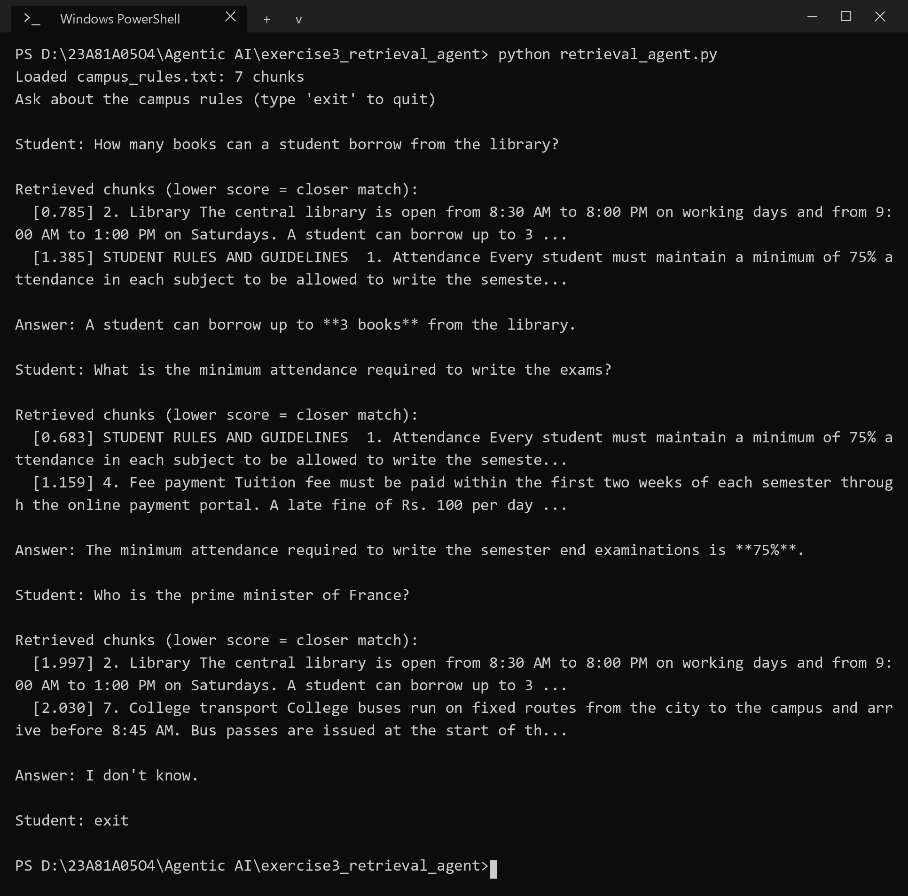
RESULT
The agent retrieved the library chunk for the borrowing question and the attendance chunk for the exam question and answered both from them (3 books, 75% attendance). For the unrelated question the best score was about 2.0 and the agent answered that it does not know.

4. LangGraph Basics: Self-Correction Coding Agent
AIM
To build a LangGraph agent that generates Python code for a small question, checks the result for errors and revises the code when an error is found.
DESCRIPTION
LangGraph models an agent as a graph. The state is a shared dictionary (question, code, output, has_error, revisions). Each node is a function that reads the state and returns updates, edges define the order, and a conditional edge chooses the next node at run time. This gives a controlled pipeline instead of one direct generation: the path of the agent is fixed by the developer and the LLM only fills in the steps.
The self correction (reflection) loop is generate, check and revise. The check node runs the code in a temporary folder after the user approves it (human approved execution) and looks for Traceback or Error in the output. If an error is found, the revise node sends the code and the error text back to the LLM and the graph returns to the check node. The loop stops after 2 revisions so that it cannot run forever, which is a basic rule of safe iterative improvement. The text check is deliberately simple: it also flags a program that prints its own Error message, as the second run below shows.
ALGORITHM
1. Define the state and the three nodes: generate, check and revise.
2. generate asks the LLM for a self contained Python script and extracts the code block.
3. check shows the code, asks the user for permission, runs it with a 10 second limit and looks for Traceback or Error in the output.
4. If an error is found and fewer than 2 revisions were made, revise sends the code and the error to the LLM and the new code goes back to check.
5. Otherwise the graph ends and the final code is printed.
PROGRAM
self_correction_agent.py
"""
Exercise 4 - Self-Correction Coding Agent (LangGraph)

generate -> check -> (error found?) -> revise -> check -> ... -> done

check runs the generated code (only after the user says yes) and looks for
"Traceback" or "Error" in what it prints. If found, the agent revises the code
using that error message. It stops after MAX_REVISIONS revisions.
"""
import re
import subprocess
import sys
import tempfile
from typing import TypedDict

from dotenv import load_dotenv
from langchain_groq import ChatGroq
from langgraph.graph import END, START, StateGraph

load_dotenv()
llm = ChatGroq(model="openai/gpt-oss-20b", temperature=0)

MAX_REVISIONS = 2

GENERATE_PROMPT = (
"You are a Python coding assistant. Write a short, complete Python script for the task below. "
"The script must run on its own with no user input and print its result. "
"If it needs a file, create a small sample file first. "
"Reply with only one ```python code block."
)

REVISE_PROMPT = (
"The Python script below was run and printed an error. Fix it. "
"Reply with only one corrected ```python code block."
)

class State(TypedDict):
question: str
code: str
output: str
has_error: bool
revisions: int

def extract_code(text):
match = re.search(r"```(?:python)?\s*\n(.*?)```", text, re.DOTALL)
return (match.group(1) if match else text).strip()

def generate(state):
print("\n[generate] writing code...")
reply = llm.invoke([("system", GENERATE_PROMPT), ("human", state["question"])])
return {"code": extract_code(reply.content), "revisions": 0}

def check(state):
print("\n--- code ---")
print(state["code"])
print("------------")
answer = input("Run this code to test it? (y/n): ").strip().lower()
if answer != "y":
print("[check] skipped, not running the code")
return {"output": "(not run)", "has_error": False}

# run in a temp folder so any sample files it creates don't end up in the project
with tempfile.TemporaryDirectory() as tmp:
script = f"{tmp}/script.py"
with open(script, "w", encoding="utf-8") as f:
f.write(state["code"])
try:
run = subprocess.run(
[sys.executable, script],
capture_output=True, text=True, encoding="utf-8", errors="replace",
timeout=10, cwd=tmp,
)
output = (run.stdout + run.stderr).strip()
except subprocess.TimeoutExpired:
output = "Error: the script took more than 10 seconds"

has_error = "Traceback" in output or "Error" in output
print(f"[check] output:\n{output}")
print("[check] error found" if has_error else "[check] no error found")
return {"output": output, "has_error": has_error}

def revise(state):
print("\n[revise] fixing the code...")
message = f"Task: {state['question']}\n\nScript:\n{state['code']}\n\nError output:\n{state['output']}"
reply = llm.invoke([("system", REVISE_PROMPT), ("human", message)])
new_code = extract_code(reply.content)
# if the model sends back nothing, keep the previous code instead of losing it
return {"code": new_code or state["code"], "revisions": state["revisions"] + 1}

def after_check(state):
if state["has_error"] and state["revisions"] < MAX_REVISIONS:
return "revise"
return END

graph = StateGraph(State)
graph.add_node("generate", generate)
graph.add_node("check", check)
graph.add_node("revise", revise)
graph.add_edge(START, "generate")
graph.add_edge("generate", "check")
graph.add_conditional_edges("check", after_check, {"revise": "revise", END: END})
graph.add_edge("revise", "check")
agent = graph.compile()

def main():
print("Self-Correction Coding Agent (type 'exit' to quit)\n")
while True:
question = input("Coding question: ").strip()
if question.lower() == "exit":
break
if not question:
continue
try:
result = agent.invoke({"question": question, "code": "", "output": "", "has_error": False, "revisions": 0})
except Exception as e:
print(f"Something went wrong: {e}")
continue

print("\n=== Final answer ===")
print(result["code"])
if result["has_error"]:
print(f"\nStill showing an error after {result['revisions']} revision(s):\n{result['output']}")
elif result["revisions"]:
print(f"\n(Corrected after {result['revisions']} revision(s))")
print()

if __name__ == "__main__":
main()
OUTPUT
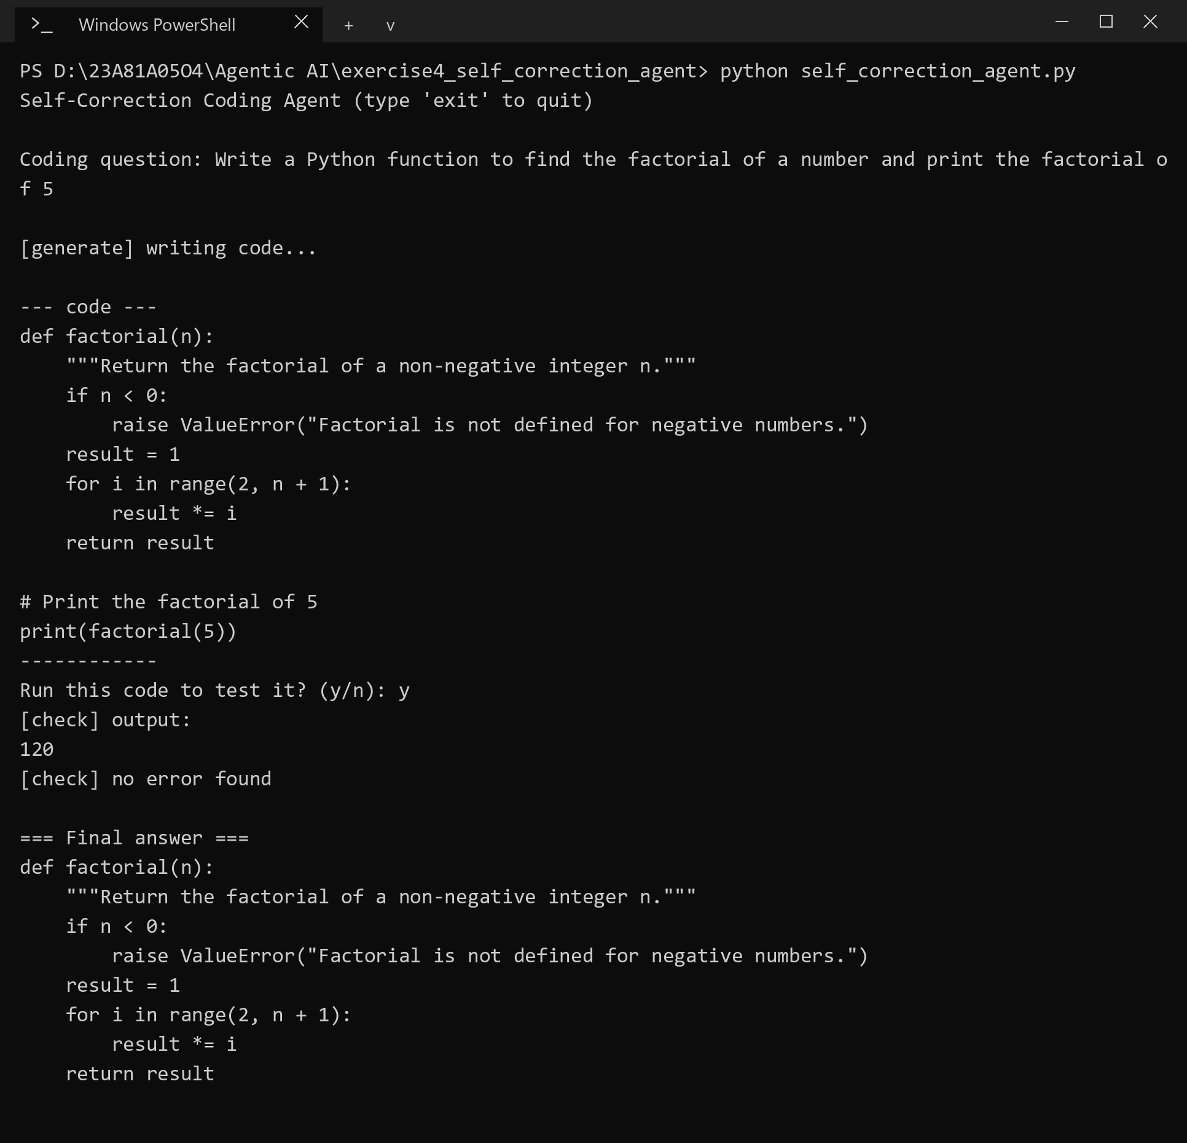
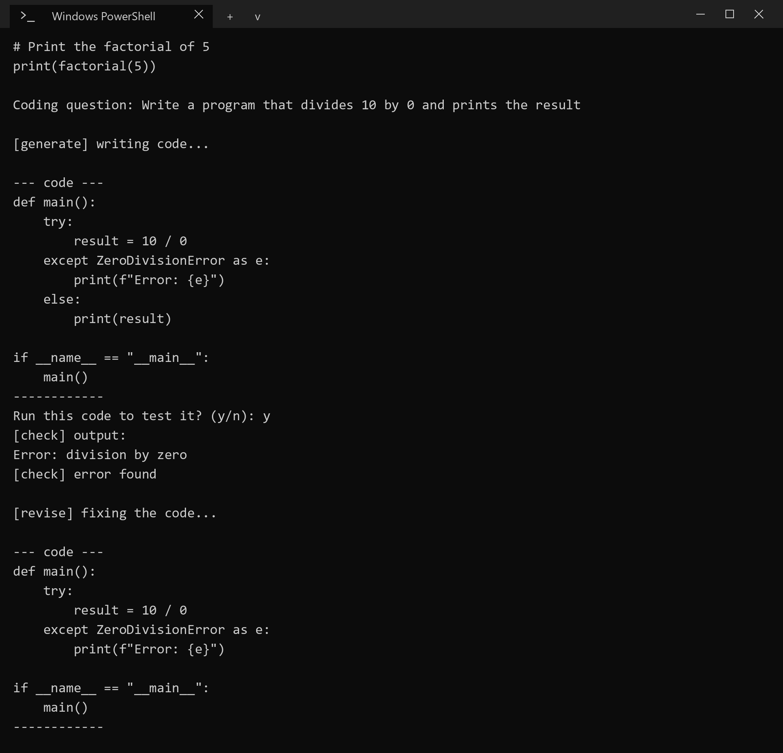
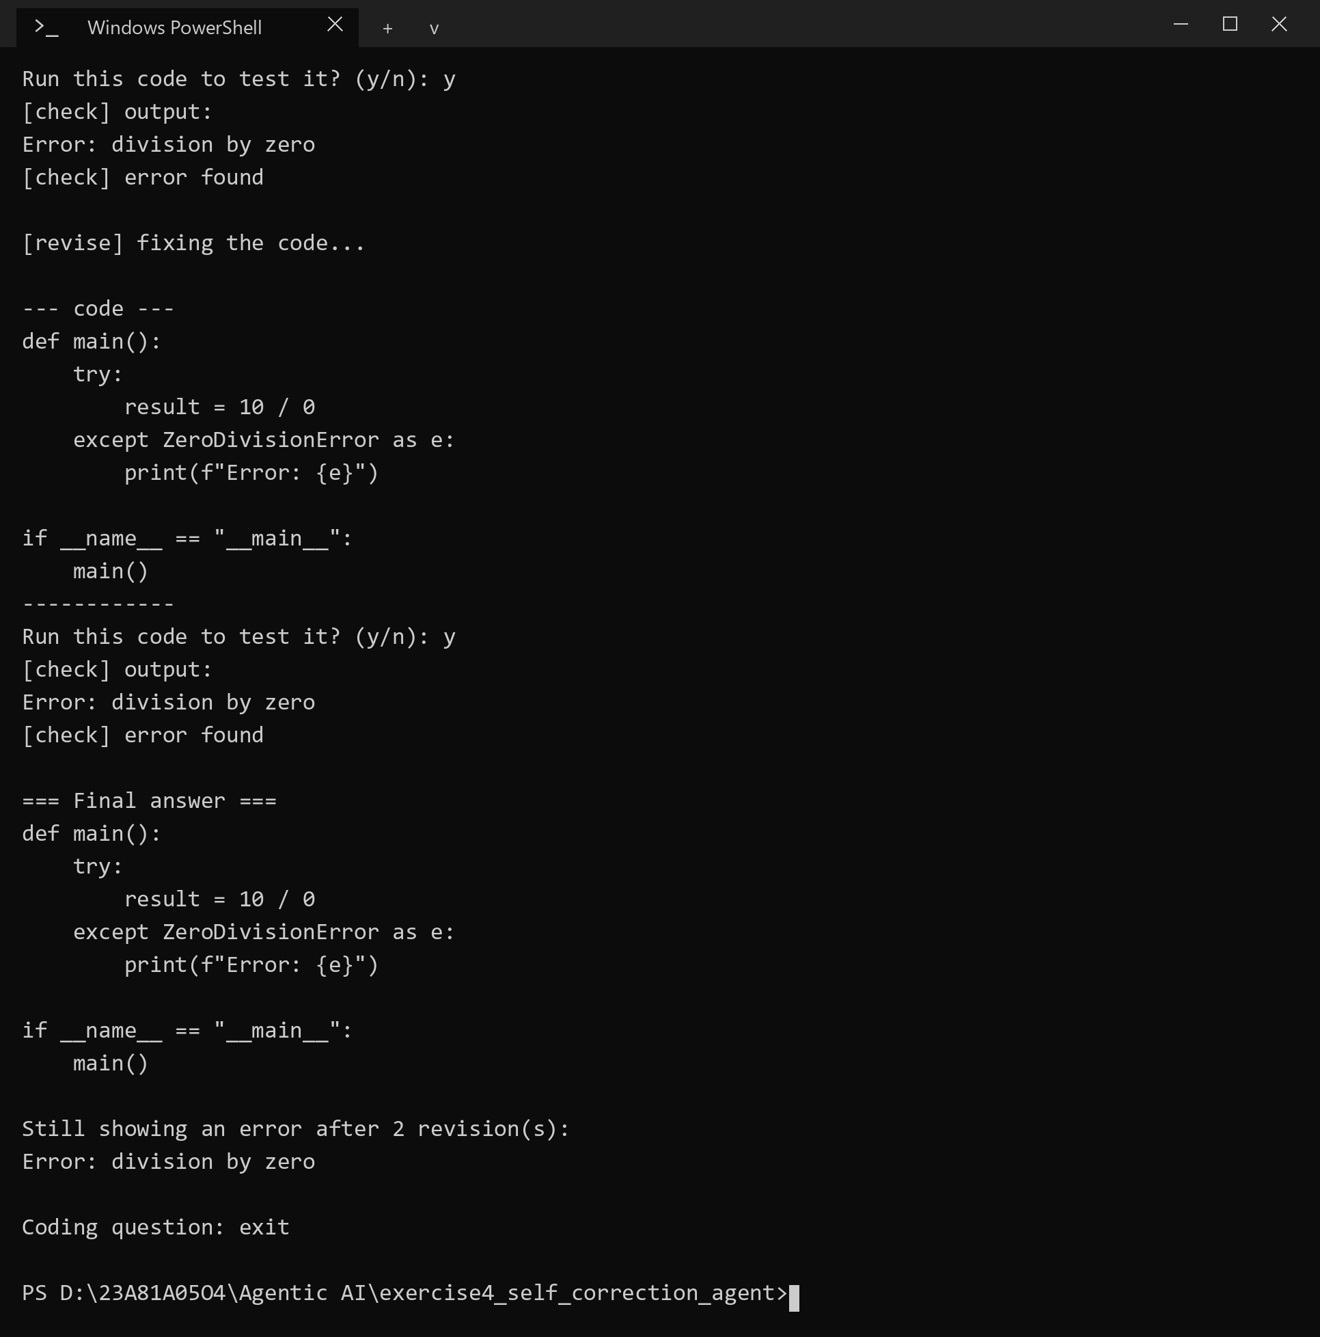
RESULT
The factorial program ran without an error on the first attempt. The division by zero program handles the error itself and prints Error: division by zero, which the text check treats as an error, so the agent revised it twice, stopped at the limit and reported the remaining error. This shows both the correction loop and the limit of a simple text check.

5. Agentic RAG with Structured Retrieval: Campus Information RAG Agent
AIM
To build a multi-document RAG system that loads several campus documents into one vector store, retrieves context for a student query and answers from it with reference snippets.
DESCRIPTION
Naive RAG retrieves from one source and trusts whatever comes back. A campus has many sources (academic handbook, exam rules, department brochure), so the system must know which document each chunk came from. Every chunk carries its file name as metadata, all chunks are embedded into one Chroma store, and a single similarity search can return chunks from different documents.
The retrieved chunks are given to the LLM labelled with their source, and the prompt asks it to answer only from them and to cite the file name in brackets. After the answer the program prints the reference snippets, so the student can check every claim against the original text. Citing sources makes the answer grounded and helps prevent hallucination. Naive RAG still has limits: the number of chunks is fixed, a vague question can bring back irrelevant chunks, and nothing rewrites the query or estimates confidence. Agentic RAG adds such steps, for example query rewriting, multi-step retrieval and confidence checks, under the control of an agent.
ALGORITHM
1. Read every .txt file in the docs folder (academic_handbook, exam_rules, department_brochure) as a Document with its file name as the source.
2. Split the documents into chunks of 500 characters and embed them into one Chroma store.
3. For each question, retrieve the 3 most similar chunks.
4. Build the context with the source name before each chunk and ask the LLM to answer from it and cite the source.
5. Print the answer and the reference snippets with their source file names.
PROGRAM
campus_rag.py
"""
Exercise 5 - Multi-document Campus RAG

Loads every .txt file in docs/ (academic handbook, exam rules, department brochure),
embeds the chunks into one Chroma store, retrieves for a student query and
answers from the retrieved text. The source snippets are printed under the answer.
"""
from pathlib import Path

from chromadb.utils.embedding_functions import DefaultEmbeddingFunction
from dotenv import load_dotenv
from langchain_chroma import Chroma
from langchain_core.documents import Document
from langchain_core.embeddings import Embeddings
from langchain_core.output_parsers import StrOutputParser
from langchain_core.prompts import PromptTemplate
from langchain_groq import ChatGroq
from langchain_text_splitters import RecursiveCharacterTextSplitter

load_dotenv()

DOCS_DIR = Path(__file__).parent / "docs"
TOP_K = 3

class LocalEmbeddings(Embeddings):
"""Small MiniLM model that ships with chromadb, runs locally, no extra API key."""

def __init__(self):
self.model = DefaultEmbeddingFunction()

def embed_documents(self, texts):
return [[float(x) for x in vec] for vec in self.model(texts)]

def embed_query(self, text):
return self.embed_documents([text])[0]

def build_vector_store():
docs = []
for path in sorted(DOCS_DIR.glob("*.txt")):
docs.append(Document(page_content=path.read_text(encoding="utf-8"), metadata={"source": path.name}))

splitter = RecursiveCharacterTextSplitter(chunk_size=500, chunk_overlap=50)
chunks = splitter.split_documents(docs)
print(f"Loaded {len(docs)} documents -> {len(chunks)} chunks")

return Chroma.from_documents(chunks, LocalEmbeddings())

prompt = PromptTemplate.from_template(
"""You are a helpful assistant for college students.
Answer the question using only the context below. Mention the source file name in brackets,
like [exam_rules.txt], for the facts you use. If the answer is not in the context, say you don't know.

Context:
{context}

Question: {question}

Answer:"""
)
llm = ChatGroq(model="openai/gpt-oss-20b", temperature=0)
chain = prompt | llm | StrOutputParser()

def answer_question(store, question):
results = store.similarity_search(question, k=TOP_K)

context = "\n\n".join(f"[{doc.metadata['source']}]\n{doc.page_content}" for doc in results)
answer = chain.invoke({"context": context, "question": question})

print("\nAnswer:", answer)
print("\nReference snippets:")
for i, doc in enumerate(results, 1):
snippet = doc.page_content.replace("\n", " ")[:200]
print(f" {i}. ({doc.metadata['source']}) {snippet}...")

def main():
store = build_vector_store()
print("Ask about academics, exams or the department (type 'exit' to quit)\n")
while True:
question = input("Student: ").strip()
if question.lower() == "exit":
break
if not question:
continue
try:
answer_question(store, question)
except Exception as e:
print(f"Something went wrong: {e}")
print()

if __name__ == "__main__":
main()
OUTPUT
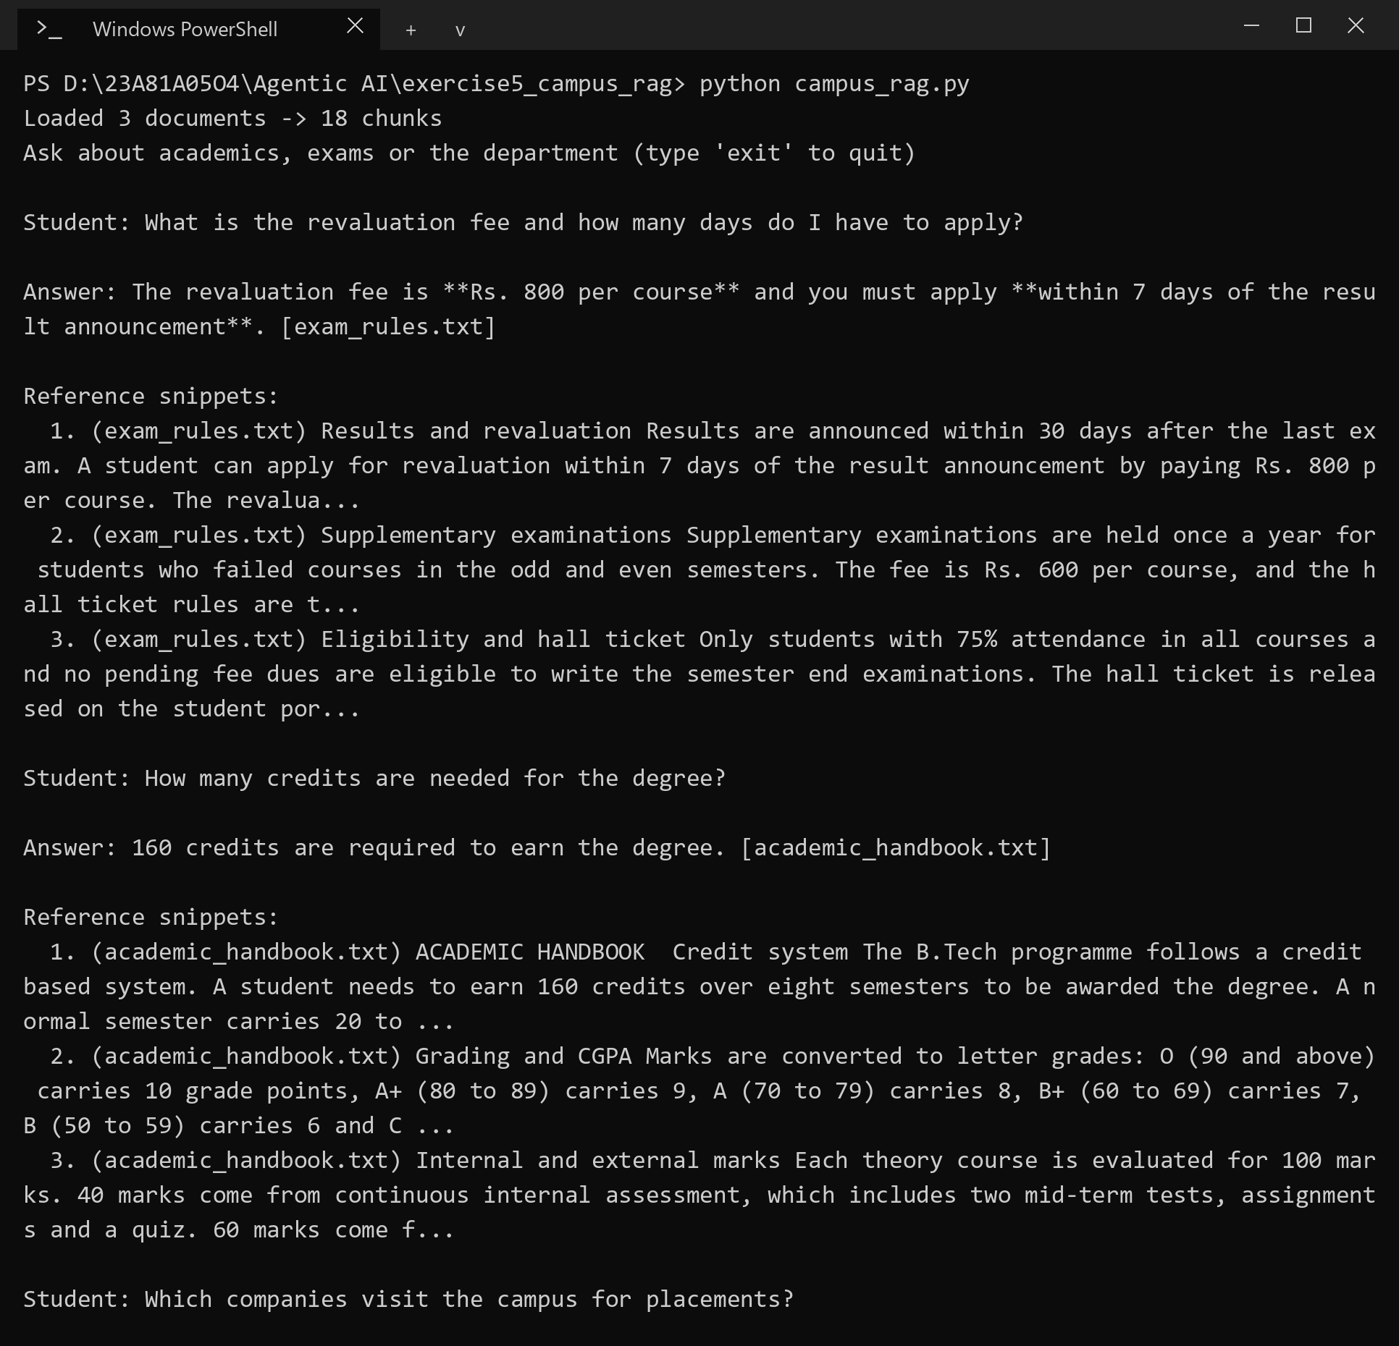
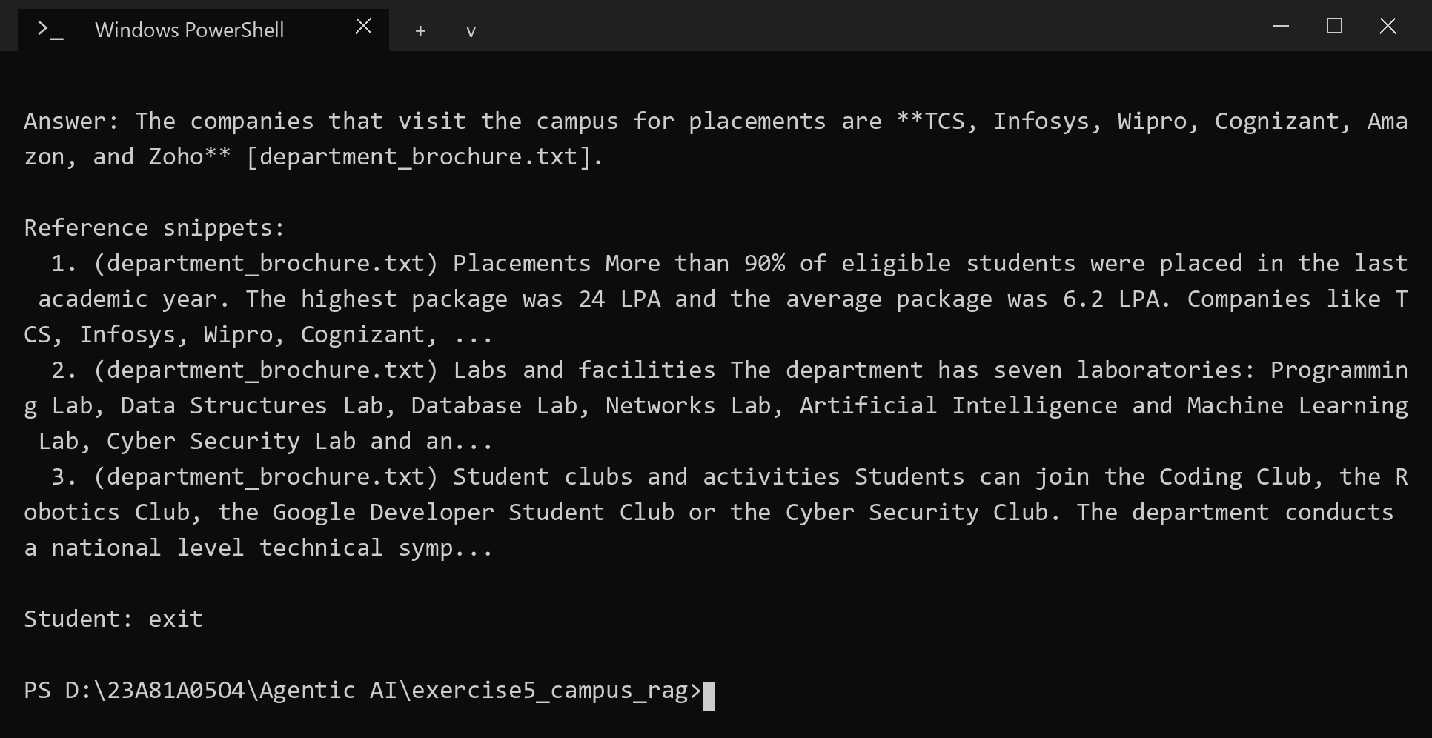
RESULT
The revaluation question was answered from exam_rules.txt (Rs. 800 per course, within 7 days), the credits question from academic_handbook.txt (160 credits) and the placement question from department_brochure.txt. Each answer was followed by the snippets it was taken from.

6. Multi-Agent Collaboration: Research Agent and Refiner Agent
AIM
To build a two-agent pipeline in which a Research Agent produces bullet points on a topic and a Refiner Agent turns them into a short explanation.
DESCRIPTION
A multi-agent system splits a task between agents with different roles instead of asking one agent to do everything. Each agent is defined by its role prompt, and the agents cooperate by message passing: the output of one agent becomes the input of the next. Here the pipeline is a simple chain, Research Agent followed by Refiner Agent, where the program itself passes the message.
The Research Agent is told to produce 5 to 6 factual bullet points only. The Refiner Agent receives the topic and those bullets and is told to write 4 to 5 sentences of prose without adding facts that are not in the bullets, which keeps it faithful to the research. Separating the roles keeps each prompt short and easy to test. In a campus setting the same pattern can prepare study notes: one agent collects the points and another writes the explanation. A larger system would add a coordinator agent to delegate tasks and to decide what to do when the outputs of two agents conflict.
ALGORITHM
1. Define the role prompts of the two agents.
2. Read the topic from the user.
3. Call the Research Agent with the topic and get the bullet points.
4. Pass the topic and the bullet points to the Refiner Agent.
5. Print the refined explanation as the final answer.
PROGRAM
multi_agent.py
"""
Exercise 6 - Two-agent pipeline

Research Agent : topic -> bullet points
Refiner Agent : bullet points -> short explanation
The refined explanation is what the user gets at the end.
"""
import os

from dotenv import load_dotenv
from groq import Groq

load_dotenv()
client = Groq(api_key=os.getenv("GROQ_API_KEY"))
MODEL = "openai/gpt-oss-20b"

RESEARCH_PROMPT = (
"You are a Research Agent. For the given topic, list 5 to 6 short factual bullet points. "
"Output only the bullets, one per line, each starting with '- '."
)

REFINER_PROMPT = (
"You are a Refiner Agent. You get a topic and raw bullet points from a researcher. "
"Turn them into one short, well-structured explanation of 4 to 5 sentences in plain prose. "
"Do not use bullet points and do not add facts that are not in the bullets."
)

def ask(system, user):
response = client.chat.completions.create(
model=MODEL,
messages=[
{"role": "system", "content": system},
{"role": "user", "content": user},
],
temperature=0.3,
)
return response.choices[0].message.content.strip()

def research_agent(topic):
return ask(RESEARCH_PROMPT, topic)

def refiner_agent(topic, bullets):
return ask(REFINER_PROMPT, f"Topic: {topic}\n\nBullet points:\n{bullets}")

def run_pipeline(topic):
print("\n[Research Agent] working...")
bullets = research_agent(topic)
print(bullets)

print("\n[Refiner Agent] working...")
explanation = refiner_agent(topic, bullets)

print("\nFinal answer:")
print(explanation)

def main():
print("Research Agent -> Refiner Agent (type 'exit' to quit)\n")
while True:
topic = input("Topic: ").strip()
if topic.lower() == "exit":
break
if not topic:
continue
try:
run_pipeline(topic)
except Exception as e:
print(f"Something went wrong: {e}")
print()

if __name__ == "__main__":
main()
OUTPUT
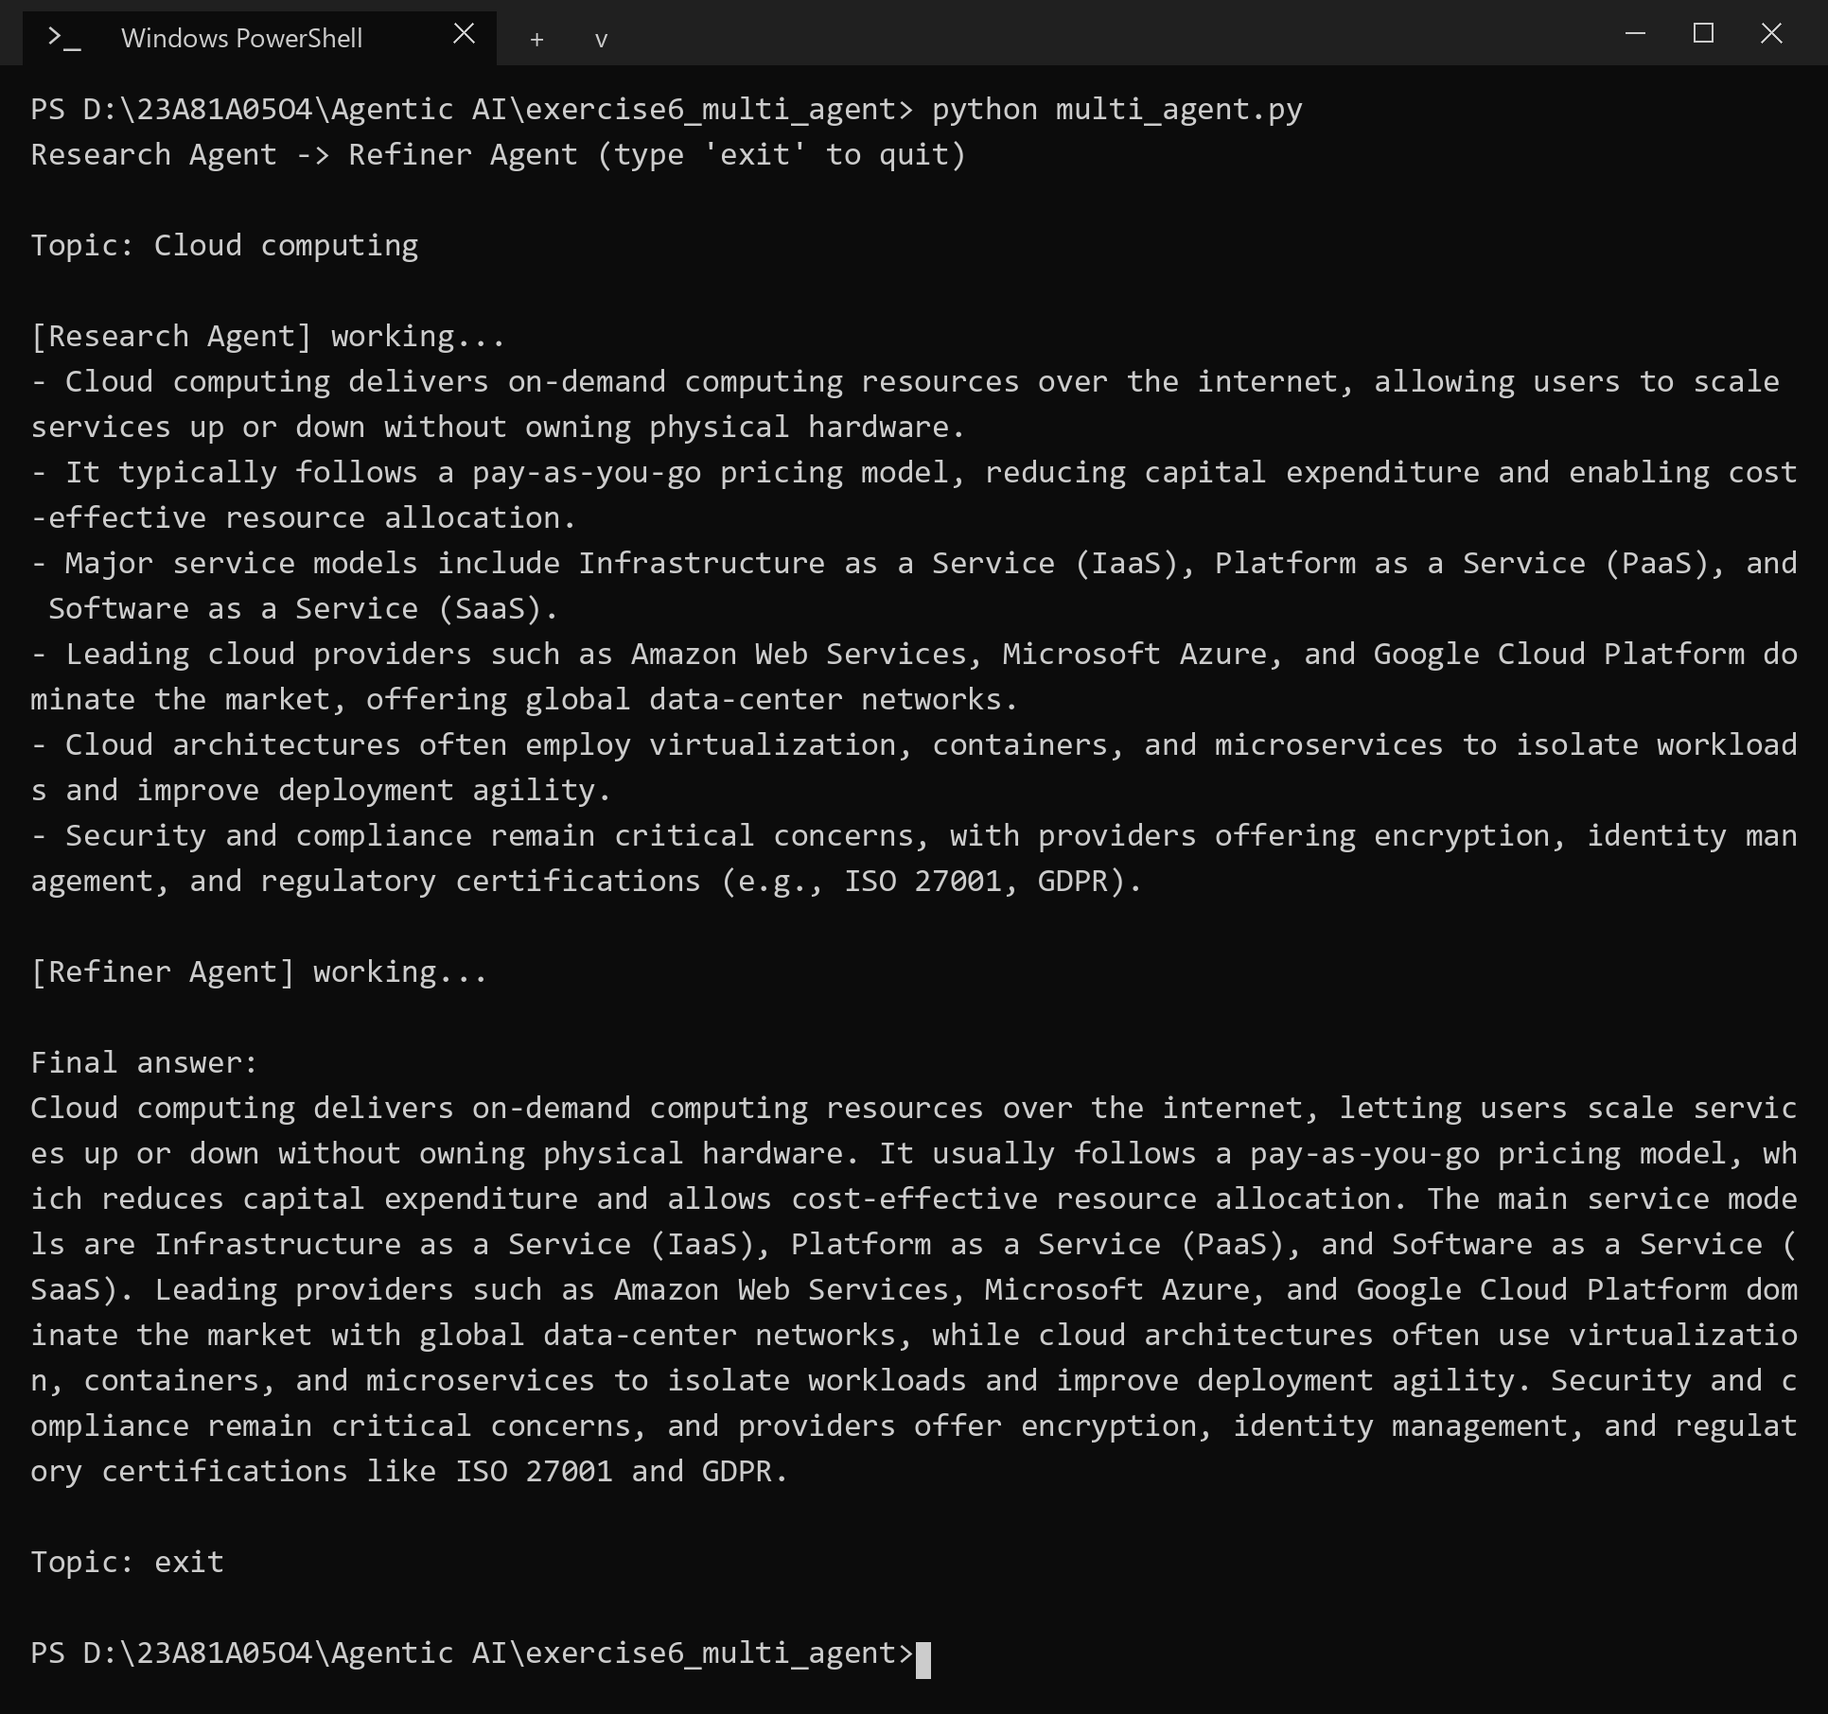
RESULT
For the topic Cloud computing the Research Agent returned six bullet points and the Refiner Agent combined them into a short paragraph covering the same points.

7. API-Enabled Agent for External Automation: Weather Lookup Agent
AIM
To build an agent that answers a question needing live data by calling a public API, parsing the JSON response and displaying both the raw data and an explanation.
DESCRIPTION
An agent becomes useful for real tasks when it can reach outside data. The tools here are two public APIs of Open-Meteo that need no key: a geocoding API that turns a city name into latitude and longitude, and a forecast API that returns the current weather. The functions are described to the LLM as tools (function calling). The model decides which one to call and with which arguments, and the program makes the HTTP request with the requests library and parses the JSON.
This is the ReAct loop in full. The LLM reasons (Thought), chooses a tool call (Action), the program performs it and returns the result (Observation), and the cycle repeats until the model has enough data to answer. For the sports day question the agent first looked up the coordinates of Hyderabad, then fetched the weather for them and finally wrote a recommendation. The raw JSON is displayed so that the student can see the data the explanation is based on. For safety only read-only GET requests are made, errors are returned to the model as an observation instead of crashing the agent, and the loop is limited to 5 steps.
ALGORITHM
1. Describe the two API functions (get_coordinates and get_weather) to the LLM as tools.
2. Read the student's question and send it to the LLM.
3. If the LLM asks for a tool call, run the function, which calls the API and parses the JSON, and send the result back as an observation.
4. Repeat until the LLM answers without a tool call, with a maximum of 5 steps.
5. Print the raw JSON of the weather API and the explanation.
PROGRAM
api_agent.py
"""
Exercise 7 - API-enabled agent (ReAct loop + Open-Meteo public API)

Case study: a student asks about the weather before a campus event
("Is it ok to hold the sports day in Hyderabad today?").

The agent follows the ReAct cycle:
Thought (LLM reasons) -> Action (LLM picks an API function) -> Observation (we call the API)
and repeats until the LLM can answer. Open-Meteo needs no API key.
At the end we print the raw JSON from the weather API and the explanation.
"""
import json
import os

import requests
from dotenv import load_dotenv
from groq import Groq

load_dotenv()
client = Groq(api_key=os.getenv("GROQ_API_KEY"))
MODEL = "openai/gpt-oss-20b"

MAX_STEPS = 5

SYSTEM_PROMPT = (
"You answer weather questions for college students. Use the functions to get real data, "
"never guess. When you have the data, reply with a short, friendly explanation that includes "
"the key numbers (temperature, humidity, rain, wind) and a clear recommendation."
)

# ---- functions that call the public APIs and return parsed JSON ----
def get_coordinates(city):
url = "https://geocoding-api.open-meteo.com/v1/search"
data = requests.get(url, params={"name": city, "count": 1}, timeout=10).json()
if not data.get("results"):
return {"error": f"city '{city}' not found"}
place = data["results"][0]
return {
"name": place["name"],
"country": place.get("country"),
"latitude": place["latitude"],
"longitude": place["longitude"],
}

def get_weather(latitude, longitude):
url = "https://api.open-meteo.com/v1/forecast"
params = {
"latitude": latitude,
"longitude": longitude,
"current": "temperature_2m,relative_humidity_2m,precipitation,wind_speed_10m,weather_code",
"timezone": "auto",
}
response = requests.get(url, params=params, timeout=10)
response.raise_for_status()
return response.json()

FUNCTIONS = {
"get_coordinates": get_coordinates,
"get_weather": get_weather,
}

# how the LLM sees the functions
TOOL_SCHEMAS = [
{
"type": "function",
"function": {
"name": "get_coordinates",
"description": "Look up the latitude and longitude of a city.",
"parameters": {
"type": "object",
"properties": {"city": {"type": "string", "description": "City name"}},
"required": ["city"],
},
},
},
{
"type": "function",
"function": {
"name": "get_weather",
"description": "Get the current weather at a latitude and longitude.",
"parameters": {
"type": "object",
"properties": {
"latitude": {"type": "number"},
"longitude": {"type": "number"},
},
"required": ["latitude", "longitude"],
},
},
},
]

def run_agent(question):
messages = [
{"role": "system", "content": SYSTEM_PROMPT},
{"role": "user", "content": question},
]
raw_weather = None

for _ in range(MAX_STEPS):
response = client.chat.completions.create(
model=MODEL, messages=messages, tools=TOOL_SCHEMAS, temperature=0
)
message = response.choices[0].message

thought = getattr(message, "reasoning", None)
if thought:
print(f"Thought: {thought.strip()[:300]}")

# no more actions -> this is the final answer
if not message.tool_calls:
if raw_weather:
print("\n--- Raw API response ---")
print(json.dumps(raw_weather, indent=2))
print("\n--- Explanation ---")
print(message.content.strip())
return

messages.append({
"role": "assistant",
"content": message.content or "",
"tool_calls": [
{
"id": call.id,
"type": "function",
"function": {"name": call.function.name, "arguments": call.function.arguments},
}
for call in message.tool_calls
],
})

for call in message.tool_calls:
name = call.function.name
print(f"Action: {name}({call.function.arguments})")
try:
args = json.loads(call.function.arguments)
observation = FUNCTIONS[name](**args)
if name == "get_weather":
raw_weather = observation
except Exception as e:
observation = {"error": str(e)}
print(f"Observation: {json.dumps(observation)}\n")
messages.append({
"role": "tool",
"tool_call_id": call.id,
"content": json.dumps(observation),
})

print("Stopped: too many steps without a final answer.")

def main():
print("Campus Weather Agent (type 'exit' to quit)\n")
while True:
question = input("Student: ").strip()
if question.lower() == "exit":
break
if not question:
continue
print()
try:
run_agent(question)
except Exception as e:
print(f"Something went wrong: {e}")
print()

if __name__ == "__main__":
main()
OUTPUT
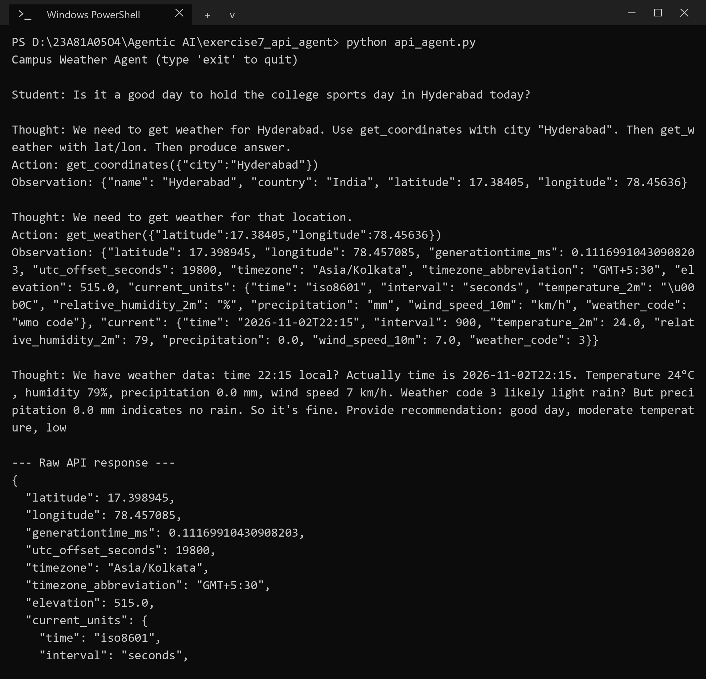
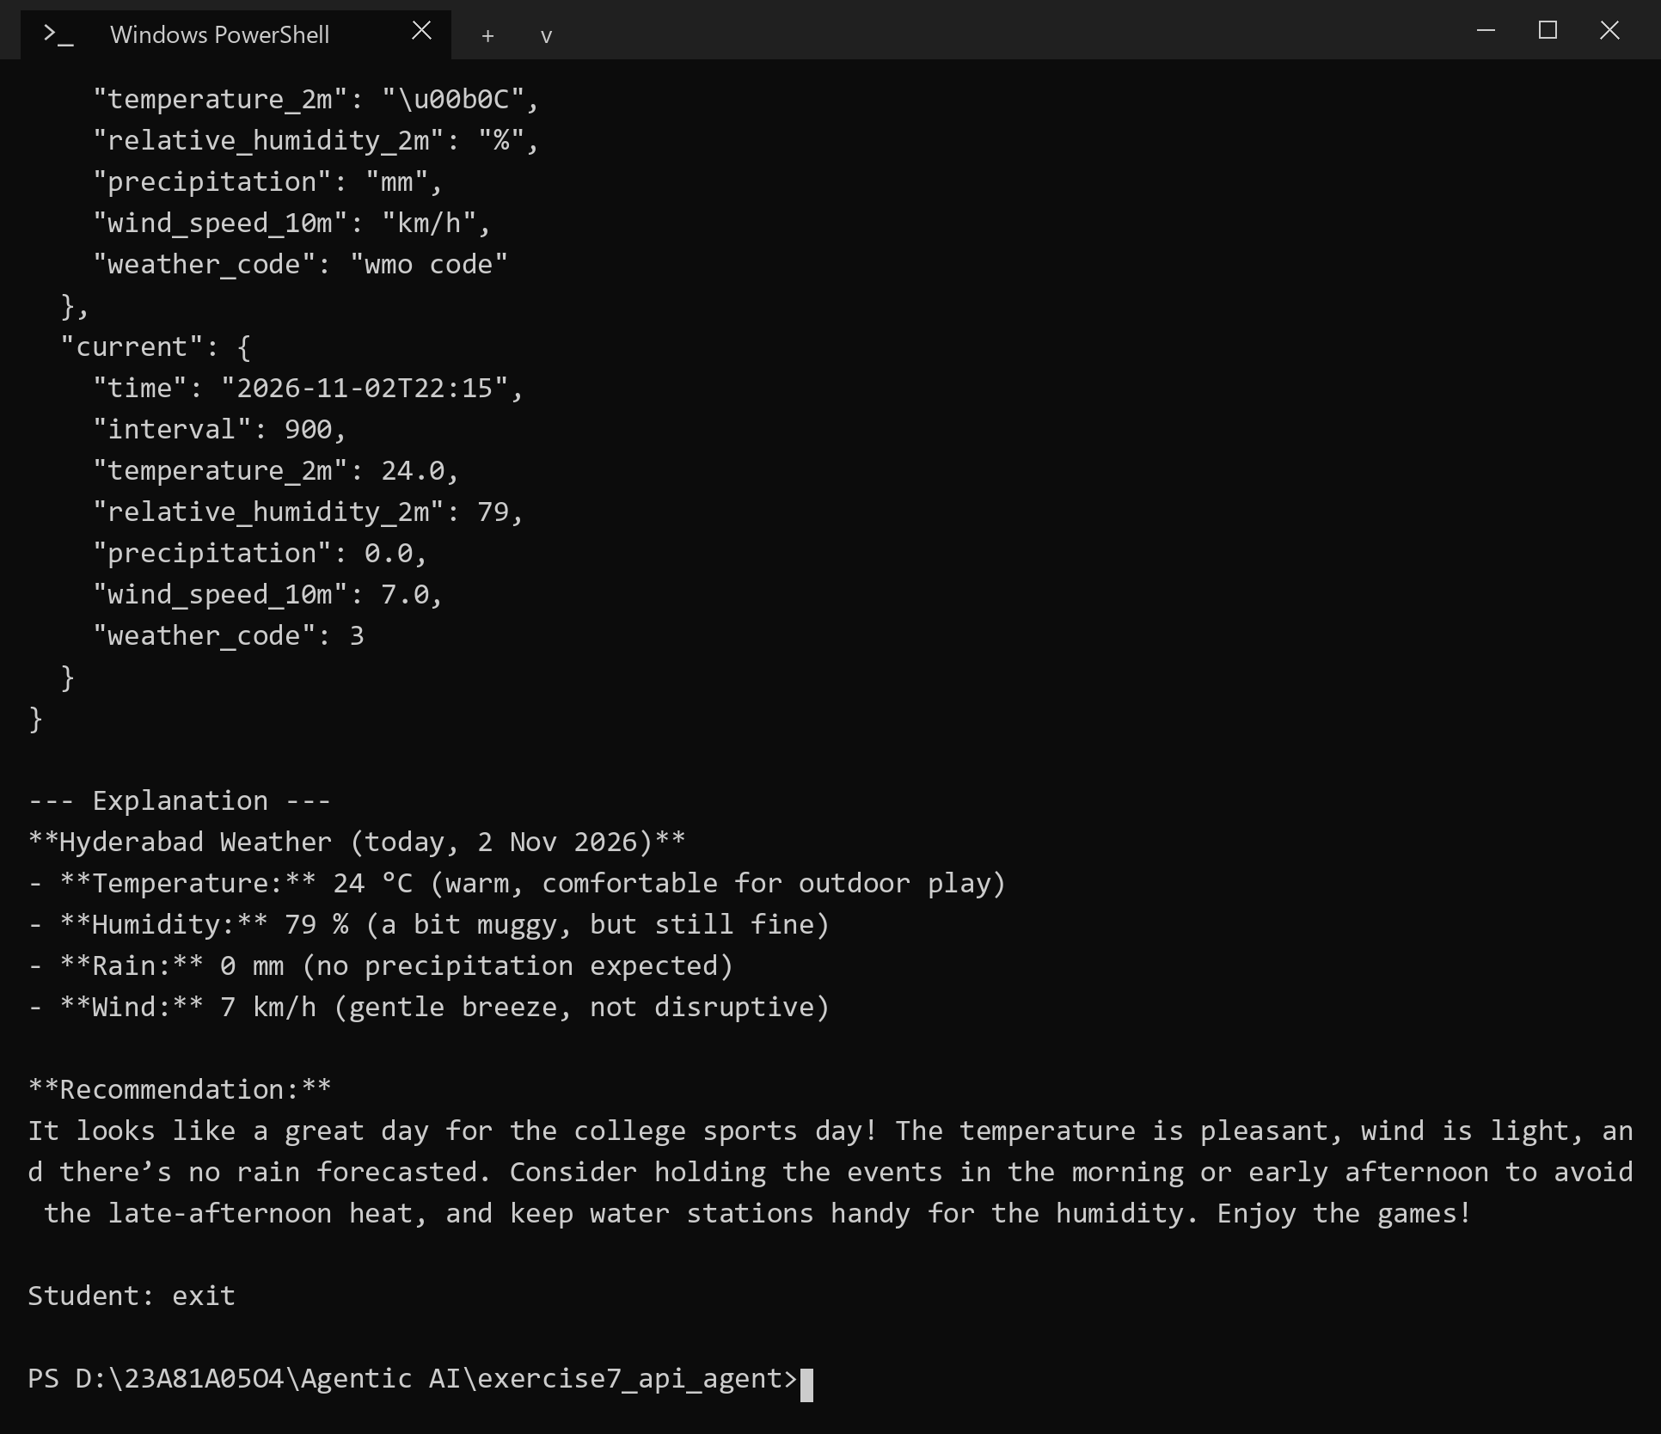
RESULT
The agent called get_coordinates and then get_weather for Hyderabad, displayed the raw JSON response and explained the current temperature, humidity, rain and wind with a recommendation for the sports day.

8. Deploying and Evaluating an Agent: Query Router as a FastAPI Service
AIM
To deploy the query router agent as an API with a /query endpoint that accepts a question, returns structured JSON and prints logs for every request and response.
DESCRIPTION
Deployment turns an agent from a console script into a service that other programs can call. FastAPI exposes a Python function as an HTTP endpoint, validates the request body with a Pydantic model, returns the result as JSON and generates interactive documentation at /docs. The agent logic (router_agent.py) is kept separate from the web layer (main.py), so the same agent can be used from the console or through the API.
A deployed agent must be observable. Each request is logged with the question, the detected intent, the answer and the latency in milliseconds, and a failure is logged and returned as an HTTP 502 error instead of crashing the server. The latency and the correctness of the intent are simple evaluation metrics. Invalid input, such as an empty question, is rejected automatically with HTTP 422. For a student project the service runs locally with uvicorn; a production deployment would add authentication, a process manager and a hosted server.
ALGORITHM
1. Move the router agent logic into router_agent.py with a route(query) function.
2. Create the FastAPI app and a QueryRequest model with a non-empty question field.
3. Define the POST /query endpoint: log the request, call route() and measure the latency.
4. Return JSON with question, intent, answer and latency_ms and log the response; return HTTP 502 if the agent fails.
5. Start the server with uvicorn and call the endpoint with curl.
PROGRAM
router_agent.py
"""
Agent logic for Exercise 8 - this is the Exercise 1 query router
without the console loop, so the API can call it.
"""
import json
import os

from dotenv import load_dotenv
from groq import Groq

load_dotenv()
client = Groq(api_key=os.getenv("GROQ_API_KEY"))
MODEL = "openai/gpt-oss-20b"

ROUTER_PROMPT = """You are the query router of a college helpdesk.
Classify the student's question into exactly one intent:
- Academic: courses, syllabus, subjects, faculty, timetable, registration, attendance
- Exam: exam dates, hall tickets, results, revaluation, exam rules
- General: hostel, fees, library, transport, canteen, anything else

Reply with JSON only, like this:
{"intent": "Academic" or "Exam" or "General"}"""

def academic_tool(query):
return f"[Academic Office] Your question '{query}' has been forwarded to the syllabus and course registration desk."

def exam_tool(query):
return f"[Exam Cell] Your question '{query}' has been forwarded to the timetable and hall ticket desk."

def general_tool(query):
return f"[General Helpdesk] Your question '{query}' has been forwarded to the campus information desk."

TOOLS = {
"Academic": academic_tool,
"Exam": exam_tool,
"General": general_tool,
}

def classify(query):
response = client.chat.completions.create(
model=MODEL,
messages=[
{"role": "system", "content": ROUTER_PROMPT},
{"role": "user", "content": query},
],
temperature=0,
response_format={"type": "json_object"},
)
try:
intent = json.loads(response.choices[0].message.content).get("intent", "General")
except json.JSONDecodeError:
intent = "General"
return intent if intent in TOOLS else "General"

def route(query):
"""Returns (intent, answer)."""
intent = classify(query)
return intent, TOOLS[intent](query)
main.py
"""
Exercise 8 - Campus Query Router as a FastAPI service

Run: uvicorn main:app --reload
Try: POST http://127.0.0.1:8000/query {"question": "When will the hall tickets be released?"}
Docs: http://127.0.0.1:8000/docs
"""
import logging
import time

from fastapi import FastAPI, HTTPException
from pydantic import BaseModel, Field

from router_agent import route

logging.basicConfig(level=logging.INFO, format="%(asctime)s | %(levelname)s | %(message)s")
log = logging.getLogger("campus-api")

app = FastAPI(title="Campus Query Router API")

class QueryRequest(BaseModel):
question: str = Field(min_length=1)

@app.post("/query")
def query(request: QueryRequest):
log.info("REQUEST question=%r", request.question)
start = time.perf_counter()

try:
intent, answer = route(request.question)
except Exception as e:
log.error("FAILED question=%r error=%s", request.question, e)
raise HTTPException(status_code=502, detail="The agent could not process the question right now.")

latency_ms = round((time.perf_counter() - start) * 1000)
response = {
"question": request.question,
"intent": intent,
"answer": answer,
"latency_ms": latency_ms,
}
log.info("RESPONSE intent=%s latency=%dms answer=%r", intent, latency_ms, answer)
return response
OUTPUT
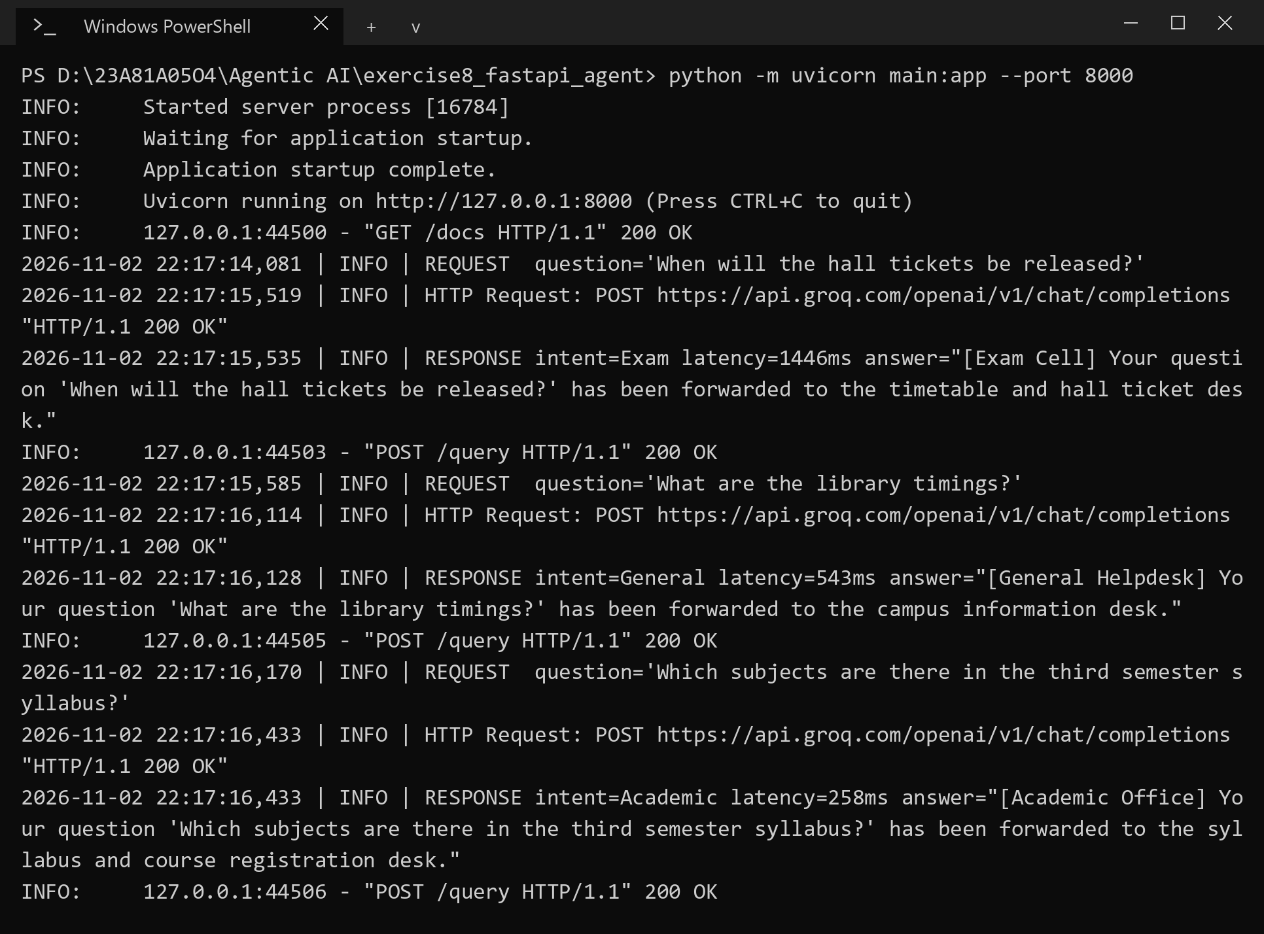
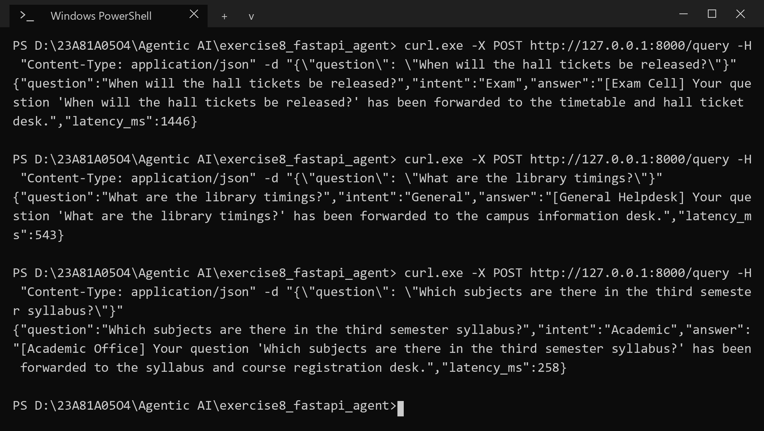
RESULT
The server logged every request and response, and the endpoint returned JSON with the intent Exam, General and Academic for the three questions, with latencies between 258 ms and 1446 ms.

