**DAA ASSIGNMENT -1**

**DAGGU MARUTHI**

**2303A51L98**

**CSE-L**

**BATCH-30**

Imagine you work for a large logistics company that handles a high volume of  
package deliveries on a daily basis. The company's success hinges on ensuring that  
packages are delivered to their respective destinations efficiently and on time. To  
solve this problem, you create a program that can quickly process and classify  
packages based on their destination.

**CODE**

**#include<stdio.h>**

**int main() {**

**int i, j, temp;**

**int opt;**

**int a[100], n;**

**printf("Enter the value of n: ");**

**scanf("%d", &n);**

**for(int i = 0; i < n; i++) {**

**printf("Enter element at a[%d]: ", i);**

**scanf("%d", &a[i]);**

**}**

**for(i = 0; i < n-1; i++) {**

**int min = i;**

**for(j = i+1; j < n; j++) {**

**if(a[min] > a[j])**

**min = j;**

**}**

**if(min != i) {**

**temp = a[i];**

**a[i] = a[min];**

**a[min] = temp;**

**}**

**}**

**printf("Choose option 1 for ascending and 2 for descending: ");**

**scanf("%d", &opt);**

**if(opt == 1) {**

**printf("Ascending order of elements:\n");**

**for(i = 0; i < n; i++)**

**printf("%d\n", a[i]);**

**} else if(opt == 2) {**

**printf("Descending order of elements:\n");**

**for(i = n-1; i >= 0; i--)**

**printf("%d\n", a[i]);**

**} else {**

**printf("Invalid option selected.\n");**

**}**

**return 0;**

**}**

TEST CASE 1:  
INPUT:  
Enter time to reach destination:  
20  
15  
30  
42  
OUTPUT:  
15  
20  
30  
42

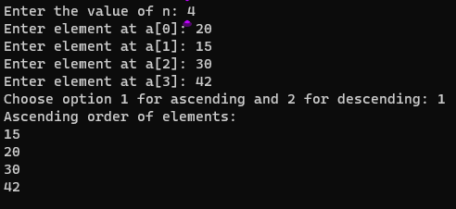  
TEST CASE 2:  
INPUT:  
Enter time to reach destination:  
15  
69  
80  
14  
OUTPUT:  
80  
69  
15  
14

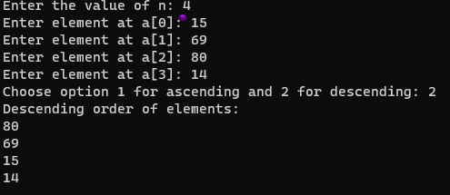

WEEK1_2_GN_DAA:  
Imagine you are working for a retail store that sells a wide variety of products. The  
store has a vast inventory with thousands of items, and it's becoming challenging for  
the employees to manage and locate products efficiently. Customers often ask for  
specific items, and employees need to find them quickly. The sorting program's  
primary goal is to organize the products in the inventory systematically, allowing for  
faster and easier access to items when needed.  
Implement an efficient sorting algorithm to arrange the products based on product  
IDs.  
Test Case-1  
Input:  
Enter Products IDs:  
87, 67, 21, 59, 99, 46, 84, 32, 43, 12, 90, 23  
After Sorting Product IDs:  
12,21,23,32,43,46,59,67,84,87,90,99

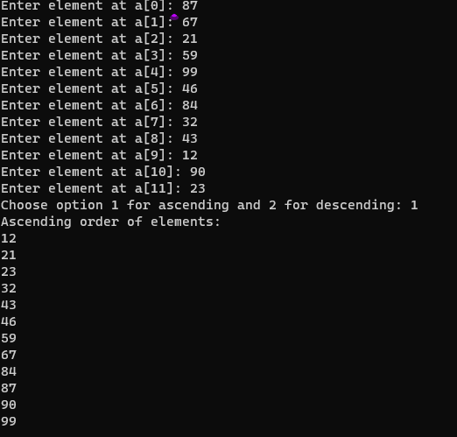  
Test Case-2  
Input:  
Enter Products IDs:  
64,56,21,90,32,87,59,60,43,10,29,74  
After Sorting Product IDs:  
10,21,29,32,43,56,59,60,64,74,87,90

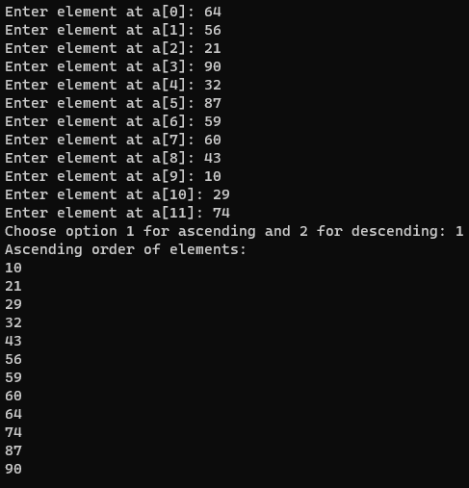  
WEEK1_3_GN_DAA:  
Imagine you're working for a large online marketplace company that facilitates the  
buying and selling of various products. As part of the order processing system, the  
company receives thousands of new orders every minute from customers all around  
the world. To ensure efficient and timely order fulfillment, the orders need to be  
sorted based on various criteria before they can be processed and shipped.

Some customers may request advanced shipping or have urgent requirements.  
So, implement an application to arrange the Orders based on priority Number.  
Test Case-1  
Input:  
Enter orders Priority Number:  
87, 67, 21, 59, 99, 46, 84, 32, 43, 12, 90, 23  
After Sorting Orders Priority:  
12,21,23,32,43,46,59,67,84,87,90,99



Test Case-2  
Input:  
Enter orders Priority Number:  
44,66,37,90,81,43,55,19,98,33,72,51  
After Sorting Orders Priority:  
19,33,37,43,44,51,55,66,72,81,90,98

