A Major Project Phase I Report
On

Self-Correcting Agentic Multimodal Retrieval-Augmented Generation for Reliable Document Question Answering
Submitted in the Partial Fulfillment of the Requirements
For the Award of the Degree of

Bachelor of Technology
In
CSE(Artificial Intelligence and Machine Learning)
By
Y.Vedhik Reddy 23211A66J8
K.Maruthi 24215a6619

Under the Guidance of
Ms. Srilakshmi V Assistant Professor
Dr. B. VeeraSekhar Reddy Assistant Professor



DEPARTMENT OF CSE(ARTIFICIAL INTELLIGENCE AND MACHINE LEARNING)
B V RAJU INSTITUTE OF TECHNOLOGY
(UGC Autonomous, Accredited by NBA & NAAC)
Vishnupur, Narsapur, Medak, Telangana State, India – 502 313
2026-2027

Department of CSE(Artificial Intelligence and Machine Learning)

Certificate
This is to Certify that the Major Project Phase I Entitled “Self-Correcting Agentic Multimodal Retrieval-Augmented Generation for Reliable Document Question Answering” Being Submitted By
Y.Vedhik Reddy 23211A66J8
K.Maruthi 24215A6619

In Partial Fulfillment of the Requirements for the Award of Degree of Bachelor of Technology in CSE(Artificial Intelligence and Machine Learning) to B V Raju Institute of Technology is Record of Bonafide Work Carried Out During the Period From June 2026 to October 2026 by Them Under the Supervision of
Ms. Srilakshmi V Assistant Professor
Dr. B. VeeraSekhar Reddy Assistant Professor

This is to Certify that the Above Statement Made by the Students are Correct to the Best of Our Knowledge.

Ms. Srilakshmi V Dr. B. VeeraSekhar Reddy
Assistant Professor Assistant Professor

The Major Project Phase I Viva-Voce For This Team Has Been Held on ____________.

External Examiner Dr. G Uday Kiran
Program Coordinator

Candidate’s Declaration
We Hereby Certify that the Work Which is Being Presented in the Major Project Phase I Entitled “Self-Correcting Agentic Multimodal Retrieval-Augmented Generation for Reliable Document Question Answering” in Partial Fulfillment of the Requirements For the Award of Degree of Bachelor of Technology and Submitted in the Department of CSE(Artificial Intelligence and Machine Learning), B V Raju Institute of Technology, Narsapur, is an Authentic Record of Our Own Work Carried Out During the Period From June 2026 to October 2026, Under the Supervision of Dr. B. VeeraSekhar Reddy, Assistant Professor and Ms. Srilakshmi V, Assistant Professor.
The Work Presented in this Major Project Phase I Report Has Not Been Submitted By Us For the Award of Any Other Degree of This or Any Other Institute/University.

Y.Vedhik Reddy 23211A66J8
K. Maruthi 24215A6619

Acknowledgement
We stand at the culmination of a significant journey, one that has been both challenging and rewarding. The success of our major project phase I is not solely a reflection of our efforts but a testament to the invaluable support and guidance we have received from many quarters. It is with deep gratitude that we acknowledge those who have made this achievement possible.
Foremost, we extend our sincerest appreciation to Dr. B. VeeraSekhar Reddy and Ms. Srilakshmi V whose expertise and insightful supervision have been pivotal in navigating the complexities of this project. Their unwavering support and encouragement have been our guiding light throughout this journey.
Special thanks are due to Ms. Srilakshmi V, our Project Coordinator, whose assistance and guidance have been instrumental in the successful execution of our project. Her dedication and support have been a source of inspiration and motivation.
We reserve our utmost gratitude for Dr. G Uday Kiran, Program Coordinator of the Department of CSE (Artificial Intelligence and Machine Learning), whose leadership and academic guidance have enriched our learning experience and contributed significantly to our project's success.
Our journey would not have been the same without the constant encouragement, support, and guidance from the esteemed faculty of the Department of CSE (Artificial Intelligence and Machine Learning). We are deeply thankful to everyone who contributed to our journey, whose belief, guidance, and support have been crucial to our achievement. This project reflects not only our academic efforts but also the collaborative spirit and collective wisdom that guided us.
J. Shiva Kumar 24215A6615
P. Vamshi Krishna 24215A6618
Abstract
ReportMind AI is a prototype for transforming financial PDF reports into structured metrics and explanatory insights. The application combines a React and Vite browser interface, an Express API written in TypeScript, a Python FastAPI service using Docling, and MongoDB persistence through Mongoose. Uploaded reports are registered in the backend, converted into page and table content, and analyzed through configured external AI providers. The active analyzer supports ordered fallback across Gemini, OpenRouter and Hugging Face. Guarded arithmetic enriches available financial values with growth, margin and ratio calculations.
This report documents the implementation using source evidence and separates completed code paths from partial integration and proposed enhancements. The backend contains upload, retrieval and deletion routes, processing-step records, analysis services and structured data models. The frontend includes connected upload and dashboard paths, while report-library and comparison views use sample records. Inspection identified contract and display issues involving report identifiers, metadata, percentage units and insight mapping.
No complete application execution, measured accuracy or performance evaluation is claimed. Focused source and synthetic helper checks support selected observations, while application test cases remain pending validation. The project provides a modular foundation for report analysis, with future work focused on data fidelity, source provenance, recoverable processing, user access control and reproducible evaluation.
Keywords: Financial Report Analysis, PDF Extraction, Docling, Language Models, Structured Metrics, React, MongoDB.

Table of Contents
Chapter 1 1
Introduction 1
1.1 Background of the Study 1
1.2 Evolution of Large Language Models 3
1.3 Problem Statement 5
1.4 Need for Reliable Document Question Answering 7
1.5 Limitations of Existing Approaches 9
1.6 Multimodal Document Understanding 10
1.7 Retrieval-Augmented Generation 11
1.8 Agentic Retrieval and Self-Correction 12
1.9 Motivation of the Proposed Study 13
1.10 Aim of the Project 15
1.11 Objectives of the Project 16
1.12 Research Questions 18
1.13 Scope of the Project 19
1.14 Proposed Contributions 21
1.15 Organization of the Report 23
Chapter 2 25
Review of Literature 25
2.1 Introduction to Literature Review 25
2.2 Foundation Models and Standalone LLM Limitations 27
2.3 Information Retrieval and Dense Semantic Search 28
2.4 Retrieval-Augmented Generation Architecture and Chunking Dynamics 29
2.5 Vector Databases and Cross-Encoder Reranking 30
2.6 Multimodal Document Understanding 31
2.7 Citation-Aware Prompting and Context Management 33
2.8 Agentic AI, Self-Reflection, and Corrective Workflows 35
2.9 Evaluation Frameworks and Factual Consistency 36
2.10 Comparative Analysis, Research Gaps, and Proposed Positioning: 37
Chapter 3 39
Methodology 39
3.1 Overview of the Proposed System 39
3.2 Multimodal Document Ingestion and Preprocessing 44
3.3 Modality-Specific Representation and Indexing 48
3.4 Query Processing and Agentic Retrieval 51
3.5 Multimodal Retrieval and Evidence Fusion 53
3.6 Context Construction and Answer Generation 54
3.7 Critic-Guided Verification 57
3.8 Self-Correction and Iterative Retrieval 59
3.9 Algorithms and Computational Complexity 61
3.10 System Implementation and Technology Stack 63
3.11 Summary of Proposed Methodology 70
Chapter 4 72
Results and Discussion 72
4.1 Introduction 72
4.2 Experimental Environment 74
4.3 Document Processing and Indexing Results 76
4.4 Question Answering and Retrieval Results 78
4.5 Grounded Answer Generation 79
4.6 Source Attribution and Transparency 80
4.7 Retrieval and Generation Performance 81
4.8 Chunk-Size Evaluation 83
4.9 Computational Efficiency 84
4.10 Reliability and Hallucination Analysis 85
4.11 Cross-Modal Verification and Self-Correction 87
4.12 Overall Discussion 88
4.13 Summary of Results 94
Chapter 5 95
Conclusion and Future Scope 95
5.1 Introduction 95
5.2 Conclusion 96
5.3 Major Contributions of the Project 98
5.4 Limitations of the Current System 100
5.5 Future Scope 101
5.6 Future Experimental Evaluation 103
5.7 Practical Applications 105
5.8 Final Conclusion 106
References 107
Appendix A 109
API Reference 109
A.1 Backend Report Endpoints 109
A.2 Representative Response Shapes 110
A.3 Conversion Service Endpoints 110
Appendix B 112
Database Data Dictionary 112
B.1 Report Collection 112
B.2 FinancialMetrics Collection 113
B.3 Insight Collection 114
Appendix C 116
Installation Execution and User Guide 116
C.1 Preparation 116
C.2 Conversion Service 116
C.3 Backend 117
C.4 Frontend 117
C.5 User Workflow 118
C.6 Troubleshooting 118
Appendix D 119
Source Traceability and Submission Checklist 119
D.1 Chapter Evidence Map 119
D.2 Editable Placeholders 119
D.3 Finalization Checklist 120

List of Figures
Figure 1.1 Report processing lifecycle 21
Figure 3.1 System architecture derived from active source 39
Figure 3.2 Use cases supported by active API and connected views 41
Figure 3.3 Data flow for upload and analysis 42
Figure 3.4 Sequence for accepted upload and background processing 45
Figure 3.5 MongoDB entity relationships and embedded structures 48
Figure 3.6 Backend activity and failure handling 59
Figure 3.7 Local deployment arrangement supported by the repository 68
Figure 4.1 Actual PDF upload screen 92
Figure 4.2 Actual report processing state 92
Figure 4.3 Actual completed-report dashboard 92
Figure 4.4 Report library demonstration screen 93
Figure 4.5 Comparison demonstration screen 93

List of Tables
Table 1 Objective and implementation mapping 16
Table 2 Comparison of report analysis approaches 37
Table 3 Functional requirements and implementation status 40
Table 4 Implemented metric calculations 54
Table 5 Software environment requirements 64
Table 6 Executed documentation verification checks 76
Table 7 Defects and validation implications 85
Table 8 Feature inventory and evidence status 88
Table 9 Application test case register 89
Table 10 Proposed future evaluation measures 103
Table 11 Backend API endpoints 109
Table 12 Report fields and embedded data 112
Table 13 Financial metric fields and constraints 113
Table 14 Insight fields and constraints 114
Table 15 Chapter evidence and repository locations 119

List of Abbreviations
Abbreviation | Full Form
AI | Artificial Intelligence
API | Application Programming Interface
AST | Abstract Syntax Tree
CORS | Cross-Origin Resource Sharing
DTO | Data Transfer Object
HTTP | Hypertext Transfer Protocol
JSON | JavaScript Object Notation
KPI | Key Performance Indicator
LLM | Large Language Model
MIME | Multipurpose Internet Mail Extensions
OCR | Optical Character Recognition
PDF | Portable Document Format
QA | Quality Assurance
UI | User Interface
USD | United States Dollar
YoY | Year over Year

Chapter 1

Introduction

1.1 Background of the Study
Financial reports combine narrative explanations with numerical statements, tables, accounting periods and currency units. A reader must connect these elements before drawing a useful conclusion. Revenue alone, for example, does not establish profitability; the reader must also identify the relevant costs, reporting period and basis of comparison. When information is distributed across a PDF, moving it into a structured analytical view requires both document interpretation and arithmetic.
ReportMind AI is a software project for uploading financial PDF reports, extracting their content, requesting structured financial analysis from external language-model services, storing the resulting records and presenting them through a browser interface. Its repository contains a React application, an Express API written in TypeScript, a Python service using FastAPI and Docling, and Mongoose models for MongoDB. This report documents the inspected implementation and explains the engineering decisions visible in its source code [1].
The project addresses the practical transition from document content to structured information. It is an analytical prototype whose service pipeline is more developed than several parts of its user interface. Consequently, implementation coverage and operational validation are discussed separately. A code path demonstrates how a feature is intended to operate, while a verified execution would be needed to establish its actual behavior on a particular report.
Financial document analysis involves several distinct kinds of correctness. A transcription can reproduce a number accurately while assigning it to the wrong year. A calculation can be mathematically correct while combining amounts expressed at different scales. A generated explanation can sound convincing while discussing information that the report never supplied. These distinctions make financial reporting a useful setting for studying the connection between document processing and software correctness.
ReportMind treats the uploaded document as the starting point of an analysis record. The original filename, generated storage filename, status and extraction output belong to a parent Report object. FinancialMetrics and Insight objects represent later stages. This separation allows an application to keep document identity apart from interpretations of its content. It also makes the boundaries between services visible to a reviewer.
The educational value of the project lies in these boundaries. It combines file handling, asynchronous orchestration, HTTP communication, document transformation, model prompting, database validation and browser presentation. A useful evaluation must follow information through this entire chain. Reviewing only the final dashboard would conceal where a missing value or incorrect unit originated, while reviewing only the model response would ignore errors introduced during presentation.

1.2 Evolution of Large Language Models
Language-model development provides the technical background for ReportMind's use of externally hosted inference. The Transformer introduced by Vaswani et al. uses attention as the principal mechanism for relating elements of a sequence, replacing the recurrent and convolutional architecture used in many earlier sequence models [10]. This architectural contribution is relevant background; ReportMind does not implement or train a Transformer.
For an application developer, the practical consequence of pretrained language models is an interface through which instructions and document content can be supplied together. The application specifies an extraction task, an expected output structure and relevant text. The provider returns a generated response. ReportMind uses this pattern to request financial fields and then explanatory insights. Training the underlying provider model is outside the repository's scope.
There are three separate forms of application adaptation to distinguish. Prompting changes the instructions supplied for a request. Retrieval changes which source material accompanies those instructions. Fine-tuning changes model parameters through a training process. The active project demonstrates prompting, but contains neither a retrieval index nor a training workflow. Its selection among providers changes the inference service rather than creating a newly trained financial model.
This distinction matters when describing technical contribution. The project contributes the surrounding analysis workflow, schema definitions and integration logic. It does not claim improvements to the architecture or pretraining of the language model itself. A model identifier in configuration is an operational dependency, and its availability must be checked independently of the report's architectural explanation.
The evolution toward retrieval and critique mechanisms is examined later as related research. Those mechanisms offer possible responses to incomplete context and unsupported answers, but their existence in the literature does not automatically make them part of ReportMind. The project's current behavior remains bounded document prompting followed by parsing, enrichment and persistence.

1.3 Problem Statement
The problem is to transform a company financial report in PDF form into a reusable collection of financial metrics and explanatory insights, while preserving a manageable processing workflow. Manual transfer can require repeated searching, transcription, ratio calculation and chart preparation. These steps also make it difficult to maintain a consistent schema across reports with different layouts.
The repository implements this problem as an upload-and-analysis workflow. The system accepts a PDF, obtains page and table content from a parsing service, sends bounded document context to an AI provider, derives additional metrics where suitable operands exist, and stores both metrics and insights. The desired output is a structured report record rather than an answer to an arbitrary user question.
The main engineering challenge is consistency across service boundaries. A document parser, language-model response, database model and dashboard must agree on field names, units and status values. Source inspection identified mismatches in these contracts, discussed in Chapter 4. The report therefore evaluates the architecture as an implemented prototype without asserting reliable financial accuracy or completed integration.
The input problem includes heterogeneous presentation. A financial table may place the current period before or after the comparative period, abbreviate currency units, or show losses in parentheses. Explanatory notes may qualify figures elsewhere in the document. The processing problem therefore includes selecting the correct semantic context as well as recognizing text.
The output problem is equally important. The system must communicate unavailable values honestly, preserve percentage conventions and keep generated interpretations separate from observed source facts. A dashboard that replaces missing history with fixed values changes the meaning of the result. Such a display can appear complete without being supported by the source document.
The project problem can consequently be expressed as a chain of obligations: accept a document, preserve its identity, extract usable representations, interpret fields, calculate only justified quantities, persist coherent records and present those records faithfully. The implementation addresses much of the service chain, while the validation chapter identifies where these obligations remain incomplete.

1.4 Need for Reliable Document Question Answering
Reliable document question answering means answering from the supplied document with an identifiable basis for the response. In a financial setting, a question such as which period a revenue figure belongs to cannot be answered safely from a number alone. The nearby heading, unit statement and table column can be as important as the amount. A reliable answer must also permit an unavailable or ambiguous result when the document does not establish the fact.
ReportMind is not currently a conversational question-answering application. It has no active endpoint that accepts an arbitrary question, searches an evidence index and returns a cited answer. Its fixed financial extraction prompts nevertheless address related information needs: they ask for revenue, profit, expenses, ratios and reporting periods from the uploaded material. This section therefore motivates reliability requirements for structured analysis without attributing a chat feature to the implementation.
A useful conceptual test is to translate each extracted field into a question. The revenue.current field asks what revenue the selected current period reports. The fiscalYear field asks which financial year the analysis describes. A margin asks which numerator and denominator support the calculation. This perspective helps identify missing evidence even though users do not type these questions into the current interface.
Reliability also requires consistency between the stored answer and the displayed answer. If the backend stores a margin as a percentage and the frontend treats it as a fraction, the same nominal field produces different meanings. The source inspection identified this exact class of mismatch. Correctness must therefore be assessed after browser transformation, not only after extraction.
For future question answering, ReportMind would need explicit question input, evidence selection, answer provenance and an abstention policy. Until then, its contribution should be evaluated as structured financial report analysis. The shared requirement is defensible evidence for every user-visible claim.

1.5 Limitations of Existing Approaches
The existing workflow described by the repository is manual report reading followed by spreadsheet entry and dashboard preparation. This is a problem context, not a measured institutional baseline. No time study, analyst survey or comparison dataset was supplied, so the report does not attach percentages or productivity figures to that workflow.
The limitations motivating the project are repeated transcription, inconsistent report structures and the need to combine financial statements with explanatory text. Automated parsing addresses only part of this process. Reliable interpretation also requires consistent handling of scales, periods, negative values, missing metrics and comparisons. These requirements become explicit validation targets in Chapter 4.
A fixed template parser can work well when a document family has stable labels and layouts, but the project does not establish such a restricted input family. A general document converter offers broader structural access, yet it cannot determine all financial meanings solely from geometry. A direct language-model prompt can interpret prose and tables together, but it depends on which information the application includes and whether the response is verified.
The relevant limitation is not that one technique is universally unsuitable. Each addresses a different stage of the problem. Manual review supplies judgment, conversion supplies accessible content, structured storage supplies repeatable fields, and arithmetic supplies reproducible calculations. ReportMind combines several stages but must still demonstrate that the combination preserves meaning.
There is no measured comparison against a deployed commercial product in the repository. Accordingly, the project does not claim superior accuracy, lower cost or faster operation than an existing service. Its justification is the need for an integrated educational prototype with inspectable components. A future comparative study would need common documents, common acceptance criteria and recorded baseline results before making stronger claims.

1.6 Multimodal Document Understanding
For this project, multimodal document understanding concerns the relationship between narrative text, tabular structure and page layout in financial PDFs. These representations carry complementary information: prose explains assumptions, tables organize quantities, and layout associates headings with values. A PDF may also contain charts or scanned images, but their presence in a file does not establish that ReportMind performs dedicated visual reasoning over them.
The implemented conversion boundary receives PDF bytes and returns page text and table cells through the Docling wrapper. The later AI boundary receives serialized text, rather than a separate image stream. It is therefore more precise to describe the active workflow as structured document conversion followed by text-based financial analysis. No custom image encoder, image embedding store or visual question-answering model is implemented in the inspected application.
This representation choice creates useful opportunities and limits. A correctly extracted table can place amounts beside period labels in a prompt. A lost merged heading can remove the distinction between consolidated and standalone values. Approximate page splitting can preserve words while weakening source location. Evaluating only whether text exists would miss these structural effects.
The design discussion treats multimodality at the document level and examines how the implementation reduces it to an application schema. Chapter 3 explains the actual transformation, while Chapter 4 identifies the tests required for scanned documents, repeated headers and complex financial tables. Future image-aware processing is discussed as an extension with its own evidence and evaluation requirements.

1.7 Retrieval-Augmented Generation
Retrieval-augmented generation combines generation with information selected from an external collection. Lewis et al. describe an architecture coupling a pretrained sequence generator with a dense index accessed through a retriever [11]. The central distinction is that relevant material is selected for the current task rather than relying only on model parameters or a fixed document prefix.
ReportMind does not implement that retrieval stage. Its analyzer builds page and table strings and truncates them to configured character limits. MongoDB stores extracted content and analysis records, but no embedding pipeline, similarity query or ranked passage result is present. Reading a report by its identifier is ordinary record retrieval, not semantic evidence retrieval.
The topic is relevant because a long financial report can contain decisive evidence outside the retained prefix. A possible future design could select income statements, balance sheets and relevant notes for each requested metric. Such a design would need to preserve table headers, report identity and period metadata. It would also need evaluation to show whether selected context actually improves completeness.
Retrieval alone would not establish numerical correctness. If a selected passage contains values for several years, the generation stage still has to choose the right column and preserve scale. A useful future system would retain the source location of selected evidence and distinguish extracted operands from calculated outputs. In this report, RAG supplies a conceptual comparison and a development direction, not a description of completed functionality.

1.8 Agentic Retrieval and Self-Correction
An agentic retrieval workflow makes explicit decisions about gathering more evidence, changing a search or revising an answer. Self-RAG studies retrieval and critique through learned reflection mechanisms [14], while Corrective Retrieval Augmented Generation examines assessment of retrieved material and corrective actions [15]. These works motivate treating evidence quality as a decision point instead of assuming every supplied context is sufficient.
ReportMind's provider fallback must be distinguished from those mechanisms. When a configured provider call or response parsing fails, another provider may be attempted. The application does not assess a supported answer against source cells and then retrieve missing evidence. Changing a provider after a technical failure is an availability strategy; it is not factual self-correction.
A future financial verification workflow could first check whether required fields are supported, then identify missing periods or conflicting amounts, and finally request targeted evidence. Deterministic rules could validate arithmetic and units before a model produces a revised narrative. Every revision would need an attempt record, a stopping condition and an explanation of which evidence changed.
The present report uses these concepts to clarify an architectural gap. No critic agent, retrieval tool loop or bounded correction controller is shown in the implemented diagrams. Adding those components would change the software and require new testing. Their proposed value should be judged against simpler alternatives, such as better context selection and explicit validation, rather than assumed from terminology.

1.9 Motivation of the Proposed Study
The motivation is to reduce the repetitive preparation involved in report analysis and to make a common set of financial measures available through one interface. A structured representation can support later comparison and review even when the original PDF layout is complex. A separate document conversion service also enables the project to use Python document-processing libraries while retaining TypeScript for API and browser development.
Another motivation is service flexibility. The active analyzer supports three provider families and attempts them in a fixed fallback order when configured. This design gives the application an alternative when a provider call or response parsing fails. It is an availability mechanism; it does not independently establish that an extracted number is correct.
The study is also motivated by the need to make an AI application's behavior inspectable. A financial summary is difficult to assess when the reviewer can see only the final prose. By separating conversion, extraction, calculation and display, the project exposes intermediate representations that can support diagnosis. The stored extraction content is particularly useful for comparing what the parser returned with what the model was allowed to read.
An academic project benefits from this separation because each stage can be examined using an appropriate method. Parser helpers can be checked with deterministic fixtures. HTTP contracts can be inspected field by field. Financial calculations can be verified against known operands. Generated narratives require source review rather than ordinary string equality. The combination creates a practical study of heterogeneous validation methods.
The motivation does not require claiming that all stages already meet their goals. Identifying a mismatch between backend and frontend units is a valuable engineering finding because it explains how an otherwise plausible analysis becomes misleading. Similarly, distinguishing sample records from connected data establishes what a demonstration can legitimately show. The proposed study is strongest when its claims remain tied to these inspectable facts.

1.10 Aim of the Project
The aim of ReportMind AI is to provide a modular application for converting financial PDF reports into stored financial metrics and explanatory insights that can be reviewed through a browser. The aim includes a coherent processing workflow, reusable data structures and a clear path from uploaded document to analytical output.
The unit of analysis is one uploaded report. The backend creates a Report identifier, associates extraction and processing state with that identity, and stores financial and narrative records referring to it. This identity should remain stable when the client asks for status or retrieves results. Preserving it is a prerequisite for reliable report review and future comparison.
The intended analytical output is a structured representation of reported financial information. It is not a prediction of future returns, a certified audit opinion or a replacement for professional interpretation. Generated recommendations in the schema are model-produced commentary or simple rule output. Their presence does not establish a validated financial advisory capability.
The project aim can be assessed at two levels. At the implementation level, the relevant modules and service calls exist. At the validation level, a permitted test document must travel through those modules and produce results consistent with its source. The report supports the former through code evidence and defines the latter through pending tests. This distinction keeps the aim meaningful without overstating achieved operation.

1.11 Objectives of the Project
The aim is to provide a modular prototype for transforming financial PDF reports into structured metrics, generated insights and dashboard data. The following table relates the objectives to inspected implementation evidence. The achievement statements refer to source coverage, with live execution remaining a separate validation activity.
Table 1 Objective and implementation mapping
Objective | Source coverage | Qualification
Extract document text and tables | DoclingParser and schema transformers | Layout and version compatibility unverified
Produce structured analysis | MultiAIAnalyzer metrics and insight prompts | Provider availability and extraction quality unverified
Persist processed reports | Report, FinancialMetrics and Insight models | Runtime database behavior unverified
Present analytical information | Dashboard hook and chart components | Several values use synthetic fallbacks
Support report review and comparison | Library and comparison pages | These pages currently use sample records

These objectives imply concrete acceptance conditions. Upload acceptance must return an identifier that the browser can retain. Conversion must preserve the fields needed to interpret a table. Analysis must produce schema-compatible data without replacing absent source values with invented ones. Persistence must associate outputs with the correct report, and the dashboard must preserve the meaning of amounts, percentages and ratios.
The objectives also require transparent failure behavior. A document that cannot be processed should remain distinguishable from one that completed successfully. A provider failure should not produce a success-looking dashboard. Missing optional metrics should be represented as unavailable rather than silently synthesized. These conditions are especially important when several services contribute to one result.
The test register in Chapter 4 translates the objectives into scenarios. It includes valid uploads, invalid files, provider failures, zero revenue, ratio calculations, deletion and browser fidelity. Some scenarios depend on future feature completion, such as comparing actual selected reports or enforcing user ownership. Their inclusion defines a validation roadmap; it does not imply that those tests have passed.

1.12 Research Questions
The study uses research questions as a framework for evaluating a software prototype, rather than as evidence of completed experiments. The first question is whether the conversion wrapper preserves sufficient text, table labels and period information for the requested financial fields. Answering it requires comparing returned content with manually annotated document regions.
The second question is how bounded context affects coverage across different report layouts. The current analyzer keeps prefixes subject to page and character limits. An evaluation should determine whether required evidence appears within those retained strings and identify which omissions arise before inference. This separates context coverage from model interpretation.
The third question is whether extracted financial meaning survives the API, persistence and frontend boundaries. The reported identifier, margin and metadata mismatches show why this question is necessary. A successful evaluation would follow the same field through parser context, model output, stored record and displayed value.
The fourth question concerns the contribution of deterministic enrichment. Which missing ratios can be computed from supported operands, and can the application explain the unit and source of each operand? The existing formulas provide an inspectable basis, but their inputs remain dependent on extraction quality.
The fifth question is how failures should be represented and recovered. The current in-process execution and separate database saves permit interrupted or partial states. A future experiment should examine restart behavior and distinguish retryable service failures from invalid document content.
Finally, would evidence retrieval or critique improve results after basic data contracts are corrected? This question remains prospective. It should be assessed through controlled comparisons against the existing pipeline, with the same documents and evaluation rules, rather than by adding components and assuming improvement.

1.13 Scope of the Project
The implemented service scope includes PDF upload, local file storage, asynchronous processing in the backend process, document conversion through an HTTP service, financial metric extraction, insight generation, metric enrichment and MongoDB persistence. Public API routes provide listing, status retrieval, complete-report retrieval, metrics, insights and deletion. The frontend supplies routes for a dashboard, uploads, a report library, comparisons and settings.
The scope does not establish a financial decision service, a trained project-specific model or a benchmarked prediction system. No project training dataset, accuracy study or labeled evaluation corpus is present in the inspected tree. The AI models are accessed through provider APIs. ReportMind does not implement vector indexing, retrieval-augmented question answering, critic agents or iterative factual verification. Those concepts belong to the reference report and have not been transferred into this report as project features.
Authentication, report ownership enforcement, durable job queues, functional exports and full report comparison remain outside the verified active implementation. Their presence in dependency lists, UI labels or older documents is insufficient to establish completion.
The intended user is a person reviewing company reports, such as a student analyst, business analyst or report reviewer. An operator configures services, database connectivity and provider credentials. These are descriptive responsibilities for understanding the system, rather than implemented security roles.
The backend routes are public and no login, token validation or role middleware appears in the active route chain. The optional Report.userId field is not populated by the upload controller and does not provide ownership control. A static profile display in the frontend must not be interpreted as an authenticated account. In the current design, possession of a reachable endpoint is sufficient to invoke its supported operations.
The document scope includes requirements, architecture, database relationships, endpoint contracts, implementation decisions and validation planning. Research concepts requested in the chapter sequence are discussed in relation to the actual pipeline. Where a heading concerns functionality absent from the repository, the section explains the closest implemented behavior and identifies what an extension would require.
The evidence scope is the inspected source snapshot and focused helper checks. No private financial dataset, executed provider benchmark or authenticated user study was supplied. Consequently, the report cannot establish production readiness or measured business benefit. This boundary does not reduce the usefulness of the implementation description; it defines what an academic reviewer can reproduce and what remains to be demonstrated.

1.14 Proposed Contributions
The proposed system organizes processing into a browser layer, orchestration layer, conversion layer and persistence layer. The browser uploads a report and requests analytical data. The backend coordinates extraction and AI calls. The Python service transforms PDF content into an application schema. MongoDB stores uploaded-report metadata, financial records and generated insights.
The contribution is the integration of document conversion, external AI services and structured financial models in one project. Additional arithmetic fills missing ratios when appropriate operands are available. The design also records processing steps so extraction, analysis and storage can be represented independently. These are useful software contributions even though quantitative improvement over manual analysis has not been measured.
Figure 1.1 summarizes the backend lifecycle. The error branch is an alternative outcome, and HTTP acceptance precedes completion of processing.
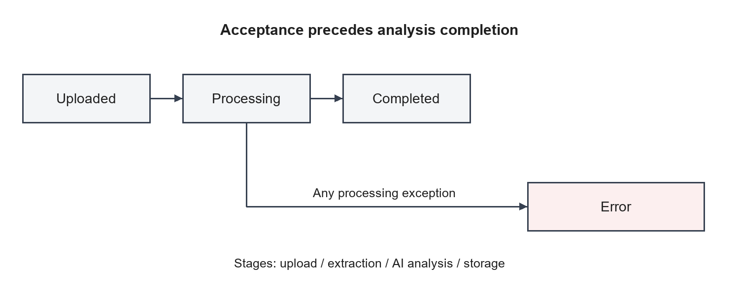
Figure 1.1 Report processing lifecycle
The architectural contribution is the separation of application orchestration from document conversion. The backend can expose a stable report API while the Python service manages conversion-specific dependencies. This boundary is useful because changes to a document library can be investigated independently from browser rendering, provided the response contract remains aligned.
The data contribution is an explicit distinction between document metadata, financial measurements and narrative insights. It gives the project a place to record processing state and allows later retrieval of different result categories. The current models still need more precise provenance and unit semantics, but their separation makes those extensions identifiable.
The analytical contribution is the combination of prompted extraction and guarded arithmetic. The arithmetic is inspectable and can be tested independently using known operands. The generated interpretation has a different assurance requirement and must be reviewed against evidence. Recognizing these different origins is a useful foundation for an explainable analysis system.

1.15 Organization of the Report
Chapter 2 reviews related document-processing and financial reasoning approaches. Chapter 3 presents requirements, design and implementation within the reference document's Methodology chapter. Chapter 4 presents validation evidence, pending test cases, implementation results and limitations. Chapter 5 concludes the report and identifies future work. References and appendices provide API details, database fields, operating instructions and source traceability.
The implementation evidence is the main branch tree identified by SHA 1db0fe8f383a95502d68d7e42c5959f7bd8acd0b, inspected on 14 October 2026. Important behavior was traced through routes, controllers, services, schemas and frontend hooks. Repository documentation was treated as supporting context because portions describe an earlier Next.js and Claude architecture that differs from the active code. No secret values or private report contents were used.
The fifteen sections in Chapter 1 establish background, motivation, scope and questions. Chapter 2 reviews the requested research areas, including retrieval, reranking, context handling and corrective workflows. Its closing comparison positions ReportMind as an implemented document-analysis prototype and distinguishes research possibilities from active components.
Chapter 3 follows the requested methodology sequence while explaining the actual ingestion, representation, prompt construction, parsing, arithmetic and storage mechanisms. Sections whose titles refer to retrieval or critique explicitly state their implementation status. Detailed requirements and deployment material remain within this chapter, with endpoint and field dictionaries in the appendices.
Chapter 4 separates source findings, executed helper observations and pending experimental results. It includes the requested discussions of grounding, attribution, performance, chunk size and cross-modal verification without assigning invented scores. Chapter 5 connects the conclusions to the project's objectives and orders future work according to technical dependencies. The appendices support reproduction and institutional completion without changing the five-chapter structure.

Chapter 2

Review of Literature

2.1 Introduction to Literature Review
The literature review focuses on document conversion, financial numerical reasoning, bounded language-model context and structured validation. These topics directly explain ReportMind's processing requirements. The cited research provides conceptual background; its benchmark results are not results of this project. The implementation itself is cited separately through the inspected repository [1].
Existing approaches can be compared by what they preserve and what they require from the user. A manual spreadsheet workflow preserves analyst judgment but needs explicit data entry. Document conversion produces machine-readable content, while financial reasoning systems additionally interpret the relationship between values and surrounding text. ReportMind combines conversion and prompted analysis but currently lacks a controlled evaluation of their combined accuracy.
The review is organized around decisions that ReportMind must make. The first decision concerns how to represent financial document content. The second concerns how much evidence to supply to inference. The third concerns how to detect unsupported or structurally invalid outputs. The final decision concerns how to evaluate the complete user-visible workflow.
Sources were selected from primary research publications and official framework documentation. Research papers establish concepts and task formulations; documentation explains library interfaces and validation mechanisms. Neither source category proves that a particular capability is enabled in the inspected project. Implementation claims are therefore tied to repository files, while research claims use numbered references.
The comparison is qualitative. It does not reproduce benchmark scores as ReportMind results or claim that a newer architecture is necessarily superior on the project's documents. A method can be conceptually relevant while requiring substantial implementation and evaluation work. This is particularly true for retrieval and critique mechanisms, which are absent from the active pipeline but useful for interpreting its limitations.

2.2 Foundation Models and Standalone LLM Limitations
Foundation-model use changes how task logic is expressed. Instead of encoding every extraction rule in application code, ReportMind supplies an instruction and an expected response shape to an external model. This can accommodate varied wording, but it makes part of the transformation dependent on generated behavior. The application must therefore define what it will accept and how accepted values will be checked.
The Transformer literature explains the attention-based architectural background [10]. For this project, the relevant engineering issue is not the internal training procedure but the boundary between source evidence and generated output. A provider may return syntactically valid JSON that refers to the wrong period, assumes a currency, or includes a plausible but absent figure. Structural validity and factual support are different properties.
ReportMind partially addresses structure by requesting JSON and validating selected fields before saving through Mongoose. These checks cannot establish source fidelity. For example, a numeric revenue value satisfies a type requirement even if it came from the wrong table column. The database's default currency can make an incomplete response appear more complete without verifying the document's unit.
The project also uses low-temperature requests and provider fallback. Low temperature is a request setting, not proof of reproducibility or correctness. Fallback changes the service used after failure, but can introduce differences in response style and field completeness. A rigorous comparison must record the actual provider and model used for each operation rather than assuming all attempts are equivalent.
The resulting design lesson is to assign the model a bounded interpretation role and validate the surrounding contracts explicitly. Where a fact cannot be supported, the system should preserve uncertainty instead of making the presentation look complete. This is a requirement for future hardening, not a claim that the current pipeline already enforces it comprehensively.

2.3 Information Retrieval and Dense Semantic Search
Karpukhin et al. describe dense passage retrieval using a dual-encoder approach that represents questions and passages for relevance matching [12]. This provides a research basis for selecting text by meaning rather than only by matching literal strings. It is relevant to financial documents where a metric may be described using different labels across companies.
ReportMind currently retrieves database records by report identifiers and list filters. Its companyName filter uses a regular expression, and its data models include ordinary indexes. These operations support application navigation; they do not rank document passages for a financial question. No dense-vector field, embedding generator or semantic search query appears in the active processing path.
A potential retrieval extension would begin with the evidence unit. A table row without its column headings is an inadequate unit for comparing periods. A paragraph without the preceding unit statement may misrepresent a number's scale. Candidate evidence should therefore preserve report identity, section title, period labels and source coordinates alongside its searchable representation.
Evaluation would need annotated evidence, not merely a final answer. For a question about current-year revenue, a reviewer would identify the relevant statement and acceptable supporting cells. The retriever could then be assessed on whether those regions occur among its selected candidates. This separates a failure to find evidence from a failure to interpret evidence after selection.
The proposed benefit for ReportMind is better coverage than retaining a fixed prefix. The tradeoff is additional indexing, dependency management and evaluation effort. A simple section-aware selector may be a useful baseline before introducing dense search. The report leaves that choice open until document-specific evidence can justify it.

2.4 Retrieval-Augmented Generation Architecture and Chunking Dynamics
RAG provides a sequence of evidence selection followed by conditioned generation [11]. For ReportMind, adopting this architecture would require a new searchable document representation and a task-specific selection stage before the existing prompt construction. The current direct prompting pipeline is a baseline against which such an extension could be compared.
Chunking determines the units that selection can return. A fixed character boundary can divide a table header from its rows or separate a unit statement from a financial amount. A very large chunk can preserve those associations but include unrelated information that consumes the context budget. The correct design criterion is evidence completeness for a task, not a universal chunk length.
The current code's character limits must not be described as an evaluated chunking strategy. It concatenates page text and table text, then retains bounded prefixes. There is no configurable overlap, ranked chunk list or per-query selection. Although both chunking and truncation affect context length, they have different behavior and different evaluation requirements.
A proposed comparison should hold the documents, requested metrics and inference settings constant while varying only the context construction method. Candidate methods could include the existing prefix, section-preserving blocks and table-aware blocks with nearby explanatory text. Results should record whether the required evidence was included, whether the resulting field was correct, and how much context was consumed.
This experimental structure avoids attributing all differences to the model. If an amount never appears in the supplied context, its omission is a selection failure. If it appears with the correct headings but is interpreted incorrectly, the error belongs later in the pipeline. That separation would make retrieval research directly useful to ReportMind's engineering decisions.

2.5 Vector Databases and Cross-Encoder Reranking
A vector search store would hold searchable representations and their associated evidence metadata in a future retrieval design. Its purpose would be to return candidate document regions, while the existing MongoDB records would continue to represent uploaded reports and analytical outputs. The current repository does not configure such a store, and no particular vector database is selected in this report.
Reranking is a separate decision. Nogueira and Cho describe using BERT for passage reranking [13]. In a candidate-selection architecture, a more detailed relevance assessment can be applied after an initial search. This research is relevant to a future ReportMind workflow that must distinguish a general discussion of revenue from the specific financial statement containing the requested period's value.
Candidate relevance alone would still be insufficient for financial interpretation. A high-ranked paragraph might describe growth while the actual current and previous values reside in a table. The selection process would need to preserve links between those regions. It would also need document and access filters so evidence from another report is not introduced inadvertently.
The tradeoff should be evaluated explicitly. An additional reranking step creates another model dependency and adds work before generation. It may improve evidence ordering, but no latency or accuracy benefit is established for this project. A practical experiment would compare the same initial candidates with and without reranking, then assess both evidence coverage and the correctness of final fields.
The present report therefore treats vector storage and reranking as prospective components. They are not included in the implemented architecture or deployment diagrams. Their adoption should follow a documented need, such as repeated failure to include relevant financial statements within the existing prompt budget.

2.6 Multimodal Document Understanding
Auer et al. introduce Docling as a document-conversion package using specialized layout and table-recognition models [2]. The report provides a basis for choosing structured conversion when financial information is embedded in PDF layouts. The official project documentation describes its conversion interfaces and supported processing capabilities [6].
ReportMind invokes DocumentConverter and transforms its output into page, table and section records. This wrapper is important: application behavior depends on how the wrapper consumes the library output, not simply on the library's capabilities. The project uses Markdown-derived page splitting and table fallbacks, which can reduce the precision of source-page mapping. Its two Python dependency manifests also request substantially different Docling versions. These observations motivate compatibility tests and explicit provenance handling.
Zhu et al. introduce TAT-QA, a benchmark addressing questions that require both table content and associated financial text [4]. The study supports treating tabular and textual representations as complementary inputs. A number may be correctly located in a cell while its meaning depends on a nearby period label, unit statement or narrative qualification.
ReportMind supplies both page text and serialized tables to its analysis prompts. The design is compatible with this need, but its flattened grid omits merged-cell structure and its prompts truncate context. The implementation should therefore be validated on reports with repeated year columns, parenthetical negatives and unit changes. This report does not claim that ReportMind implements TAT-QA's reasoning method or achieves its benchmark results.
For the project, the main implication is that conversion output should retain relationships, not only strings. Period headings, unit notes and cell coordinates provide context for interpretation. The application Table schema preserves row and column indexes, but does not fully represent merged spans or a verified source region for each value. Those omissions constrain later attribution.
The conversion and analysis stages should be evaluated independently. A correctly extracted amount associated with an incorrect heading is a transformation problem even if the later model reproduces it consistently. Conversely, correct table output followed by the wrong period selection is an interpretation problem. This separation allows useful improvements without assuming a single component is responsible for every error.

2.7 Citation-Aware Prompting and Context Management
Liu et al. investigate how language models use long contexts and show that performance can depend on the position of relevant information [5]. This finding motivates evaluating document coverage rather than assuming that a longer prompt always improves analysis.
The ReportMind analyzer considers up to 50 pages before limiting page text to 25,000 characters and table text to 15,000 characters in each prompt. These bounds control input size but are not semantic retrieval. A statement placed after the retained prefix may never reach the model. The appropriate project interpretation is that large-report coverage is limited and needs measurement on representative inputs. No claim of a particular accuracy reduction or optimal limit is made.
Citation-aware prompting would require the generator to identify which supplied evidence supports each output. In ReportMind, page labels occur in prepared text, but the stored financial fields do not carry a required source citation. A label in a prompt is therefore not equivalent to an enforced provenance contract. The application can save an amount without a page or cell reference.
A future citation contract should be specific enough to verify. A useful financial citation would identify the report, source region, table or paragraph, period and unit statement. The application should check that the cited region exists and that the claimed amount is supported there. An arbitrary page number generated by a model would not meet this requirement, particularly while page splitting remains approximate.
Context management also requires keeping evidence and instructions distinct. Uploaded prose is content to analyze, including any instruction-like sentences within it. It should not determine access policy, output schema or tool permissions. A document-analysis prompt can state this separation, but enforcement also depends on application design and validation.
For ReportMind, the near-term improvement is to record what content was actually supplied and which output fields it supported. That would allow reviewers to explain whether an error arose from truncation, ambiguous evidence or generation. Citation-aware generation can then be evaluated against those recorded inputs instead of being accepted on appearance alone.

2.8 Agentic AI, Self-Reflection, and Corrective Workflows
Self-RAG and Corrective RAG provide examples of research that introduces explicit assessment into retrieval and generation workflows [14], [15]. Their relevance to ReportMind is the idea that an initial result may require additional evidence or revision. The project does not implement either research system or claim their evaluation results.
A useful financial correction signal should be concrete. A missing fiscal year, contradictory currency, zero denominator or unsupported claim can be represented as a structured issue. A vague instruction to improve an answer is harder to test because it does not specify what evidence or rule was violated. Deterministic checks should therefore identify straightforward problems before a language-model critic is considered.
Correction also needs a defined action. A missing operand could trigger selection of another statement region; a unit conflict could require human review; a malformed response could trigger a constrained retry. These actions should not all be described as the same mechanism. ReportMind currently handles technical failure by moving to another configured provider and records processing errors when the operation fails.
An iterative design would need limits on attempt count and resource use. It should record the original answer, the issue, newly supplied evidence and the accepted revision. Without that history, a later answer can appear improved without showing why it is more defensible. An unresolved conflict should remain unresolved rather than being hidden by repeated generation.
The literature thus informs a possible extension, while the present implementation supplies a simpler baseline. The key research question is whether a specific corrective mechanism improves verified field support after ordinary contract and provenance problems have been resolved.

2.9 Evaluation Frameworks and Factual Consistency
RAGAs proposes automated evaluation of retrieval-augmented generation across distinct aspects of system quality [16]. Its relevance is the separation of evaluation dimensions rather than the transfer of a single aggregate score. ReportMind has no integrated RAGAs evaluation, and its current architecture would first require project-specific definitions of evidence and correctness.
Financial extraction needs checks at several levels. Conversion completeness asks whether the required source text and cells survived parsing. Field correctness asks whether the right amount, sign, currency and period were assigned. Arithmetic consistency asks whether a derived quantity follows from its operands. Narrative support asks whether each explanatory claim is justified. Browser fidelity asks whether presentation preserves the stored meaning.
These levels should have separate denominators. A field-level accuracy measure is uninterpretable unless the report specifies which fields were eligible, how missing fields were scored and whether scale differences were normalized. A narrative support measure needs a definition of a claim and a rule for partial support. A latency measure needs a start and end event, including how failed jobs are handled.
The source confidenceScore does not answer those questions. It is part of the model output and is not calibrated against a labeled evaluation set. Reporting it as system accuracy would confuse a prediction about confidence with a measured outcome. The present report therefore reserves numerical performance claims for future recorded experiments.
Human review remains necessary for the planned financial evaluation. Two reviewers can annotate source values independently, resolve disagreements and preserve a rationale for ambiguous cases. Automated comparisons can then operate on that reviewed reference. The proposal is a validation design, not a claim that such a dataset or review panel already exists.

2.10 Comparative Analysis, Research Gaps, and Proposed Positioning:
Table 2 compares architectural approaches without introducing unmeasured performance claims. The comparison is a design analysis based on the cited literature and the inspected project, rather than an empirical comparison of commercial products.
Table 2 Comparison of report analysis approaches
Approach | Main output | Strength | Limitation relevant to this project
Document conversion | Text, layout and table representation | Makes PDF content machine readable | Does not by itself validate financial meaning
Financial QA research | Answers with numerical reasoning | Explicit attention to operands and operations | Different task from fixed metric extraction
Direct prompted analysis | Model-generated structured response | Flexible extraction and explanation | Context selection and factual validation needed
ReportMind prototype | Stored metrics, insights and dashboard data | Integrated service architecture | Partial UI integration and pending execution evidence

The practical gap addressed by ReportMind is the absence of a single project workflow connecting PDF upload, structured extraction, external analysis, persistence and visualization. Its modular service boundary is a reasonable response to that integration problem.
The remaining gap is assurance. The current implementation does not prove that financial fields are grounded in particular source cells, and several frontend transformations introduce values that are absent from the source response. The report positions these issues as engineering limitations to resolve before reporting user-visible analytical reliability. The project does not establish research novelty beyond its application integration.
Across the reviewed approaches, the central gap for ReportMind is evidence continuity. The application has modules for conversion and analysis, but it does not maintain a verified link from each displayed claim back to its source region. More sophisticated retrieval would not remove that gap unless provenance survives selection, generation, persistence and display.
The project's immediate positioning is therefore an integration prototype with a documented validation roadmap. Its strongest existing contributions are modular service boundaries, structured financial storage and explainable arithmetic. Its research-facing opportunities concern context coverage, evidence selection and verification, all of which require controlled experiments before claims of improvement are justified.
The proposed development order follows this analysis: align data contracts, establish genuine end-to-end fixtures, add source provenance, compare context-selection methods, and only then assess additional critique or retrieval components. This order makes the contribution of each change measurable and avoids confusing a growing component list with demonstrated reliability.

Chapter 3

Methodology

3.1 Overview of the Proposed System
The methodology follows the actual source sequence: accept a report, persist initial metadata, convert the PDF, analyze bounded context, enrich metrics, store outputs and expose retrieval endpoints. This chapter combines requirements analysis, system design and implementation to preserve the reference's chapter organization while covering the required engineering detail.
The processing controller uses an asynchronous function in the Express process. The HTTP upload response is returned after the initial Report save, while parsing and analysis continue. This arrangement improves the separation between acceptance and long processing, but it does not provide a persistent queue or restart recovery. Figure 3.1 shows the components and their real interactions.
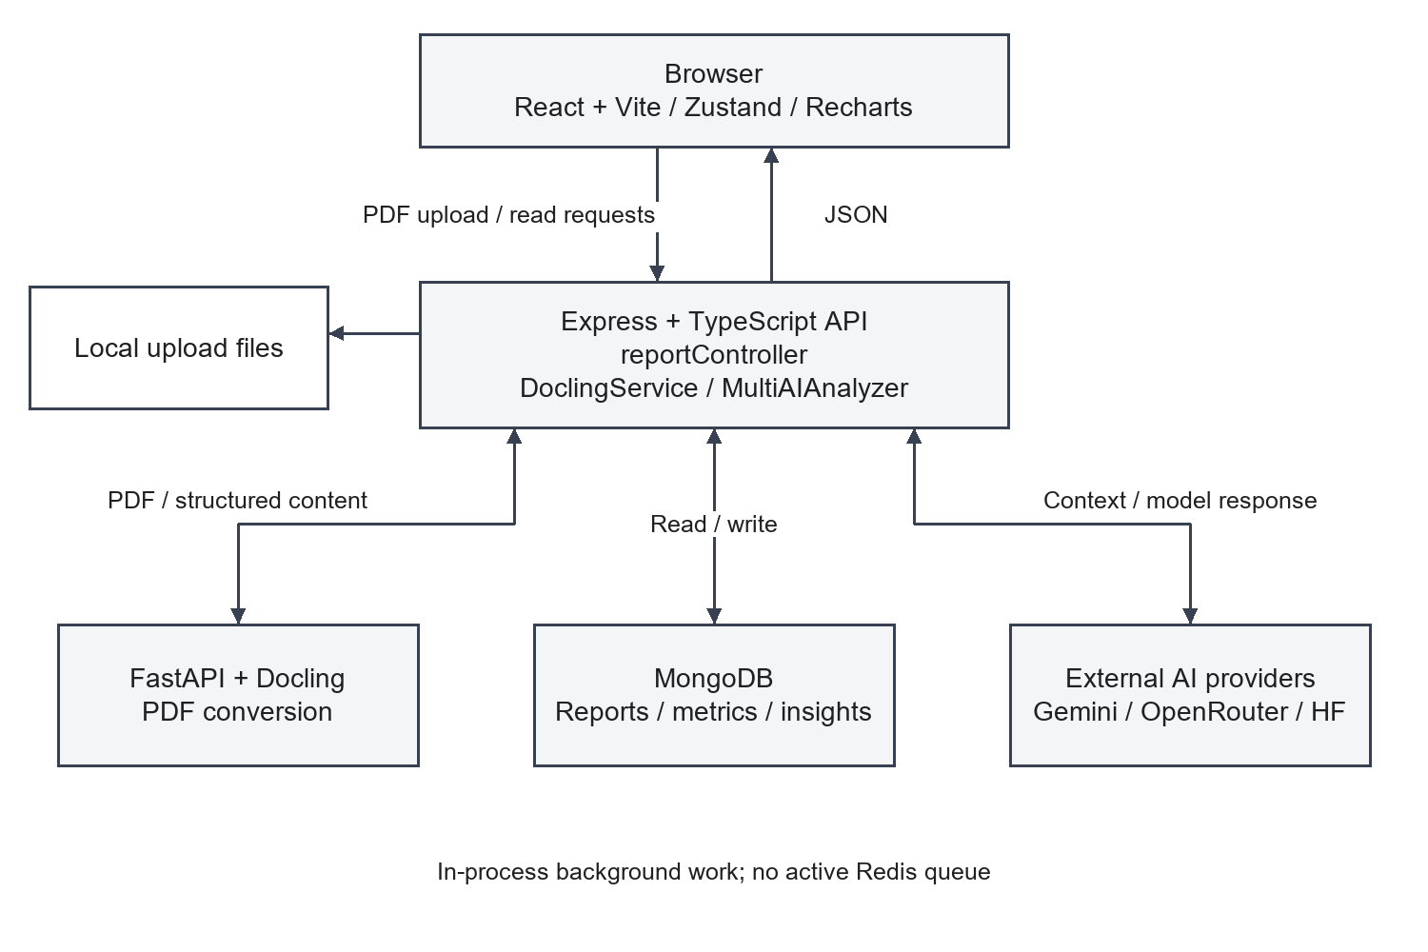
Figure 3.1 System architecture derived from active source
Table 3 distinguishes source-backed behavior from partially integrated or proposed requirements. An implemented route or handler is evidence of code coverage; it is not evidence that the entire operation has passed a live test.
Table 3 Functional requirements and implementation status
ID | Requirement | Evidence and status
FR02 | Reject unsupported uploads and limit size | MIME filter and 50 MiB backend limit implemented
FR03 | Record report metadata and processing steps | Report model and upload controller implemented
FR04 | Extract page and table content | FastAPI parse endpoint and Docling wrapper implemented
FR05 | Extract financial metrics and generate insights | Active MultiAIAnalyzer methods implemented
FR06 | Attempt configured alternative AI providers | Ordered provider loops implemented
FR07 | Derive missing ratios from available metrics | Enrichment arithmetic implemented
FR08 | Retrieve status, metrics and insights | Public GET routes implemented
FR09 | List and delete reports | Backend handlers implemented; library UI remains sample-based
FR10 | Present dashboard information | Connected hook exists; data consistency is partial
FR11 | Compare selected actual reports | Proposed completion; current view uses sample records
FR12 | Authenticate and isolate users | Proposed; no active enforcement found
FR13 | Export analytical results | Proposed; visible controls have no implementation path

The analysis user uploads reports and reads available information. The operator maintains configuration and service availability. These responsibilities do not correspond to implemented authorization roles. There is no administrative route grouping, session model or privilege hierarchy in the inspected application.
The principal use case begins when a user selects a PDF on the upload page. The page passes files to the store, which calls the API client. The backend saves a Report record and starts processing. The user can retrieve report status through the API and inspect outputs after completion. Automatic refresh of this progression is not fully integrated in the inspected upload UI, so manual re-fetching remains part of a reliable demonstration procedure.
An additional API use case deletes a report and its associated records. The controller performs the three database deletions concurrently and then attempts to remove the stored file. A file-deletion failure is logged, while a database failure leads to an error response. The report library's visible delete button is not connected to this API path.
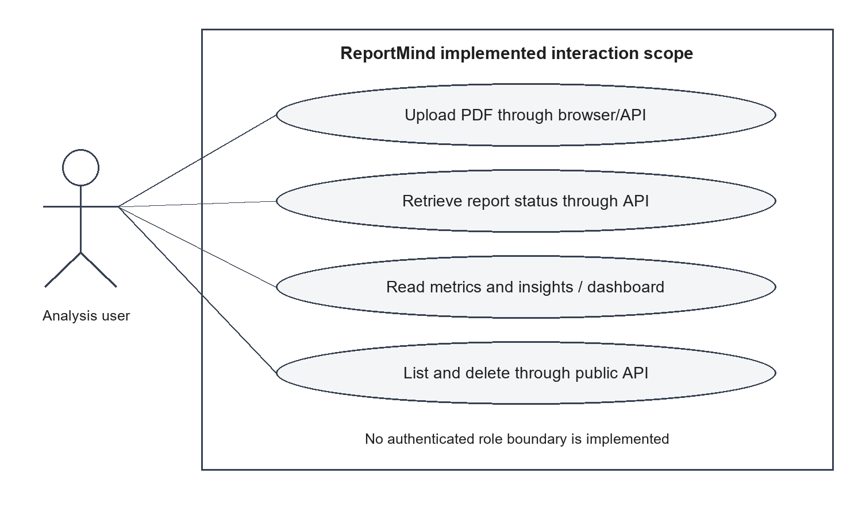
Figure 3.2 Use cases supported by active API and connected views
Figure 3.3 presents the processing data flow. PDF bytes move from the browser to backend storage and then to the conversion endpoint. Structured pages and tables return to the backend and become input to provider prompts. Generated JSON and calculated fields become database records. Read endpoints subsequently supply browser data.
Provider fallback is internal to the analyzer and is not a distinct user action. The diagram also distinguishes local PDF storage from MongoDB. MongoDB stores extracted content and analysis records, while the original file is retained as a local upload. The prototype does not upload original PDF bytes directly to a provider; it sends prepared textual context.
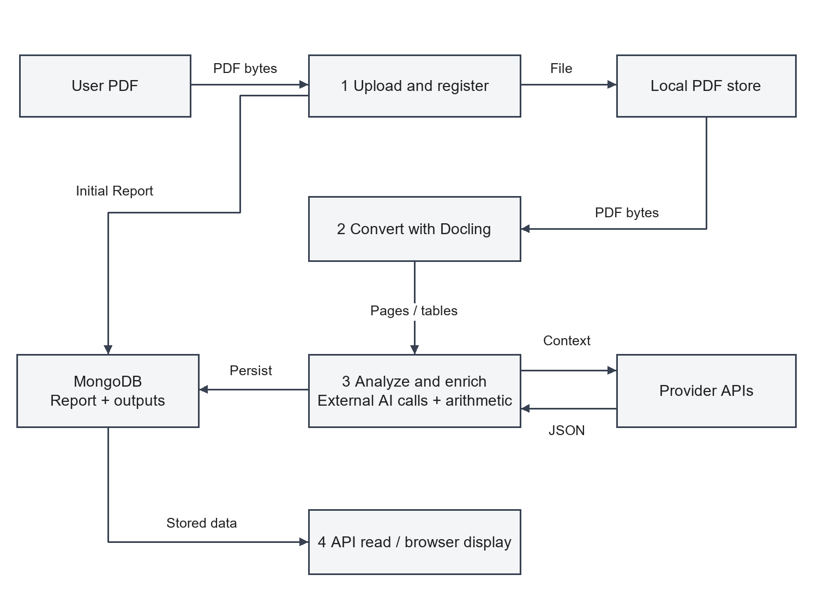
Figure 3.3 Data flow for upload and analysis
The methodology separates the processing contract from the presentation contract. The processing contract defines what a completed report should contain and how failure is recorded. The presentation contract defines how stored fields become cards, charts and text without changing their meaning. Both contracts are necessary because the frontend is not a passive copy of the database; it transforms values and selects which outputs to show.
The data flow can be inspected as a sequence of handoffs. Each handoff should preserve report identity and make invalid or incomplete data visible. For example, the conversion response must describe the tables actually returned, and the upload response must expose an identifier the browser understands. These handoffs provide practical validation boundaries for the later test cases.

3.2 Multimodal Document Ingestion and Preprocessing
After Multer writes a file, uploadReport creates a Report with status uploaded and four processing steps: upload, docling_extraction, ai_analysis and data_storage. The upload step is completed immediately, and the remaining steps are pending. The controller saves this record, invokes processReportAsync and returns HTTP 202 with message, reportId and status processing.
The processing function retrieves the record, marks extraction as processing and sets the overall report status to processing. It calls the Python service, stores page and table output, completes extraction and begins AI analysis. Financial metrics are extracted first; insight generation receives the extracted metrics as additional context. The controller completes analysis, begins storage, enriches the results and saves FinancialMetrics and Insight records before marking the Report completed.
The source assigns report.status to analyzed before the analysis calls, but that assignment is not saved immediately. The later final save establishes completed. Clients should therefore not rely on observing analyzed as a stable persisted intermediate state. Figure 3.4 shows ordering at the service boundary and the separate acceptance response.
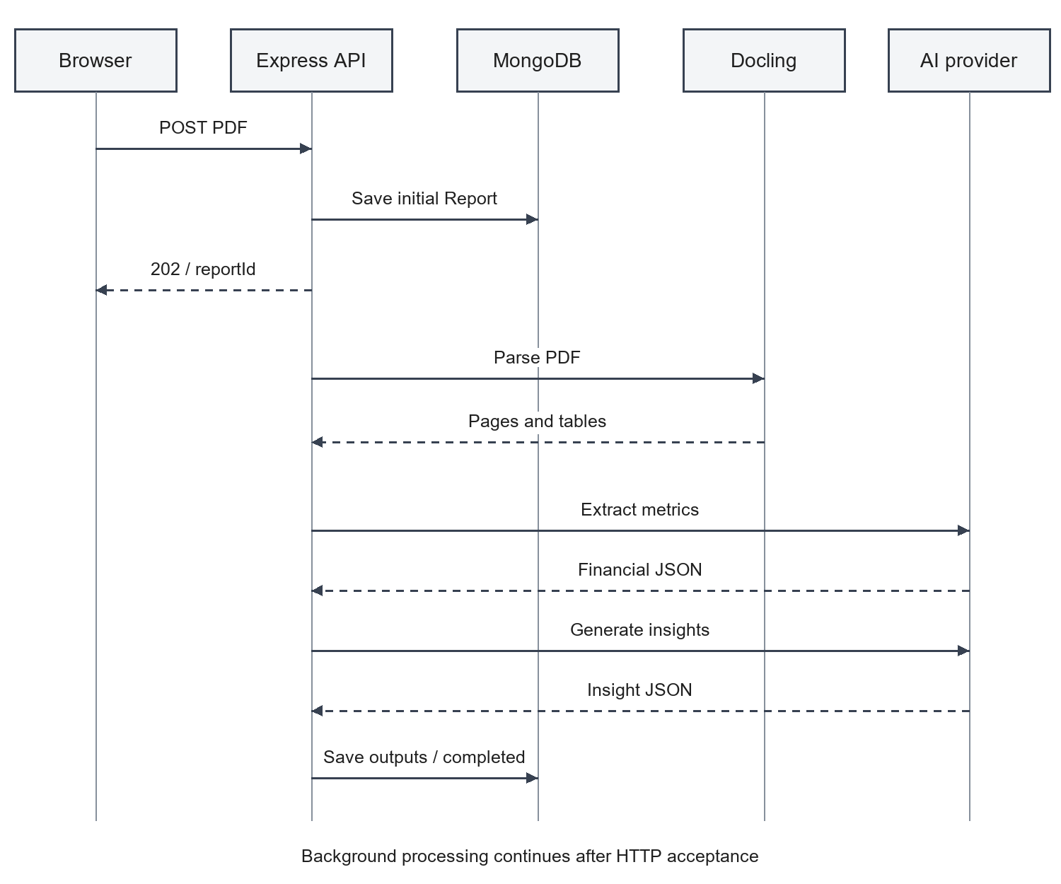
Figure 3.4 Sequence for accepted upload and background processing
The Python upload endpoint validates the filename extension, reads the uploaded content, writes a temporary PDF, invokes the parser and removes the temporary file in a finally block. The parser constructs a ParsedDocument from separate functions for pages, tables, sections and metadata. Its synchronous conversion call occurs inside an async endpoint and can occupy the service worker during processing.
Page extraction uses exported Markdown. When Markdown contains supported separators, it is split at those markers; otherwise it is divided approximately by line count using the reported page count. The resulting page numbers should therefore be understood as transformed segment numbers when the approximation path is used. They do not guarantee an exact PDF-page location.
Table extraction first attempts structured table objects and then Markdown tables. Cell row and column indexes and content are mapped into the application Table schema. The Markdown fallback sets pageNumber to one because it cannot establish original provenance. Sections are obtained from Markdown headings, with estimated page tracking. The backend stores pages, tables and selected metadata but does not preserve the top-level sections list returned by Python.
The Python DocumentMetadata schema provides totalPages but no totalTables. The Node interface and controller expect totalTables. This is a contract discrepancy rather than evidence that no tables were extracted. A future correction should either add the field to the service response or derive it explicitly from the returned table count.
Ingestion begins before model inference. File acceptance checks, storage naming and temporary-file cleanup determine whether the system has a stable input to analyze. The generated backend filename distinguishes stored uploads, while the original filename remains descriptive metadata. Neither filename proves document integrity; validity must be established by conversion and controlled validation behavior.
Preprocessing should preserve financial meaning while removing irrelevant formatting artifacts. Whitespace cleanup can improve readable text, but removing symbols indiscriminately could alter negatives, decimal separators or currency indicators. The focused helper check confirms only the specific whitespace and null-byte behavior tested. It does not establish correctness on every financial notation.
The separate Python service offers a useful troubleshooting boundary. A failed provider call should not be confused with failed conversion, and a malformed PDF should be diagnosed before assessing model quality. Direct conversion tests can compare text and tables against a small known fixture. Full workflow tests can then examine whether the backend uses that returned representation correctly.
For scanned or image-heavy reports, actual parsing behavior remains dependent on the selected Docling version and environment. The application does not supply a measured OCR study. The proper methodological response is to include such documents in a future fixture set and report failures explicitly, rather than assuming conversion-library capabilities imply validated project coverage.

3.3 Modality-Specific Representation and Indexing
Report is the parent entity and embeds extraction pages, tables and processing steps. FinancialMetrics refers to Report through reportId and stores typed financial groups. Insight also refers to Report and stores narrative and categorized analytical output. Figure 3.5 depicts these application relationships, not database-enforced foreign keys.
Insight.reportId has a unique constraint expressing at most one insight record per report. FinancialMetrics.reportId is indexed but not unique, so the schema permits multiple metric documents for one parent even though the controller intends one result. Read handlers use findOne and do not define which record would be selected if duplicates exist. The diagram shows the permitted cardinalities and explains the controller's intention.
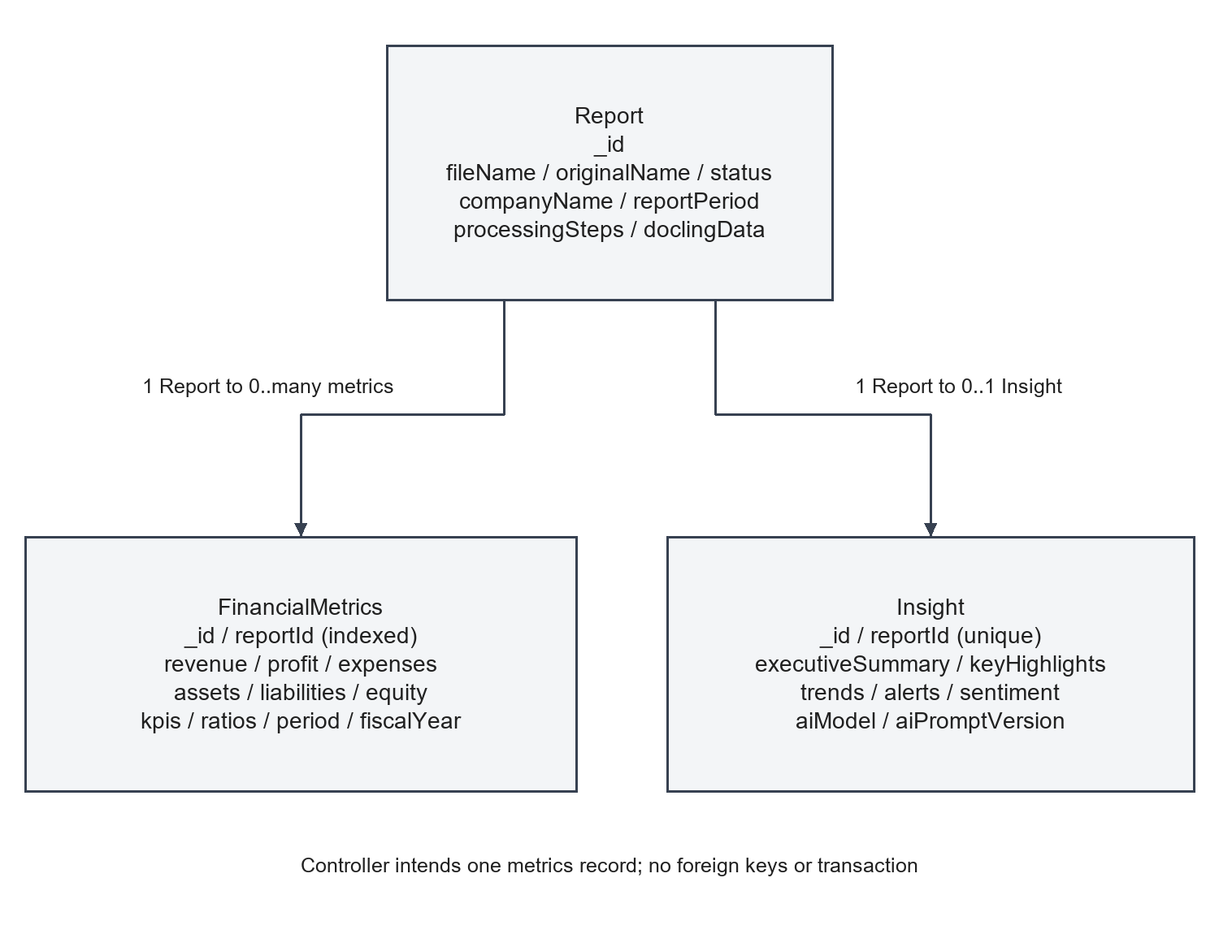
Figure 3.5 MongoDB entity relationships and embedded structures
Report indexes support status and upload time, userId and upload time, and company and period combinations. The userId index exists without active user enforcement. FinancialMetrics indexes include reportId, fiscal year and quarter, and period. Insight indexes include reportId and overall sentiment. Index declarations describe schema intent; actual installed indexes were not inspected in a running database.
The schema constrains report status and reportType to enumerated values. FinancialMetrics requires reportId, current revenue, revenue currency, profit currency, period and fiscal year; several currency fields default to USD. Confidence is bounded between zero and one. Insight requires reportId, executiveSummary, aiModel and aiPromptVersion; trend and alert enums constrain several categories, directions and severity fields. Sentiment scores are bounded between minus one and one.
Appendix B records the field groups and constraints. An absent source value should remain distinguishable from a calculated or defaulted value. The current models do not comprehensively encode that distinction.
The implemented representations are page text, table cells, processing metadata, financial fields and narrative insights. The application does not maintain distinct vector representations for text, images and tables. Its indexes are MongoDB schema indexes supporting report and output access. This is a persistence design rather than a multimodal semantic index.
A table cell carries rowIndex, columnIndex and content. That representation is sufficient to reconstruct a simple grid for a prompt, but it does not encode every relationship available in a PDF. A merged heading can govern several columns; a footnote can qualify a value without occupying the same row. The current schema cannot guarantee preservation of these relationships.
The financial model represents interpreted values independently from the original grid. This makes later API consumption simpler but creates an information-loss boundary: a revenue amount has no required link to the source cell that produced it. The same is true of a generated explanation. A future provenance structure should be designed at this boundary rather than added only to the final dashboard.
Indexing should be assessed according to the actual access path. A reportId index can support finding a report's outputs, while an embedding index would support selecting evidence by semantic relevance. These solve different problems and should not be conflated in architecture diagrams. The implemented entity diagram intentionally shows only the real report and output relationships.

3.4 Query Processing and Agentic Retrieval
The backend mounts report routes under /api/reports and its health router under /api/health. Upload accepts multipart form data with a file field and optional companyName, reportType and reportPeriod values. The current browser API client appends only the file, so the optional descriptive fields are not supplied by that UI path.
GET /api/reports supports status, companyName, limit and skip. It returns report records without doclingData plus a pagination object. Individual GET endpoints retrieve summary status, financial metrics, insights or a combined representation. DELETE removes the parent and associated analysis records. Appendix A describes methods, response shapes and error conditions.
All inspected routes lack authentication. A JSON error string is common in backend responses, whereas several frontend handlers read a message field first. This mismatch can hide the most specific server error from the browser. Invalid ObjectId values are not validated at the route boundary and may become generic 500 responses after a Mongoose cast failure.
MultiAIAnalyzer registers Gemini, OpenRouter and Hugging Face in that order when their respective environment keys are present. Construction throws if none are configured. Since the controller creates an analyzer instance during module loading, provider configuration is required for the active backend initialization path.
Metrics and insights each attempt their own provider loop. A request error or parsing error moves that operation to the next configured provider. Therefore, metrics and insights can be generated by different providers for the same report. The current stored aiModel value is derived from the metrics provider, which may not accurately identify the insight-generation provider.
The source Gemini call selects gemini-1.5-flash-latest with a 30-second request timeout. OpenRouter tries OPENROUTER_MODEL, if supplied, followed by meta-llama/llama-3.1-70b-instruct, also with a 30-second timeout. Hugging Face uses HUGGINGFACE_MODEL or mistralai/Mistral-7B-Instruct-v0.1 and a 60-second timeout. These are source-configured identifiers. Current provider support, pricing and availability have not been established through live calls.
Each call uses temperature 0.1 and a provider-specific output limit. The existence of a low temperature does not prove deterministic extraction. There is no project model training, fine-tuning, vector retrieval or confidence calibration in the active analyzer. ClaudeAnalyzer is a separate legacy implementation that is not imported by the active report controller.
The term query has two meanings in this system. HTTP clients query stored report records through the backend routes. The analyzer also submits task instructions to providers. Neither path implements a user-directed agent that plans searches over document evidence. The fixed extraction task is determined by application code rather than an arbitrary user question.
At the API boundary, route parameters select a report and query parameters filter the report list. These operations need validation regardless of AI behavior. A malformed identifier, negative pagination value or overly broad company expression can fail before document reasoning begins. The implementation currently provides limited boundary validation, which is reflected in the pending test register.
At the inference boundary, provider selection follows configured availability and failures. The loop has no relevance score for document regions and no tool selection based on the contents of the report. Its state is operational: which provider is configured, which request failed and whether parsing succeeded. Describing that loop as agentic retrieval would misrepresent its decision process.
A future agentic interface would need a question schema, available evidence tools, bounded actions and persistent attempt records. It would also need authorization rules so a query cannot access another user's reports. These requirements are prospective and are not part of the current public endpoint contract.

3.5 Multimodal Retrieval and Evidence Fusion
ReportMind's closest implemented equivalent to evidence fusion is the joint inclusion of page text and table text in a financial-analysis prompt. The source prepares these two strings separately and supplies them to the provider. This combines representations at the input level, but does not rank, reconcile or verify evidence from different modalities.
Consider a hypothetical report where the narrative says revenue increased and a table contains current and previous amounts. Supplying both may help interpretation, but the application has no explicit rule that checks whether the sentence and amounts agree. If the text and table were extracted from different periods, their simultaneous presence could create ambiguity rather than resolve it. This example illustrates a validation need, not an observed output.
A robust evidence-fusion design would preserve the origin of each candidate value and specify precedence or conflict handling. It should distinguish repeated presentations of the same amount from genuinely inconsistent sources. It should also retain the unit statement and reporting basis, since consolidated and standalone figures can refer to different scopes.
The present pipeline delegates interpretation of these relationships to the model. Deterministic enrichment occurs only after financial values have been extracted; it does not revisit table cells to resolve a conflict. Consequently, the report cannot claim cross-modal corroboration merely because both text and tables appear in the prompt.
For future work, evidence fusion could be evaluated with deliberately selected fixtures containing agreement, omission and contradiction between prose and tables. The expected behavior should be defined before execution: preserve a supported value, identify an unresolved conflict, or request additional review. A system that always returns a complete answer would not necessarily be the more reliable one.

3.6 Context Construction and Answer Generation
Text context begins with page labels and uses section content if page-level sections exist, otherwise content or text fields. At most 50 pages are considered. Table context builds a row-column grid and serializes rows into Markdown-style text. Prompts then retain at most 25,000 characters of document text and 15,000 characters of table text. These are character limits, not token counts.
The financial prompt requests revenue, profit, expenses, cash flow, balance-sheet fields, KPIs, ratios and period information. It instructs the provider to use explicit document data, omit missing metrics and attend to scale and currency. The sample JSON structure is less extensive than the full requested field list. The insight prompt requests a summary, highlights, trends, alerts, comparisons, recommendations, risks and sentiment, with extracted metrics as additional input.
Responses are parsed by extracting text between the first opening and last closing brace and applying JSON.parse. The metrics parser checks revenue, current revenue, period and fiscalYear using truthiness. This rejects a valid numeric zero revenue even though the Mongoose schema allows zero. The insight parser checks executiveSummary and an array of keyHighlights but leaves much validation to persistence. An instruction to avoid invented values is not a substitute for source-grounded verification.
The controller normalizes KPI and insight arrays before enrichment. It computes fields only when operands have numeric types, and it avoids division by zero for the guarded ratios. Existing ratio or margin values are preserved with nullish-coalescing assignments rather than overwritten. Table 4 lists the implemented arithmetic. These formulas describe code behavior and are not benchmark results.
Table 4 Implemented metric calculations
Metric | Calculation | Guard and representation
Revenue growth rate | Growth percentage / 100 | Four decimal fractional representation
Net margin percentage | 100 x net profit / revenue | Numeric inputs; revenue nonzero; two decimals
Operating margin percentage | 100 x operating profit / revenue | Numeric inputs; revenue nonzero; two decimals
Expense ratio percentage | 100 x total expenses / revenue | Numeric inputs; revenue nonzero; KPI entry
Current ratio | Current assets / current liabilities | Numeric inputs; liabilities nonzero
Debt to equity | Total liabilities / selected equity | Uses total or shareholder equity; nonzero denominator
Return on equity percentage | 100 x net profit / selected equity | Numeric inputs; nonzero equity

The backend also creates basic alerts if the relevant arrays are empty. Debt to equity above two leads to a leverage warning and may produce a recommendation and risk entry. Expense ratio above seventy produces an expense warning; above sixty can produce a cost-optimization recommendation. These are prototype thresholds chosen in code. No industry study was supplied to establish their appropriateness across sectors.
When revenue values exist, a comparison and basic reported-revenue highlight may be created. The enrichment logic therefore mixes provider output with deterministic arithmetic and rule-generated text. A future data model should make these origins explicit so users can distinguish extracted values, derived values and generated interpretations.
The generated result is a structured analysis rather than a conversational answer. This affects both prompting and validation. Required financial fields must be parseable and compatible with persistence, while optional fields must remain distinguishable from unsupported defaults. Narrative output should be treated as an interpretation of the supplied document and metrics, not as an independent source of financial facts.
The metrics operation precedes the insight operation. This creates a dependency: an incorrect extracted amount can influence both stored metrics and later commentary. Comparing only whether the two outputs agree would therefore be insufficient, because they may share the same upstream error. Source evidence is needed to assess both.
The prompt construction also creates a reproducibility boundary. The exact included text, table serialization and truncation limits determine what the provider can see. A future evaluation should record those inputs or their permitted reproducible representations alongside the configuration. Otherwise, a discrepancy between runs could arise from context changes rather than the model alone.

3.7 Critic-Guided Verification
There is no active critic component in ReportMind. The implemented checks concern response parsing, required-field presence, schema constraints and guarded arithmetic. These are useful validation mechanisms, but they do not constitute an independent factual review of each generated claim against source evidence.
FastAPI documents multipart file handling through UploadFile [7], while Mongoose documents schema validation for required fields and value constraints [8]. These mechanisms support a service boundary where files are accepted as uploads and analytical outputs are checked before persistence.
In ReportMind, Python Pydantic models describe the conversion response and Mongoose models constrain stored metrics and insights. The active AI parser also performs limited JSON and required-field checks. These layers serve different purposes: a syntactically valid JSON response can still contain a wrong financial value, and a valid database record can still have inconsistent currency or period semantics. The implementation therefore requires both structural validation and evidence-based numerical review.
A proposed verification layer could begin with deterministic issues. It could require a period, explicit currency and scale; check that referenced evidence exists; verify calculations from accepted operands; and flag a disagreement between an amount and its source cell. A model-based critic could then review narrative support, but its judgment would need evaluation against human annotations.
Criticism should produce structured findings rather than an unqualified approval score. Each finding should identify the field or claim, the supporting or conflicting evidence, the violated rule and the available action. Possible actions include accepting the value, recomputing a derived field, marking it unavailable or requesting review. These records would make later correction inspectable.
The current truthiness rejection of zero revenue illustrates why basic validation deserves attention before adding a critic model. A valid numerical value can be rejected by ordinary application logic. Conversely, a nonzero but incorrect value can pass the same check. Improving this distinction is a direct engineering requirement and does not require agent terminology.

3.8 Self-Correction and Iterative Retrieval
Any exception in processReportAsync is caught and causes the parent Report to be updated to error with an appended error step. Earlier writes are not rolled back. For example, a FinancialMetrics save can succeed before an Insight save fails, leaving partial output attached to an error report. The complete endpoint may therefore expose a mixture of available and missing analysis data.
The backend stores a processing-step error message and timestamps. The frontend defines failed rather than the backend error status, which can prevent a clear error presentation. Figure 3.6 models the backend's normal and error paths without implying a durable worker queue.
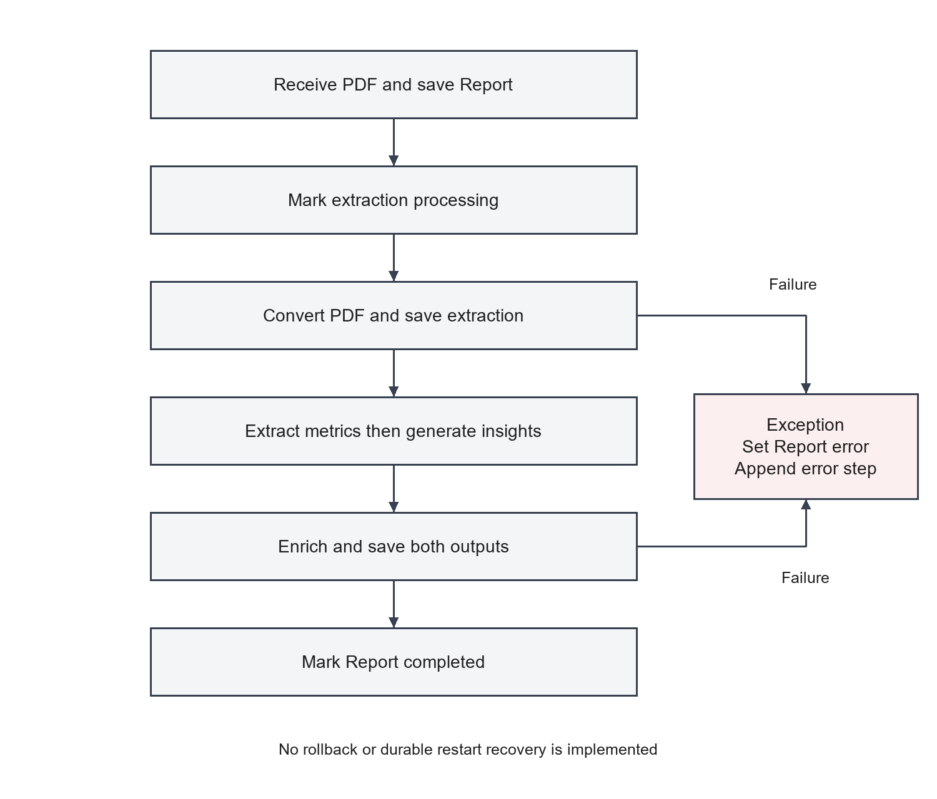
Figure 3.6 Backend activity and failure handling
The active failure path records an error; it does not reopen the document, select additional evidence or revise a previously accepted analysis. Provider fallback may continue an operation after technical failure, but no persisted correction cycle compares an initial answer with a revised one. The methodology therefore documents error handling as implemented and correction as proposed.
A future iterative process would need to distinguish recoverable service failures from semantic conflicts. A timeout may justify a controlled retry. A missing period label may justify selecting another source region. Conflicting financial values may require human review rather than repeated inference. Using the same action for all three cases would make results difficult to interpret.
Each attempt should have a stable identity and idempotent output handling. The existing metrics schema permits multiple records for a report, while insights are unique by reportId. Repeated processing without a defined update policy could therefore create inconsistent behavior across result categories. Correction cannot safely be added without considering these persistence semantics.
The stopping rule should also be explicit. A future process could stop when all required evidence checks pass, when a configured attempt budget is exhausted, or when an unresolved conflict requires review. The report does not prescribe a validated numeric attempt limit because no such experiment has been performed. Its methodological requirement is bounded, explainable behavior with a retained history of changes.

3.9 Algorithms and Computational Complexity
The implemented algorithm is a sequential orchestration pipeline with two potentially repeated provider operations. Let P denote pages inspected, L the total characters prepared from those pages, and C the table cells traversed. Building page strings requires work proportional to the text visited, while table serialization includes traversal of cells and construction of row-column grids. Its cost also depends on declared grid dimensions, especially for sparse or malformed table coordinates.
Prompt truncation bounds the strings sent to a provider, but does not necessarily bound all preprocessing work. A complete intermediate string may be constructed before slicing. The distinction matters when reasoning about memory use for large documents. The code's page and character limits are configuration facts; they are not measured CPU or memory bounds.
The guarded financial formulas perform a fixed collection of numeric operations. Array normalization and searches over KPI or insight entries depend on those array lengths. The overall application cost, however, includes PDF conversion and external inference, whose internal complexity is outside the controller's source. It would be misleading to express total processing time only in terms of the small arithmetic routine.
For latency analysis, a useful decomposition is total completion time equals upload handling, conversion, metric attempts, insight attempts, enrichment and persistence, plus communication overhead. This is an analytical decomposition, not an observed measurement. Provider operations are ordered rather than launched as a voting ensemble, and metrics and insights each have their own fallback sequence.
The conceptual algorithm can be summarized without implying additional components:
Register uploaded PDF and its processing steps
Return accepted response with report identifier
Convert the stored PDF into pages and tables
Prepare bounded financial context
Try configured providers until metrics are parsed
Try configured providers until insights are parsed
Enrich available fields with guarded arithmetic
Save outputs and mark the report completed
On failure, record the parent report error state
No embedding construction, nearest-neighbor search or cross-encoder computation belongs in the complexity description of the active implementation. Those would require a separate analysis if added later. The practical evaluation should measure stage durations and peak resource use on documented inputs before choosing scaling strategies.

3.10 System Implementation and Technology Stack
The architecture suggests maintainability through separate services and typed interfaces. React components, backend service classes and Python transformation functions divide responsibilities into manageable modules. However, shared contracts are duplicated between TypeScript and Python, and source inspection found drift between them. A future shared schema or generated client would strengthen maintainability without changing the basic architecture.
Reliability requires processing failures to become visible and not leave a report indefinitely unfinished. The controller records an error state and an error step when processing throws. It does not guarantee recovery after a backend restart or atomic rollback after partial persistence. The desired requirement is durable, recoverable processing; the existing behavior is a simpler in-process implementation.
Accuracy requires consistent currency, scale and period interpretation, and transparent handling of absent values. The prompts ask providers to avoid guessing, while the schemas enforce some types and ranges. Neither mechanism proves factual correctness. Accuracy, numerical completeness, response latency and concurrent throughput are unmeasured quality attributes in this report.
Security requirements include authenticated access, scoped report ownership, controlled file handling and confidential provider configuration. The active code supplies some validation and configurable error verbosity but no user access control. Express production guidance identifies transport protection and defensive input handling as relevant practices [9]; they are future deployment requirements here, not completed safeguards.
Table 5 records dependency declarations rather than installed production versions. Node dependencies use version ranges, so the actual installed versions depend on lock files and installation. Only the frontend lock file is present in the inspected tree; it was inventoried rather than treated as execution evidence.
Table 5 Software environment requirements
Component | Repository declaration | Purpose
TypeScript | Backend ^5.3.2; frontend ^5.3.3 | Compilation and typed development
React and Vite | React ^18.2.0; Vite ^5.0.12 | Browser application and development build
Express and Mongoose | Express ^4.18.2; Mongoose ^8.0.0 | API routing and MongoDB modeling
Python | Docker uses Python 3.11 | Document conversion service
FastAPI and Uvicorn | 0.115.0 and 0.32.0 | Python HTTP service
Docling | 2.6.1 in primary manifest; >=2.70.0 in alternate | PDF conversion; version compatibility unresolved
Pydantic | 2.9.2 | Conversion-response schema
MongoDB | No server version pinned | Persistent report and analysis data
External AI provider | At least one supported key | Model inference for metrics and insights

No verified minimum CPU, memory or disk specification is established by the repository. A development computer needs capacity for the browser, Node service, MongoDB and Docling conversion models, along with space for uploads, logs and model resources. An operator should measure the chosen environment with representative PDFs before fixing institutional hardware specifications. No GPU requirement is demonstrated by the application code, and no processor or RAM configuration is reported as an experimental fact.
The processing path assumes a valid PDF, reachable MongoDB, an available conversion service, configured provider credentials and model responses compatible with the expected JSON structure. A valid PDF MIME label is insufficient to establish valid PDF content. A provider may fail because of credentials, limits, network conditions, model availability or an unsuitable response. These are dependencies to verify during execution.
Technical feasibility is supported by the presence of appropriate modules and interfaces, rather than by a completed integration run in this documentation session. Operational feasibility depends on an operator starting the separate services and managing credentials. Economic feasibility is unresolved because no hosting budget, provider usage measurements or cost study was supplied. The report does not describe any provider as permanently free.
The principal constraints are finite prompt context, prototype security, duplicated schemas and incomplete frontend wiring. The financial nature of the data also makes unit consistency and source traceability necessary acceptance criteria. Confidential document use would require a reviewed deployment and data-handling policy; none is asserted as already implemented.
The frontend is a Vite React application using React Router for navigation, Zustand for client state and Axios for service calls. Recharts supplies charts, Tailwind CSS supplies presentation utilities and react-dropzone supplies file selection. The active application is not Next.js despite the older README description.
The backend is an Express application that connects to MongoDB before listening. Routes delegate to reportController. DoclingService forwards files to the Python service. MultiAIAnalyzer supplies the active extraction and insight logic. The controller then enriches and persists results. Winston handles application logging, while dotenv loads configuration.
The conversion service initializes one DoclingParser and exposes parsing and health endpoints. The parser invokes Docling's DocumentConverter and delegates transformation to schema_transformers. Pydantic defines page, cell, table, section and metadata structures. The service returns structured content; it does not perform the external financial AI analysis.
The database stores a Report parent record, a FinancialMetrics record referring to it, and an Insight record referring to it. There is no relational foreign-key enforcement or cross-collection transaction in this workflow. Stored PDF files remain on the backend filesystem because successful processing does not delete them.
App.tsx defines dashboard, upload, reports, compare and settings routes with a redirect from the root. AppLayout supplies the shared layout. A theme store and toggle support changing the interface mode; notification preferences and profile labels are presentational.
UploadPage selects files through UploadZone and uploads them sequentially. useReportsStore inserts a temporary report, tracks byte-upload progress and replaces it with the response representation. The source currently reads response._id or response.id, while the backend returns reportId. The stored ID can therefore be undefined immediately after upload. Progress also becomes 100 at upload acceptance, which does not mean extraction and analysis are complete.
useDashboardData chooses the first completed report in the store and requests its metrics and insights. Its dependency tracks the completed report ID. This reduces repeated effect execution, but completion changes still require report-state updates. The inspected upload page performs an initial fetch; it does not establish continuous processing-status polling.
The dashboard includes metric cards, revenue/profit lines, expense and revenue-source charts, KPI sparklines, comparison bars, a detail table and insight cards. The transformation expects fields such as breakdown, sources and insights.insights that are not part of the active stored schemas. It also uses fixed historical values and default insight text. These data issues are discussed in Chapter 4 rather than presented as reliable application results.
ReportsPage and ComparisonPage call useReportsData, which supplies four hardcoded sample records after a delay. Search, filter, view, download and delete controls have no implemented behavior in those pages. The comparison selectors do not drive selection of actual report data. These views demonstrate layout and navigation, with data integration remaining incomplete.
The backend accepts files with application/pdf MIME type and applies a fixed 50 MiB limit. The Python endpoint separately checks the .pdf extension. Neither check verifies the full content signature or safety of a file. File storage uses a timestamp and random suffix, and temporary files are removed by the Python endpoint. Successful backend uploads remain on disk until deletion.
The Express CORS callback allows origins even when they are absent from the configured allowlist. CORS therefore does not provide the stated restriction in normal requests. Python permits all origins. No rate limiting, authorization middleware, report ownership check or restricted internal-path endpoint access is established by active source.
The Python parse-from-path endpoint accepts a server filesystem path and checks existence before parsing. It is described as internal but has no authentication or allowed-directory restriction. Deployment should keep this service private and resolve path access before external exposure. Provider keys are read from environment variables; the report includes only names, never values.
The backend has request logging, generic exception handling, route-not-found responses and configurable development error details. The analyzer may log fragments of failed model responses. A production privacy review should consider whether those fragments contain report information. Parsing, provider and database failures are observable in code, but error-message fidelity and recovery are incomplete.
The repository provides a Dockerfile for the Python service using Python 3.11, requirements.txt, Uvicorn on port 8000 and a health check. The backend and frontend provide development and build commands. There is no Docker Compose file, orchestrator configuration or CI/CD workflow in the inspected tree. Figure 3.7 shows the supported local arrangement, not a verified cloud deployment.
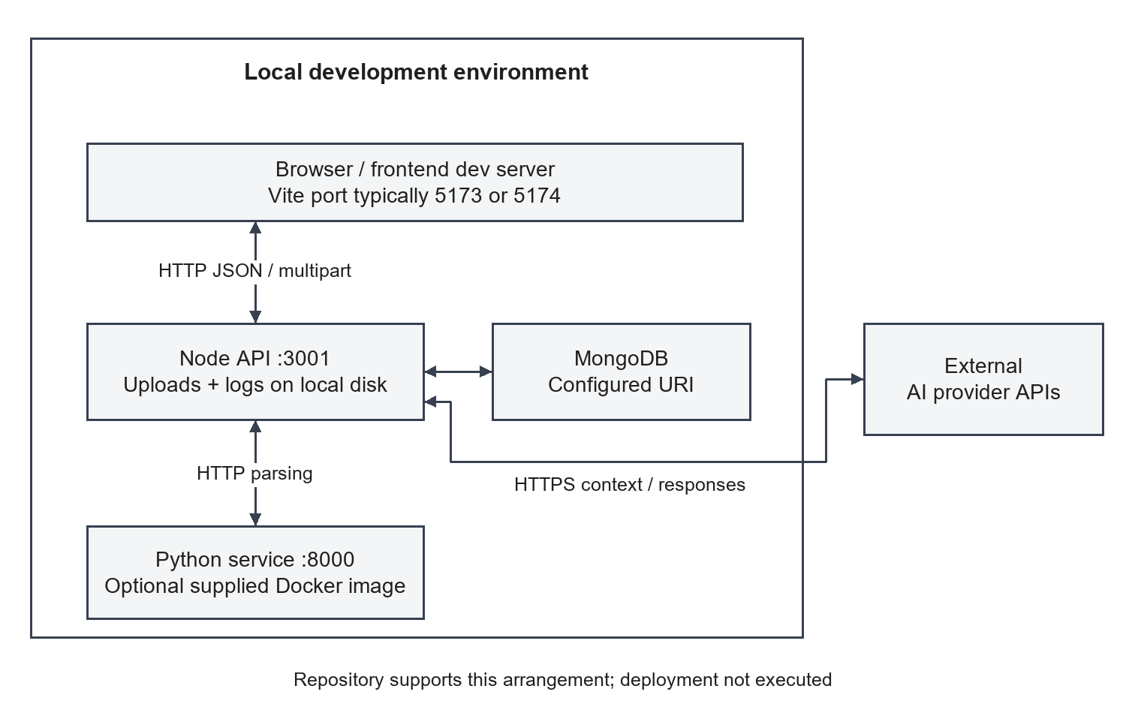
Figure 3.7 Local deployment arrangement supported by the repository
Default backend and conversion ports are 3001 and 8000. Frontend development origins include 5173 and 5174. The browser API base is configurable through VITE_API_BASE_URL. The backend uses DOCLING_SERVICE_URL, MONGODB_URI, UPLOAD_DIR, NODE_ENV, PORT and ALLOWED_ORIGINS. Provider configuration uses GEMINI_API_KEY, OPENROUTER_API_KEY, HUGGINGFACE_API_KEY and optional model/referrer variables. The conversion entry point uses HOST and PORT; it does not explicitly load its .env file.
Bull and ioredis appear in backend dependencies but no queue construction or worker is active. Redis is therefore not a demonstrated runtime requirement for the inspected pipeline. Joi and ExcelJS are similarly declared without active request validation or export paths. The distinction prevents deployment diagrams from including components that the application does not actually use.
The implementation reflects a deliberate language boundary: TypeScript organizes web-facing behavior, while Python hosts document conversion. The HTTP interface makes that separation explicit, but duplicated schemas require disciplined compatibility checks. A change to Python metadata is not automatically propagated to a TypeScript interface or Mongoose schema.
Dependency declarations also need interpretation. A package can remain in a manifest after its feature path becomes inactive. The presence of queue or alternative-provider dependencies is therefore not evidence of an active worker or model integration. The technology table describes the code path actually used by the controller, and the deployment diagram omits inactive infrastructure.
Security is part of the implementation assessment rather than an assumed framework property. React, Express and MongoDB do not provide report ownership merely by being selected. The route chain must establish identity and apply access conditions to each report operation. Since that behavior is absent, the methodology treats authenticated use as future work and avoids inventing user roles in diagrams.

3.11 Summary of Proposed Methodology
The separate conversion service keeps heavy Python document libraries outside the Node process, at the cost of another deployment and schema boundary. MongoDB accommodates nested extraction and financial structures, while the lack of transactions can leave partial records after failure. Provider fallback improves the chance of obtaining an output but does not compare answers or correct factual disagreements.
Bounded prompt prefixes reduce input size but can omit later financial statements. In-process background work keeps initial implementation simple but cannot guarantee recovery from interruption. A dashboard transformation provides flexible display defaults but currently conflates unavailable facts with generated or fixed values. These tradeoffs explain the present system and guide future enhancements.
The implemented method is document ingestion, structured conversion, bounded prompting, response parsing, guarded enrichment and persistence. The browser then retrieves and transforms the results. This sequence is the basis for the architecture, data-flow and activity diagrams, and it defines the points where validation evidence should be collected.
The requested retrieval and critique topics reveal the difference between current method and potential extension. ReportMind currently has no semantic index, arbitrary-question endpoint, evidence reranker or critic-controlled loop. Its provider fallback and error recording are operational mechanisms. Their description remains separate from future factual verification.
The method's strongest property is inspectable decomposition. A reviewer can examine conversion output independently from provider response and can verify arithmetic separately from narrative support. Its main weakness is incomplete evidence continuity across those stages. Source locations, units and generation origins are not consistently retained as enforceable contracts.
Chapter 4 therefore evaluates the implementation through source findings and narrowly executed helper checks, then defines the larger experiments still required. This follows directly from the method: an architecture diagram explains how components interact, while a recorded execution is required to demonstrate that the interaction succeeds on a particular document.

Chapter 4

Results and Discussion

4.1 Introduction
This chapter reports source-level observations and limited executed helper checks. No complete application run, financial benchmark, user study, penetration test or production deployment was performed during report preparation. The repository includes test scripts and guides, but no captured test report establishes that its full workflow passed.
Application execution is intentionally pending. The review used the implementation snapshot to establish modules, endpoints, data models and identifiable defects. Separate synthetic helper checks exercised document cleanup and transformation without importing Docling or starting services. Their scope and results are recorded explicitly so they cannot be confused with a live PDF conversion or provider test.
This chapter distinguishes three kinds of material. Source observations describe behavior visible in the inspected files. Executed helper observations describe specific checks that were actually run during documentation. Proposed experiments specify how application behavior should be tested later. Keeping these categories separate prevents a test plan from being mistaken for a result table.
The distinction is especially important for the requested retrieval and question-answering sections. ReportMind does not implement those capabilities, so their subsections discuss the applicable structured-analysis behavior and explain why retrieval-specific scores are unavailable. No precision, recall, hallucination rate or response-time distribution is assigned without an executed experiment.
The findings still provide a useful result. They establish the active architecture, identify integration defects and define a reproducible path for assessing the system. A confirmed source mismatch is a valid engineering observation even when the complete application has not been run. Its runtime effect remains subject to the associated test.
The discussion proceeds from environment and conversion to generation, attribution, performance and reliability. The final sections consolidate the feature status and application test register. Genuine screenshot slots remain explicitly pending, so a future demonstration can be inserted without confusing conceptual diagrams with observed screens.

4.2 Experimental Environment
backend/src/test.ts is a service-check script using Axios. Its default runTests method invokes backend health and Docling connectivity checks. Upload, status and insight methods are defined but commented out in the executed sequence. A successful default script run would therefore not prove the full upload-and-analysis workflow.
docling-service/test_direct.py is a direct conversion diagnostic tied to a developer-local PDF path. It inspects library output and Markdown, rather than asserting document-specific expected financial results. That local fixture was not supplied and was not used for this report. API_TESTING_GUIDE.md provides manual procedures, but a guide is not an executed result log.
No frontend test suite, coverage report or CI workflow is present in the inspected file inventory. The report does not label these absent artifacts as failed tests; they are gaps in validation evidence.
The proposed application validation strategy begins with deterministic unit checks, followed by service integration, user workflow, negative inputs and deployment checks. A representative fixture set should include a small digital financial statement, a multi-page report, a scanned PDF, a table with negative values and unit scaling, and a report with missing optional metrics. These are proposed fixtures; no project dataset is claimed.
Integration testing requires running MongoDB, the Express API, the Python conversion service and a configured provider or an explicitly labeled test double. It should compare API responses with saved database records and inspect processing transitions. Tests of actual AI quality need human-reviewed expected values, documented provider/model identifiers and source-page evidence.
System tests should exercise the browser upload, report refresh and dashboard path. Security tests should verify authenticated ownership once implemented, as well as file-type, size, path, origin and error handling. Performance tests should record measured extraction, inference and total completion times on a documented machine. No latency, memory or throughput numbers are reported as observed results here.
The documentation environment supported reading source files, inspecting schemas and executing focused Python helper checks. It did not establish a running MongoDB-backed application with live provider inference. Consequently, the environment used for source analysis must not be described as a successfully configured experimental deployment.
A future execution record should identify operating system, processor, memory, Python and Node versions, exact dependencies and the provider/model used by each stage. It should also identify the test document by a permitted stable reference, its page count and whether it is digital or scanned. These details affect reproducibility and interpretation of failures.
The version discrepancy between Python manifests deserves a controlled comparison. Testing different Docling versions while also changing prompts or documents would make it difficult to attribute a difference. The first compatibility test should hold the fixture and transformation code constant and compare returned schema and source fidelity. Only after that should wider performance experiments be attempted.

4.3 Document Processing and Indexing Results
The following checks were performed on 14 October 2026 using the bundled Python runtime. Five Python files passed AST parsing. Synthetic tests invoked existing transformer functions and Pydantic schemas, while two checks confirmed interface discrepancies in source text. Table 6 records the actual observations. A passed check means the described observation was confirmed, including when that observation is a defect.
Table 6 Executed documentation verification checks
ID | Check | Actual observation | Outcome
SV02 | Clean synthetic whitespace and null byte | Output Revenue 120 | Confirmed
SV03 | Transform a two-column Markdown table | Two rows, four cells; page defaults to one | Confirmed
SV04 | Extract pages from a synthetic object | Four lines split into two approximate pages | Confirmed
SV05 | Inspect Pydantic metadata serialization | totalTables absent | Contract gap confirmed
SV06 | Compare upload response and client ID read | reportId versus _id or id | Contract gap confirmed
SV07 | Compare margin representations | Backend percentage multiplied again by frontend | Calculation gap confirmed

These checks do not validate actual PDF layouts, provider responses, database availability or rendered charts. Their evidence supports a narrow conclusion: selected helpers behave as described, and the documented contract issues are visible in the inspected implementation.
The executed checks support narrow conclusions about transformation and contracts. The synthetic Markdown table check demonstrates how a simple grid is converted into cells. The approximate-page check demonstrates the fallback segmentation behavior. Neither reproduces the full complexity of a financial PDF or establishes accuracy of physical page attribution.
The metadata observation is particularly relevant to indexing and later display. Python's serialized metadata does not include totalTables while the backend expects it. The tables themselves may still be present. A missing count should therefore be treated as a response-contract defect rather than interpreted as a document with no tables.
No semantic indexing result can be reported because no semantic index is built. MongoDB index declarations establish intended record-access structures, but the report did not inspect installed indexes in a running database or measure query execution. These distinctions prevent a generic heading from introducing unsupported functionality.
The next useful document-processing experiment is a source-aligned fixture review. For each expected table, the reviewer should compare cell contents, row and column labels, units and page location. A failure record should identify whether text was absent, structure was lost or a location was approximate. This would turn the current implementation description into reproducible conversion evidence.

4.4 Question Answering and Retrieval Results
The active project produces fixed financial metrics and insights. It does not expose an arbitrary-question workflow or return ranked document passages. Consequently, question-answering accuracy, retrieval recall and reranking quality have not been measured and are not applicable results for the current implementation. They remain possible future evaluation dimensions if the architecture is extended.
The nearest applicable workflow result is source coverage for the requested financial fields. The analyzer prompt requests categories such as revenue, profit, expenses and reporting period. Source inspection confirms that these requests are constructed and that response parsers expect selected fields. It does not confirm what a live model would extract from a particular report.
A useful future evaluation can nevertheless be expressed through field questions. For each report, a reviewer can ask which amount represents current revenue, what period it belongs to and which source region supports it. The returned financial record can then be assessed against those annotations. This tests the implemented task without requiring an invented chat interface.
The evaluation should include cases where no answer exists. If the PDF omits a requested optional metric, a correct outcome may be absence rather than a numeric value. A system that fills every field can look successful while reducing factual reliability. The current UI's synthetic fallbacks make this distinction essential at the presentation stage.
For future retrieval, the same annotated source regions could become relevance labels. A separate experiment would measure whether selected evidence contains the required information before evaluating the generated field. Until such a component exists and is tested, the report retains an explicit not-implemented status for retrieval results.

4.5 Grounded Answer Generation
Grounding requires a generated value or claim to be supported by the document supplied for analysis. ReportMind's prompts request explicit document data and discourage invented metrics, but those instructions are not independently enforced through evidence links. The current output schema can store a financial amount without identifying its supporting table cell.
An illustrative example clarifies the distinction. If a hypothetical fixture reports revenue of 200 and net profit of 20 in the same currency, scale and period, a derived net margin of 10 percent follows from the operands. These numbers are an arithmetic example, not ReportMind execution results. If the amounts refer to different periods, the same arithmetic is no longer an acceptable analysis even though the calculation remains mathematically valid.
The project has an inspectable mechanism for deriving ratios, but the support of its operands remains upstream. It also preserves existing provider-supplied ratios rather than always recomputing them. A future grounding check should therefore distinguish extracted fields, model-calculated fields and controller-calculated fields, then verify each according to its origin.
Generated narrative has a further dependency on extracted metrics. Agreement between an insight and a stored number does not establish agreement with the PDF, because the insight prompt receives the extracted metrics. A source review must check the original evidence, not only consistency between two outputs that share an input.
No measured grounding rate is available. The proposed assessment is claim-by-claim support classification with retained source references and reasons for rejection. This would produce a defensible result and identify whether better context, stronger validation or improved presentation is the most useful next intervention.

4.6 Source Attribution and Transparency
The current data model provides report-level association but not complete claim-level attribution. FinancialMetrics and Insight refer to a Report through reportId. This identifies which uploaded report an output belongs to, but it does not identify the page, table cell or paragraph supporting a specific statement.
Page metadata itself has limitations. The Markdown fallback can divide text approximately, and a table extracted from Markdown receives a default page number. A displayed page citation derived from these fields would need qualification. Exact-looking references should not be introduced until the conversion wrapper preserves trustworthy physical source locations.
Provider provenance also has a gap. Metrics and insights can succeed through different fallback providers, while the stored insight aiModel is derived from the metrics provider. The result can therefore misidentify which service generated the narrative. A future record should store provider and exact model separately for each operation, together with prompt and schema versions.
Transparency includes the origin of browser data. A fixed historical series or generic fallback insight should be labeled as demonstration content or replaced with an unavailable state. Otherwise, a user may reasonably interpret it as extracted evidence. The current report identifies those sources of synthetic presentation rather than treating them as observed financial trends.
An improved audit record would connect document identity, conversion configuration, supplied context, returned fields, enrichment operations and displayed values. Such a record would support debugging and academic evaluation. It should be designed with appropriate data minimization, since complete prompts and responses may contain confidential document content. No such comprehensive audit facility is claimed for the current code.

4.7 Retrieval and Generation Performance
The repository provides request timeouts and input bounds, but these are configuration choices rather than measurements. DoclingService uses a 600,000 ms timeout, equivalent to ten minutes, despite a comment describing a shorter duration. Provider calls have different timeouts. Total report time depends on conversion, both analysis operations, fallback attempts and persistence.
No extraction accuracy, numerical error rate, response latency distribution or user statistic is available. The provider-generated confidenceScore is a self-reported field, not a calibrated evaluation score. It must not be described as project accuracy. Future evaluation should compare extracted figures with manually checked source values and record currency, scale, period and provenance for every accepted metric.
The project's quality bottleneck is currently semantic and contractual consistency across layers. Even a correct extracted net margin can be displayed incorrectly because the frontend assumes a different representation. Measuring model quality without correcting that mapping would not establish trustworthy user-visible results.
Generation performance should be separated into service availability, response validity, financial correctness and completion latency. A provider that returns quickly may still omit required fields. A valid response may contain unsupported values. A fallback sequence may eventually succeed while increasing total time. Combining all of these into one success label would hide important behavior.
Retrieval performance is not an applicable measured category for the current pipeline. The report instead identifies context coverage as the relevant upstream question: did the retained page and table prefixes contain the evidence required for the requested fields? That can be measured without inventing a semantic retrieval component.
A future performance log should record stage start and completion events, provider attempts and final state. Successful and failed jobs should both be included, with the handling of timeouts made explicit. Averages alone could conceal long fallback cases, so the experimental plan calls for distributions and per-stage inspection after real runs are available.

4.8 Chunk-Size Evaluation
No chunk-size experiment was executed, and the active source does not contain a chunk retriever. Its existing limits are a maximum of 50 considered pages, 25,000 characters of page text and 15,000 characters of table text. These are separate bounds, not a tested optimum or a token-level budget. The section documents a proposed evaluation suitable for ReportMind.
The baseline would preserve the current prefix construction. Alternative contexts could retain complete sections, preserve table headers with their rows, or combine a financial statement with nearby notes. The experiment should hold document set, requested fields, provider configuration and scoring rules constant. Otherwise, a difference in output cannot be attributed specifically to context construction.
The first outcome should be evidence inclusion. Before making any model call, check whether the context contains each annotated source region needed for a field. The second outcome should be field correctness after generation. This two-stage design distinguishes missing evidence from interpretation failure and reduces the temptation to explain every error as hallucination.
Context lengths should be measured in both characters and provider-relevant tokens where available. A table serialization with many delimiters may use the budget differently from prose. The study should also record whether a boundary removes a header, unit note or comparative period. Those structural effects may matter more than the nominal size alone.
No numeric best size, improvement percentage or preferred overlap is reported. The implementation currently supplies no evidence for those claims. The future experiment should select a strategy only after examining the tradeoff between evidence completeness, processing cost and supported output quality.

4.9 Computational Efficiency
Computational efficiency cannot be established from request timeouts or dependency names. The source shows where work occurs, but no measured CPU utilization, memory profile, throughput or cost record is available. The analysis here identifies likely measurement boundaries rather than assigning invented performance values.
The Python endpoint performs synchronous conversion within an async function. This design can occupy the worker while a report is converted. The backend similarly starts long work in its own process rather than delegating to a durable queue. These observations motivate concurrency and restart tests, but do not establish a numerical capacity limit.
Memory use spans several representations: original upload bytes, converter output, page strings, table grids, prompts and database-bound objects. Truncating the final prompt does not prove that earlier representations were small. A future profile should observe peak memory during conversion and context preparation separately from external inference latency.
Storage efficiency also requires measurement. Successful processing retains the original PDF and embeds extraction content in the Report document. Metrics and insights add separate records. A storage study should record actual sizes and retention policy before extrapolating capacity from a few reports. The current project has no established archival or automatic cleanup policy for completed uploads.
Optimization should follow a measured bottleneck. If conversion dominates, adding a faster database index may have little effect on completion time. If repeated provider attempts dominate, context and response reliability may matter more. The proposed evaluation therefore records per-stage durations and resource use before selecting architectural changes.

4.10 Reliability and Hallucination Analysis
The defects below are based on code inspection and the explicitly described helper checks. They were not repaired as part of report preparation. Their status is open in the inspected snapshot, and runtime consequences need confirmation through the associated tests.
Table 7 Defects and validation implications
ID | Source observation | Implication | Status
D02 | Backend margin is percent; UI multiplies by 100 | Inflated displayed profit margin | Open; SV07
D03 | Python metadata lacks totalTables | Backend metadata contract incomplete | Open; SV05
D04 | UI reads insights.insights rather than stored fields | Generated insights can be replaced by defaults | Open; source
D05 | Schema lacks breakdown and sources expected by UI | Some charts can have no actual category data | Open; source
D06 | Library/comparison hook contains fixed records | User cannot review actual records through these views | Open; source
D07 | Metrics parser rejects current revenue zero | Valid zero-value reports rejected | Open; source
D08 | Backend error versus frontend failed status | Failure display can be inconsistent | Open; source
D09 | Metrics provider used as insight aiModel | Provenance can identify the wrong generating provider | Open; source
D10 | In-process work and separate saves | Restart loss and partial persistence possible | Open; design
D11 | Origin callback permits unlisted origins | CORS restriction ineffective for normal requests | Open; source
D12 | Sample histories and comparisons synthesized | Displayed values lack report evidence | Open; source

The dashboard generates some previous values using fixed multipliers, supplies fixed KPI history points and returns generic default insight statements. The expense card also contains a fixed change value. These must not be used as evidence of real quarter-by-quarter performance. The financial detail table formats percentage and ratio rows as currency, adding another presentation inconsistency.
Additional issues include absent frontend polling, generic handling of malformed IDs, unbounded or weakly validated pagination parameters, public deletion, an unrestricted server-path parsing endpoint and approximate page mapping. The source also includes unused imports under strict compiler settings and no captured successful build evidence. The report does not infer a successful production build from the presence of build scripts.
The term hallucination is reserved here for unsupported generated content, not every application error. A percentage multiplied twice is a deterministic presentation defect. A missing upload identifier is an API contract defect. A financial claim unsupported by the supplied document is a generation-support problem. These categories require different remedies and should not be collapsed into one error rate.
The source reveals several conditions that can contribute to unsupported presentation: truncated context, incomplete provenance, default insight text and synthesized histories. Their presence establishes risk mechanisms, not an observed frequency of hallucination. A rate would require a defined set of claims and a reviewed support label for each one.
The most useful reliability experiment would trace a single report end to end and then broaden to a diverse fixture set. It should retain failures and missing values rather than exclude them from the denominator. This approach would show whether defects are isolated to a specific layout, provider response or frontend mapping and provide a defensible basis for corrective work.

4.11 Cross-Modal Verification and Self-Correction
No cross-modal verification or self-correction experiment is available for the active implementation. The prompt combines text and table representations, but the application does not compare their claims through an explicit verification routine. Provider fallback also does not establish that an earlier answer was factually corrected.
A suitable future verification fixture would contain a known relationship between narrative and table data. One case could repeat the same amount consistently; another could contain a rounded narrative amount; a third could discuss a different reporting scope. Expected handling should be specified by reviewers so that legitimate differences are not automatically labeled contradictions.
Correction should then be evaluated against the initial output. The log should record the issue detected, evidence added or changed, resulting revision and whether that revision resolves the issue without introducing new errors. Reporting only the final answer would conceal unsuccessful correction attempts and additional resource use.
Human review is especially important where financial conventions determine whether two statements agree. A rounded figure, a restated prior period or a consolidated total can differ from another amount for a valid reason. An automated critic should not force agreement by discarding such context. The project currently has no evaluated policy for those cases.
The appropriate conclusion is that verification and correction remain research directions. The existing architecture provides places where they could be inserted, particularly between parsed metrics and persistence, but a diagram of a proposed component would not demonstrate its effectiveness. This report retains implemented diagrams and describes the extension requirements in prose.

4.12 Overall Discussion
The principal source-backed result is a coherent backend sequence that links upload, document conversion, provider analysis and structured persistence. The controller and models demonstrate the intended output categories and status tracking. There are also reusable HTTP retrieval methods and a connected dashboard hook. These results establish implementation coverage, with execution correctness pending validation.
The frontend provides a substantial visual shell and reusable chart components. Its upload path invokes the backend, and the dashboard requests completed-report data. However, the report library and comparison pages use hardcoded records, and display defaults can introduce unsupported histories and insights. Table 8 separates feature coverage from demonstrated operation.
Table 8 Feature inventory and evidence status
Capability | Classification | Evidence boundary
PDF conversion wrapper | Implemented source | Actual PDF and library compatibility pending
Provider fallback | Implemented source | Live providers unverified
Metrics and insight persistence | Implemented source | Database integration pending
Deterministic enrichment | Implemented source | Guarded formulas inspected
Dashboard requests and charts | Partially integrated | Field and unit mismatches present
Report library and comparison | Demonstration/sample | Hardcoded records and unwired controls
Theme switching | Implemented UI handler | Browser rendering not captured
Notifications and export | Planned or presentational | No active implementation path
Authentication and ownership | Planned | No active route enforcement
Durable queue and Redis worker | Dependency only | No active queue use
Claude analysis | Legacy alternate module | Active controller uses MultiAIAnalyzer

Table 9 provides a compact validation register. All application outcomes are pending execution unless a source defect is separately confirmed in Section 4.10. Detailed preconditions and steps follow the table so the cases remain usable without compressing long procedures into narrow cells.
Table 9 Application test case register
ID | Scenario | Expected acceptance result | Actual result
TC02 | No upload file | 400 with clear error | Pending
TC03 | Unsupported file type | Rejection with client-readable validation error | Pending
TC04 | File exceeding 50 MiB | Controlled size rejection | Pending
TC05 | PDF conversion | Correct text, tables and metadata | Pending
TC06 | Complete processing | Persisted completed status and both outputs | Pending
TC07 | Primary provider failure | Next configured provider attempted | Pending
TC08 | All provider failures | Report error state and recorded failure | Pending
TC09 | Missing source metric | Omitted or explicitly unavailable output | Pending
TC10 | Zero revenue | Valid zero accepted; no division by zero | Pending
TC11 | Ratio calculation | Consistent arithmetic and percentage units | Pending
TC12 | Report list and pagination | Correct records and pagination shape | Pending
TC13 | Missing or malformed report ID | Controlled not-found or validation response | Pending
TC14 | Delete report | Parent, outputs and intended file removed | Pending
TC15 | Browser upload status | Correct ID and processing state refresh | Pending
TC16 | Dashboard data fidelity | Values agree with persisted metrics | Pending
TC17 | Actual report comparison | Selected actual records drive comparison | Pending
TC18 | Access and origin control | Unauthorized operations blocked after controls added | Pending future implementation

TC01 and TC02 use a reachable backend and MongoDB. For TC01, submit a known valid PDF in multipart field file, record the 202 JSON and confirm that reportId refers to the newly stored Report. For TC02, submit the same request without a file and verify the 400 error. Do not treat acceptance as proof of completed processing.
TC03 and TC04 use the upload endpoint with controlled invalid fixtures. Submit a non-PDF MIME type, then a PDF-labeled file above 50 MiB. Verify rejection and check whether temporary or stored files remain. The current generic Express error middleware may return 500 for Multer errors; the desired validation response therefore needs reconciliation with the implementation.
TC05 requires the conversion service and a fixture whose text and table values have been manually recorded. Submit the PDF directly to /parse-pdf and compare returned text, cells and page metadata. Repeat with a scanned report and a table with merged headings. Record the exact Docling version because transformer compatibility is unresolved.
TC06 starts with TC01. Poll the backend status endpoint until completed or error, then retrieve metrics, insights and the combined record. Verify step timestamps and check that no required output is missing. Record any partial persistence rather than treating the completed upload request as the actual result.
TC07 and TC08 require controlled provider failure conditions. For TC07, make the first configured provider fail and verify that the next provider is attempted and its identity is recorded accurately. For TC08, make all configured providers fail and verify the parent error state, failure description and absence of a misleading completed presentation. A test double must be labeled as such and cannot establish live model availability.
TC09, TC10 and TC11 use manually reviewed financial fixtures or deterministic analyzer responses. TC09 omits an optional metric and checks that the dashboard does not invent a value. TC10 supplies revenue equal to zero and confirms that parsing accepts it after the identified truthiness issue is resolved. TC11 uses known operands for margins and ratios and compares backend values with browser values using the same unit convention.
TC12 creates a small known set of records, queries status and company filters, and exercises limit and skip. Check total, returned order and hasMore. TC13 queries a valid but nonexistent ObjectId and then a malformed ID; the first should produce a not-found response and the second a clear validation response after route validation is added.
TC14 begins with a completed report in an isolated test database. Delete it, then retrieve parent, metric and insight records and check the stored file. Simulate a file-permission error separately and document the controller's warning behavior. Avoid using a real academic or company report as a destructive test fixture.
TC15 opens the actual upload screen and observes the store representation after acceptance. Confirm correct report identity and continued status refresh until analysis ends. TC16 opens the dashboard on the resulting record and checks margins, historical points, details and insight text against API outputs. Distinguish extracted values, arithmetic and sample fallbacks in the observation log.
TC17 selects two real reports and verifies that the chosen records drive comparison. The current view is a sample implementation, so this test requires feature completion. TC18 tests unauthenticated and cross-user access after security controls exist, plus requests from an unapproved browser origin. Present code does not satisfy those acceptance requirements.
No genuine application screenshots were supplied or found in repository assets. The following editable capture slots identify exactly what should be recorded. They are text placeholders, not fabricated screenshots. Capture real application screens after starting the existing application in a suitable environment, and remove sensitive filenames or report information before submission.
[GENUINE SCREENSHOT PENDING]
Capture /upload with the real file selection area before upload. Include a non-confidential PDF filename and the actual browser state.
Figure 4.1 Actual PDF upload screen
[GENUINE SCREENSHOT PENDING]
Capture /upload after acceptance with a real report record. Verify the ID mapping and distinguish byte-upload progress from processing completion.
Figure 4.2 Actual report processing state
[GENUINE SCREENSHOT PENDING]
Capture /dashboard using a known completed report. Include source-verified revenue and profit values; label any remaining synthetic histories or defaults.
Figure 4.3 Actual completed-report dashboard
[GENUINE SCREENSHOT PENDING]
Capture /reports and clearly label it as a sample-data view until the hook is connected to actual records. Sample companies are not project users or observed financial results.
Figure 4.4 Report library demonstration screen
[GENUINE SCREENSHOT PENDING]
Capture /compare and label it as a sample-data view until actual selection and data integration are implemented.
Figure 4.5 Comparison demonstration screen
The combined findings show that completeness of the backend pipeline and completeness of the user workflow are different matters. Public routes exist for listing and deletion, while the visible library controls remain unconnected. A dashboard hook requests data, while its transformations can introduce unit and field mismatches. Assessing only one layer would therefore overstate the project's operational coverage.
The development priorities follow the observed dependencies. Data contracts and synthetic display fallbacks should be corrected before interpreting dashboard screenshots as analytical evidence. Conversion compatibility and source provenance should be established before evaluating advanced retrieval. Durable execution and access control are required before describing wider deployment as dependable.
The test cases provide a concrete route from the current state to demonstrated behavior. Their expected outcomes are acceptance criteria, and their actual outcomes remain pending unless a narrow source check is separately recorded. This distinction lets the report remain useful as a project submission while accurately identifying the evidence that must accompany a future demonstration.

4.13 Summary of Results
The service decomposition and structured schemas provide a useful basis for future improvement. The processing-step record allows analysis of where failures occur, and stored extraction content supports later review. These strengths do not eliminate the limitations of prefix truncation, approximate page mapping, incomplete validation and unmanaged background execution.
The most useful near-term validation would align one report's source PDF, parser output, provider response, database record and dashboard presentation. This trace should show which metrics were extracted, derived or unavailable. Only after that evidence exists should the report claim successful end-to-end analysis or quantified benefit over manual work.
The source-backed result is a modular financial-document analysis prototype with upload, conversion, provider inference, enrichment, persistence and retrieval code paths. The executed observations confirm selected helper behavior and specific contract discrepancies. The broader application outcomes, including live model quality and browser fidelity, have not been established through execution.
The requested research dimensions have explicit status. Semantic retrieval, reranking, critic-guided verification and iterative correction are not implemented. Chunk-size optimization, retrieval quality, hallucination frequency and computational performance are not measured. These are substantive boundaries that determine how the report's conclusions should be interpreted.
The practical outcome of the analysis is a prioritized validation plan. It begins with contract alignment and a source-verified report, proceeds through conversion and arithmetic checks, and then assesses the complete browser workflow. More advanced context-selection experiments become meaningful after those foundations are stable. The report thus provides both an account of the existing project and a defensible basis for its next evaluation stage.

Chapter 5

Conclusion and Future Scope

5.1 Introduction
This chapter draws conclusions about ReportMind from the implementation and validation evidence described earlier. It separates completed source work from unverified operation and identifies future enhancements according to their dependency on reliable data handling. The purpose is to explain what the project currently contributes and what evidence is required to support stronger claims.
The project addresses a recognizable workflow: financial information arrives in a PDF, while users need structured fields and explanations. Its architecture connects document conversion with external inference and persistent application records. The design is broad enough to support further development, but its present assurance depends on correcting several contracts and validating actual reports.
The conclusions do not rely on invented benchmark results. No measured accuracy, latency improvement or reduction in manual effort has been established. Instead, the evidence consists of inspected modules, schema and route relationships, helper checks and a defect register. These support conclusions about architecture and implementation coverage, while defining the limits of operational claims.
Future scope is organized around those limits. The first priorities improve the trustworthiness of existing output. Later priorities add retrieval, attribution and corrective behavior only where controlled experiments justify them. This order preserves the project's central purpose and makes future progress assessable through recorded results.

5.2 Conclusion
ReportMind AI provides an implemented prototype architecture for converting financial PDF reports into structured metrics and explanatory insights. Its active backend coordinates local uploads, a Docling conversion service, external AI providers, deterministic metric enrichment and MongoDB persistence. A React interface supplies connected upload and dashboard paths together with demonstration library and comparison views.
The report establishes the project's actual technology stack, data models, APIs and processing logic from source evidence. It also identifies the difference between code coverage and verified operation. No claim of completed benchmark evaluation, production security or reliable financial accuracy is made without supporting evidence.
The upload, conversion integration, provider fallback, enrichment and persistence objectives have identifiable source implementations. The browser display objective is partly achieved because dashboard requests exist but data mapping and units require correction. Actual report-library and comparison integration, exports, durable processing and user access control remain incomplete.
These conclusions are based on the inspected snapshot and the focused verification log. They do not imply that the project cannot run; they state what this report can substantiate. Complete workflow acceptance and financial-quality assessment require the test execution and capture procedures described in Chapter 4.
The analysis also demonstrates that reliability is a property of the entire workflow. A correct model response can be undermined by inconsistent percentages in the frontend. A valid schema can contain an incorrect period. A successfully accepted upload can still fail during background processing. Each layer must preserve both identity and meaning for the result to be defensible.
The project's contribution should therefore be described as an implemented foundation for automated report analysis with partial integration and pending operational validation. This conclusion is specific enough to be supported by the repository and useful enough to guide further work. It acknowledges the existing modules without interpreting unexecuted tests as successful demonstrations.

5.3 Major Contributions of the Project
The project brings Python document conversion and TypeScript application services into one processing pipeline. It defines explicit MongoDB structures for reports, financial fields and generated analytical content. It also supplies ordered provider fallback, processing-stage records and reusable frontend components.
A further contribution is deterministic enrichment of missing ratios from available numeric fields. This makes part of the analytical behavior explainable independently of model generation. The current work would become more transparent by recording the operands, source locations and generation origins alongside those computed values.
One contribution is a clear separation between the document-processing service and the application API. This permits Python conversion tools to coexist with TypeScript web services without requiring all processing to share one runtime. The interface is explicit and can be tested directly, although its duplicated schema currently needs alignment.
A second contribution is the organization of outputs into report, financial and insight records. This supports distinct retrieval paths and exposes the difference between input metadata, numeric analysis and narrative interpretation. It also provides a concrete basis for discussing uniqueness, partial persistence and future versioning.
A third contribution is the source-visible combination of provider fallback and deterministic enrichment. The former provides alternative inference attempts, while the latter makes selected calculations inspectable. These are different mechanisms with different validation requirements, and the report explains both without claiming independent factual verification.
Finally, the project supplies a browser interface and connected data paths that make the application workflow tangible. The remaining sample views and transformation issues are documented, enabling future development to focus on fidelity rather than merely adding screens. No contribution is presented as a novel model-training method or an evaluated retrieval algorithm.

5.4 Limitations of the Current System
The important limitations are incomplete frontend integration, inconsistent field and unit contracts, approximate document provenance, unverified model availability and no captured end-to-end results. Public APIs and permissive origin handling prevent the project from claiming production access control. In-process background work and non-transactional saves constrain recovery and consistency.
Long reports may lose relevant information after prompt truncation, and valid zero revenue is rejected by the current response parser. Provider confidence values are not calibrated, and generated interpretations are not independently checked against source cells. These limitations must be visible to an academic reviewer because they determine the scope of the demonstrated contribution.
The limitations can be grouped by the point where they affect evidence. Conversion limitations concern exact page attribution and table structure. Context limitations concern the omission of later material. Generation limitations concern unsupported values and uncalibrated confidence. Persistence limitations concern partial saves and output cardinality. Presentation limitations concern synthetic histories, field mapping and unit conversion.
Operational limitations form another group. Processing is tied to the backend process, so restart recovery is not established. Public routes provide no user isolation. Provider support and cost depend on external configuration that has not been tested in this report. These conditions prevent a claim of production readiness, even though the architecture is suitable for controlled development.
The scope of validation is itself a limitation. Focused helper checks do not establish full PDF conversion or live inference quality. Source inspection identifies defects but does not quantify their frequency across documents. The future evaluation must preserve this distinction by recording actual outcomes and associating them with the exact tested snapshot.

5.5 Future Scope
The first enhancement should align upload identity, status names, error messages and financial unit conventions across layers. Correct the reportId mapping, adopt one margin representation and add an explicit totalTables contract. The frontend should map stored highlights, trends and alerts directly and display unavailable values without generating unsupported histories.
The next enhancement should connect the report library and comparison views to actual API data and implement selection, search and actions. Byte-upload completion and analytical completion should have distinct representations, with periodic status retrieval or another supported refresh mechanism. Exports should be implemented only after the exported values can be traced to validated records.
Background work can be moved into a durable queue with retry policies, idempotent processing and restart recovery. Bull and Redis may be candidates because they are declared dependencies, but introducing them would be new implementation work. Database writes should provide a defined consistency strategy, with unique metric records and transaction or recovery behavior where appropriate.
Authentication, report ownership, route validation, controlled origin handling and limits on internal-path parsing are priorities before wider deployment. Uploaded content and failed provider responses should be reviewed for logging exposure. Deployment should also establish transport security, service isolation, secret configuration and health checks that reflect actual dependency state.
Provider and model identity should be stored independently for extraction and insight generation. Versioned schema validation, explicit response normalization and unit checks would reduce interface drift. These enhancements follow directly from the inspected defects rather than adding unrelated technology.
After the immediate contract and reliability work, evidence provenance should become a first-class data requirement. Each extracted value should retain its source region, period, currency and scale. Each derived value should identify its operands and formula. Each narrative claim should identify supporting evidence or remain explicitly unverified. These additions would make later retrieval and critique experiments meaningful.
Context selection can then be improved through controlled alternatives to prefix truncation. A section-aware baseline may be sufficient for some reports; a searchable evidence index may be useful for larger or repeated-query workloads. The choice should be based on measured evidence coverage and field correctness, not on a requirement to include fashionable infrastructure.
Agentic retrieval and critic-guided correction remain longer-term options. Their implementation would require explicit actions, bounded attempts, provenance and evaluation. The application should retain a human-review outcome for unresolved financial conflicts. Automated revision should not be treated as successful merely because it produces a more confident explanation.
Future interface work should also prioritize unavailable states and evidence access. A chart with missing data should communicate that condition accurately. A reviewer should be able to inspect why a ratio was calculated and where its operands came from. Such capabilities would strengthen the project's core analytical purpose more directly than unsupported decorative comparisons.

5.6 Future Experimental Evaluation
Future evaluation should use a documented collection of permitted financial PDFs with manually reviewed expected fields. Each report should identify source periods, currency, scale and numerical sign conventions. The evaluation should separate conversion completeness, metric accuracy, arithmetic consistency, narrative support and browser fidelity.
Record the exact application commit, dependencies, provider/model configuration and test machine. Measure actual times for conversion, metric extraction, insight generation and persistence. Include failure cases and absent metrics, and distinguish live inference from controlled test doubles. A comparison with manual review can be made only after a measured baseline and common acceptance criteria exist.
Table 10 Proposed future evaluation measures
Measure | Evidence required | Current status
Unit and period consistency | Human-reviewed currency, scale and period | Not measured
Table extraction completeness | Expected cells and layout fixtures | Not measured
Insight support | Claim-by-claim source review | Not measured
Processing time | Timestamped execution traces and environment | Not measured
Workflow completion rate | Defined report set and failure register | Not measured
Dashboard fidelity | API-to-browser comparisons | Not measured

The planned evaluation should proceed in stages. First, freeze the tested source version and resolve dependency compatibility. Second, prepare permitted fixtures with reviewed expected values and source locations. Third, validate conversion and arithmetic independently. Fourth, execute the complete workflow and compare persisted and displayed values. Finally, introduce retrieval or verification variants through controlled comparisons.
The fixture set should represent meaningful difficulty categories rather than an arbitrary large count. Useful categories include simple digital statements, multi-year tables, scanned pages, missing optional fields, negative values, different scales and reports whose relevant statement appears late. The report proposes these categories without claiming that a dataset has already been collected.
Each outcome should include an error category and a reason. An omitted field due to missing context differs from a wrong unit, an invalid response or a browser transformation defect. Recording the category helps identify which change should be evaluated next. Successful results should also retain evidence so that correctness can be audited rather than assumed.
Comparative experiments should change one major factor at a time and include failures in reporting. Any eventual aggregate score must define its denominator and treatment of ambiguous cases. Only then can the project make credible claims about accuracy, efficiency or benefit relative to a manual or automated baseline.

5.7 Practical Applications
ReportMind's immediate practical application is a controlled educational demonstration of financial-document processing. Students can inspect how a PDF becomes structured content, how a service requests analysis and how database records become browser displays. The architecture provides examples of service integration, schema design and asynchronous processing within a single application domain.
A second potential application is assisted preparation of a financial review. After validation and contract correction, an analyst could use extracted fields as a starting point for checking a report, while retaining responsibility for source confirmation and interpretation. This is a proposed use case, not evidence of current deployment or measured time savings.
A third application is software testing and evaluation. The project exposes common failure modes in document AI: missing provenance, context omission, inconsistent units and synthetic presentation. Its modules can support controlled experiments that compare different conversion or context strategies while keeping the surrounding API stable.
More sensitive or multi-user use would require additional controls. The current public routes and lack of ownership enforcement do not support a claim of confidential enterprise deployment. Similarly, generated recommendations should not be described as verified investment advice. Practical suitability depends on the validation, access control and operational measures appropriate to the intended setting.
These applications remain connected to the actual project. They do not require describing ReportMind as a trained predictive model or an implemented conversational RAG system. The value lies in organizing financial evidence and making its processing inspectable, with future capabilities assessed against that purpose.

5.8 Final Conclusion
ReportMind AI establishes a modular foundation for automated financial report analysis. Its source integrates a React frontend, Express orchestration, FastAPI and Docling conversion, external model inference, guarded financial calculations and MongoDB records. The report has explained these components and their interactions while identifying incomplete contracts and user-interface paths.
The principal lesson is that reliable analysis requires continuity of evidence. Document content must survive conversion, relevant information must reach inference, generated fields must preserve period and units, and the browser must display the stored meaning accurately. A failure at any one of these stages can weaken an otherwise plausible result.
The requested research topics provide a useful framework for future work, but they remain distinct from current implementation. Retrieval, reranking and self-correction should be introduced only with clear requirements and controlled evaluation. The immediate priority is to validate the existing workflow using genuine documents, explicit expected results and source-linked observations.
The project can therefore be concluded as an implemented analytical prototype with a concrete route toward stronger reliability. Its next academic milestone should be reproducible evidence of end-to-end behavior, followed by measured improvements to context coverage and factual support. Institutional details and genuine screenshots remain editable so the final submitted report can accurately reflect the team's confirmed information and demonstration evidence.

References
[1] maruthishalivahana, ReportMind AI source repository, main-branch tree SHA 1db0fe8f383a95502d68d7e42c5959f7bd8acd0b. Inspected 14 October 2026. https://github.com/maruthishalivahana/report-mind
[2] C. Auer et al., Docling Technical Report, arXiv:2408.09869, 2024. https://arxiv.org/abs/2408.09869
[3] Z. Chen et al., FinQA A Dataset of Numerical Reasoning over Financial Data, Proceedings of EMNLP, 2021, pp. 3697-3711. https://aclanthology.org/2021.emnlp-main.300/
[4] F. Zhu et al., TAT-QA A Question Answering Benchmark on a Hybrid of Tabular and Textual Content in Finance, Proceedings of ACL-IJCNLP, 2021, pp. 3277-3287. https://aclanthology.org/2021.acl-long.254/
[5] N. F. Liu et al., Lost in the Middle How Language Models Use Long Contexts, Transactions of the Association for Computational Linguistics, vol. 12, 2024, pp. 157-173. https://aclanthology.org/2024.tacl-1.9/
[6] Docling project, Documentation, accessed 14 October 2026. Current documentation is conceptual background, not proof of compatibility with either repository manifest. https://docling-project.github.io/docling/
[7] FastAPI, Request Files, official documentation, accessed 14 October 2026. https://fastapi.tiangolo.com/tutorial/request-files/
[8] Mongoose, Validation, official documentation, accessed 14 October 2026. Current documentation is background; the project declares Mongoose ^8.0.0. https://mongoosejs.com/docs/validation.html
[9] Express, Production Best Practices Security, official documentation, accessed 14 October 2026. https://expressjs.com/en/advanced/best-practice-security/
[10] A. Vaswani et al., Attention Is All You Need, arXiv:1706.03762, 2017. https://arxiv.org/abs/1706.03762
[11] P. Lewis et al., Retrieval-Augmented Generation for Knowledge-Intensive NLP Tasks, NeurIPS, 2020, arXiv:2005.11401. https://arxiv.org/abs/2005.11401
[12] V. Karpukhin et al., Dense Passage Retrieval for Open-Domain Question Answering, Proceedings of EMNLP, 2020, pp. 6769-6781. https://aclanthology.org/2020.emnlp-main.550/
[13] R. Nogueira and K. Cho, Passage Re-ranking with BERT, arXiv:1901.04085, 2019. https://arxiv.org/abs/1901.04085
[14] A. Asai et al., Self-RAG Learning to Retrieve, Generate, and Critique through Self-Reflection, arXiv:2310.11511, 2023. https://arxiv.org/abs/2310.11511
[15] S.-Q. Yan, J.-C. Gu, Y. Zhu and Z.-H. Ling, Corrective Retrieval Augmented Generation, arXiv:2401.15884, 2024. https://arxiv.org/abs/2401.15884
[16] S. Es, J. James, L. Espinosa Anke and S. Schockaert, RAGAs Automated Evaluation of Retrieval Augmented Generation, Proceedings of EACL System Demonstrations, 2024. https://aclanthology.org/2024.eacl-demo.16/

Appendix A

API Reference

A.1 Backend Report Endpoints
The following shapes are source-derived, and angle-bracket values are descriptive placeholders. No endpoint has authentication middleware in the inspected snapshot. Dates are serialized JSON date strings. MongoDB document responses may include _id, timestamps and schema metadata; the controller does not define a public versioned response DTO.
Table 11 Backend API endpoints
Method and path | Request | Success response | Error behavior
GET /api/health | No body | status, timestamp, services | 503 when Docling health fails
POST /api/reports/upload | Multipart file; optional descriptive fields | 202 message, reportId, status | 400 no file; other failures may be 500
GET /api/reports | status, companyName, limit, skip query | reports and pagination | 500 on query failure
GET /api/reports/:id | Report ID | id, fileName, status, timestamps, steps, metadata | 404 absent; 500 exception
GET /api/reports/:id/metrics | Report ID | FinancialMetrics document | 404 absent; 500 exception
GET /api/reports/:id/insights | Report ID | Insight document | 404 absent; 500 exception
GET /api/reports/:id/complete | Report ID | report, doclingData, financialMetrics, insights | 404 absent parent; 500 exception
DELETE /api/reports/:id | Report ID | message | 404 absent; 500 exception

A.2 Representative Response Shapes
The upload response is the contract consumed by a client. Its reportId field should be retained when requesting later status or data. The following example describes structure only and is not a captured response.
{
"message": "Report uploaded successfully. Processing started.",
"reportId": "<new MongoDB ObjectId>",
"status": "processing"
}
The list endpoint defaults limit to 50 and skip to zero. It returns reports without heavy extraction data. companyName is converted into a case-insensitive regular expression, and numeric pagination values are converted without comprehensive boundary validation.
{
"reports": ["<Report document without doclingData>"],
"pagination": {
"total": "<number>",
"limit": "<number>",
"skip": "<number>",
"hasMore": "<boolean>"
}
}
The combined endpoint can return null metrics or insights if processing has not produced them. Clients should examine report.status and actual output presence. Summary retrieval uses id and original filename, whereas list retrieval returns stored Report fields, including the generated fileName and originalName.

A.3 Conversion Service Endpoints
GET / and GET /health return service status information. POST /parse-pdf accepts multipart field file and returns ParsedDocument with pages, tables, sections and metadata. Its Page entries contain pageNumber and text; Table entries contain pageNumber, rowCount, columnCount, cells and optional title; cells contain rowIndex, columnIndex and content.
POST /parse-pdf-from-path accepts file_path as a string query parameter because it is a scalar endpoint parameter without a body annotation. The service checks path existence and parses it directly. It has no active directory or authentication restriction. The /parse-pdf endpoint rejects a non-PDF filename with 400 and wraps parsing exceptions with 500. The path endpoint returns 404 for a missing path and 500 for conversion errors.

Appendix B

Database Data Dictionary

B.1 Report Collection
Table 12 Report fields and embedded data
Field or group | Type | Constraint or meaning
fileName, originalName | String | Required generated storage name and supplied filename
fileSize | Number | Required upload bytes
uploadedAt | Date | Defaults to current time
status | String enum | uploaded, processing, analyzed, completed, error
userId, companyName, reportPeriod | String | Optional; userId not enforced
reportType | String enum | Optional quarterly, annual, monthly, other
doclingData.pages | Embedded array | pageNumber, content/text, optional sections
doclingData.tables | Embedded array | page, row/column counts, cells and title
doclingData.metadata | Embedded object | totalPages, totalTables, extractedAt
processingSteps | Embedded array | step, status, start/completion dates, optional error
createdAt, updatedAt | Date | Mongoose timestamps

Embedded page sections have heading, level and content. Embedded table cells require numeric rowIndex and columnIndex, with content defaulting to an empty string. The application interface does not describe merged spans. Processing-step statuses are pending, processing, completed and error. No field links a metric directly to a page or table cell.

B.2 FinancialMetrics Collection
Table 13 Financial metric fields and constraints
Group | Fields | Constraints and interpretation
revenue | current, previous, currency, growthRate, growthPercentage | current and currency required; currency defaults USD
profit | gross, operating, net, currency; gross/operating/net margins | currency required with USD default; numeric profit fields optional
expenses | total, operating, rnd, marketing, administrative, currency | Optional values; USD currency default
cashFlow | operating, investing, financing, freeCashFlow, currency | Optional values; USD currency default
assets | total, current, fixed, currency | Optional values; USD currency default
liabilities | total, current, longTerm, currency | Optional values; USD currency default
equity | total, shareholderEquity, currency | Optional values; USD currency default
kpis | name, value, unit, change | name/value required for entries; value is Mixed
ratios | currentRatio, quickRatio, debtToEquity, returnOnAssets, returnOnEquity, priceToEarnings | Optional numbers; only a subset derived in controller
period, fiscalYear, fiscalQuarter | String, Number, Number | period/year required; quarter optional
extractedAt, confidenceScore | Date, Number | Current-time default; confidence between 0 and 1
createdAt, updatedAt | Date | Mongoose timestamps

The model does not store a provider field, source operands or a unit-scale field for each metric. AI-returned provider metadata is used during controller processing but is not a defined FinancialMetrics schema property. Required types and ranges do not establish correct source interpretation.

B.3 Insight Collection
Table 14 Insight fields and constraints
Group | Fields | Constraint or meaning
executiveSummary | String | Required
keyHighlights | String array | Generated or enriched highlights
trends | category, description, direction, significance | Required entry fields; direction and significance enums
alerts | type, title, description, severity | Required entry fields; type and severity enums
comparisons | metric, currentValue, previousValue, change, changePercentage, interpretation | Optional entry fields
recommendations | title, description, priority, category | Optional; priority high, medium or low
riskFactors | title, description, likelihood, impact | Optional; likelihood/impact high, medium or low
sentiment | overall, score, financial/operational/market/future_outlook aspects | Overall enum; numeric scores between -1 and 1
aiModel, aiPromptVersion | String | Required; controller stores provider label and 2.0
generatedAt, processingTime | Date, Number | Date defaults now; time optional and not populated by active controller
createdAt, updatedAt | Date | Mongoose timestamps

Trend category is a required string in the runtime schema, despite a narrower TypeScript union. The controller's aiModel value does not identify the exact provider model and can describe the metrics provider rather than the insight provider. Accurate model provenance therefore remains an enhancement.

Appendix C

Installation Execution and User Guide

C.1 Preparation
These instructions describe how to run the existing repository; they were not executed during report preparation. Use an isolated development environment, obtain permitted test PDFs and select one compatible Python dependency manifest. Resolve the Docling version discrepancy before interpreting parser results.
Install Node.js compatible with the backend and frontend toolchain, Python 3.11 for the supplied container path, MongoDB and the project dependencies. Keep provider credentials in the operator's environment or an untracked backend .env file. The inspected active pipeline does not require a Redis worker. Do not insert credentials into this report or into screenshots.

C.2 Conversion Service
From docling-service, create an environment and install requirements.txt if reproducing the supplied Dockerfile dependency choice. The alternate requirements-updated.txt requests a different Docling range and must be evaluated separately. The following commands are source-based instructions, not verified execution output.
python -m venv .venv
.venv\Scripts\activate
pip install -r requirements.txt
python app.py
The default service listens on port 8000. HOST and PORT can be supplied as environment variables. Verify /health and parse a known test PDF. A health response alone does not establish accurate extraction. The Dockerfile is an alternative packaging path for this service only.

C.3 Backend
From backend, install dependencies and create a local .env from the supplied example. Configure MONGODB_URI and DOCLING_SERVICE_URL, plus at least one supported provider key. Optional provider model settings should be checked for availability with the chosen account. If module resolution reports form-data missing, note that active source imports it while backend/package.json does not declare it directly; dependency reproducibility needs review.
npm install
npm run setup
npm run dev
The supplied build path is npm run build followed by npm start. A successful TypeScript build has not been established in this report. The backend must connect to MongoDB before listening, and analyzer construction needs configured providers. Confirm /api/health and inspect its Docling service value. Its MongoDB healthy label is hardcoded in the response and should not be treated as a live connectivity probe after startup.

C.4 Frontend
From frontend, install dependencies, set VITE_API_BASE_URL if the backend differs from the local default, then use the development command. The source default is http://localhost:3001/api. The exact browser port depends on Vite availability; supported local origins include 5173 and 5174.
npm install
npm run dev
The frontend also supplies npm run build and npm run preview. These instructions do not certify a successful build. Confirm the active routes, loading/error presentation and connections to the backend before taking application screenshots.

C.5 User Workflow
Open /upload and select a permitted PDF. UploadZone filters PDF selection and displays a 50 MB label, but does not configure a client maxSize option; the backend enforces 50 MiB. Confirm the backend's accepted response and retain reportId. Because the immediate store mapping is defective, a fresh list request may be needed to recover the correct record representation during a demonstration.
Use the status endpoint or a report refresh to observe processing. After completed, request metrics and insights and compare key fields with the original report. Open /dashboard and verify its values against the API, especially percentage units and any default histories. The library and comparison screens remain demonstrations using sample data until their integration is completed.
Deletion is implemented through the backend API but is not wired to the library card controls. Exports and notifications should not be described as working features based on their visible buttons. Keep a record of actual behavior when executing the test cases.

C.6 Troubleshooting
If the backend cannot start, inspect provider configuration and MongoDB connectivity. If extraction fails, check service reachability, PDF validity, the chosen Docling version and conversion logs. If analysis fails, check provider access and response structure while protecting credentials and document content.
If a report completes but charts are empty or misleading, inspect field mapping rather than assuming extraction failure. Missing breakdown and source fields, an insight-array mismatch and margin scaling are known sources of browser discrepancies. If processing stops after a restart, there is no durable active worker to resume it automatically.

Appendix D

Source Traceability and Submission Checklist

D.1 Chapter Evidence Map
Table 15 Chapter evidence and repository locations
Report content | Principal repository evidence
Upload, process and delete | backend/src/controllers/reportController.ts; routes/reports.ts; utils/upload.ts
API initialization and health | backend/src/index.ts; routes/health.ts; utils/database.ts
Database design | backend/src/models/Report.ts, FinancialMetrics.ts and Insight.ts
Active provider analysis | backend/src/services/MultiAIAnalyzer.ts
Conversion interface | backend/src/services/DoclingService.ts; docling-service/app.py
Parsing and transformation | docling-service/parser.py, schemas.py and schema_transformers.py
Frontend routes and upload | frontend/src/App.tsx; pages/UploadPage.tsx; store/useReportsStore.ts
Dashboard data behavior | frontend/src/hooks/useDashboardData.ts; pages/DashboardPage.tsx
Sample views | frontend/src/hooks/useReportsData.ts; pages/ReportsPage.tsx and ComparisonPage.tsx
Test evidence boundary | backend/src/test.ts; docling-service/test_direct.py; API_TESTING_GUIDE.md
Dependency and deployment | frontend/package.json; backend/package.json; Python manifests; Dockerfile

D.2 Editable Placeholders
Student names and roll numbers, department, college and address, guide names and designations, coordinator, academic year, project phase and study period remain editable bracketed placeholders. Certificate date, examination date and signature locations are intentionally blank templates. No institutional approval, signature or certificate number has been fabricated.
The five screenshot locations in Section 4.12 remain pending genuine captures. Institutional logo placement is optional and must use an authorized logo; none from the reference was transferred. Publication details, plagiarism results and approval claims were omitted because no relevant evidence was supplied.

D.3 Finalization Checklist
Before institutional submission, replace the preliminary-page placeholders and obtain approval of the certificate wording. Insert genuine screenshots with the specified labels, execute applicable tests and update their actual-result entries from logs. Keep the implemented-versus-planned distinction when describing incomplete views.
Open the document in Microsoft Word, update the table of contents, figure/table lists and page fields, and inspect every page. Dynamic fields are included with update-on-open requested, but their cached page numbers were not refreshed during generation. Pagination and page rendering remain subject to verification because the packaged renderer was unavailable and Word automation access was denied in this environment.
The requested editable DOCX is the report deliverable. This finalization note makes remaining evidence and formatting checks explicit without asserting that unsigned institutional templates or unexecuted application tests are complete.

