Ansible : Creating first playbook

1. Go to Ubuntu and install ansible as (sudo apt install ansible)

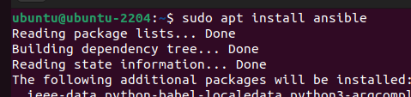

1. Check ansible version as : (ansible –version)

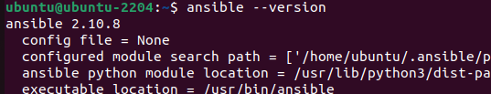

1. Create a directory



1. Create ansible file as:

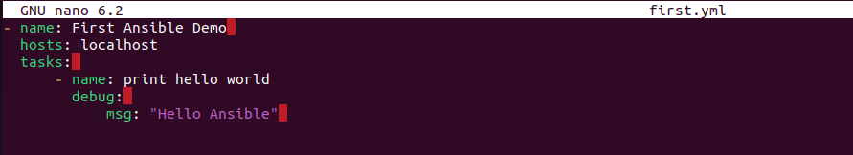

1. Exit from editor by pressing Ctlr+o, Enter and then Ctrl+x
2. You can view the file content using cat command

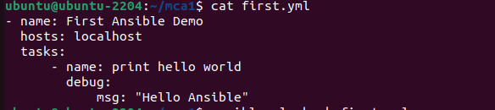

1. Update the above file and run it to display Ubuntu details.

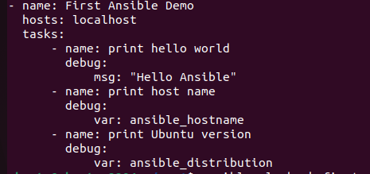

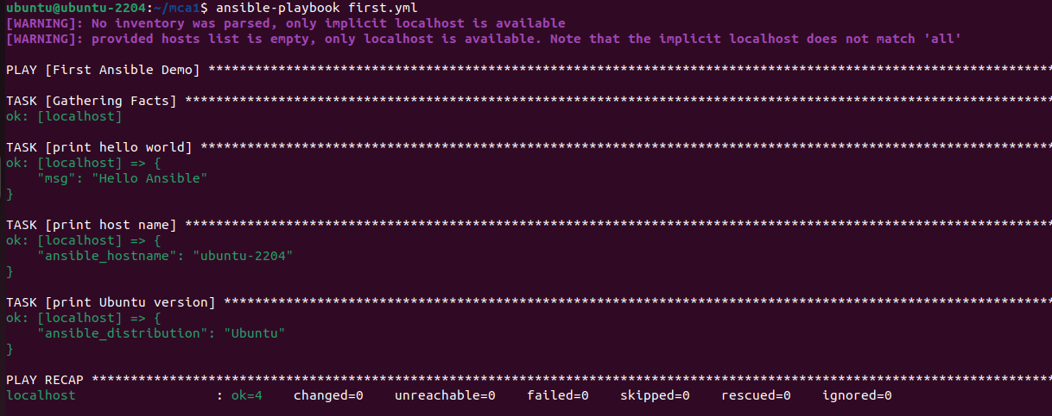

Install and run apache using Playbook as:

1. Creating simple yml for apache

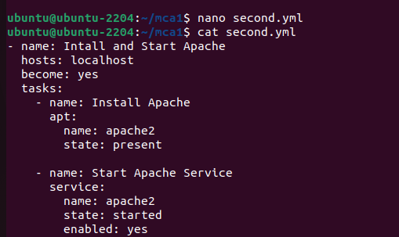

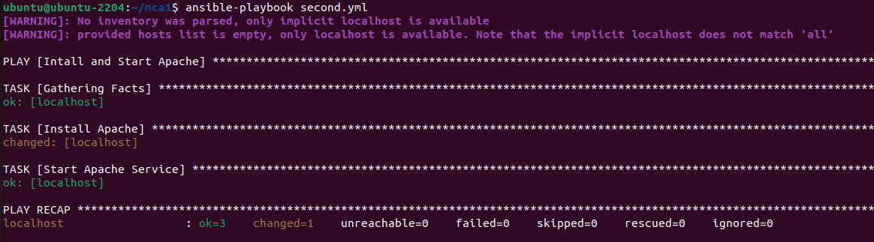

1. Checking apache details using following command:

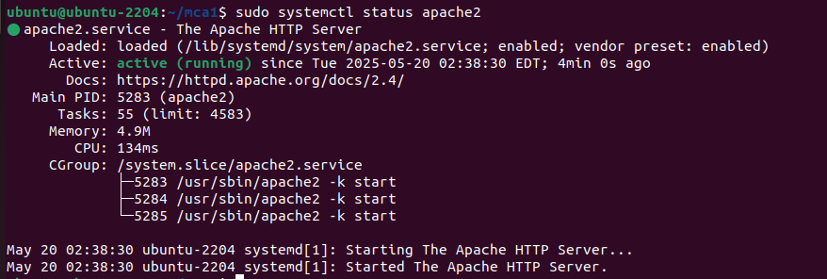

Playbook for infrastructure as code: (Running HTML file)

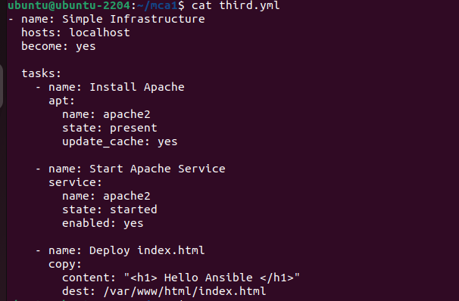

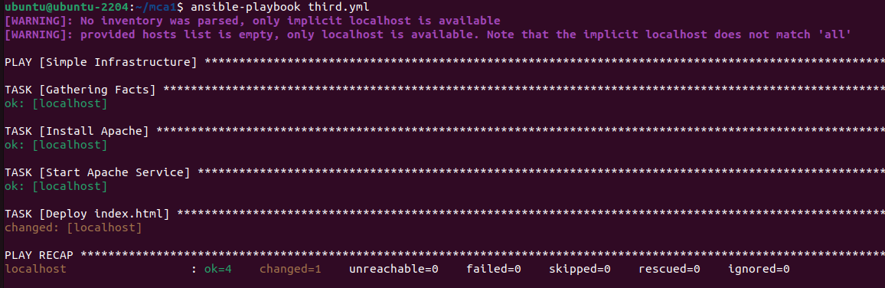

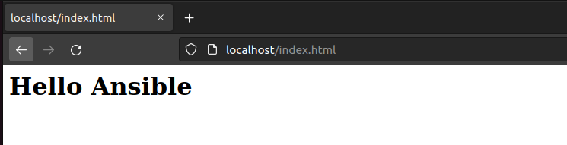

Playbook for Application Deployment (Running PHP file)

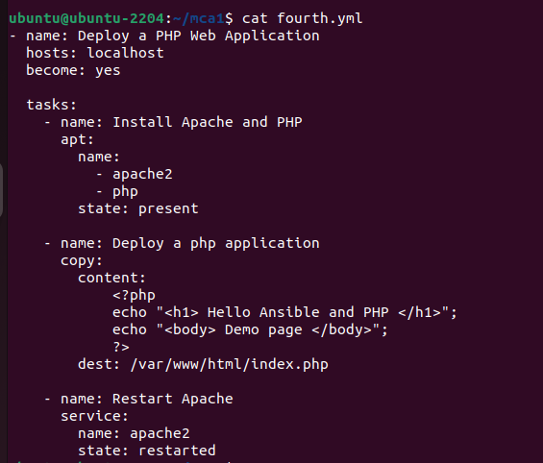

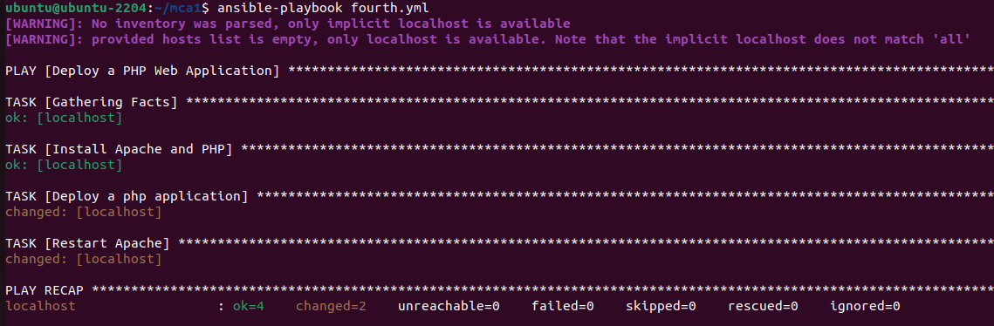

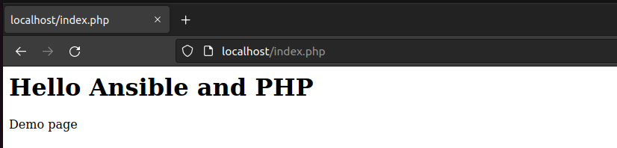

Playbook for running Java file:

Install jdk and jre by using the following commands:

sudo apt install openjdk-21-jdk-headless

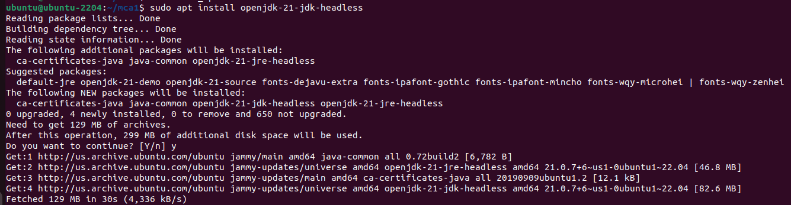

sudo apt install openjdk-21-jre-headless

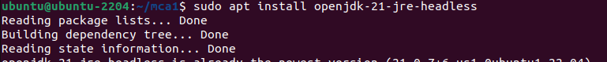

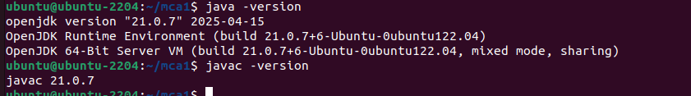

Running java Program

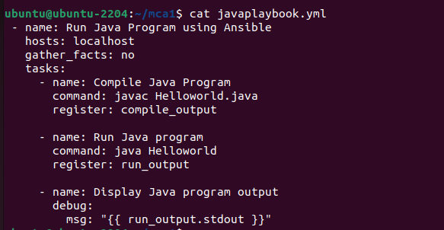

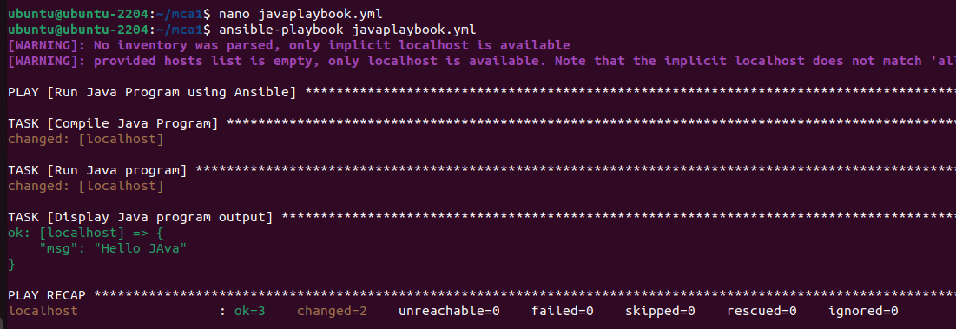

Pull Demo

