- Go to First account and select the repository you want to fork and click on the fork option.
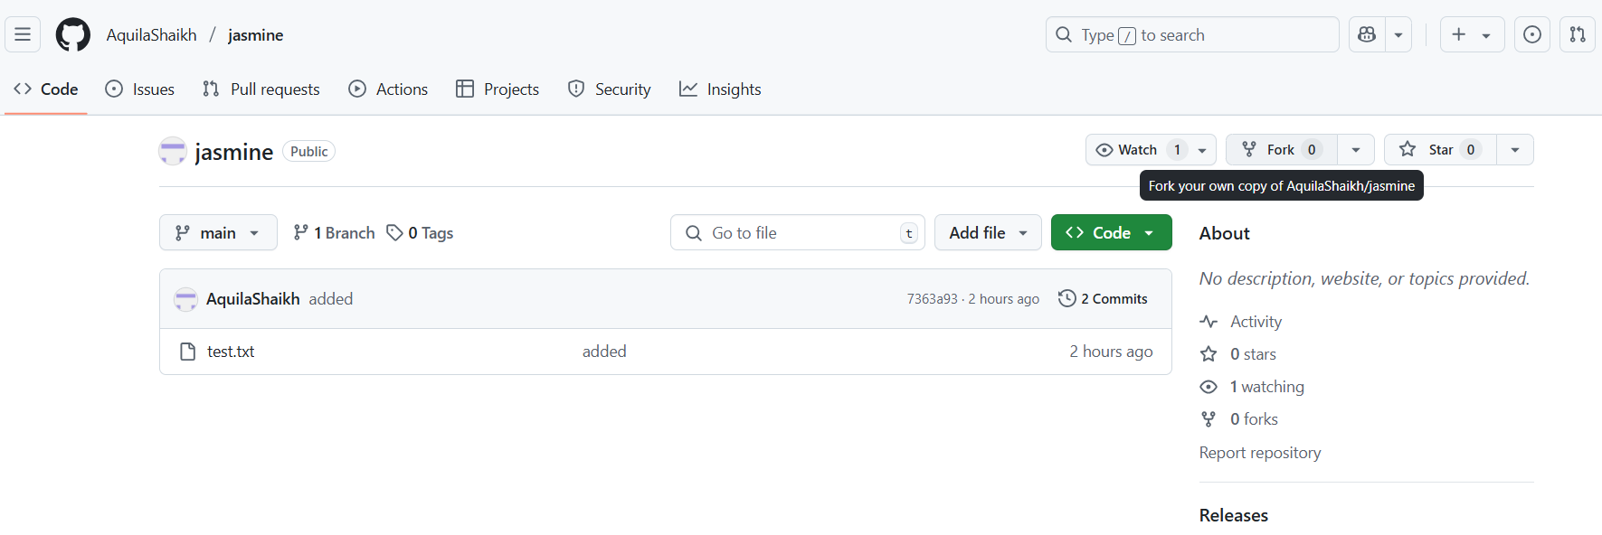
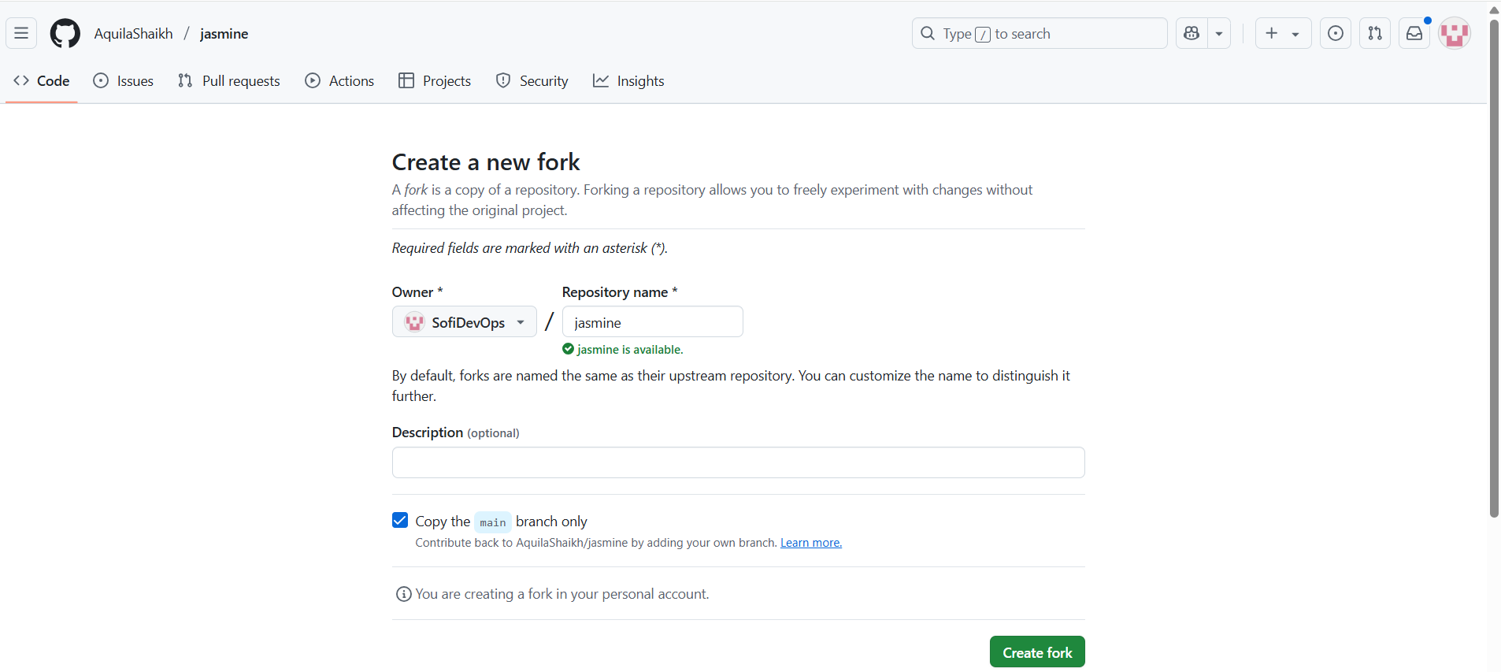
- Click on the fork option.
- Now you will be able to see that forked repository in your second account.
- Clone that forked repository in any folder, say “DemoFork”
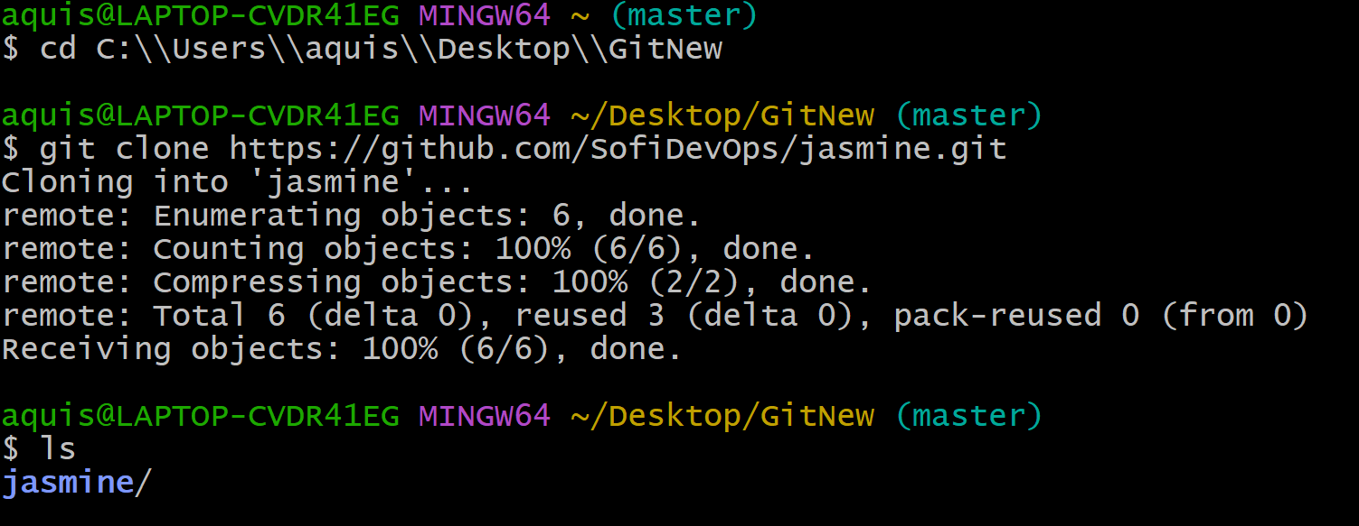
- You will be able to see the reposotory in your folder.

- Check the file present in your repository.
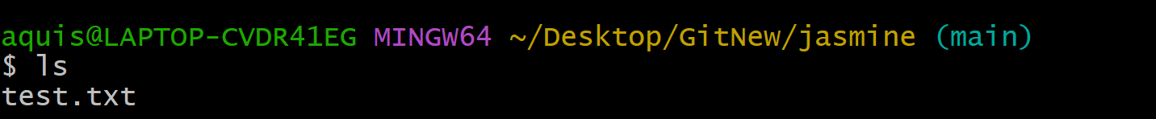
And content of your file.
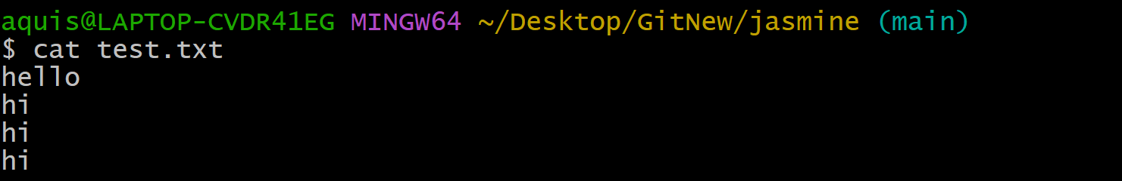
- Modify your file and check the status.
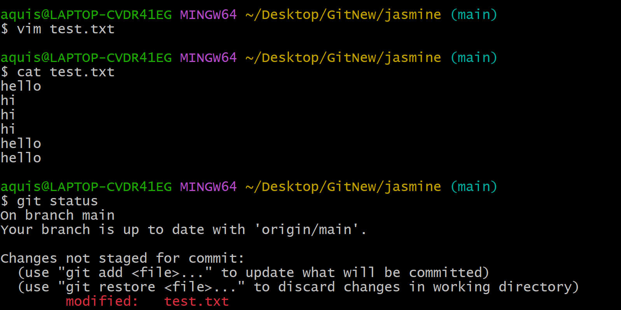
- Check origin and remove it.
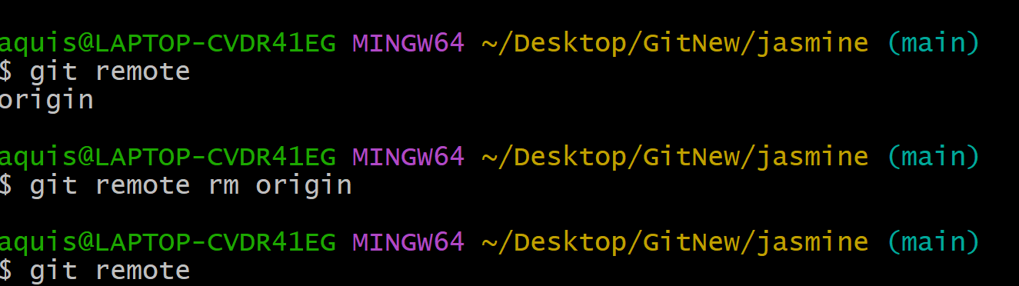

- Perform add and commit. Check the status.
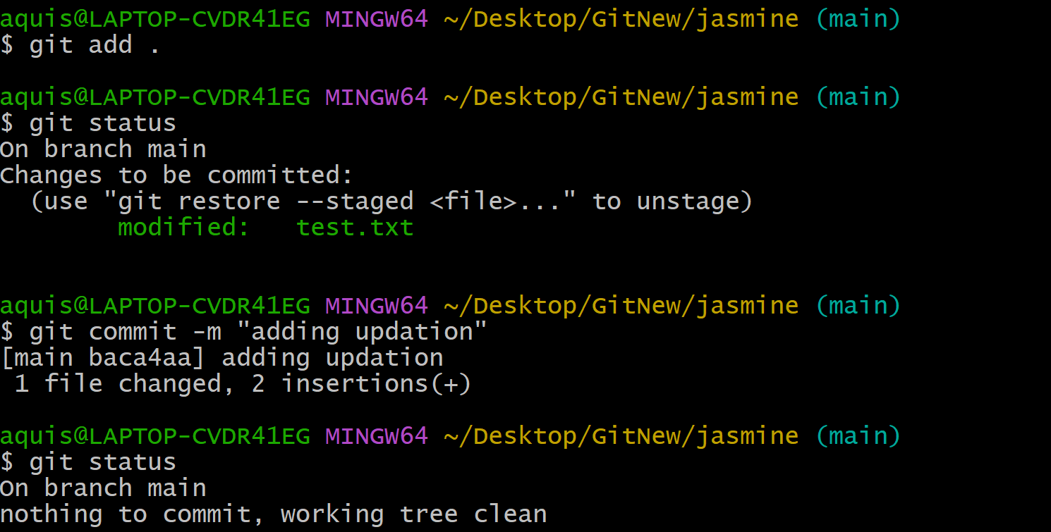
- Add your repository to the remote origin.
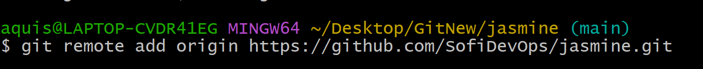
- Go to your profile and create token to set url
Profile→ Settings→
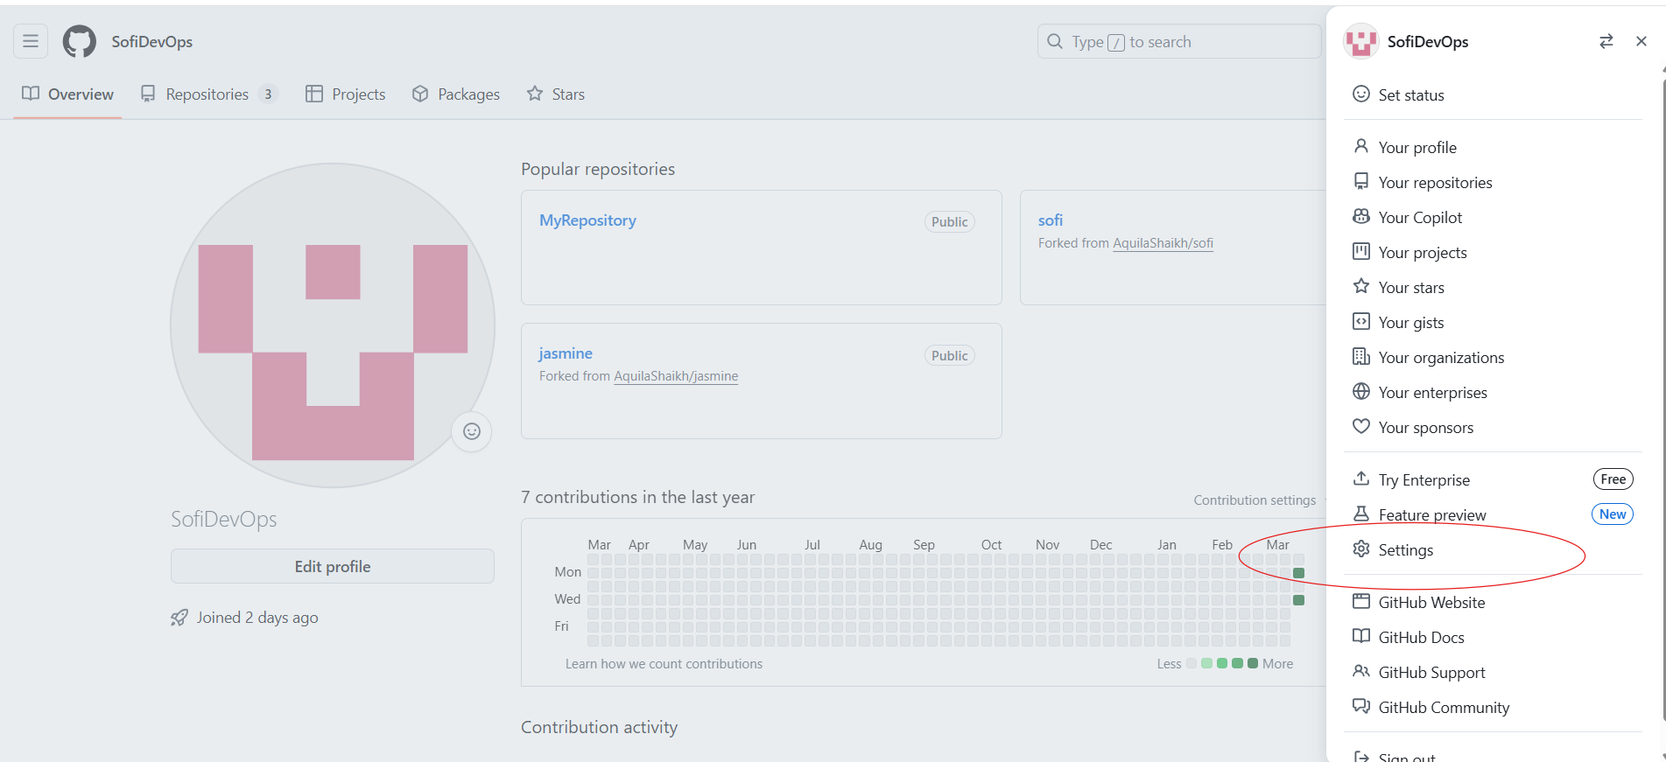
- Developer Settings
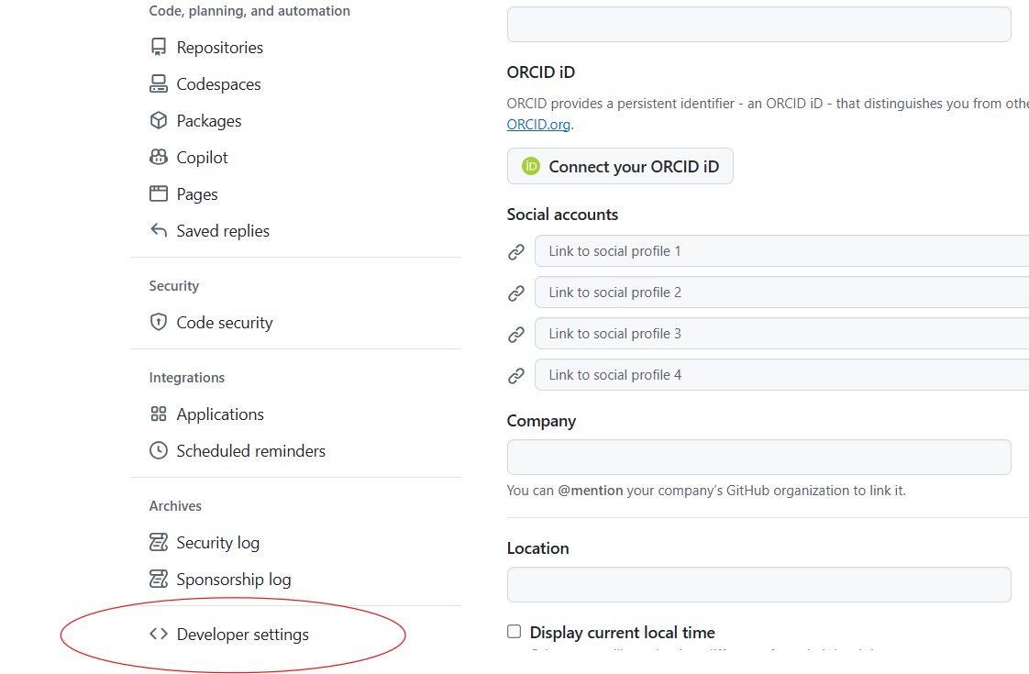
→Personal access tokens→Tokens(Classic)
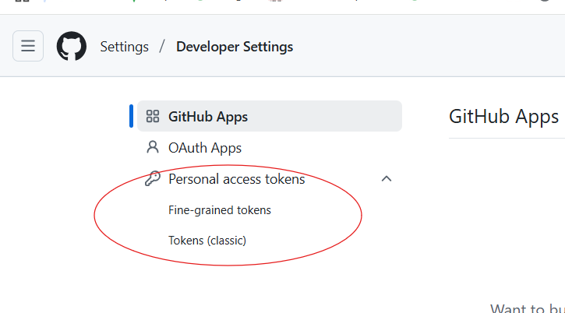
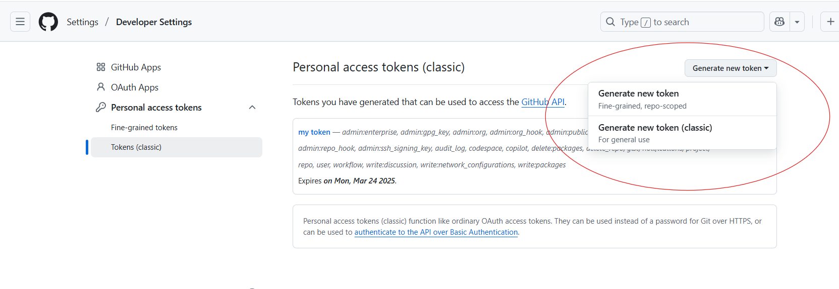
→It will ask you for authentication→ Perform Authentication
→ You can set expiration date of your token
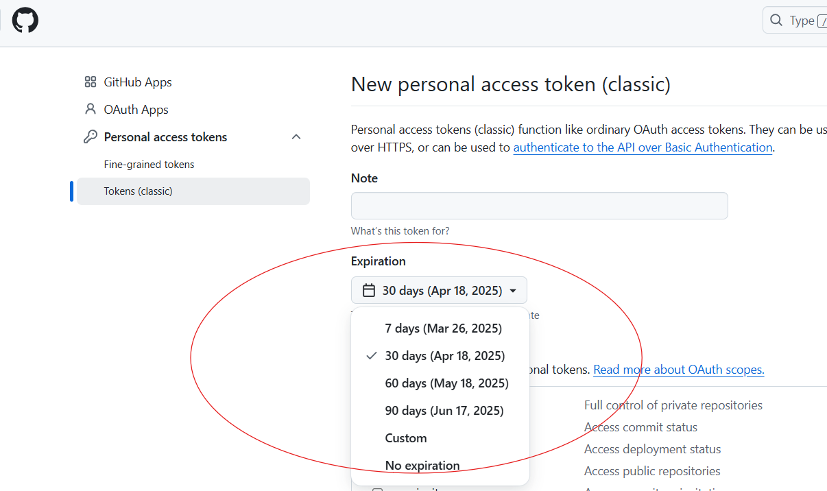

→you can also select “custom”.
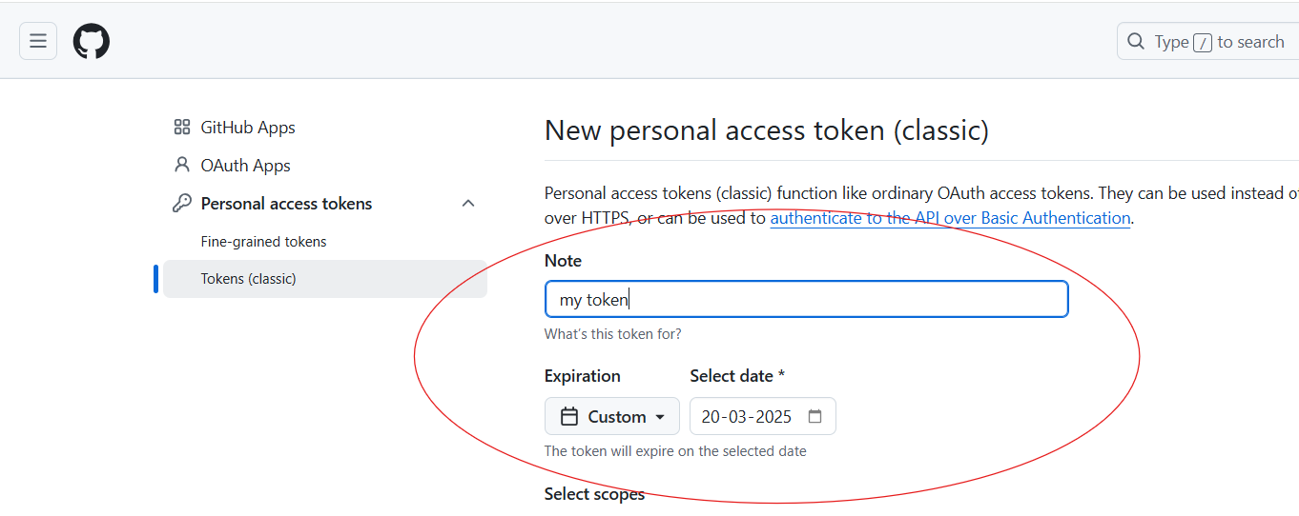
→Select all the scopes for your token.
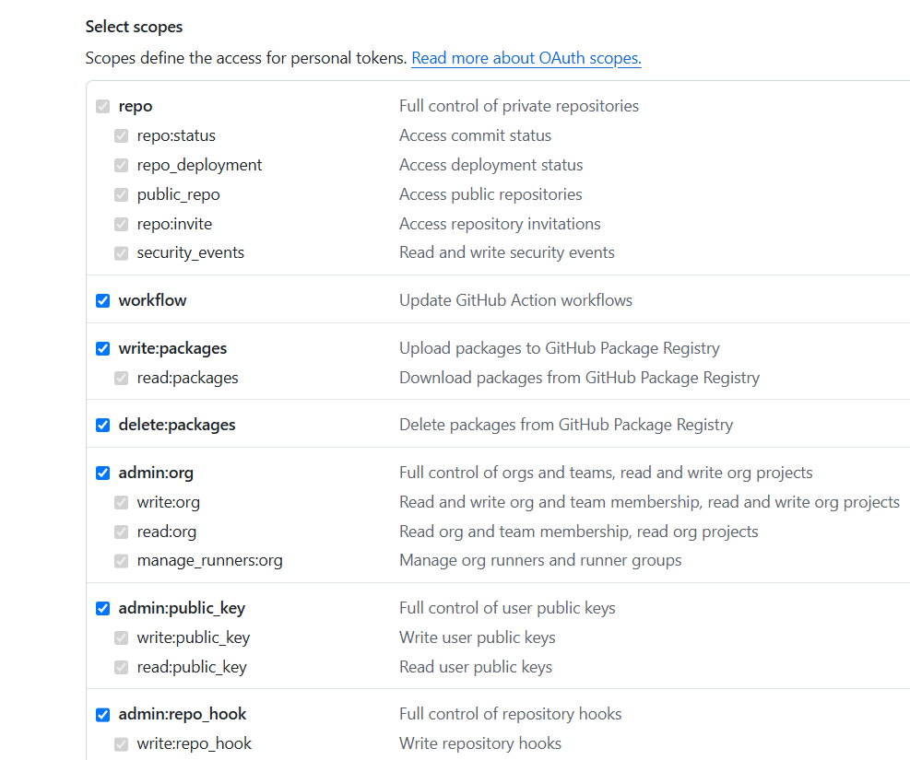
→Click on “Generate Token”
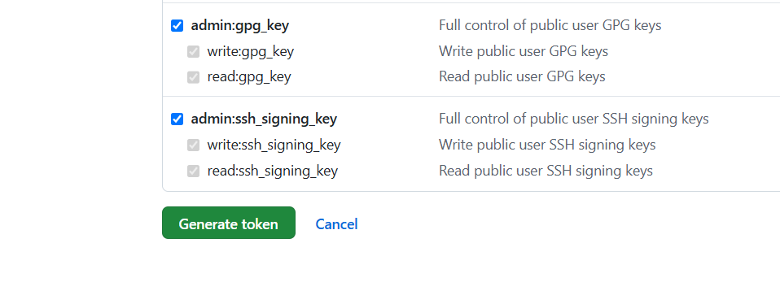
→Your token has been generated
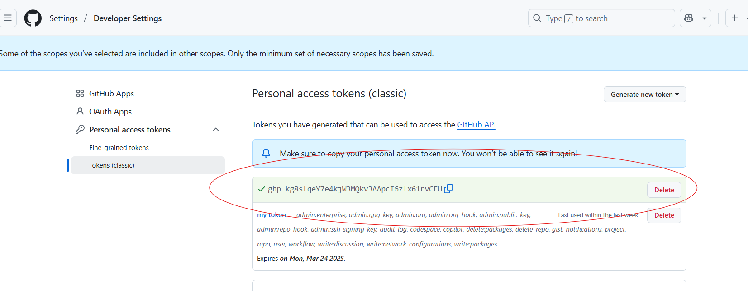
- Set url using generated token.
- Perform “Push” operation on main.
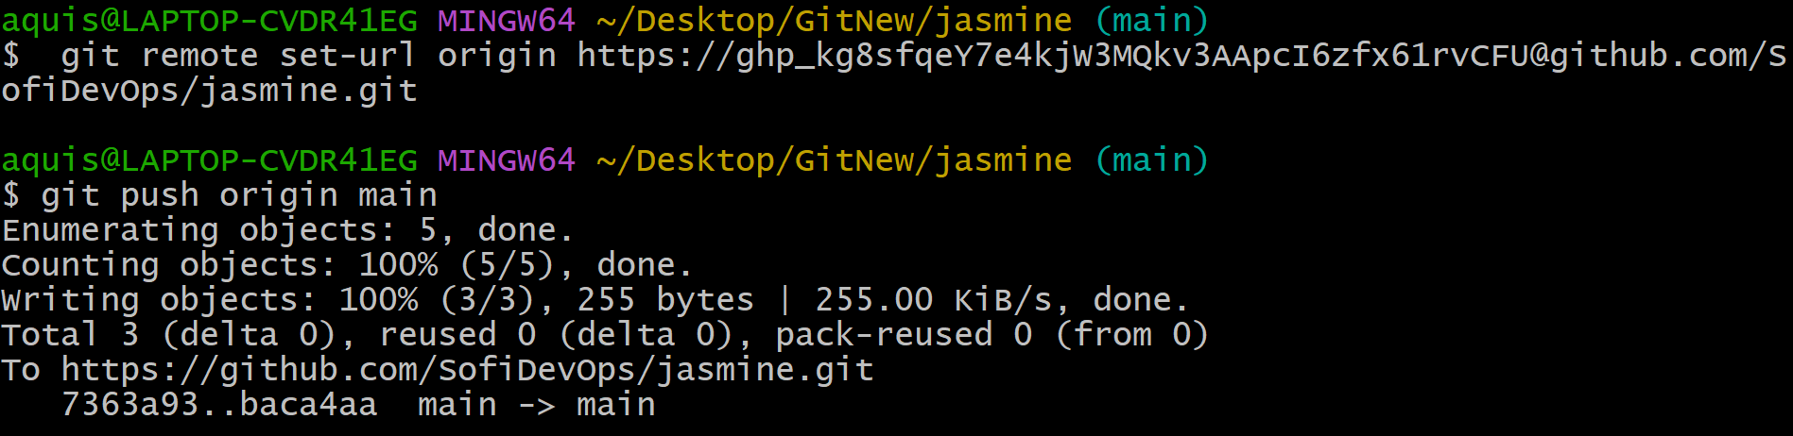
- Refresh your Git hub and check the content of your file.
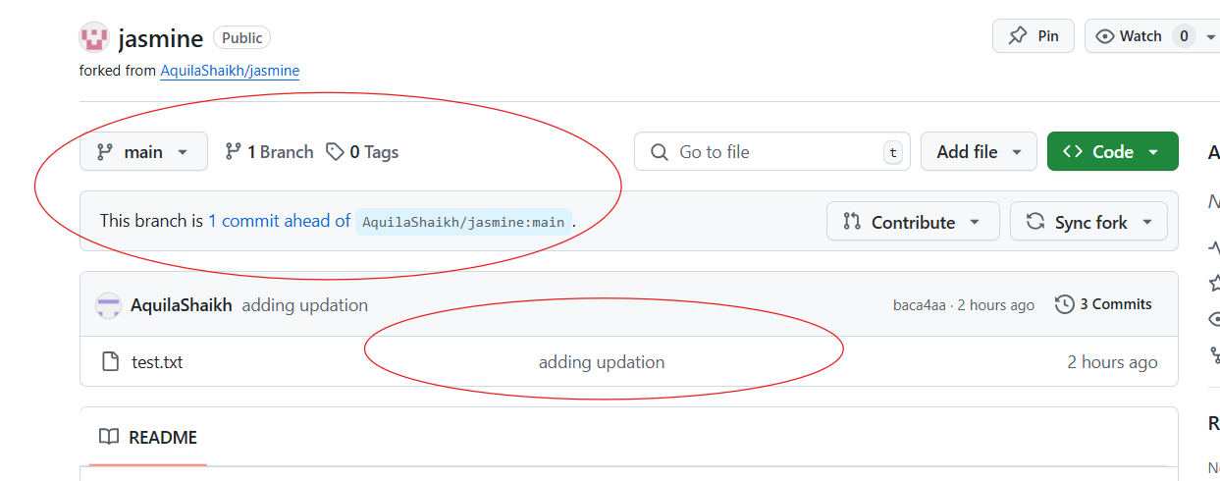
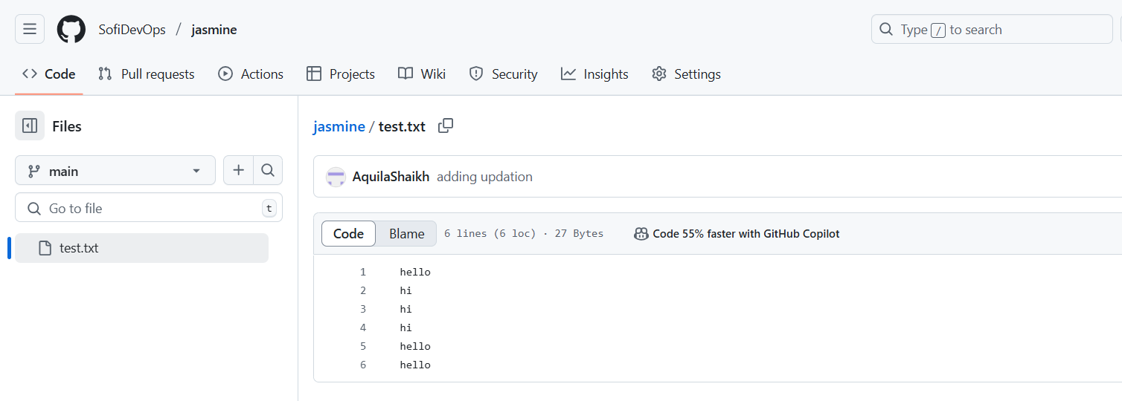
- Create Pull request from second account.
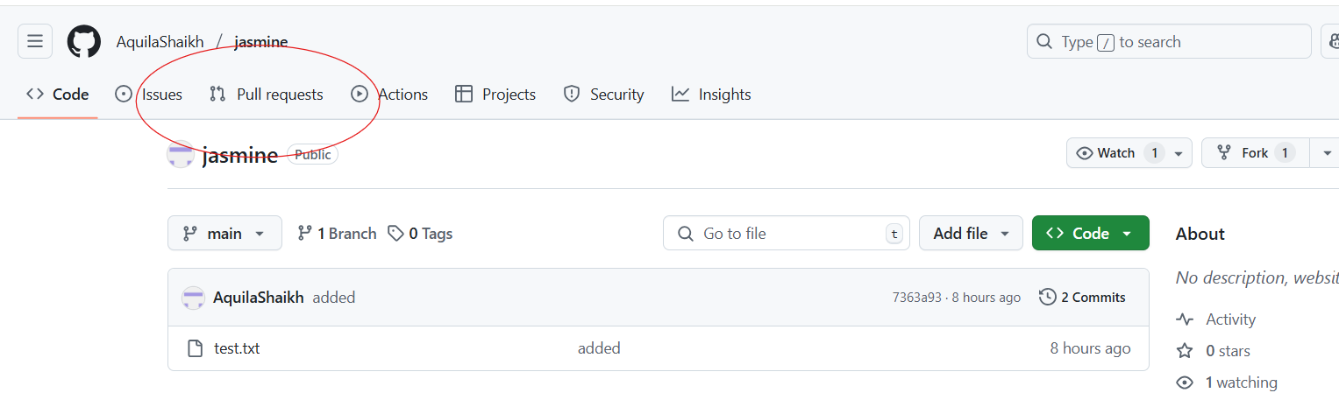
- Click on new Pull request.
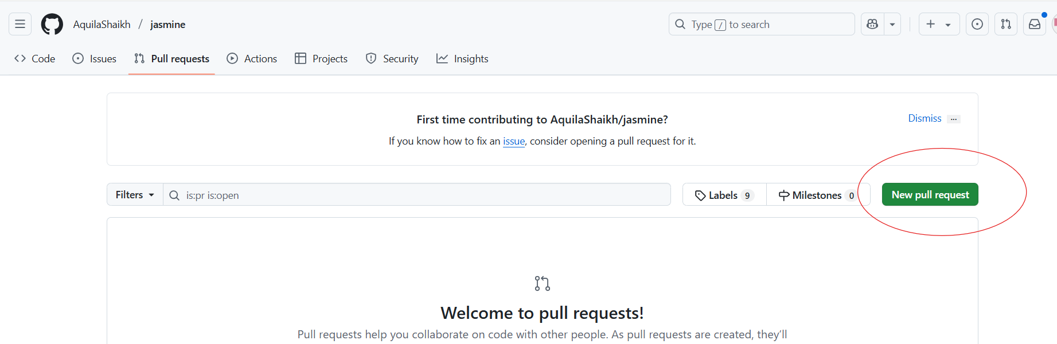
- Select proper branches and repository
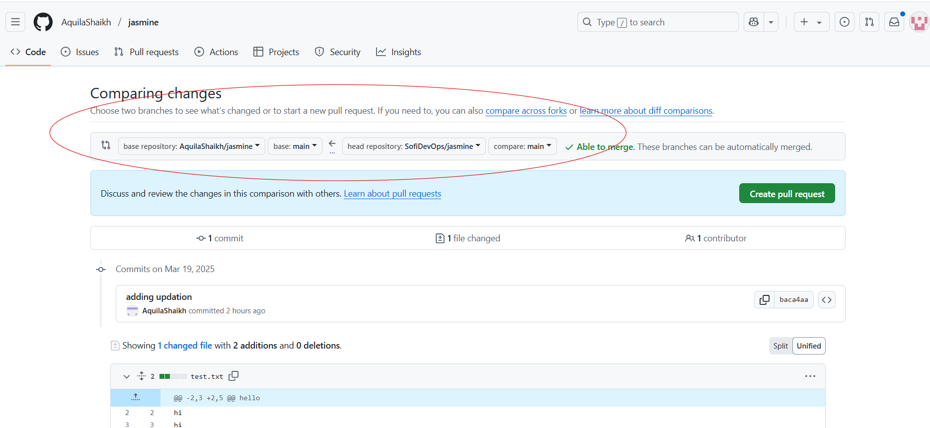
- Create Pull request
- Give title and click on “Create pull request”
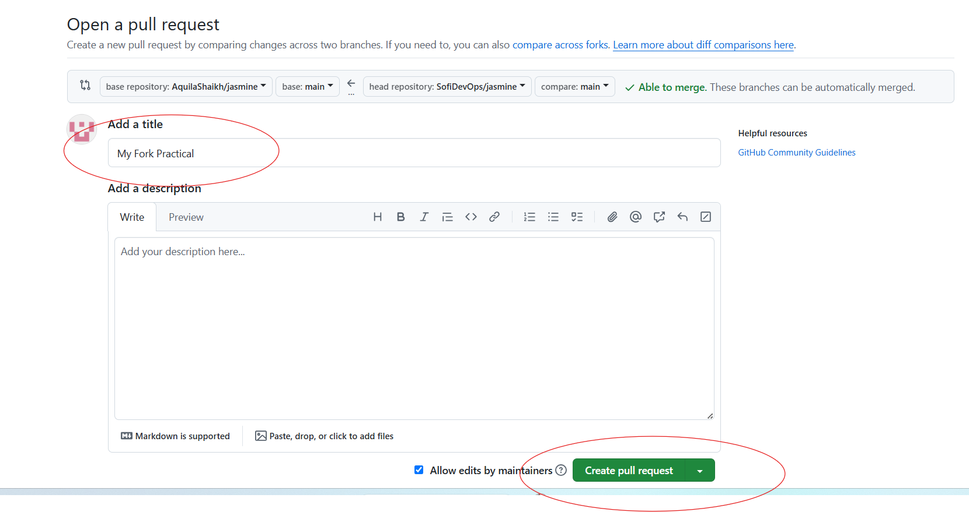
- Your Pull request has been generated.
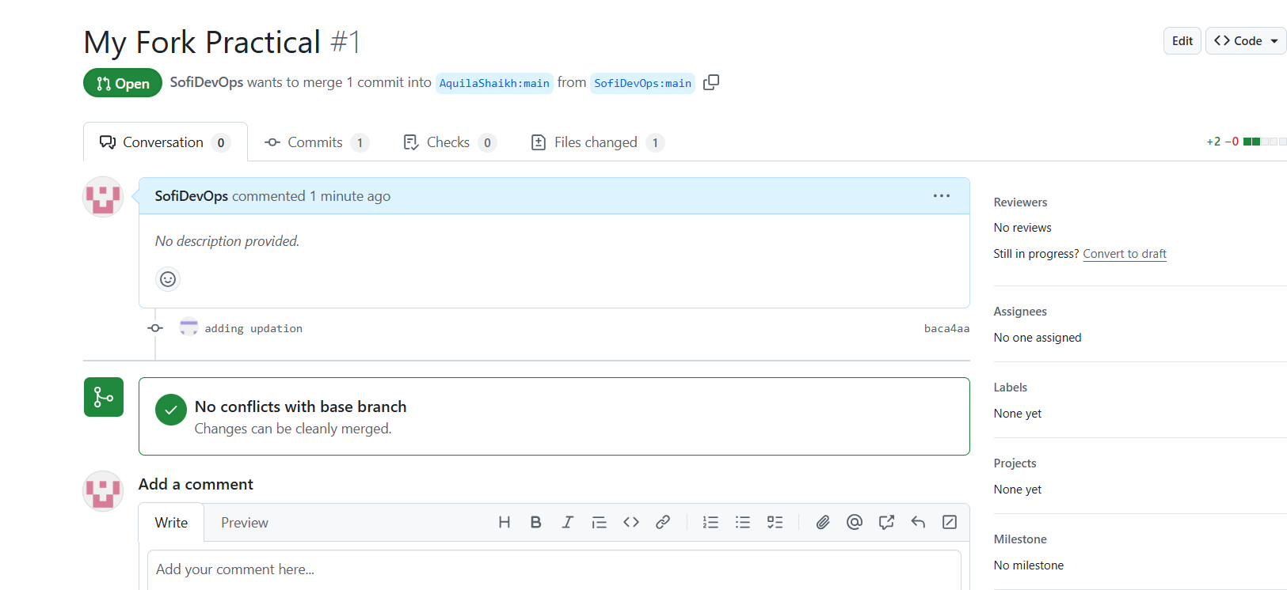
- Check your first accout and repository for Pull request
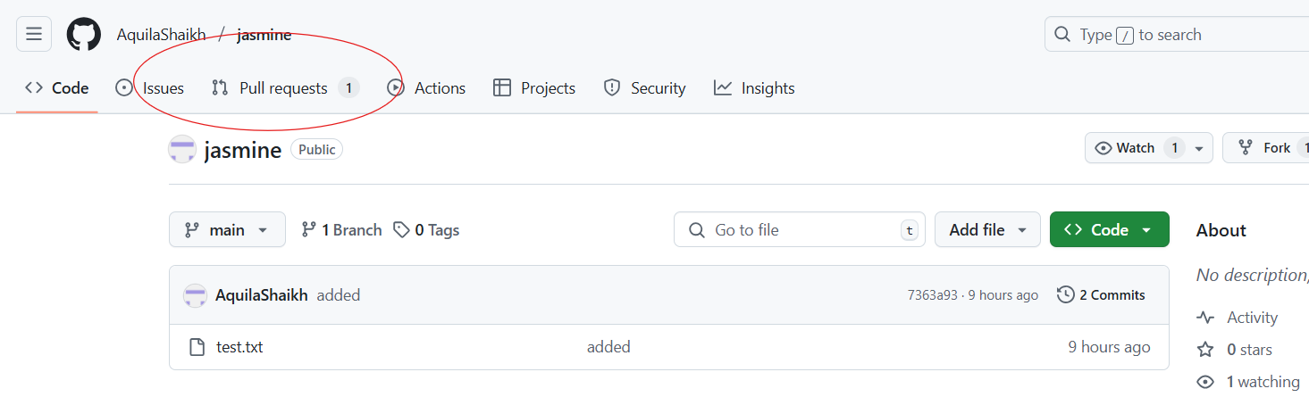
- Click on Merge request.

