- Create a Repository by clicking on “Repository”
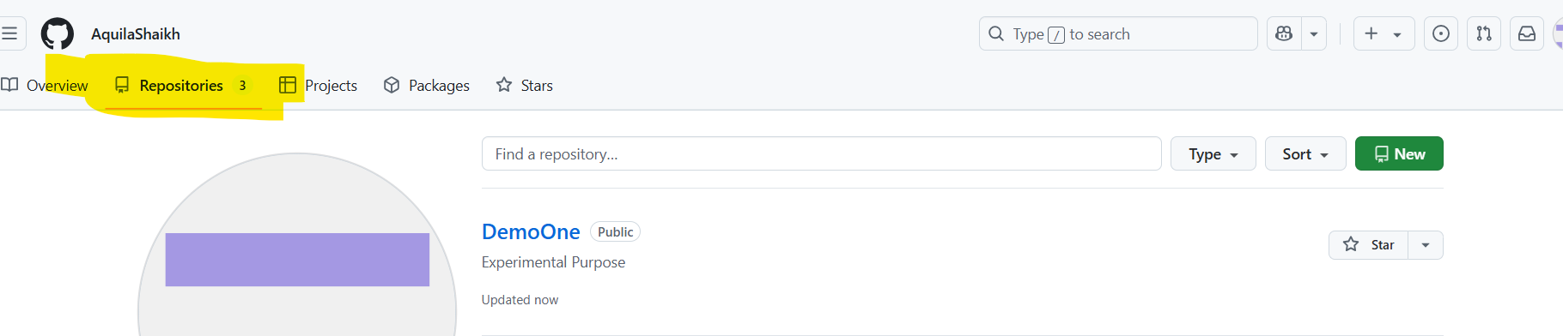
- Upload an existing text from your system.
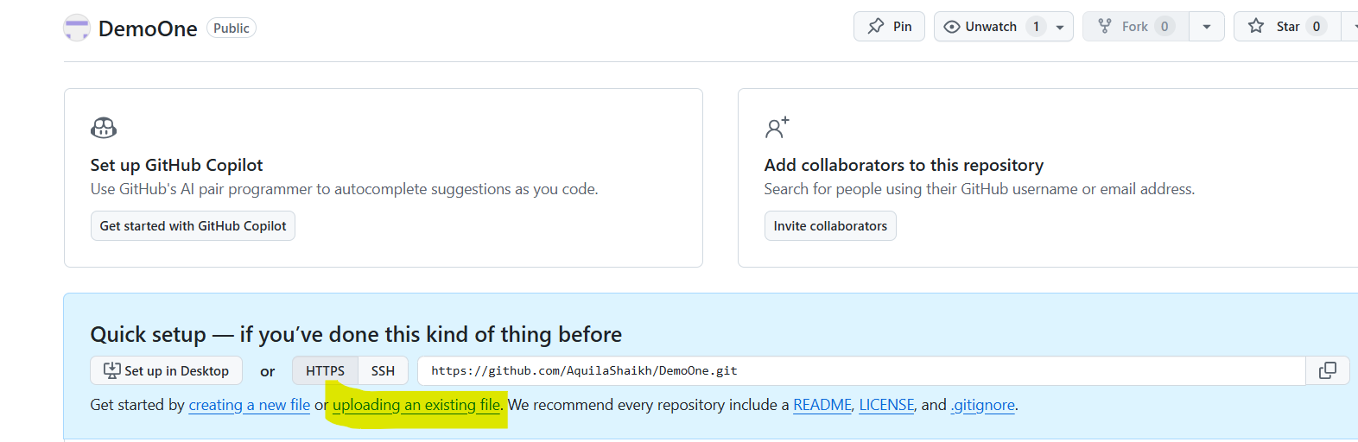
- Choose your file.

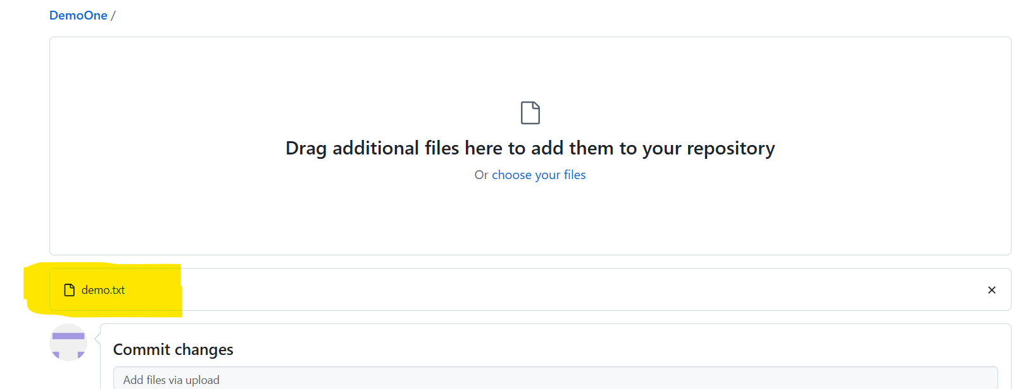
- Click on “Commit changes”
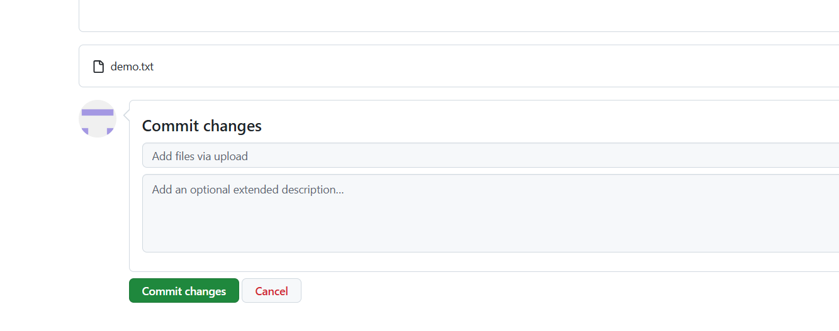

- Your text file has been uploaded in your repository and you will have one file
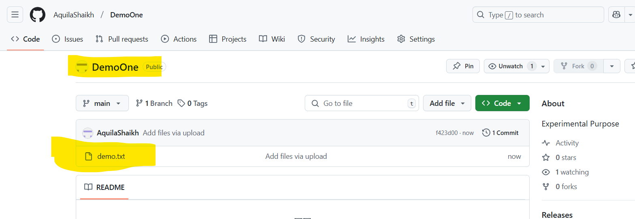
- Click on “Code” and copy the reposiroty link.
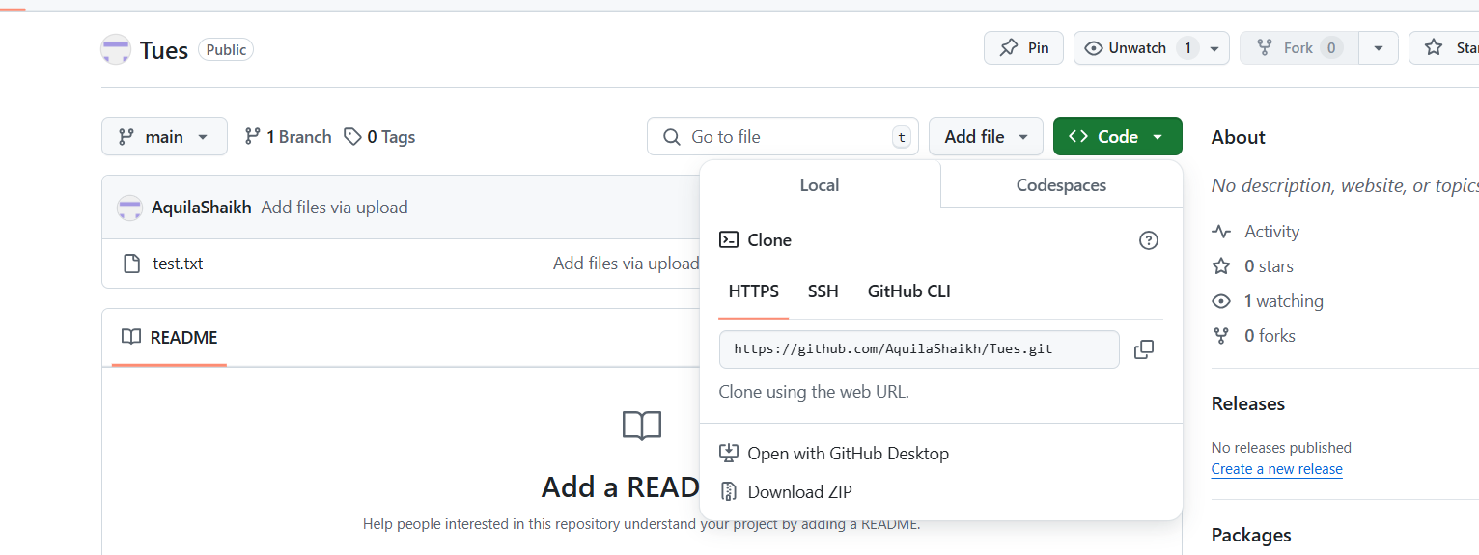
- Go to git bash and clone the repository
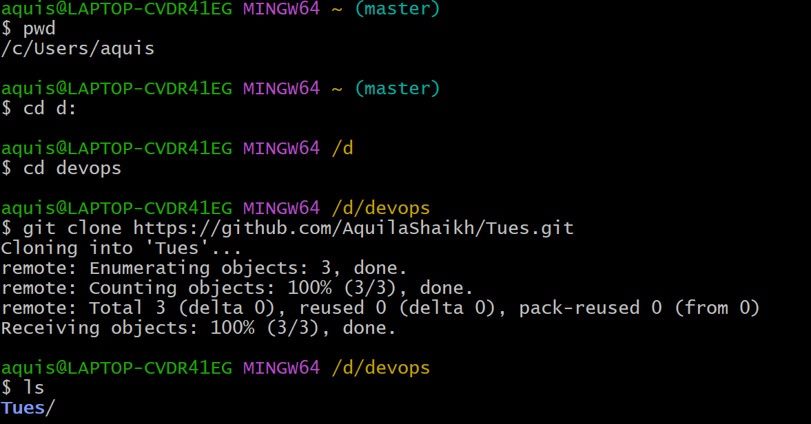

- Go to that Folder that is “Tues”
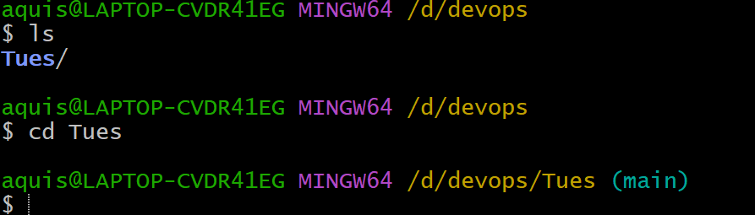

- Now check text file is there in your “Tues” repository
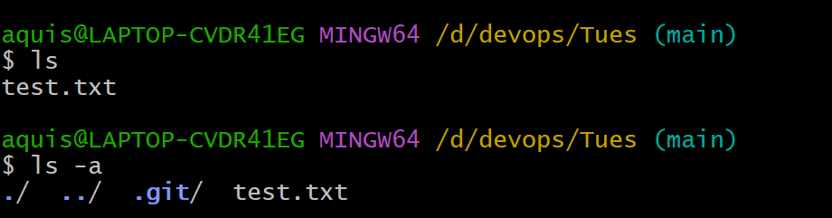

- Git status command tells you the status of your repository.


- Git log → you will see all the commits that have been performed on the particular repository

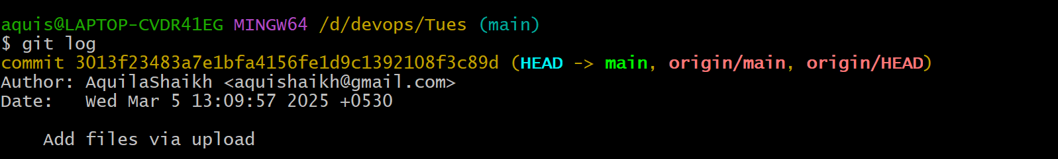

Here it is showing only one commit while uploading that text file.

- Now let us go head and change the content of the file
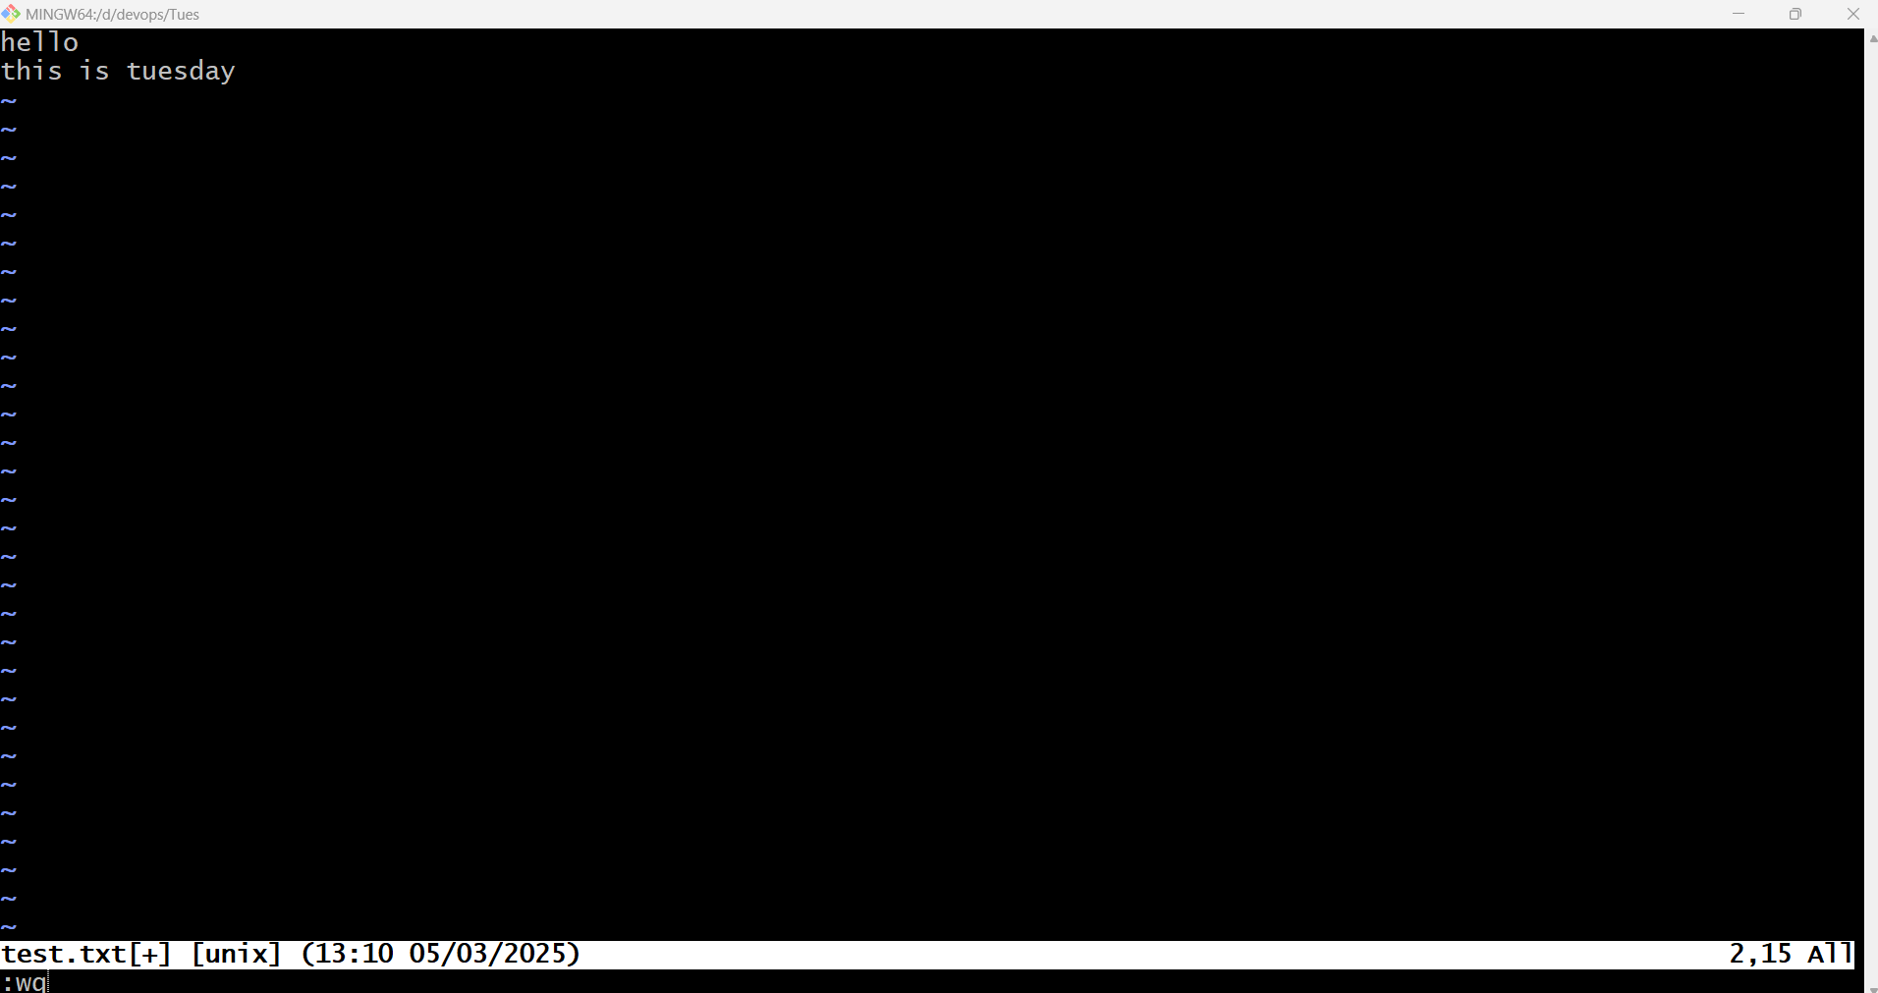

- Now, if check the status then→

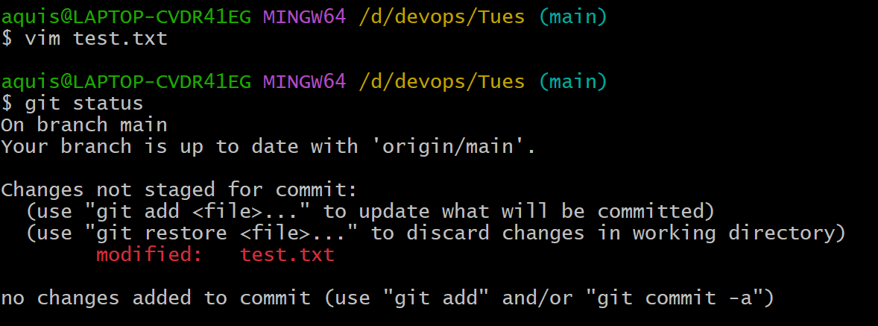
It is showing that the file “test.txt” is in modified state.
- There are 3 states of the file
- Modified
- Satge
- Commit
We cannot directly commit anything from modiefied state.
So we first need to bring the file from modified to stage state.
And for that we need to add that file by using the following command→
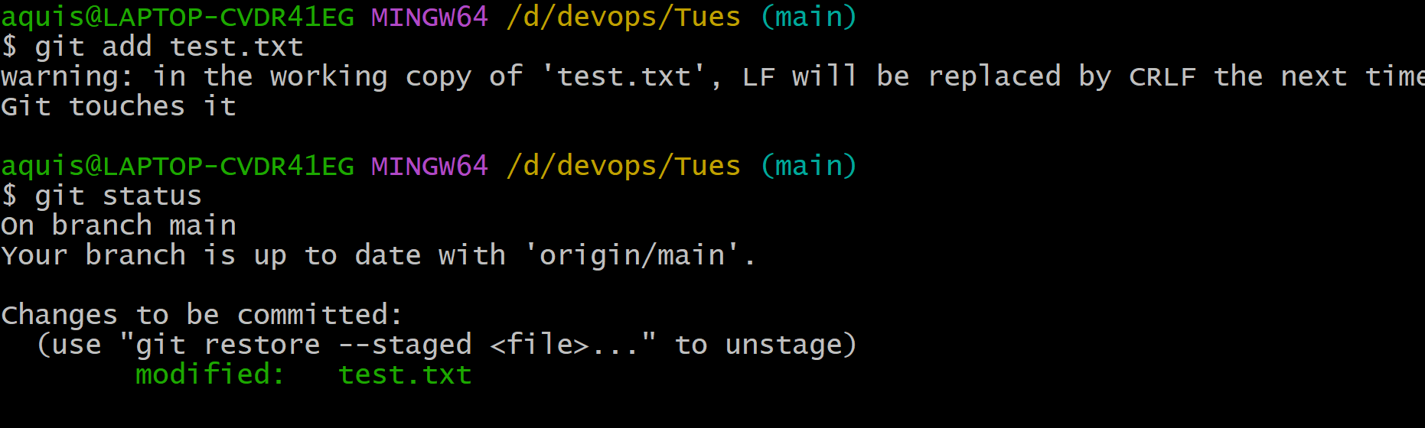
- Now the file is in the Stage state.
We can perform Commit operation→
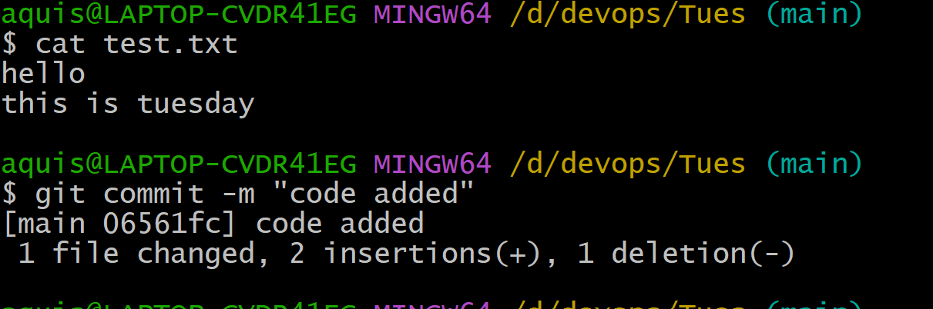

- We can go to git hub page and check →
Still the file is not changed/uploaded
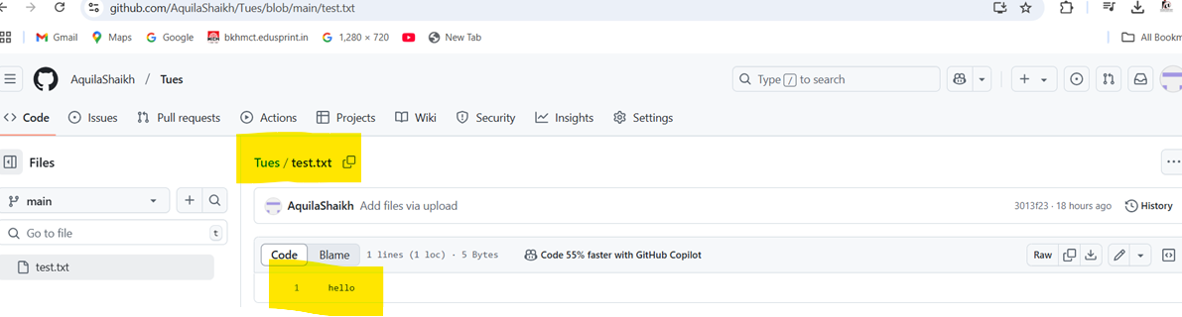
- lets upload the modified file on the Git hub
By using push command→
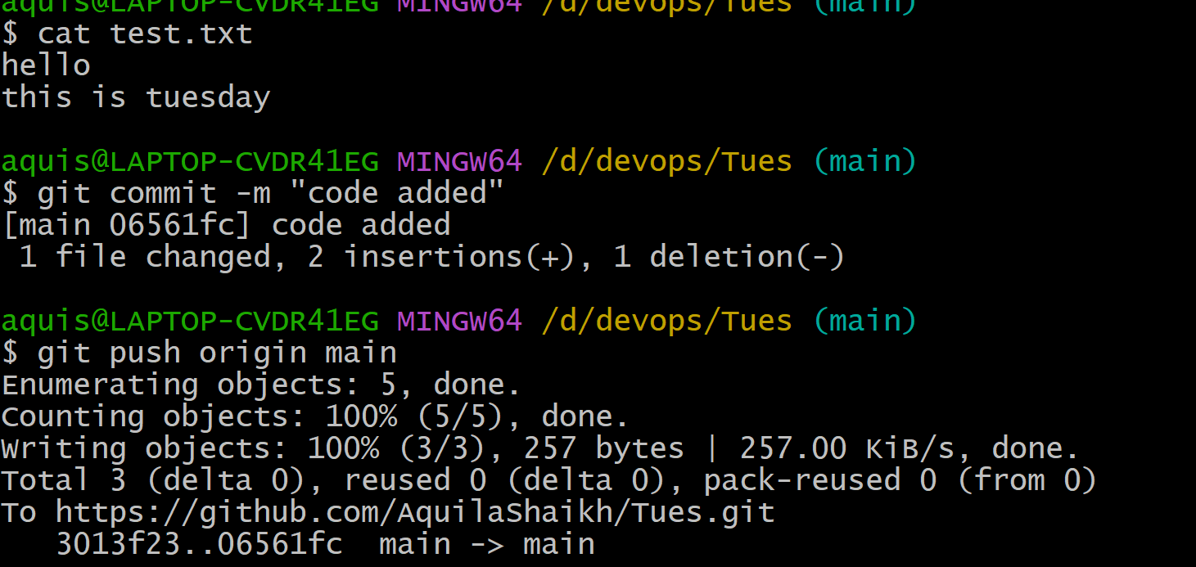

- we can go to git hub and check whether the modified file has been uploaded
