SYMCA Batch: A Lekha M. Naik 202130
Practical No. 04
Programs on Remote Object Communication
Aim: 1) Retrieve the Student Score from the database. (Use Concept of JDBC and RMI)
Code:
InterfaceStud.java
import java.rmi.*;
public interface InterfaceStud extends Remote
{
public double findScore(String name)throws RemoteException;
}
DBStud.java
import java.rmi.*;
import java.rmi.server.*;
import java.sql.*;
public class DBStud extends UnicastRemoteObject implements InterfaceStud {
private PreparedStatement pstmt;
public DBStud()throws RemoteException
{
super();
initilizeDB();
}
protected void initilizeDB()
{
try{
Class.forName("com.mysql.jdbc.Driver");
System.out.println("driver registered");
Connection conn =
DriverManager.getConnection("jdbc:mysql://localhost:3306/symca","root",""); System.out.println("Database connected");
pstmt = conn.prepareStatement("select * from student where Name =?");
}
catch(Exception ex)
{
System.out.println(ex);
} }
public double findScore(String name)throws RemoteException
{
double score = -1;
try
{
pstmt.setString(1,name);
SYMCA Batch: A Lekha M. Naik 202130
ResultSet rs = pstmt.executeQuery();
if(rs.next())
{
score = rs.getDouble(2);}
}
catch(SQLException ex)
{
System.out.println(ex);
}
System.out.println(score);
return score;
}
}
RegisterStud.java
import java.rmi.*;
import java.rmi.registry.*;
public class RegisterStud
{
public static void main(String[] agrs)
{
try
{
DBStud obj = new DBStud();
Registry reg = LocateRegistry.getRegistry();
Naming.rebind("DBStud",obj);
}
catch(Exception e)
{ }
}
}
ClientStud.java
import java.rmi.*;
import javax.swing.*;
import java.awt.*;
import java.awt.event.*;
public class ClientStud extends JApplet
{
private InterfaceStud student;
private JButton getScore = new JButton("GetSocre");
private JTextField name = new JTextField();
private JTextField tfscore = new JTextField();
private JLabel lname = new JLabel("Student");
SYMCA Batch: A Lekha M. Naik 202130
private JLabel lscore = new JLabel("Score");
public void init()
{
try
{
student = (InterfaceStud)Naming.lookup("DBStud");
}
catch(Exception e)
{
}
JPanel panel = new JPanel();
panel.setLayout(null);
lname.setBounds(15, 15, 75, 33);
panel.add(lname);
name.setBounds(95, 15, 150, 33);
panel.add(name);
lscore.setBounds(15, 65, 75, 33);
panel.add(lscore);
tfscore.setBounds(95, 65, 150, 33);
panel.add(tfscore);
getScore.setBounds(95, 130, 150, 33);
panel.add(getScore, BorderLayout.CENTER);
add(panel,BorderLayout.CENTER);
getScore.addActionListener(new ActionListener()
{
public void actionPerformed(ActionEvent ae)
{
getScore();
}
}
);
}
public void getScore()
{
try
{
double score = student.findScore(name.getText());
SYMCA Batch: A Lekha M. Naik 202130
if(score<0)
tfscore.setText("Not Found");
else
tfscore.setText(""+score);
}
catch(Exception ex)
{ }
}
public static void main(String[] args)
{
ClientStud applet = new ClientStud();
JFrame frame = new JFrame();
frame.setTitle("Class Result");
frame.add(applet,BorderLayout.CENTER);
frame.setSize(300,250);
applet.init();
frame.setVisible(true);
} }
Output:
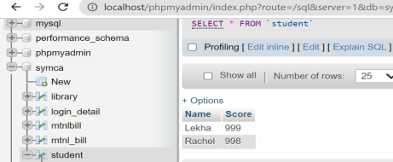
SYMCA Batch: A Lekha M. Naik 202130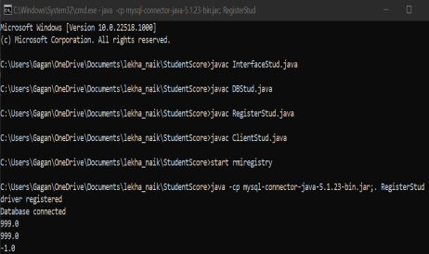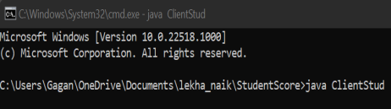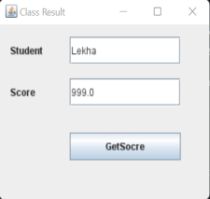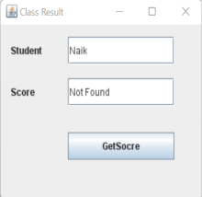
SYMCA Batch: A Lekha M. Naik 202130
Practical No. 04
Programs on Remote Object Communication
Aim: 2) Using MySQL create Library database. Create table Book (Book_id, Book_name, Book_author) and retrieve the Book information from Library database using Remote Object Communication concept.
Code:
InterfaceLib.java
import java.rmi.*;
public interface InterfaceLib extends Remote
{
public String[] findInfo(String id)throws RemoteException;
}
ImplLib.java
import java.rmi.*;
import java.rmi.server.*;
import java.sql.*;
public class ImplLib extends UnicastRemoteObject implements InterfaceLib
{
int find = 0;
String info[];
public ImplLib()throws RemoteException
{
super();
}
public String[] findInfo(String id)throws RemoteException
{
try
{
Class.forName("com.mysql.jdbc.Driver");
System.out.println("Driver Registered");
Connection conn =
DriverManager.getConnection("jdbc:mysql://localhost:3306/library","root",""); System.out.println("Database connected");
Statement stmt = conn.createStatement();
String str = "select * from Book where Book_id='"+id+"'";
ResultSet rs = stmt.executeQuery(str);
while(rs.next())
{
find++;
}
info = new String[find];
ResultSet rst = stmt.executeQuery(str);
for(int i = 0; i < find; i++)
SYMCA Batch: A Lekha M. Naik 202130
{
rst.next();
info[i] = "Result:\n \n ID: "+rst.getString(1)+"\n \n
Book Name: "+rst.getString(2)+"\n \n Author: "+rst.getString(3);
System.out.println(info[i]);
}
}
catch(Exception ex)
{
System.out.println(ex);
}
return info;
}
RegisterLib.java
import java.rmi.*;
import java.rmi.registry.*;
public class RegisterLib
{
public static void main(String[] agrs)
{
try
{
ImplLib obj = new ImplLib();
Registry reg = LocateRegistry.getRegistry();
Naming.rebind("ImplLib",obj);
}
catch(Exception e)
{}
}
}
ClientLib.java
import java.rmi.*;
import javax.swing.*;
import java.awt.*;
import java.awt.event.*;
public class ClientLib extends JApplet
{
private InterfaceLib library;
private JButton getDetail = new JButton("Get Detail");
private JTextField name = new JTextField();
private JLabel lname = new JLabel("Book");
private JLabel result = new JLabel("Result");
SYMCA Batch: A Lekha M. Naik 202130
public void init()
{
try
{
library = (InterfaceLib)Naming.lookup("ImplLib");
}
catch(Exception e)
{
}
JPanel panel = new JPanel();
panel.setLayout(null);
lname.setBounds(15, 15, 75, 33);
panel.add(lname);
name.setBounds(95, 15, 150, 33);
panel.add(name);
result.setBounds(15, 65, 750, 45);
panel.add(result);
getDetail.setBounds(115, 130, 150, 33);
panel.add(getDetail, BorderLayout.CENTER);
add(panel,BorderLayout.CENTER);
getDetail.addActionListener(new ActionListener()
{
public void actionPerformed(ActionEvent ae)
{
getDetail();
}
}
);
}
public void getDetail()
{
try
{
String[] str = library.findInfo(name.getText());
String r = "";
for(int i = 0; i<str.length; i++)
SYMCA Batch: A Lekha M. Naik 202130
{
r += " \n"+str[i];
System.out.println(str[i]);
}
result.setText(r);
}
catch(Exception ex)
{ }
}
public static void main(String[] args)
{
ClientLib applet = new ClientLib();
JFrame frame = new JFrame();
frame.setTitle("Book Details");
frame.add(applet,BorderLayout.CENTER);
frame.setSize(450,250);
applet.init();
frame.setVisible(true);
} }
Output:
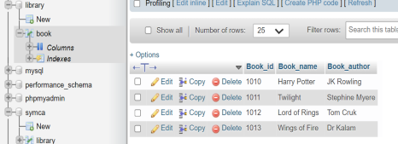
SYMCA Batch: A Lekha M. Naik 202130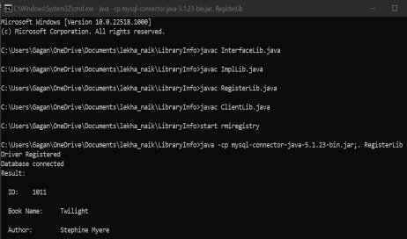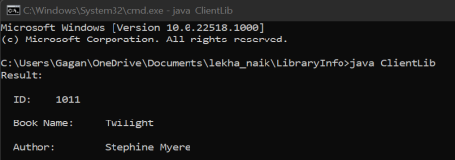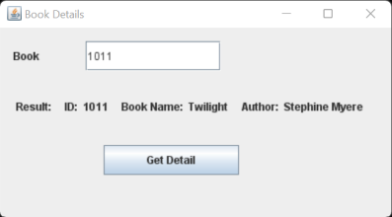
SYMCA Batch: A Lekha M. Naik 202130
Practical No. 04
Programs on Remote Object Communication
Aim: 3) Using MySQL create Elecrtic_Bill database. Create table Bill (consumer_name, bill_due_date, bill_amount) and retrieve the Bill information from the Elecrtic_Bill database using Remote Object Communication concept.
Code:
InterfaceBill.java
import java.rmi.*;
public interface InterfaceBill extends Remote
{
public String[] findBill(String name)throws RemoteException;
}
ImplBill.java
import java.rmi.*;
import java.rmi.server.*;
import java.sql.*;
public class ImplBill extends UnicastRemoteObject implements InterfaceBill {
int find = 0;
String info[];
public ImplBill()throws RemoteException
{
super();
}
public String[] findBill(String name)throws RemoteException
{
try
{
Class.forName("com.mysql.jdbc.Driver");
System.out.println("Driver Registered");
Connection conn =
DriverManager.getConnection("jdbc:mysql://localhost:3306/elecrtic_bill","root",""); System.out.println("Database connected");
Statement stmt = conn.createStatement();
String str = "select * from Bill where consumer_name='"+name+"'";
ResultSet rs = stmt.executeQuery(str);
while(rs.next())
{
find++;
}
info = new String[find];
ResultSet rst = stmt.executeQuery(str);
for(int i = 0; i < find; i++)
SYMCA Batch: A Lekha M. Naik 202130
{
rst.next();
info[i] = "Bill:\n \n Customer: "+rst.getString(1)+"\n \n
Due Date: "+rst.getString(2)+"\n \n Amount: Rs."+rst.getString(3); System.out.println(info[i]);
}
}
catch(Exception ex)
{
System.out.println(ex);
}
return info;
} }
RegisterBill.java
import java.rmi.*;
import java.rmi.registry.*;
public class RegisterBill
{
public static void main(String[] agrs)
{
try
{
ImplBill obj = new ImplBill();
Registry reg = LocateRegistry.getRegistry();
Naming.rebind("ImplBill",obj);
}
catch(Exception e)
{}
}
}
ClientBill.java
import java.rmi.*;
import javax.swing.*;
import java.awt.*;
import java.awt.event.*;
public class ClientBill extends JApplet
{
private InterfaceBill electric;
private JButton getBill = new JButton("Get Bill");
private JTextField name = new JTextField();
private JLabel lname = new JLabel("Customer");
private JLabel result = new JLabel("Bill");
SYMCA Batch: A Lekha M. Naik 202130
public void init()
{
try
{
electric = (InterfaceBill)Naming.lookup("ImplBill");
}
catch(Exception e)
{ }
JPanel panel = new JPanel();
panel.setLayout(null);
lname.setBounds(15, 15, 75, 33);
panel.add(lname);
name.setBounds(95, 15, 150, 33);
panel.add(name);
result.setBounds(15, 65, 750, 45);
panel.add(result);
getBill.setBounds(115, 130, 150, 33);
panel.add(getBill, BorderLayout.CENTER);
add(panel,BorderLayout.CENTER);
getBill.addActionListener(new ActionListener()
{
public void actionPerformed(ActionEvent ae)
{
getBill();
}
} );
}
public void getBill()
{
try
{
String[] str = electric.findBill(name.getText());
String r = "";
for(int i = 0; i<str.length; i++)
{
r += " \n"+str[i];
System.out.println(str[i]);
SYMCA Batch: A Lekha M. Naik 202130
}
result.setText(r);
}
catch(Exception ex)
{ }
}
public static void main(String[] args)
{
ClientBill applet = new ClientBill();
JFrame frame = new JFrame();
frame.setTitle("Bill Details");
frame.add(applet,BorderLayout.CENTER);
frame.setSize(450,250);
applet.init();
frame.setVisible(true);
} }
Output:
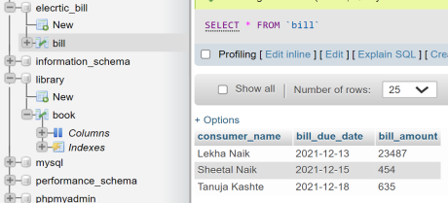
SYMCA Batch: A Lekha M. Naik 202130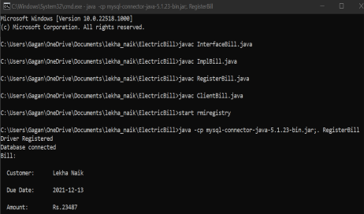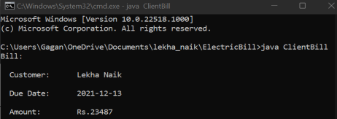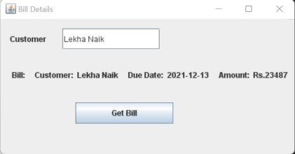
SYMCA Batch: A Lekha M. Naik 202130
Practical No. 05
Program on Mutual Exclusion
Aim: Implementation of Mutual Exclusion using Token Ring technique. Code:
TokenRingServer.java
import java.net.*;
public class TokenRingServer
{
public static DatagramSocket ds;
public static DatagramPacket dp;
public static void main(String[] args)throws Exception
{
ds = new DatagramSocket(2000);
while(true)
{ byte[] buffer = new byte[1024];
dp=new DatagramPacket(buffer,buffer.length);
ds.receive(dp);
String msg=new String(dp.getData(),0,dp.getLength());
System.out.println("Message from:"+msg);
} } }
TokenRingClient1.java
import java.net.*;
import java.io.*;
public class TokenRingClient1
{
public static DatagramSocket ds;
public static DatagramPacket dp;
public static BufferedReader br;
public static void main(String[] args)throws Exception
{
boolean hasToken = true;
ds = new DatagramSocket(2001);
while(true)
{
if(hasToken==true)
{
System.out.println("Do you want to Enter CS? (yes/no): ");
br=new BufferedReader(new InputStreamReader(System.in));
String choice =br.readLine();
if(choice.equalsIgnoreCase("yes"))
{
System.out.println("The Client/Process is ready to Write");
System.out.println("Enter the Message: ");
SYMCA Batch: A Lekha M. Naik 202130
br=new BufferedReader(new
InputStreamReader(System.in));
String msg = "Client1-->"+br.readLine();
dp=new
DatagramPacket(msg.getBytes(),msg.length(),InetAddress.getLocalHost(),2000); ds.send(dp);
System.out.println("Message Sent");
}
else if(choice.equalsIgnoreCase("no"))
{
System.out.println("I am Not ready to Enter the Critical
Section");
String msg1="Token";
dp=new
DatagramPacket(msg1.getBytes(),msg1.length(),InetAddress.getLocalHost(),2002); ds.send(dp);
hasToken=false;
} }
else
{
System.out.println("Waiting for Token");
byte[] buffer = new byte[2048];
dp=new DatagramPacket(buffer,buffer.length);
ds.receive(dp);
String prevProcessMsg=new String(dp.getData(),0,dp.getLength());
System.out.println("PreviousProcessMsg is: "+prevProcessMsg);
if(prevProcessMsg.equals("Token"))
{
hasToken=true;
System.out.println("I have Token now");
}
} } } }
TokenRingClient2.java
import java.net.*;
import java.io.*;
public class TokenRingClient2
{
public static DatagramSocket ds;
public static DatagramPacket dp;
public static BufferedReader br;
public static void main(String[] args)throws Exception
{
boolean hasToken = true;
ds = new DatagramSocket(2002);
while(true)
{
if(hasToken==true)
{
SYMCA Batch: A Lekha M. Naik 202130
System.out.println("Do you want to Enter CS? (yes/no): ");
br=new BufferedReader(new InputStreamReader(System.in));
String choice =br.readLine();
if(choice.equalsIgnoreCase("yes"))
{
System.out.println("The Client/Process is Ready to Write");
System.out.println("Enter the Message: ");
br=new BufferedReader(new
InputStreamReader(System.in));
String msg = "Client1-->"+br.readLine();
dp=new
DatagramPacket(msg.getBytes(),msg.length(),InetAddress.getLocalHost(),2000); ds.send(dp);
System.out.println("Message Sent");
}
else if(choice.equalsIgnoreCase("no"))
{
System.out.println("I am Not Ready to Enter the Critical
Section");
String msg1="Token";
dp=new
DatagramPacket(msg1.getBytes(),msg1.length(),InetAddress.getLocalHost(),2003); ds.send(dp);
hasToken=false;
} }
else
{
System.out.println("Waiting for Token");
byte[] buffer = new byte[2048];
dp=new DatagramPacket(buffer,buffer.length);
ds.receive(dp);
String prevProcessMsg=new String(dp.getData(),0,dp.getLength());
System.out.println("PreviousProcessMsg is "+prevProcessMsg);
if(prevProcessMsg.equals("Token"))
{
hasToken=true;
System.out.println("I have Token now");
}
} }
} }
TokenRingClient3.java
import java.net.*;
import java.io.*;
public class TokenRingClient3
{
public static DatagramSocket ds;
public static DatagramPacket dp;
public static BufferedReader br;
SYMCA Batch: A Lekha M. Naik 202130
public static void main(String[] args)throws Exception
{
boolean hasToken = true;
ds = new DatagramSocket(2003);
while(true)
{
if(hasToken==true)
{
System.out.println("Do you want to Enter CS? (yes/no): ");
br=new BufferedReader(new InputStreamReader(System.in));
String choice =br.readLine();
if(choice.equalsIgnoreCase("yes"))
{
System.out.println("The Client/Process is Ready to Write");
System.out.println("Enter the Message: ");
br=new BufferedReader(new
InputStreamReader(System.in));
String msg = "Client1-->"+br.readLine();
dp=new
DatagramPacket(msg.getBytes(),msg.length(),InetAddress.getLocalHost(),2000); ds.send(dp);
System.out.println("Message Sent");
}
else if(choice.equalsIgnoreCase("no"))
{
System.out.println("I am Not Ready to Enter the Critical
Section");
String msg1="Token";
dp=new
DatagramPacket(msg1.getBytes(),msg1.length(),InetAddress.getLocalHost(),2001); ds.send(dp);
hasToken=false;
} }
else
{
System.out.println("Waiting for Token");
byte[] buffer = new byte[2048];
dp=new DatagramPacket(buffer,buffer.length);
ds.receive(dp);
String prevProcessMsg=new String(dp.getData(),0,dp.getLength());
System.out.println("PreviousProcessMsg is "+prevProcessMsg);
if(prevProcessMsg.equals("Token"))
{
hasToken=true;
System.out.println("I have Token now");
} }
} } }
SYMCA Batch: A Lekha M. Naik 202130
Output:
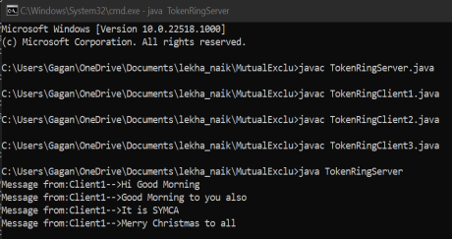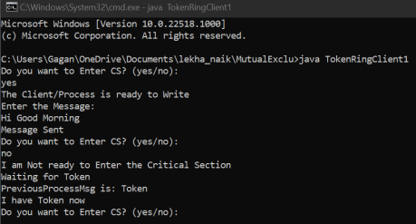
SYMCA Batch: A Lekha M. Naik 202130
SYMCA Batch: A Lekha M. Naik 202130
Practical No. 06
Implementation of Cloud Computing Services
Aim: Implementation of Storage as a Service using Google Docs.
Desciption: Google Docs Editors is a web-based productivity office suite offered by Google within its Google Drive service. The suite includes Google Docs, Google Sheets, Google Slides, Google Drawings, Google Forms, Google Sites, and Google Keep. The Google Docs Editors suite is available freely for users with personal Google accounts: through a web application, a set of mobile apps for Android and iOS, and a desktop application for Google's Chrome OS.
Implementation Steps:
Step 1: In Web Browser Search Bar, write ‘Google Docs Editors Suite’ and press Enter. Following results will be shown, click on below highlighted link for Google Docs.
Step 2: Below page of ‘Google Docs’ will be opened. Click on the ‘Go to Docs’ button.
SYMCA Batch: A Lekha M. Naik 202130
Step 3: Redirection to Google Account ‘Sign In’ page will be done. Log In to your Google Account using E-mail address and password.
Step 4: After Signing In, following Start Page in Google Docs will be opened. You can Switch between Docs/Sheets/Slides/Forms by clicking on their options given in Side Bar.
SYMCA Batch: A Lekha M. Naik 202130
Creating Google Docs:
Step 1: From the ‘Start a new document’ area click on ‘+’ sign named ‘Blank’ to Create a New Google Doc File. Also, ready Templates are available for various kinds of documents here which can be used by modifying as per needed.
Step 2: Google Docs File will get opened. We can Insert and Edit the Document file as desired using various functionality provided by Google Docs and they are AutoSaved in the Cloud (Google Drive) of User Account. After which we can Export the file created or Share the Document online with help of the below shown option.
SYMCA Batch: A Lekha M. Naik 202130
Step 3: Google Docs File can be shared using various ways by Importing File Offline or by Sharing with other Users Online. When clicked on Share button, first we must Name the File.
By adding the E-mail addresses of Users, as shown below, we can Share the Google Docs File online through Google Drive(Cloud) with those Users.
Also, Google Docs can be shared through Link by giving Access Rights as per Author as to whether User with Link should only View/Comment or also Edit.
SYMCA Batch: A Lekha M. Naik 202130
Creating Google Forms:
Step 1: For Creating Google Forms, select Forms option then from the ‘Start a new form’ area click on ‘+’ sign named ‘Blank’ to Create a New Google Form. Also, ready Templates are available for various types of forms here which can be used on the go.
Step 2: Google Form will be opened. We can Insert and Edit the Form as desired using various components provided by Google Forms and they are AutoSaved in the Cloud (Google Drive) of User Account. Below Theme Options are shown using which Theme Color, Background Color, Header Image, Font Style can be set for particular Form.
SYMCA Batch: A Lekha M. Naik 202130
Step 2: Google Form provides with Components for Forms as shown below using which user-friendly forms can be made very easily. Also, we can add different Sections.
Video/Image can also be added to Google Forms. Certain Field can also made mandatory to be filled by marking it as Required with option shown below.
SYMCA Batch: A Lekha M. Naik 202130
Step 3: When clicked on Share button, Google Form can be shared using various ways by mailing through E-mail addresses of Users or sharing through Link to the Form.
Step 4: Form User will attempt the from and Submit the Form Responses.
SYMCA Batch: A Lekha M. Naik 202130
Step 5: Form creator can check the Form Replies received in the Responses Section as shown below. The responses can also be exported in .csv format offline.
Step 6: All Google Docs Files can be accessed when required from Google Drive (Cloud) in User Account.
SYMCA Batch: A Lekha M. Naik 202130
Practical No. 07
Implementation of Identity Management using Cloud Computing concept Aim: Implementation of Identity Management.
Implementation Steps:
Step 1: Open the following link https://aws.amazon.com/
Go to My Account -> AWS Management Console
Step 2: Click on Create a new AWS account
SYMCA Batch: A Lekha M. Naik 202130
Step 3: Fill all the details and click on Continue. Fill your contact number and home address and click on Create Account and Continue.
Now most curtail step AWS will ask for credit card and debit card details. You must Close the Browser. Now again Open the Link https://aws.amazon.com/.
Step 4: Go to My Account->AWS Management Console
Enter your ID and click on Next, after that enter password and click on Sign In
SYMCA Batch: A Lekha M. Naik 202130
Step 5: Go to Security credentials
Step 6: Now click on Users
SYMCA Batch: A Lekha M. Naik 202130
Step 7: Click on Add user
Step 8: Provide the User name and check the check box in front of Programmatic access and AWS Management Console access and enter the password for new user Click on Custom password and click on Next Permission
SYMCA Batch: A Lekha M. Naik 202130
Step 9: Click on Create group
Step 10: Fill the Information and click on Create group
SYMCA Batch: A Lekha M. Naik 202130
Step 11: Click on Next Tag leave blank, again click on Next Review leave as it is and click on Create user
Step 12: Click on Close
SYMCA Batch: A Lekha M. Naik 202130 And Copy Account ID
Now Logout the Admin Account and try to Login as User (newly created).
Step 13: Again Go to My Account -> AWS Management console Click on Next, provide the Account ID, username and password and click on Sign In.
SYMCA Batch: A Lekha M. Naik 202130
It will ask you to change the password which is been set by administrator.
Yow will Redirect to Home Screen
SYMCA Batch: A Lekha M. Naik 202130
Practical No. 08
App Development using Cloud Computing
Aim: 1) To develop Application for windows Azure / Amazon AWS using Windows Azure Platform Training Kit and Visual Studio.
Implementation Steps:
Step 1: Download Visual Studio Professional 2019 and Install.
While Installing select Azure Development in Workload as following and Install: OR
In case, Visual Studio 2019 is already installed, open it and select Create a new project
SYMCA Batch: A Lekha M. Naik 202130 Step 2: Here click on Install more tools and features
Now, select Azure Development in Workload and Click on Modify
SYMCA Batch: A Lekha M. Naik 202130
OR
In Individual components select following and Click on Modify:
Now Installation will be done as follows:
SYMCA Batch: A Lekha M. Naik 202130
Restart and Relaunch the System
Step 3: Now Restarting Visual Studio after installing above steps, you will find Azure Cloud Service (classic) as below:
SYMCA Batch: A Lekha M. Naik 202130
Else, apply Filter in drop down as: C#, Azure, Cloud
Select Azure Cloud Service (classic) and click Next
Give Project Name and click Create
SYMCA Batch: A Lekha M. Naik 202130
Step 4: Following will appear Select ASP.NET Web Role and click > arrow
Following will be done and now click OK
SYMCA Batch: A Lekha M. Naik 202130 Following will appear Select Empty and click Create
Step 5: Following will get created. Now select WebRole1 in Solution Explorer
SYMCA Batch: A Lekha M. Naik 202130 Right click on WebRole1, click on Add then, click on Web Form
Give name to Form and click OK
SYMCA Batch: A Lekha M. Naik 202130 Step 6: Modify WebForm as required and Save.
Step 7: Click on Web Server (Google Chrome) button to Debug and Execute the Form
SYMCA Batch: A Lekha M. Naik 202130
Execution will take place as follows:
Following is the Output
SYMCA Batch: A Lekha M. Naik 202130
Practical No. 08
App Development using Cloud Computing
Aim: 2) To develop applications using Google App Engine by using Eclipse IDE
Implementation Steps:
Step 1: Open Eclipse and go to Help Menu -> Install New Software
In Install window Click on the “Add” button besides the Work with textbox. Add Repository window appears. Enter the Location as
“https://dl.google.com/eclipse/plugin/4.4” and click on “OK” button.
SYMCA Batch: A Lekha M. Naik 202130
From the available software select the required software and tools for the GAE. Then click on the “Next” button. In the Install Details window click on “Next” button. In the Next Window "Review the Items to be Installed" then click on “Next” In the next window for Review Licenses select the option “I accept……” and click on “Finish” button. After Installation you will get option to "Restart Eclipse", click on Yes. So that the software you selected gets updated.
Step 2: Go to File Menu -> New -> Other
In the New window select Google -> Web Application Project and click on “Next” button.
SYMCA Batch: A Lekha M. Naik 202130
Enter the details for the new Web application project. Deselect the Use Google Web Toolkit option under the section Google SDKs. Click on the “Finish” button. From the Package Explorer open the .java file (Here it is
“Google_App_EngineServlet.java”).
Step 3: Edit the file as required (Unedited file too can be used. Here the editing is done to “what should be displayed” on the browser). Save the file. Click on the Run option available on the Tools bar.
SYMCA Batch: A Lekha M. Naik 202130
Step 4: In the browser (Here, Google Chrome) type the address as “localhost:8888” which is "Default".
In localhost:8888 the link to the Google_App_EngineServlet.java file as Google_App_Engine is displayed. Click on this link. It will direct you to “localhost:8888/Google_App_Engine”.
The output text entered in the java program is displayed as the output when clicked the link “Google_App_Engine”.

