**Maruti Pundlik Dalvi**

**Seat no. 2012202**

**Roll no. MCA2024096**

**Subject: DevOps Lab**

1. **Describe the steps to resolve a merge conflict when two branches modify the same lnein html file. Include Git Commands to:**
2. **Identify conflicting files**

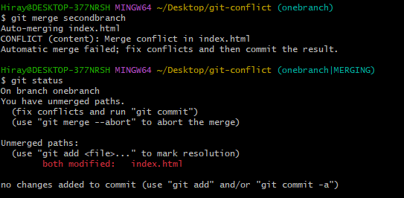

1. **Edit the file to resolve conflicts.**

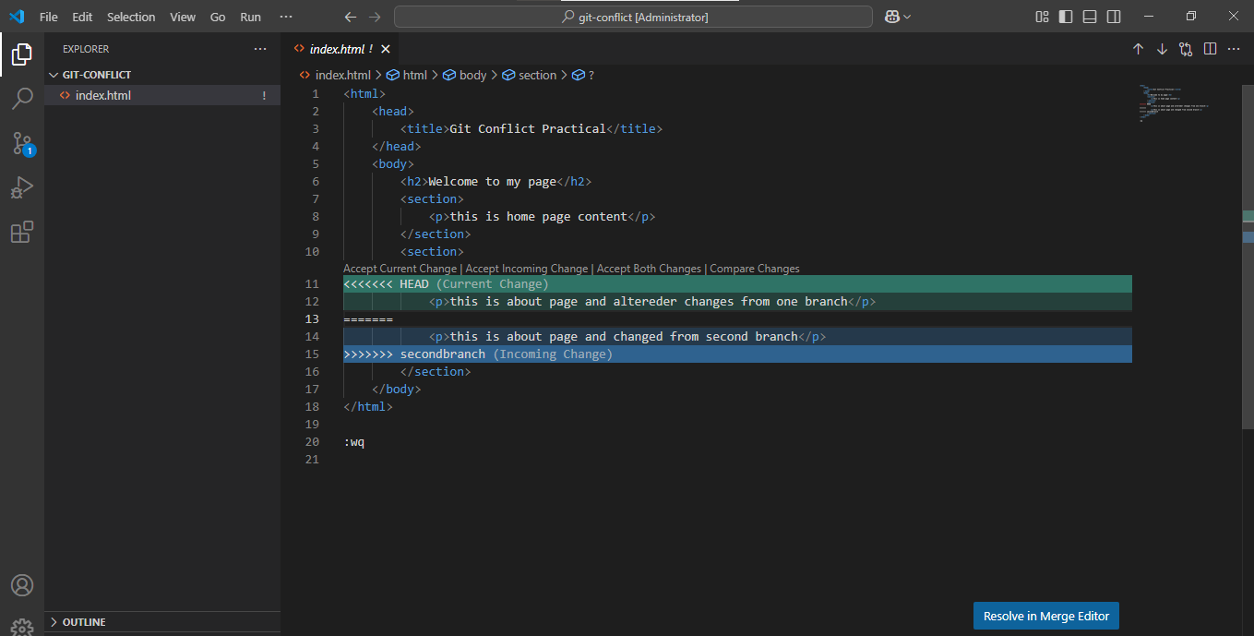

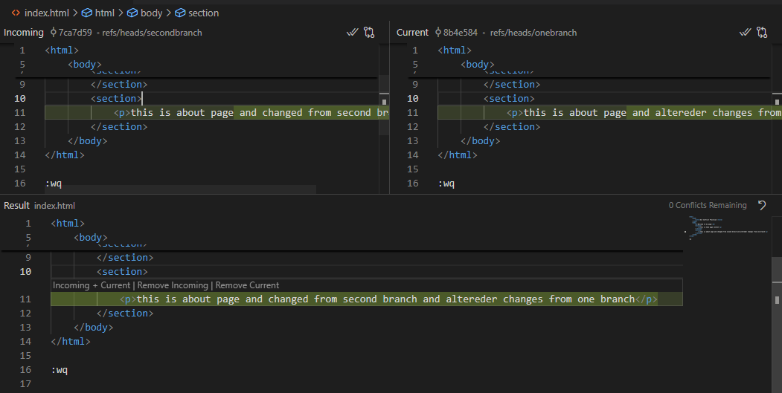

1. **Finalize the merge.**

**We can merge the branch using following command**

gitmerge branch 'secondbranch' into ‘onebranch’

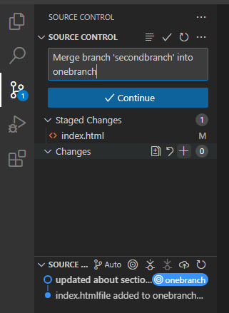

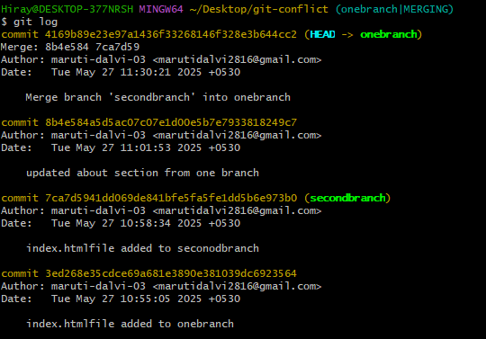

B) directory_playbook.yml

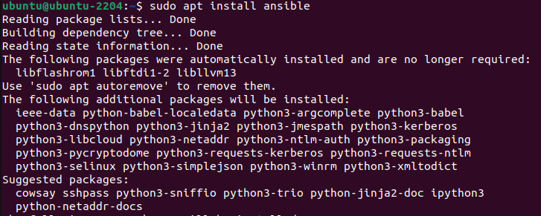

- name: Playbook to create and delete a directory on all managed nodes

hosts: all

become: yes

tasks:

- name: Create the directory /tmp/testdir

file:

path: /tmp/testdir

state: directory

mode: '0755'

register: dir_creation # Register the result for later verification

- name: Verify if the directory was created successfully

stat:

path: /tmp/testdir

register: dir_stat

- name: Debug the status of the directory creation

debug:

msg: "Directory creation successful: {{ dir_stat.stat.exists }}"

- name: Delete the directory after verifying its creation

file:

path: /tmp/testdir

state: absent

when: dir_stat.stat.exists # Only delete if directory exists

register: dir_deletion

- name: Debug the status of the directory deletion

debug:

msg: "Directory deletion successful: {{ dir_deletion.changed }}"