# 1.'noh.txt'파일을 t/m으로 진행하여 일단 상위 단어개수인

# 20개를 추출하여 시각화 하시오?

txt_HW3=readLines("noh.txt")

spch=sapply(txt_HW3,extractNoun,USE.NAMES = F)

spch=unlist(spch)

class(spch)

spch=Filter(function(x){nchar(x)>=2},spch)

write(spch,"noh2.txt")

outp=read.table("noh2.txt")

wc=table(outp)

hh=head(sort(wc,decreasing = T),20)

pp=barplot(hh,ylim = c(0,30),las=2,col=rainbow(20))

text(pp,hh,paste0(hh,"개"),pos=3,cex=2,col=2)

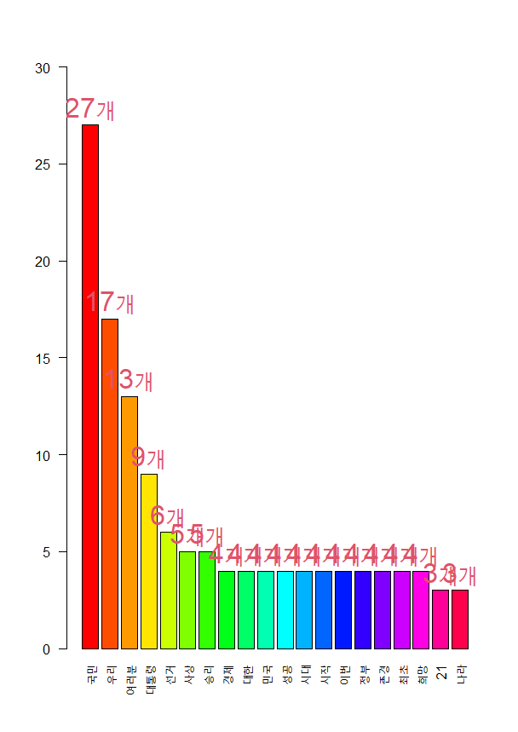

# 2.'hong.txt'파일을 t/m으로 진행하여 일단 상위 단어개수인

# 20개를 추출하여 시각화 하시오?

xtx_HW3=readLines("hong.txt")

spch1=sapply(xtx_HW3,extractNoun,USE.NAMES = F)

spch1=unlist(spch1)

class(spch1)

spch=Filter(function(x){nchar(x)>=2},spch)

write(spch1,"hong2.txt")

outp1=read.table("hong2.txt")

wc1=table(outp1)

hh1=head(sort(wc1,decreasing = T),20)

pp1=barplot(hh1,ylim = c(0,40),las=2,col=rainbow(20))

text(pp1,hh1,paste0(hh1,"개"),pos=3,cex=2,col=2)

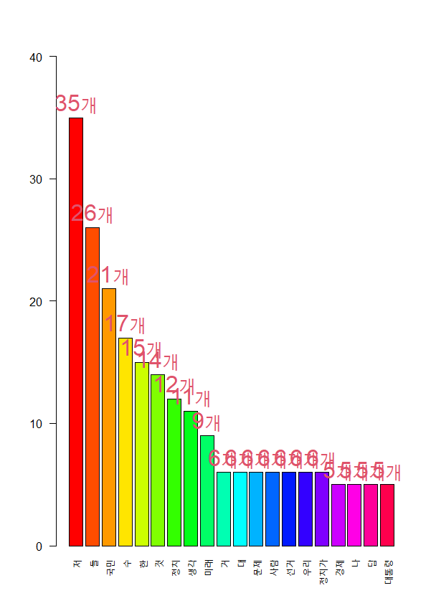

Wordcloud의 시각화

Q1. 'noh.txt

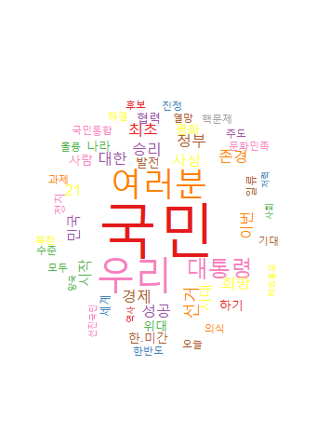

wordcloud(

names(wc),

freq = wc,

scale = c(5,0.5),

rot.per = 0.25,

min.freq = 2,

random.order=F,

random.color=T,

colors=palate)

wordcloud2(

data=wc,

size=0.4,

shape = "diamond" #circle, triangle...

)

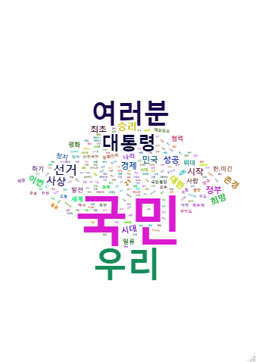

Q2. hong.txt

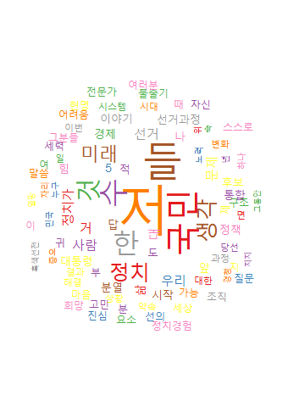

wordcloud(

names(wc1),

freq = wc1,

scale = c(5,0.5),

rot.per = 0.25,

min.freq = 2,

random.order=F,

random.color=T,

colors=palate)

wordcloud2(

data=wc1,

size=0.4,

shape = "diamond" #circle, triangle...

)

