**Project Phase – I**

**Synopsis**

SUBMITTED TO

Dr .BABASAHEB AMBEDKAR TECHNOLOGICAL UNIVERSITY, LONERE.

IN THE PARTIAL FULFILLMENT OF THE REQUIREMENTS FOR THE AWARD

OF THE DEGREE OF

**BACHELOR OF ENGINEERING (CSE)**

**Submitted By**

**Soundarya Yelgulwar 2062191242027**

**Yogita Bansode 2062191242002**

**Neha Jadhav 2062191242024**

**Service Booking System**

***SEVA***

**Under the guidance of**

**Prof. Girish Kumbhar**



**DEPARTMENT OF COMPUTER SCIENCE & ENGINEERING**

**BHARATRATNA INDIRA GANDHI COLLEGE OF ENGINEERING**

**Dr. BABASAHEB AMBEDKAR TECHNOLOGICAL UNIVERSITY, LONERE**

**2022-2023**



**CERTIFICATE**

**This is to certify that the Seminar report entitles**

**Service Booking System**

***SEVA***

**Submitted By**

**Soundarya Yelgulwar 2062191242027**

**Yogita Bansode 2062191242002**

**Neha Jadhav 2062191242024**

**Is a Bonafide work carried out by the above students under the guidance of Prof. Girish Kumbhar towards the fulfilment of the requirement by Dr. BABASAHEB AMBEDKAR TECHNOLOGICAL UNIVERSITY, LONERE for the award of the degree of Bachelor of Technology (Computer Science and Engineering) for academic year 2022-2023.**

**Project Guide Project External Head of Department**

**ACKNOWLEDGEMENT**

We express our deepest gratitude and appreciation to our project guide Prof. Girish Kumbhar for his invaluable assistance throughout this entire project. His commitment, hard work, and dedication have been instrumental in making this project a success. His insightful contributions and valuable suggestions have helped to shape the project and ensure its timely completion. His technical expertise and attention to detail have been invaluable in addressing the challenges we faced and overcoming them. His willingness to go above and beyond the call of duty has not gone unnoticed. His prompt response to our queries, proactive approach, and constructive feedback have contributed to the overall success of our project.

We would also like to take this opportunity to express our gratitude to Prof. B.J. Patil, Principal - BIGCE Solapur, for his support, guidance, and leadership during our time here, at the Institution. His unwavering commitment to education has been an inspiration to us all. We are truly grateful for the opportunities and resources you have provided to us and our fellow students. Your efforts to create a positive and inclusive learning environment have helped us to grow both academically and personally.

Once again, thank you for your hard work, motivation, and commitment to the project. Your dedication towards education has made a significant impact on our lives, and we will forever be grateful for your contributions.

Sincerely,

Soundarya Y

Yogita B

Neha J

**CONTENTS**

**1. Introduction**

1.1 Planning

1.2 Feasibility Study

**2. Analysis**

2.1 Project Analysis

2.2 Software/Hardware Requirements

**3. Use Case & Data Flow Diagrams**

3.1 Use Case Diagram

3.2 Data Flow Diagram

**4. Implementation**

4.1 User Interface Code

4.2 Project Modules

**5. Future Scope**

**6. Conclusion**

**7. Reference**

**INTRODUCTION**

A Service Booking website is an online platform that allows users to book various types of services online, such as salon appointments, home cleaning, plumbing services, and more. With the increasing popularity of online shopping and digital transactions, Service Booking websites have become a convenient and efficient way for customers to book services without having to physically visit the service provider.

The primary objective of a Service Booking website is to make the booking process simple, fast, and convenient for customers. These websites typically offer a user-friendly interface that allows customers to browse through different services, select a service, and book an appointment at their convenience. Service Booking websites also typically provide various features such as online payment, customer feedback, and service provider ratings to enhance the user experience.

Service Booking websites are not only beneficial for customers but also for service providers. These websites provide an additional channel for service providers to connect with customers and expand their customer base. Service providers can use these websites to manage their bookings, appointments, and payments, reducing their administrative workload and improving their efficiency.

In summary, Service Booking websites are a convenient and efficient way for customers to book various services online, and for service providers to connect with customers and manage their bookings. The rise of digital technology and online transactions has made Service Booking websites an essential tool for businesses looking to offer better services and enhance the customer experience.

**PLANNING**

* **Feasibility**

The prime focus of feasibility is evaluating the practicality of the proposed system keeping in minimum several factors such as cost efficiency, time management and memory management. Feasibility study is conducted once the problem is clearly understood. Feasibility study is a high-level capsule version of the entire system analysis and design process. The objective is to determine quickly at a minimum expense how to solve a problem. The purpose of feasibility is not to solve the problem but to determine if the problem is worth solving. A feasibility study on a Service Booking website would typically involve analysing the technical, economic, operational, and legal aspects of the project.

Below are the key factors that would be considered:

**Technical Feasibility :**  This would involve assessing the technical requirements of the project. This project is developed using CSS, HTML and PHP. This includes analysing the web development tools needed to create the website, the hosting services required, and the database management system that is MySQL is used to store user data and service provider information.

**Economic Feasibility :** This involves evaluating the financial viability of the project. The economic feasibility of a Service Booking website depends on various factors, such as the market demand, competition, pricing strategy, revenue streams, and operational efficiency. A well-designed and executed Service Booking website can generate sufficient revenue to cover its costs and generate a profit over time

**Operational Feasibility :** This involves assessing whether the Service Booking website can be effectively integrated into the existing business operations. This includes analysing the workflow and processes involved in booking and delivering the services, and assessing whether the website can be integrated into these processes without causing disruptions.

**Legal Feasibility :** This involves analyzing the legal aspects of the project, including compliance with data protection and privacy regulations, intellectual property rights, and any other legal requirements.

**Market Feasibility :** This involves analysing the market for the services offered by the Service Booking website. This includes identifying the target market, analysing the demand for the services, and evaluating the competition.

Based on the analysis of these factors, a feasibility report can be prepared that will identify any potential risks, challenges, and opportunities associated with the project. The report will help to determine whether the project is feasible and whether it should be pursued.

**ANALYSIS**

* **Project Analysis**

**User Experience Analysis :** This involves assessing the ease of use, accessibility, and user-friendliness of the website. This includes analysing the navigation, layout, and design of the website, as well as the responsiveness and accessibility across different devices.

**Booking Process Analysis :** This involves assessing the booking process, including the availability of services, pricing, payment options, and cancellation policies. The analysis should focus on how easy it is for users to book a service and complete the transaction.

**Service Provider Analysis :** This involves analyzing the service providers listed on the website, including their reputation, qualifications, and reviews. The analysis should focus on how well the website vets and verifies service providers to ensure quality and reliability.

**Customer Service Analysis :** This involves analysing the customer service options available on the website, including support channels, response times, and the quality of service provided. The analysis should focus on how well the website resolves customer issues and ensures satisfaction.

**Security and Privacy Analysis :** This involves assessing the website's security measures to ensure that customer data is protected and privacy is maintained. The analysis should focus on how the website handles sensitive information, such as payment details and personal data.

**SOFTWARE AND HARDWARE**

**REQUIREMENTS**

**Software Requirements :**

* Operating System : Windows 7 and above
* Programming Languages : HTML, CSS, PHP
* Database : MySQL
* Browser : Chrome, Firefox, Operamini

**Hardware Requirements :**

* Processor
* Memory (RAM)
* Storage (Hard Drive or SSD)
* Graphics Card
* Display
* Input Devices
* Network Connectivity

**USE CASE AND DATA FLOW**

**DIAGRAMS**

**Use Case Diagram :**

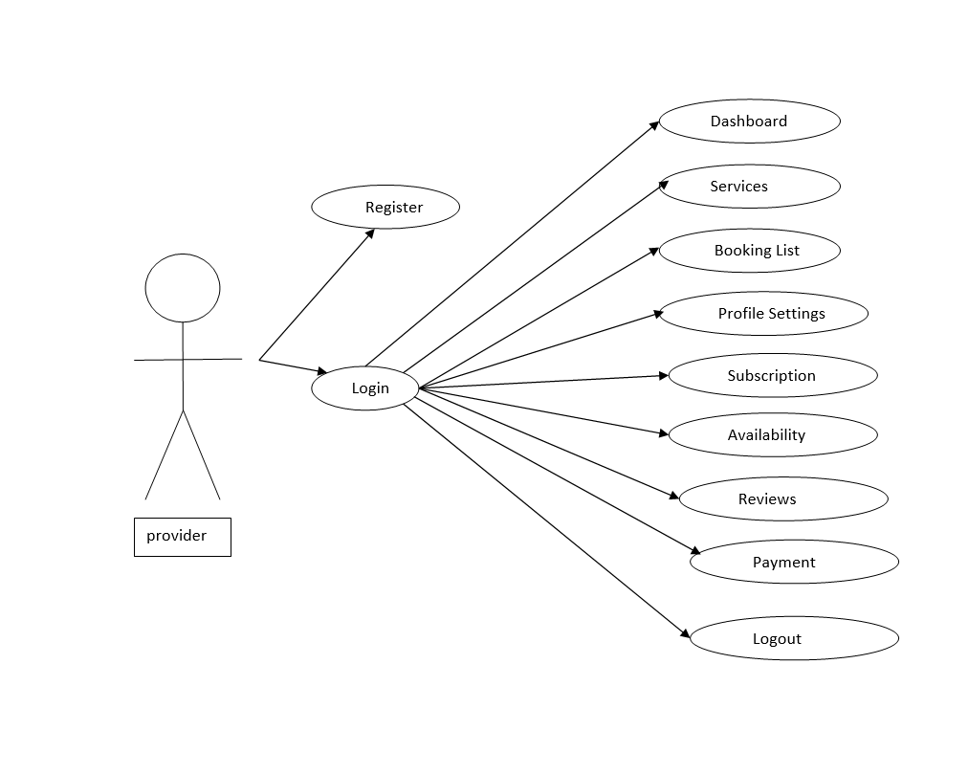

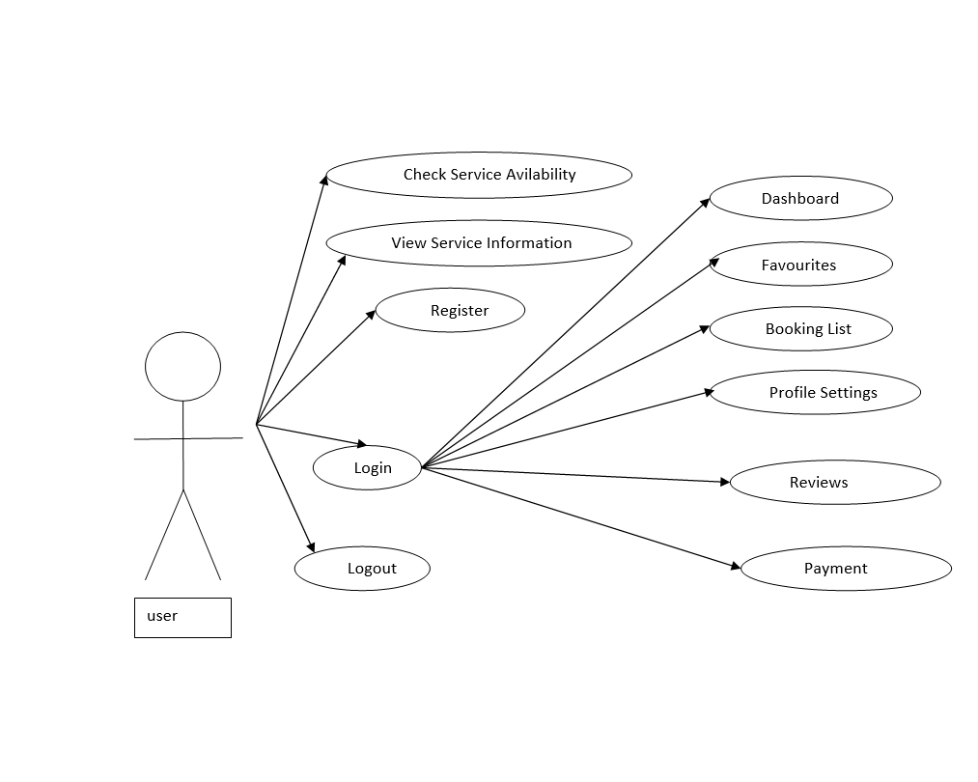

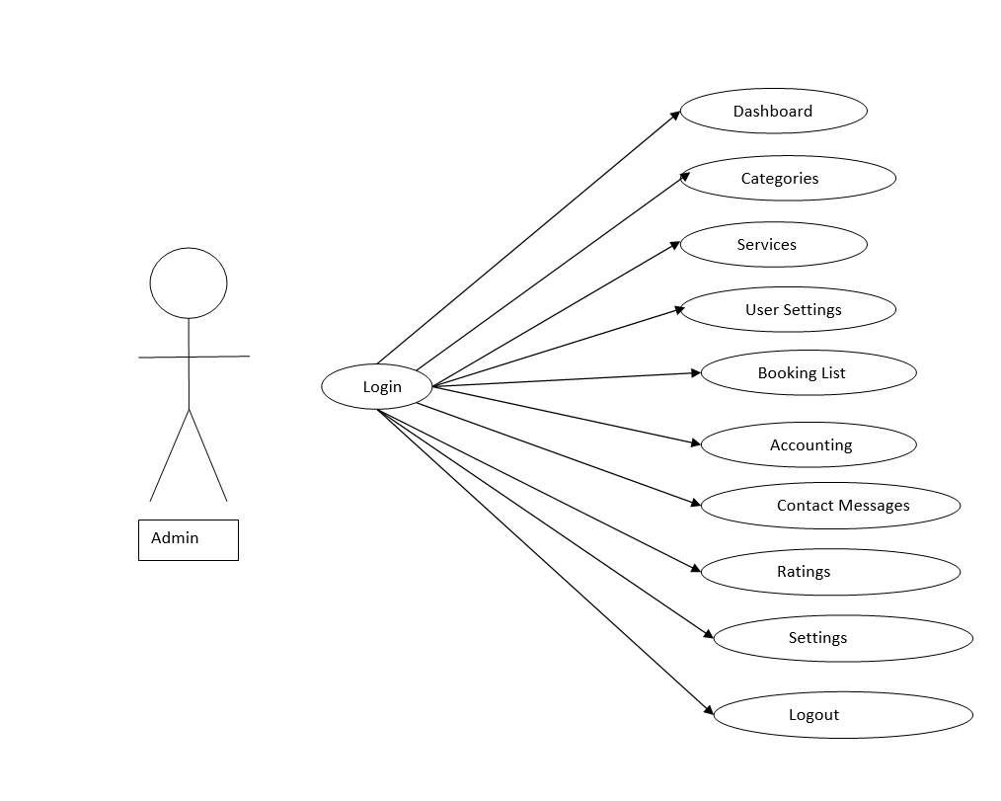

**Data Flow Diagram :**

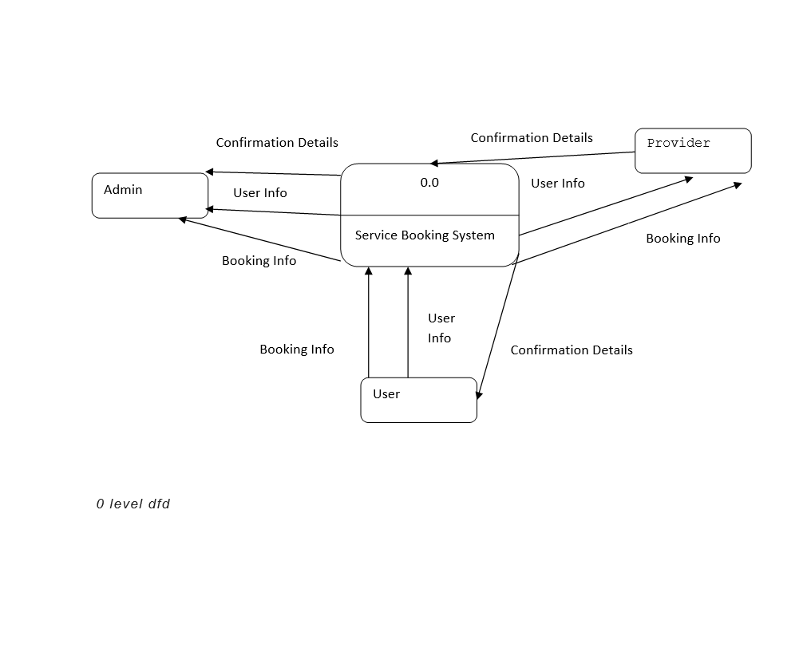

Level 0 DFD

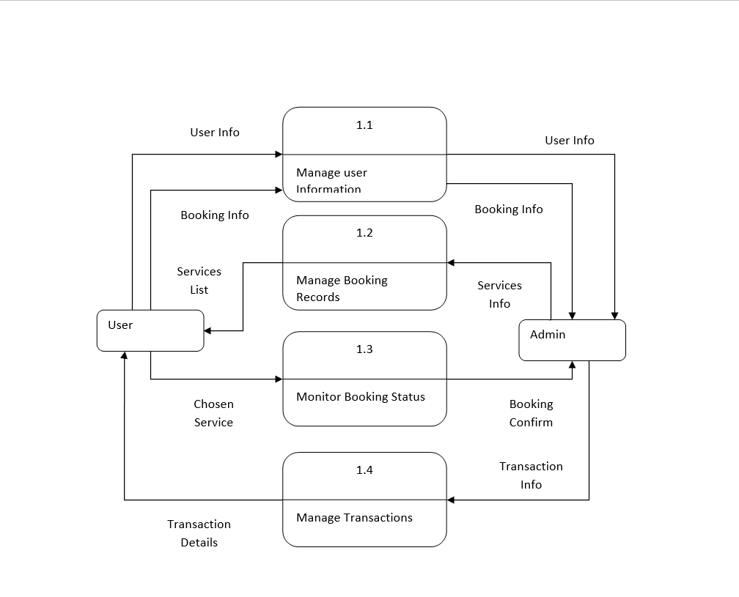

Level 1 DFD

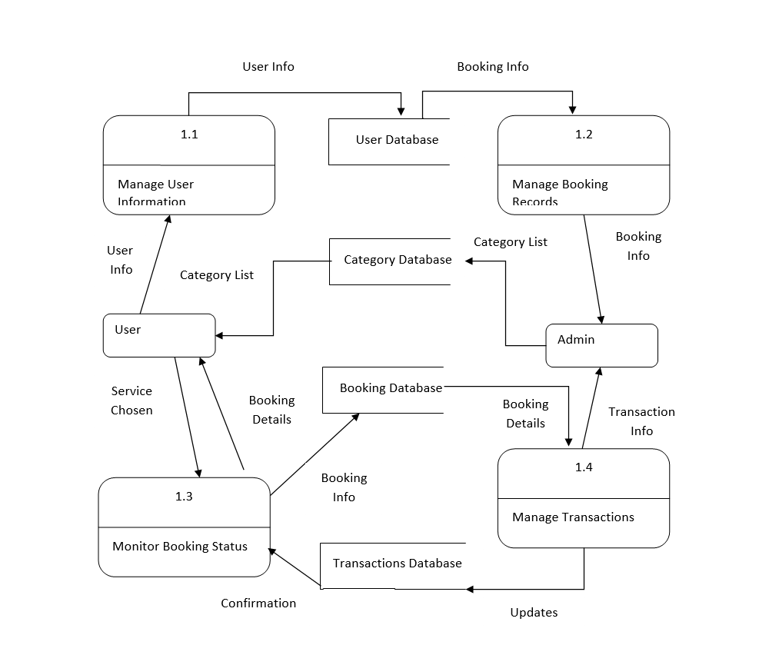

Level 2 DFD

**IMPLEMENTATION**

**User Interface Code :**

* **HTML5 :** HTML5 is a markup language used for structuring and presenting content on the World Wide Web. It is the fifth and final major HTML version that is a World Wide Web Consortium (W3C) recommendation. The current specification is known as the HTML Living Standard.

* **CSS3 :**  CSS3 stands for Cascading Style Sheet level 3, which is the advanced version of CSS. It is used for structuring, styling, and formatting web pages. Several new features have been added to CSS3 and it is supported by all modern web browsers.

* **PHP Admin :** PHPMyAdmin is a free software tool written in PHP that is intended to handle the administration of a MySQL or MariaDB database server. You can use phpMyAdmin to perform most administration tasks, including creating a database, running queries, and adding user accounts.

**Tools:**

* **Visual studio code :**

Visual Studio Code is a lightweight but powerful source code editor which runs on your desktop and is available for Windows, macOS and Linux. In visual studio code editors can run any programming language using these installed packages.

**PROJECT MODULES**

There are several important modules that are included in a service booking website, depending on the specific needs of the website and the services being offered. Here are some modules that could be important for a service booking website :

**User Management :** This module handles user registration, login, and authentication. It allows customers and service providers to create accounts, manage their profiles, and access the website's services.

**Service Management :** This module allows service providers to create and manage their services. They can specify details about the services they offer, including the types of services, the duration, the location, the availability, and the pricing.

**Booking Management :** This module handles the booking process, from selecting a service to making a payment. It allows customers to browse through the available services, select a specific service provider and time slot, and make a payment for the service.

**Payment Gateway Integration :** This module integrates with a third-party payment gateway to process payments for the services being offered. It ensures that payments are processed securely and efficiently.

**Review and Feedback Management :** This module allows customers to provide feedback and reviews for the services they have received. It helps to build trust and credibility for the service providers and helps customers to make informed decisions when booking services.

**Notification and Communication Management :** This module handles notifications and communication between customers and service providers. It can send email or SMS notifications to customers and service providers about new bookings, cancellations, or changes to existing bookings.

**Reporting and Analytics :** This module provides insights and analytics about the usage of the website, the performance of the service providers, and the preferences of the customers. It can help to identify areas of improvement and optimize the services being offered.

Overall, these modules work together to provide a seamless and user-friendly experience for customers and service providers. By incorporating these modules, a service booking website can offer a comprehensive and efficient platform for booking services online.

**FUTURE SCOPE**

The future scope of a service booking website is vast and promising, as the use of online platforms for booking services continues to increase. Here are some potential areas of growth and development for service booking websites in the future:

**Integration with AI and Machine Learning :** As technology advances, service booking websites can incorporate AI and machine learning algorithms to provide personalized recommendations for customers and optimize the booking process.

**Expansion of Services :** Service booking websites can expand the range of services being offered, from traditional services like plumbing and electrical work to new and emerging services like home automation, digital marketing, and virtual assistance.

**Integration with IoT Devices :** With the increasing popularity of smart home devices, service booking websites can integrate with IoT devices to provide a more streamlined and efficient service. For example, a service provider could be notified when a smart device detects a malfunction, and a customer could book a repair service directly from their device.

**Global Expansion :** Service booking websites can expand their services to new regions and countries, enabling customers to book services from anywhere in the world.

**Expansion to B2B Services :** Service booking websites can expand to offer services for businesses, such as hiring freelancers or booking corporate training sessions.

**CONCLUSION**

In conclusion, a service booking website offers a comprehensive and efficient platform for booking services online. By providing a seamless and user-friendly experience for both customers and service providers, a service booking website can help to bridge the gap between the demand for services and the supply of service providers. With the use of various modules such as user management, service management, booking management, payment gateway integration, review and feedback management, notification and communication management, and reporting and analytics, service booking websites can provide a range of services to meet the needs of their customers. With the increasing popularity of online platforms for booking services, the future scope of service booking websites is vast and promising. By staying up to date with emerging technologies and trends, service booking websites can continue to offer innovative and efficient services to their customers.

**REFERENCE**

‘Service Booking System - An Introduction to its Development’

by Jaro Pušnik

‘Service Booking System - A Comprehensive Guide’

by Yatharth Gupta

‘How to Create a Service Booking Website’

by Mobindustry

‘Service Booking Website Development Company’

by AIS Technolabs