Summary of papers on super-resolution with medical images:

**Paper 1. A Fast Medical Image Super Resolution Method Based on Deep Learning Network**

* [Link](https://ieeexplore.ieee.org/document/8471089)
* **Images:** Retinal, Brain and Bone images (3 channels red blue, green)

* **Network :** 3 components 🡪 sub-pixel convolutional layer + mini-network and hidden layers.

Sub-pixel and mini network designed to shorten time of super-resolution.

**Paper 2. (from the link you sent me) A resolution adaptive deep hierarchical (RADHical) learning scheme applied to nuclear segmentation of digital pathology images**

* [**Link**](https://www.ncbi.nlm.nih.gov/pmc/articles/PMC5935259/)
* **Images:** breast cancer images
* **Approach:** resolution adaptive hierarchical learning scheme where DL networks at lower resolution are leveraged to determine if higher levels of magnification are necessary to provide results of nuclear segmentation 🡪 so actually no high resolution creation here because I think the images are already in HR.

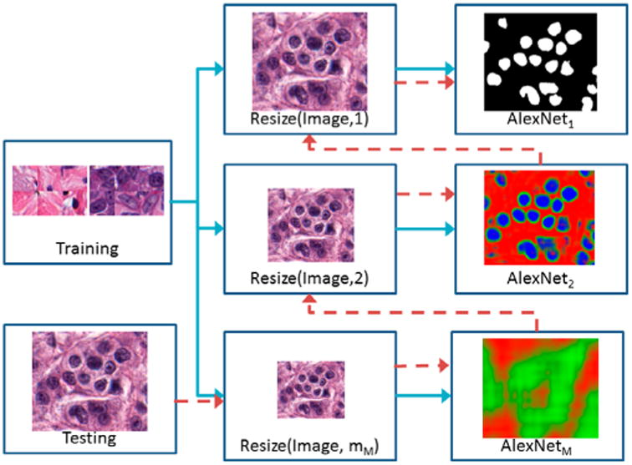

**Paper 3. Deep Learning enables cross-modality super-resolution in fluorescence microscopy**

* [**Link**](https://www.researchgate.net/publication/331512035_Deep-learning_enables_cross-modality_super-resolution_in_fluorescence_microscopy_Conference_Presentation) **for paper and** [**additionnal information**](https://static-content.springer.com/esm/art%3A10.1038%2Fs41592-018-0239-0/MediaObjects/41592_2018_239_MOESM1_ESM.pdf)
* **Images:** TIRF microscopy images of subcellular structures within cells and tissues

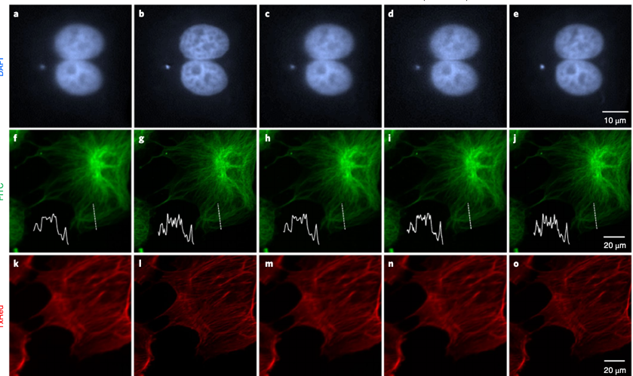

* **Network:** GAN Network

**Paper 4. Super Resolution Techniques for Medical Processing**

* **A picture containing photo, text

  Description automatically generated**[**Link**](https://ieeexplore.ieee.org/document/7095900/)
* Gives a summary of all available techniques but no precise network. Also, again images provided are more bone-like.
* **Simple approaches:** Conventional interpolation methods (nearest neighbor, bilinear and bicubic interpolations) and more sophisticated methods using sparse-coding super-resolution algorithms find a sparse representation and enable a super-resolution gain (dictionary learning)

**Paper 5. Deep CNN Denoiser and Multi-Layer Neighbor Component Embedding for Face Hallucination**

* [**Link**](https://www.ijcai.org/Proceedings/2018/0107.pdf)
* Proposes solution for tiny LR images 🡪 general face hallucination method integrating model-based optimization and discriminative inference. Deep CNN denoiser prior is plugged into super-resolution optimization model with the aid of image-adaptive Laplacian regularization.
* **Images**:
* **Network**:
  + Step 1: Deep CNN denoiser based global face reconstruction
  + Step 2: MNCE based residual compensation

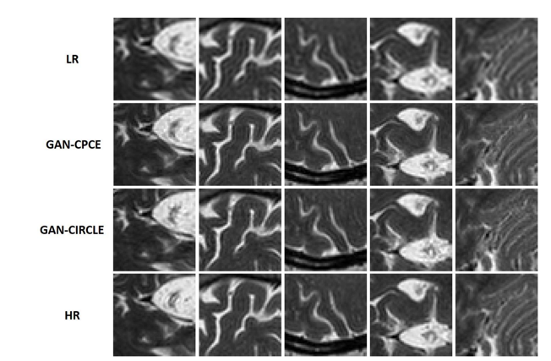

**Paper 6. Super-resolution MRI through Deep Learning**

* [**Link**](https://www.google.com/search?q=super-resolution+mri+through+deep+learning&oq=Super-resolution+MRI+through+Deep+Learning&aqs=chrome.0.0l3.271j0j7&sourceid=chrome&ie=UTF-8)
* **Images:**
* **Network:** Adapt two networks for CT to MRI 🡪 path-based convolutional encoder-decoder with VGG (GAN-CPCE) and GAN constrained by the identical, residual and cycle learning ensemble (GAN-CIRCLE)

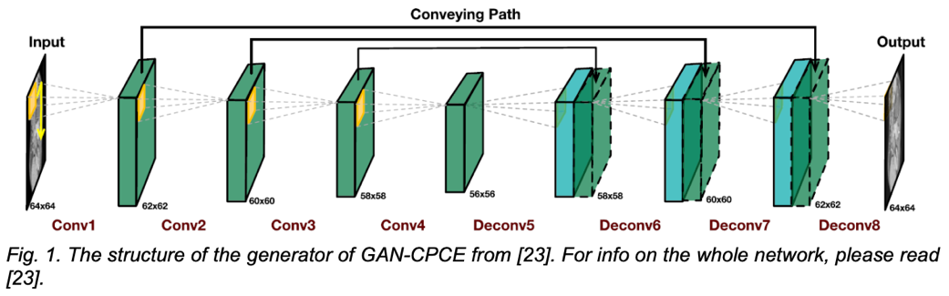

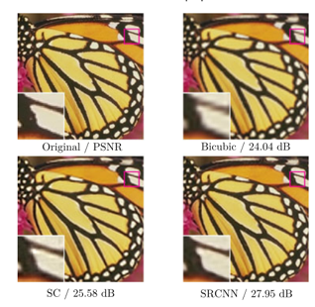

**Paper 7. Image Super-resolution Using Deep Convolutional Networks**

* [**Link**](https://ieeexplore.ieee.org/stamp/stamp.jsp?tp=&arnumber=7115171)
* **Images**
* **Network:** SRCNN convolutional network that directly learns an end-to-end mapping between low- and high-resolution images. Pipeline:
  + overlapping patches densely cropped from the input image and pre-processed so that each patch is a high-dimensional vector
  + non-linear mapping of high-dim vectors to another high-dimensional vector
  + reconstruction : aggregation of high-resolution patch-wise representations to generate final HR image

**Paper 8. Super-Resolution of MRI Images via Convex Optimization with Local and global prior regularization and spectrum fitting**

* [**Link**](http://downloads.hindawi.com/journals/ijbi/2018/9262847.pdf)
* Convex optimization formulation (no CNN)

