Sentiment Analysis for Amazon Fashion Reviews

Course: COMP 262

Daniela Diaz - 301281747
Jaturaput Jongsubcharoen - 301391425
Juan David Barrero - 301352353
Maria Paula Nova - 301374220
Anmol Shrestha - 301364068

Vijayalakshmi Tiruchengode Angamuthu
25/02/2026
Table of Contents
1. Introduction 5
2. Phase 1 – Dataset Data Exploration (EDA) 6
2.1 Method 6
2.2 Key Statistics 6
2.3 Visualizations 7
Figure 1a. Ratings Distribution (Train) 7
Figure 1.b: Reviews Across Products (Histogram) 8
Figure 1.b: Top 10 Product ASINs by Number of Reviews 9
Figure 1.c: Reviews per Product (Boxplot) 10
Figure 1.d: Reviews per User (Histogram) 11
Figure 1.d: Reviews per User (Boxplot) 12
Figure 1.f: Review Length (Words) Distributions 13
Figure 1.f: Review Length (Words) Boxplot 14
Figure 1.g: Distribution of Repeated Reviews per Reviewer 15
Figure 7.1 (Additional Visualization): Accuracy Comparison: VADER vs TextBlob 16
Figure 7.2 (Additional Visualization): VADER vs TextBlob Performance Comparison 17
2.4 Outliers and Examples 18
3. Text Basic Preprocessing 19
3.1 Labeling (ratings to sentiment classes) 19
3.2 Column Selection 19
3.3 Cleaning and Quality Checks 20
3.4 Text Normalization Strategy (Model-Specific) 20
3.4.1 Preprocessing for VADER 20
3.4.2 Preprocessing for TextBlob 20
3.5 Outlier Treatment 21
4. Models 22
4.1 Lexicon Study and Selection 22
4.2 VADER Model 22
4.3 TextBlob Model 24
5.1 Sampling Procedure 26
5.2 Evaluation Metrics 26
5.3 Results 27
5.4 Confusion Matrices 28
Figure 7a. VADER Confusion Matrix 28
Figure 7b. TextBlob Confusion Matrix 29
5.5 Discussion 30
6. Conclusion 31
7. Assumptions 32
8. References 32
9. Appendix 1: Project plan 33
9.1 Project Objectives 33
9.4 Tools and Technologies 37
9.5 Plan for Phase 2 37
10. Appendix 2: Meeting register (simple table showing date and time of each meeting, who attended, subjects discussed and assignments). 38

1. Introduction
In this project, we perform sentiment analysis on the Amazon Fashion reviews dataset using a lexicon-based approach. The main objective of Phase 1 is to build a complete and reproducible pipeline that includes dataset exploration, sentiment labeling based on rating values, text preprocessing, selection and justification of sentiment lexicons, and model evaluation.
Ratings (1–5 stars) are used as proxy ground-truth labels and mapped into three sentiment categories: Negative, Neutral, and Positive. Two lexicon-based models, VADER and TextBlob, are implemented to classify review texts. These models rely on predefined sentiment dictionaries and scoring rules, making them interpretable and suitable as baseline approaches.
This phase establishes a strong analytical foundation by combining exploratory data analysis with quantitative evaluation metrics, including accuracy, precision, recall, F1-score, and confusion matrices. The results provide a baseline comparison that will support the development of more advanced machine learning models in the next phase of the project.

2. Phase 1 – Dataset Data Exploration (EDA)

2.1 Method
We performed exploratory data analysis on the training dataset to understand rating distribution, user and product coverage, review length variability, presence of outliers, and duplicate entries. Statistical summaries and visualizations were generated programmatically and stored in the phase1_outputs/ directory to ensure reproducibility.

2.2 Key Statistics
Rows before dropping invalid ratings: 3,176
Rows after dropping invalid ratings: 3,176
No rows were removed due to invalid ratings.
Average rating: 4.404
Median rating: 5.000
The median rating of 5 indicates a strong positive skew in the dataset.
Unique users (reviewer_id): 406
Unique products (asin): 31
This suggests that the dataset contains a relatively small set of products, with repeated review activity from a limited group of reviewers.
Missing review_text rows: 16
Duplicate full_text rows: 2,733
Duplicate (summary, review_text) pairs: 2,733
These duplicate text entries represent a large portion of the dataset and should be considered an important data characteristic rather than a minor issue. They were retained for this baseline lexicon-based analysis, but their high frequency should be acknowledged as a limitation when interpreting the results.

2.3 Visualizations
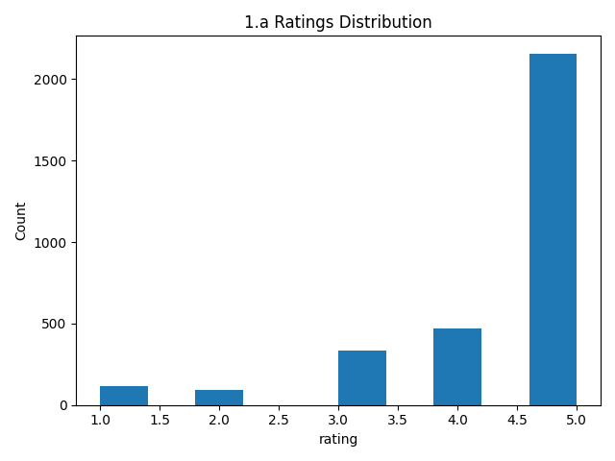

Figure 1a. Ratings Distribution (Train)
The rating distribution is clearly imbalanced, with 5-star reviews making up the largest share of the dataset, while 1-star and 2-star reviews are much less frequent. This shows a strong positive skew, so this is really normal in e-commerce review data. Due to this imbalance, model results should be interpreted carefully, since a model may appear to perform well simply by favoring the majority positive class.
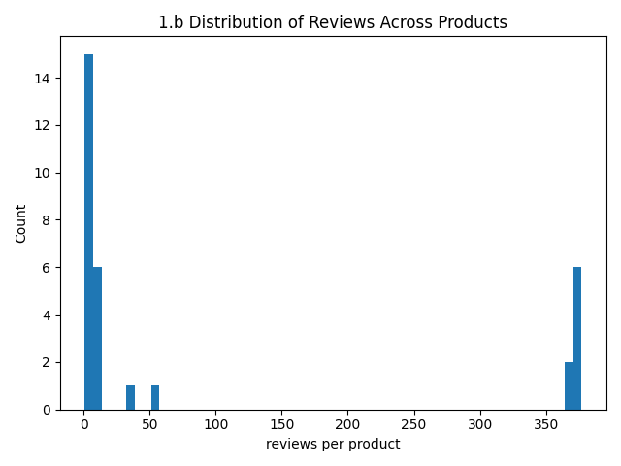

Figure 1.b: Reviews Across Products (Histogram)
The distribution of reviews across products is highly uneven. Most products receive only a small number of reviews, while a small group of products receive very large numbers of reviews. This indicates a long-tail pattern, where review activity is concentrated on a limited number of popular products rather than being spread evenly across all products.

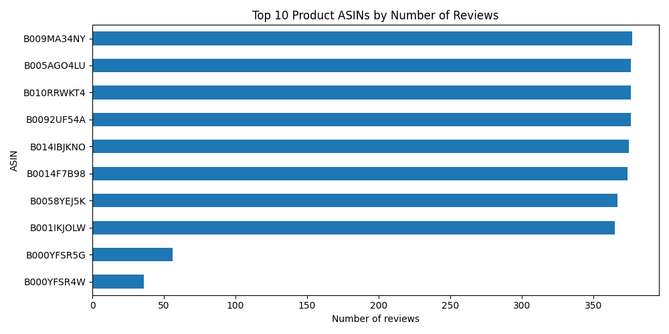

Figure 1.b: Top 10 Product ASINs by Number of Reviews
The top reviewed products are not equally represented. Several ASINs have very high and similar review counts, while the last few products in the top 10 have much lower counts. This shows that a small subset of products dominates customer attention and review activity in the dataset.

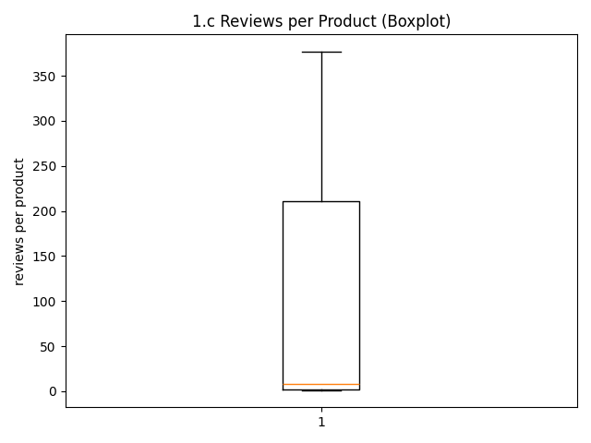

Figure 1.c: Reviews per Product (Boxplot)
Most products receive only one review (median = 1), while a small number of products receive a very large number of reviews with the maximum that reaching around 380 reviews, so the mean number of reviews per product is about 1.92, indicating a highly skewed long-tail distribution where a few popular products accumulate many reviews while most products receive very few.

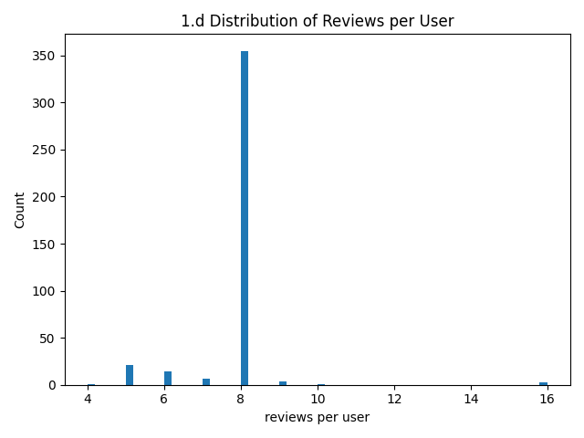

Figure 1.d: Reviews per User (Histogram)
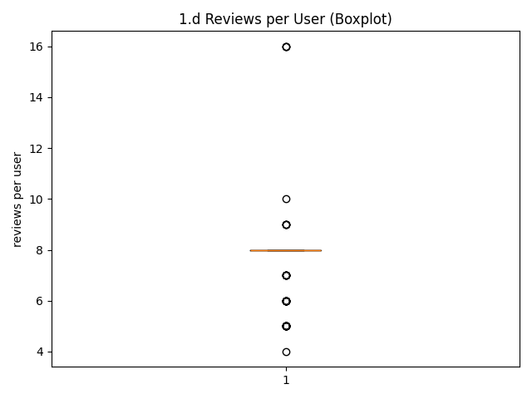

Figure 1.d: Reviews per User (Boxplot)
Most users contributed around 8 reviews, as shown by the histogram and the median value in the boxplot. A small number of users contributed fewer or more reviews, ranging from about 4 to a maximum of around 16 reviews. This indicates that user activity is relatively concentrated around 8 reviews with a few outliers.

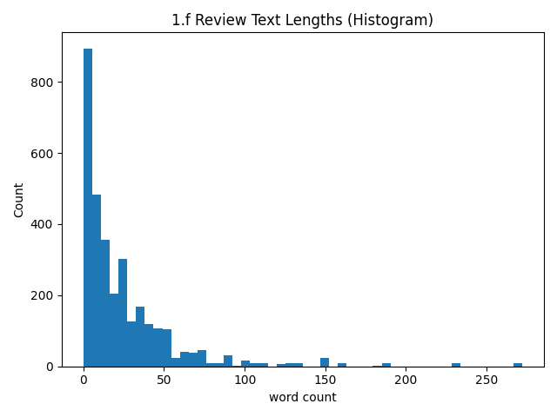Figure 1.f: Review Length (Words) Distributions
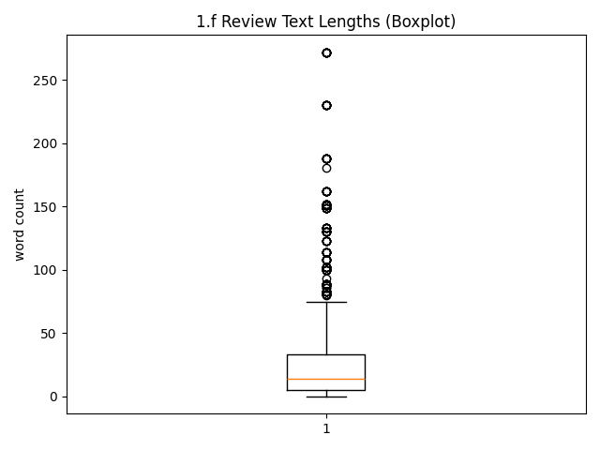

Figure 1.f: Review Length (Words) Boxplot
Most reviews are relatively short, with a median length of around 10–15 words. The distribution is highly right-skewed, meaning that while most reviews contain only a small number of words, a few reviews are much longer. The longest reviews reach over 250 words, indicating the presence of several outliers.

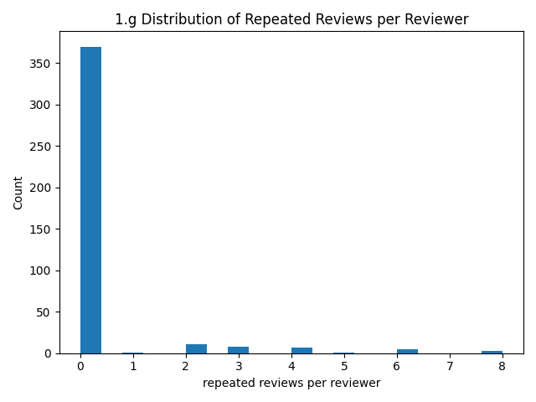

Figure 1.g: Distribution of Repeated Reviews per Reviewer
The histogram of repeated reviews per reviewer displays that most reviewers have repeated reviews as 0 for the same product, but a smaller number of reviewers have multiple repeated reviewer-product pairs which are a lot of numbers or reviews compared to greater number or reviewer, so this justify that duplicate same-user same-product reviews are not evenly distributed across the dataset; instead, they are concentrated in a limited subset of reviewers. Therefore, repeated reviewer-product behavior exists in the dataset, but it is driven by a small group of users rather than by the reviewer population as a whole.

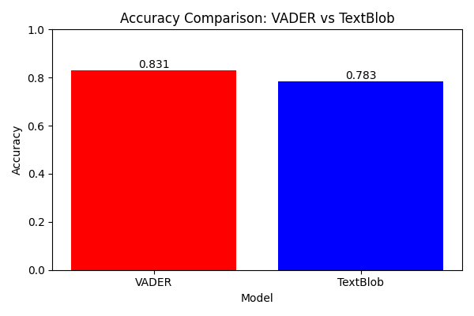

Figure 7.1 (Additional Visualization): Accuracy Comparison: VADER vs TextBlob
This chart compares the accuracy of VADER and TextBlob sentiment models. VADER achieved 83.1% accuracy, while TextBlob achieved 78.3% accuracy. This indicates that VADER performs better for sentiment classification on this dataset, likely because it is optimized for short, informal text such as user reviews.
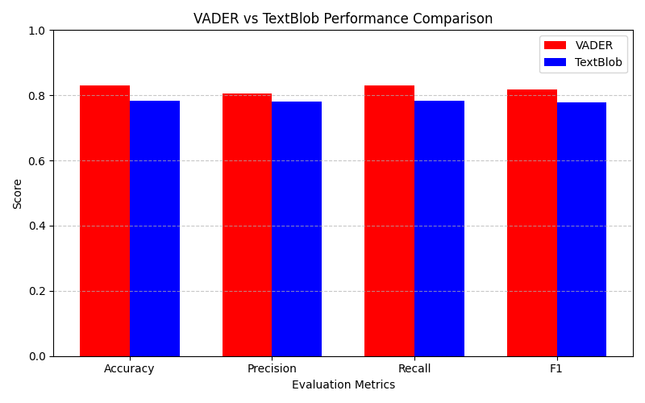

Figure 7.2 (Additional Visualization): VADER vs TextBlob Performance Comparison
This figure is to compare the performance of VADER and TextBlob across four evaluation metrics. VADER consistently outperforms TextBlob in accuracy, precision, recall, and F1-score. Therefore, this figure finally visualizes that this indicates that VADER provides more reliable sentiment classification performance for the Amazon review dataset.

2.4 Outliers and Examples
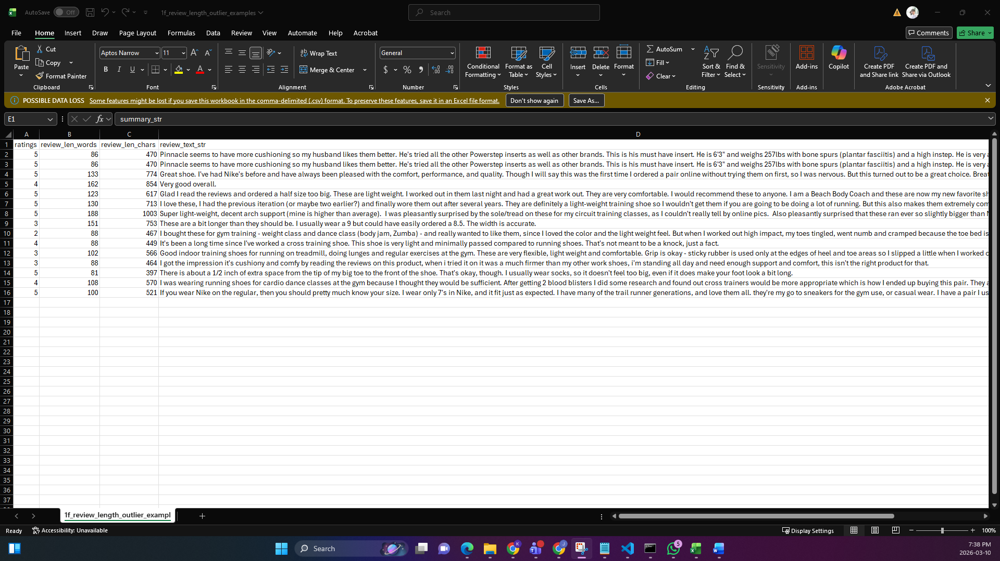
Review length outliers were detected using the IQR rule ( 1.5 × I Q R 1.5×IQR), with an upper bound of 215 words. Reviews above this threshold were identified as outliers. These outliers primarily correspond to unusually long reviews that contain detailed product descriptions, extended personal experiences, or repetitive content. Since these reviews still represent valid customer feedback and may contain useful sentiment information, they were retained in the dataset.
Representative examples were exported to phase1_outputs/1f_review_length_outlier_examples.csv.

3. Text Basic Preprocessing

3.1 Labeling (ratings to sentiment classes)
To enable supervised evaluation, numerical ratings (1–5 stars) were converted into categorical sentiment labels following the project rubric:
- Ratings 4–5 : Positive
- Rating 3 : Neutral
- Ratings 1–2 : Negative
This mapping treats user ratings as proxy ground-truth sentiment labels. Although numerical ratings may not perfectly reflect textual tone in all cases, they provide a consistent and scalable labeling strategy for model evaluation.
Given the strong skew toward 5-star reviews observed in the EDA phase, this labeling strategy results in class imbalance, with the Positive class dominating the dataset.

3.2 Column Selection
- The dataset contains two textual components:summary and review_text
- Both fields were combined into a single feature called full_text.
The summary field is typically short and opinion-focused, often containing strong sentiment cues. The review_text field provides additional context and elaboration. Combining both fields increases lexical coverage and improves the likelihood that sentiment-bearing words are captured by lexicon-based models.
This approach reduces the risk of sparse-text misclassification and improves robustness across short and long reviews.

3.3 Cleaning and Quality Checks
- Reviews with invalid or non-numeric ratings were removed prior to labeling.
- Empty textual entries were identified after conversion and counted.
- No additional imputation was performed, as lexicon models require actual text content.
- The dataset did not require major cleaning for structural integrity.

3.4 Text Normalization Strategy (Model-Specific)
Different preprocessing strategies were applied depending on the sentiment model used.

3.4.1 Preprocessing for VADER
Minimal preprocessing was applied:
- Removal of URLs
- Normalization of whitespace
VADER leverages punctuation, capitalization, and emphasis markers (e.g., exclamation points, ALL CAPS). Excessive normalization could remove meaningful sentiment signals. Therefore, preprocessing was intentionally minimal.

3.4.2 Preprocessing for TextBlob
More aggressive normalization was applied:
- Conversion to lowercase
- Removal of URLs
- Removal of non-alphabetic characters (except apostrophes)
- Whitespace normalization
TextBlob computes polarity using a general-purpose lexicon. Lowercasing and removing noise stabilizes polarity scoring and reduces variability introduced by formatting differences.

3.5 Outlier Treatment
Review length outliers were identified using the IQR rule but were retained in the dataset. Since lexicon-based models do not depend on fixed-length representations, review length does not directly impact feature dimensionality.
Retaining outliers preserves the natural distribution of customer opinions.

4. Models

4.1 Lexicon Study and Selection
Three lexicon-based sentiment approaches were analyzed: VADER, TextBlob, and SentiWordNet. The evaluation criteria included suitability for review-style text, implementation complexity, interpretability, and computational efficiency.
VADER and TextBlob were selected for implementation. SentiWordNet was not selected due to its requirement for part-of-speech tagging and word-sense disambiguation, which increases preprocessing complexity without guaranteed performance improvement for short review texts.
These two models were chosen to provide strong, interpretable baseline performance before introducing more complex approaches in later phases.

4.2 VADER Model
VADER (Valence Aware Dictionary and sEntiment Reasoner) is a rule-based sentiment analysis model specifically designed for social media and short review text (Hutto & Gilbert, 2014).

a. Assumptions / Heuristics / Packages Used
- Package: nltk.sentiment.vader
- Function used: SentimentIntensityAnalyzer()
- Uses lexicon-based scoring with rule-based heuristics
- Classification thresholds applied:
  - compound ≥ 0.05 which is defined as positive
  - compound ≤ -0.05 which is defined as negative
  - otherwise will be defined as neutral
Assumptions:
- Word-level sentiment scores adequately represent review polarity
- Punctuation and intensity modifiers contribute meaningfully to sentiment
- Ratings-derived labels represent ground-truth sentiment
b. How the Model Works
VADER computes four sentiment scores for each text: positive, negative, neutral, and a combined compound score. The compound score is a normalized weighted aggregate of lexical features.
The algorithm:
- Tokenizes the input text.
- Matches words against a predefined sentiment lexicon.
- Applies heuristic adjustments for:Negations, Intensifiers,Capitalization and Punctuation emphasis
- Produces a final compound score in the range [-1, 1].
The compound score is then mapped to a categorical sentiment label using predefined thresholds.
c. Fine-Tuning Steps
No training was required since VADER is rule-based. However, fine-tuning was applied through threshold selection. The standard thresholds (±0.05) were retained, as they are recommended in the original VADER documentation and provided stable classification performance.

4.3 TextBlob Model
a. Assumptions / Heuristics / Packages Used
- Package: textblob
- Function used: TextBlob(text).sentiment.polarity
- Polarity score range: [-1, 1]
- Classification thresholds applied:
  - If polarity > 0.1, it is defined as positive
  - If polarity < -0.1, it is defined as negative
  - If Otherwise will be defined as neutral
Assumptions:
- Aggregated word-level polarity reflects overall sentiment
- Text normalization improves scoring stability
- Ratings-derived labels are valid evaluation targets
b. How the Model Works
TextBlob computes sentiment polarity by:
- Tokenizing text.
- Assigning polarity values to words using a predefined lexicon.
- Aggregating word-level scores into a single polarity score.
The resulting polarity score represents the overall emotional tone of the text. The score is then mapped into one of three sentiment categories based on selected thresholds.
c. Fine-Tuning Steps
Since TextBlob is lexicon-based, no parameter training was required. Fine-tuning was performed by adjusting classification thresholds. Instead of using zero as the boundary, ±0.1 thresholds were applied to reduce false positive and false negative classifications and improve class separation.

5.1 Sampling Procedure
All evaluation metrics reported in Phase 1 are based on the reproducible random sample of 1000 labeled reviews selected from the training dataset using a fixed random seed (42). This ensured consistency and fairness in model comparison. All evaluation metrics reported in this phase are based on the same sampled dataset.

5.2 Evaluation Metrics
To evaluate the performance of the sentiment classifiers, the following metrics were used:
- Accuracy
- Weighted Precision
- Weighted Recall
- Weighted F1-score
- Confusion Matrix
Accuracy measures the proportion of correctly classified instances. However, due to the fact that the strong class imbalance observed in the dataset (dominance of positive reviews), weighted precision, recall, and F1-score were used to provide a more reliable performance assessment.
Confusion matrices were generated to analyze misclassification patterns across the three sentiment classes: Negative, Neutral, and Positive.

5.3 Results
Model Performance Comparison
Model | Accuracy | Precision (weighted) | Recall (weighted) | F1 (weighted)
VADER | 0.831 | 0.806164 | 0.831 | 0.817365
TextBlob | 0.783 | 0.780078 | 0.783 | 0.778511
VADER achieved a higher overall accuracy at around 83.1% compared to TextBlob at around 78.3%. In addition, although TextBlob obtained slightly higher weighted precision, its lower recall resulted in a reduced overall F1-score.

5.4 Confusion Matrices

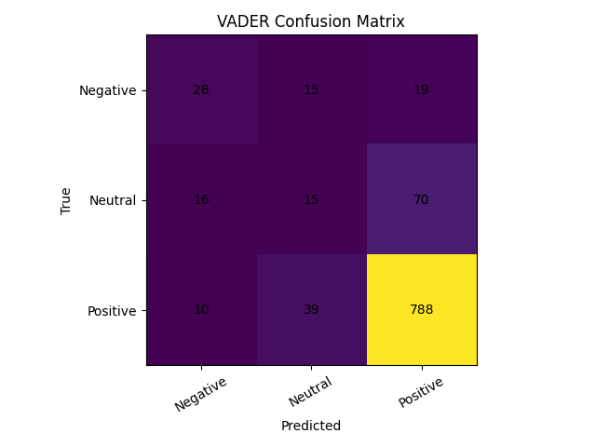

Figure 7a. VADER Confusion Matrix

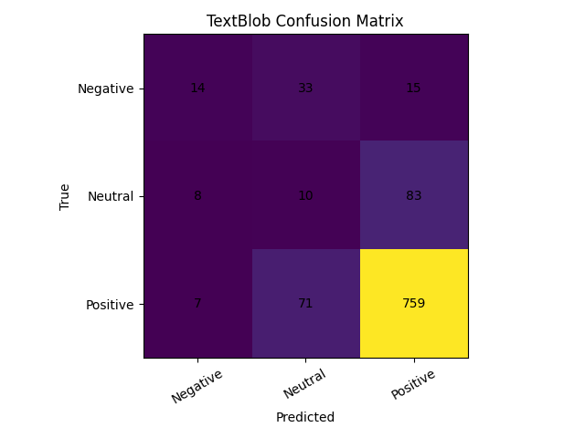

Figure 7b. TextBlob Confusion Matrix
The confusion matrices provide deeper insight into classification behavior. Due to the dataset’s strong positive skew, both models perform best in predicting the Positive class. The Neutral class is expected to be the most challenging, as neutral sentiment often lacks strong polarity indicators.

5.5 Discussion
The results indicate that VADER outperforms TextBlob in overall predictive performance. VADER’s rule-based handling of punctuation, emphasis, negations, and degree modifiers likely contributes to its stronger performance on review-style text.
TextBlob shows lower precision, recall, and F1-score compared to VADER, suggesting weaker overall classification performance on this dataset.
The class imbalance observed during dataset exploration plays a significant role in model behavior. Since the majority of reviews are positive, accuracy alone can be misleading. The use of weighted metrics ensures that minority classes are properly accounted for.
Common failure cases for both models include:
- Subtle or mixed sentiment reviews
- Sarcasm
- Domain-specific product terminology
- Reviews with weak emotional language
Overall, VADER provides the stronger lexicon-based baseline for this dataset.

6. Conclusion
This phase successfully implemented a complete lexicon-based sentiment analysis pipeline for the Amazon Fashion reviews dataset. The analysis began with a detailed exploratory data analysis (EDA), which revealed strong positive rating skew, long-tail distributions across products and users, and significant variability in review length.
Text preprocessing included rating-based labeling, column selection, normalization strategies tailored to each model, and careful handling of outliers. These steps ensured data consistency while preserving sentiment-bearing features.
Two lexicon-based models, VADER and TextBlob, were implemented and evaluated using weighted classification metrics to account for dataset imbalance. The results showed that VADER achieved higher overall performance (83.1% accuracy) compared to TextBlob (78.3% accuracy), demonstrating stronger robustness for review-style text.
The findings highlight the importance of model-specific preprocessing and threshold tuning when applying lexicon-based approaches. While both models provide interpretable and computationally efficient baselines, performance limitations remain, particularly in handling subtle or mixed sentiment.
Overall, Phase 1 establishes a strong analytical foundation and provides reliable baseline results that can be extended in future phases using supervised machine learning and advanced text representation techniques.

7. Assumptions
The following assumptions were made during Phase 1 of the project:
- Numerical ratings (1–5 stars) are treated as proxy ground-truth sentiment labels.
- The mapping of ratings into three classes (Negative, Neutral, Positive) appropriately represents sentiment polarity.
- Thresholds used for mapping lexicon scores to sentiment classes (±0.05 for VADER and ±0.1 for TextBlob) are heuristic and may influence classification boundaries.
- Combining summary and review_text improves lexical coverage for sentiment detection.
- The random sample of 1000 reviews is representative of the broader dataset distribution.
- Reviews are assumed to be written in English, consistent with the lexicons used.

8. References
McAuley, J. (n.d.). Recommender systems and personalization datasets. University of
California, San Diego. http://jmcauley.ucsd.edu/data/amazon/
Ni, J., Li, J., & McAuley, J. (2019). Amazon review data (2018). University of California,
San Diego. https://nijianmo.github.io/amazon/index.html
Loria, S. (n.d.). TextBlob: Simplified text processing. https://textblob.readthedocs.io/
Bird, S., Klein, E., & Loper, E. (2009). Natural language processing with Python.
O’Reilly Media.
Hutto, C. J., & Gilbert, E. (2014). VADER: A parsimonious rule-based model for
sentiment analysis of social media text. Proceedings of the International AAAI
Conference on Web and Social Media, 8(1), 216–225.
https://ojs.aaai.org/index.php/ICWSM/article/view/14550

9. Appendix 1: Project plan

9.1 Project Objectives
The objective of this project is to construct a sentiment analysis model for Amazon Fashion product reviews using both lexicon-based and machine learning approaches.
Phase 1 focuses on dataset exploration, preprocessing, labeling, lexicon study, implementation of two lexicon-based sentiment classifiers, and validation of model performance using appropriate evaluation metrics.
The goal of this phase is to establish a clear, reproducible analytical pipeline that serves as a strong baseline for more advanced machine learning models in Phase 2.

Week | Activities | Status
Week 3 | Dataset selection and familiarization | Completed
Week 4 | Data exploration (EDA), statistics and visualization | Completed
Week 5 | Labeling and text preprocessing design | Completed
Week 6 | Implementation of VADER and TextBlob models | Completed
Week 7 | Model evaluation, comparison and documentation | Completed
Week 8 | Presentation preparation and final submission | Completed

Task | Responsible Member | Description
Dataset Exploration  (Phase 1.1 a–g) | Daniela Diaz | Performed statistical analysis including counts, averages, distribution of reviews across products and users, review length analysis, duplicate detection, visualization generation, and EDA findings summary.
Preprocessing & Labeling  (Phase 1.2 a–c) | Maria Paula Nova | Implemented rating-to-sentiment mapping, column selection justification, text cleaning pipeline, quality checks, and outlier handling strategy.
VADER Implementation  (Phase 1.3 & 1.6) | Jaturaput Jongsubcharoen | Studied VADER lexicon, implemented sentiment classification using compound score thresholds, tuned classification boundaries, and validated model behavior.
TextBlob Implementation  (Phase 1.3 & 1.6) | Juan David Barrero | Studied TextBlob lexicon, implemented polarity-based classification, adjusted decision thresholds, and contributed to performance comparison.
Report Writing & Integration  (Phase 1.7 & Report Requirements) | Anmol Shrestha | Generated evaluation metrics (accuracy, precision, recall, F1), confusion matrices, comparison table, discussion analysis, and final documentation formatting.

9.4 Tools and Technologies
- Python
- Pandas
- NumPy
- Matplotlib / Seaborn
- NLTK (VADER SentimentIntensityAnalyzer)
- TextBlob
- Scikit-learn (evaluation metrics)
All experiments were conducted using reproducible sampling with a fixed random seed.

9.5 Plan for Phase 2
Phase 2 will extend the project using machine learning models. Planned steps include:
- Text representation using TF-IDF or similar techniques
- Implementation of two supervised models
- Training and testing using stratified split
- Comparison of Lexicon vs Machine Learning approaches
- Implementation of review-based recommender enhancement
- LLM-based summarization and automated response generation

10. Appendix 2: Meeting register (simple table showing date and time of each meeting, who attended, subjects discussed and assignments).
Date | Time | Attendees | Topics Discussed | Assigned Tasks
Feb 10, 2026 (Tue) | 7:00 - 7:45 PM | All Team Members | Project overview, dataset understanding, review of Phase 1 requirements | Daniela: EDA statistics; Juan: labeling design; Jaturaput: lexicon study; Maria: preprocessing planning
Feb 12, 2026 (Thu) | 7:30 - 8:15 PM | All Team Members | Initial EDA findings, rating distribution analysis | Daniela: finalize visualizations; Juan: duplicate/outlier checks
Feb 14, 2026 (Sat) | 6:30 - 7:30 PM | All Team Members | Labeling strategy (ratings to sentiment classes), column selection discussion | Maria: implement labeling; Jaturaput: normalization logic
Feb 16, 2026 (Mon) | 7:00 - 8:00 PM | All Team Members | Lexicon selection discussion (VADER vs TextBlob vs SentiWordNet) | Jaturaput: implement VADER;  Juan: implement TextBlob
Feb 18, 2026 (Wed) | 7:15 - 8:15 PM | All Team Members | Model evaluation metrics (accuracy, precision, recall, F1), confusion matrices | Juan: compute metrics  Team: interpret results
Feb 21, 2026 (Sat) | 6:00 - 7:00 PM | All Team Members | Final report review, formatting, presentation preparation | Anmol: finalize documentation and slides

