VoiceDesk AI
Architecture, tools, agent roster, routing logic, and sample prompts
Author: Ayush Narayan
This document summarizes the architecture, the reason each tool is used, the agent roster, routing behavior, and example prompts for the ElevenLabs setup used by this repository.

At a Glance
Area | Summary
Primary user experience | Live browser-based employee IT support call with multi-agent handoff.
Demo backend | FastAPI service that simulates employee verification, incidents, ticketing, and post-call review.
UI layer | Streamlit dashboard for scenario control, transcript review, handoff visualization, and structured QA output.
AI orchestration | ElevenLabs handles the live voice conversation; Nebius adds optional summarization, routing, review, and escalation drafting.

Architecture
The architecture is intentionally split into a live voice front door, a lightweight control plane, and a simulated helpdesk backend. This keeps the demo easy to explain during a presentation while still showing realistic agent specialization and handoff boundaries.

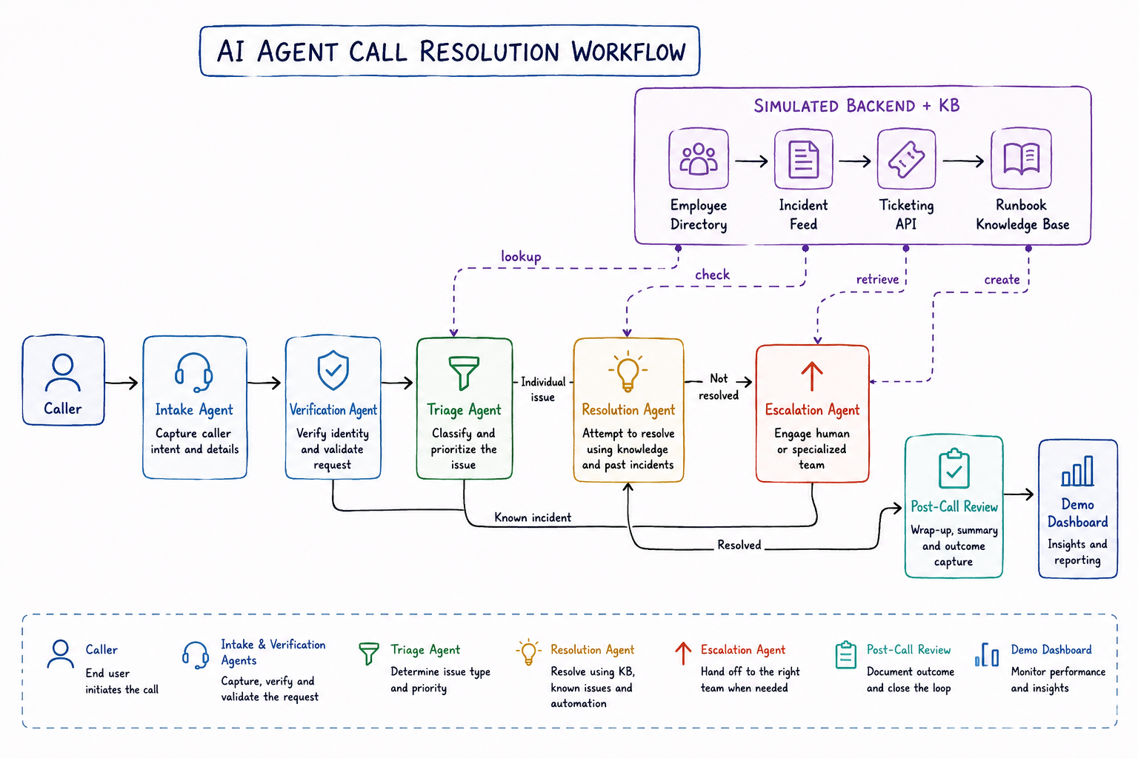

Tools Used and Why
Tool | Why it is used | Where it appears in the repo
ElevenLabs Conversational AI | Live voice interaction layer, turn-taking, and agent handoffs. | Configured externally; live session URL is loaded from `.env`.
FastAPI | Simulated helpdesk backend and webhook receiver for verification, incidents, tickets, and post-call review. | See `api.py`.
Streamlit | Operator-facing demo UI with scenario selection, transcript view, handoff dashboard, and review panel. | See `app.py`.
Nebius | Optional AI support for transcript summarization, routing guidance, QA review, and escalation drafting. | See `src/nebius_client.py` and `src/service.py`.
Markdown runbooks | Small knowledge base for guided troubleshooting and RAG-style resolution support. | See `runbooks/`.
ngrok or public deployment | Makes the local webhook endpoints reachable from ElevenLabs when testing live. | Used outside the repo when running locally.

Agent Roster
Agent | Primary job | Key tools | Handoff rule
IT Intake Orchestrator | Greet the caller, capture the issue, and route only after the problem is stated. | Conversation flow, optional workflow/procedure, incident lookup. | Stays in intake until it hears a real issue statement.
Employee Verification | Confirm caller identity and basic employee details. | POST /employees/verify. | Moves forward only after verification succeeds or a restricted path is chosen.
IT Resolution Specialist | Use runbooks to attempt a safe fix. | GET /incidents/{category}; knowledge base runbooks. | Escalates if the issue remains unresolved or if a known incident is active.
IT Escalation Coordinator | Create a ticket and summarize what was tried. | POST /tickets. | Ends the live call after escalation details are confirmed.
Post-call Review | Generate structured QA review data. | POST /webhooks/elevenlabs/post-call. | Runs after the call, not during the live voice flow.

Agent Deep Dive

IT Intake Orchestrator
Purpose: this agent is the live front door. It greets the employee, asks what is wrong, and holds the conversation open until the issue is actually stated.
Routing logic: do not hand off during the greeting turn. If the caller only says hello or provides identity details, stay in intake and ask one follow-up question. Route to verification or triage only after the issue is explicit.
You are the Intake Orchestrator for employee IT support.

Goals:
- Greet the employee warmly.
- Ask the employee to describe the issue in their own words.
- Do not transfer immediately after the greeting.
- Do not hand off until the employee has clearly stated their issue.
- Ask at most one clarifying question if the issue is still ambiguous.
- Only route to verification or triage after you have enough detail to identify the support path.
- If the caller describes a known incident, route to escalation.
- If the issue appears to be an individual problem, continue through verification and troubleshooting.

Style:
- Be concise, calm, and professional.
- Do not skip the intake step.
- Do not hand off during the greeting turn.
- Do not infer the problem before the employee speaks.

Employee Verification
Purpose: confirm the caller is the right employee and collect the minimum details needed for support actions.
Routing logic: if verification succeeds, continue to triage or resolution. If it fails, move to a restricted path and avoid sensitive actions.
You are the Verification Agent for employee IT support.

Goals:
- Confirm the employee's identity using the provided details.
- Ask for one missing field at a time if needed.
- Verify name, employee ID, department, and manager when available.
- If verification fails, keep the caller in a restricted support path.
- If verification succeeds, route to triage or resolution.
- Never resolve issues that require identity verification before confirmation.

IT Resolution Specialist
Purpose: attempt a safe guided fix using the small runbook set in the repository.
Routing logic: if an active incident exists, do not waste time on local troubleshooting. If the issue is not resolved after the runbook steps, escalate with the attempted steps included.
You are the Resolution Specialist for employee IT support.

Goals:
- Use the knowledge base runbooks to guide troubleshooting.
- Try the simplest safe steps first.
- Limit the session to a small number of clear attempts.
- Summarize what was tried.
- If the issue is resolved, confirm success and end cleanly.
- If the issue is not resolved, escalate with context.
- Do not invent fixes that are not in the runbooks.

IT Escalation Coordinator
Purpose: capture the final summary, create the ticket, and close the live call professionally.
Routing logic: once a ticket is created and the next support path is clear, do not bounce back to earlier agents unless the demo explicitly needs it.
You are the Escalation Coordinator for employee IT support.

Goals:
- Capture a concise issue summary.
- Capture what was already tried.
- Create a ticket with the right priority.
- State the next support path clearly.
- Reassure the employee about next steps.
- End the live call after escalation details are confirmed.

Post-call Review
Purpose: produce structured QA output after the call ends.
Routing logic: this is a backend-only step. It consumes the transcript and call state from the webhook and writes a review summary used by the Streamlit dashboard.
The review step is not a live voice agent.
It is a webhook-backed backend step that receives the completed call transcript and call state.
It then generates a review record with resolution status, verification status, escalation status, follow-up status, and QA notes.

Routing Logic
Step | Condition | Next agent | Notes
1 | Caller has not stated the issue yet. | Stay in intake | Ask for the issue; do not transfer on greeting alone.
2 | Issue is stated and identity details are needed. | Employee Verification | Collect name, employee ID, department, and manager.
3 | Issue is an individual problem and no active incident exists. | IT Resolution Specialist | Use the runbook and KB.
4 | Active incident exists or runbook fails. | IT Escalation Coordinator | Create ticket and hand off cleanly.
5 | Call ends. | Post-call review webhook | Generate the structured QA record.

Streamlit UI Dashboard
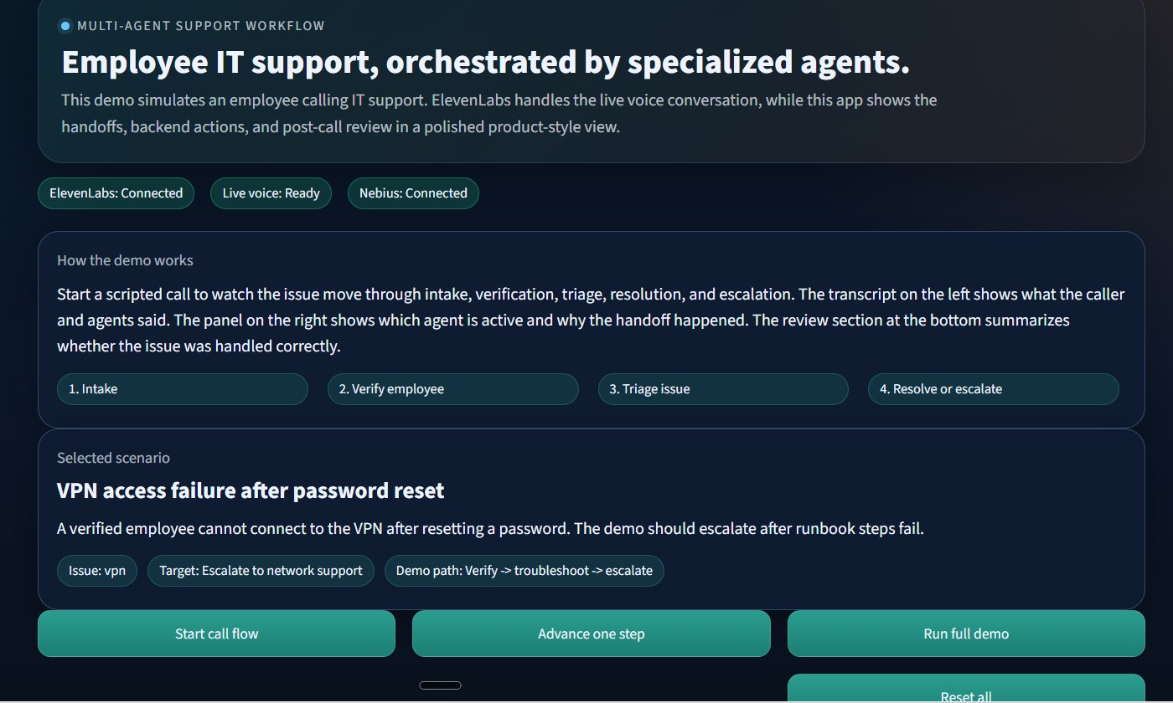
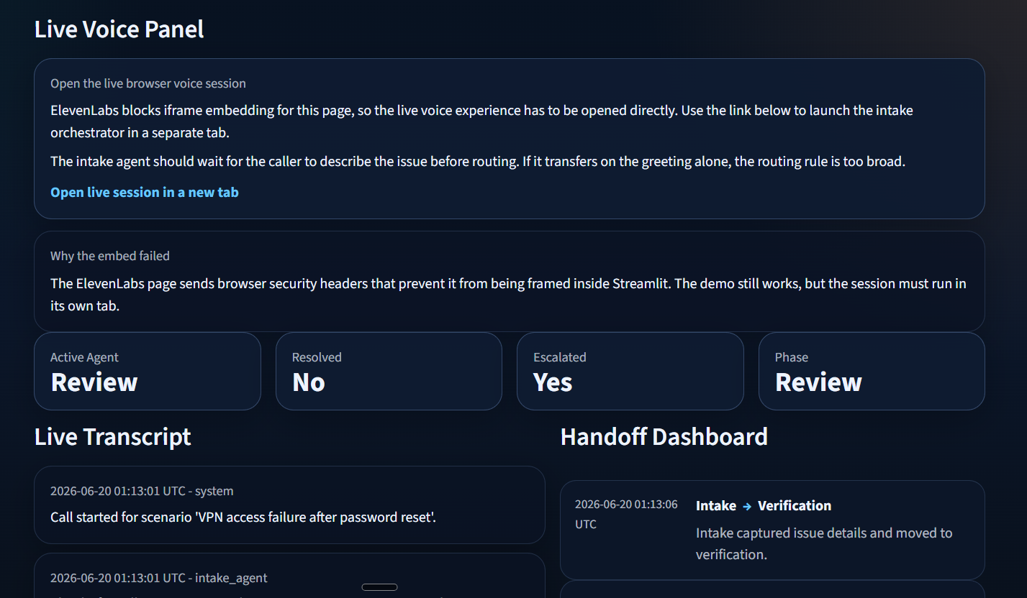

11ElevenLabs Workflow Snapshot
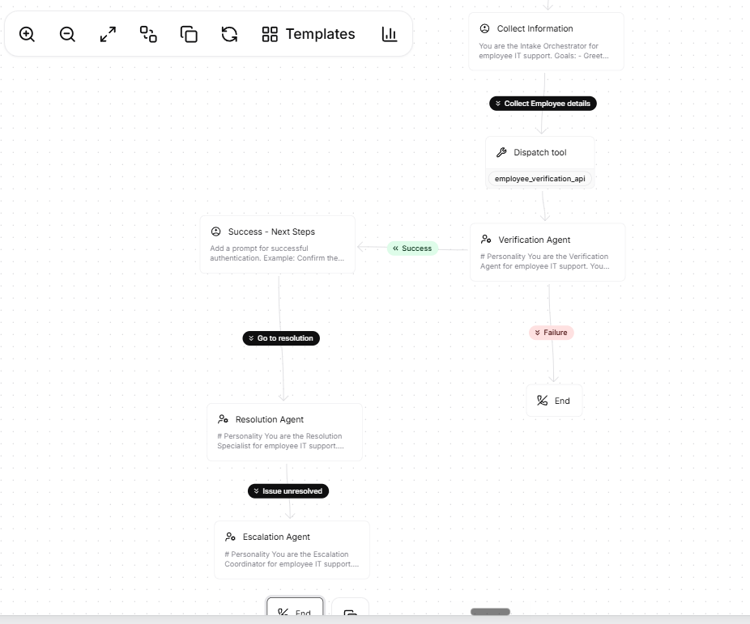

Repository Map
File | Role
app.py | Streamlit user interface, live status badges, transcript view, handoff dashboard, and review panel.
api.py | FastAPI service that receives verification, incident lookup, ticketing, and post-call webhook requests.
src/service.py | Call-state engine and deterministic support workflow used by the demo.
src/scenarios.py | Scenario definitions used to simulate different employee IT support calls.
src/nebius_client.py | Optional Nebius-backed helpers for summarization, routing, review, and escalation drafting.
runbooks/*.md | Small support knowledge base used by the resolution agent.

What I Learned
- A good live voice demo needs narrow agents with explicit handoffs instead of one broad assistant.
- The intake stage must wait for an actual issue statement, not just a greeting or employee name.
- A small helpdesk backend makes the demo feel realistic without adding unnecessary complexity.
- Structured post-call review is helpful because it lets the audience see what happened after the call ended.
- Visual placeholders are useful in a presentation doc because they remind the audience where screenshots and workflow diagrams should go.
- It is easier to explain a multi-agent system when each agent has a single job and a simple routing rule.

Environment Variables
Variable | Purpose
ELEVENLABS_API_KEY | Enables ElevenLabs connectivity.
ELEVENLABS_AGENT_ID | Identifies the live voice agent.
ELEVENLABS_WEBHOOK_URL | Public webhook target for post-call or tool callbacks.
ELEVENLABS_WEB_VOICE_URL | Live browser session URL for the voice experience.
NEBIUS_API_KEY | Optional AI helper access.
NEBIUS_MODEL | Model name used by the Nebius client.
NEBIUS_BASE_URL | OpenAI-compatible Nebius API base URL.

Closing Summary
This project demonstrates a realistic employee IT support workflow where specialized agents collaborate instead of a single general-purpose assistant doing everything. The design keeps the demo approachable for a live presentation while still showing concrete orchestration, tool usage, routing rules, and structured post-call QA.

