Stasiu Tippett
Computer Science 311
February 27, 2026

Introduction
The goal of this project was to build a FAQ chatbot that can answer questions regarding a product. At first, This project uses some cheap earbuds that are nice but a little bit hard to use. They are a good candidate for this project because they come from a less common manufacturer so looking up how to use them can be more difficult. Instead of reading a long annoying FAQ or looking at google or large language model (LLM) output without context this project allows the user to simply chat with an LLM that understands the parameters and steps outlined in the FAQ. The process of giving AI context of data is called Retrieval Augmented Generation (RAG). When using an LLM the model has training information, but that information could be incomplete or inaccurate. Additionally, LLM’s are known to hallucinate i.e. provide a confident answer that is essentially made up. RAG systems allow the LLM to reference accurate and up to date documentation. The question can be made in natural language instead of looking through documentation and crafting search terms. The chat bot has a CLI tool and a graphical UI for whichever the user prefers.

Methods used
RAG sounds good but how does it work under the hood. The RAG pipeline used in this project is indicative of the standard application that uses RAG. The base of the pipeline is the document being stored in a vector database. Next the applicable pieces of information are retrieved from the database using the semantics of the question. The pieces of information are then passed to the LLM API. The model itself is stateless so being given data which has been pulled from a database ideally grounds the LLM in objective references. This can minimize or remove the hallucination problem which plagues LLM.
What is RAG? Rag has two primary components. The ability to search through a persistent source of information. In the case of this project the FAQ documents. The second component is the generative model (LLM) itself. RAG integrates the retrieval into the generative process itself. But why is it necessary? LLMs commonly produce confident and even seemingly coherent answers which turn out to be wrong in the end. This becomes more of a problem when the answer is on a topic not inside the models training. The model might not contain the data for several reasons. Maybe the data came out after the training was completed or maybe the data is private, and the RAG pipeline accesses data which belongs to an individual or organization. Or it could be an obscure topic that the model only vaguely understands. RAG solves for this by having verifiable context taken out of the source docs if it is relevant and has the needed information the LLM output would be vastly more accurate. This has a grounding effect on the LLMs output.
Text Embedding what is it and how does it work? The next method used is called text embedding. We remember what a vector is from physics class direction and magnitude as opposed to simple magnitude of scalars. Text embedding takes small pieces of text and creates relations between them. These relationships are stored in arrays and are called vectors because they point in the direction of the other part of text and they have a value that quantifies the distance between the two pieces of text. It is essentially a mapping of semantic or fixed length chunks of text and embedding into a high-dimensional vector space. This ties around to the retrieval process. In order to retrieve correlated pieces of data, knowing what is related to what is and how related they are is very powerful. This allow the retrieval prosses to compare many small chunks of text and measure by how related to each other they are enabling the retravel of data that relates to a common topic. The users question literally relates to information in the database which is bundled with the question and passed to the API giving the model the ability to have much more insight into the answer. Text Embedding works similarly to LLMs in the sense that an embedding model is needed. A helpful way to think of it like a reverser LLM although that is not entirely accurate and more of an analogy. Conveniently the embedding models don’t need as many resources to get quite good results. For this project all-MiniLM-L6-v2 was chosen. It is a good model for a project of this scale because it is lightweight and fast. It is very supported with LangChain libraries and addons to make it convenient to tie into the project. This model is suited for data that is broken down at the sentence level.
Large Language Models (LLMs) are a vital and the most hyped-up part of the pipeline. Although the LLM is not the primary store of information it plays an important part in synthesizing the final output. The LLM has three tasks to complete. First it takes the retrieved chunks and reads them. Then it reads and follows the actual prompt from the user. Finally, it puts together the final output for the user including proper formatting and style. Dividing up tasks is the real power of RAG. It was particularly interesting in this implementation that the motel was run locally on the same device using Ollama. It is amazing that 16GB of ram is sufficient to use this kind of technology. The API exposed by the local model is totally interchangeable with the more standard ones accessible online. This is a benefit of the project because it could work with local or over the internet based APIs.
The final method used in this project is text chunking. Text chunking is needed because plain text can’t be directly fed into the embedding system. The embedding model is only able to handle chunks of text about the size of a sentence. If too much text is sent to the embedding model it will truncate the text and it will not be included. Missing text would make retrieval less accurate. Breaking up a text file into smaller chunks will function better with the input limits. In addition the size of the pieces of information that can be accessed are much smaller making it granular. Also, if the chunks of text are too big different topics will be included in each chunk which will complicate things. The chunks of text do have to align with the sentences and paragraphs of the original text. This keeps the chunks much more manageable and logically consistent. Like the LLM the embeddings library is run on the local machine making things self-contained. In the case of the embeddings model there is no API instead a python library interacts with the model.

Dataset Information
The source of the persistent data used in the RAG pipeline was the manufacturer’s website. The website had a FAQ that was used as the data. To count the number of records simply counted the number of chunks in the ChromaDB once the embedding was completed. The dataset contained a total of 267 chunks each being its own record.
Prior to embedding the data was text. The full text counts as the feature by itself. After the embedding was completed each record had three features. The first feature is the text content itself this is a chunk of text that was chunked by the embeddings model and is of string data type. The second is the Embedding vector. The embedding vector is an array of floats and is simply a multi dimensional vector array that holds the vectors. The final feature is the chunk metadata. The metadata is of Dictionary data type and is simply a python Dictionary. It holds the position of that chunk in the source document and its location in the ChromaDB itself.
Preprocessing is the process of preparing data for the embedding. The first step in preprocessing is text sanitization. This was simply accomplished by calling the LangChain TextLoader function and limiting the encoding to utf-8. Next the text is chunked by passing it to RecursiveCharacterTextSplitter function belonging to the LangChain text splitter. It is passed two values 500 and 50. 500 represents the maximum size of each chunk and 50 represents the allowable overlap. The overlap allows for context to be kept for each chunk. The size is measured in charictures in this case utf-8. Lastly the embedding model converts each chunk to a vector and puts it in the ChromaDB. This allows the data to persist with its meta data and relative position in the form of a vector.
Libraries, Tools, and Frameworks
Like meany Python projects this one required a lot of dependencies. From the vector embedding to the final UI these are the tools that made it all possible.
- LangChain
- ChromaDB
- HuggingFace
- OpenAI Python client
- Streamlit
LangChain is a LLM orchestration framework that helps manage interacting with multiple moving parts instead of a primitive chat with the LLM. It can facilitate passing information to the LLM as well as allowing it to interact with tools and things like that. This project only scratched the surface of its capabilities. However model context protocol is a more contemporary alternative for many of LangChain’s capabilities.
ChromaDB is a persistent vector store for keeping and searching vectorized chunks of data. Langchain can interact with it and make passing vector data to the LLM a lot more convenient. The embedding model will insert the data into the database, so the embedding model only needs to run once. Alternatively the embedding model can keep the embeddings in memory if referencing only needs to happen once.
HuggingFace is a website that is very important in the world of data siance and machine learning. Especially in the world of open source models and data. In this project the HuggingFace embedding model was used to vectorize the data. The model was all-MiniLM-L6-v2 which was a good size to run on a laptop. HuggingFace has an abundant and overwhelming number of models and data that can be accessed by the open source community.
OpenAI Python client is a wrapper that allows python to interact with LLM APIs. OpenAI the creators of ChatGPT created the OpenAI API and it became the current standard for LLM APIs. This python library allows python programs to interact with LLMs over the internet via the API. It’s a convenient library to use because it only takes one function call assigned to a variable and the program can start piping data to the LLM and getting responses.
Lastly Streamlit is a web app UI library for a LLM chat interface. It should not be used in production applications but for projects like this it’s a spectacular tool to spin up a quick UI to interact with LLMs. It really was a pleasure to use because it only took a few lines of code to get a working UI and a few small modifications to the TOML config file and the interface was exactly how it should be for ease of use.
Application Design
The application design is the strong point of this project. The design is quite clean and modular yet it gets a lot done. At a high level it represents a flow of data from the boring FAQ to the structured, formatted and hype-specific LLM output. The architecture flows from the original text FAQ through sanitization which removes characters that can’t be chunked and stored in the database. Next it and its embeddings are stored in the ChromaDB. Once the user presents a query it is compared to the embeddings in the database to look for similarity. The original question and any relevant data is passed to the LLM in formatted manner so it can tell the question from the context. And finally the LLM’s response is received and passed to the user as a final output. This is how the data flow through the pipeline to facilitate RAG.
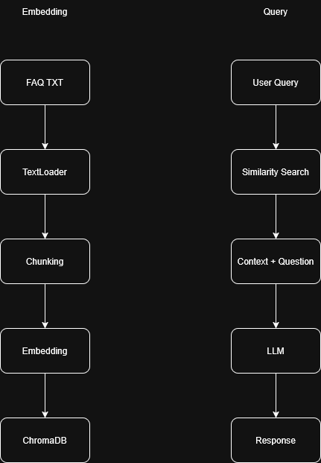
The code is broken up into four files that each accomplish different steps in the process. First is the embeddings.py which contains two functions. One to sanitize chunk and embed the data. And the second to query the database with the user’s question. The llm.py file handles calling the openAI API and passing it the user’s data. It contains one function called llm() that facilitates this. It includes the system prompt that tells the LLM that it needs to respond and to keep responses short. Thes functions are called from the app.py and the main.py. These allow either the UI or the CLI interface depending on the user’s preference. Both main.py and app.py check if the database exists and if not they create it using the provided data. The project contains a fair amount of configuration that is handled by the various config files. This includes the .env and the .streamlit files.

Instructions for Running
Getting this project up and running is pretty straightforward. First navigate to the GitHub for the project then clone the repo to your machine. Next create a Python environment and activate it. The project includes a requirements.txt so simply use pip to install dependencies into the local environment. Next obtain an LLM API key. For this project a local LLM was used that is capable of running on a laptop. Its API key was saved but any OpenAI compatible API key will work. The interface for configuring this project is the .env file. Create one and populate with the following values.
- DATA_PATH: file path to .txt file
- OPENAI_BASE_URL: URL the LLM is at.
- OPENAI_API_KEY: API key to preferred model
- MODEL_NAME: name is required for compatibility
- EMBEDDING_MODEL: The embedding model
- CHROMA_PATH: File path to the vector database
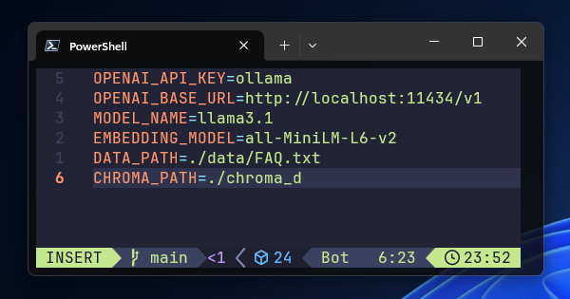
Here is what the configuration looked like. Keep in mind it’s not a one size fits all. To begin with only the LLM info needs to be provided unless the user wants a custom implementation. The rest will fill itself in if nothing custom is selected. The project is technically modular so it could be pointed at a different text file of data. Also, a different embeddings model could be used if preferred.
The project has two user interfaces a CLI and a UI. Simply run the main.py to use the cli interface to talk to the model or run “streamlit run app.py” to use the web app version. When using the UI version, the command will open the browser, and a chat UI will be visible. If the browser doesn’t launch, simply open it and navigate to the URL displayed in the terminal. If the cli is preferred just run the main.py file and chat right in the terminal. The user can then ask the chat bot questions pertaining to the product FAQ.

Results
Given the relatively low intelligence of the local models the output was quite good and would work even better with a larger model like ChatGPT or Claude. The super prompt had to be adjusted because at first the LLM was giving long responses. Once told to keep the responses to one or two sentences it worked well. The web UI also had to be configured in its configuration file to make it more user friendly and minimalist. Once set up it works well for answering questions about specific information that is as up to date as the file and as specialized as needed. As demonstrated in the screenshot the model is able to see numbers in the FAQ like the battery life. Additionally it is able to semantically look up information like how to pause. The noise cancellation question, however, seems to not reference the FAQ and the LLM answered based off its knowledge, which is important to note the limits of this kind of technology.
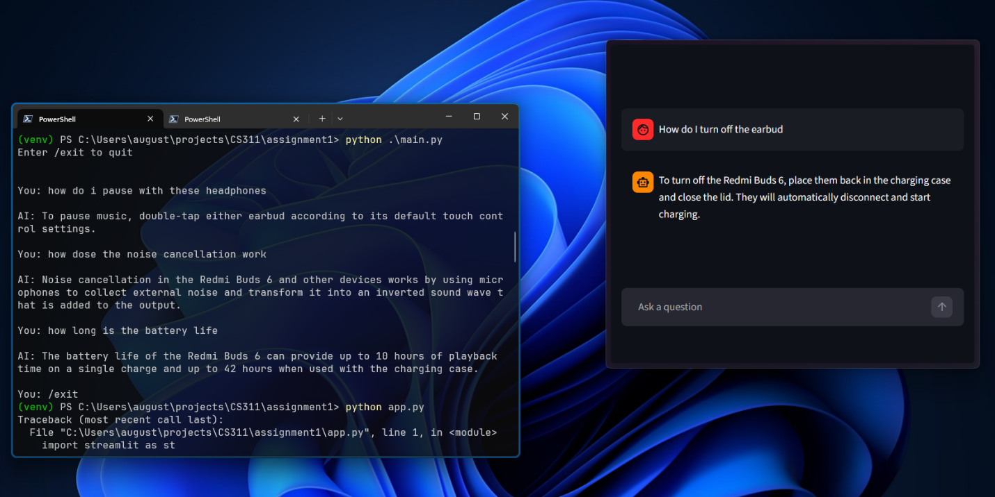

Insights
During this project a significant amount of insight was derived. Some portions of the project ran smoothly but others had some friction. The RAG responses were pretty grounded in the FAQ. It is visible in the screenshot and can be compared to the FAQ in the GitHub. The local Ollama LLM ran its inference without any problems and the output was fairly good for its size. The modular structure of the project was also a strong point. The separation of concerns with the different Python files makes it manageable. And the modular setup allows for future expansion or changes. Some of the friction point on the other hand made the project less than perfect. First concern is the dataset. The dataset is plain text instead of tables or some kind of structured data. There is also a trade off with the sizes of the chunks of text. If the chunks are too small context is lost but if the chunks of text are too large the information becomes noisy. The shortcoming of the CLI interface is it doesn’t maintain a conversation memory. That problem is solved by the UI. Lastly for production or serious use a more powerful model would be a better fit. The local LLM is perfect for building the RAG pipeline, but it doesn’t have the most powerful intelligence.
There are some potential improvements that could be made on the project. First a different data source could be used instead. It could be a CSV or some other kind of more structured data as opposed to text. This could facilitate filtered retrieval. Next the search of the data could be multi-faceted i.e. it could search for keywords as well as the semantic search. This would be an interesting approach to make the gathering of data more thorough. A more coding heavy improvement would be adding memory to the CLI interface so the LLM could see the conversation history. Although there could be improvements the final project is comprehensive and allows real use for talking to a FAQ.

References
Study.com. (n.d.). Practical application for artificial intelligence: Learning chatbot. Retrieved February 24, 2026, from https://study.com/academy/lesson/practical-application-for-artificial-intelligence-learning-chatbot.html

Study.com. (n.d.). Large language models and artificial intelligence. Retrieved February 24, 2026, from https://study.com/academy/lesson/large-language-models-and-artificial-intelligence.html

Xiaomi. (n.d.). Redmi Buds 6 FAQ. Retrieved February 24, 2026, from https://www.mi.com/global/support/faq/details/KA-509528/

