Stasiu Tippett
Computer Science 311
March 3, 2026

Price Prediction App

Introduction
This project is a natural gas prediction application. We start with a training data set of historical daily or monthly closing prices. The application uses a random forest algorithm to create a model of past natural gas prices based on the data set and predicts the next day’s price. In addition, it provides statistics about the data set and includes a visualization chart to make it much more readable. This kind of prediction model would have a myriad of use cases in business finance and logistics as well as other fields. For example, how can a business know what it is going to spend in the future if the price in the future is unknown. Prediction models can give planners at least an idea of what to expect. On the other hand, in the case of financial speculation being able to predict future prices would be the Midas touch for hedge funds or commodity traders making prediction models a powerful tool used in some of those cases. In a logistics use case, knowing the price of things could provide context for where it is most worthwhile to transport goods to and what costs will be associated with the transport expense.
Algorithms Used
Prediction seems like the realm of fortune tellers with magical powers of researchers who have tons of disconnected information that affects other information but for machine learning it is neither. Instead, it simply looks at the value being predicted in the past and infers from past relations what the data in the future is likely to be. For this machine learning application, the algorithm used was Random Forest. Random forest creates a collection of trees in the case of this project 200. Each tree is made up of a different random batch of data the branching is made up of different input features. Once completed the trees are averaged to get the prediction. The Random Forest algorithm is best suited for this data set because it handles nonlinear data relationships well. Also, it tends to be more resistant to overfitting when more training runs or performed. It is also a strong contender when the dataset contains relatively few features like was the case with the dataset used in this project. It is applicable for datasets that do not have an assumption for the distribution of the data like normal form or left or right distribution. If the data is more spread-out Random Forest, is a good call.

Dataset Information
The dataset for this project was acquired and downloaded from Kaggle. Kaggle is a data science website that has a lot of code and data sets which can be downloaded and used for projects. For this project a CSV was downloaded it contains the historic prices of Natural Gas. The dataset covered time between January 7, 1997 through September 1, 2020. The records in the dataset correspond to the total number of rows in each CSV files used. The data set has daily records and monthly. For this project the daily records were used. There was a total of 5953 records contained in it. Each record in the original data set had two features. One feature for date and the other for price. The project used lag features to model the recent trends.
Name | Description | Data Type
Price | Today’s price | Float
Date | Today’s date | String
Lag1 | Price from 1 day ago | Float
Lag2 | Price from 2 days ago | Float
Lag3 | Price from 3 days ago | Float
Lag4 | Price from 4 days ago | Float
Lag5 | Price from 5 days ago | Float
Lag6 | Price from 6 days ago | Float
Lag7 | Price from 7 days ago | Float

The data set being worked with in this project is pretty simple. Despite its simplicity it needs to be described in detail. The data CSV contains two columns containing the data. It is time series data so one column is the date and the other is the price. The date column is a string and the price is a floating point number. The date could be switched to date time data type if needed. The price floating point represents the per unit price of gas on the corresponding date. The data set is simple but suitable for this project. The engineered features of the project are very important due to the fact that we only have one column that is numeric. The fundamental logic behind the training of this module is that the price history contains data about how the price will perform in the future. Compounding this trend into the model is the ultimate goal.

Tools and Libraries
This project only uses three tools that are outside of pythons built in tools. Python projects tend to stack up the dependencies, but this project is able to get it done with just three.
- Pandas
- matplotlib
- scikit-learn
Pandas is a data handling library the that allows programs to move data sets from file into memory in what are called data frames. Commonly abbreviated as df. It is incredibly powerful and is used for many machine leaning and data analytics tasks.
Matplotlib is a data charting and visualization library that is used to easily display data in python programs and notebooks. Although there are better and more contemporary libraries that can do the same thing with better charts Matplotlib is definitely the industry standard.
Scikit-Learn is a simple machine learning library with a myriad of easily accessible. This library abstracts so much and put powerful algorithms at your disposal with a few simple lines of code.
Design and Implementation
The design implementation of this program is sleek and follows a logical flow to handle the information. The philosophy used in programming was to keep thing minimal and directly to the point with no frills to it while still doing everything required well. The flow of data is intended to be from a CSV file containing price data of natural gas through to a trained model with the capability to predict the future price of natural gas. The first step is to use Pandas to load the data into a data frame and assign the column that is supposed to be predicted. The script uses a simple loop to look for the correct column for the prediction. It searches for the price and close keywords. At this point the information about the dataset is printed to the terminal. This helps to ensure the data is loaded properly and nothing has gone wrong. Potential problems would be a problem with opening the file or permissions or it could be a problem with the data itself being corrupted or incompatible with the script. If something goes wrong, giving the user feedback is quite valuable. Now the program turns to working on the model itself. To begin with the engineered features. They consist of a lag of seven days. This is done by creating a matrix where each row is a day’s price covering the last seven days. These prices are paired with the current day’s price. If any rows are shifted, they are removed to which will keep the training data clean. Given that the data itself is in order because of its time series data the training data is split based on time and not randomly. The training testing split is the standard eighty twenty split. With this split the model is trained on the first eighty percent then the trained model is tested on the remaining twenty percent to insure it actually has prediction power. Now that the data is divided up it is passed to the training algorithm itself. In this case it is a Random Forest Regressor that contains two hundred trees. The training is preformed with the lag feature. The model is then evaluated against the test data. For the last two part step the script prints the prediction for the price of natural gas on the day following the end of the data set and a chart depicting the actual price and the predicted price. The tomorrow prediction is made using the lag feature to give a predicted price. The chat is created using the Matplotlib library. It is always crazy seeing how much can be done with just a few lines of code when taking advantage of powerful tools like this library. The chart really gives a lot more context than simply printing numbers to the terminal. Overall, the script ends up being like fifty lines of code and still is able to get the needed work done. In particular scikit-learn abstracts away a lot of the complexity of the machine learning algorithms that can be encountered with cutting edge libraries like PyTorch. It is really empowering to be able to access machine learning algorithms with only a few lines of code. This is the power of Python and select libraries when handling data and machine learning.

Running Instructions
Running the app is pretty straightforward. First navigate to the projects GitHub repe then clone it on to your machine. Besides python3 there are only three other dependencies that need to be installed.
- Pandas
- matplotlib
- scikit-learn
These can be installed by running “pip install pandas matplotlib scikit-learn”. It may be best to install using an environment or install globally based on your preference. The data set is fairly small so it was not added to the git ignore and will therefore come with the repo. It could otherwise be acquired from Keggel. Once the dependencies are installed run “python main.py”. The terminal will display data pertaining to the dataset and the MAE and RMSE. The next day’s prediction will then be displayed. Lastly matplotlib will display a chart showing the predicted price compared to the actual price.

Results
The project has two kinds of results after the inference is run. First the consol output then the chart. The consol output summarizes the data and describes how accurate the training was. The output also has the file name and other information about the data set. The graph uses Matplotlib to display the data set and the prediction made by the model. The graph has colors and compares the two. There are some statistics about the data set including mean, standard deviation, minimum and quartiles. Having access to this information allows the user to ensure the data is loaded correctly and the model was able to perform its training. Given that the price in the data set is denominated in dollars it is important not to stray too far from thinking about things in dollars. Looking at a raw number can distract too much from the dollar or cent value.
After the features are loaded the script next moves on to do the training. After it completes it displays the actual metrics of the model. The model has a Mean Absolute Error (MAE) of 0.0785 meaning the difference between the actual price and the prediction. In this case it is approximately eight cents most of the time. On the other hand, Root Mean Squared Error (RMSE) amounted to 0.1397. The RMSE is like the MAE except it uses square roots thus punishing larger differences more as they get bigger. That makes it more sensitive to large errors for a short time. These numbers show the that the predictions are fairly accurate except for a few days when the predictions were off by more than the average.
They say a picture is worth a thousand words and that holds true in the world of data. In this project the graph gives a visual representation of the data and model being worked with. The graph also corroborates the information that was printed to the terminal. The chart shows two lines one represents the data in the data set. While the other one represents the prediction made by the model. It takes a glance to see how the two compare. It is evident that they correlate very closely. This shows that the model is able to generally predict the movement of the data. One noticeable thing is that the line representing the prediction is smoother than the actual data turned out to be, this celebrates the RMSE being higher than the MAE. Lastly the script logs a next day prediction to the terminal. This prediction comes from the most recent set of price history. This is the models educated guess on what the price will be the day after the end of the data set. It has a label saying tomorrow’s prediction on it making it clear what it is.

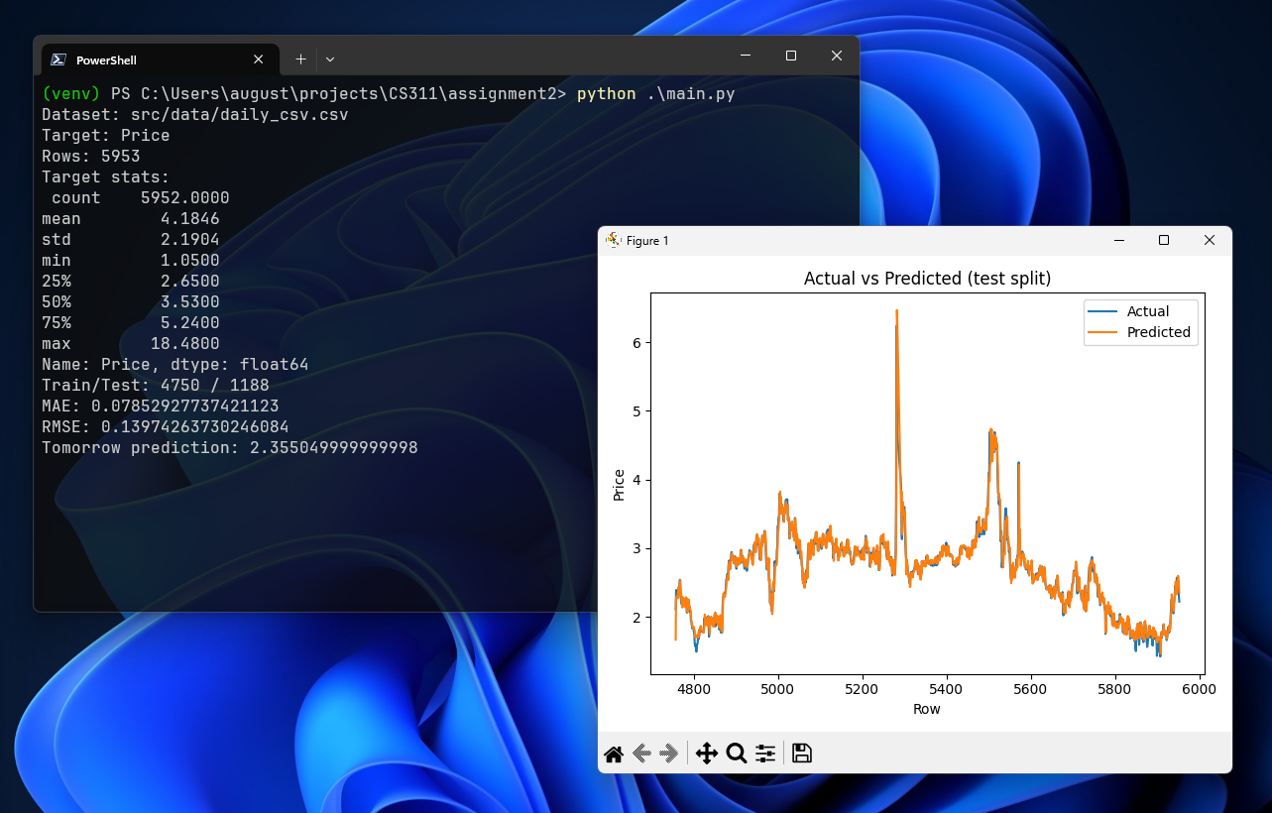

Insights
The Random Forest model was able to track the data quite closely. The MAE was 0.0785. MAE is the difference between the predicted price and the actual price. The Root Mean Squared Error (RMSE) was 0.1397. RMSE is like the MAE but it penalizes larger errors more because it uses square roots. In the dataset the price had a range between $1.05 to $18.48. The MAE being approximately 0.08 means that the price prediction stayed around 8 cents from what the price ended up being. This is small compared to the total price range. The RMSE ended up being larger because it penalizes larger errors. This would suggest that the model is inaccurate for short periods of time, probably around the spiking price changes where it swings back and forth. This can be verified by looking at the chart. The price is harder for it to predict around rapid changes using short term history.
There are a few limitations that jump out about this project. Firstly, the model only predicts based off historical data in this case lagging seven days. The model doesn’t contain any external data like supply and demand indicators. Other external data that could give the model more insight would be storage level, weather, seasonality and economic factors. Second, the lag window of seven days is simple and easy to train but may not give the model as much context as longer windows. A larger window would be able to predict repeating patterns that play out over weeks or months. Third, the Random Forest may not be the optimal algorithm for this use case. There are algorithms that are designed to be used especially with time series data. These special algorithms actually have the ability to store patterns that can be directly found when they are repeated. An example of a more optimized algorithm would be Long Short-Term Memory (LSTM). AS is evident by the name it has memory which allows that algorithm to memorize patterns and predict them if they come back cyclically. Finally, the hyperparameters used in training were default except for the number of trees. Hyperparameters are the knobs for training a model so more tuning of them can result in a better trained model. Good examples of hyperparameters that could improve performance are max_depth, min_sample_leaf and n_estimators. The max_depth controls how the model overfits. The min_sample_leaf requires each leaf to contain more points. And lastly, n_estimators is the number of decision trees giving more trees can make the predictions more stable but only to a point.
There are a few obvious steps that could be taken to improve this project. One good one would be to other engineered features like a rolling standard deviation or momentum features. Momentum features in particular would help the model with its weak point of the price rapidly changing direction. A very powerful improvement would be adding more pieces of price information. An example of price related data would be sales volume. Adding volume to the price data would basically give an added dimension to the model unfortunately this data set does not contain volume data. Finally, an expansive improvement would be to train multiple models and compare their performance and use the most optimal model for actual predictions. This is how real-world data scientists would do it. Examples of algorithms that could be compared are Support Vector Regression, XGBoost, Linear Regression and ExtraTreeRegressor. Training and comparing all of these would be fun and interesting but would be quite a large project.

References

Tunguz, B. (2021). Natural gas prices [Data set]. Kaggle. https://www.kaggle.com/datasets/tunguz/natural-gas-prices

Matplotlib developers. (n.d.). Matplotlib documentation. Retrieved February 28, 2026, from https://matplotlib.org

pandas development team. (n.d.). pandas documentation. Retrieved February 28, 2026, from https://pandas.pydata.org

scikit-learn developers. (n.d.). scikit-learn documentation. Retrieved February 28, 2026, from https://scikit-learn.org

Ntokos, A. (n.d.). Supervised learning in machine learning. Study.com. https://study.com/academy/lesson/supervised-learning-in-machine-learning.html

Perkins, S. (n.d.). Neural networks in machine learning: Uses & examples. Study.com. https://study.com/academy/lesson/neural-networks-in-machine-learning-uses-examples.html

Breiman, L. (2001). Random forests. Machine Learning, 45(1), 5–32. https://doi.org/10.1023/A:1010933404324

