# HACO COMPANY LIMITED

**INTRODUCING AMARA BEAUTY PRODUCTS**

SPECIALLY MADE FOR YOU AS IT CONTAINS:

* Cocoa butter
* A unique blend of effective heritage oils,natural extracts,vitamin A&E ,Amino acids

**BENEFITS OF USING AMARA PRODUCTS INCLUDE:**

* Rejuvenate skin giving you the confidence of smooth and glowing
* Smoothens the skin
* Moistens the skin

We are located at Ruiru town

Mathigu Road

Opposite DOCTORS PLAZA

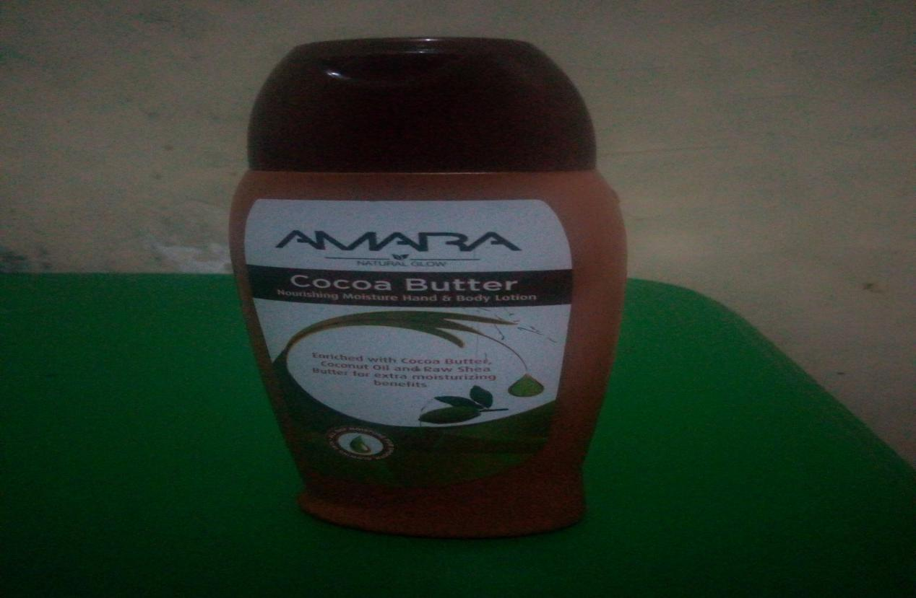

|  |  |
| --- | --- |
| **Working Hours** |  |
| **Opening hours** | **8:00AM** |
| **Closinghours** | **6:00AM** |