Dr. Jan Wedigo Radermacher, Ph.D.

Chair of Finance

Goethe University Frankfurt

**Financial Economics with Python**

Ein Bild, das Text enthält.

Submitted on 30 January 2023 by:

Marvin Silva Fortes (..)  
Marc Eberle (7218978)

Alexander Weinbuch (7240559)

Table of Contents

1 Team 1

2 Development of Idea 1

3 Product Development 2

# 1 Team

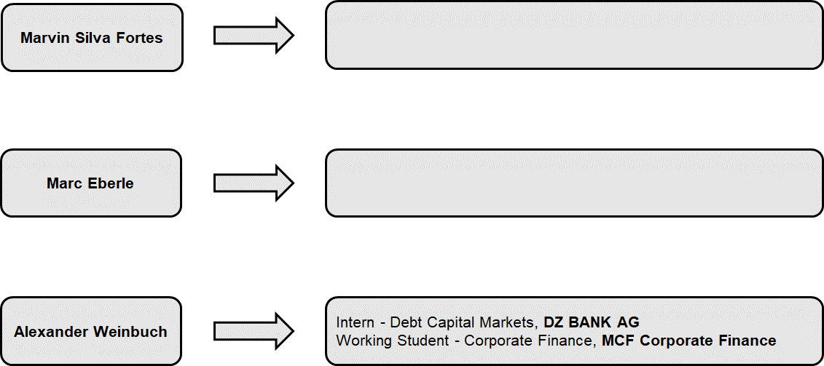

# 2 Development of Idea

As shown in the team introduction, Alex worked for DZ BANK in Debt Capital Markets. During that time, he was confronted with insider trading for the first time as he was not allowed to publish any confidential information and trade stocks only with permission. Following this experience, made him think about insider trading and wondered whether insiders are better investors than other investors. But with finishing the internship and therefore the end of mandatory reports to the Compliance team in the bank, insider investing was not a frequently appearing topic anymore.

A few days before Prof. Radermacher required the groups to select an idea for their dashboard, Alex was listening to one of his and Marc’s favorite podcasts “Doppelgänger TechTalk” by Philipp Klöckner and Philipp Glöckler and Philipp Klöckner is one of the angel investors at Gorillas (now part of Getir). The two podcasters talked about the earning published by Just Eat Takeaway and Delivery Hero and Philipp Klöckner explained to the audience that due to his investment he is not allowed to talk about competitors and exactly developments in the industry. With the topic of insider trading coming to Alex’s mind, he asked Marvin and Marc to include the topic in our Python project.

# 3 Product Development

Based on our understanding, the most important part of developing a dashboard for the first time is a well-defined niche which needs further applications to become accessible to the public or at least the people who are really interest in the topic. Since all group members are interested in capital markets and invest actively in different markets, we agreed on the topic of insider trading and started to look at the current situation of access to information in this niche segment. This was one of the first issues we faced in our project as most websites only display selected information on insider trading or show outdated data that is published in SEC Form 4 Filings. After several searches and general research we found some websites that display the information we are interested in. Most of the websites display the information in an extremely messy and confusing format, which makes it almost impossible for “standard” retail investors to understand who is treading how many shares, how many shares does the person hold and most importantly is this information at all relevant.

Due to this situation, we decided to focus our project on making information on insider trading accessible to retail investors, comparing the performance of insider trades to the market, and help investors to make use of this information in a broader context, e.g. understand the market sentiment.

We started looking for further websites we could use to apply Web Scraping and gather relevant information. One main obstacle we faced and still face is that those websites with most sufficient and best-formatted data are only accessible through a subscription. At the same time, these circumstances motivate us to bring (more) transparency into a very important niche segment that provides crucial information as from our perspective (potential) investors have a right to have proper information on what insiders (e.g. C-level executives, x% owners, and founders) are doing with their holdings in the companies.

What all websites, we visited during our initial research and development phase, are missing:

1. Newsletter that informs the (potential) investor on a weekly/monthly basis about what insiders of the largest US companies (investor’s companies of interest) are trading.
2. Integrated overview of a firm’s stock price development, news on the firm
3. Comparison of the performance of insider trades with the market in the relevant period (S&P500)
4. Giving information on the most relevant question: Do insiders generate Alpha? Are insiders better investors?

To implement these features and give information on these questions, we started to build the tool around our initial idea.

Within the process, we even developed a company/tool name with a slogan:

* Company/Tool name: InsidersInvest (short form iInvest – you will understand why when you see our presentation)
* Slogan: Transparency for all

We even implemented another graphical element as we think that this best describes the purpose of our tool. The flower we used is growing from beneath the surface, which is where information on insider trades currently is located. Our tool helps information to spread, grow, and reach sunlight to help investors make for fundamental decisions. Furthermore, investors knowledge is also growing like a flower – first there is a seed, planted beneath the surface but with water (relevant information) the seed develops into a beautiful flower.

In the following sections, we will explain our different tasks, challenges, and results.

# 4 Application of Ideas and Features (incl. Problems)

In the following sections Alex, Marvin and Marc will describe their individual tasks, problems, learnings and present their results.

## 4.1 Alex

After developing and formulation the idea, I started to look for websites that provide us with reliable and recent data. As described above, one of the main problems

# 5 Project Summary

|  |  |  |  |
| --- | --- | --- | --- |
|  | **Marvin** | **Marc** | **Alex** |
| **Main Field of Study** |  |  | Finance and Accounting |
| **Interests** |  |  | Football, Hiking, and Capital Markets |
| **Professional Experience** |  |  | Debt Capital Markets, Corporate Finance |
| **Prior Experiences with Programming** *On Scale from 1 to 10 (with 1 as lowest)* |  |  | 2 (during my internship - VBA) |
| **Own project started before  (not only in the context of Programming)** |  |  | No |
| **Programming Languages (before)** |  |  | VBA |
| **Programming Languages (after)** |  |  | VBA, Python, HTML |
| **Biggest Challenge(s)** |  |  | Understanding Web Scraping; Using CSS flies; Start thinking like an project co-manager; Time management (Bachelor Thesis - thanks to the team for consideration) |
| **Biggest Struggle(s)** |  |  | Relying on blog entries about Yahoo Finance API which was discontiued |
| **Biggest Learning(s)** |  |  | There is always someone who had the exact same problem before - just google it! |
| **What do you like about the product?** |  |  | Easy to access and understand, filter options, Insider's Alpha (never seen before) |
| **What will be your next improvement?** |  |  | More Case Studies, Weekly Newsletter, UI optimization |