Prerequisite installations:

1. IDE Application (e.g. Microsoft Visual Studio Code)

2. Node.js

Download Link: https://nodejs.org/en/download/

3. Electron

Enter command 'npm install electron' via IDE terminal

1. Navigate to the Github Repository page <https://github.com/marvinba/Poker-Client/>

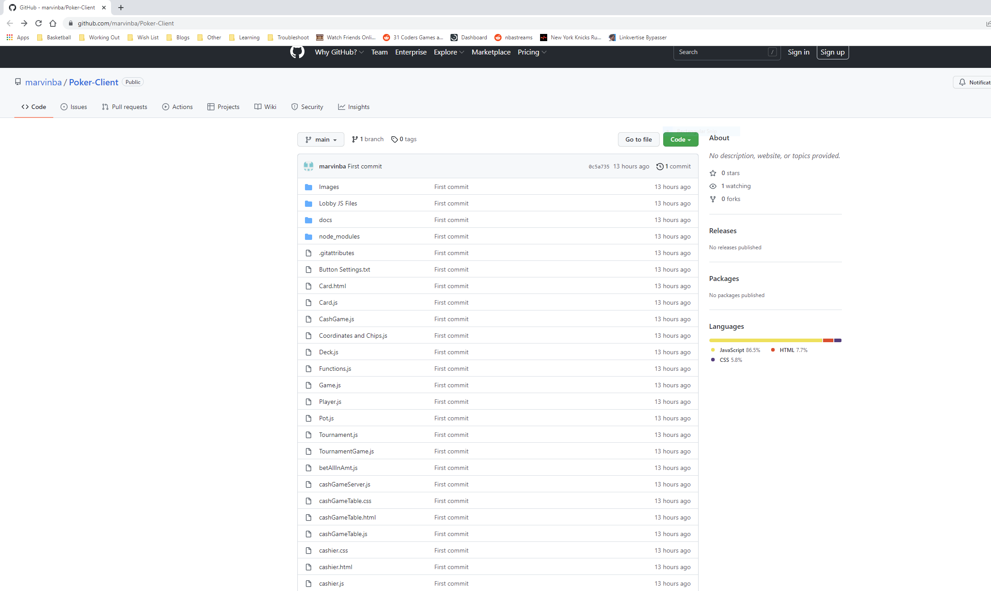

2. Click code and select 'Download Zip' from the dropdown menu

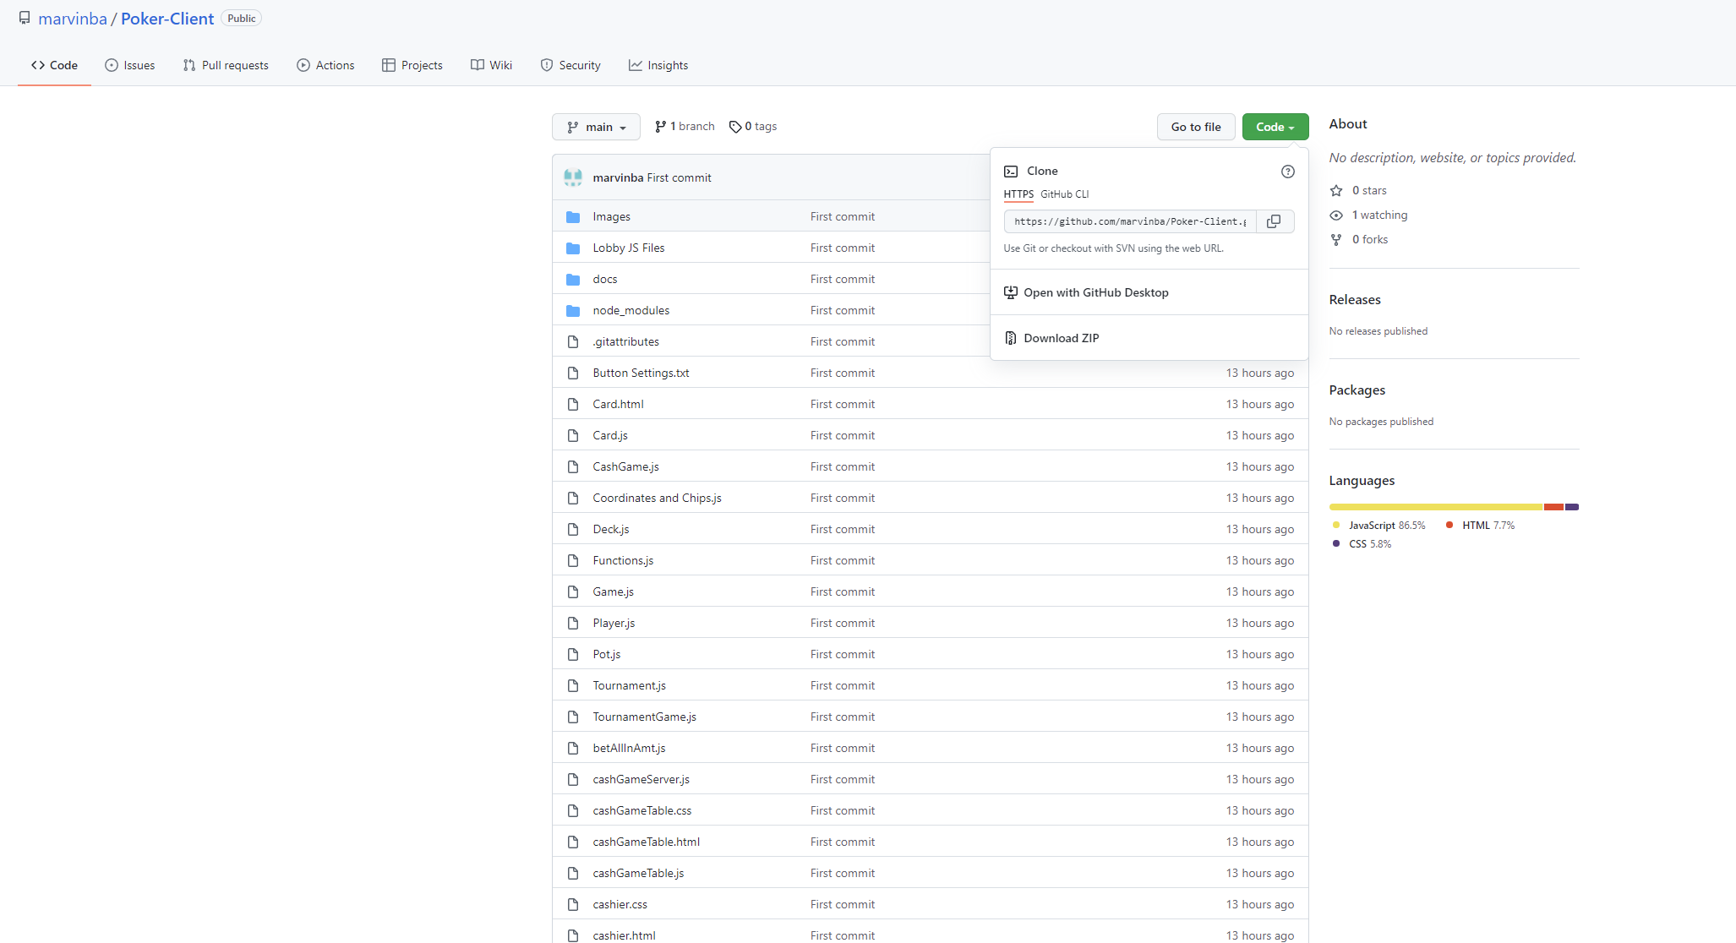

3. Extract the folder ‘Poker-Client-main’ with all of its contents intact inside the downloaded zip file.

4. In your IDE, select the directory you extracted the files to via Explorer

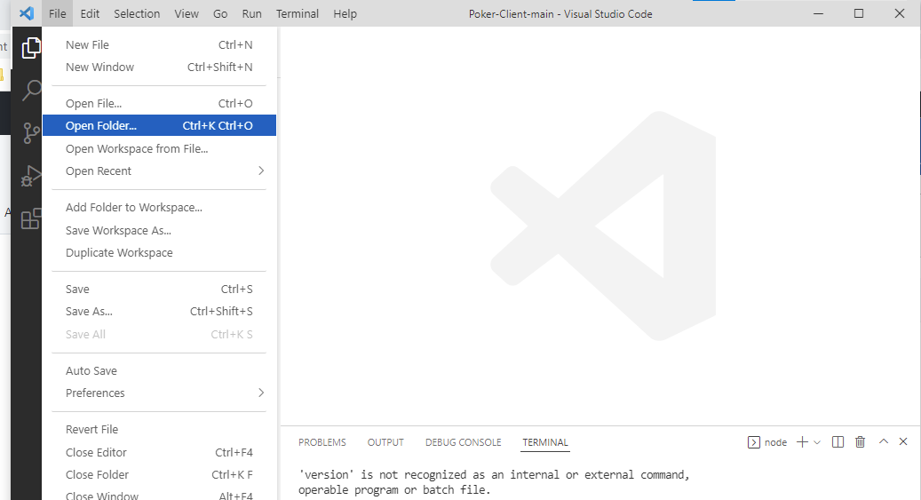

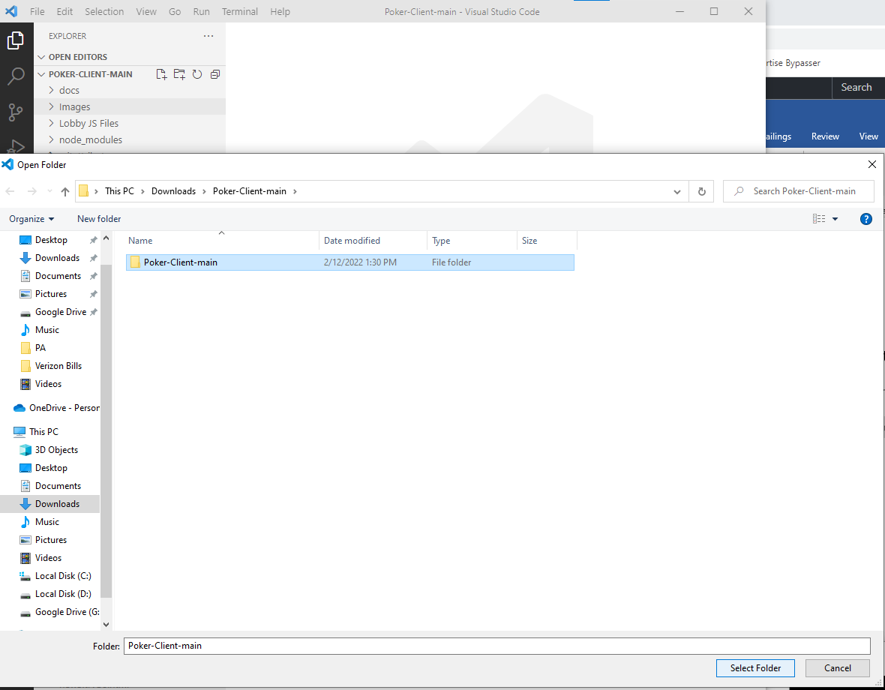

5. Enter command 'npm run start' to start application.

