MARVINBOT S.A.S

mARC Server installation

procedure

Table Of Content

**0.** **The mARC server directory content hierarchy and required libraries** 2

0.1 Prerequisites 2

0.1.1 Windows Operating System (x86_32 and x86_64) 2

0.1.2 Linux Operating System (x86_32 and x86_64) 3

3.1 Directory hierarchy 3

**4.** **Windows installation** 5

1.1 mARC Server as a service 5

1.1.1 Manual Installation/Uninstallation 5

1.1.1.1 Installing 5

1.1.1.2 Uninstalling 6

1.1.2 Launching the mARC server « as a service » manually 6

1.1.3 Stopping the mARC server « as a service » manually 9

1.2 mARC Server with UI layer 9

2. **Linux Installation** 11

2.1 Console version 11

2.2 UI layer version 12

# **The mARC server directory content hierarchy and required libraries**

Once you downloaded the mARC server and uncompressed in the directory of your choice, you are in the situation similar as below:

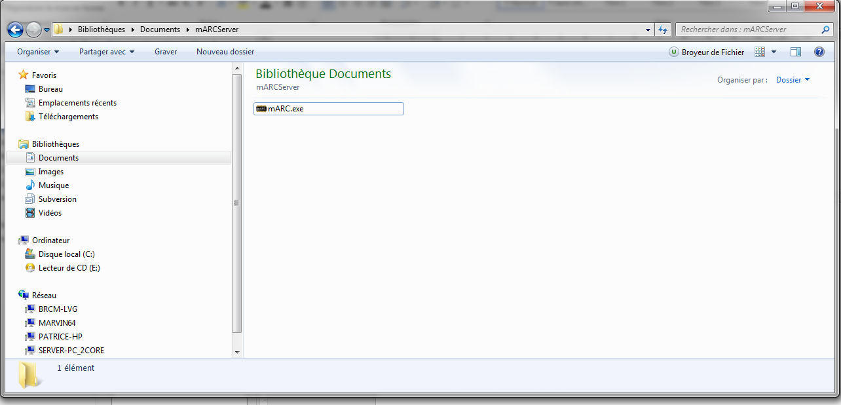

Here the binary executable is installed in the Windows “My Documents\mARCServer” directory.

# Prerequisites

## Windows Operating System (x86_32 and x86_64)

For the server to execute, you need first to install the Microsoft visual C++ Run Time library.

If you need the **UI sequel of the server**, you also need the .NET framework 4.5 or superior.

You can download the MSVCRT dynamic libraries from Microsoft web site:

<http://www.microsoft.com/fr-fr/download/details.aspx?id=5555>

The .Net framework is available from:

<http://www.microsoft.com/fr-fr/download/details.aspx?id=40779>

## Linux Operating System (x86_32 and x86_64)

For the console binary executable of the server, you just need the C library.

For the **UI sequel of the server** you need the Qt 5.3 or superior library:

1. QtCore
2. QtGui
3. QtWidgets

The best way is to install Qt Creator which install them for you:

http://qt-project.org/downloads

# Directory hierarchy

One the server is running (see below for more information how to achieve this), you will see three directories and one file have been created along:

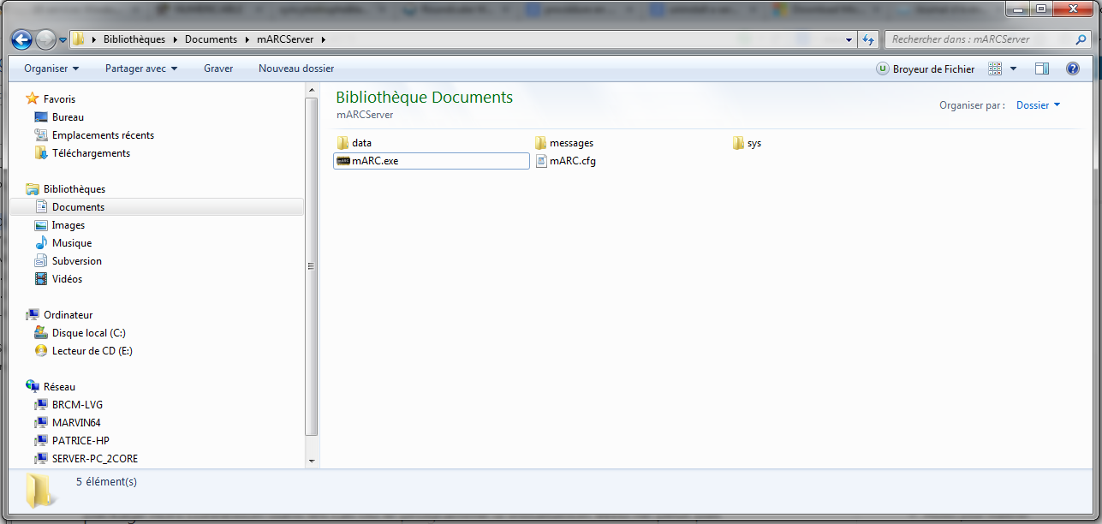

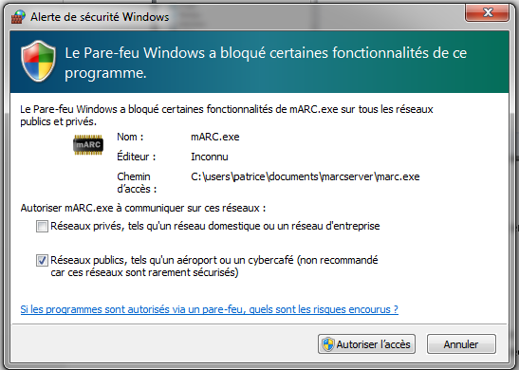And Windows asks you if you allow the server to communicate through the Windows Fire Wall. You should of course authorize it:

The file .cfg contains the defaults parameters of the indexation engine and basic tuning of the global variables of the server. You can edit and modify these.

The server contains apart from the I.A. Core Engine, an indexation engine and an optimized proprietary binary database to make it easier for you to start develop with the I.A. engine. But these are optional.

The directory “data” contains all the binary database files of the tables and index you will create with your application.

The directory “messages” contains the journalized log file of the server. When you first run the server you should find a freshly created file in it as below:

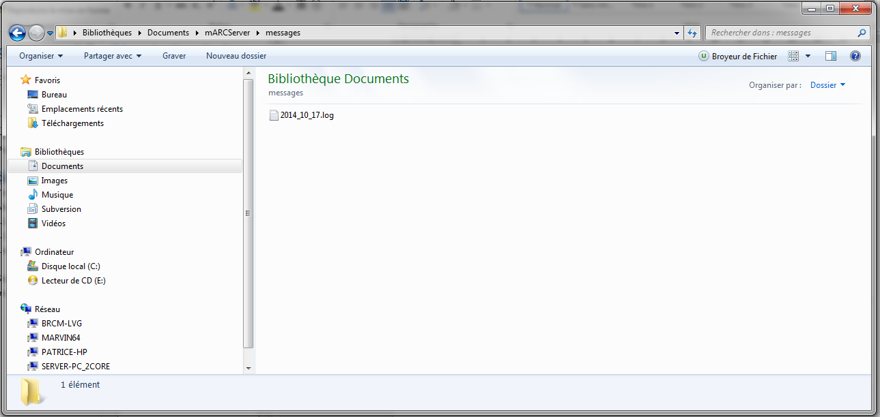

If you open it, you will see something like this:

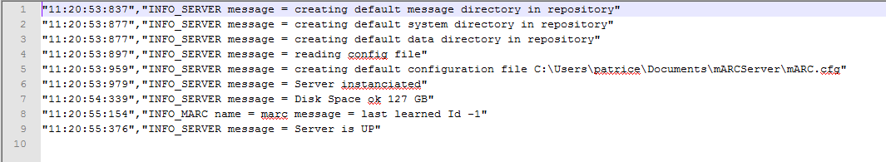

The “sys” directory contains information about the operating system environment.

# **Windows installation**

First, unzip the compressed folder containing the mARC server binary executable in the location of your choice. We assume the binary executable has been unzipped in the following directory:

“C:\Users\User1\My Documents\mARCServer\marc_test.exe”.

# 1.1 mARC Server as a service

Execution of a service under Windows OS is performed as a two-steps procedure. First you have to install the service for Windows to register it as a service and then you are able to launch it.

# Manual Installation/Uninstallation

## 1.1.1.1 Installing

1. Start up the command prompt (CMD) with administrator rights.

2. Type in the command line window that just popped up:

sc create marc_test binpath= C:\Users\User1\mARCServer\mARC.exe

## Uninstalling

The procedure is the same as above but with the delete option:

sc delete marc_test

# Launching the mARC server « as a service » manually

Now that the mARC server is installed as a service, you can launch it or stop it using the services manager:

1. Start up the command prompt (CMD) with administrator rights.

2. Type in the command line window that just popped up:

services

The Windows services manager just opens and you should see something like this:

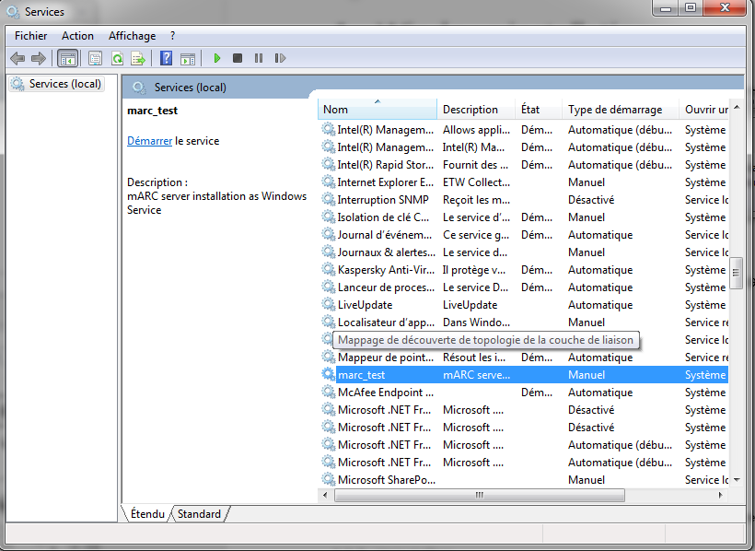

To launch it, you right-click on the “marc_test” item. A menu shows like this:

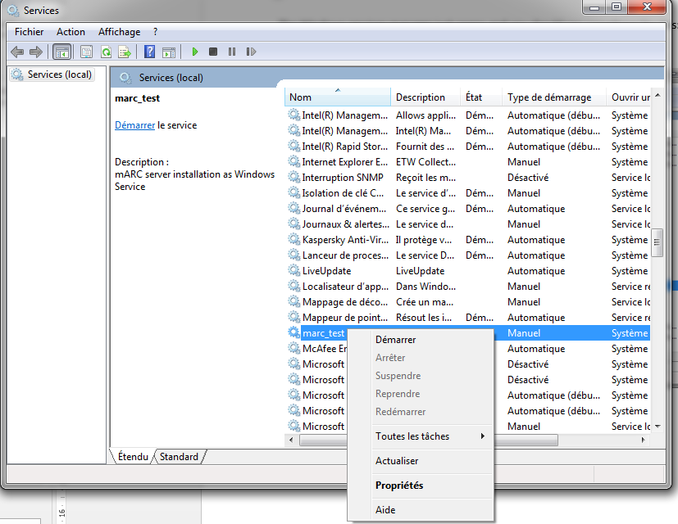

You just have to left-click on the “launch” button. The mARC Server will launch and automatically create a new entry in the Windows Event Logs Manager. To open it, just

1. Cleft-click on the Windows “Start” button.
2. Type in the search bar : **eventvwr**

A window like this should show:

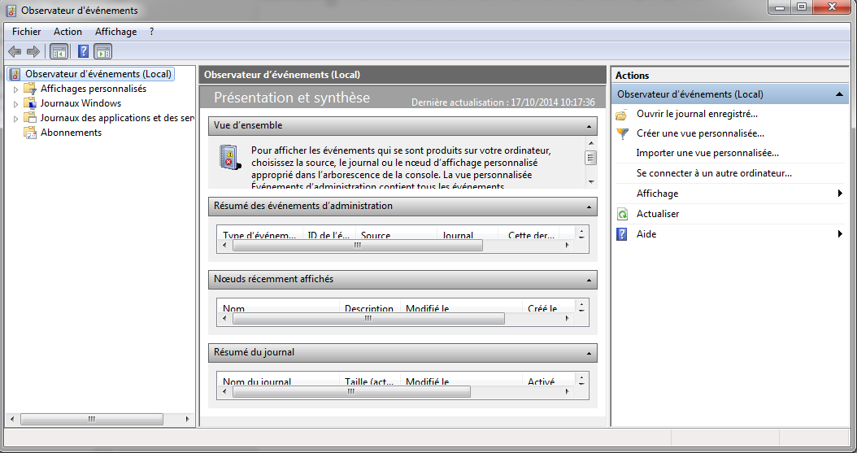

Left-click on the item “Applications and services logs” to see the mARC Server “mARCServerLogs” journal entry:

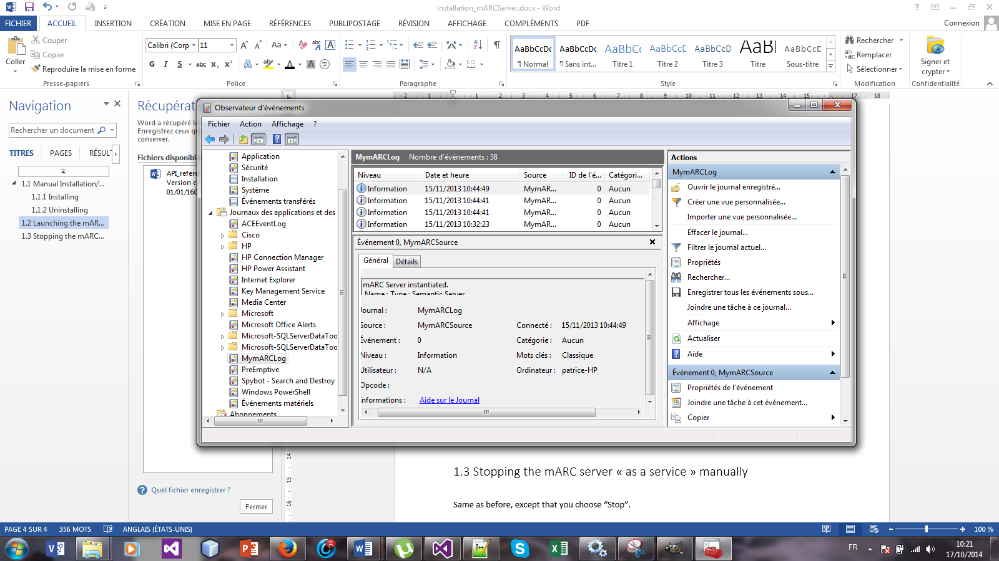

In the “general” tab you can read in this example:

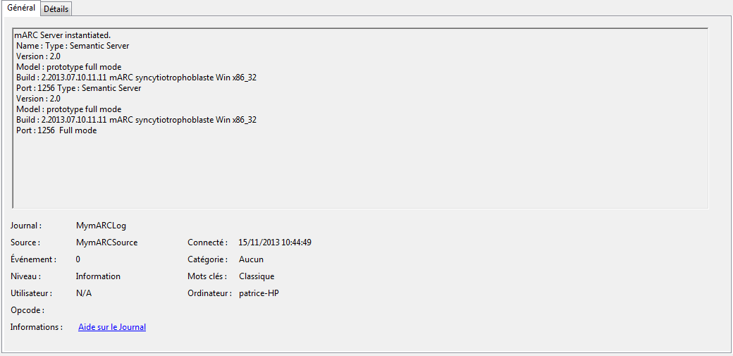

In the “Details” tab, you get:

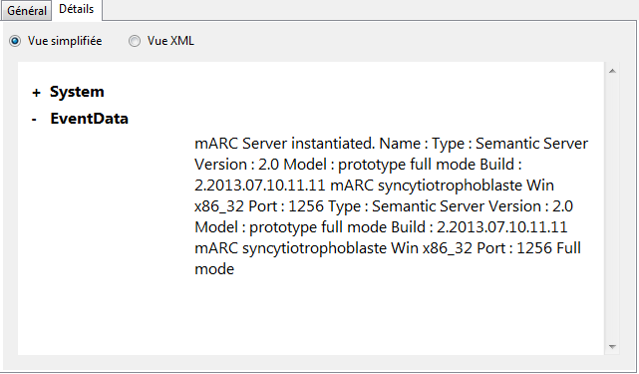

# 1.1.3 Stopping the mARC server « as a service » manually

Same as before, except that you choose “Stop”.

# mARC Server with UI layer

Once you uncompressed and put the binary in a given location, you just double left-click on the binary icon to launch the server. As described above you will need to authorize the server through the Windows Fire Wall (see section 3.1). You shall then see a window pop up:

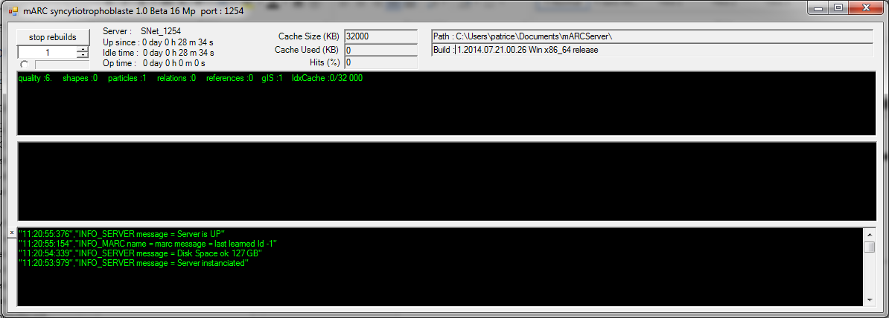

You are now ready to go. The upper text box gives you some metrics about the server. The number of cells of the underlying knowledge graph, the number of relations between these cells, the number of indexation references and the indexation cache used during indexation stages. On the first run, the knowledge graph is of course empty as is the indexation cache, so everything is zero, except the number of cells which is one: the mother cell.

# 2. **Linux Installation**

For linux operating system, the service binary executable is a console binary executable. Assume you have uncompressed the content of the mARC Server directory in

/home/user1/mARCServer

To launch the mARC server console binary executable, you must first make it executable. To achieve this, open a terminal and type at the prompt:

cd /home/user1/mARCServer

**chmod a+x mARCServer.exe**

**Now just type:**

./mARCServer.exe

# Console version

You can detach the mARC server from the open terminal with the command **nohup**. In this way you can close the terminal, the server will still execute in background. To achieve this just type the following command at the prompt:

sudo nohup mARCServer.exe &

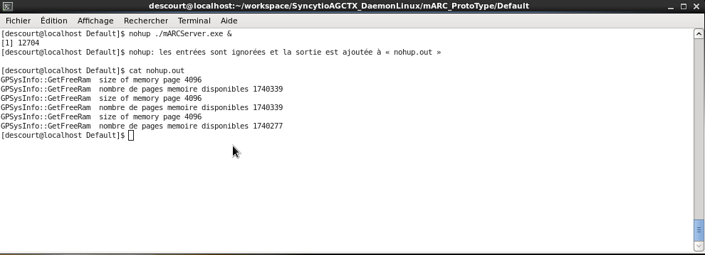

The ampersand character allows the program to execute in the background. As you can see above all the console Outputs from the server will be flushed in the default file nohup.out. Now you can execute the ‘top’ command to see that the server is running in background:

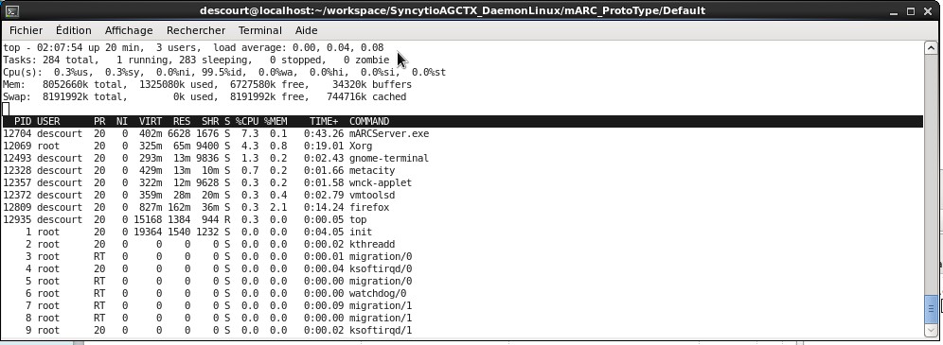

As you can read the mARC Server is running under process id 12704.

# UI layer version

Once you typed

./mARCServer.exe

You should see a window pop up:

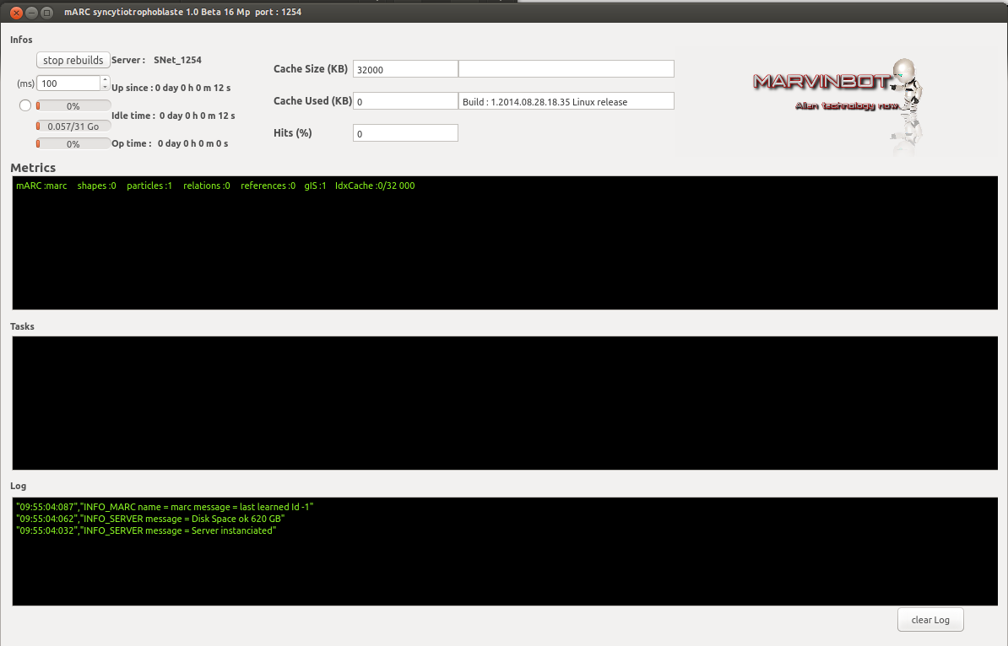

You are now ready to go. The upper text box gives you some metrics about the server. The number of cells of the underlying knowledge graph, the number of relations between these cells, the number of indexation references and the indexation cache used during indexation stages.