1. **MARVIN JADE C. GO**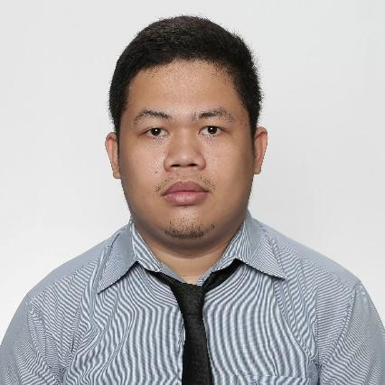

Gran Europa Village, Brgy. Lumbia,

Cagayan de Oro City

marvinjadego@gmail.com  
09151600067

**EDUCATIONAL ATTAINMENT**

Bachelor of Science in Computer Science

Xavier University – Ateneo de Cagayan

Corrales Avenue, Cagayan de Oro City

**Awards**:

Dean’s List First Semenster SY 2019-2020

Top 3 Sales Representative Non-Voice Campaign February – March 2022

**Goal**:

-to be able to master building websites using Javascript by applying to jobs that have mentors, watching me grow as a web developer, or as a citizen of the Republic of the Philippines.

**Experiences**:

**Roving Jr. Technical Support**

Wilcon Depot Inc.

Butuan City, Malaybalay City, CDO City, Opol Mis. Or.,

Lumbia, CDO City, Iligan City and Quezon City

April 2023- January 2024

-Responsible for basic IT technical/network/system troubleshooting, communicating other stores when not present, CCTV installation and troubleshooting, remote access computers, communicate with the Wilcon IT team, network, head office technical, system, and admins for requests, travel, etc.

**IT Specialist**

GTS Linkedsys BPO

2nd floor Sajonia Bldg. Purok 8 Codilla St.,

Poblacion, Initao, Misamis Oriental

July-December(2022)

-got promoted as an IT. Never was a first option but my performance as a Customer Service Representative, and as a tenured agent, one did say I was a techy person.

**Customer Service Representative** Phone Support 1st wave Red Pocket Mobile/**SME**

GTS Linkedsys BPO

2nd floor Sajonia Bldg. Purok 8 Codilla St.,

Poblacion, Initao, Misamis Oriental

March-July(2022)

-passed the very first assessment that underwent training under a Red Pocket Mobile staff. The training had 5 more assessments and passed most of it as the highest with a breaking record of 100%. The very first account of the company that is still now growing stronger with some other positions offered. After a few months of being a CSR and with the growing numbers of representatives I was promoted as one of the **SME.**

**Call Center Agent** also one of the top agent

GTS Linkedsys BPO

2nd floor Sajonia Bldg. Purok 8 Codilla St.,

Poblacion, Initao, Misamis Oriental

January-March(2022)

-part of the very first successful campaign that lasted for 2 months that shifted

to full voice campaigns

**Data Entry Specialist**

Various employee and company

Remote

2021

**IT** (OJT)

SSS Carmen Branch

2018-2019