**Software Requirements Specification**

**for**

**TRAFFIC ACCIDENTS ANALYSIS**

**Version 1.0 approved**

**Prepared by GROUP**

**15/07/2019**

Table of Contents

1. Introduction 3

2. Overall Description 3

3. External Interface Requirements 6

4. System Features 6

5. Other Nonfunctional Requirements 6

1. Introduction

**1.1 Purpose**

The intended purpose of this document is to provide information about the requirements of the data pipeline that analyzes traffic accident data informed insights.

* 1. **Document Conventions**

This document consists of headers and sub headers of font type Calibri, font size 14 and 12 and are bold in nature. The body of this document is in Calibri font type and font size 14.

* 1. **Intended Audience and Reading Suggestions**

The document is designed as a guide for the developing team and the project supervisor for tracking the ongoing progress.

* 1. **Product Scope**

He system uses attributes from the data on the traffic accidents (accident description, time of accident, nature of weather condition, etc.) to give an insight through analysis. The goal is to portray understandable patterns and the relationship between the attributes in the traffic accident data.

* 1. **References**

<https://www.denvergov.org>

2. Overall Description

**2.1. Product Perspective**

The data pipeline is designed to utilize data provided by Denver police department on traffic accidents as input csv files.

**2.2User Classes and Characteristics**

The use case is to describe the entities of the system as well as the processes.

**1.Actors**

* **The developers**

They are responsible for developing the analytics system and also aid in giving the interpretation of the obtained results to the police.

* **Denver police organization**

They provide traffic accident data and also receive the output of the data pipeline.

The information they receive from the system would help them make insightful better decisions for example when devising means to curb the crime accidents

**2.Use cases**

The following use cases are involved ibn our data analytics pipeline:

* **Reading of provide files.** This will involve lo0ading of the csv files containing traffic accident data from Denver police station such that a further processing for example cleaning can be done on the data from those files. Data is read from the csv files and imported into a data frame which is used in the cleaning process.
* **Clean the extracted data.** This is done to acquire the desired key features for example ROAD_CONDITION, ROAD_LOCATION by removing unnecessary columns, checking missing values.

This is will involve careful examination of every feature and a thorough understanding of its impact on the desired outcomes of the pipeline for example the impact of the FIRST_OCCURRENCE_DATE feature on the time that has more accidents to outcome.

* **Visualization of the cleaned dataset.** It will occur in form of graphs, features and charts i.e. a plot of a bar graph showing the month or the year with the highest number of accidents, which type of accidents occurred most in a particular weather condition and so many others.

**Figure1: Use Case Diagram for the system**

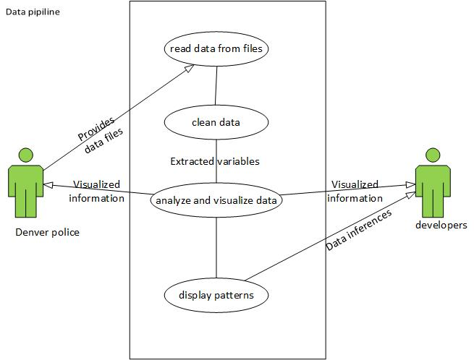

**2.3 Assumptions and Dependencies**

* The system uses anaconda tool for all its processing.
* To be able to create elegant and well graphically represented visuals, the system will use the matplotlib package in python

3. External Interface Requirements

**3.1. User Interface**

The system will only generate graphical representations from the input data, from which meaning will then be relayed to the users.

4. System Features

**4.1. Read csv files.**

4.1.1 Functional Requirements

System needs local access to the necessary csv files.

* 1. **Create graphs from variables** 
     1. Functional requirements
* System needs numerical variables as input to be able to create visualizations.

5. Other Nonfunctional Requirements

**5.1 Performance Requirements**

The system will only extract and use attributers corresponding to the scope of analysis from the dataset any attributes contained within the datasets do not fit the purpose of the system will not be used.

COLLEGE OF COMPUTING AND INFORMATION SCIENCES

**BSSE 2301 PROFESSIONAL SOFTWARE ENGINEERING**

**MINI PRACTICAL**

**PROJECT II**

**SOFTWARE REQUIREMENTS SPECIFICATION DOCUMENT**

**SUPERVISOR:** GRACE KAMULEGEYA

|  |  |  |  |
| --- | --- | --- | --- |
|  | NAMES | Reg No | Stud No |
| 1 | KAMASU PAUL | 17/U/4521/EVE | 217017362 |
| 2 | KIYINGI ALOYSIOUS | 17/U/5344/PS | 217002946 |
| 3 | NAKAYENGA VIOLA | 17/U/7565/PS | 217003981 |
| 4 | KAAYA MARVIN | 17/U/4253/EVE | 217017391 |