1. What techniques are used for Requirement Elicitation?

Interviews, Joint Application Design, Questionnaires, Document Analysis, and Observation.

1. Compare the requirement elicitation techniques.

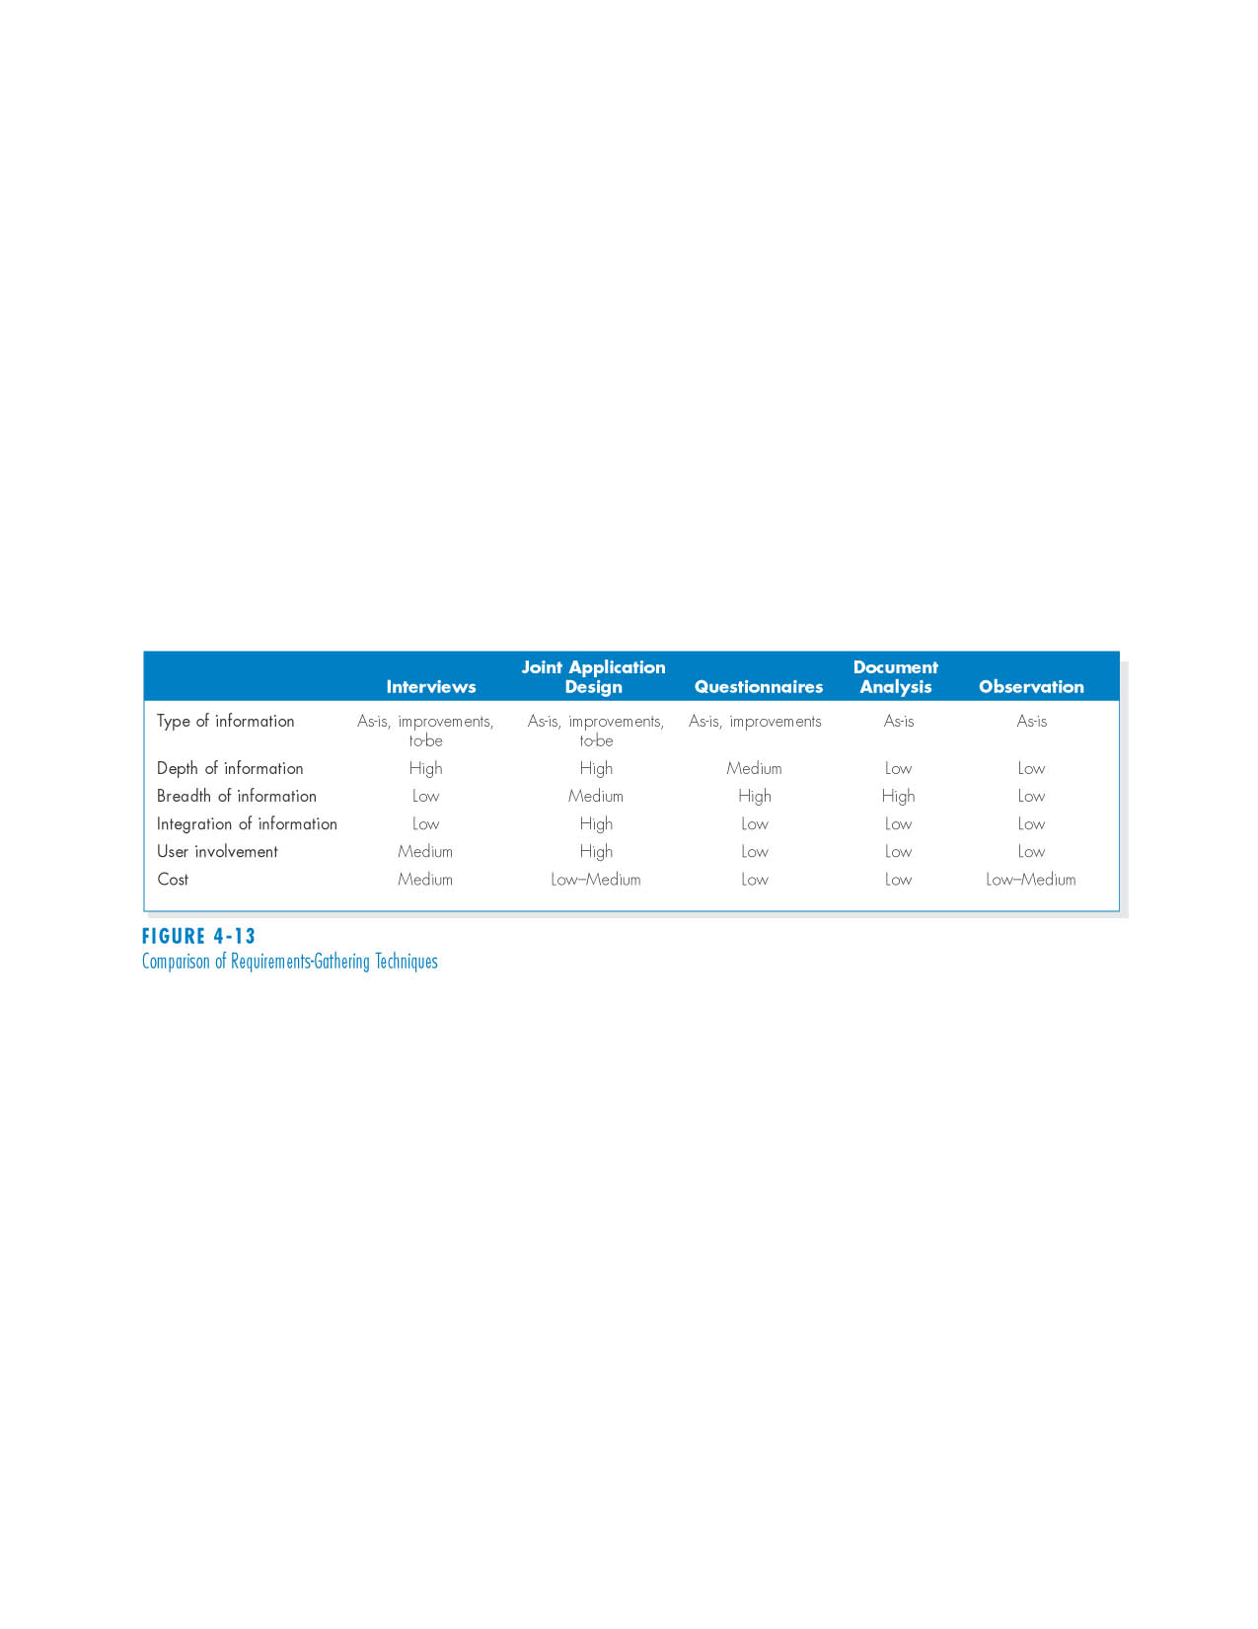

1. What are the requirement analysis strategies?

Problem Analysis, Root Cause Analysis, Duration Analysis, Activity-Based Costing, Informal Benchmarking, Outcome analysis, Technology analysis, and Activity Elimination.

1. What are the key tasks in the Design phase?

The design phase decides how the new system will operate. The design phase develops the system requirements that describe details for building the system. We also describe three alternative strategies for acquiring the system.

1. What is Architecture Design?

Architecture Design is the plans for how the system will be distributed across multiple computers and what hardware, operating system software, and application software will be used for each computer.

1. What are the three acquisition strategies? Describe them.

Develop a custom application in-house. Buy a packaged system and (possibly) customize it; and Outsourcing, it is rely on an external vendor, developer, or service provider to build or provide the system.

1. Identify the three types of architectures and provide a short explanation of each, along with key advantages and disadvantages.

Client-server architectures have four important benefits.

* + Scalable
  + Can support different types of clients and servers through middleware.
  + The presentation logic, the application logic, and the data processing logic can be independent.
  + If a server fails, only the applications requiring that server are affected.

Server-Based architectures

* Server computer handles presentation logic,
* Application logic,
* Data acccess logic and
* Data Storage

Client-Based Architectures

* Client computer handles presentation logic,
* Application logic and
* Data acccess logic
* Server computer handles data storage

8. What are the key principles in UI design?

Layout, Content awareness, Aesthetics, User experience, Consistency, and Minimize user effort