Hong Kong Institute of Vocational Education (Tsing Yi)
Department of Information Technology
Higher Diploma in Software Engineering
Final Year Project (ITE4116M) – Final Report
(2022/2023)
Project Title: Online Learning and Tutoring Platform (Tutor Cat)
Supervisor: | Clarence Lau
Co-supervisor:  Student: | Esther Yuen  Mak Chi Wang
We declare that this is a group project and that no part of this submission has been copied from any other student’s work or from any other source except where due acknowledgment is made explicitly in the text, nor has any part been written for us by another person.
Student | Contribution to the project (%)  (Total 100%) | Signature
Chan Kei Sum | 25% | 
Chan Wai Kuen | 25% | 
Chiu Chung Yiu | 25% | 
Mak Chi Wang | 25% | 
- Abstract
In recent years, the education system worldwide has been affected by the covid-19 pandemic. In Hong Kong, the government announced the suspension of face-to-face classes and switched to online teaching. The pandemic has changed the way students learn from traditional learning to e-learning. They spend more time at home than ever before, so online learning has become a necessary tool for education. The registration number of online classes has grown exponentially, which is likely to continue. Online Education webs had become the ones with the most growth and potential top-grossing webs.

Since the demand for online education has grown, an online learning website “Tutor Cat” will be developed to provide an online matching platform for students and tutors. Students and tutors can register on our web and find students or tutors to learn or teach. Our web will suggest tutors to students according to the subject they want to learn. Students can review the rating of the tutors to make choices, and rate the tutor after completing every lesson. In this report, we will deliver a complete introduction to this web, driving question, problem finding, proposed solution, requirements, software process model, and project plan.
Contents
1. Abstract 3

- Introduction
  - Group Background
Online teaching has become a hot topic under the influence of the epidemic, and our team saw a business opportunity. We also believe that there is no online tutoring platform suitable for the Hong Kong market. We decided to develop a website for tutors and students to find a mentor or customer that suits them.
  - Project Background
The covid-19 pandemic has given us an unprecedented challenge, especially in the education system for students and Tutors. Online learning and tutoring platforms have become the only solution to accept the challenge during this chaotic period.
In Hong Kong, due to the increase in citywide coronavirus cases, a huge number of students were affected by covid-19. With this unexpected shift away from face-to-face learning to online learning, the tutoring web is one of the emerging main modalities of higher education.
Online learning is a new platform for students and tutors to teach and learn based on the use of electronic media and devices as tools for improving access to training, communication, and interaction, and that facilitates the adoption of new ways of understanding and developing learning. However, finding an acceptable quality tutor or suitable students would be a big challenge for the students, parents, and Tutors.
- Driving Question
Explain how the project answers this question: “How can Software Engineering techniques be used to develop software systems for supporting human activities?”
In the last few years, Software Engineering techniques have made a big leap and play a vital role in improving human habits. System software is a type of computer program that is designed to run a computer's hardware and website programs. Plenty of software engineers develop software systems to support different categories(politics, economy, society) of human life. Thus, people can use software systems to handle these data through computers.
The typical examples of human activities are supported and brought a lot of benefits by software systems below:
In our daily life, we are influenced by communication software such as WhatsApp and Wechat. According to Digital 2022: Global Overview Report, WhatsApp is the most widely used instant messaging software in the world, with 100 billion messages sent every day. We can see that humans no longer write letters and phone calls as the main medium of communication. People can send text, video, and photos even at an instant location on this software. It is more convenient for people to communicate. It speeds up the flow of information in the world.
Many big companies are required to record a huge amount of data such as business information and staff’s personal information. Once upon a time, many traditional companies used hard copies and handwriting to store this information. Hard copies are difficult to keep and are easy to destroy. Also, it is difficult to track and look for the thief if he/she steals the information. However, software technology development improves these privacy and security issues. Nowadays, many big companies such as Muji, Fortress, and Nike are using computerized maintenance management systems to help manage assets, schedule maintenance, and track work orders. Therefore, the company and personal information can be encrypted by a software system to prevent data loss. Besides, all actions consisting of updating and deleting records can be traced to protect the interests of the company.
- The Problem
  - Scope of The Problem
Nowadays, online education programs have become more sophisticated and accessible due to the proliferation of the web and digital technology. Online education has also spurred changes in traditional colleges, most colleges offer online courses in 2022. Therefore, students can study from home using different equipment online, however, the growth of distance learning programs has many important side effects. Although all kinds of schools around the world now offer open courseware, online degrees, and online classes that are both legitimizing and popularizing the idea of education online, it does also have a few drawbacks.

To solve these problems, a website will be developed for students and tutors to study and teach online. This Website allows students to search courses by subjects or tutors, also, students can communicate with the tutor after the course time. There is a rating system to improve the quality of tutors and students to avoid inappropriate actions. Moreover, the notes system is provided to students to have better learning at home. Tutors or students can upload their own notes online for selling, the system will return with points(system currency) when someone buys them. This website enables students and tutors to connect anytime and anywhere. Through our online course, chatroom system, and notes system, tutors are able to cultivate the internal motivation and potential of students and thus help them achieve their goals.
  - Description of Problem

False academic certificate
It is not easy to assure the tutors’ academic certificates since they were submitting soft copies. Since everyone can register to become a tutor and they can fabricate academic credentials or edit by software, it is hard to verify. HKCAAVQ provides assessment services for the public to do the process of qualification assessment, but it will cost some assessment fees and time to complete the review.

The rights and interests of tutors are unbalanced
On the other hand, if a tutor encounters a student with a bad attitude or a poor learning attitude, he will not dare to criticize or punish him because he is worried that the bad student will damage his reputation, so it is not fair for the tutor fair.

Students' chaotic schedules
In addition, Students usually have a lot of subjects that need tutoring, or the school has a lot of activities that need to be arranged, so a student will encounter the problem of chaotic time arrangement, which may lead to mistakes every time he customizes tutoring time for himself, for example, two students arrive at the same time Subject remedial activities, but only found out on the day.

Students struggle to get notes that suit them
As a student, the only way to get notes is through school and course tutors. The channels are very narrow, and each tutor makes notes for different students. For example, some students are good at doing problems to understand concepts, and some need to use images. Or explain the concept in detail to understand the content of the tutoring.
  - Description of Problem Environment

Imitation certificate
Tutors can forge certificates, leading to the uneven quality of tutors on the platform. There is no guarantee that students can acquire knowledge and improve their knowledge in this environment. A more stringent certificate validation procedure is required, to reduce the risk of tutors logging into the platform to teach with forged documents.

Lack of platform for knowledge exchange
There is no unified knowledge exchange platform. Although there are many methods and materials on the Internet, the quality of the materials cannot be guaranteed. At the same time, students have no way of knowing whether the contents of the notes are what they want. Therefore, a platform for integrating learning materials is needed, allowing sharers to classify the types of learning materials and provide a brief description of them.

Tutors and students lack protection:
In terms of tutors, the current tutoring platform has no way to ensure the quality of students. The tutor has the opportunity to encounter some unruly or misbehaving students. And on the student side, students have the opportunity to encounter some teaching styles that do not meet expectations. Therefore, a system that can protect tutors and students is needed.
- Proposed Solution
  - Exploration of Possible Solutions

Possible solutions for false academic certificate
A tutor rating system is important for students, after every lesson, the tutor would be rated out of five stars, according to the learning vibes, academic materials, and tutors' attitude. It will help students to identify the tutor by their rating.

Possible solutions for the rights and interests of tutors are unbalanced
The lack of discipline from the students. Besides the tutor rating system, there is a student rating system as well. Tutors can rate students according to whether they follow the instructions from the tutors or not. Moreover, negative attitudes from students will be recorded in the system, and tutors can decide whether to accept or reject the lesson. The good intentions of the rating system will decrease the chance of students being undisciplined.

Possible solutions for students' chaotic schedules
Fourth, online education enables the tutor and the student to set their own learning pace, and the flexibility of setting a schedule is essential to both tutor and student. When scheduling problems, such as schedule disorganisation, overscheduling, and lack of course availability, the scheduling system can help the tutor request the course rescheduling. This will support time management for tutors to arrange different course time slots and reduce the mistake of duplicate course time.

Possible solutions for students who struggle to get notes that suit them
Finally, there are some students falling way behind in the class due to online learning such as technical issues, a lack of digital knowledge, or studying environments. A notes system allows tutors or even students to upload their notes to sell for points according to the subject and content. It will help students to follow up on the online class and increase students’ self-motivation.
  - Scope of The Proposed Solution

Enhanced Certification of tutor Credentials
To prevent tutors from falsifying academic certificates, we need to strengthen the platform's function of authenticating academic qualifications. At the same time use manual and mechanical to certify the tutor's certificate. And provide a reporting system for students to report some tutors who are suspected of forging academic certificates.

Provide a platform for communication
Most tutoring platforms in Hong Kong do not provide a communication platform between students and tutors. On this platform, students can solve their academic problems and get some learning experience at the same time. The learning experience is very important, a good learning style can shorten the learning time. At the same time, tutors can communicate and discuss teaching experiences with each other.
  - Proposed System Architecture

Network Configuration
We will use the client-server model to build our server since the client-server network facilitates data transmission while protecting the sent data. Using the network is a smart solution for businesses looking for quicker and more secure data transfer. 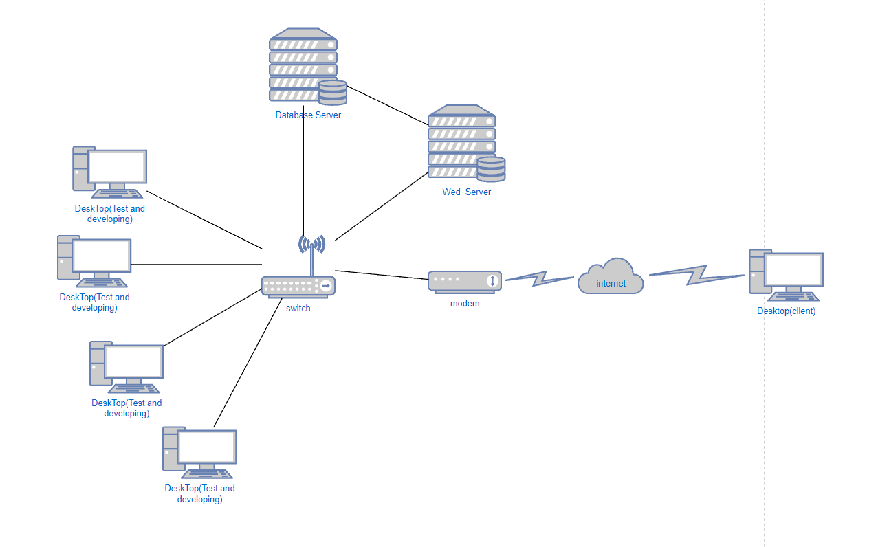

Network Management Protocol
Due to using the DHCP network management protocol, we don’t have to assign the IP for each device. DHCP will assign the IP to each device automatically.

Three-tier architecture
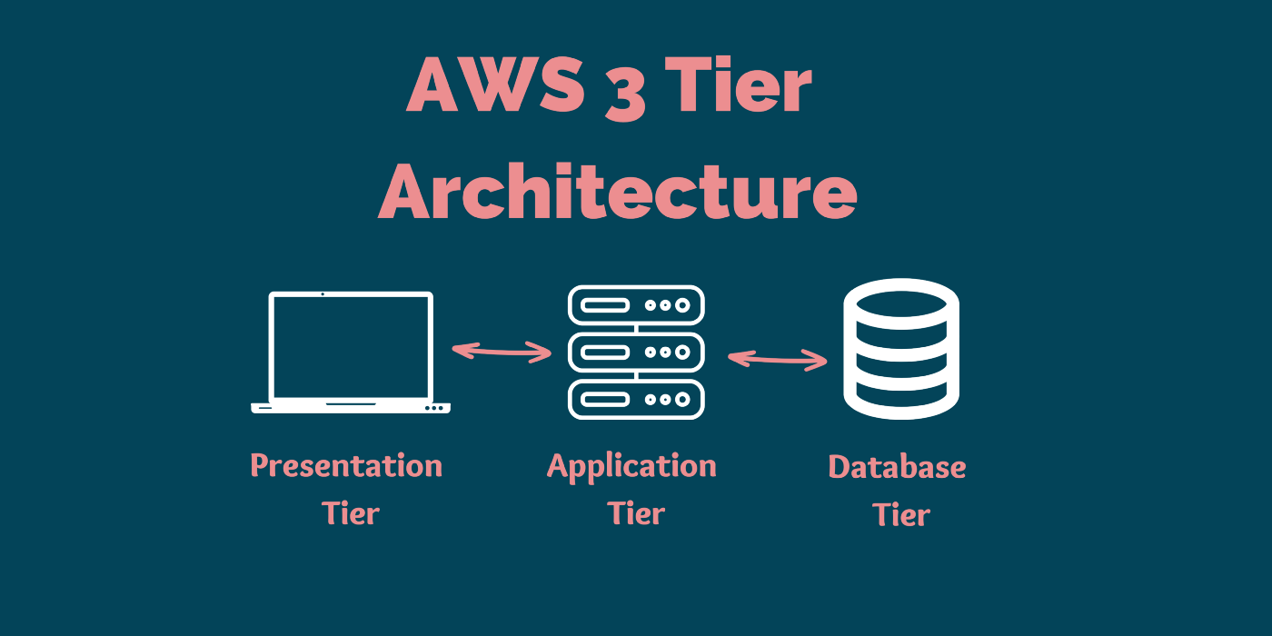 Three-tier architecture, which separates websites into three logical and physical computing tiers, is the predominant software architecture for traditional client-server websites.
Three-tier architecture, which separates websites into three logical and physical computing tiers, is the predominant software architecture for traditional client-server websites.

Web Server (HTML 5 ):
The web server is the presentation tier and provides the interface for the user. This is usually a page on the web or a page of a website.

website Server (PHP ):
The corresponding website server to the middle tier, housing the logic used to process user inputs. For example, a web server sends the information to the website server, then the tier will query the database to return the value that the web server needed.
Database Server (MySQL Database):
The database server is the data or backend tier of a website. It runs on database management software, such as MySQL.
  - Advantages of This Solution

Advantages of the 3-tier architecture:
It can improve security because the presentation tier and data tier can't communicate directly, and a well-designed website tier can function as a sort of internal firewall, preventing SQL injections and other malicious exploits.
  - Advantages of The Website:
- Our system can increase the employment rate for more tutors.
- Compared with other systems we do not charge fees, and our website is more attractive to students and tutors.
- Ask students to find more suitable notes for them, improve learning efficiency, and contribute to students in the education field.
  - Drawbacks of The Solution:
- The risk of system development is relatively high, and it is difficult to predict the expected completion date of the system.
- The development time is longer because the programming language is relatively new, it takes time to learn and apply.
  - Data Description
All data from the clients including tutors and students will be centralized on a database server (in a third-party database server) providing SQL service (using MySQL) in pursuit of data integrity. In addition, each type of client has its own independent database table to store the data. Therefore, the database must have enough capacity to store the data.
To avoid data loss, all data from the company databases will be backed up by the NAS server per week. Backing up the data per week will balance the possibility of data loss caused by backing up once a month and the huge operational cost caused by backing up once a day.
  - The Cosine-similarity Algorithm
How to calculate the cosine-similarity and it works
For example, there is the similarity of two Tutor calculation processes.
Tutor / Rating | Student 1 | Student 2 | Student 3 | Student 4 | Student 5
Tutor 1 | 5 | 3 | 1 | 5 | 2
Tutor 2 | 0 | 1 | 5 | 2 | 4

Tutor 1 = [5,3,1,5,2]
Tutor 2 = [0,1,5,2,4]
Using these two vectors we can calculate cosine similarity. First, we calculate the Tutor of the vectors:
Tutor 1 •Tutor 2 = 5 x 0 + 3 x 1 + 1 x 5 + 5 x 2 + 2 x 4 = 26
Second, we calculate the magnitude of the vectors:
||Tutor 1|| = √(5²+3²+1²+5²+2²) = 8
||Tutor 2|| = √(0²+1²+5²+2²+4²) = √(46)
Finally, cosine similarity can be calculated by dividing the dot product by the magnitude
similarity (Tutor 1, Tutor 2) = (Tutor 1 •Tutor 2) / (||Tutor 1|| ||Tutor 2||)
= 26/ (8 x √(46)) = 0.4791……
The angle between the vectors is calculated as:
Cos(θ) = 0.4791……
θ = arccos(0.4791) = 61.37336192
Then, we need to get the 5 tutor who is the top 5 rating of the student, and get it into a formula(tutor ID(similarity)*student Rating ), then we will get a list, the first 5 are the most similar to the student preferences. So we can display the recommended tutor to show in the user interface to let students choose.
  - Functional requirement:

In-house System
- All users can log in to the system
- All users can change their account password
- All users are able to change passwords via email authentication(Forget password)
- Students can register for an account using email.
- Tutors need to provide proof of identity to apply for an account.( Certificate of Achievement).
- Admin able to approve tutor accounts
- Admin able to ban accounts.

User Settings System
- Tutors and students can update their profile (description, profile picture, QR code for payment, qualifications.)
  - Tutors and students can change the personal information of students’ accounts. Users can upload certified QR Code Images for payment.
- Tutors can update their qualifications.
  - Tutors need to submit supporting documents and assessment fees to update their qualifications.
- Tutors and students can deactivate or delete their own accounts.
  - Tutors and students can deactivate or delete their accounts, using their email and password.
- All users can change the language
  - Users can change the language of the user interface(Traditional Chinese, English)

Course System
- All users can view the course description and video. Also, message the course creator.
  - All users can view the course description. Demonstrate the content of the course and the qualifications of the tutor through descriptions and certificates
- Tutors can create different courses.
  - Tutors can create courses that need to match the certification. There will be relative functions to match students. (calendar, subject, Teaching methods…)
- Tutors can edit and update their courses.
  - Tutors can edit and update their courses. For example, change the teaching time, course items, and price.
- Tutors can delete courses.
  - Tutors can delete courses from their accounts
- Tutors can provide teaching materials to students.
  - Tutors can provide teaching materials to students for more detailed teaching. The system allows tutors to upload files(pdf, docx, image…).
- Tutors can provide competency assessments.
  - Tutors can send assessments to assess students' abilities. It is convenient for tutors to adjust the intensity of lessons. They can input the start date, end date, and assessment results.
- Students can search for courses
  - Students can search for courses by inputting the course information. The system will search for the appropriate tutor based on the student's questionnaire.
- Students can purchase courses.
  - Students can purchase courses after login to their account. Students can message the tutor and upload the receipt.
- Students can complete and upload the competency assessments.
  - Students can complete and upload competency assessment answers used to assess students' abilities. Let students and tutors know clearly where they need to strengthen their learning.
- Students can request to change the class time or cancel courses.
  - Students are able to apply to the Tutor to change the time or cancel the class. The user can change the class time if the website is accepted. If the user has a legitimate reason to cancel the class, the tutor will need to refund points.
- Admin is able to cancel a course with inappropriate content.
  - Admin can cancel the course after login to their account. There will be assistance systems that automatically select some courses that have the potential to be inappropriate content and hand it over to the administrator to filter and punish.
- Admin is able to check and judge student/tutor complaints against tutors/students.
  - There is a chance that malicious users will use our web to spread inappropriate content. There are also opportunities for irresponsible tutors or students. For example, late, unexcused absences and uncooperative class attitude. If one of the users is reported by a certain number of users with a similar problem, the admin will give a warning to the user.
- Admin is able to check the tutors' list.
  - Admin is able to check the tutors' list and see the tutor's certificate recognition status. (applying, successfully approved, failed…)

Rating System
- Students can rate tutors.
  - Students who have purchased a course are able to rate and comment on the tutor. ( time management, attitude… )
- Students can report tutors.
  - Students who have purchased a course are able to report the tutor. ( time management, attitude… )

Chatroom System
- Users can read messages
  - All users who have a registered account can receive messages from another user or system. They can also check the online status, last seen time, and message status(send success or not).
- Users can send messages
  - All users who have a registered account can send messages to another user. They can see the sent date, time, and status of the messages.
- User can upload files and images
  - All users who have a registered account can send files of a certain size to another user. They can see the sent date, time, and status of the messages.
- Admin is able to warn the user through the communication system.
  - Admin can login to the account and message the offending user, giving them the reason for the violation and the content of the penalty.

Schedule System
- A timetable for tutors to choose the days when they can teach
  - Timetable for the tutor to choose the days, the system helps to record the class time.
- Tutors can watch the teaching timetable
  - The tutor knows when the class is scheduled for the class through the scheduling system. Tutors can check if students apply to cancel classes or change class times.
- Students can watch the timetable.
  - Timetable for the student to know the class they need to attend soon.
- Students are able to choose a day and time.
  - Able to choose class times when purchasing courses, the system will show the time when the tutor is able to teach. If the time doesn't match, students can still cancel the purchase

Notes System
- The tutor or students can upload and sell notes.
  - The tutor or students can upload and sell notes, with a suitable description(subject, summary, price). Tutor or student provide a trial version
- Student can buy notes using credit points
  - Students are able to use points in your account to purchase notes.
- Students can download notes after login into their account.
  - After students purchase notes, they can download files as pdf or docs.

Point System
- Students can use point to buy courses or notes
  - Students can get points from buying courses or notes everytime, the value of point is 1:1 to the actual price.

Assistance System
- When students ask certain questions, the system will provide a selection bar for the tutor.
  - Users input any sentence in the message box, and the ai will provide several ways to respond to the recipient of the message. For example, If the student asks about the price of the course, there will be options available for tutors to click on.
- User is able to send messages to the admin for customer service
  - There are several options for the user to choose from (login problem, refund questions…)It is convenient for administrators to know the current predicament of users.
  - Non-Functional requirement

Usability
Due to containing plenty of vitality and function, the platform must provide a user-friendly and neat interface for users. It is essential to improve human-computer interaction, the platform provides some hints and sets up several classifications for users to select different functions. The system can be handled easier by clients.
Having clear guidelines, the platform boosts the opportunities for students to find what service they want and succeed in buying the lessons or notes.

Operational
Logging
Protecting the client's personal information, the platform provides the operation logging function which provides various permissions for different users such as admin, tutor, student, and parent. After logging in to the account, the user can see his/her personal information only besides admin.
When a user forgets his/her account’s name and password, he/she can use the function of forgot password. After entering the email the user used to register, he/she will receive the reset password link by email.
Run Hours
The database server will be open for 24 hours to prevent data loss. In addition, the website system also offers 24 hours service, which is more flexible for students and tutors to arrange their tutor schedules. On the other hand, students can also ask the tutor some questions at any time.

Software Platform
The online learning website is a consumer demand platform. The feature of this platform is having a payment system in order to track the status of the consumer’s request and to rate the service received. Consumers can track the purchase record and tutor history through payment, so it is a cornerstone of security. Meanwhile, they can reflect on feedback to give some suggestions or gratitude to tutors.

Security
Access control
The admin can create, read, modify, and delete all user accounts.
A login function means that the users will have to login to the system to have different permission for personal information management and viewing in the system. In addition, the users need to log out after using the system. The system allows permission below:
Module and Function | The Access of Admin User
 | CREATE | READ | UPDATE | DELETE
All Module and Function | ✓ | ✓ | ✓ | ✓
Approve tutor account | ✓ | ✓ | ✓ | ✓
Ban accounts | ✓ | ✓ | ✓ | ✓
Tutor list | ✓ | ✓ | ✓ | ✓
Inappropriate content |  | ✓ | ✓ | ✓
Send warming to user | ✓ | ✓ | ✓ | ✓

Module and Function | The Access of Tutor User
 | CREATE | READ | UPDATE | DELETE
Profile(description, profile picture, QR code for payment, qualifications.) | ✓ | ✓ | ✓ | ✓
Course List | ✓ | ✓ | ✓ | ✓
Teaching materials | ✓ | ✓ | ✓ | ✓
Message | ✓ | ✓ | ✓ | ✓
Group for teaching | ✓ | ✓ | ✓ | ✓
Receive warming |  | ✓
Teaching timetable | ✓ | ✓ | ✓ | ✓
Note | ✓ | ✓ | ✓ | ✓

Module and Function | The Access of Student User
 | CREATE | READ | UPDATE | DELETE
Profile(description, profile picture, QR code for payment, qualifications.) | ✓ | ✓ | ✓ | ✓
Course List |  | ✓
Teaching materials |  | ✓
Search course function |  | ✓
Purchase course | ✓ | ✓ | ✓ | ✓
Rating tutor | ✓ | ✓
Report tutor | ✓ | ✓
Message | ✓ | ✓ | ✓
Group for teaching |  | ✓
Receive warming |  | ✓
Teaching timetable |  | ✓
Notes | ✓ | ✓ | ✓ | ✓

Module and Function | The Access of Non-register
 | CREATE | READ | UPDATE | DELETE
Course List |  | ✓
Search course function |  | ✓

Compatibility
The system should be compatible with different language speakers. The website server will be provided with two languages such as English and Traditional Chinese to meet Hong Kong users’ needs. Therefore, tutors and students who are used to speaking English can also use this platform smoothly through the English version

  - Role of users

Tutor
Tutors can teach through the platform and be able to gain teaching experience from the platform. Find their audience from it and give themself the characteristics of teaching. And tutors can share their reading methods and notes through the platform to promote the learning speed of students.

Student
Students can get the content they need through the platform. At the same time, they can also consult relevant tutors through the platform. They will also find their ideal tutor according to the teaching mode they need. Students can discuss and exchange knowledge and learning experiences with each other in the group.
  - Hardware
Hardware Type | Specification
NAS x 1 | CPU Model: Realtek RTD1296  CPU Architecture: 64-bit  CPU Frequency: 4-core 1.4 GHz  System Memory: 512 MB DDR4 non-ECC  Volume type: RAID 1, RAID 0  Compatible Drive Type : 3.5/ 2.5" SATA HDD or 2.5” SATA SSD
The reason for choosing this specification:
This NAS has a 2 bay NAS enclosure, currently, we will only use 2 bays for RAID 1, the use of RAID 1 is to copy the data to another Disk when accessing data, so data can be preserved even if a disk is damaged. On the other hand, we will not consider using other RAID technologies, because our development team is small, so it does not require too many hardware resources to cooperate.
Hardware Type | Specification
DESKTOP x 4 | Operating System: Windows 10 Pro (Windows 11 Pro license included)  Processor: Intel i3-12100  Memory: 8GB  Hard Disk: 256GB  Hard disk type: SSD  Graphics Card: Intel Integrated Graphics
The reason for choosing this specification:
These computers are used by developers. The computer specifications are relatively general. For example, the CPU is only i3, and the system memory is only 8gb. The hard disk is only 256gb, but it is enough for developing simple website.

After the product is complete , these 4 desktop will be the test device of the system.
Hardware Type | Specification
MONITOR x 6 | Screen size: 24 inches  Resolution: 1920 x 1080  Screen refresh rate: 75Hz  Contrast: 1000:1  Brightness: 250cd/㎡  Response time: 5ms  Interface: HDMI, D-Sub
The reason for choosing this specification:
One monitor for all computers and servers.
Hardware Type | Specification
Router | Wireless/Wired: Wireless  Wi-Fi system: Wi-Fi 6 (802.11ax)  Transmission speed: 574+1201Mbps  Wi-Fi Speed Specifications: AX1800  Tri-Band/Dual-Band/Single-Band: Dual-Band  Mesh Wi-Fi: Yes  GigaBit LAN: Yes  Number of WAN bits: 1  Number of LAN bits: 4  External Antenna/Internal Antenna: External Antenna
The reason for choosing this specification:
There are two main functions of the router. For the first time, it connects the developer's desktop to the Internet to help them search for data or communication on the Internet. On the other hand, because we develop website, the method for connecting the website and the database to the Internet is the most efficient. The convenience is to use wi-fi, so the router is very important.
Hardware Type | Specification
Server x 2 | Processor: Intel Xeon E-2224  Chipset: Intel C242  Memory: Original 16GB DDR4 ECC (Memory slots: 4 DIMMs)  Storage device: Original 1TBx2 SATA3 hard drive  Array: Support Intel software RAID 0, 1, 10, 5  Display (card) chip model: Aspeed AST2510 with 64MB VRAM  Optical disc player: DVD-RW  Network: Built-in dual Giga network card

The reason for choosing this specification:
The reason for buying two servers is because one is responsible for the web server and the other is the database server. Separating them can effectively prevent hackers from stealing user data.

Hardware Type | Specification
Switch | 16 PoE+ ports with 190W power budget. Unmanaged 300-Series PoE Switches are easy, reliable, and affordable network connectivity for homes and small offices. Providing power and data from a single Ethernet cable
The reason for choosing this specification:
This switch connects devices on a computer network.

  - Software
Software | Description
Apache 2.4.54 (released 2022-06-08) | Apache HTTP Server is a free and open source web server that is the most popular web server software in use today, serving web content over the Internet.
Database Server - MySQL Community Server 8.0.28 | A relational database management system that supports a wide variety of applications in corporate IT environments.
Version Control Tool - Git | Software to control the version of other software.
Microsoft Defender Firewall | The software protects computers running the Windows operating system, it can avoid attacks from hacking or Computer viruses.
Visual Studio Code | A tool of programming development, it can code different languages.
Old Stable PHP 8.1.14 | PHP is a general-purpose scripting language geared toward web development.
HTML 5 | The term HTML5 is essentially a buzzword that refers to a set of modern web technologies. This includes the HTML Living Standard, along with JavaScript APIs to enhance storage, multimedia, and hardware access.

- Requirements
  - Reliability Requirements
The reliability requirements are important when developing an application since it will ensure that the performance of our application is consistent and trustworthy, also, it will lead us to develop the app to approach perfection. To increase the reliability of the application, we will use different methods to avoid errors, such as error detection when testing the application, and error removal when errors are found in the test, hence the reliability requirements were in first priority.
Saving plenty of consumers and transaction information, the system must be reliable. It must use a stable and fast server and test perfectly to avoid exceptions before launching. Also, maintenance services play a vital role to ensure that the system and servers work smoothly.
To solve the problem of data inconsistency, the system will provide multi-threading. Only one user can update information in a section at a time lest other users repeat to update.
  - Performance Requirements
The platform is required to display a concise interface for users to search for functions and deal with consumer requests. Thus, performance should be tidy and reloaded quickly. For instance, the loading time for data insertion and data requesting should be reduced. When the user fills out the electronic spreadsheet, the performance should provide many options for the user to choose from.
  - Future extensions of the proposed solution
Our platform is mainly for students and tutor to match each other, it will not provide a built-in online communication function. However, the platform will cooperate with other online applications such as Zoom and Skype. We believe that it is user-friendly for students to start the lessons with a computer or mobile phone. In the future, our company has confidence to cooperate with more video call platforms such as Microsoft Teams due to future extensions . Our platform offers more options from the client to choose and increases the competitiveness compared with other online learning platforms.
After building an online learning platform, the platform still needs to be maintained by software engineers. Companies incur these costs for general or preventative maintenance that help keep the platform in proper working order. To protect the safety of the client and company information, the engineers have to test the platform regularly. It is helpful to prevent data loss and decrease the chance of error.
  - Implementation Language

Implementation language | Description
HTML5 | The Design language of interface
PHP language | The Design language of API and login processing
MySql language | The language of Database

- Use Case
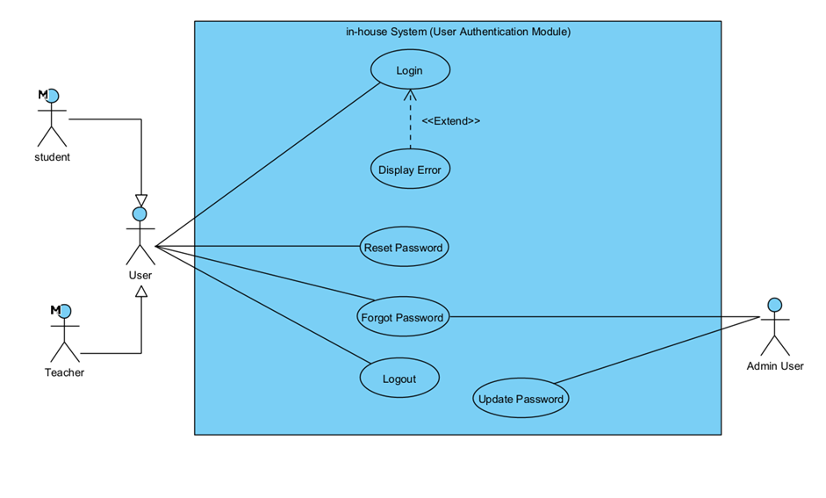
Actor Specification
Actor Name: | User(Tutor,student)
Description: | Users can sign up for a student or tutor account and login in the system.

Actor Name: | Admin User
Description: | Admin can help users update their password if they forgot their password.

Use Case Description
Use Case Name | Sign up
Use Case ID | UC-100
Primary Actor(s) | Student or tutor
Brief Description | Users can sign up for an account.
Pre-conditions | -
Flow of Events | - Users click the sign up icon.  - Users select a student or tutor.  - Users input information to sign up for an account.  - Users click the sign up button.
Priority | High

Use Case Name | Login
Use Case ID | UC-101
Primary Actor(s) | Student or tutor
Brief Description | Users can login their account.
Pre-conditions | Users sign up for an account.
Flow of Events | - Users click the login icon.  - Users input information to login.  - Users click the login button.
Priority | High

Use Case Name | Logout
Use Case ID | UC-102
Primary Actor(s) | Student or tutor
Brief Description | Users can log out their account.
Pre-conditions | Users login their account.
Flow of Events | - Users click the logout icon.
Priority | High

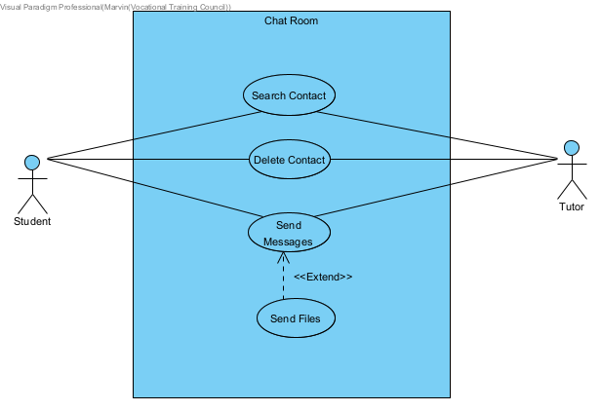Actor Specification
Actor Name: | Student
Description: | Students can search the tutor to add and delete contact, send messages and files.

Actor Name: | Tutor
Description: | Tutors can search the student to add and delete contact, send messages and files.

Use Case Description
Use Case Name | Search Contact
Use Case ID | UC-200
Primary Actor(s) | Student or tutor
Brief Description | Users can search the tutor or student to add to their contact list.
Pre-conditions | Users need to click the search icon to search for a tutor or student.
Flow of Events | - Users click the search icon.  - Users type the tutor or student name to search for contact.  - Users can add the tutor or student to the contact.
Priority | High

Use Case Name | Delete Contact
Use Case ID | UC-201
Primary Actor(s) | Student or tutor
Brief Description | Users can search the tutor or student to delete in the contact list.
Pre-conditions | Tutors or students should be in the contact list.
Flow of Events | - Users find the tutor or students in the contact list.  - Users click the delete icon to delete contact.
Priority | Low
Use Case Name | Send Messages
Use Case ID | UC-202
Primary Actor(s) | Student or tutor
Brief Description | Users can send text messages in chat rooms.
Pre-conditions | Tutors or students should be in the contact list.
Flow of Events | - Users click the tutor or students in the contact list.  - Users type text in the message box.  - Users click the send button to send messages.
Priority | High

Use Case Name | Send Files
Use Case ID | UC-203
Primary Actor(s) | Student or tutor
Brief Description | Users can send files in chat rooms.
Pre-conditions | Tutors or students should be in the contact list.
Flow of Events | - Users click the tutor or students in the contact list.  - Users click the file button in the message box.  - Users upload the file to send.  - Users click the send button to send files.
Priority | High

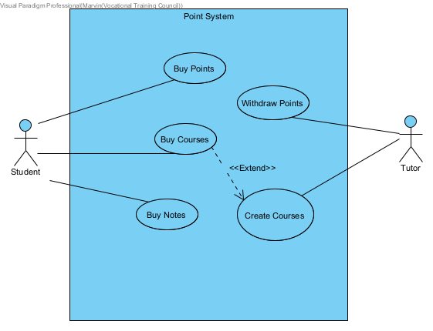Actor Specification
Actor Name: | Student
Description: | Students can buy points for courses and notes.

Actor Name: | Tutor
Description: | Tutors can create courses to earn points and withdraw points.

Use Case Description
Use Case Name | Buy Points
Use Case ID | UC-300
Primary Actor(s) | Student
Brief Description | Users can use different payment methods to buy points.
Pre-conditions | Users need to create a student account.
Flow of Events | - Users click the buy points icon.  - Users select payment methods.  - Users select the amount of points to pay.
Priority | High

Use Case Name | Withdraw Points
Use Case ID | UC-301
Primary Actor(s) | Tutor
Brief Description | Users can withdraw points to earn money.
Pre-conditions | Users need to create a tutor account.
Flow of Events | - Users click the withdraw points icon.  - Users select withdraw type.  - Users select the amount of points to withdraw.
Priority | High

Use Case Name | Buy Courses
Use Case ID | UC-302
Primary Actor(s) | Student
Brief Description | Users can use points to buy courses.
Pre-conditions | Users need to create a student account and sufficient points.
Flow of Events | - Users select a subject to buy a course.  - Users select a tutor to buy a course.  - Users buy courses by points.
Priority | High

Use Case Name | Buy Notes
Use Case ID | UC-303
Primary Actor(s) | Student
Brief Description | Users can use points to buy notes.
Pre-conditions | Users need to create a student account and sufficient points.
Flow of Events | - Users select a subject to buy notes.  - Users buy notes by points.
Priority | High

Use Case Name | Create Courses
Use Case ID | UC-304
Primary Actor(s) | Tutor
Brief Description | Users can create courses to get points.
Pre-conditions | Users need to create a tutor account.
Flow of Events | - Users select a subject to create a course.  - Users insert course’s information including time and points.  - Users create courses after confirmation.
Priority | High

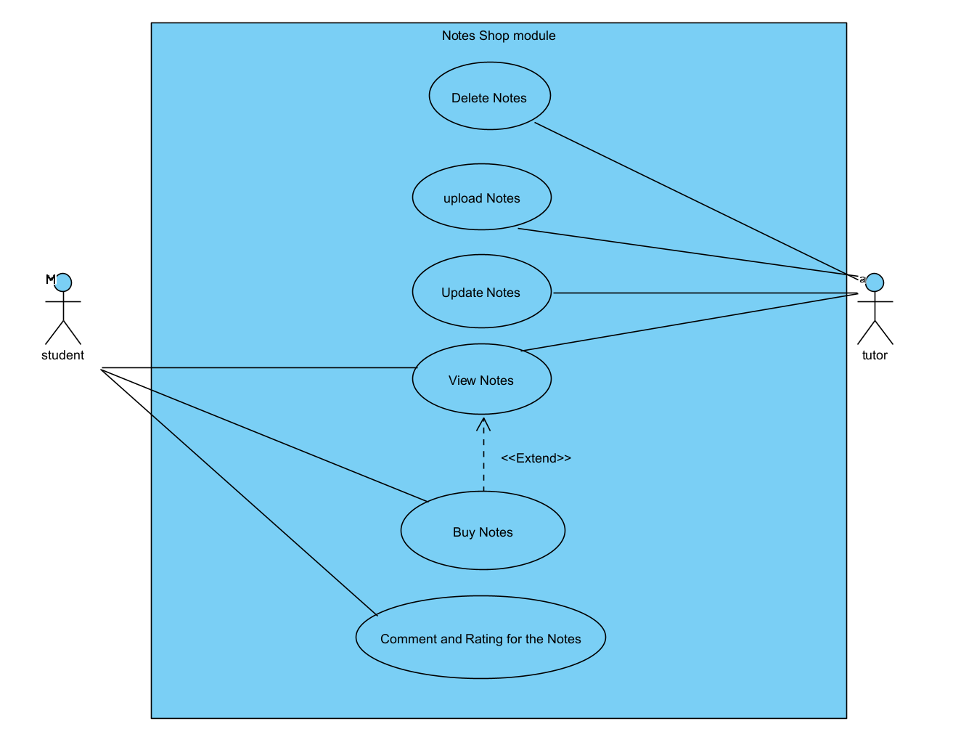
Actor Specification
Actor Name: | Student
Description: | Students can view the notes list, buy notes and comment and rating for the notes.

Actor Name: | Tutor
Description: | Tutors can view, delete, upload and update notes.

Use Case Description
Use Case Name | View Notes
Use Case ID | UC-400
Primary Actor(s) | Studen, teahcer
Brief Description | The user views the notes list.
Pre-conditions | The user finds needed notes.
Flow of Events | - The User uses a searching function to filter the notes and the system shows the required notes.
Priority | High

Use Case Name | Buy Notes
Use Case ID | UC-401
Primary Actor(s) | Student
Brief Description | The user buys the notes.
Pre-conditions | The user found needed notes.
Flow of Events | - The user clicks the notes icon and the system shows the notes’s page.  - The user clicks the “Buy” button and the system shows the order page.  - The user clicks the “Confirm” button to buy a note.
Priority | Low

Use Case Name | Comment and rating for the notes
Use Case ID | UC-402
Primary Actor(s) | Student
Brief Description | The user comment and rating after reading notes
Pre-conditions | The user found needed notes.
Flow of Events | - The user clicks the book icon and the system shows the note’s page.  - The user clicks the “Buy” button and the system shows the order page.  - The user clicks the “Confirm” button to buy a note.
Priority | Low

Use Case Name | Delete Notes
Use Case ID | UC-403
Primary Actor(s) | Tutor
Brief Description | The user delete notes record
Pre-conditions | The user has an existing notes record.
Flow of Events | - The user clicks the “Delete” button and the system delete notes record.
Priority | Low

Use Case Name | Upload Notes
Use Case ID | UC-404
Primary Actor(s) | Tutor
Brief Description | The user upload notes record
Flow of Events | - The user clicks the “Upload” button.  - The user selects a suitable file.  - The user enters the “Confirm” button and the system displays notes.
Priority | Low

Use Case Name | Update Notes
Use Case ID | UC-405
Primary Actor(s) | Tutor
Brief Description | The user update notes record
Flow of Events | - The user clicks the “Update” button.  - The user selects a suitable file.  - The user enters the “Confirm” button and the system displays updated notes.
Priority | Low

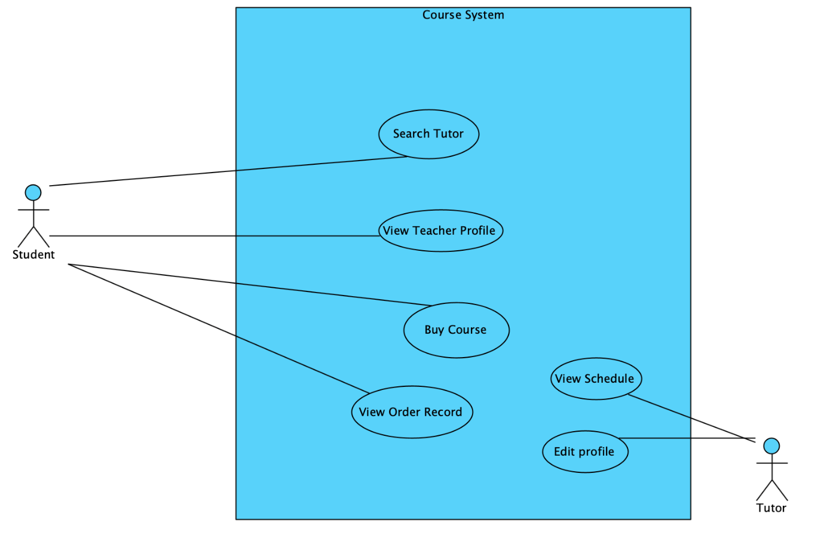
Actor Specification
Actor Name: | Student
Description: | Students can view the Tutor list, buy courses and view order records in the system.

Actor Name: | Tutor
Description: | Tutor can edit the course in the profile.

Use Case Description
Use Case Name | Search Tutor
Use Case ID | UC-500
Primary Actor(s) | Student
Brief Description | Students search for a Tutor by using a search function.
Pre-conditions | The user needs to select an option in the filter to search for a Tutor.
Flow of Events | - The User selects the subject or type keyword on the filter.  - The User clicks the “Search” button and the system shows the Tutor list.
Priority | High

Use Case Name | View Tutor Profile
Use Case ID | UC-501
Primary Actor(s) | Student
Brief Description | The student sees the Tutor in detail in the profile.
Pre-conditions | The User must find specific Tutor the view detail
Flow of Events | - The User selects a specific Tutor on the list and clicks the “apply now” button.  - The system shows the Tutor’s profile.
Priority | High

Use Case Name | Buy Course
Use Case ID | UC-502
Primary Actor(s) | Student
Brief Description | The student buys the course.
Pre-conditions | The student must log into the system.
Flow of Events | - The User selects a course on the Tutor profile and the system shows detail of course.  - The User clicks the “Book” button, the system shows the order of course.  - After the user confirms the order, he/she clicks the “Confirm” button to make payment and the system creates the order.
Priority | Low

Use Case Name | View Order Record
Use Case ID | UC-503
Primary Actor(s) | Student
Brief Description | The student view bought course history.
Pre-conditions | The student must log into the system.
Flow of Events | - The User selects his/her own profile page  - The User clicks the “My course” button, the system shows the record of course about different states such as upcoming, completed and canceled.
Priority | Low

Use Case Name | View Schedule
Use Case ID | UC-504
Primary Actor(s) | Tutor
Brief Description | The tutor views the course on schedule.
Pre-conditions | The tutor must log into the system.
Flow of Events | - The User clicks the “Schedule” button and the system shows the tutor schedule.
Priority | Low

Use Case Name | Edit profile
Use Case ID | UC-505
Primary Actor(s) | Tutor
Secondary Actor(s)
Brief Description | The tutor updates the profile and edits the course .
Pre-conditions | The tutor must log into the system.
Flow of Events | - The User clicks the “Edit Profit” button and the system shows the edit page.  - The User updates information and clicks the ”save changes” button to update his/her profile. The system updates the profile page.
Alternative Flows & Exceptions | - If the user wants to reset the password, he/she clicks ”Reset Password” after step 1.  - The user enters the current password, new password and confirms the password.  - The user clicks “Confirm” and the system updates the password.
Priority | High

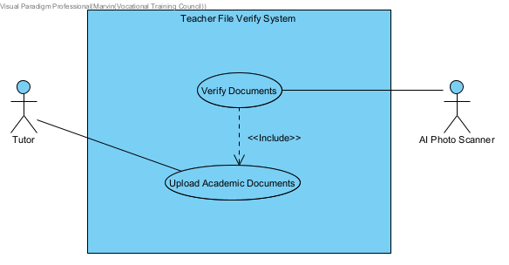
Actor Specification(Tutor file verify system)
Actor Name: | Tutor
Description: | Tutors can upload academic documents in the system.

Actor Name: | AI photo scanner
Description: | AI photo scanners can verify documents sent by Tutor in the system.

Use Case Description
Use Case Name | Upload Academic documents
Use Case ID | UC-600
Primary Actor(s) | Tutor
Brief Description | Tutors upload academic documents in the system.
Flow of Events | 1.Tutor upload academic documents in the system.  2.Waiting for verify
Priority | High

Use Case Name | Verify documents
Use Case ID | UC-601
Primary Actor(s) | AI photo scanner
Brief Description | AI photo scanner verify documents
Pre-conditions | There have a documents verify request
Flow of Events | 1.Tutor upload academic documents in the system.  2.Request sent to AI photo scanner for verify  3.AI photo scanner will Confirm whether the picture is approved.
Priority | High

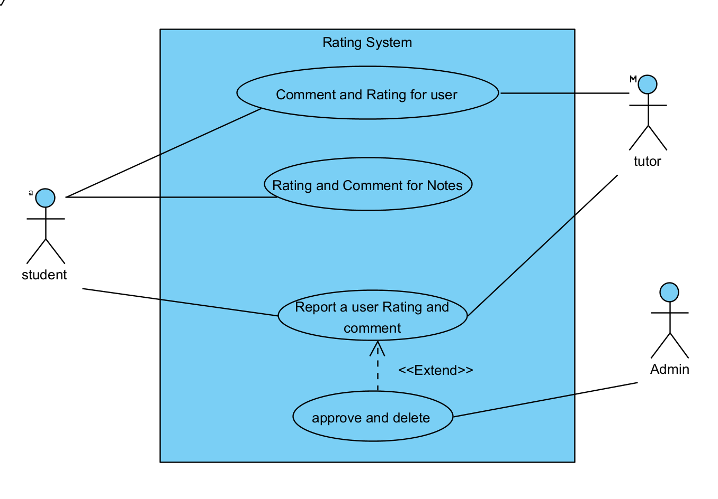
Actor Specification
Actor Name: | Admin
Description: | Admin can approve and delete comments.

Actor Name: | Student
Description: | Students can comment and report notes and users.

Actor Name: | Tutor
Description: | Tutors can report comments and users.

Use Case Description

Use Case Name | Comment and rating for user
Use Case ID | UC-700
Primary Actor(s) | Student, Tutor
Brief Description | The user can comment and rating for the user.
Pre-conditions | The tutor must log into the system.
Flow of Events | - The user clicks the other’s profile.  - The user types the comment and chooses the number of stars.  - The user enters “enter”.
Priority | Low

Use Case Name | Rating and Comment for Notes
Use Case ID | UC-701
Primary Actor(s) | Student
Brief Description | The user can comment and rating for the notes.
Pre-conditions | The tutor must log into the system.
Flow of Events | - The user clicks the details of the course .  - The user types the comment and chooses the number of stars.  - The user enters “enter”.
Priority | Low

Use Case Name | Report a user Rating and comment
Use Case ID | UC-702
Primary Actor(s) | Student, tutor
Brief Description | The user can report the user's comment and rating.
Pre-conditions | The tutor must log into the system.
Flow of Events | - The user searches for the user’s comment and rating.  - The user clicks “Report” to report the specific comment and the message of the report is sent to the admin by the system.
Priority | Low

Use Case Name | Report a user Rating and comment
Use Case ID | UC-703
Primary Actor(s) | Student, tutor
Brief Description | The user can report the user's comment and rating.
Pre-conditions | The tutor must log into the system.
Flow of Events | - The user searches for the user’s comment and rating.  - The user clicks “Report” to report the specific comment and the message of the report is sent to the admin by the system.
Priority | Low

Use Case Name | Approve and delete report
Use Case ID | UC-704
Primary Actor(s) | Admin
Brief Description | The user can verify the report.
Pre-conditions | The user must log into the system.
Flow of Events | - The user can check the report list.  - The user can click the “Approve” or “Delete” button to deal with the report.
Priority | Low

- ER Diagram
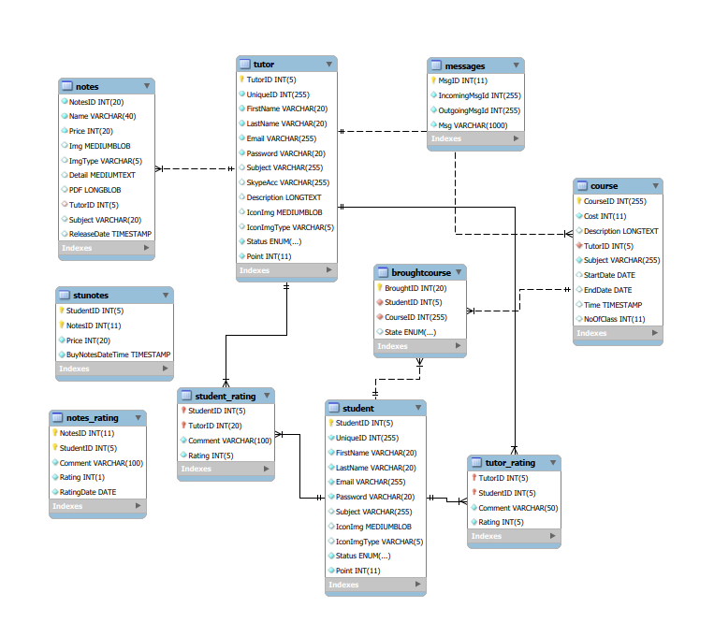

- Sequence Diagram
  - Sign-Up
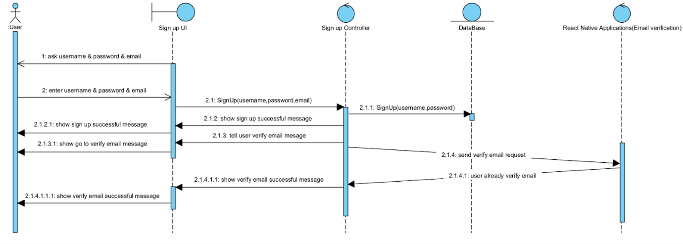
  - Login
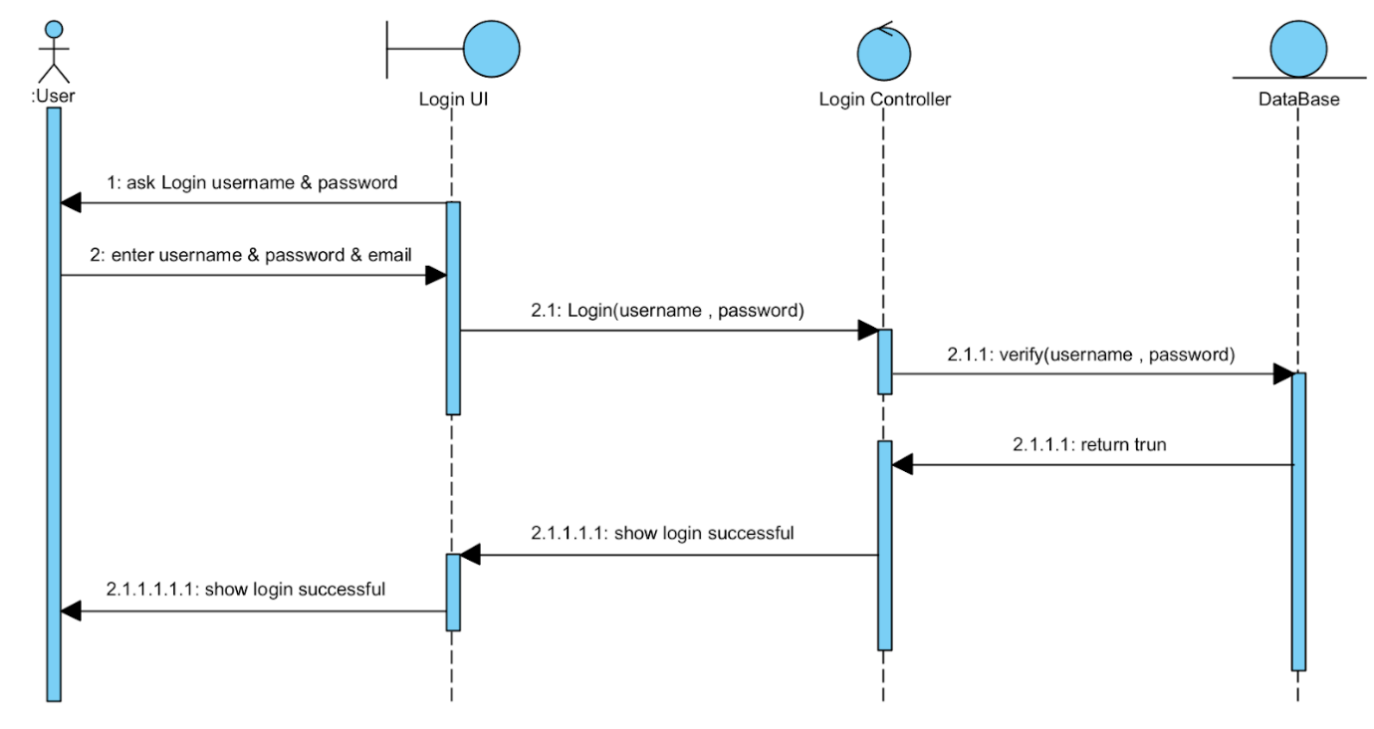
  - Course System
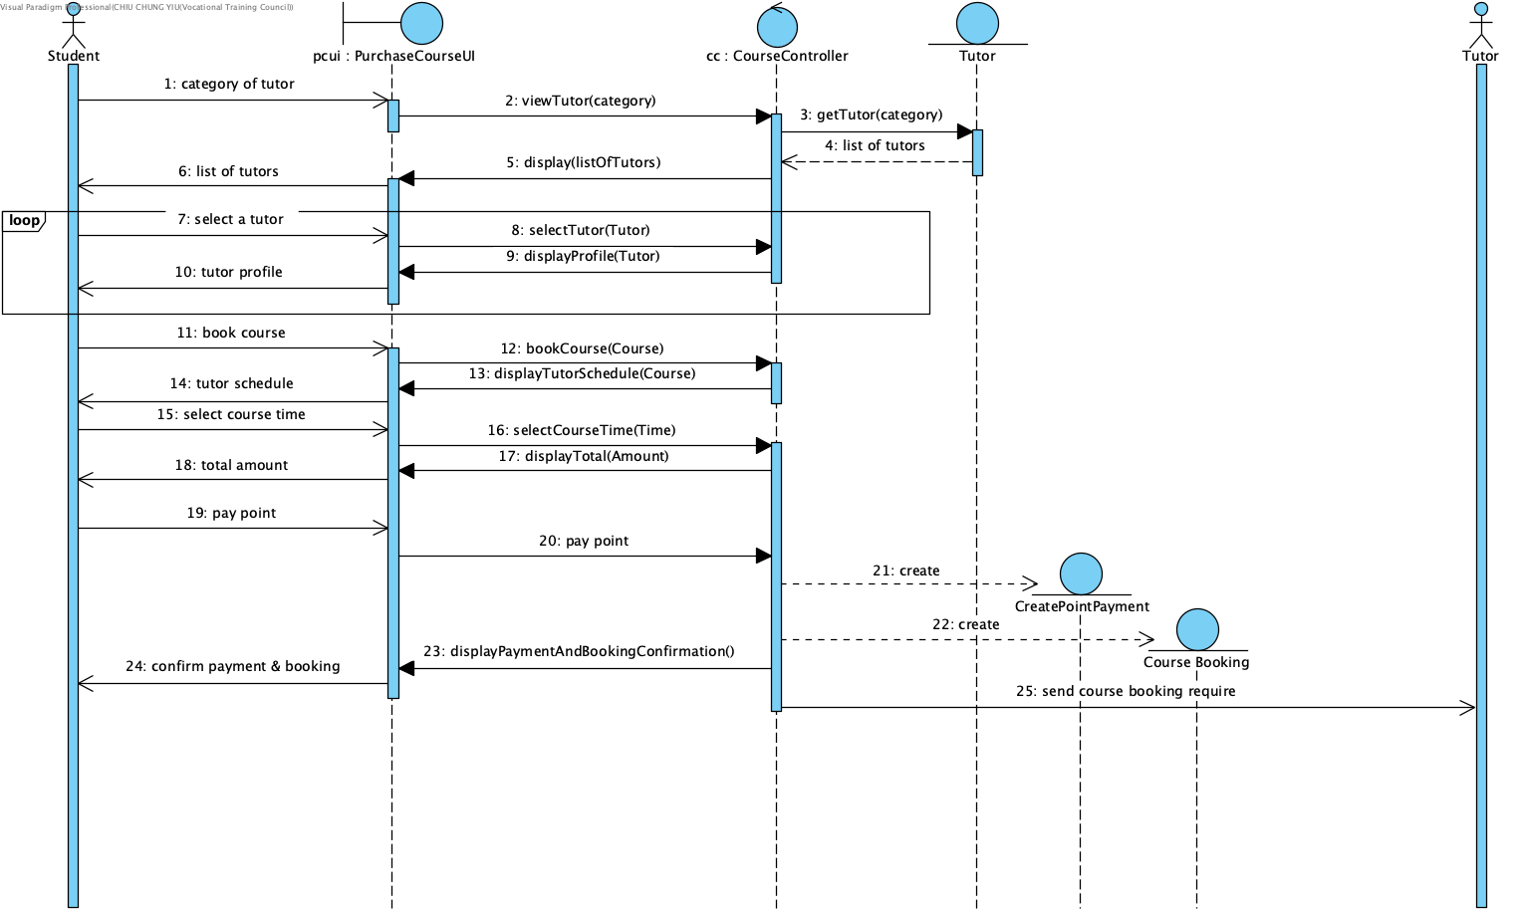
  - Notes System
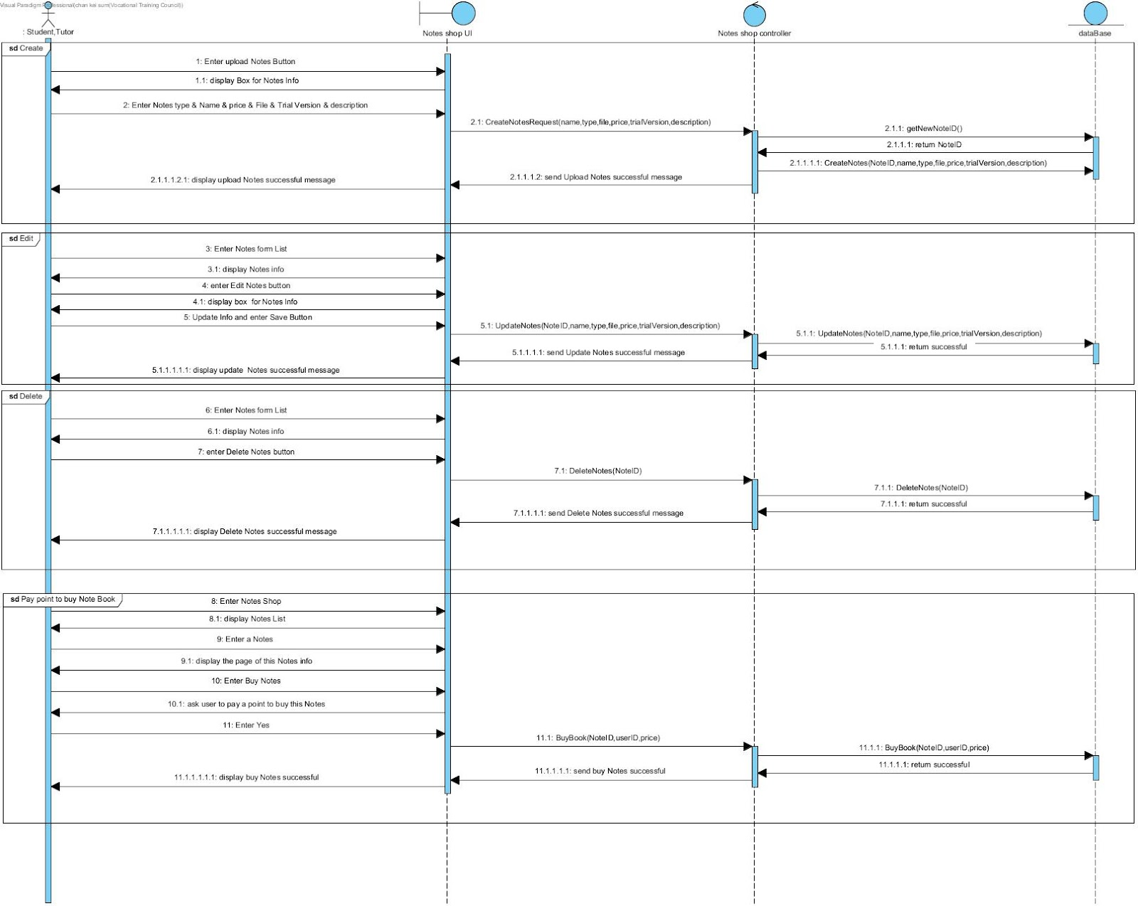
  - Profile System
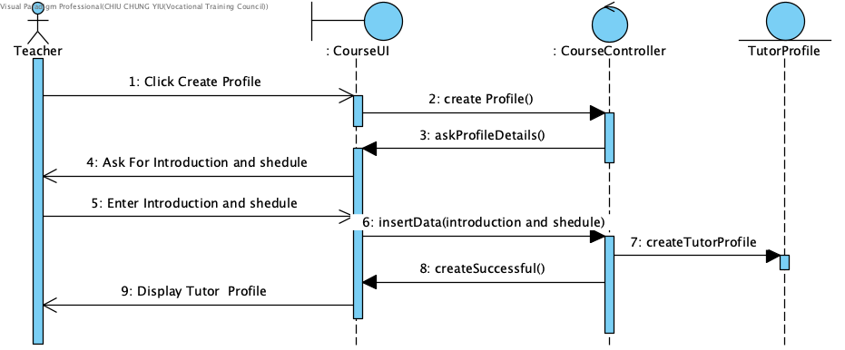
  - Point System
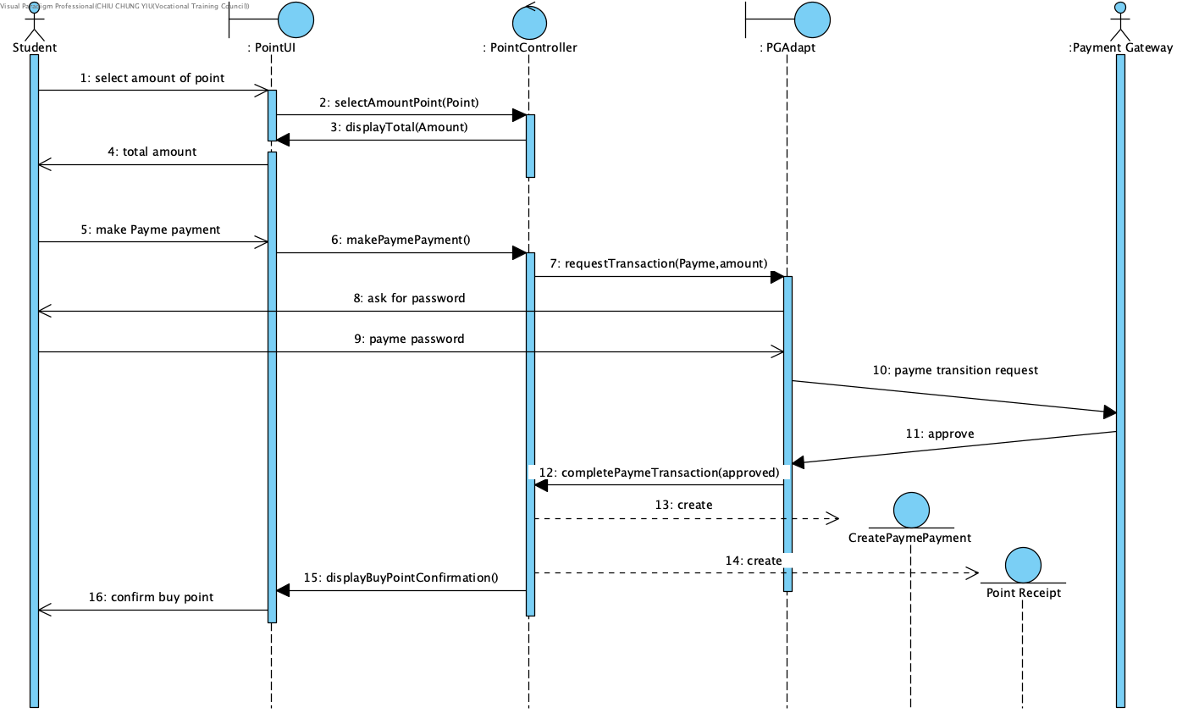
  - Chat Room
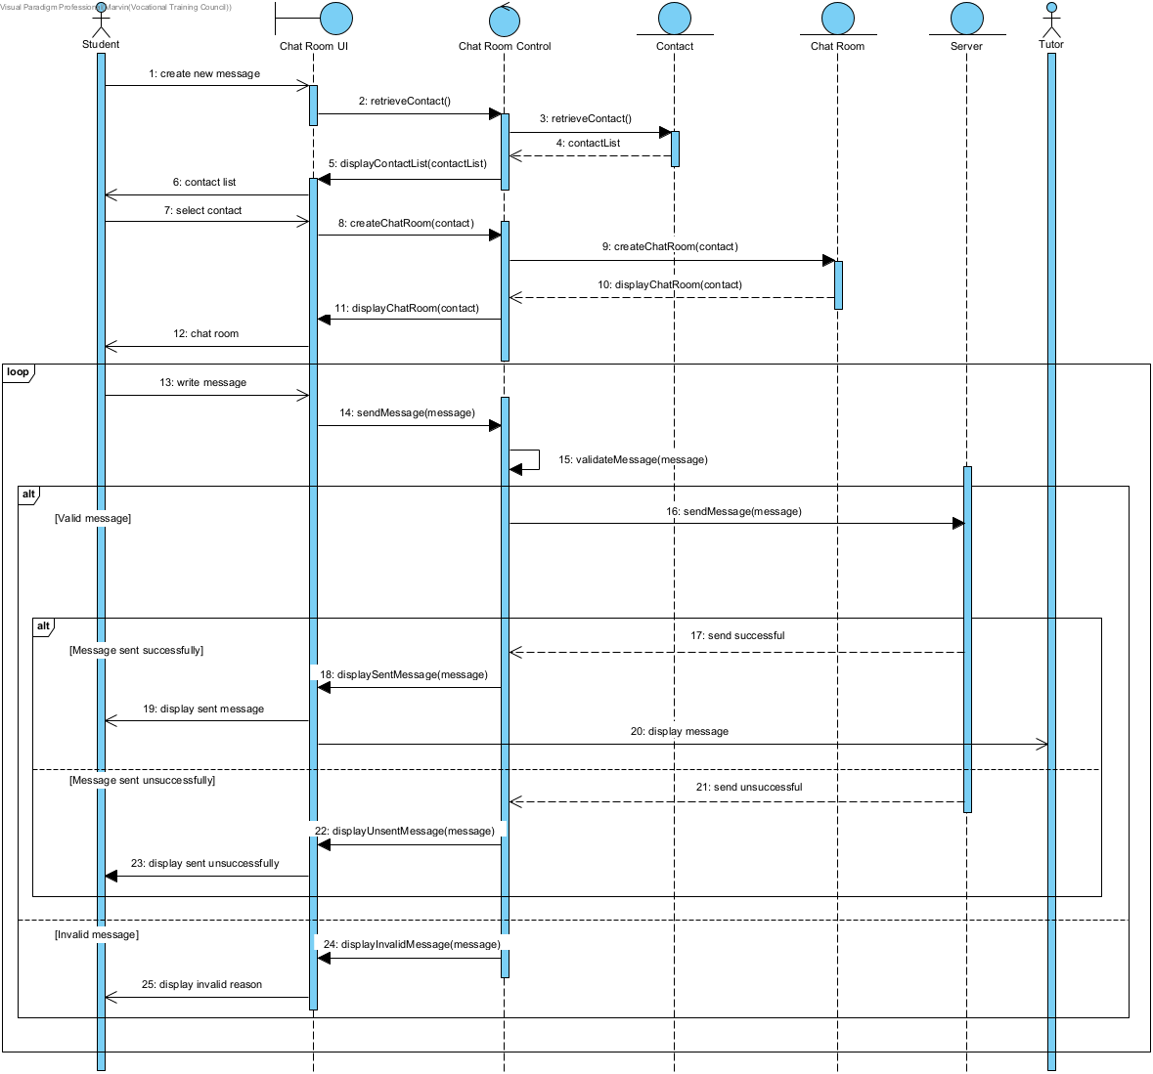
  - Rating System
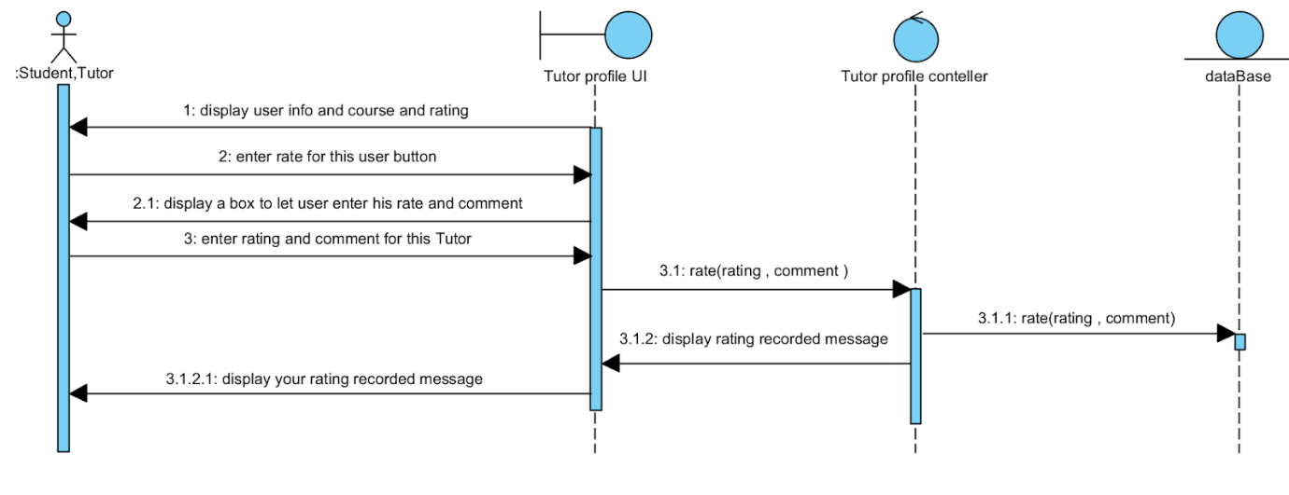

- Implementation
record of the implementation work, e.g. test plan, test results, changes to design and justification of changes. The implementation documentation should include the user guide and installation guide which are submitted in a separated volume.

- Results and conclusions
a summary and a critical discussion of the results, conclusions, any problems/difficulties encountered, any delays/changes in project schedule, limitations of the proposed system, and in some cases a subsection suggesting further developments to be undertaken.
- Critical Evaluation
  - Any problems/difficulties encountered
Problems
Before we change the programming language of our system, we are using React Native front-end language, because react native is too many versions, and we meet many version compatibility issues. For example, we have met many npm install errors and import package errors. So, the development progress of our react native is not as expected.

Difficulties
After considering the planned feasibility, we changed to using HTML 5 as the front-end language, and PHP as the API language, so we need to develop the system again. Because of this reason, we have a tight development time. This is the main difficulty of our system development.
  - Any delays/changes in project schedule
Using new programming languages such as react native and node.js is a big challenge for us. We spend additional time learning it after school. Also, the react native is not easy for us to debug because it lacks guidelines to remind us where error is. Therefore, we design to use html to write the front-end and php to write the back-end. These languages which we learnt before, so we can use them more skillfully in the project.

  - Limitations of the proposed system
The actual operating system differs from our proposed system. When we actually build these functions,We found that some functions are not as simple as we imagined.Because of our technical problems, we may not be able to re-enact the full functionality.So we need to trade off functionality from the suggestion system.In addition to technical limitations, I think our suggestion system lack of careful consideration. Leading to a lot of loopholes when we actually started designing and programming.In the end, we need to change the programming language to fit the system we need.
  - Potential difficulties associated with the suggested progression route
The first potential difficulty is that we were behind schedule when we tried to learn a new programming language. Since we have changed our system from a mobile application to a website, we used html instead of react native and php + javascript instead of node js. We found that we need more time to learn new languages (react native and node js) and we could not catch up with the suggested progression route. Therefore, we decided to use familiar language(html + javascript + php) to catch up with it. Second, we may provide different payment methods to let user top-up points, it may require additional resources to implement the plan successfully. Additionally, more elements may need to be adjusted or reorganized in order to accommodate the new processes and procedures. The progression could also become challenging if we can not handle the payment method for the points system. Finally, depending on the length of time required to create a healthy working environment while still achieving goals, there may be significant deadlines that must be met which could add pressure and stress during implementation.
- Software Process Model
We will use Agile software development methodology to develop our system. since It’s an adaptive approach that responds to changing requirements quickly and efficiently. Also, Constant feedback drastically minimizes risk later on. Then
Continual communication improves transparency between the client and the team.
It focuses on working with software, which means there is less documentation to worry about. Therefore, our system which depends on user opinions needs to be continuously improved to improve the system.

- Project Plan
  - Gantt Chart
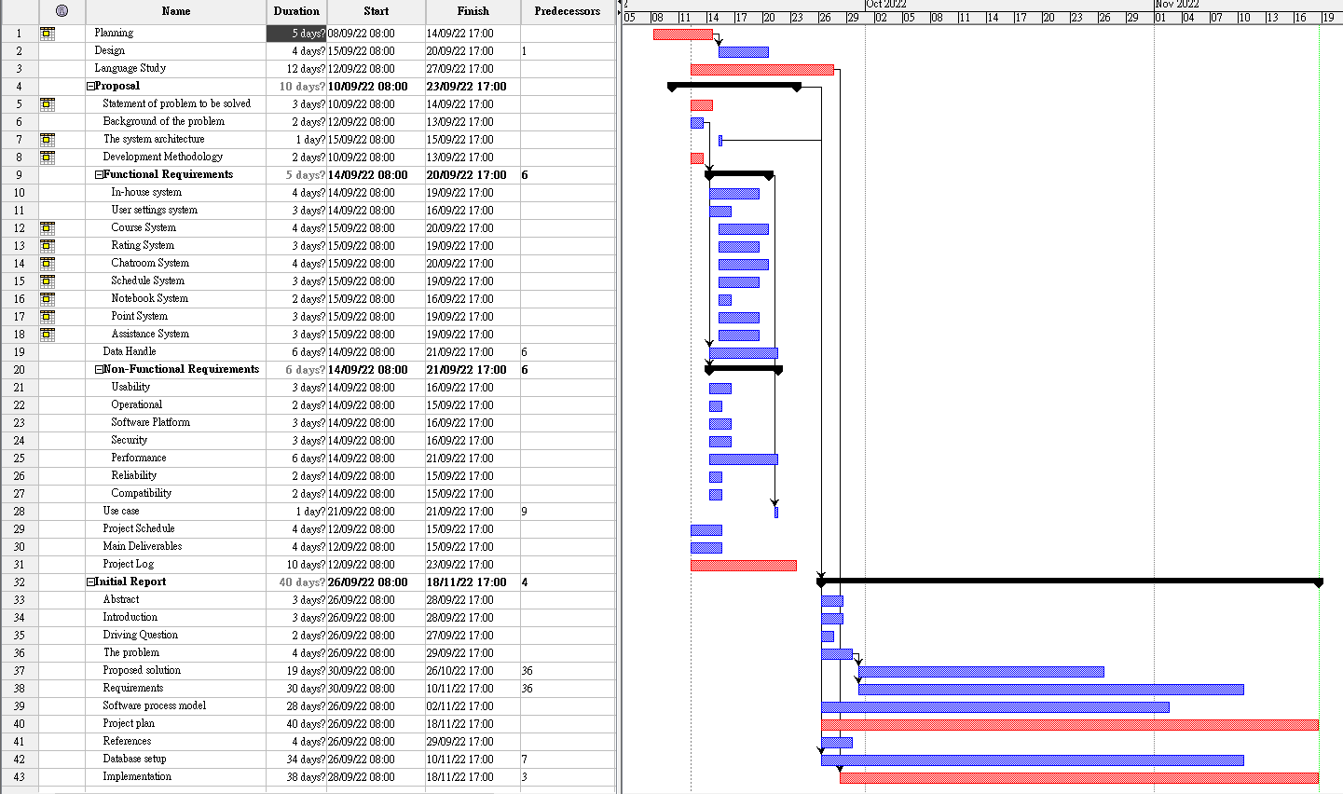
- References.
How to Create a Gantt Chart. (n.d.). Gantt.com. https://www.gantt.com/creating-gantt-charts

How to Get Started in iPhone/iPad App Development | Best Mobile App Awards. (n.d.). https://bestmobileappawards.com/blog/how-to-get-started-in-iphoneipad-app-development

Kemp, S. (2022, May 4). Digital 2022: Global Overview Report. DataReportal – Global Digital Insights.
https://datareportal.com/reports/digital-2022-global-overview-report

What is a CMMS? Definition, how it works and benefits | IBM. (n.d.).
https://www.ibm.com/hk-en/topics/what-is-a-cmms

