# Project Management

## Business Case

### Executive summary

This business case overview illustrates how the Guidance and Counseling System will handle current business challenges, as well as the project's benefits, recommendations, and justification. The business case also goes into specific project objectives, performance metrics, assumptions, restrictions, and alternative solutions.

#### Issue

Bestlink College of the Philippines guidance and counseling department has no automated system; it is time-consuming to manage counseling records. The authorized personnel use a manual way to process all the transactions, from collecting student’s information to monitoring the reports. In this way, problems are also encountered— It requires a lot of space for offices from files of paper records. There is a big chance of duplication, mistakes, and errors. With the manual process, the data would not be stored in an organized manner and can cause data loss, confusion, and no security. Everybody can access even unauthorized personnel. Guidance and counseling department needs a system to counsel students more efficiently and effectively. Due to pandemic, Individual and Group Counseling is now being used online conferencing for students who need counsel.

#### Anticipated Outcomes

The guidance and counseling system allows counsellors to counsel students more efficiently and effectively. It also improves the follow-up process for students to monitor their situation or their emotions and behaviour in class. All collected records of the students can have fast and easy access to personal information of the students as a basis on how the counsellor gives advice to the students. It saves a lot of space for the guidance department from files of paper records. It also makes student record administration more accessible, efficient, and reliable without losing quality

#### Recommendation

Guidance and Counseling in Bestlink College of the Philippines do not have an automated system for accurate monitoring of students' progress and easier follow-up and communication with guidance counselors. The proposed system helps the counselor find the students' information in the shortest time possible. The user can easily input data into the student's profile, which will reduce the amount of time work is consumed. Some of the ways that this system will achieve its desired results are:

* A portal for both parties (students and admin) to ensure that the interaction and role will process effectively.
* Accessing the respective portal and being able to register is the main priority to differentiate the role of students and admin to ensure the confidentiality of individuals' information
* Files are easily accessed and retrieved for every transaction that will be recorded in the system.
* Individual and Group Online conferences for consultation and counseling of the students.
* Counselors’ will be able to counsel students more efficiently and effectively.

### Business case analysis team

This section of the business case template describes the team members' roles that developed the business case.

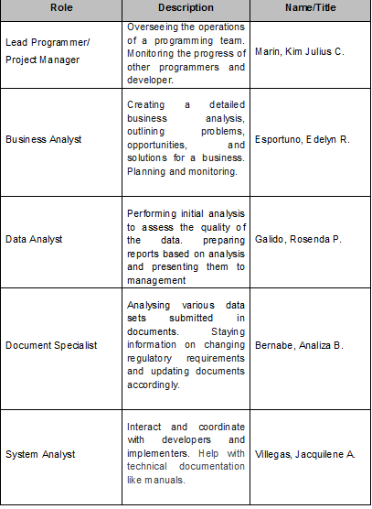

### Problem definition

#### Problem statement

The Bestlink College of the Philippines Guidance Department has no automated guidance and counseling system; guidance needs a system to counsel students more efficiently and effectively. Due to pandemic, Individual and Group Counseling is now being used online conferencing for students who need counsel. It takes time to manage counseling records. The authorized personnel use a manual way to process all the transactions, from collecting student information to monitoring the reports. In a manual process, the follow up process will take a lot of time, but when a system uses it is  convenient to follow up, it will reduce time to find and wait for the student to come and to know his/her status. With the manual process, the data would not be stored in an organized manner and can cause data loss, confusion, and no security.

#### Organizational Impact

The Guidance and Counseling project will impact in so many ways. The following explains how the organization, tools, processes, hardware, software, roles, and responsibilities will affect implementing the project.

**Tools:** The existing manual process will no longer be used as the project has been implemented. An authorized user will be required to be trained for a new useful tool for a system project.

**Processes:** Counseling to the student will be convenient and follow-up sessions will become more efficient. Generating reports of the number of studentswho counselled and the students who have emotional and psychological problems are able to analyze and give recommendations on their situation.

**Roles and Responsibilities:** In the proposed project, authorized staff will directly monitor all counselled students. Manual writing will no longer be the used way to add and monitor reports. Admin can access and generate accurate reports. Students can ask for advice from the counselor using the system that was provided to them to access.

Hardware/Software: Guidance personnel will be required to have the workstation that will meet the needs of the following:

Hardware minimum requirements:

* 32 GHz i5-3470
* 32 GB memory
* VGA Display

Software minimum requirements:

* JRE 6 for Windows OR
* JRE 6 for Linux

#### Technology Migration

A phased approach has been developed to effectively migrate the existing data to a new system project to discuss the day-to-day operations. The following is a high-level overview of the phased approach:

**Phase I:** Hardware/Software will be purchased, and the guidance and counseling system will be created in the web-based environment and tested by the project team.

**Phase II:** Developed system will be installed to the workstation and will be tested by our team.

**Phase III:** The guidance counseling department's files, records and counseling from the manual system will be transferred to the newly developed system.

**Phase IV:** The authorized personnel will have training on the newly developed web application.

### Project Overview

### The Guidance and Counseling system overview describes how this project will address the Guidance and Counseling Department's problem. The overview consists of a project description, goals and objectives for the Guidance and counseling system, project performance criteria, project assumptions, constraints, and major milestones. As the project is approved and moves forward, each of these components will be expanded to include more detail in working toward the project plan.

#### Project description

The Guidance and Counseling system is software designed to enable more accurate monitoring of students' counseled progress and easier follow-up and communication with guidance counselors. The program's output also includes a method for managing advice data information at the right time. Counselors would interact and access confidential documents more effectively, resulting in better case management.

The researchers conducted this study to provide the Guidance and Counseling Department of Bestlink College of the Philippines with a system  that will manage all the inquiries of the students to ask for counseling. The system provided to make counseling services will improve in the manner of giving an online conference, follow-up session, requesting documents like good moral and generating accurate reports.  It also helps the counsellor to determine what advice the student has by checking the student's profile.

#### Goals and objectives

The proposed project directly supports several goals and objectives established by the guidance and counseling department. The following table lists the business goals and objectives that the system supports and how it supports them:

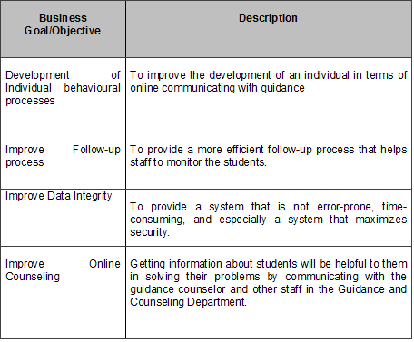

#### Project performance

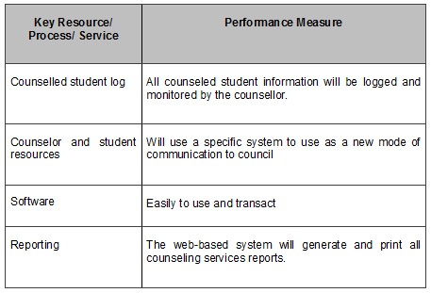The table below is the key resources, processes, or services and their project performance measure.

#### Project assumption

The following assumptions apply to the Guidance and counseling system. As project planning begins and more assumptions are identified, they will be added accordingly.

* Manage the records of students and provide fast and easy access to personal information and a basis for academic status.
* Helps counselors to counsel students more efficiently and effectively through individual or group counseling online.
* Generating reports will not be a burden to the counselor for it will be easy to access by the desired date.

#### Project constraints

#### Major project milestones

The following are the major project milestones identified at this time. As the project planning moves forward and the schedule is developed, the milestones and their target completion dates will be modified, adjusted, and finalized as necessary to establish the baseline schedule.

|  |  |
| --- | --- |
| **Milestones/ Deliverables** | **Target Date** |
| Project Charter |  |
| Project Review |  |
| Kick-off | Dec. 18, 2021 |
| Sprint 1 | Jan 9, 2022 |
| Sprint 2 | Jan 23, 2022 |
| Sprint 3 | Feb 6, 2022 |
| Sprint 4 | Feb 20, 2022 |
| Sprint 5 | March 6, 2022 |
| Sprint 6 | March 20, 2022 |
| Sprint | April 3, 2022 |

### Strategic Alignment

The proposed system is supporting the progress of the Guidance and Counseling Department. This project will help the administration to improve for the betterment and maturity of the department.

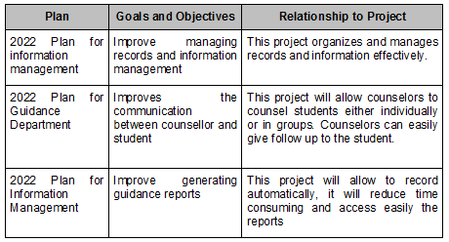

### Cost-benefit analysis

The following table captures the cost and savings actions of the Guidance and Counseling project, descriptions of these actions, and the costs or savings associated with them through the year.

|  |  |  |  |
| --- | --- | --- | --- |
| **Action** | **Action Type** | **Description** | **First-year Cost** |
| Purchase licenses and products for Web-based applications. | Cost | Initial Investment for Guidance and Counseling system |  |

### Approvals

The signatures of the people below indicate an understanding of the purpose and content by those signing it. By signing this document, you indicate that you approve of the proposed project outlined in this business case and that the following steps may be taken to create a formal project following the details outlined herein.

|  |  |  |  |
| --- | --- | --- | --- |
| **Approver Name** | **Title** | **Signature** | **Date** |
| Enrico Pineda | Project Owner |  |  |
| Khristian Hosena | Project Adviser |  |  |

## Project charter

This Charter formally authorizes the Guidance and Counseling System to develop and implement a new Guidance System to be used in Bestlink College of the Philippines. A project plan will be developed and submitted to the Project Sponsor for approval. The project plan will include scope statement; schedule; cost estimate; and provision for scope, resource, schedule communications, quality, risk, procurement and stakeholder management as well as project control.

Guidance and Counseling is the process of helping individuals discover and develop their educational, vocational, and psychological potentialities to achieve an optimal level of personal happiness and social usefulness.

Counseling is a component of school provided by counselors to students. The goal of incorporating guidance and counseling into the school system was to eliminate many young people's overwhelming ignorance about their career options and emotional personality instability. The role of Information Technology in guidance can be viewed in three ways: as a tool, an alternative, or an agent of change. Because of the growth of websites and helplines as forms of technically mediated customer satisfaction, Information Technology's potential as a change agent is now greater than ever. Telephones, websites, and e-mail, in addition to face-to-face facilities, could be alternative services; or portals into a broad, flexible, and well-integrated range of services. The goal of the guidance and counseling system  in the school was to help counsellors usually deliver the sessions in a safe and inclusive learning environment to help the students.

The developers expected to develop a system that would meet the needs of such a newly blooming administrative structure that would be much more convenient, especially during this pandemic period.

The Guidance and Counselling system is software designed to enable more accurate monitoring of students' progress and easier follow-up and communication with guidance counselors. The program's output also includes a method for managing advice data information at the right time. Counsellors’ would interact and access confidential documents more effectively, resulting in better case management. Furthermore, proper counseling record management will support school-based counseling and guidance.

The Project Manager, Kim Julius C. Marin, is hereby authorized to communicate with all contractors and management as needed, to interface with management as needed, to negotiate for resources, to delegate responsibilities within the project framework, and to communicate with all contractors and management as needed to ensure the project's successful and timely completion. The Project Manager is in charge of designing the project plan, monitoring the project's schedule, cost, and scope during implementation, and maintaining project control through performance measurement and corrective action.

The project plan will be submitted and approved in accordance with the milestone schedule below. Upon approval of the project plan, resources will be assigned to the project and work will commence within 30 days  The Project Sponsor must approve any schedule changes which may impact milestones. A detailed schedule will be included in the project plan. The high-level milestone schedule is:

## Stakeholder Strategy

### Introduction

The Stakeholder Management Strategy for Guidance and Counselling system will identify and classify the stakeholders of the project. By this, it will help to know the influence and interest of the stakeholders. It will also know the use and methodology in approaching or communicating with the stakeholders. In doing this, the project will be free to gain input for the progress of the project. Identifying and communicating with stakeholders gives help to ensure the success of the proposed project by gaining support and input for the project. The project will benefit by having clear objectives and maximizing the resources required to complete the project.

### Identify stakeholders

The Project Team will have a meeting session through Google meet to identify stakeholders for the project. This session will include the primary project team and project sponsor. These stakeholders may include students, guidance and counseling personnel, and development team who will be affected by the project. The following criteria will be used to determine if an individual will be included as a stakeholder:

1. Will the person or their department be directly affected by this project?

2. Will the person or their department hold a position from which they can influence the project?

3. Will the person have an impact on the project’s resources (material, personnel, funding)?

4. Will the person potentially benefit from the project?

### Key stakeholders

The project team will identify the key stakeholders who have more impact and will be affected in this project. Key stakeholders are the people who are more needed in the project’s progress. Once the key stakeholder has been identified, the project manager will make a plan to gather their ideas, concerns, or any form of participation in this project. The Guidance and Counselling stakeholders that are involved in the project will benefit from the system. They will use this system to improve their counselling and communication with the students.

By analyzing, the project team will involve the key stakeholders in every project meeting, session, or any deliverable work. Through communication with the key stakeholders, it will ensure the need to address all the concerns.

### Stakeholder analyst

This analysis aims to determine the stakeholders' level of power or influence and plan the management approach for each stakeholder. The chart below will establish stakeholders and their levels of power and interest for use on the power/interest chart as part of the stakeholder analysis.

The project team will categorize stakeholders based on their organization or department. The project team will use a power/interest matrix to highlight the possible impact each stakeholder could have on the project once all stakeholders have been classified. The project team will also construct a stakeholder analysis matrix based on this analysis, which will show each stakeholder's issues, level of involvement, and management strategy.

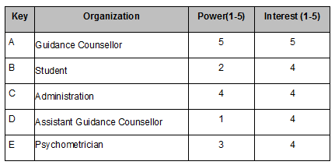

Below is the power/interest chart for the Guidance and Counselling stakeholders. Each letter represents a stakeholder in accordance with the key in the chart above.

5

5

1

1

Power

Interest

A

B

C

D

E

Based on the power and interest analysis and chart above, the stakeholders A and C must be kept informed and have a large participation as they reside on the upper right quadrant of the matrix. Stakeholders B, D and E will require minimum involvement effort for they reside in the lower right quadrant.

The stakeholder analysis matrix will be used to capture stakeholder concerns, level of involvement based on the stakeholder analysis and power/interest matrix above.

|  |  |  |  |
| --- | --- | --- | --- |
| **Stakeholder** | **Concerns** | **Quadrant** | **Strategy** |
| A | Gathering resources and scheduling data constraints for the production of the project | Key Player | Frequently communication and obtaining data required for the planning |
| B |  |  |  |
| C | Product performance must meet or exceed current product | Key Player |  |
| D |  |  |  |
| E |  |  |  |

# Project Planning

## Project management plan

### Introduction

The Guidance and Counselling System has been given to the project team (L) Cluster 6 to move forward for project initiation within the research and development group.  This project will result in the development of the Guidance and Counselling Department within the Bestlink College of the Philippines and supports progressive and fast-acting solutions to the counsellor/personnel which improve productivity in the workplace. The Project team believes that having a Guidance and Counselling system installed in the school premises will enable the counsellor to use a system which assesses the student online to counsel them. It improves the follow-up session of the student concern. The Guidance and Counselling system provides accurate services that can help students with their needs although pandemic students can use the system to give them services that can lean and give them guidance to their emotional, psychological and also their academic matters.  The project team expected to develop a system that would meet the needs of such  a newly blooming administrative structure that would be much more convenient.  It is more reliable nowadays because it helps students to lessen their problems. Guidance Counsellors’ would communicate and access the confidential documents and information of the students more effectively, allowing for improved case management. Furthermore, proper counseling record management will be employed to support school-based counseling and guidance.

### Project management approach

To ensure project success and timely completion, the Project Manager, Kim Julius Marin, is hereby authorized to interface with management as needed, negotiate for resources, delegate responsibilities within the project framework, and communicate with all project team members and management as needed. The product owner will examine and approve all project and subsidiary management plans. Throughout the project, the project team will report on their progress. The Project Manager is in charge of keeping the project team informed about their progress and performance.

### Project scope

The Guidance and Counselling system focused on the counseling of the students. This system provides the needs of the students that can help them to increase their personality even though the students not experiencing a face-to-face class system can provide the services that can help the student to encourage and to communicate with the guidance counsellor.

This study primarily focused on the students that would use the Guidance and Counselling System within Bestlink College of the Philippines. The Researcher aimed to describe the importance and implementation of the study within and outside school premises. Using information services, the students can make their inquiries, concerns, and problems addressed in a systematic and efficient way without going to school.

### Milestone list

The below chart lists the major milestones for the Guidance and Counseling system. This chart comprises only major project milestones such as completion of a project phase or gate review. Suppose any scheduling delays may impact a milestone or delivery date.

|  |  |  |
| --- | --- | --- |
| **Milestone** | **Description** | **Date** |
| Completed Requirements Gathering | All Guidance and Counselling system requirements must be determined based upon design. | October 22, 2021 |
| Guidance and Counselling System Design | This is the theoretical design for the software and its functionality. | November 8, 2021 |
| Guidance and Counselling System Coding | Coding was completed, resulting in a software prototype. | December |
| Guidance and Counselling System Testing and Debugging | All functionality tested and all identified errors corrected |  |
| Implementation of Guidance and Counselling System | Completed software and documentation for Implement in Bestlink College of the Philippines Guidance Department |  |

### Schedule baseline and WBS

The WBS for the Guidance and counseling system consists of work packages with a given proper time of work for team development. Work packages were developed through close collaboration among project team members and stakeholders with input from functional managers and research from past projects.

The WBS Dictionary consists of all work packages for the Guidance and Counseling Project. These include all tasks, resources, and deliverables.

The WBS and Project Charter were used to create the Guidance and Counseling Project timeline, which included input from all project team members. The project sponsor reviewed and approved the timetable. The Project Manager will keep track of the schedule. Any planned timetable adjustments will require the project sponsor's permission. The impact of the modification on the schedule, cost, resources, scope, and risks will be determined by the Project Manager and team.

If the Project Sponsor approves the change, it will be implemented by the Project Manager, who will update the schedule and related documentation, as well as notify all stakeholders.

### Change management plan

The Change Management Plan may be incorporated as an appendix to the Project Management Plan or as a distinct, stand-alone document for complex or big projects. On the system, the project team has a complete Change Management Plan Template.

The following comprise the College of Computer Studies Department change control process for all system projects and will be used on the Guidance and Counselling System Project:

1. Determine whether or not a change is required (Any Stakeholder) a completed College of Computer Studies modification request form will be submitted to the project manager by the requestor.

2. Changes should be recorded in the change request registry (Project Manager). For the course of the project, the project manager will keep track of all change requests.

3. Carry out a change assessment (Project Manager, Project Team, and Requestor). The project manager will assess the cost, risk, schedule, and scope implications of the change.

4. Submit a request for a modification to the Scrum Team (ST) (Project Manager). The change request and analysis will be sent to the College of Computer Studies for evaluation by the project manager.

5. Scrum Group (SG) Based on all submitted material, the SG will discuss the proposed change and decide whether or not it will be authorized.

6. Change must be implemented (Project Manager) If the SG approves a change, the project manager will update and re-baseline the project documentation as needed, as well as communicate any changes to the team and stakeholders.

A change request for the Guidance and Counseling System Project can be submitted by any team member or stakeholder. The SG will be chaired by the Guidance and Counseling System Project Adviser, and any changes to the project scope, cost, or timeline must be approved by him. The Project Manager will log all change requests in the change control register and track them through to completion, whether they are allowed or not.

### Communication Management Plan

This Communication Management Plan guaranteed that the project's progress was communicated throughout. These will be used to ensure that the project team and stakeholders communicate effectively and clearly. This will allow anyone to simply conduct and plan meetings or any other type of communication for the project's growth. To guarantee successful communication on this project, the Project Manager will take the lead. The Communications Matrix below details the communication requirements. The Communications Matrix will determine what information should be communicated, who should convey it, when it should be communicated, and to whom it should be communicated.

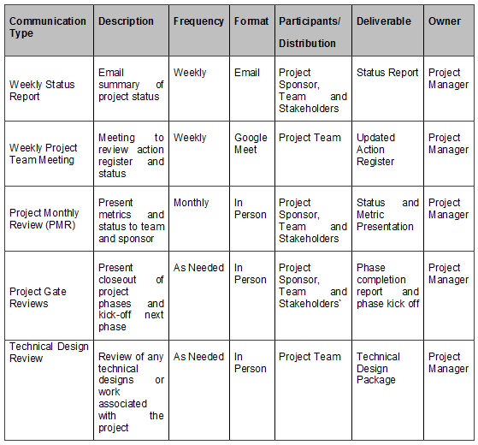

Project Team directory for all communications is:

|  |  |  |  |
| --- | --- | --- | --- |
| **Name** | **Title** | **E-mail** | **Contact Number** |
| Enrico Pineda | Project Owner | xxx | xxx-xxx-xxxx |
| Khristian Hosena | Project Sponsor | 21khristian@gmail.com | 0997-447-0712 |
| Kim Julius C. Marin | Project Manager | KimMarin43@gmail.com | 0951-273-3788 |
| Edelyn R. Esportuno | Business Analyst | edelynesportuno1@gmail.com | 0905-769-1046 |
| Rosenda P. Galido | Data Analyst | rosendagalido12@gmail.com | 0963-615-2535 |
| Analiza B. Bernabe | Document Specialist | anabernabe23@gmail.com | 0917-693-0709 |

Communications Conduct:

Meetings:

The Project Manager will distribute a meeting agenda at least early prior to any scheduled meeting and all participants must comply and review the agenda prior to the meeting. During all project meetings, all information and agenda will take notes; this must be the record for the team’s concern.

Email:

All email pertaining to the Guidance and Counselling Project should be professional, active, and provide brief communication. Email should be distributed to the correct project participants in accordance with the communication matrix above based on its content. All attachments should be in one of the organization’s standard software suite programs and adhere to established company formats.

Informal Communications:

Any issues, concerns, or status that arises from informal communications between team members must be communicated to the Project Manager so the appropriate action may be taken.

### Cost management plan

The Project Manager will be responsible for managing and controlling the project's costs, and will have the authority to do so. Throughout the project's life cycle, the manager must be informed of and present the project's cost performance status or calculations reports. The project manager must present it to the Project Sponsor, as the Project Sponsor will be in charge of all financial authority, choices, and adjustments.

### Procurement Management Plan

### The Project Manager will manage all procurement activities under this project. The Project Manager is authorized to approve all procurement actions up to (estimated cost). Any procurement actions exceeding this amount must be approved by the Project Sponsor.

### Project scope management plan

The project's scope is defined by the Scope Statement, Work breakdown structure. Measurement of project scope will be approved and documented by the Project Manager, Sponsor, and Stakeholders. The scope management plan includes all deliverables as well as measurements of work performance. Any suggested scope adjustments must be presented to the Project Manager for approval. After that, the project manager will study and assess the proposed adjustments before sharing them with the project team and stakeholders. The project manager will submit updated project documents and communicate with all stakeholders regarding the scope adjustments once the changes are made. The acceptance of the final project deliverables and scope is the responsibility of the Project Sponsor.

### Schedule management plan

This schedule deliverables were identified in Work Breakdown Structure (WBS). All activity has been defined to identify specific work that will be performed for the completion of all deliverables.  Once a schedule has been developed, it will be reviewed by the project team and any assigned project tasks will be monitored. The project team and resources must agree to the proposed work package assignments, durations, and schedule. Once this is achieved the project sponsor will review and approve the schedule and it will then be base lined.

In accordance with Bestlink College of the Philippines Department standard, the following will be designated as milestones for all project schedules:

• Completion of scope statement and WBS

• Base lined project schedule

• Approval of final project budget

• Approval of roles and responsibilities

• Requirements definition approval

• Project implementation

• Acceptance of final deliverables

The project team is responsible for participating in work package definition, sequencing, duration, and resource obtaining. The project team will also review and validate the proposed schedule and assign all work packages on the schedule approved.

### Quality management plan

All Guidance and Counselling project team members will play a role in quality management. The team must ensure that work is completed at an adequate level of quality, from individual work packages to the final project deliverable. The following are the quality roles and responsibilities for the Guidance and Counselling system:

All quality requirements for the Guidance and Counselling system must be approved by the Project Sponsor. All project tasks and deliverables will be reviewed by the Project Sponsor to verify that they meet the specified and agreed quality standards. In addition, the Project Sponsor will sign off on the project deliverable's final acceptance.

The Project Manager is responsible for quality management throughout the project. The Project Manager is responsible for implementing the Quality Management Plan and ensuring all tasks, processes, and documentation are compliant with the plan. The Project Manager will work with the project’s quality specialists to establish acceptable quality standards. The Project Manager is also responsible for communicating and tracking all quality standards to the project team and stakeholders.

The Quality Specialists are responsible for working with the Project Manager to develop and implement the Quality Management Plan. Quality Specialists will recommend tools and methodologies for tracking quality and standards to establish acceptable quality levels. The Quality Specialists will create and maintain Quality Control and Assurance Logs throughout the project.

The remaining members of the project team and the stakeholders will be responsible for assisting the Project Manager and Quality Specialists in the establishment of acceptable quality standards. They will also ensure that all quality standards are met and communicate any concerns regarding quality to the Project Manager.

Quality control for the Guidance and counselling system will utilize tools and methodologies for ensuring that all project deliverables comply with approved quality standards. To meet deliverable requirements and expectations, we must implement a formal process of measuring and accepting quality standards. The Project Manager will ensure all quality standards and quality control activities are met throughout the project. The Quality Specialists will assist the Project Manager in verifying that all quality standards are met for each deliverable. Suppose any changes are proposed and approved by the Project Sponsor and Panelist. In that case, the Project Manager is responsible for communicating the changes to the project team and updating all project plans and documentation.

Quality assurance for the Guidance and Counselling system will ensure that all processes used to complete the project meet acceptable quality standards. These process standards are in place to maximize project efficiency and minimize waste. For each process used throughout the project, the Project Manager will track and measure quality against the approved standards with the assistance of the Quality Specialists and ensure all quality standards are met. Suppose any changes are proposed and approved by the Project Sponsor and panelist. In that case, the Project Manager is responsible for communicating the changes to the project team and updating all project plans and documentation.

### Risk management plan

The approach we were using to identify and manage risks for this project has had a significant impact on its development. The project team will put forth effort in identifying risks associated with this project, as pooling all of its resources and recognizing risks at an early stage allows the project team to build a strategy for addressing the risks.

When gathering data, we run into roadblocks in the development of the project, which indicates the project's risk. To address and find a solution, the project manager will assess it and convey it to the project team and stakeholders.

### Risk Register

The Risk Register for this project is a log of all identified risks, their probability and impact to the project, the category they belong to, mitigation strategy, and when the risk will occur. The project manager led the initial project risk management meeting, which resulted in the creation of the register. The project team identified and classified each risk at this discussion. In addition, the team assigned a score to each risk based on the likelihood of it occurring and the potential consequence. The Risk Register also includes the risk's mitigation strategy as well as an estimate of when the risk is most likely to occur. Each risk has been incorporated into the project plan based on the assessed risks and timeframes in the risk register. The project manager will appoint a risk manager at the appropriate period in the plan—prior to when the risk is most likely to occur—to ensure adherence to the agreed-upon mitigation strategy.

### Staffing Management Plan

Staffing requirements for the Guidance and counseling system project include the following:

Project Manager – responsible for all management for the Guidance and Counselling system. The Project Manager is responsible for planning, monitoring, and managing all work activities, communicating to the project team, evaluating, coordinating, and staffing.

Programmer – responsible for coding and programming for the Guidance and Counselling system. All coding and programming tasks will be testing its performance. Responsibilities also include assisting with risk identification, determining the impacts of change requests, and status reporting.

Business Analyst- responsible for creating a detailed business analysis, outlining problems, opportunities, and solutions for a business. And also responsible for planning and monitoring.

Document Specialist- responsible for compiling all project documentation and reporting into organizational formats. Responsible for assisting the Project Manager in Configuration Management and revision control for all project documentation. Responsible for scribing duties during all project meetings and maintaining all project communication distribution lists.

Data Analyst- responsible for performing initial analysis to assess the quality of the data and preparing reports based on analysis and presenting them to management.

System Analyst- – responsible for helping establish testing specifications for the Guidance and Counselling system with the assistance of the Project Manager and Programmers. Responsible for ensuring all testing is complete and documented following standards. Responsible for ensuring all testing resources are coordinated. The System Analyst will be managed by the Project Manager, who will also provide feedback to the functional manager for performance evaluations.

The Project Manager will negotiate with all necessary to identify and assign resources for the Guidance and Counselling system. The appropriate functional manager must approve all resources before the resource may begin any project work. The project team will not be co-located for this project, and all resources will remain in their current workspace.

### Cost Baseline

The cost baseline for the Guidance and Counselling system includes all budgeted costs for completing the project.

|  |  |  |
| --- | --- | --- |
| **Project phase** | **Budgeted Total** | **Comments** |
| Planning | 2000 | Includes work hours for all project team members for gathering requirements and planning project |
| Design | 2000 | Includes work hours for all project team members for work on the Guidance and Counseling system conceptual design |
| Coding | 3000 | Includes all work hours for coding of the Guidance and Counseling system |
| Testing | 1500 | Includes all work hours for testing of the Guidance and Counseling system |
| Transition and Closeout | 3000 | Includes all work hours for transition to operations and project closeout |

### Quality Baseline

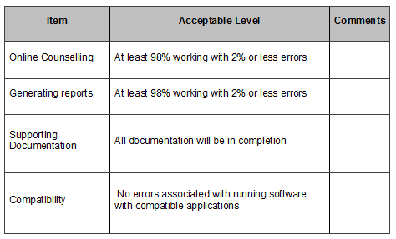

## Risk management plan

### Introduction

When a company embarks on a new project, it enters the realm of uncertainty that comes with the production of new and distinctive products or services. As a result, these firms take risks, which are critical in every undertaking that involves risk. A risk management plan's goals are to lay the groundwork for the project team to identify risks and develop solutions to mitigate or eliminate them. However, there are several preliminary project elements that must be accomplished before the risks can be identified and addressed. Thestrategy explains how to manage the risks associated with these factors.

The approach we were using to identify and manage risks for this project has had a significant impact on its development. The project team will put forth effort in identifying risks associated with this project, as pooling all of its resources and recognizing risks at an early stage allows the project team to build a strategy for addressing the risks.

When gathering data, we run into roadblocks in the development of the project, which indicates the project's risk. To address and find a solution, the project manager will assess it and convey it to the project team and stakeholders.

### Top three risk

The top three high probability and high impact risks to this project are:

**Delay Internet Connection**

Due to an unstable network the transaction may experience a delay caused by counseling interrupted. That is why the project manager will reduce the risk by using high-speed networks when necessary.

**Data Hacking**

Due to the low-level security of the system, it may encounter hackers that gain unauthorized access to the system. That is why the project manager will reduce the risk by creating restriction during logging in an account.

### Risk management approach

The approach we have taken to manage risks for this project included a methodical process by which the project team identified, scored, and ranked the various risks.  The most likely and highest impact risks were added to the project schedule to ensure that the assigned risk managers take the necessary steps to implement the mitigation response at the appropriate time.  Risk managers will provide status updates on their assigned risks in the weekly project team meetings, but only when they include their risk’s planned time frame.  Upon the completion of the project, during the closing process, the project manager will analyze each risk as well as the risk management process.

Based on this analysis, the project manager will identify any improvements that can be made to the risk management process for future projects.  These improvements will be captured as part of the lessons learned knowledge base.

### Risk identification

Risk identification was conducted in the initial project risk assessment meeting for this project.  The method used by the project team to identify risks was

**Hardware Malfunctions**

Most likely to fail was electromechanical devices that have moving parts like hard drives.

**Natural Disaster**

The most prominent risk that needs to be considered is that when natural disasters strike, they often do substantial damage to physical assets.

**Virus**

A high probability risk that may damage or steal your data or allow someone else to access your computer, without your knowledge or consent.

### Risk Qualification ad Prioritization

In order to determine the severity of the risks identified by the team, a probability and impact factor was assigned to each risk.  This process allowed the project manager to prioritize risks based upon their effect on the project.  The project manager utilized a probability-impact matrix to facilitate the team in moving each risk to the appropriate place on the chart.

Once the risks were assigned a probability and impact and placed in the appropriate position on the chart, the recorder captured the finished product. The project manager moved the process to the next step: risk mitigation/avoidance planning.

### Risk Monitoring

The most likely and greatest impact risks have been added to the project plan to ensure that they are monitored when the project is exposed to each risk.  At the appropriate time in the project schedule, a Risk Manager is assigned to each risk.  During the bi-weekly project team meeting, the Risk Manager for each risk will discuss that risk status; however, only risks that fall in the current period will be addressed.  Risk monitoring will be a continuous process throughout the life of this project.  As risks approach the project schedule, the project manager will ensure that the appropriate risk manager provides the necessary status updates, including the risk status, identification of trigger conditions, and the documentation of the results of the risk response.

### Risk Mitigation and Avoidance

The project manager has led the project team in developing responses to each identified risk.  As more risks are identified, they will be qualified, and the team will develop avoidance and mitigation strategies.  These risks will also be added to the Risk Register and the project plan to ensure they are monitored appropriately and responded to accordingly.

The risks for this project will be managed and controlled within the constraints of time, scope, and cost.  All identified risks will be evaluated to determine how they affect this triple constraint.  With the assistance of the project team, the project manager will determine the best way to respond to each risk to ensure compliance with these constraints.

In extreme cases, it may be necessary to allow flexibility to one of the project’s constraints.  Only one of the constraints for this project allows for flexibility as a last resort.

If necessary, funding may be added to the project to allow for more resources to meet the time (schedule) and scope constraints.  Time and scope are strong constraints and allow for no flexibility.  Again, the cost constraint is flexible only in extreme cases where no other risk avoidance or mitigation strategy will work.

### Risk Register

The project's Risk Register is a list of all recognized risks, their likelihood and impact on the project, the category to which they belong, mitigation method, and when the risk will occur. During the project manager's inaugural project risk management meeting, the register was produced. The project team identified and classified each risk at this discussion.

In addition, the team assigned a score to each risk based on the likelihood of it occurring and the potential consequence. The Risk Register also includes a mitigation strategy for each risk as well as an estimate of when the risk will occur.

## Scope management plan

### Introduction

Scope Management provides the scope framework for this project. The scope management strategy, roles and responsibilities related to project scope, scope definition, verification and management procedures, scope amendment control, and the project's work breakdown structure are all documented in this document. Any project communication concerning the scope of the project must go through the Scope Management created. This project aims to develop, create, and test substitute products that can be used to improve the generation of assortment reports. This covers the package's type, all programming and writing, and package testing and validation. This project will not require any external resources or outsourced units.

### Scope management approach

For this Guidance and Counselling System, scope management unit planning is the only real responsibility of the Project Manager. This project's scope is written in the Scope Statement, Work Breakdown Structure (WBS), and WBS reference. The Project Manager, Sponsor, and Stakeholders can establish and approve documentation for measuring project scope, which has deliverable quality checklists and work performance measurements. Planned scope changes are to boot initiated by the Project Manager, stakeholders, or any project team member. All modification requests and unit planning to be submitted to the Project Manager can then appraise the requested scope modification. Upon acceptance of the scope modification request, the Project Manager can submit the request to the modification panel and the project sponsor. Upon approval of scope modifications by the modification panel and Project Sponsor, the Project Manager can update all project documents and communicate the scope change to any or all or any or any stakeholders. They supported feedback and input from the Project Manager and Stakeholders. The Project Sponsor is accountable for accepting the last word on project deliverables and project scope.

### Roles and responsibilities

The Project Manager, Sponsor, and the team can all play critical roles in managing this project's scope. As such, the project sponsor, manager, and team members have to bear in mind their responsibilities so as to certify that the job performed on the project is within the established scope throughout the whole quantity of the project. The table below defines the roles and responsibilities for the scope management of this project.

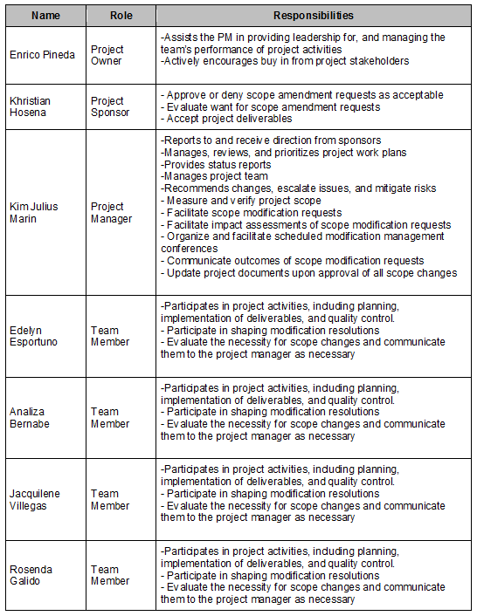

### Scope definition

The scope for this project was outlined through a comprehensive need’s assortment method. First, an intensive analysis was performed on the department’s current package applications supporting worker and user feedback. From this info, the project team developed the project needs documentation, the wanted management arrangement, and therefore the needed traceability matrix for what the new package application should accomplish.

The project description and deliverables were developed to support the desired assortment method and input from subject material specialists in package style, technical support, programming and business applications. This method of knowledgeable judgment provided feedback on the foremost effective ways to fulfil the initial needs of providing a replacement package platform from which the corporate will improve online counseling and their generating of reports.

### Project scope statement

The scope for this project was outlined through a comprehensive need assortment method. First, an intensive analysis was performed on the company’s current package applications supporting worker and user feedback. The project team developed the project needs documentation, the wants management arrangement, and the needs traceability matrix for what the new package application should accomplish. The project description and deliverables were developed to support the desired assortment method and input from specialists in package style, technical support, programming, and business applications. This method of knowledgeable judgment provided feedback on the only effective ways to fulfill the initial needs of providing a replacement package platform. The Guidance and Counselling Department will improve its counseling process.

### WBS

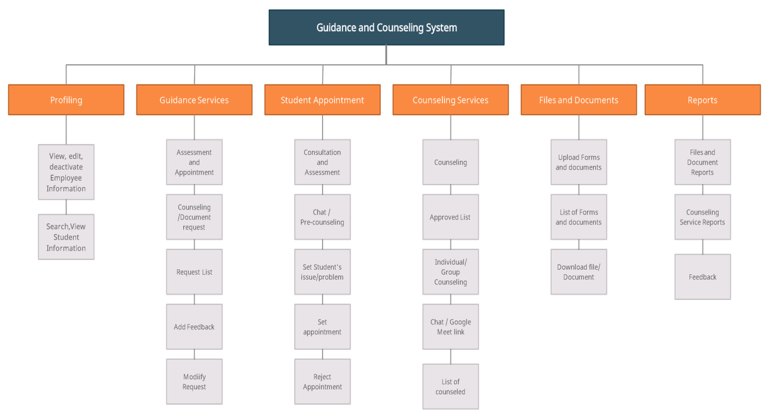

### Scope verification

### The scope of the project is formally accepted by the stakeholders. Once the Project Manager verifies that the scope meets the requirements outlined within the project setup, the Project Manager and stakeholders can formally accept the deliverable. Throughout this meeting, the Project Manager can give the deliverable to the stakeholders for formal acceptance. The stakeholder can settle for the deliverable by sign language a project deliverable acceptance document. This may make sure that project work remains within the project's scope on a homogenous basis throughout the lifetime of the project.

### Scope control

The Project Manager and the project team can work together to regulate the scope of the project. It manages and monitors  the changes of the project. The project team can make sure that they perform solely the work delineated within the Work Breakdown Structure and generate the outlined deliverables for every Work Breakdown Structure part.  Project team documents the changes and stakeholders remain informed about the changes. Any project team member or sponsor will request changes to the project scope. All modification requests should be submitted to the Project Manager within the style of a project modification request document. The Project Manager can then review the instructed modification to the scope of the project. The Project Manager can then either deny the modification request if it does not apply to the project's intent or convene a modification management meeting between the project team and Sponsor to review the modification request and perform a practical assessment of the modification.

# Project Execution plan

## Implementation and migration plan

### Purpose

This implementation and migration plan was developed to explain how the Guidance and Counselling system within the Bestlink College of the Philippines is implemented, established, and transferred to its operating environment.  It may cause changes and improvement of processes in the guidance and counselling department. The project aims to make all stakeholders aware of the details, requirements, and responsibilities involved in completing the project and moving the product to the working group. Any requested changes to the project must be implemented through the project change control process prior to review and approval.

### Description of implementation

The Guidance and Counseling system will be implemented to replace the manual transactions at Bestlink College of the Philippines that are insufficient for extension work. Implementing this system is a deliberate and highly technical endeavour. This description of implementation provides all stakeholders with a detailed understanding of how implementation will take place.

Once the Guidance and Counseling system database design is complete, the school will upload a database. The team collects all existing data from records and loads that data into the guidance and counseling database to test data integrity and compatibility between the way maintenance data is collected and the new database. Once the test has been completed and the functionality of the guidance and counseling database has been verified, operator training will be carried out with maintenance personnel for the new tool. Upon completion of the training, the Guidance and Counseling database will be uploaded to the school's maintenance servers and partitioned to prevent user access. The Guidance and Counseling department then verifies the functionality of the database on the actual servers.  At this point, in collaboration with the project team, the maintenance staff performs a final data collection of all the maintenance data in the legacy system. The project team imports the data into the guidance and counseling database. The manual system will be disregarded as soon as the project team has classified the data import as successful. At this point, a manual emergency procedure is performed. Once the team has verified whether the acceptance criteria have been met, the manually recorded maintenance data is entered into the guidance and counseling database. Completion of manual data entry and achievement of acceptance criteria formally ends the implementation phase of this project.

### Points of contact

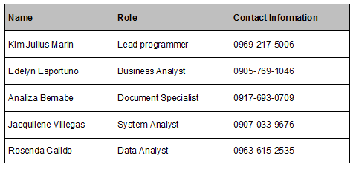The table below provides points of contact for all interested parties with urgent questions or concerns. All stakeholders should ensure that their communications are consistent with the communications plan for the Guidance and Counseling system.

### Major task

The project team has created a list of the main tasks required to implement and migrate this project successfully. All of these tasks have been checked by the project team to ensure they are within this project's scope. In addition, all essential tasks are assigned to responsible persons or groups and communicated to all stakeholders. The following is a list of the main tasks for Guidance and Counseling system implementation and migration planning.

* + - 1. Complete Guidance and Counseling system Design:

This task involves conclusion of all design work for the new Guidance and Counseling System

2. Complete Testing:

This task implies the successful testing of the Guidance and Counseling System in the testing environment.

3. Complete Handler's Training:

This task is for the completion of handler’s training on the new Guidance and Counseling System.

1. Validates Functionality on Maintenance Servers:

This task implies the IT Group packed the database onto the maintenance servers and testing functionality

1. Complete Data Capture:

This task involves apprehending all existing maintenance data form the legacy database to the Guidance and Counseling System

1. Commission / Launch:

This task stands for the official operational launch of the Guidance and Counseling System.

1. Operational Acceptance: Maintenance Operations Group

This task implies formal acceptance of the Guidance and Counseling System by the Maintenance Operations Group

1. Complete evaluations, analyze results and provide purposeful feedback:

### Implementation Schedule

The Implementation schedule for the Guidance and Counselling database project is shown below.   
For sustainability, the main tasks/steps described above are included in this timeline to raise awareness about the project team and stakeholders.

|  |  |
| --- | --- |
| **Milestones/ Deliverables** | **Target Date** |
| Complete Guidance and Counseling System Design |  |
| Complete Testing |  |
| Complete Handler's Training |  |
| Validates Functionality on Maintenance Servers |  |
| Complete Data Capture |  |
| Commission / Launch |  |
| Operational Acceptance |  |
| Complete evaluations |  |

### Security

The Bestlink College of the Philippines information technology security measures are established and implemented through the Bestlink College of the Philippines Information Technology department. The Guidance and Counseling database will remain behind the Bestlink College Philippines existing firewall and security measures managed by the Information Technology department's security administrator. The information of the students is confidential, that's why the project team is secured with the data for safety and privacy of the students. While no special or additional security measures will be implemented for legacy databases, the security administrator will be involved in designing, testing, implementing, and migrating all steps. Additionally, once the Guidance and Counseling system database has been removed for operational use, it will be monitored by the security administrator, along with other Information Technology tools, to ensure on-going compliance with the Bestlink College of the Philippines security policy.

### Implementation Support

The Bestlink College of the Philippines information technology security measures are established and implemented through the Bestlink College of the Philippines Information Technology department. The Guidance and Counseling database will remain behind the Bestlink College Philippines existing firewall and security measures managed by the Information Technology department's security administrator. The information of the students is confidential, that's why the project team is secured with the data for safety and privacy of the students. While no special or additional security measures will be implemented for legacy databases, the security administrator will be involved in designing, testing, implementing, and migrating all steps. Additionally, once the Guidance and Counseling system database has been removed for operational use, it will be monitored by the security administrator, along with other Information Technology tools, to ensure on-going compliance with the Bestlink College of the Philippines security policy.

### Listing of hardware, software and facilities

The Project Team requires a database design on Guidance and Counseling instead of where the existing database resides. While this allows improved functionality and capability, it does need any added hardware or upgrades to existing hardware.  Also, no additional facilities are required to complete the implementation and migration of this project. This project will be completed within the existing capabilities of Bestlink College of the Philippines hardware and current Facility.

### Performance Monitoring

The Guidance and Counseling system database provides the same functionality as the Legacy database but also additional functionality. It monitors the system development and also the performance through the function and design of the database.  Therefore, the design team has incorporated these other features into the Guidance and Counseling system Database Performance Monitoring Plan. After transferring the database to the production environment, different monitoring standards were added to the production environment to collect real-time data. Maintenance Operations Leads are responsible for monitoring performance and preparing weekly reports provided to IT instructors and senior executives at Bestlink College of the Philippines. Suppose Guidance and Counseling system Performance Monitoring shows that database performance is above acceptable levels. In that case, the problem immediately escalates to college staff, determining and implementing corrective measures and the root cause. The analysis begins the current approach used by all universities for IT tools.

### Implementation Requirements (Hardware/Software/ Personnel/ Facilities/ other capital investment:

For the Guidance and counseling, the project team and stakeholders have completed the requirements collection activity. This is a small and medium-sized project that is complete without a contract or external support, making the list of requirements very specific and manageable. The following list shows the requirements for a successful implementation of the Guidance and Counseling System.

**Hardware/Software:**

Functional virtual testing servers- non-existent

Functional maintenance server- non-existent

**Personnel:**

Project Owner - Enrico Pineda

Project Sponsor -  Khristian Hosena

Lead Programmer-  Kim Julius Marin

Document Specialist -  Analiza Bernabe

Business Analyst -  Edelyn Esportuno

System Analyst-  Jacquilene Villegas

Data Analyst-  Rosenda Galido

**Facilities:**

None- utilize existing facilities

**Other Capital investments:**None- utilize existing resources

### Back Out Plan

The Project team planning a database implementation identified the risk of a new database failing as soon as it runs on a Bestlink College of the Philippines maintenance server. To minimize this risk, the project team has created a back out plan that allows the BCP’s Maintenance group to continue operations if the system is not started. As the data collection task progresses, all Bestlink College of the Philippines maintenance databases are updated. The deprecated database remains on the service server until the checkout database is implemented and operationally approved. When booted and a failure problem is detected, The Information Technology department immediately removes all maintenance technician access and restores access to the old database. This allows Bestlink College of the Philippine Maintenance operations to continue while troubleshooting and additional testing on the Guidance and Counseling.

### Post Implementation Verification

After deploying the database of Guidance and Counseling systems, several steps will be taken to test the successful implementation. First and foremost, management operation managers will verify that the assigned maintenance specialist has access to the database in order to complete the maintenance task. Managers will ensure that their database maintenance approaches test their capacity to accomplish all assigned duties in the database, as well as that the right permissions and actions are in place, once this has been validated. Finally, to ensure that all database capabilities are met, maintenance managers will query and execute all set metrics and reports. Following the completion of these operations, maintenance administrators will meet with the project team to evaluate all testing efforts and check that all implementation requirements have been met.

# Project Closure

## Transition-out plan

### Executive Summary

The Bestlink College of the Philippines has sought an upgraded guidance and counselling system to maintain or handle the premises' services. A conclusion arises where the system will be entirely operated and lessen the manual labor for every transaction in the department. The system will be implemented and governed by the Information Technology Department of the premises given by the Development Team. The contract is currently negotiated, handled and it will take some time to decide the system's operations.

### Transition Approach

For this case, the Development Team will provide the Guidance and Counselling system and hand it over to the Bestlink College of the Philippines. The Staff will test the system and the development team will maintain the integrity, efficiency and troubleshoots of it. The transition will take place in 30 days to finish. Now prior to the transition, the Bestlink College of the Philippines will take a stand to The development team will handle all matters necessary for the accomplishment of the transition. As said earlier, the Bestlink College of the Philippines  will have its staff assigned at the start of the 30-day transition and it will coordinate with the development team.

### Transition Team Organization

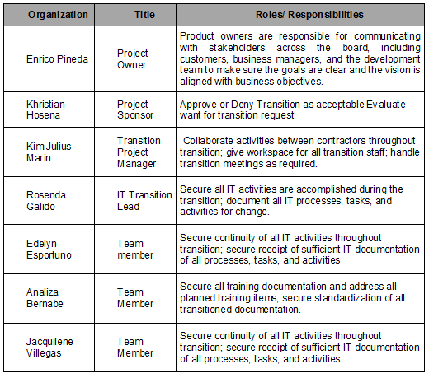The following chart illustrates the transition team members from the Development Team, Bestlink College of the Philippines, and the roles and responsibilities of each team member.

### Work Transition

For this contract transition of Guidance and Counselling, all workforce members will stay with their current firm. The Bestlink College of the Philippines workforce will remain on standby to execute their transition activities until the transition is accomplished and accepted by all parties. The development team will provide a workspace for parties involved until the transition is finished.

### Work Execution during Transition

Around the transition of this arrangement, Bestlink College of the Philippines will execute work in line with the accepted project schedule and work breakdown structure (WBS) in place. The Development Team will secure the Bestlink College of the Philippines guidance, and counseling staff will work alongside the parties involved. Nevertheless, Bestlink College of the Philippines will maintain all management for the tasks and deliverables. At the end of the 30-day transition time, upon transition acceptance will take its place.

### Subcontracts

Bestlink College of the Philippines guidance and counseling transactions activity. These subcontracts appeal to third-party tasks to secure all required transactions and facilitate functionality to support the system.

|  |  |  |
| --- | --- | --- |
| **Subcontract #** | **Awarded to** | **Task** |
|  |  |  |

### Property Transition

#### Government Furnished Equipment (GFE)

As part of this transition, all GFE delivered to Bestlink College of the Philippines will be covered by a specific contract that will be turned over to the government after the transition phase is completed and accepted. A laptop computer, flash memory, and external hard drives make up GFE. A government Information Technology officer will be in charge of assigning and issuing all electronic gadgets.

#### Incumbent Owned Equipment

All necessary equipment will remain with the incumbent upon fulfilment and acceptance of the transition. A laptop, organizational tools, maps, and other items are included in this kit. If it is determined that any incumbent-owned equipment must remain with the client in order for the contract to be completed successfully, the client and incumbent contracting staff representatives will coordinate the acquisition of the equipment through the customer's confirmed procurement management process.

#### Intellectual Property

Per the transaction contract, all intellectual property that is a direct result of work on the contract deliverables will be transitioned to the new contractor to secure the project's successful completion. The contract pricing takes intellectual property into consideration and as such, any resulting intellectual property will be possessed by the customer.

#### User Accounts and Passwords

As a part of the contract transition, various user account accesses and authorizations must be created and disabled. Currently, Bestlink College of the Philippines Guidance and Counselling personnel listed in the chart below possess the user accounts and access necessary for contract deliverables.

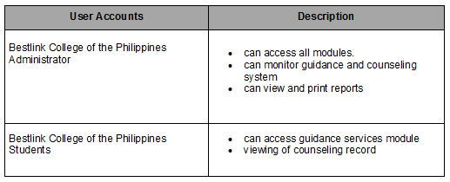The listed Bestlink College of the Philippines personnel will be granted access on the first day of the contract transition phase

### Knowledge Transfer

For this transition, knowledge transfer will occur over the entirety of the 60-day transition period. Knowledge will be transferred in a variety of ways. The current PM will help the incumbent IT Transition Lead organize two formal classroom training sessions. These sessions will concentrate on the unique IT issues that arise from database duties and activities. The incumbent PM will also coordinate two formal classroom sessions to be conducted by the incumbent Configuration Manager. These sessions will cover documentation requirements and organizational processes and assets. These sessions will be completed no later than 15 days prior to the end of the 60-day transition period. Throughout the 60-day timeframe, all guidance and counseling employees of Bestlink College of the Philippines counterparts were trained on the database, tools, procedures, and organizational assets. The PMs from the project team and the customer will meet no later than ten days prior to transition completion in order to determine if any further training or knowledge transfer is required.

### Schedule

The following GANTT chart illustrates the schedule for the transition of the transaction contract to Bestlink College of the Philippines. Any changes to this plan will need notice and approval from the client and all other parties.

### Handover and Acceptance

The client will create the resolution when the transition is finished and give formal acceptance indicating such. To accomplish this, the client's transition Project Manager will use the specified transition checklist to determine when all transition-related activities are complete. The client's transition Project Manager will meet with the transition Project Managers from each contractor to confirm that all issues and concerns have been handled. The checklist and associated documents will be signed and approved by the client's project sponsor and the company's human resources director once the client's transition PM has formally approved the transfer. The final step is the customer's contracting officer representative's formal acceptance and signing. The transition will be considered complete after all of these approvals and signatures have been obtained.

## Project acceptance

This document is the formal acceptance of the work packages and deliverables for the Guidance and Counseling System. The Guidance and Counseling has successfully met all acceptance criteria and requirements in the project documents and scope statement. Project testing has been performed to validate that all required deliverables meet its requirements. Quality and functionality were also evaluated and measured.

This project has been handed to the guidance personnel and provided training to use the project as their new way system. Transferring all the knowledge in using the project has been completed.

The Project Manager is authorized to continue with the formal close out of this project. The closeout process will include a post-project review, documentation of lessons learned, release of the Project Team, close-out all procurements and archive of all relevant project documents. Once the closing process is completed the Project Sponsor will be notified and the Project Manager will then be released from the project.

## Post project review

### Project Summary

The Guidance and Counseling project recently finished the Guidance and Counseling system, then handed it over to the operations group for counseling and monitoring. This is the completion of a difficult, however prosperous project for the cluster.

The purpose of the guidance and counseling system is to enable more accurate monitoring of students' progress and easier follow-up and communication with guidance counselors. The program's output also includes a method for managing advice data information at the right time.

The project deliverables shall include guidance and counseling system design, coding, testing, and user guide. The objectives of the guidance and counseling system are to improve the guidance and counseling services monitoring, counseling, and generating reports.

High-level risks for this project include completing implementation without impacting on going counseling operations and ensuring there are no issues with migrating collection files from the legacy system to the new system. The Project Sponsor will determine success once the system is implemented and one entire transaction cycle has been completed that meets the objectives with no discrepancies.

#### Project Team and Staffing

Staffing requirements for the Guidance and counseling system project include the following:

|  |  |  |  |
| --- | --- | --- | --- |
| **Name** | **Title** | **Project Role** | **Contact** |
| E. Pineda | Counselor of BCP | Project Sponsor |  |
| K.J Marin | PM of Guidance and Counseling System |  | KimMarin43@gmail.com |
| E. Esportuno | Business Tech |  | edelynesportuno1@gmail.com |
| R. Galido |  |  | rosendagalido21@gmail.com |
| A. Bernabe |  |  | anabernabe23@gmail.com |
| J. Villegas |  |  | jacquilenevillegas21@gmail.com |

#### Project Deliverable (Planned vs. Actual)

**Guidance and Counseling System Design**

|  |  |  |
| --- | --- | --- |
| **Planned Deliverable** | **Actual Deliverable** | **Summary** |
| Complete student online counseling and collection of reports. | Complete student online counseling and collection of reports. |  |

**Guidance and Counseling System Production (Prototype)**

|  |  |  |
| --- | --- | --- |
| **Planned Deliverable** | **Actual Deliverable** | **Summary** |
| Complete student online counseling and collection of reports. | Complete student online counseling and collection of reports. |  |

**Guidance and Counseling System Testing**

|  |  |  |
| --- | --- | --- |
| **Planned Deliverable** | **Actual Deliverable** | **Summary** |
| Testing documentation package establishing all product limits and thresholds | Testing documentation package establishing all product limits and thresholds |  |

**Guidance and Counseling System Final Project Deliverables**

|  |  |  |
| --- | --- | --- |
| **Planned Deliverable** | **Actual Deliverable** | **Summary** |
| **Able to** |  |  |
|  |  |  |
|  |  |  |

#### Transition to Operations

For many organizations, transitioning a project to an operational setting is a difficult task. The Guidance and Counseling System ensures that R&D and operations leadership use effective communication throughout the duration of a project to ensure continuity once the transition occurs. Furthermore, the Guidance and Counseling System encourages all project managers to act as senior operations leadership as stakeholders are all told to come.

As a result of effective communication and careful planning, the Guidance and Counseling System project was successfully transitioned to operations. The inclusion of the Guidance Counselor, Assistant Counselor and Psychometrician as stakeholders ensured a collaborative approach to the development of a better product that could be easily transitioned to a manufacturing setting.

Future profits will benefit from involving guidance personnel early in the project when developing sections and soliciting input from guidance personnel on critical operational issues for the project.

The Guidance and Counseling System team did not just win in human activity and bringing in guidance personnel; they also used these strengths to work out expectations of what operations needed as part of the transition. If the guidance personnel had not been included as stakeholders or participated in the project development, it is likely that this step would have gone unnoticed, resulting in project delays and additional costs.

### Project Costs

The budgeted price for the Guidance and Counseling System Project was set at Bestlink College of the Philippines. This price was broken out by project innovation in the subsequent chart with actual prices compared to the planned/budgeted price.

|  |  |  |  |
| --- | --- | --- | --- |
| **Project Phase** | **Budgeted Cost** | **Actual Cost** | **Comments** |
| Product Design | 2000 | 2000 | Product Design costs were on budget |
| Testing | 2000 | 2000 | Testing costs were on budget |

Total actual prices of the Guidance and Counseling System Project amounted to 2000 The Guidance and Counseling System project wasn't solely prospering in meeting all of its objectives and deliverables, however by finishing beneath budget, it conjointly allowed CMS to allot 4000 to alternative necessary initiatives.

Total actual prices of the Guidance and Counseling System Project amounted to 2000. The Guidance and Counseling System project wasn't solely prospering in meeting all of its objectives and deliverables, however by finishing beneath budget, it conjointly allowed CMS to allot 4000 to alternative necessary initiatives.

Product style was completed beneath budget. This was due primarily to the very fact that the Guidance and Counseling System  product’s performance specifications area the image of our previous line of products which the sole needed modification was reducing the cable size and diameter. This resulted in slightly less style work than anticipated.

Testing and transition to operations completed to allow this project. Past project documentation was utilized in developing our budgets for these parts of the project. By utilizing Guidance and Counseling System project archives and normal best practices we tend to be able to set up accurately and complete the work consistent with set up.

### Project Schedule

This section describes the project's start-to-finish schedule or timeline, as well as how the project performed in comparison to this plan. This data is useful for identifying and comprehending what may have contributed to project delays or allowed the project to be completed early or on time. This could then be used by team members on future visits or documented by alternative project groups for future visits. One of the most effective ways for a company to improve its project management methodologies and effectiveness is to archive project data throughout the project closure phase.

The Guidance and Counseling System Project schedule caught up to a one-year project with an initiation date of October 2021 and a project sale date of May 2022. The project team initially expressed concern that the schedule would likely slip due to the limited number of resources assigned to the project. The chart below depicts each stage of the project's lifecycle, as well as the planned and actual completion dates for each stage.

|  |  |  |  |
| --- | --- | --- | --- |
| **Project Phase** | **Scheduled Completion** | **Actual Completion** | **Comments** |
| Project Plan Complete and Approved |  |  |  |
| Design Completed |  |  |  |
| Coding Completed |  |  |  |
| Testing Completed |  |  |  |
| Implementation |  |  |  |
| One Transaction Complete and Project Completion |  |  |  |
| Project Closure |  | May 2022 |  |

### Recommendations

# Technical solution design

## Project Information

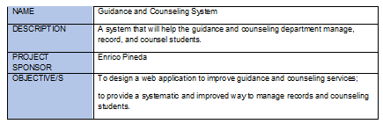

## Executive Summary

The Guidance and Counseling system is computer software that allows for more precise tracking of students' counseled progress and easier follow-up and communication with guidance counselors. The program's output has included a strategy for managing advice information at the proper time. Counselors would have more effective interactions and access to confidential papers, resulting in better counseling.

The researchers conduct this study to provide the Guidance and Counseling Department of Bestlink College of the Philippines with a system that will manage all the students' inquiries to ask for counseling. The system provided to make counseling services will improve in giving an online conference, follow-up session, and generating accurate reports. It also helps the counselor determine what advice the student needs by checking their profile.

## Requirement Definition

## Solution Description

### Logical Architecture

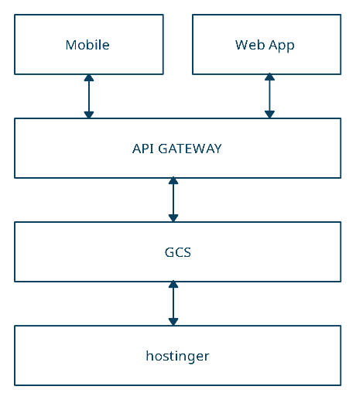

### High-Level Architecture

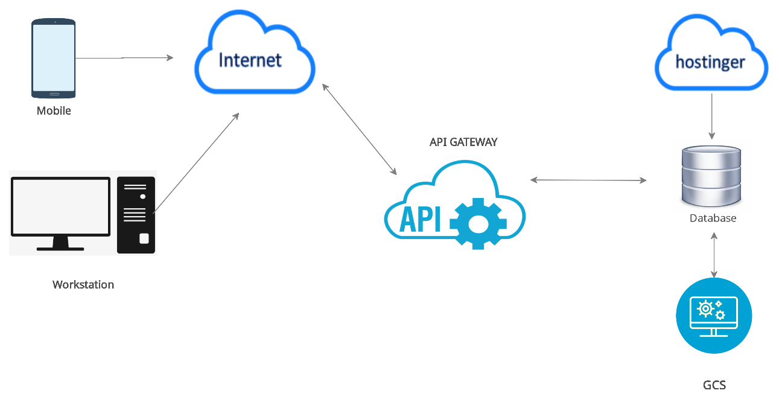

*A representation of HL architecture used here to show how the systems will interconnect.*

### Process Flow

### *Request Counseling (Student)*

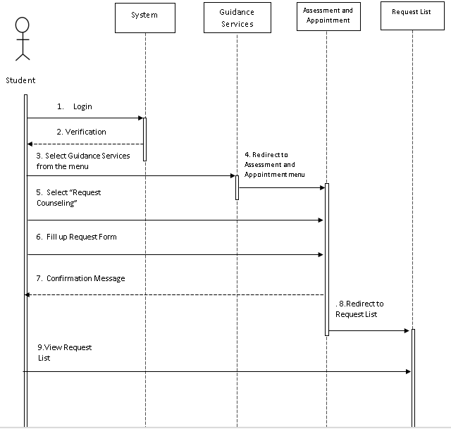

**Counseling (Guidance Staff)**

## Implementation Timeline

# System architecture

## Business Process Architecture

## Application Architecture

## Data Architecture

## Technology Architecture

# Product Backlog

## Product backlog (user stories) Table

## Product Backlog for EIS Information Security

## Product Backlog for EIS Standards

## UI/UX (Icons, color, etc.)

## Product Backlog for integration

## Product Backlog for analytics

## Application System Analytics

## EIS Analytics

# Sprint backlog

## Sprint backlog table

### User stories

### Information security

### EIS standard

### EIS integration

### Analytics

## Sprint Burndown Chart

### Sprint Backlog

# EIS Implementation Model

## Information and Data Management

### Data Integration Model

### Data Migration Strategies

### Data Analytics (Business Intelligence Framework)

### Privacy and Security

### Backup, Retention, and Disposal

## Information Security

### Application Security

### Infrastructure Security

### Cloud/ Web Service Security

### Cryptography

### incident Response

### Vulnerability Management

### Disaster Recovery

## Network Design and implementation Model

### Design Architecture

### implementation Framework

### Prototype Application

## Recommendations and conclusion

# Appendices:

## Appendix A Detailed System Architecture/ Reference requirements

### A.1 Business Process Architecture (Business Process Model)

### A.2 Application Architecture

#### A.2.1 UML- Use Case Diagram

#### A.2.2 UML- Detailed Diagrams

#### A.2.3 UI Navigation Diagram

#### A.2.4 UIs (Design Layout)

### A.3 Data Architecture

#### A.3.1 ERD

#### A.3.2 Class Diagram

#### A.3.3 Data Dictionary

### A.4 Technology Architecture

# Appendix B Deployment Diagram

# Appendix C Adviser Acceptance (Functional)

# Appendix D Sprint Burndown Charts (per sprint) Signed by the adviser

# Appendix D.1 Individual burndown charts per member

# Appendix B Deployment Diagram

# Appendix E Requirements Traceability Matrix (PB, Test Scenarios, status

# Appendix F Panel Evaluation and Signature (Plus photo ops during defense)

# Appendix G Pilot Companies Background with proofs of interviews

# Appendix H USB Copy of the codes (reliable USB)

# Appendix I IMRAD Format Summary

# Appendix J Comparison of the EIS to existing EIS’s (5 Pages)

# Appendix K Operation Manual (10 Pages max, 5 Pages min)