« Primera » documentation version 1.0

|  |  |
| --- | --- |
| Created on : 01/06/2013 | Thank you for purchasing our theme. If you have any question not located within this document, please feel free to contact us through our profile contact form page that you can find [here](https://wrapbootstrap.com/user/railscom). |
| By : Anis Marrouchi and Tarek Akrout |
| Email: anis.marrouchi@railscom.com |

# Important notes

Before proceeding to the installation phase, please read the following notes:

If you have a site that you’re willing to relook with Primera, create a full back up before installing.

Test the template on a development environment before use in it live. We are not responsible for any damages caused to your site.

If you are not really sure how to proceed with installation or lacking some technical skills to complete the customization and the installation, feel free to contact us we will assist (charges may apply).

The editing of this template needs a basic knowledge about HTML, CSS, jQuery, BootStrap. For a full customization you can contact us for an estimate.

Please report any bug you may encounter will will take care and fix it as soon as possible.

We will charge for any on demand customization or support except for technical issues (bugs).

# Technical Requirements

A basic knowledge of HTML is required. To learn about the fore mentioned language, [W3School](http://www.w3schools.com/html/default.asp) is a great place to start learning.

You will also need a text editor to editing the page, while notepad can do the job, we advise you to look for an html editor.

# Editing the template

You can easily change the content within pages, just open the page you are willing the edit in your favorite editor locate the section you want to edit (read the comments) and replace the dummy text with your content.

Tip: Use the Keyboard shortcuts to quickly locate your content (Ctrl+F for Windows/Cmd+F for MAC).

Please be advised, if you forget to close any html tags then the whole layout of the page may broke.

If you need a professional to do the job, contact us at anis.marrouchi@railscom.com.

# HTML Structure

Primera theme is based on a 1 column fixed layout, except for the FAQ page which is based on a 2 column layout nested within a 1 column page layout. All content is located within a div with the id of main. The overall structure of the template follows the same structure.

Every section of the page can be easily identified by the html comments highlight below

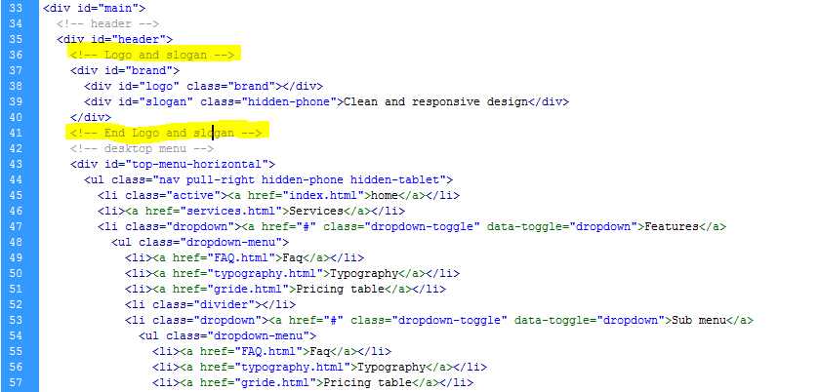

# CSS style, Files and Structure

Primera uses bootstrap version 2.2.2 responsive template and makes the customization of the style very easy. You can find extensive documentation about the use of the bootstrap theme [here](http://twitter.github.com/bootstrap/index.html).

We have used 6 styles within this template as follow:

* Bootsrap.css: This style is used by template and contains the base style
* Boostrap-responsive.css: This style takes care of the general responsive aspect of the templates
* Flexslider.css: used by the JQuery plugin flexslider
* Lightbox.css: used by the JQuery Plugin Lightbox
* Style.css: Used to override style used by the styles listed above
* Style-responsive.css: Used to override and add specific responsive effects to the template.

All styles are maintained within the css folder.

If you need to further customize the style of template, we encourage you to use a separate style sheet file and placed last within style section of the head tag.

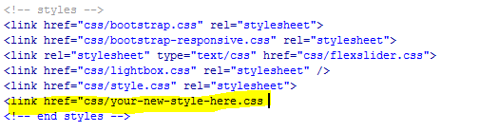

The file is separated into sections using comments:

/* === Header Section === */

some code

/* === Header Section === */

/* === Main Section === */

some code

/* === End Main Section === */

/* === Footer Section === */

some code

/* === End Footer === */

# JavaScript

We have used bootstrap plugins, jQuery library and the following jQuery plugins:

* JQuery: jQuery is a Javascript library that greatly reduces the amount of code that you must write.
* Bootstrap.js plugins including the following features: transitions, modal, dropdown, tab, tooltip, popover and much more. For the full reference refer to bootstap documentation.
* Flexslider plugin: used by the carousel and the our friends slider (index.html)
* Lightbox version 2: is a simple, unobtrusive script used to overlay images on top of the current page. Used in the latest project section (index.html)
* jquery.backgroundpos.js: adds animation to the background-image css attribute. Used by the social icon in the footer section

All JavaScript files are placed in the js folder. The javascript include are made right before the closing tag of the body. All method calls are located within the custom.js file. Comments are used to indicate the name of the called plugin and its use.

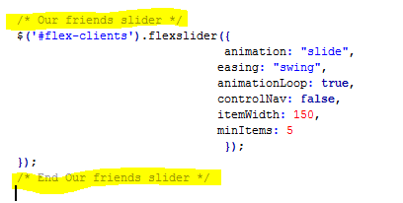

# PSD Files

We have included a layered PSD for the home page, use it to further customize Primera template.

# Sources and credits

We have used the following images acquired from the following sites within our template:

* <http://www.flickr.com/photos/marcinmoga/3585805764/>
* <http://www.flickr.com/photos/origamiancy/3596559230/>
* <http://www.flickr.com/photos/fdevillamil/3688053524/>
* <http://www.flickr.com/photos/limaoscarjuliet/3921970684/>
* <http://www.flickr.com/photos/kodomut/5203736077/>
* <http://www.flickr.com/photos/kodomut/5204402260/>
* <http://www.flickr.com/photos/pennuja/5931796920/>
* <http://www.flickr.com/photos/10768314@N00/7215362580/>
* <http://www.flickr.com/photos/littlebits/7413898556/>
* <http://www.flickr.com/photos/dirtyzound/8144710168/>
* <http://www.flickr.com/photos/milosrandjelovic/8169762476/>
* <http://www.flickr.com/photos/91014676@N05/8300033166/>
* <http://www.flickr.com/photos/phalinn/8365154564/>
* <http://www.flickr.com/photos/-o-/8402419877/>

Special thanks to the guys at

* <http://code.google.com/p/jquery-ui-map/> for the google map
* [www.woothemes.com/flexslider/](http://www.woothemes.com/flexslider/) for slider
* <http://keith-wood.name/backgroundPos.html> for background animation effect used on the social icons.
* <http://ademilter.com/lab/liffect/>

# Google Map

The contact.html page uses jquery-ui-map plugin to change the location to your address replace the coordinates in the call method found in custom.js

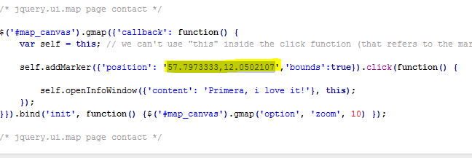

Once again, thank you so much for purchasing this theme. As mentioned in the beginning, we will help you, if you have any questions relating to this theme. No guarantees, but we will do our best to assist. If you have a more general question relating to the themes on wrapbootstrap, you might consider visiting the FAQ or asking your question in the "feedback" section (report a bug/ have an idea).