Marvin Rusinek

Website Project Brief: Travel to Lake George

**Define Site Goals**:

Why are you building this site?

Lake George is a small town in upstate New York. My objective in building this site is twofold: 1) To convey information about Lake George, such as general facts, directions, events, information about sites, etc. and 2) to attract users to the site and provide a meaningful user experience. The short term goal of the site is to provide basic content to the user. The long term goal is to make the site more dynamic where users can add content to the site via a CMS.

**Audience**: The intended audience is anyone who is interested in traveling to Lake George and those wanting to learn more about Lake George, its sites, photography, etc.

**Scenarios**:

Greg Kowalski: Greg is a middle aged man who is interested in bringing his family to Lake George for vacation in the summer and is looking for activities to spend time with his family. He comes to the site to find out what events are going on during the summer. He clicks on the events section of the site and quickly finds out what events are going on July and August.

Molly Jones: Molly is a photographer and is interested in looking at nature photographs of Lake George in the winter time. She visits the lakegeorge.com website but cannot find a cache of winter photos.

**Competitive Analysis**:

In examining the various Lake George websites, they seem to be doing similar things (such as focusing on appealing images of Lake George). My goal is to make a site that is interactive. Features that the site will have include: 1) a Javascript/Flash slideshow of various Lake George photographs, 2) an interactive Google map, and 3) use of rollover navigation. The three sites that I have chosen to perform a competitive analysis of are: [LakeGeorge.com](http://www.lakegeorge.com), [VisitLakeGeorge.com](http://www.visitlakegeorge.com/), and [LakeGeorgeNewYork.com](http://www.lakegeorgenewyork.com).

|  |  |  |  |
| --- | --- | --- | --- |
| **URL:** | **LakeGeorge.com** | **VisitLakeGeorge.com** | **LakeGeorgeNewYork.com** |
| **Homepage design** | The homepage seems to be really busy. There is too much advertising on the right side and leaves empty whitespace on the left side at the bottom of the page. Otherwise the homepage looks like a typical homepage. | Homepage strikes a balance between content and layout and is very visually appealing with the image of Lake George in the background. Flash animation is very clear. Not too many advertisements but appealing. I like how the body table appears over the LG image instead of appearing right away after the top image; modern webpages seem to be following this approach. Appealing hyperlinks appear on the left side of the table. | Homepage utilizes whitespace well. Advertisements appear on right side of the table where one would expect to see them. Page gives a nice introduction about town of Lake George. “Join our Mailing List” on homepage. External links appear in the footer navigation. |
| **Interior page design** | Interior pages seem to be more detailed than the homepage and do not have as many advertisements as the main page. | Interior pages are very detailed. Layout remains consistent in the interior pages. | Organized and detailed interior pages. Longer pages have a “back to top” feature. |
| **Search functionality** | Search appears near the top-right of the page. Searching by keyword pulls up a list of items, but it is unclear if they are listed by relevance or by how high up in the article the keyword appears. | Search is available on Lodging, Attractions, and Events pages. Search works by clicking on checkboxes and pressing submit. Lodging results are displayed alphabetically; attractions results are displayed alphabetically; events are displayed in chronological order. | None found. |
| **Features offered** | Calendar of events is on the homepage, but clicking on any of the dates doesn’t seem to work. Map of Lake George is not interactive. | Flash animation on homepage is very sharp, interactive map works well. | Site works like a guide/directory; there are no outstanding features. |
| **Navigation (primary, secondary, and contextual)** | Homepage uses pulldowns in its primary navigation. Primary navigation is repeated in the body of the page, which makes the page appear longer than it has to be. | Primary navigation appears in navbar at the top of body table, doesn’t have pulldowns, when clicking on label, secondary navigation appears on the landing pages. Several links to secondary pages appear on the left side of the table in the body of the homepage. | Primary navigation appears in a navbar at top of the page, hovering over a label brings up the secondary navigation. Having arrow would make it more apparent that there is secondary navigation. |
| **Interaction design** | Flash animation on the homepage works well. Map is not interactive. Pages are marked up in Coldfusion. | Flash animation on homepage, interactive map. Pages are done in PHP. | No apparent interactive features. |
| **Look and feel** | The homepage is probably longer than it has to be. It utilizes a table and tables within tables | Pages are scrollable yet appealing, so one doesn’t mind scrolling. | Site makes heavy use of external links. |
| **Catalog/archive functionality** | None found. | None found. | None found. |
| **Download time** | 5-7 seconds on DSL. | 3 seconds on DSL. | 9-10 seconds on DSL. |
| **Page size** | Homepage is longer than it should be. | Homepage is long, but content makes up for it. | Homepage is somewhat long. |

**Identify Content and Functional Requirements**

Original content may need to be developed for the interior webpages and amount of content for each of the webpages needs to be determined. Photographs will need to be examined for relevance. Flash will be used to create a slideshow on the homepage. I plan on including an interactive Google map on the “Map and Directions” page which will require some scripting.

**Information Architecture**

**Group and Label Content:**

Under the About LG heading, there will be two subpages: Facts (which will present facts about Lake George) and Map and Directions. The “Things to do” heading will consist of two subpages: “Sites” and “Attractions.” Other pages that will be connected to the homepage include Lodging, FAQ, and Contact Us. I plan on using sailing/boating metaphor in the rollovers.

**Site Map:**

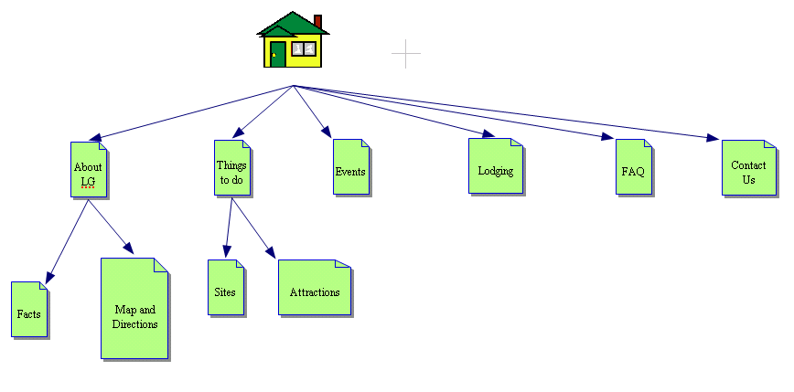

**Define Navigation:**

All navigation elements will have a rollover effect. The primary navigation of the site will contain six categories: About LG, Things to do, Events, Lodging, FAQ, and Contact Us. For those categories having secondary navigation (i.e., About LG and Things to do), rolling over the primary navigation category will bring up the secondary navigation options in a navbar appearing below the primary navigation navbar. One will have to rollover the options in the secondary navigation to view those pages. Primary navigation will be repeated in the footer navigation so that users do not have to scroll to the top.

**Page Wireframes:**

Please see the enclosed mockup files.