**Software Development Life Cycle** (SDLC) is a framework that defines the steps involved in the development of software at each phase. It covers the detailed plan for building, deploying and maintaining the software. The SDLC aims to produce a high-quality software that meets or exceeds customer expectations, reaches completion within times and cost estimates.

We can also refer it to processes followed for a software project, within a software organization. It consists of a detailed plan describing how to develop, maintain, replace and alter or enhance specific software. The life cycle defines a methodology for improving the quality of software and the overall development process.

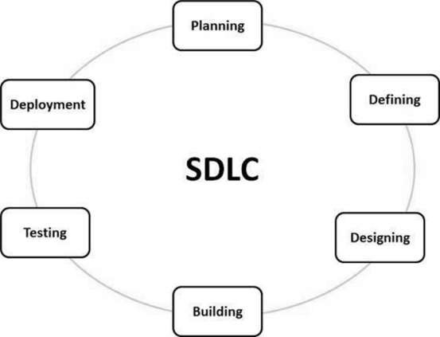

Figure 1 graphical representation of the various stages of a typical SDLC

**Stage 1: Planning and Requirement Analysis**

Requirement analysis is the most important and fundamental stage in SDLC. It is performed by the senior members of the team with inputs from the customer, the sales department, market surveys and domain experts in the industry.

This information is then used to plan the basic project approach and to conduct product feasibility study in the economical, operational and technical areas.

Planning for the quality assurance requirements and identification of the risks associated with the project is also done in the planning stage. The outcome of the technical feasibility study is to define the various technical approaches that can be followed to implement the project successfully with minimum risks.

**Stage 2: Defining Requirements**

Once the requirement analysis is done the next step is to clearly define and document the product requirements and get them approved from the customer or the market analysts. This is done through an SRS (Software Requirement Specification) document which consists of all the product requirements to be designed and developed during the project life cycle.

**Stage 3: Designing the Product Architecture**

**SRS(System Requirement Specification)** is the reference for product architects to come out with the best architecture for the product to be developed. Based on the requirements specified in SRS, usually more than one design approach for the product architecture is proposed and documented in a DDS - Design Document Specification.

This DDS is reviewed by all the important stakeholders and based on various parameters as risk assessment, product robustness, design modularity, budget and time constraints, the best design approach is selected for the product.

A design approach clearly defines all the architectural modules of the product along with its communication and data flow representation with the external and third party modules (if any). The internal design of all the modules of the proposed architecture should be clearly defined with the minutest of the details in DDS.

**Stage 4: Building or Developing the Product**

In this stage of SDLC the actual development starts and the product is built. The programming code is generated as per DDS during this stage. If the design is performed in a detailed and organized manner, code generation can be accomplished without much hassle.

Developers must follow the coding guidelines defined by their organization and programming tools like compilers, interpreters, debuggers, etc. are used to generate the code. Different high level programming languages such as C, C++, Pascal, Java and PHP are used for coding. The programming language is chosen with respect to the type of software being developed.

**Stage 5: Testing the Product**

This stage is usually a subset of all the stages as in the modern SDLC models, the testing activities are mostly involved in all the stages of SDLC. However, this stage refers to the testing only stage of the product where product defects are reported, tracked, fixed and retested, until the product reaches the quality standards defined in the SRS.

**Stage 6: Deployment in the Market and Maintenance**

Once the product is tested and ready to be deployed it is released formally in the appropriate market. Sometimes product deployment happens in stages as per the business strategy of that organization. The product may first be released in a limited segment and tested in the real business environment (UAT- User acceptance testing).

Then based on the feedback, the product may be released as it is or with suggested enhancements in the targeting market segment. After the product is released in the market, its maintenance is done for the existing customer base.

**Each of these proceses results into the following**

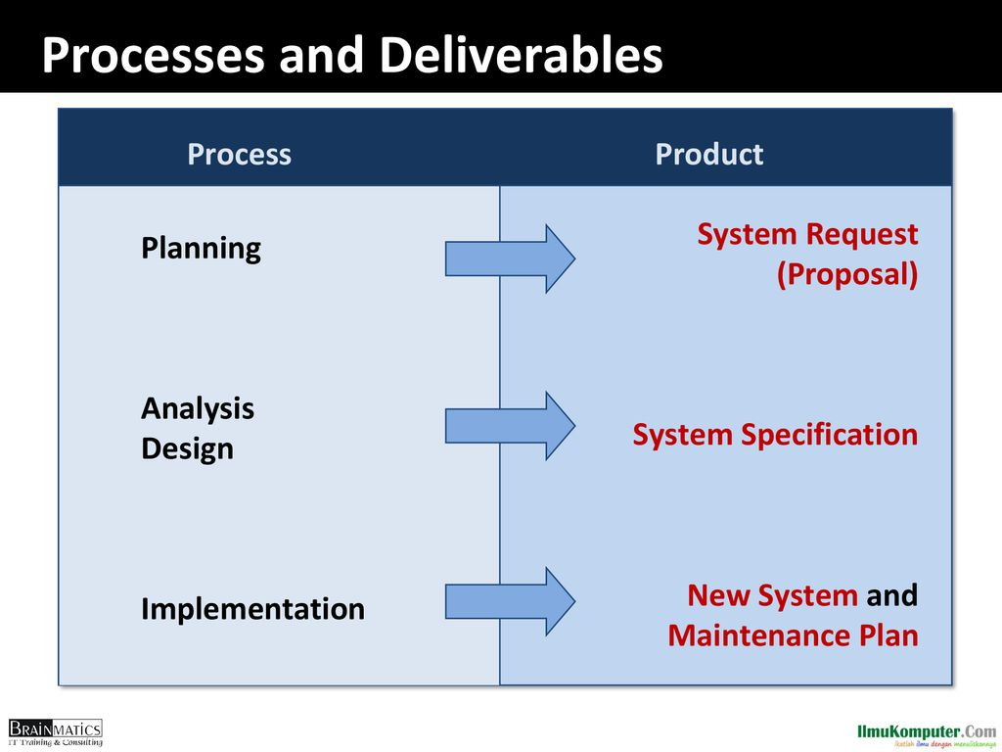

**DEVELOPMENT METHODOLOGIES**

There are various software development life cycle models defined and designed which are followed during the software development process

**Structured Design**

Here Projects move methodically from one to the next step A step is finished before the next one begins.

1. **Waterfall Method** 
   1. Waterfall approach was first SDLC Model to be used widely in Software Engineering to ensure success of the project. In this approach, the whole process of software development is divided into separate phases. In this Waterfall model, typically, the outcome of one phase acts as the input for the next phase sequentially.
2. **Parallel Development** 
   1. Addresses problem of time gap between proposal and delivery. The General process includes are;
      1. Breaks project into parallel subproject.
      2. Integrates them at the end

**Rapid Application Development (RAD)**

Rapid Application Development (RAD) is a development model that prioritizes rapid prototyping and quick feedback over long drawn-out development and testing cycles. With rapid application development, developers can make multiple iterations and updates to a software quickly without starting from scratch each time. This helps ensure that the final outcome is more quality-focused and is in alignment with the end-users’ requirements.

1. **Phased Development**
2. **Prototyping**
3. **Throw-away Prototyping**

**Agile Development**

also referred to simply as Agile -- is a type of development methodology that anticipates the need for flexibility and applies a level of pragmatism to the delivery of the finished product.

In Agile, a product is broken into small incremental builds. It is not developed as a complete product in one go. Each build increments in terms of features. The next build is built on previous functionality.

In agile iterations are termed as sprints. Each sprint lasts for2-4 weeks. At the end of each sprint, the product owner verifies the product and after his approval, it is delivered to the customer.

Customer feedback is taken for improvement and his suggestions and enhancement are worked on in the next sprint. Testing is done in each sprint to minimize the risk of any failures.

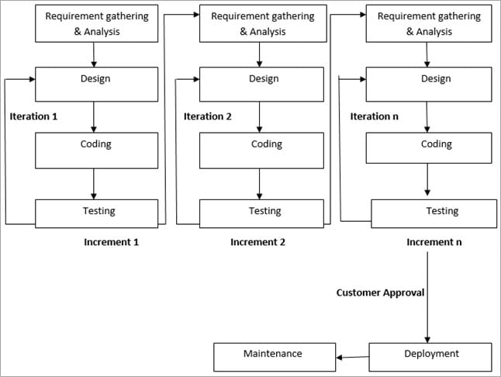

1. **Extreme Programming (XP)** 
   1. is an agile software development framework that aims to produce higher quality software, and higher quality of life for the development team. XP is the most specific of the agile frameworks regarding appropriate engineering practices for software development.
2. **Scrum**
   1. Scrum is a framework for project management that emphasizes teamwork, accountability and iterative progress toward a well-defined goal. The framework begins with a simple premise: Start with what can be seen or known. After that, track the progress and tweak, as necessary