INFORMATION SECURITY MANAGEMENT
Practical Take-Home Assessment
Identity Management using Keycloak
Centralised IAM for UniversityRealm: realm, users, RBAC, OIDC client and authentication demonstration
Student name [Your full name]
Registration number [Your registration number]
Programme [Programme / Course]
Course unit Information Security Management
Lecturer [Lecturer name]
Practical tool Keycloak 26.7.4 (OpenID Connect)
Total marks 40
Date of submission [Submission date]

Table of Contents
1. Introduction 3
1.1 Objectives 3
2. Keycloak Environment and Setup (Task 1) 4
2.1 Environment used 4
2.2 Installation steps 4
3. Realm Configuration (Task 2) 8
3.1 Creating UniversityRealm 8
3.2 Realm security settings 9
4. User Configuration (Task 2) 12
4.1 Enabling and disabling a user account 15
4.2 Identities from the institutional directory (LDAP / AD user federation) 18
5. Role Configuration (Task 3) 27
5.1 Creating the roles 27
5.2 Assigning roles to users 29
5.3 How least privilege is applied 32
5.4 Demonstrating different authorization privileges 33
6. Client Configuration (Task 4) 38
6.1 Authentication protocol: OpenID Connect 38
6.2 Redirect / allowed URLs 38
7. Authentication Demonstration (Task 4) 42
7.3 Authentication vs authorization in this implementation 47
8. IAM Architecture Diagram (Task 5A) 49
9. Security Analysis (Task 5B) 50
Risk 1: Weak, reused or stolen passwords (credential compromise) 50
Risk 2: Excessive privileges and orphaned accounts (privilege creep) 50
10. Recommendations (Task 5C) 51
Recommendation 1: Enforce Multi-Factor Authentication (MFA), starting with privileged roles 51
Recommendation 2: Harden the production deployment and connect Keycloak to the authoritative directory 51
11. Conclusion 52
12. References 53
Appendix A: Reproducing the Configuration 54
Appendix B: Marking-scheme cross-reference 54

1. Introduction
The institution is moving to a single, centralised Identity and Access Management (IAM) service built on Keycloak, an open-source Identity Provider that supports OpenID Connect (OIDC), OAuth 2.0 and SAML 2.0. The institution has three categories of users: Administrators, Lecturers and Students. Until now each application kept its own user accounts, so the same person had several passwords, there was no single place to revoke access, and permissions were inconsistent.
Acting as the IAM Administrator, I installed Keycloak and did the following:
- created the dedicated realm UniversityRealm;
- created the users admin01, lecturer01 and student01;
- configured role-based access control with the roles system-admin, lecturer and student;
- registered an institutional application, student-portal, as an OIDC client;
- showed that each user authenticates through Keycloak and receives different authorization in the application.
The report follows the required structure. Every configuration step has screenshot evidence taken from the running system. The full configuration can also be reproduced from the accompanying scripts (Appendix A).

1.1 Objectives
Task | Objective | Section
1 | Install and start Keycloak, create an administrative account, document the environment | 2
2 | Create UniversityRealm and three users with attributes; enable/disable accounts | 3, 4
3 | Create roles, assign them, apply least privilege, prove different privileges | 5
4 | Create an OIDC client, configure redirect URLs, demonstrate authentication | 6, 7
5 | Architecture diagram, security analysis and recommendations | 8, 9, 10

2. Keycloak Environment and Setup (Task 1)

2.1 Environment used
Item | Value
Operating system | Ubuntu 24.04.4 LTS (Noble Numbat), x86_64, Linux kernel 6.18
Hardware (VM) | 4 vCPU, 15 GiB RAM
Java runtime | OpenJDK 21.0.10
Keycloak version | 26.7.4 (Quarkus distribution, keycloak-26.7.4.tar.gz)
Start mode | kc.sh start-dev, development profile, embedded H2 database, HTTP port 8080
Admin Console URL | http://localhost:8080/admin
Test application | Student Portal: Node.js 22, Express 4, openid-client 5, port 3000

2.2 Installation steps
- Install the Java 21 runtime: sudo apt install openjdk-21-jre-headless.
- Download the Keycloak 26.7.4 distribution and extract it: tar xzf keycloak-26.7.4.tar.gz && cd keycloak-26.7.4.
- Start Keycloak with a temporary bootstrap administrator (Keycloak 26 creates the first admin from these variables):
export KC_BOOTSTRAP_ADMIN_USERNAME=temp-admin
export KC_BOOTSTRAP_ADMIN_PASSWORD=********
bin/kc.sh start-dev --http-port=8080
- Open http://localhost:8080/admin and sign in as the temporary admin.
- Create a permanent, named administrator iamadmin in the master realm (Users → Add user). Set its password on the Credentials tab and give it the admin realm role on the Role mapping tab.
- Sign in again as iamadmin and delete `temp-admin`. Keycloak marks the bootstrap account as temporary, and leaving a shared bootstrap credential in place is a security risk.
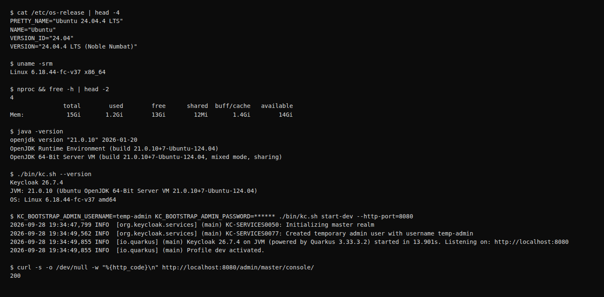
Figure 1: Environment: OS, Java and Keycloak version, and the start-up log showing Keycloak 26.7.4 listening on port 8080
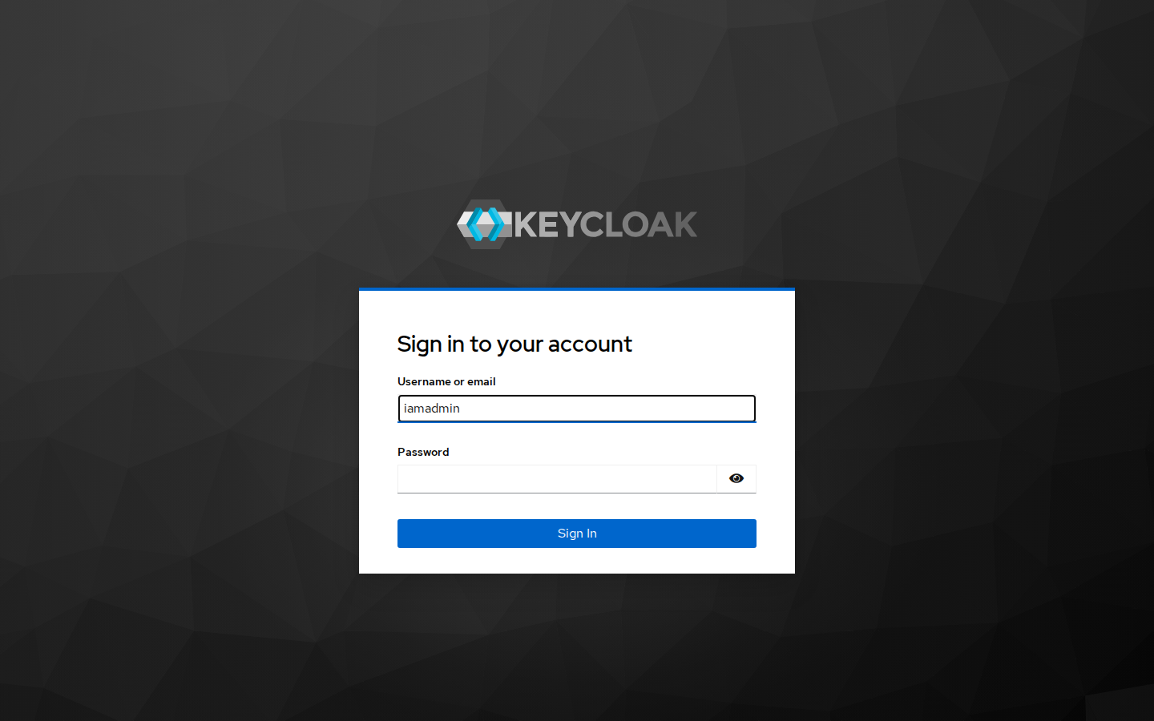
Figure 2: Keycloak Administration Console login page (master realm)
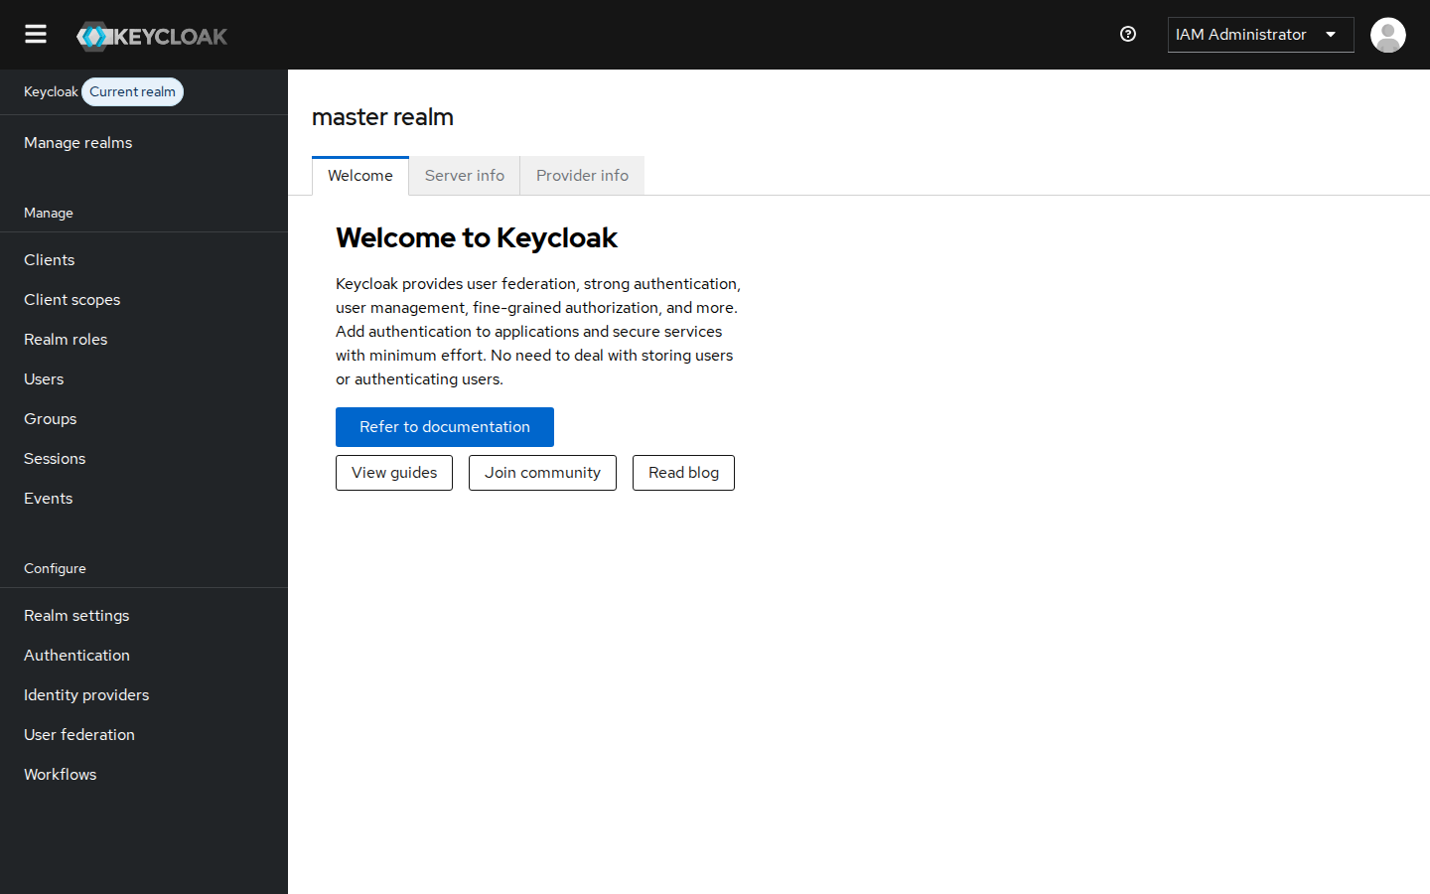
Figure 3: Successful access to the Administration Console as "IAM Administrator"
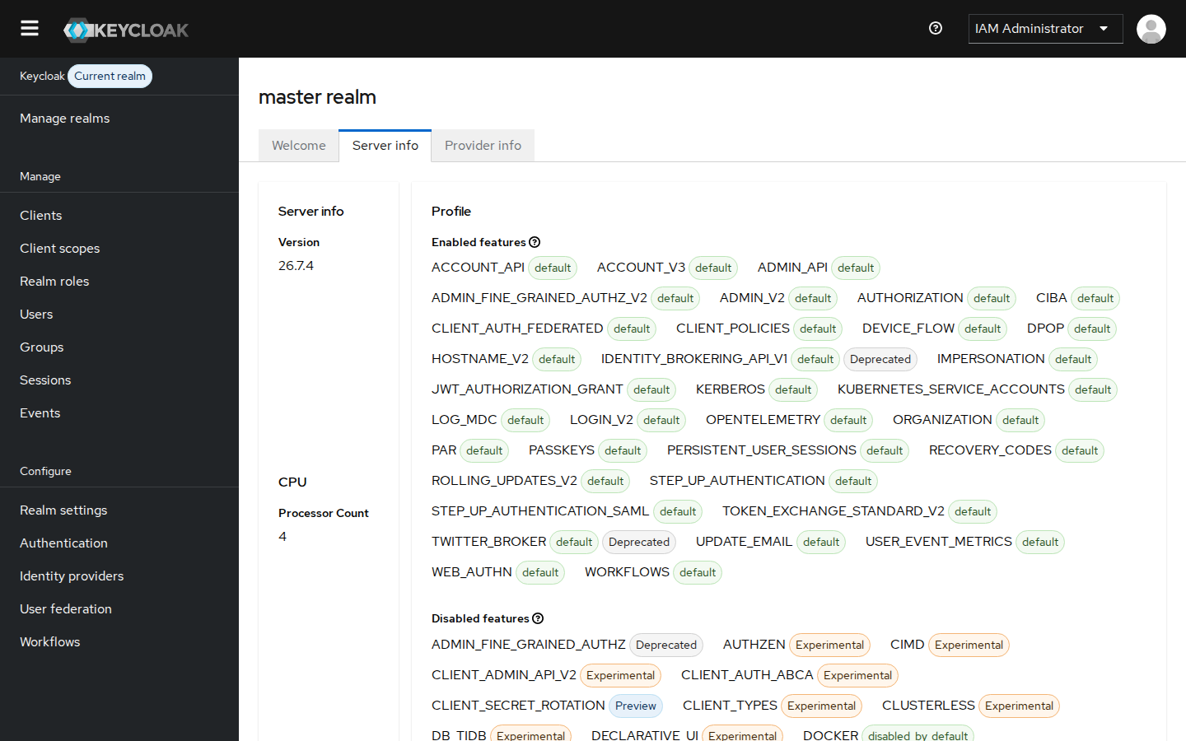
Figure 4: Server info tab confirming Keycloak version 26.7.4
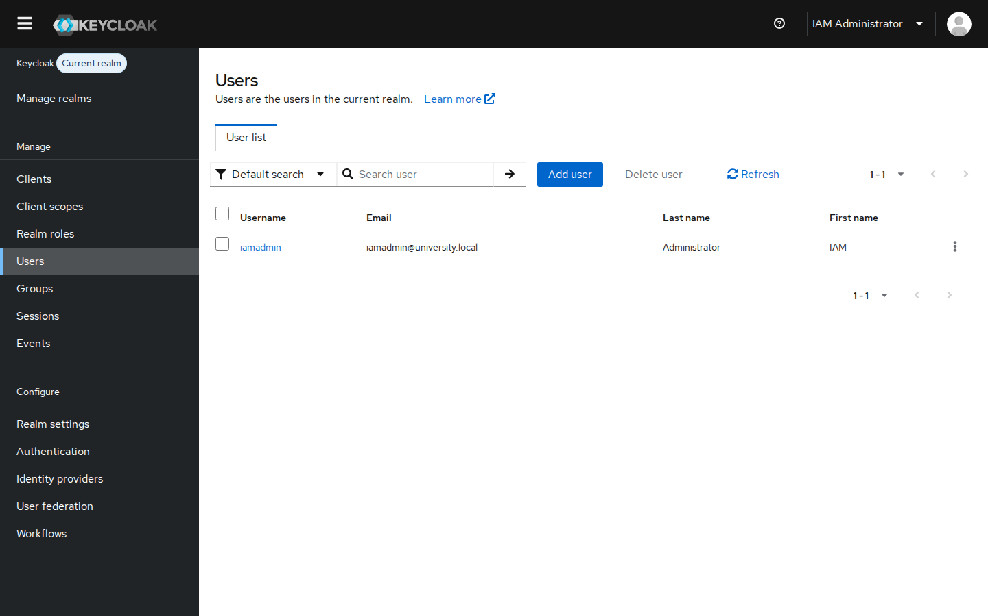
Figure 5: Permanent administrative account iamadmin in the master realm (temporary bootstrap admin removed)
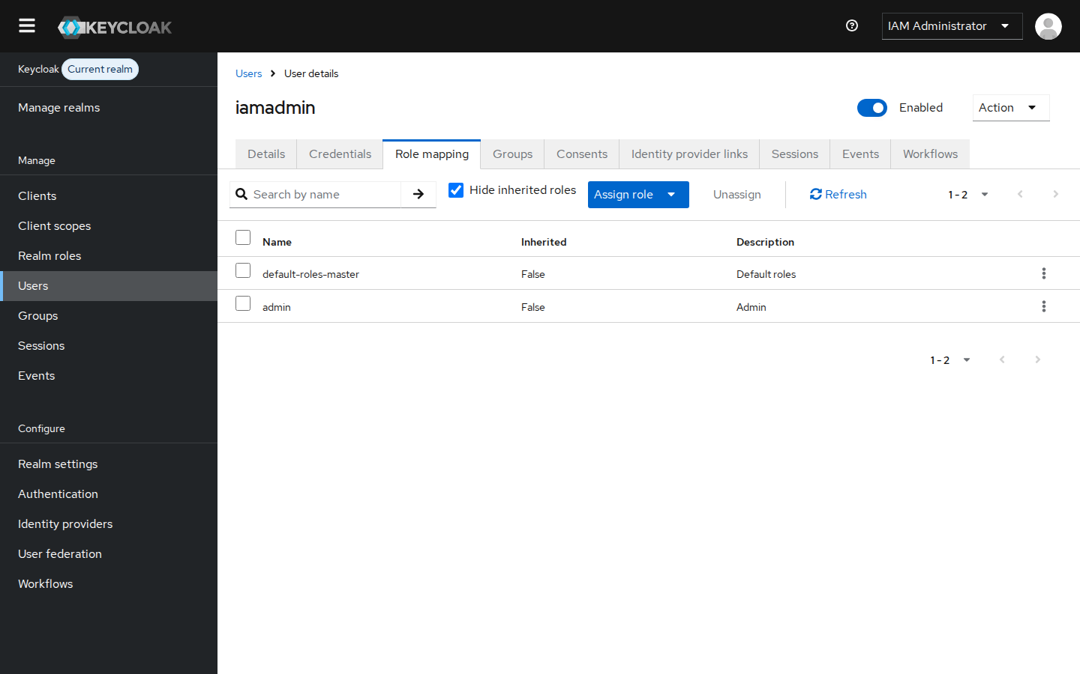
Figure 6: iamadmin holds the master-realm "admin" role

3. Realm Configuration (Task 2)
A realm is an isolated space that holds its own users, roles, clients and policies. The master realm is kept only for administering Keycloak. The institution's identities live in a separate realm, so ordinary users can never reach the Keycloak administration functions.

3.1 Creating UniversityRealm
Steps: open the realm selector and choose Manage realms → Create realm, enter Realm name UniversityRealm, and click Create. Then open Realm settings → General and set the Display name to "University Identity Service", which is shown on the login page.
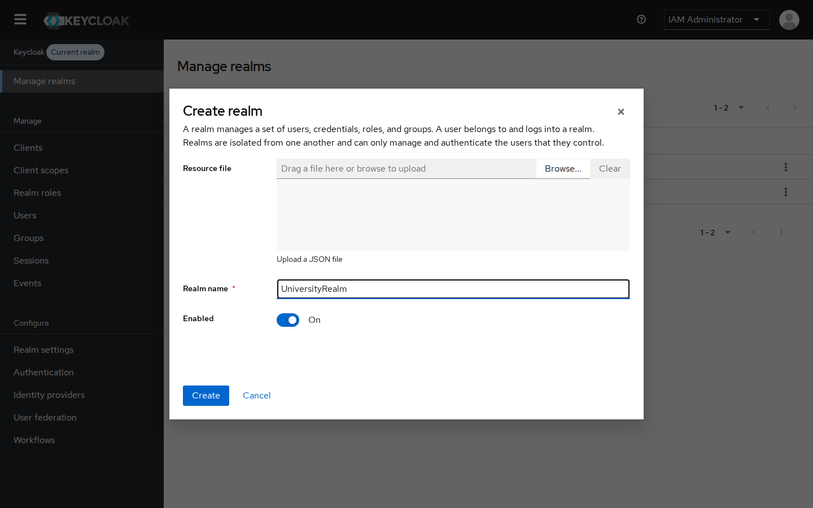
Figure 7: Create realm dialog: realm name UniversityRealm, Enabled
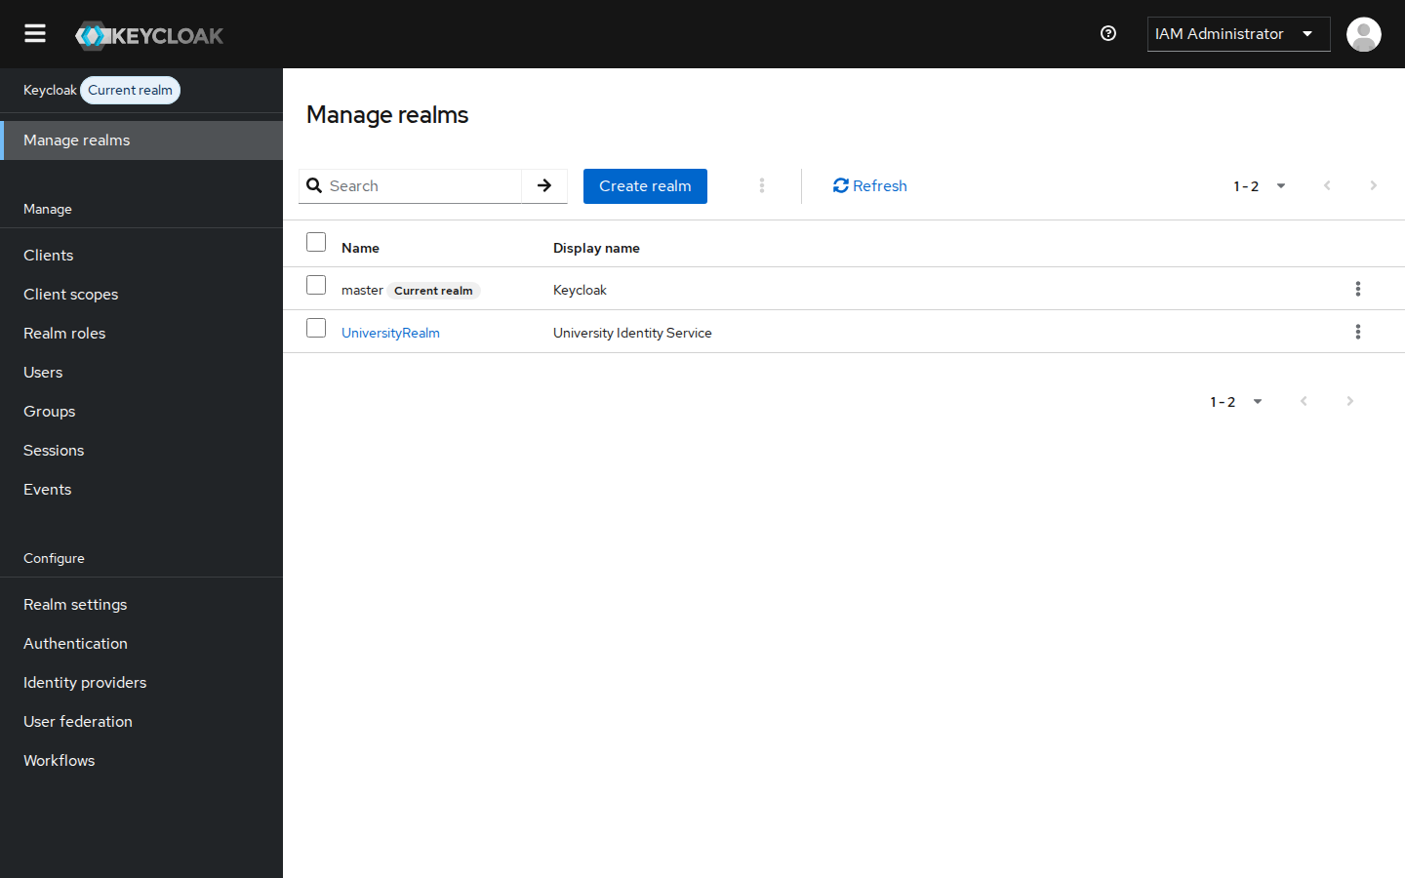
Figure 8: Manage realms: UniversityRealm created alongside master
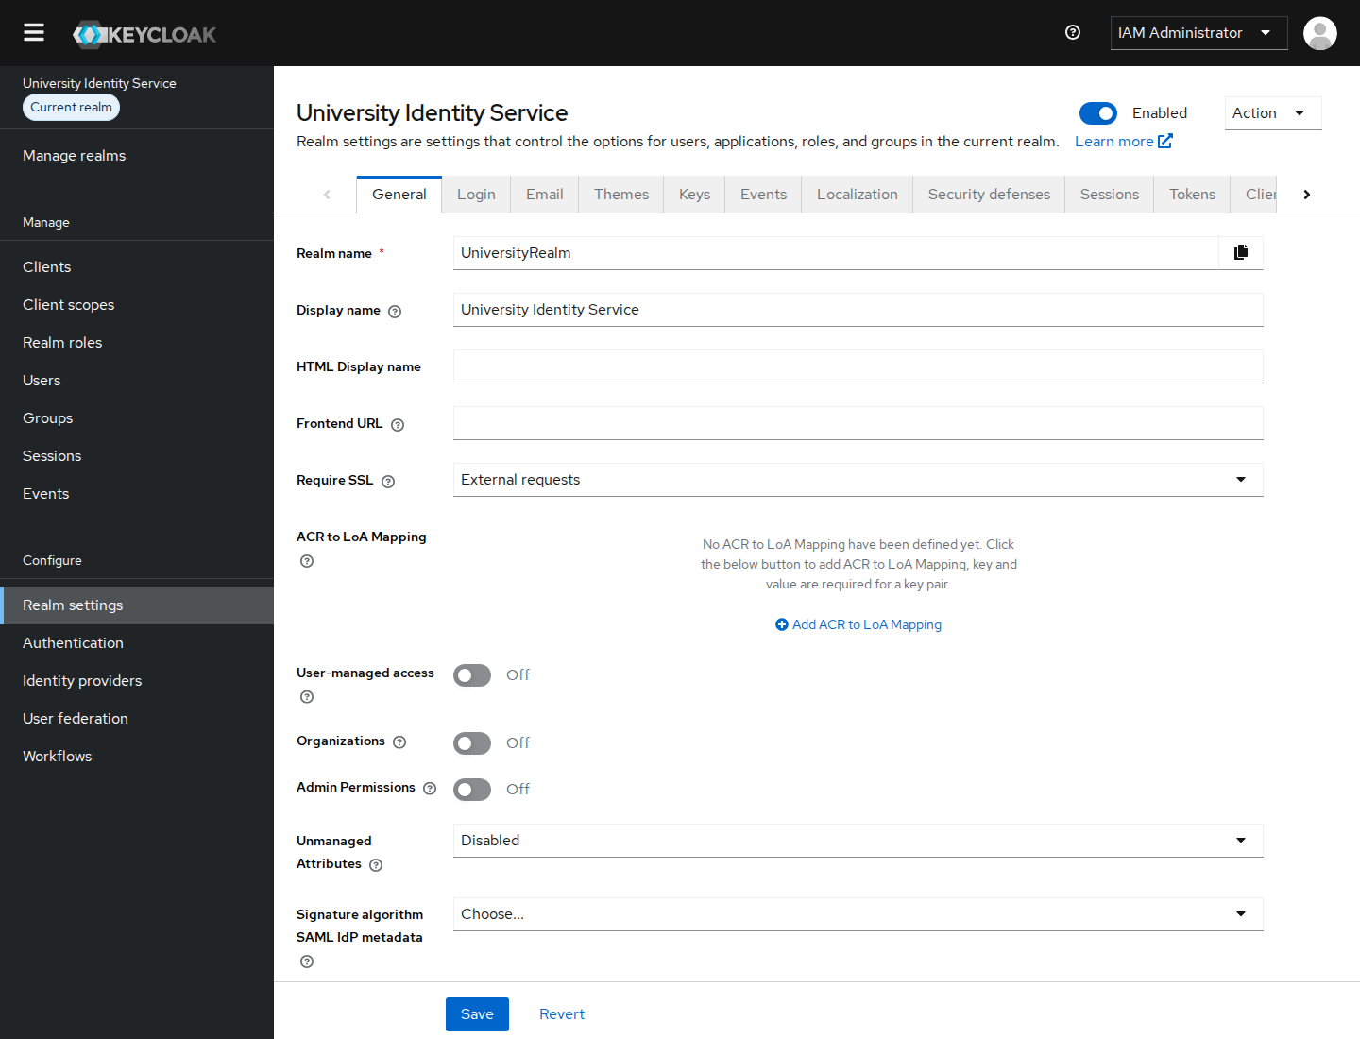
Figure 9: UniversityRealm general settings (enabled, Require SSL: external requests)

3.2 Realm security settings
Setting | Value | Purpose
User registration | Off | Only the IAM administrator creates identities
Login with email | On; duplicate emails Off | Convenient and unique sign-in
Forgot password | On | Self-service reset through verified email
Password policy | min. 10 chars, 1 upper, 1 lower, 1 digit, 1 special, not username, history 3 | Resist guessing and reuse
Brute-force detection | Lockout temporarily after 5 failures, wait 1 min increasing to 15 min | Stop password guessing
Token lifetimes | Access token 5 min, SSO idle 30 min, SSO max 10 h | Limit damage from stolen tokens or sessions
Events | Login and admin events saved for 30 days | Audit trail
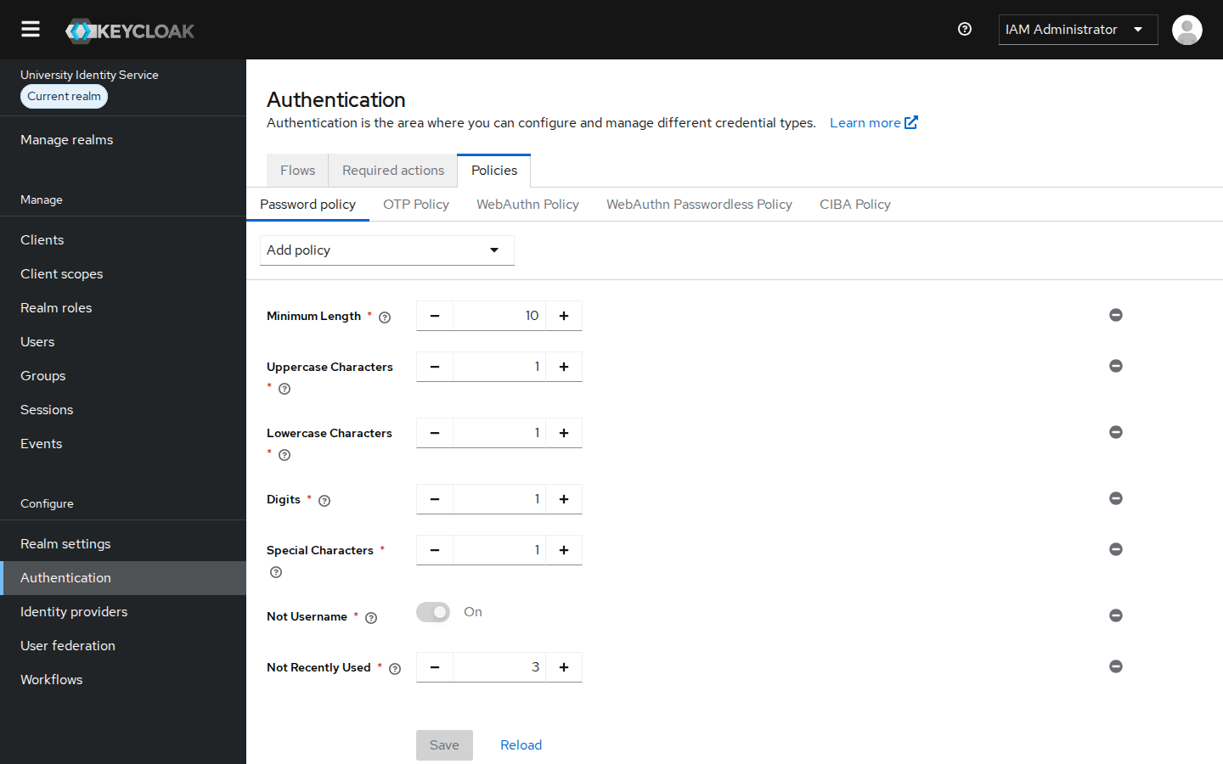
Figure 10: Authentication → Policies → Password policy for UniversityRealm
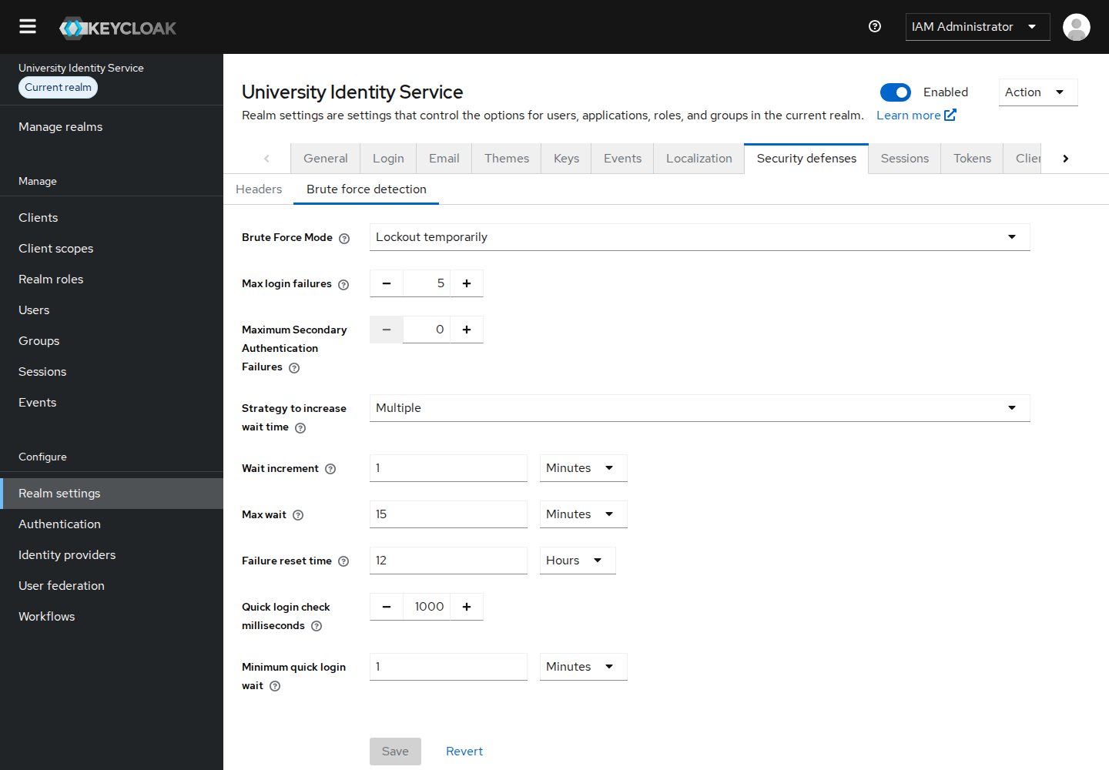
Figure 11: Realm settings → Security defenses → Brute force detection

4. User Configuration (Task 2)
Each user was created under Users → Add user with the required attributes. The password was then set on the Credentials tab with "Temporary" switched off, so it can be used for the demonstration.
Username | First name | Last name | Email | Password
admin01 | Alice | Admin | admin01@university.local | set (meets policy)
lecturer01 | Leonard | Lecturer | lecturer01@university.local | set (meets policy)
student01 | Stella | Student | student01@university.local | set (meets policy)
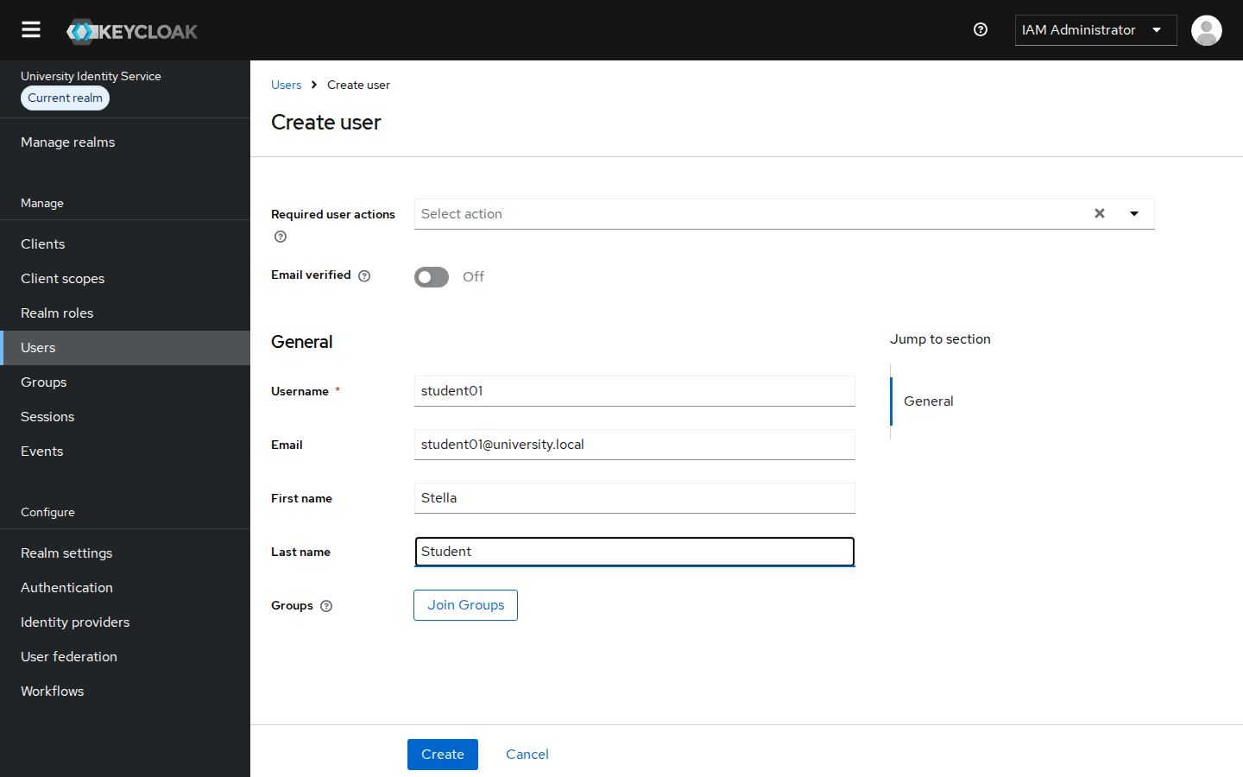
Figure 12: Users → Add user: the Create user form with username, email, first name and last name
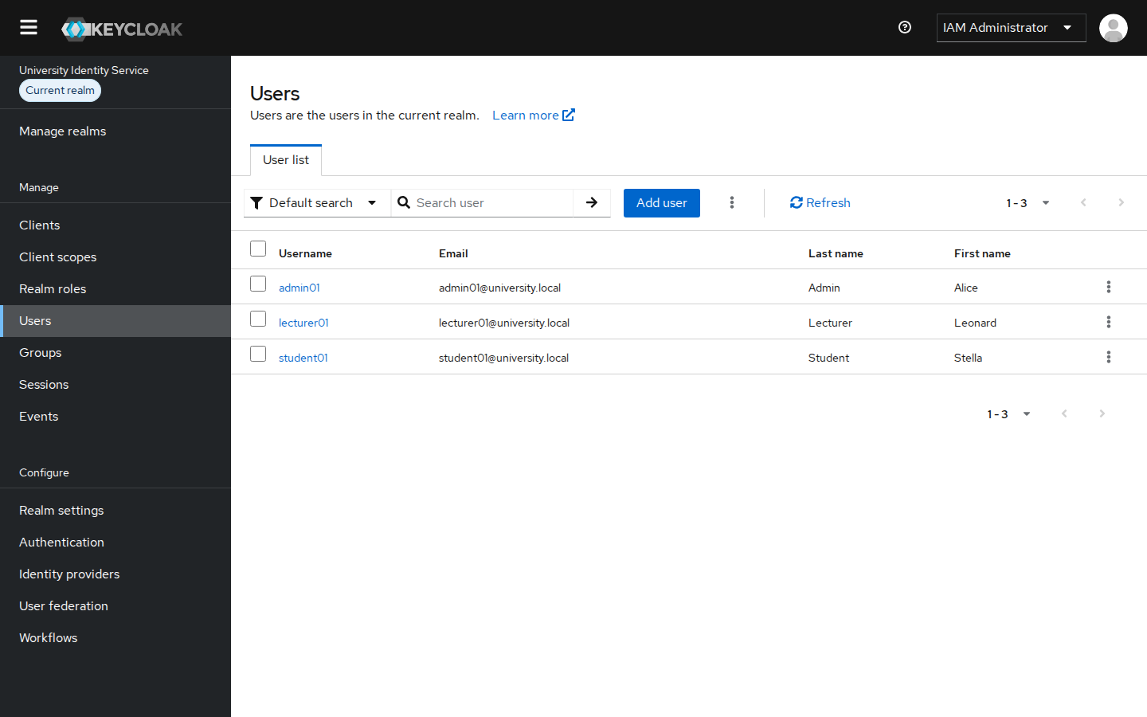
Figure 13: UniversityRealm users: admin01, lecturer01 and student01
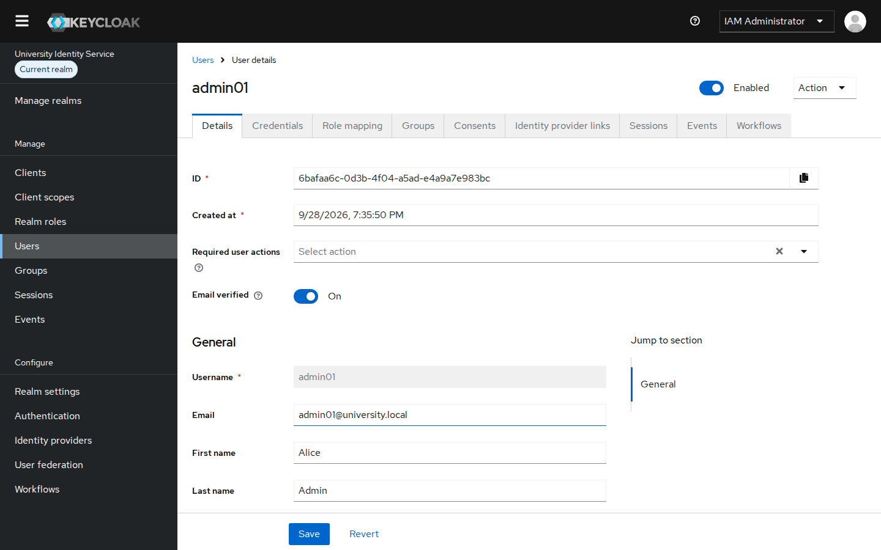
Figure 14: admin01: username, email, first name, last name
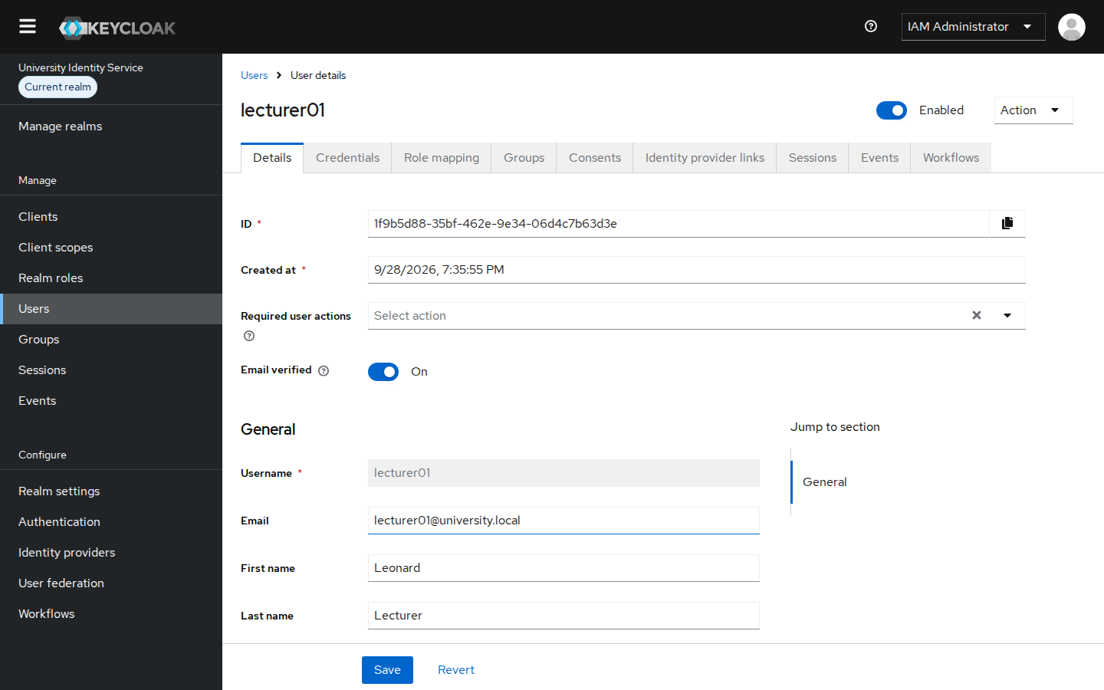
Figure 15: lecturer01 user details
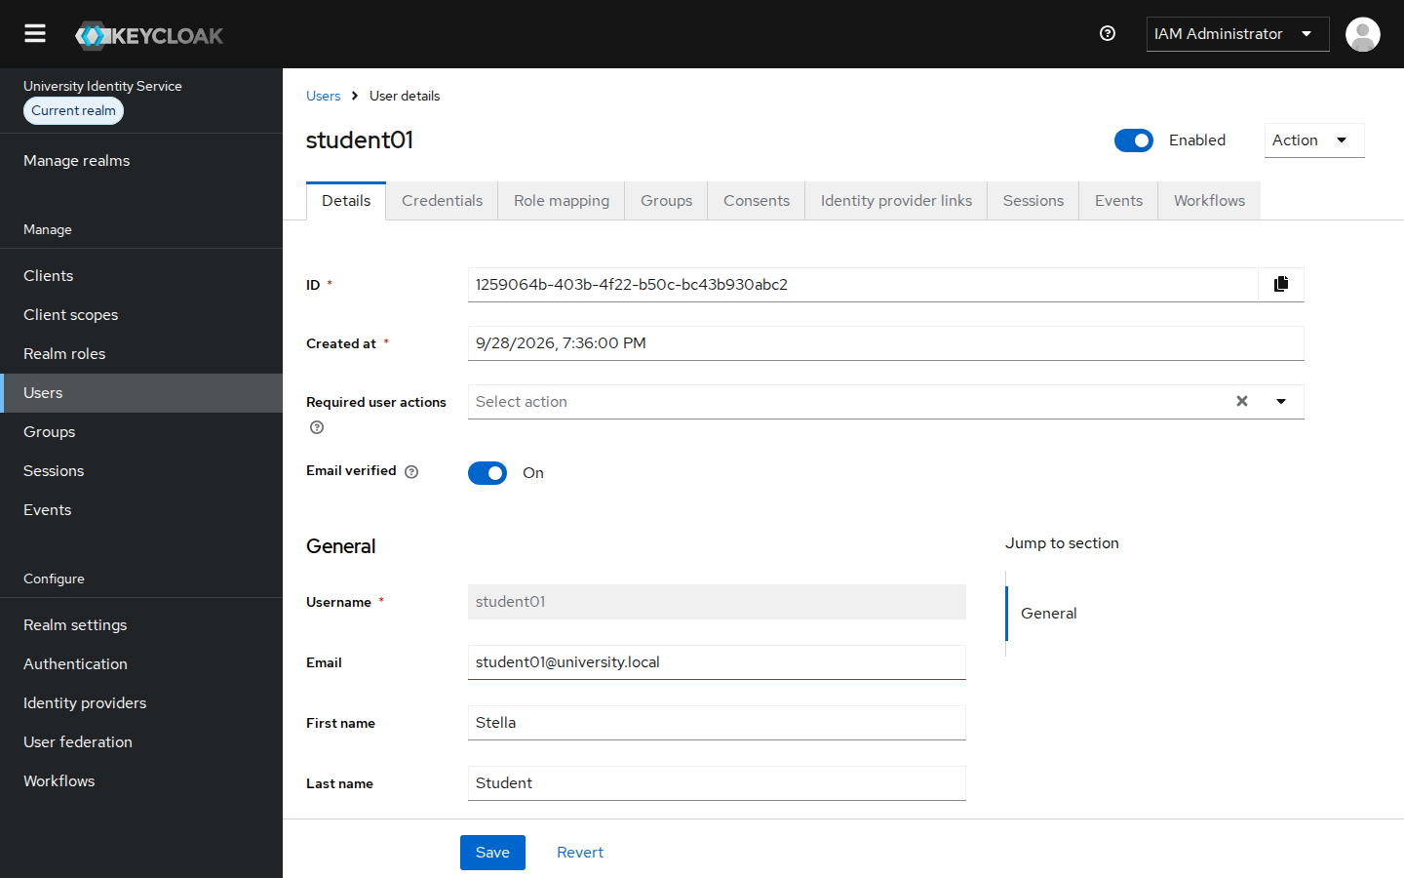
Figure 16: student01 user details
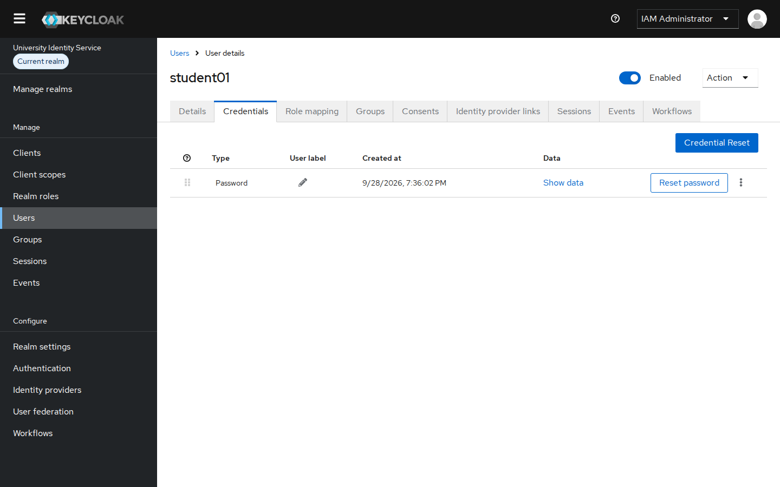
Figure 17: Credentials tab: a password credential is stored (hashed) for student01

4.1 Enabling and disabling a user account
Demonstration: on student01's Details page I switched the Enabled toggle off and confirmed the dialog. The Users list then shows a "Disabled" badge. When student01 tries to sign in to the Student Portal, Keycloak rejects the attempt with "Account is disabled, contact your administrator." The account was then switched back on and login worked again.
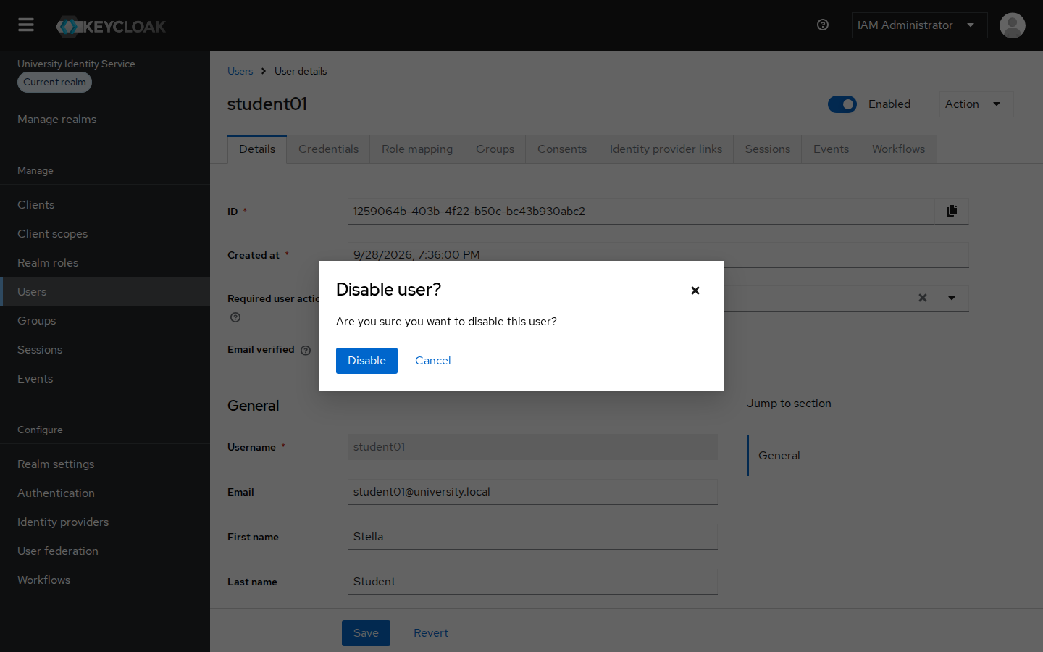
Figure 18: Disabling student01: confirmation dialog
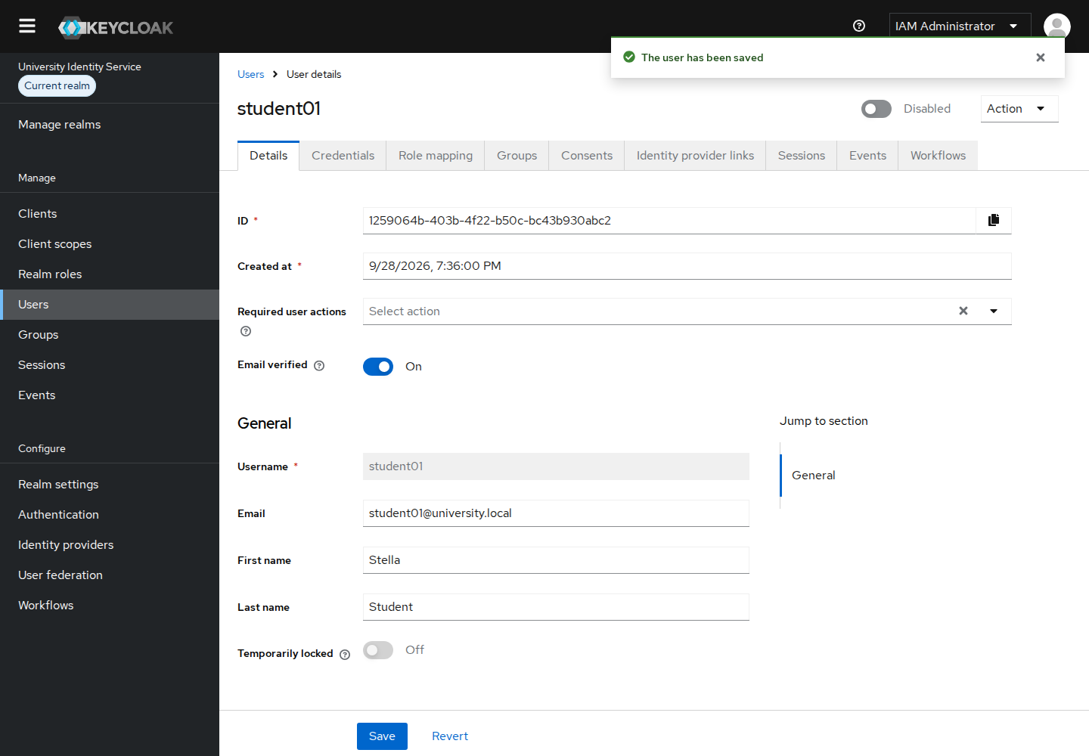
Figure 19: student01 saved as Disabled
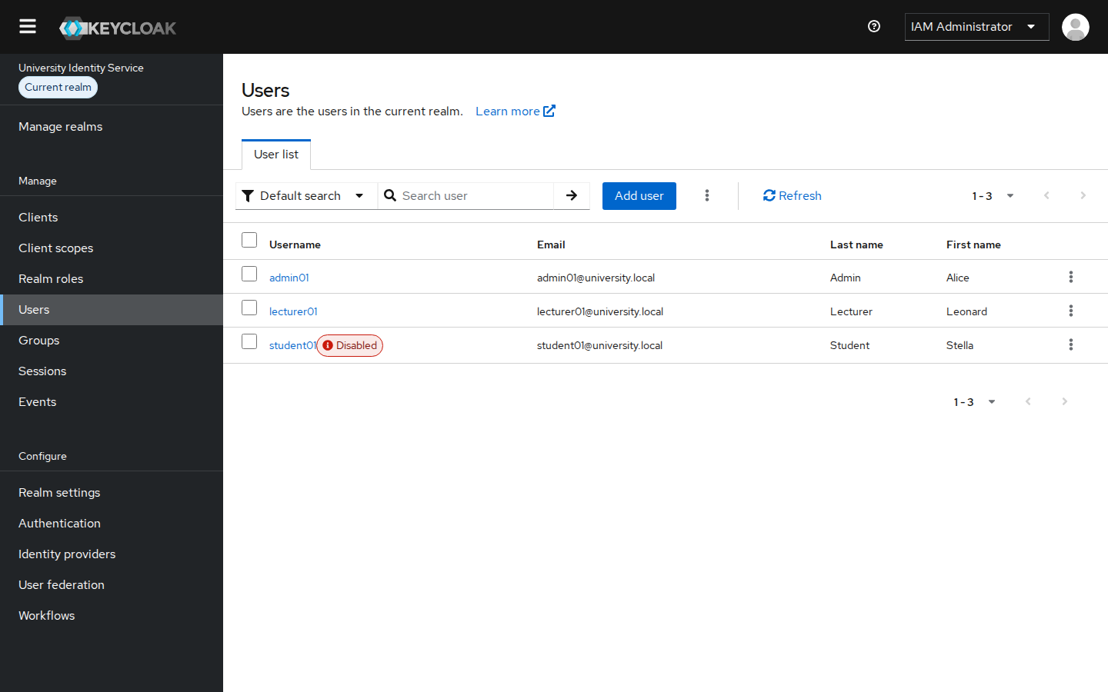
Figure 20: Users list showing student01 flagged as Disabled
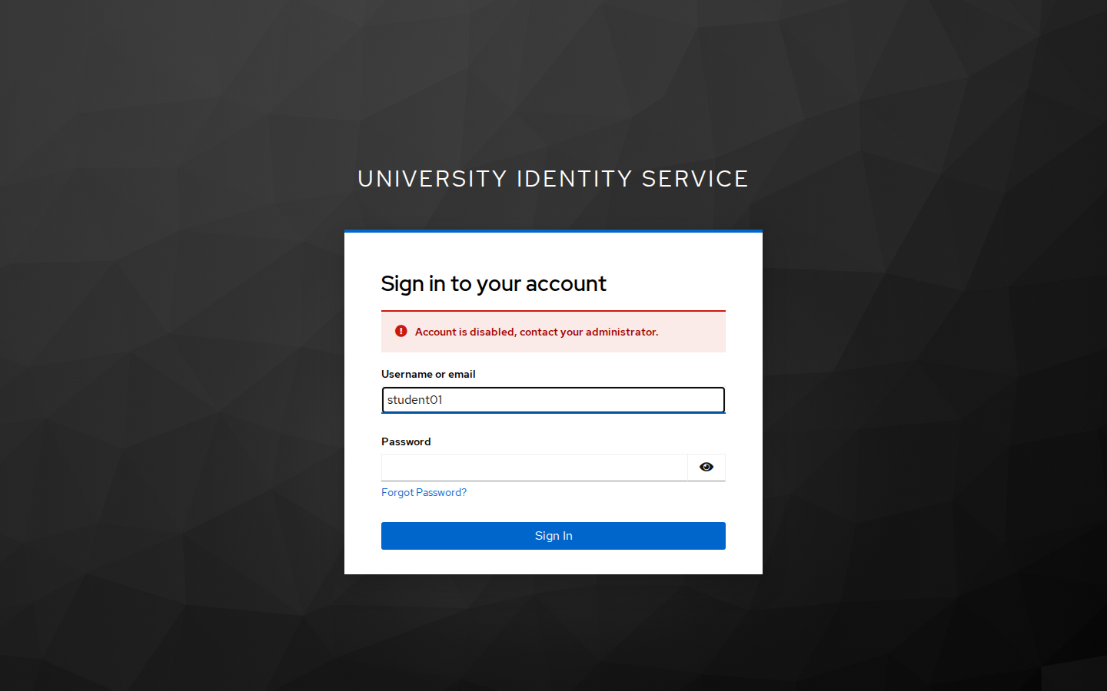
Figure 21: Login attempt by the disabled account is refused by Keycloak
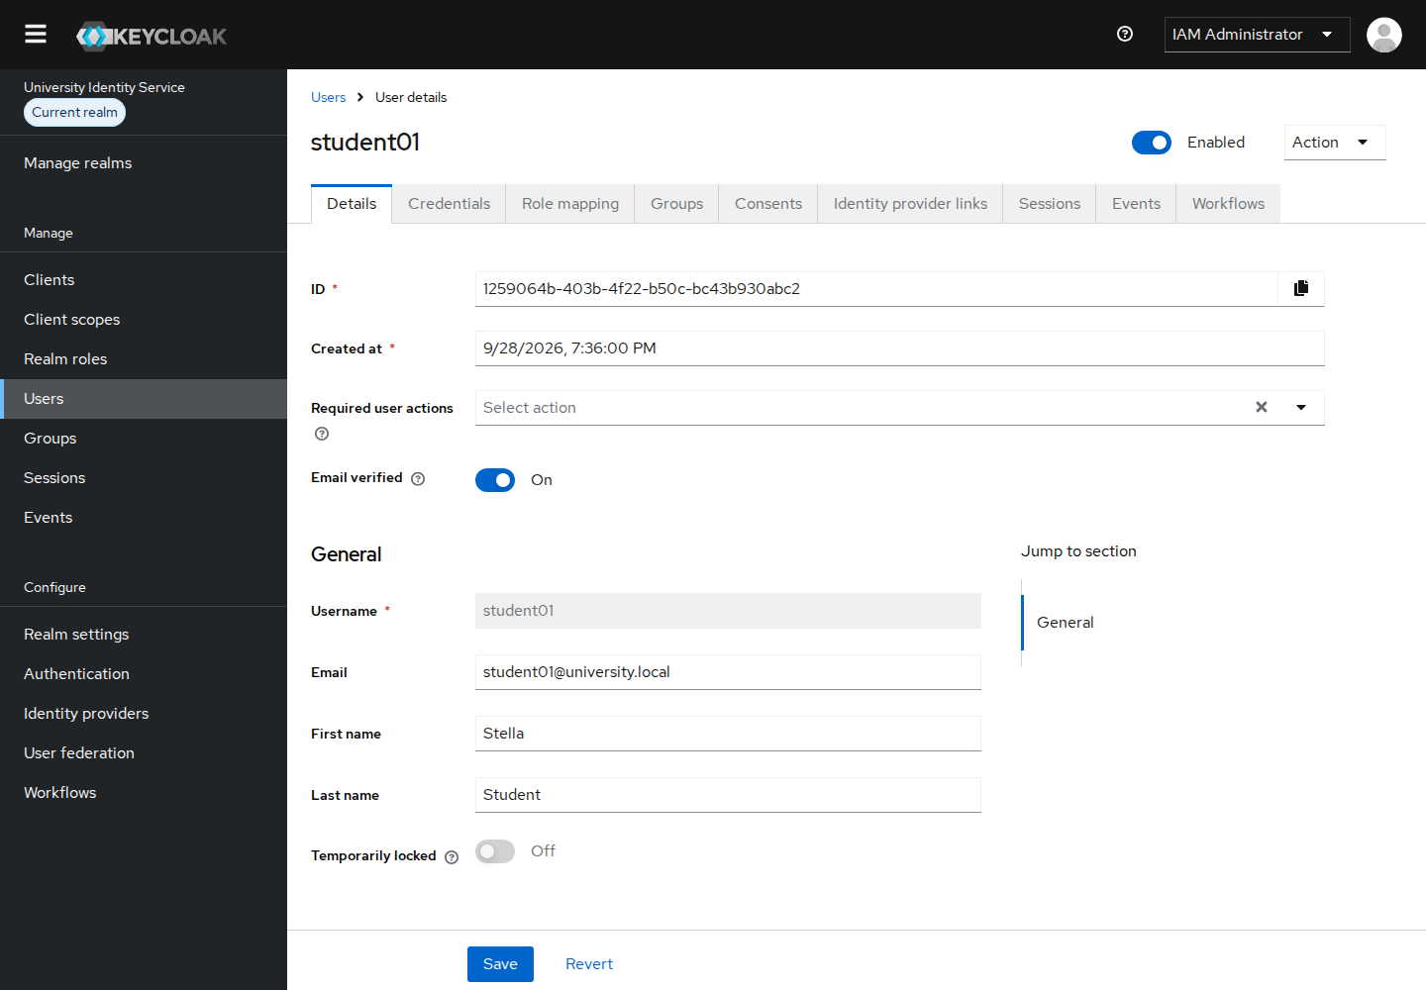
Figure 22: student01 re-enabled
When this control is needed. Disabling blocks authentication immediately but keeps the identity, its roles and its audit history. Deleting would lose all of those. Typical cases are:
- a student is suspended, has deferred, or has not cleared fees;
- a staff member is on extended leave, or their contract has ended and offboarding is still pending;
- suspected compromise: stolen credentials or unusual login events. The account is frozen while the incident is investigated;
- graduates and leavers are disabled first and deleted later under the records-retention policy;
- a disciplinary or legal hold, where evidence must be preserved.

4.2 Identities from the institutional directory (LDAP / AD user federation)
In a real university, staff and student accounts already exist in a directory (Active Directory or OpenLDAP) fed by HR and admissions. Keycloak does not need to copy passwords from it. With User Federation it reads users from the directory and checks their passwords against it at login. To show this, I installed an OpenLDAP server (dc=university,dc=local) with two extra people: lecturer02 (Grace Hopper) and student02 (Samuel Okello). Each is a member of an LDAP group, cn=lecturer or cn=student.
Configuration (User federation → Add Ldap providers):
Setting | Value | Why
Vendor / Connection URL | Other (OpenLDAP) / ldap://127.0.0.1:389 | For Active Directory: vendor Active Directory, ldaps://dc.university.local:636
Bind DN | cn=admin,dc=university,dc=local | Service account Keycloak uses to search the directory
Edit mode | READ_ONLY | The directory stays the single source of truth; Keycloak cannot change it
Users DN / username attribute | ou=people,dc=university,dc=local / uid | For AD: sAMAccountName
Import users + periodic sync | On; full sync daily, changed users hourly | Leavers disabled in the directory lose access automatically
Mapper: role-groups (role-ldap-mapper) | ou=groups groupOfNames → realm roles | Directory group membership decides the Keycloak role, so no manual role assignment is needed
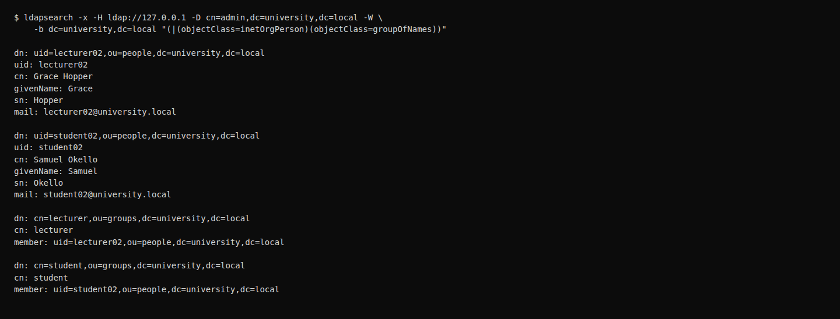
Figure 23: The OpenLDAP directory: two people and two role groups
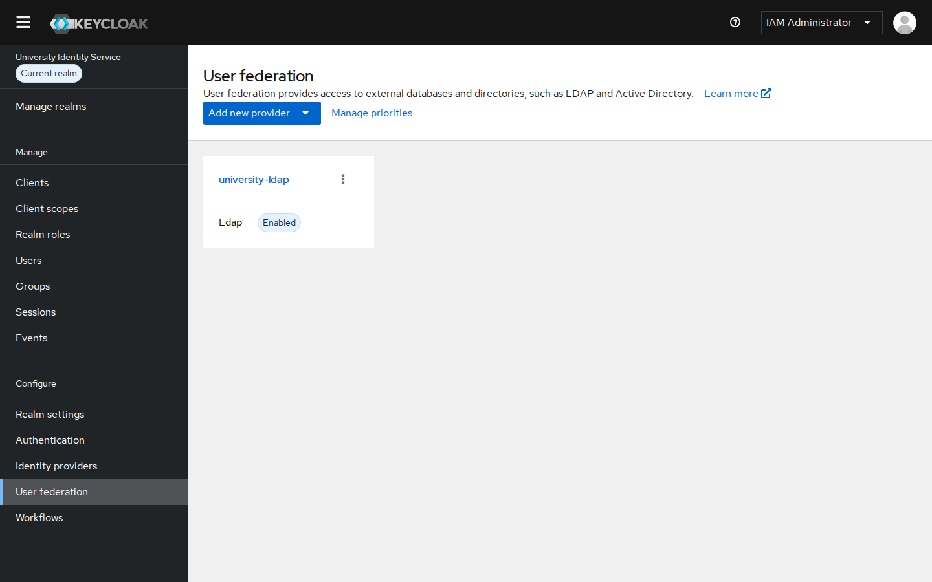
Figure 24: User federation: LDAP provider university-ldap enabled for UniversityRealm
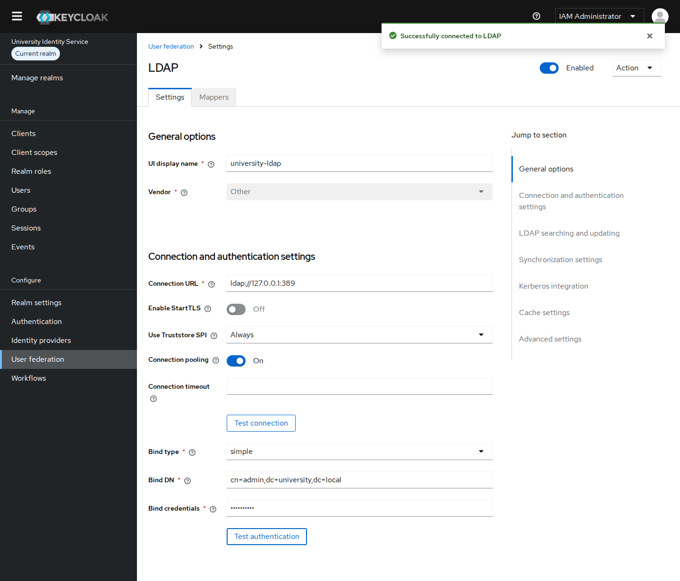
Figure 25: LDAP connection and bind settings, with "Successfully connected to LDAP" after Test authentication
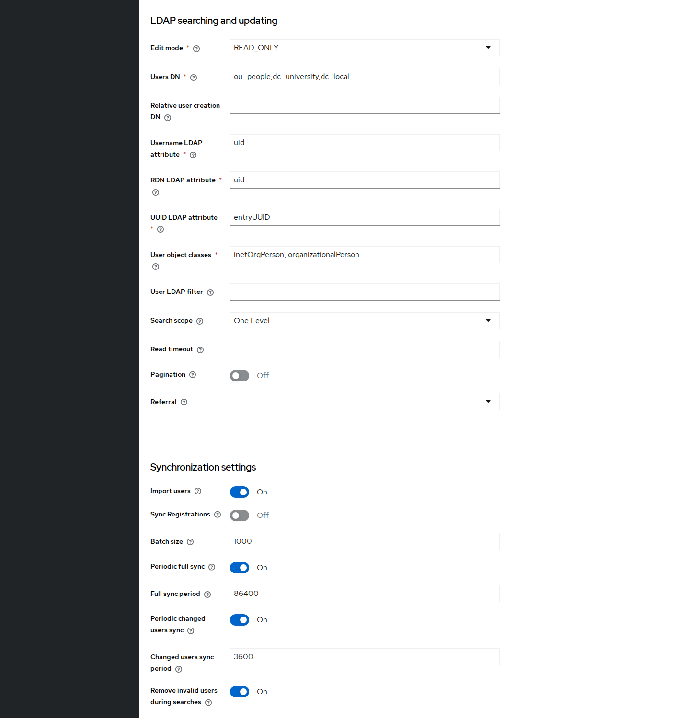
Figure 26: LDAP search settings (READ_ONLY, ou=people, uid) and synchronisation settings
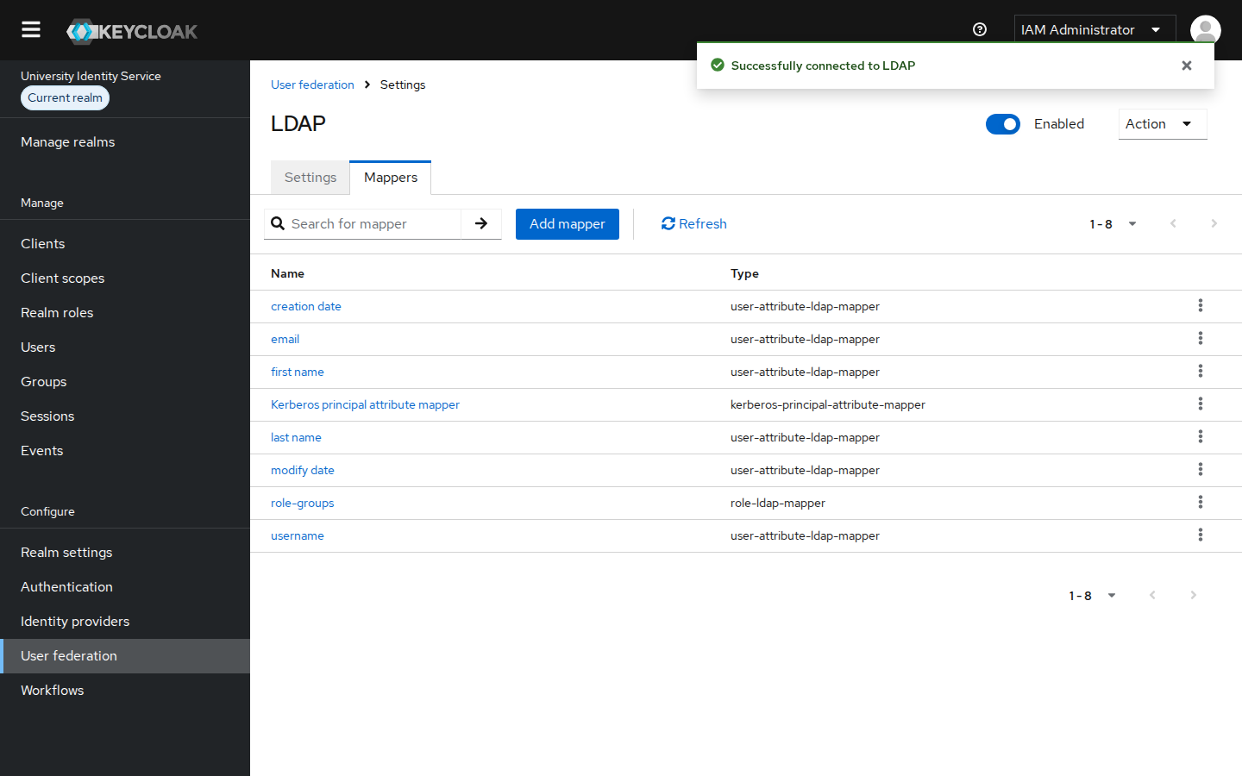
Figure 27: LDAP mappers, including role-groups (role-ldap-mapper)
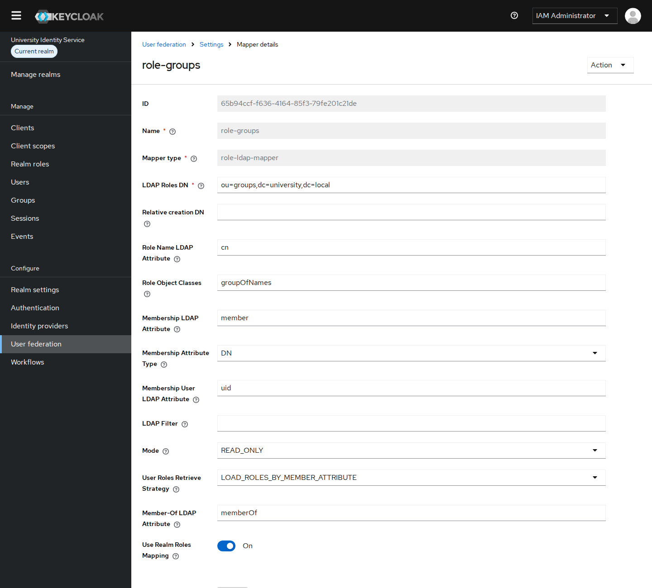
Figure 28: role-groups mapper: LDAP groups under ou=groups map to realm roles
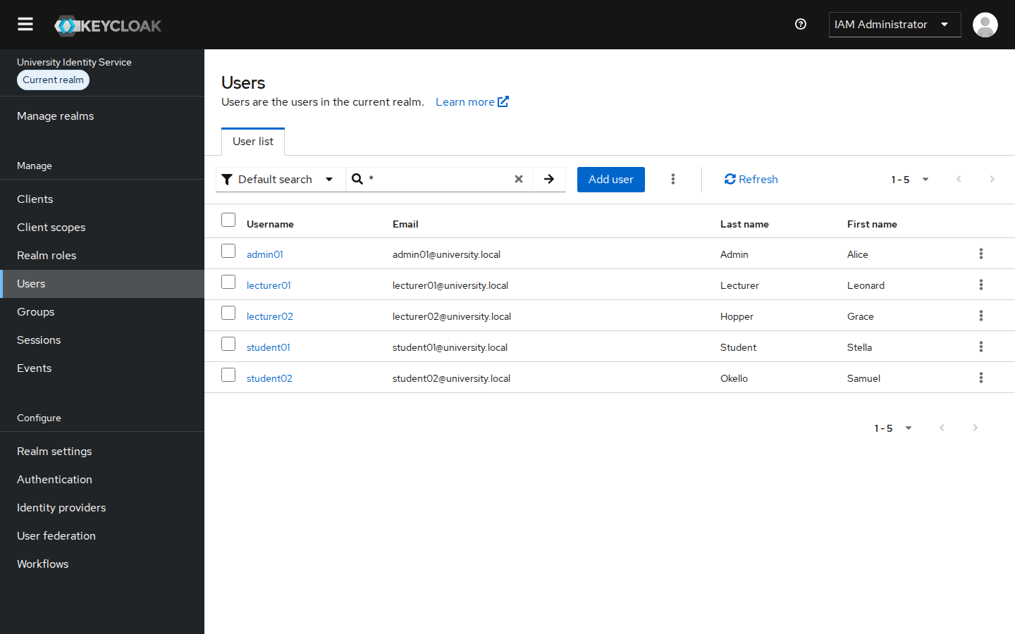
Figure 29: UniversityRealm users after sync: lecturer02 and student02 imported from LDAP
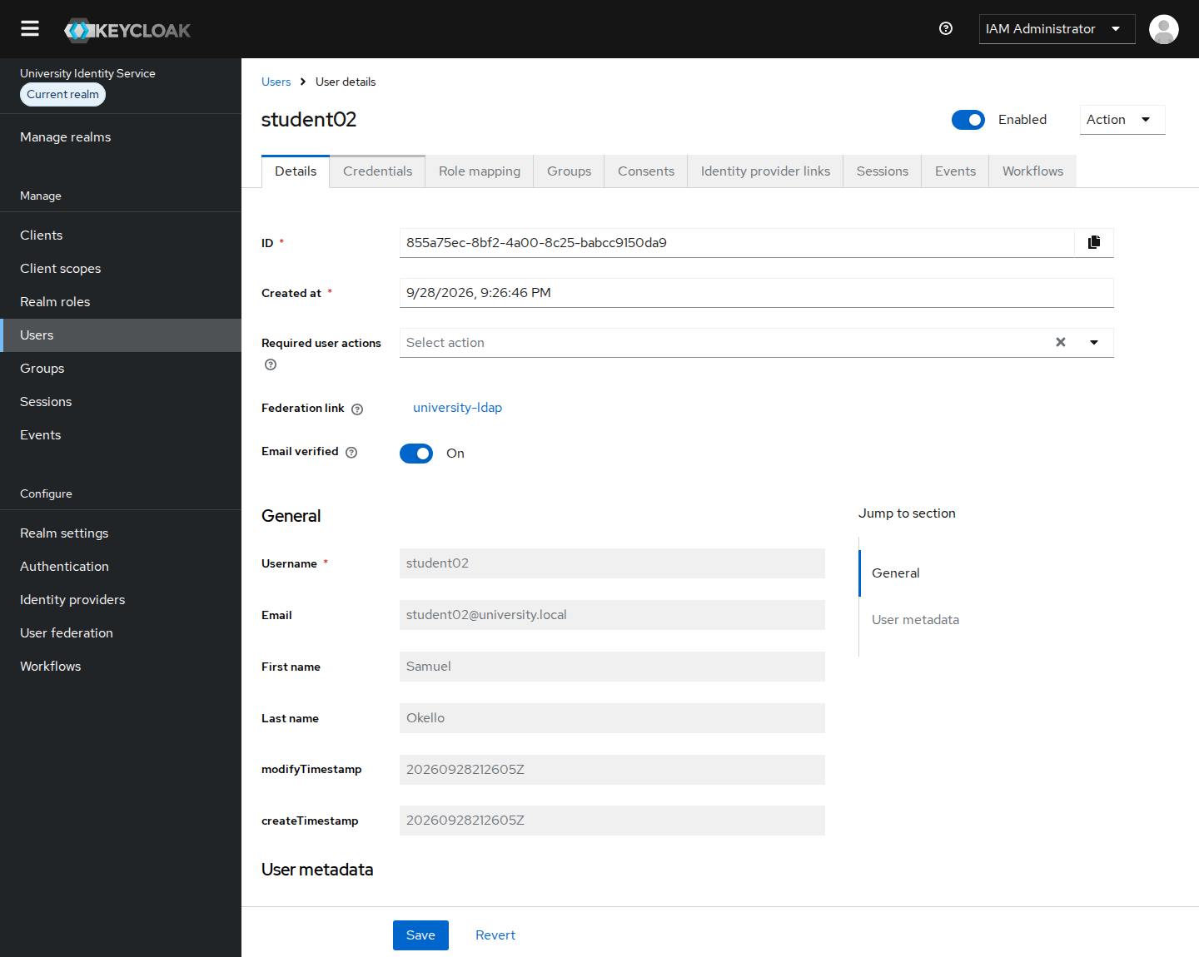
Figure 30: student02: "Federation link: university-ldap"; attributes are read-only because they come from the directory
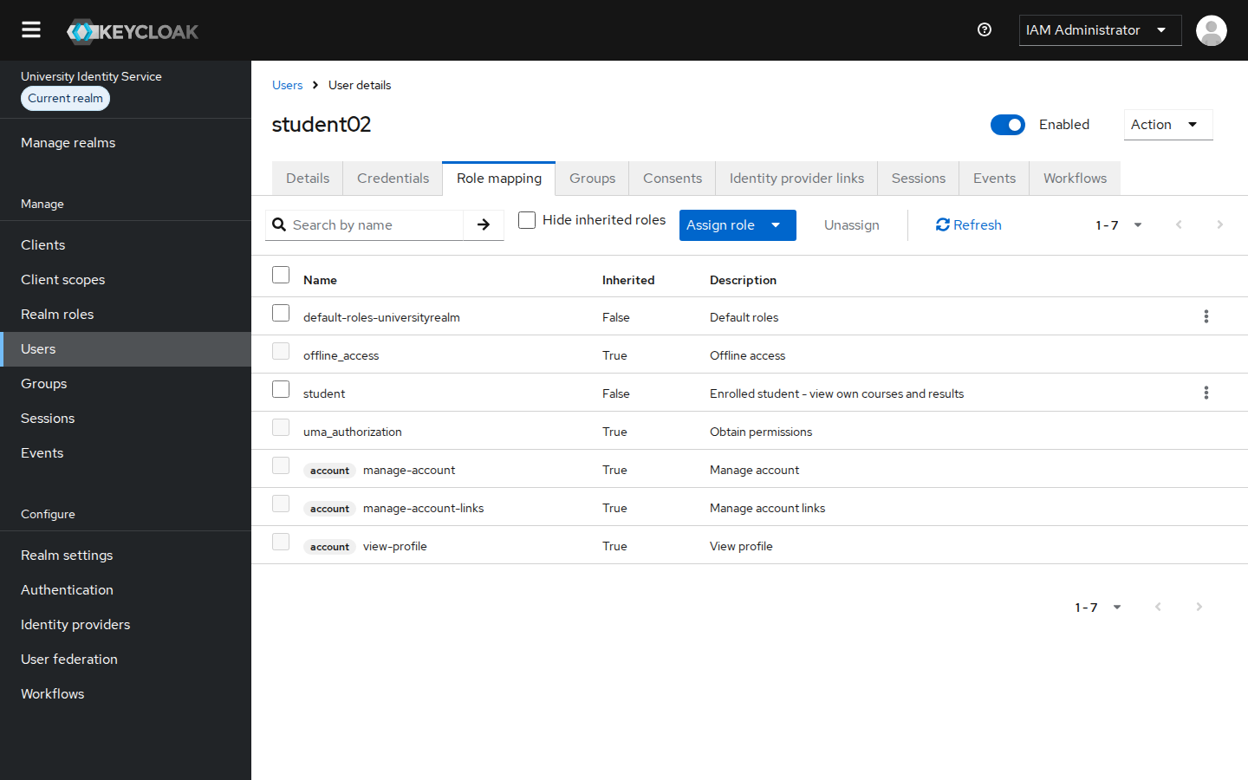
Figure 31: student02 gets the realm role student from LDAP group membership
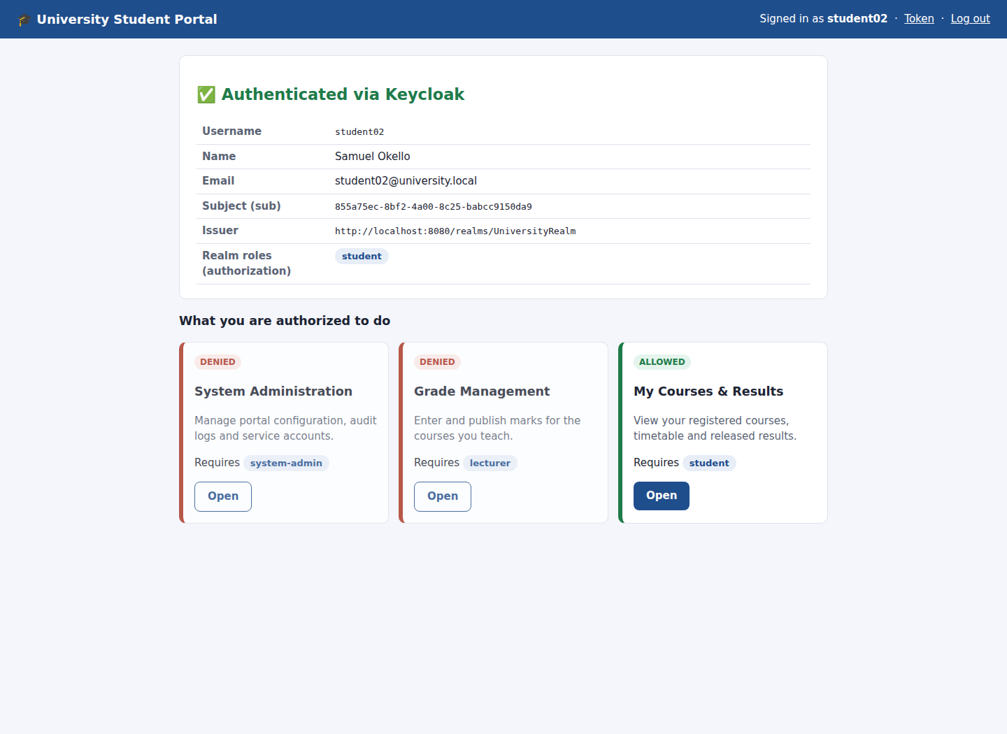
Figure 32: student02 logs in to the Student Portal with the directory password: role student, only My Courses allowed
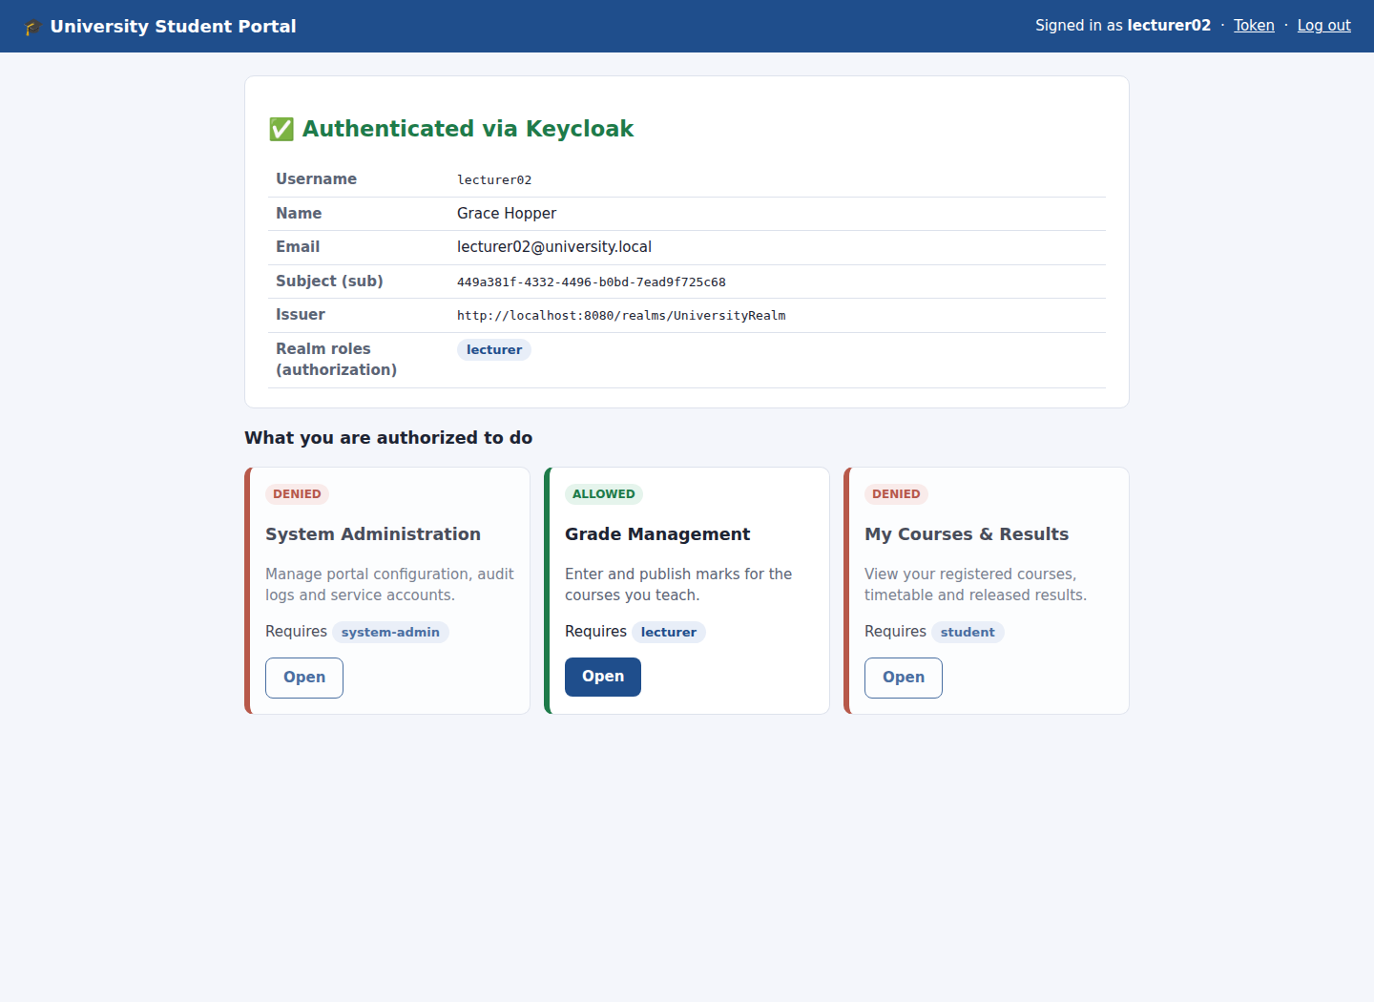
Figure 33: lecturer02 (from LDAP) is authorized for Grade Management only
The result: accounts, passwords and group membership are managed once, in the directory. Keycloak turns them into standard OIDC tokens and roles that every application trusts.

5. Role Configuration (Task 3)

5.1 Creating the roles
Under Realm roles → Create role I created three realm roles, each with a description. Realm roles, rather than client roles, were chosen so that any future institutional application such as an LMS or library system can reuse the same roles.
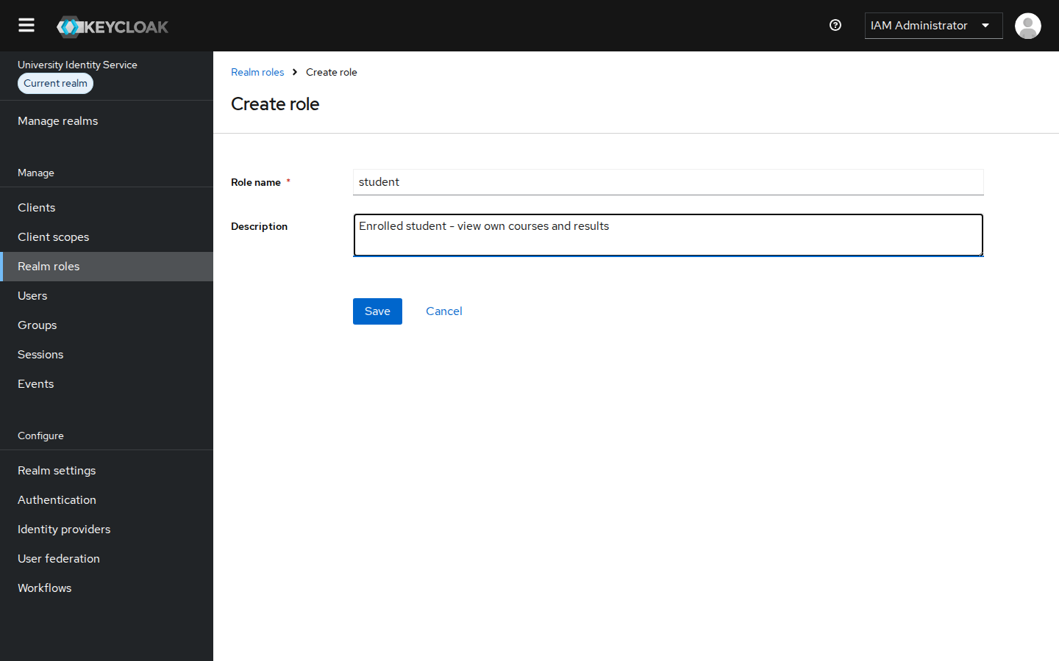
Figure 34: Realm roles → Create role: role name and description (shown for student)
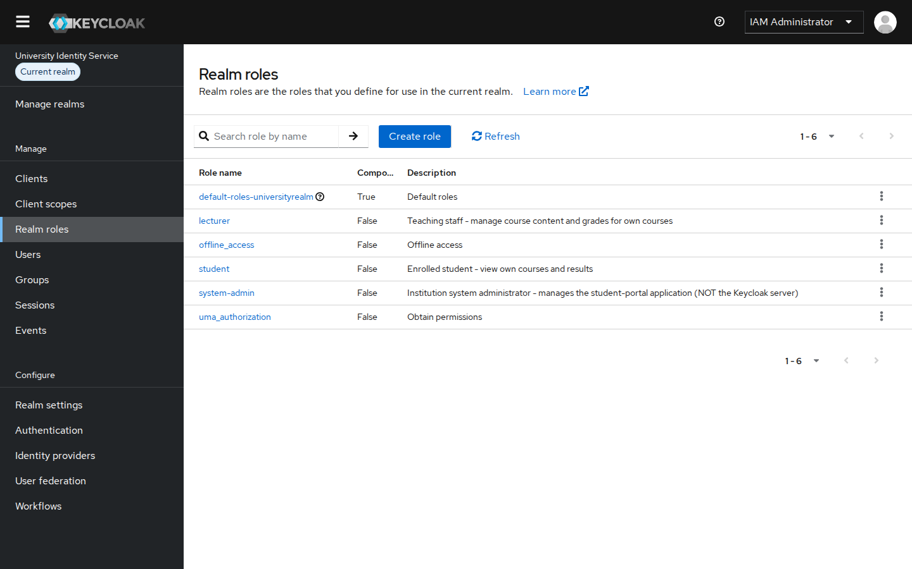
Figure 35: Realm roles: system-admin, lecturer and student (plus Keycloak defaults)
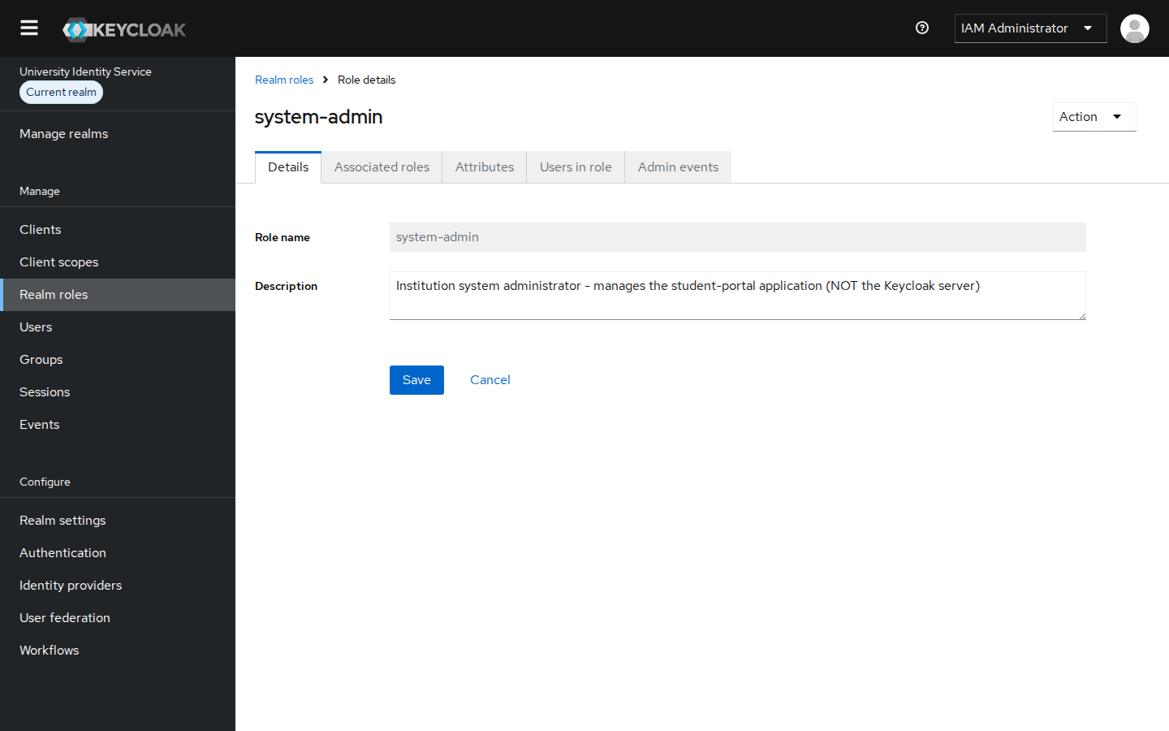
Figure 36: Role details: system-admin
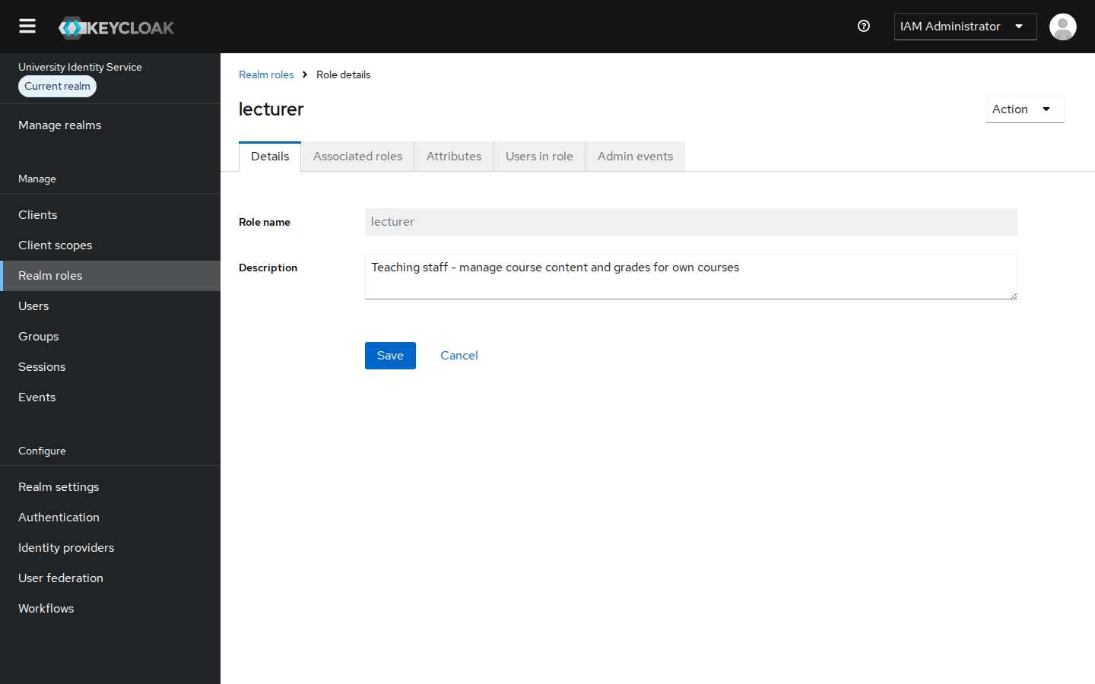
Figure 37: Role details: lecturer
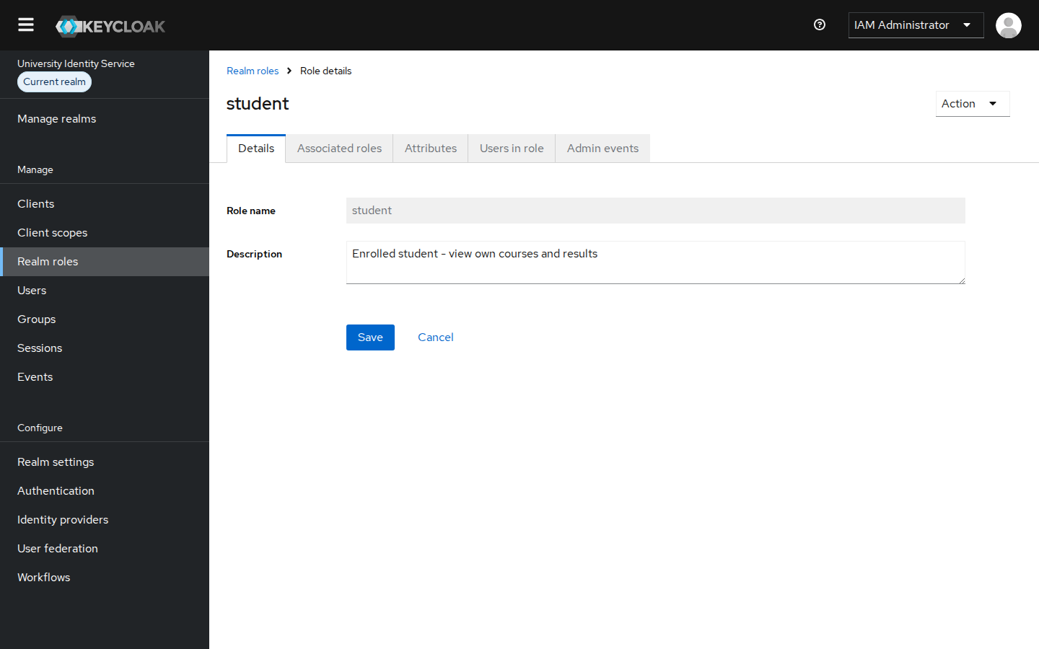
Figure 38: Role details: student

5.2 Assigning roles to users
Roles were assigned from each user's Role mapping → Assign role tab (filter by realm roles):
User | Assigned role | Access in student-portal
admin01 | system-admin | /admin (System Administration)
lecturer01 | lecturer | /lecturer/grades (Grade Management)
student01 | student | /student/courses (My Courses & Results)
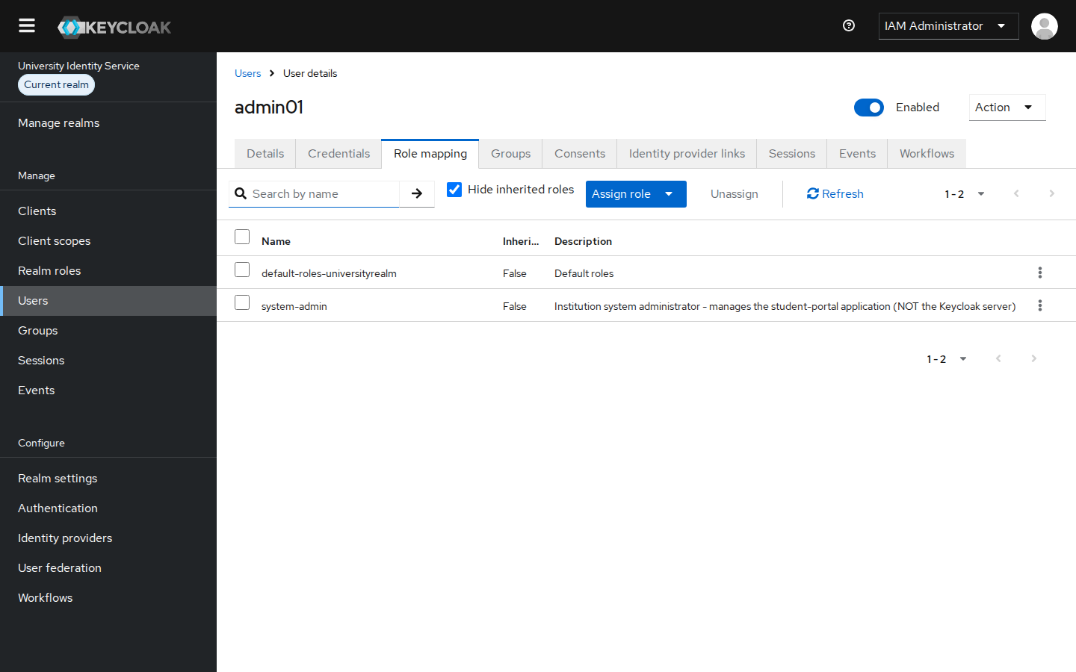
Figure 39: admin01 → system-admin
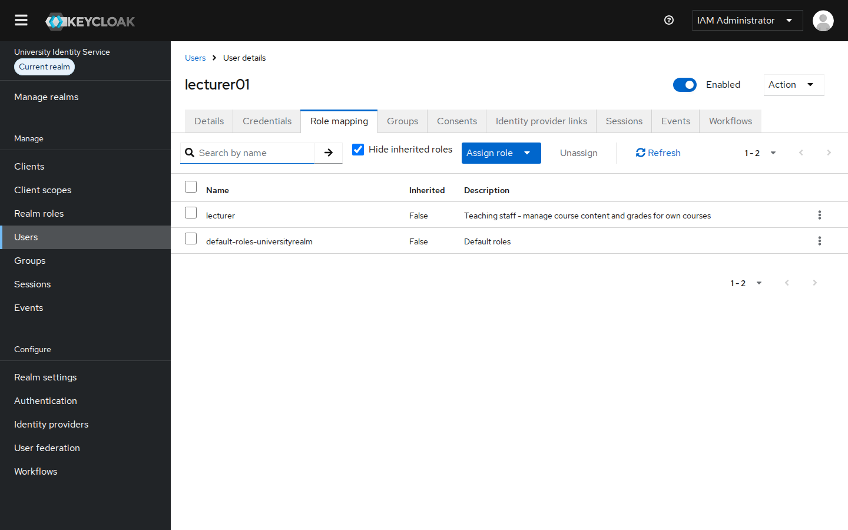
Figure 40: lecturer01 → lecturer
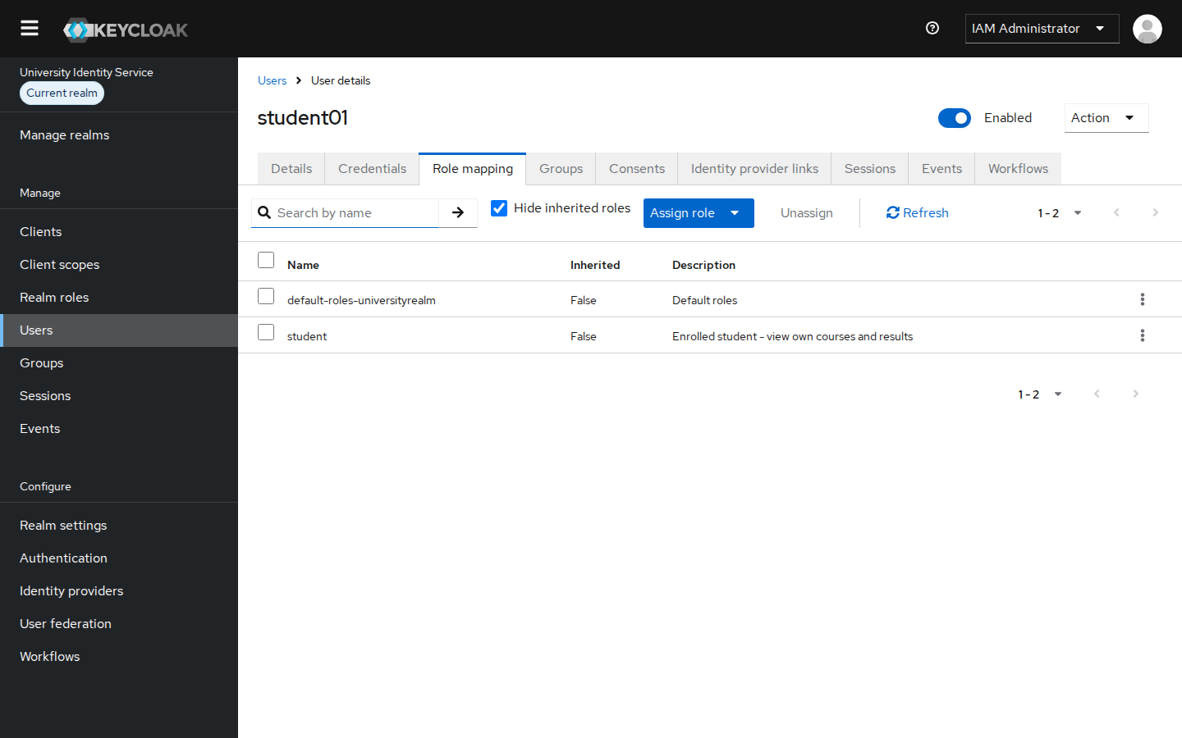
Figure 41: student01 → student
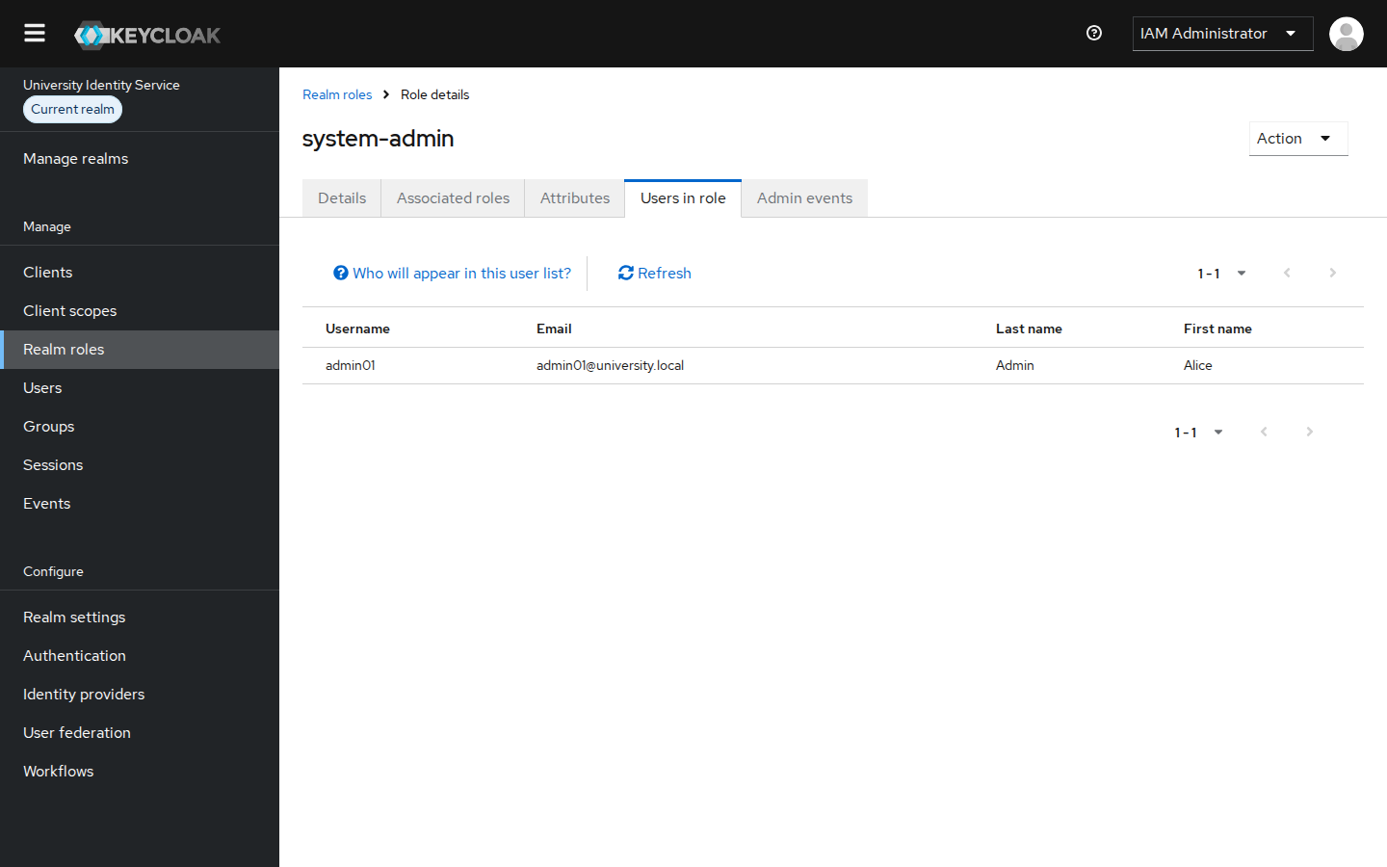
Figure 42: "Users in role" for system-admin: only admin01
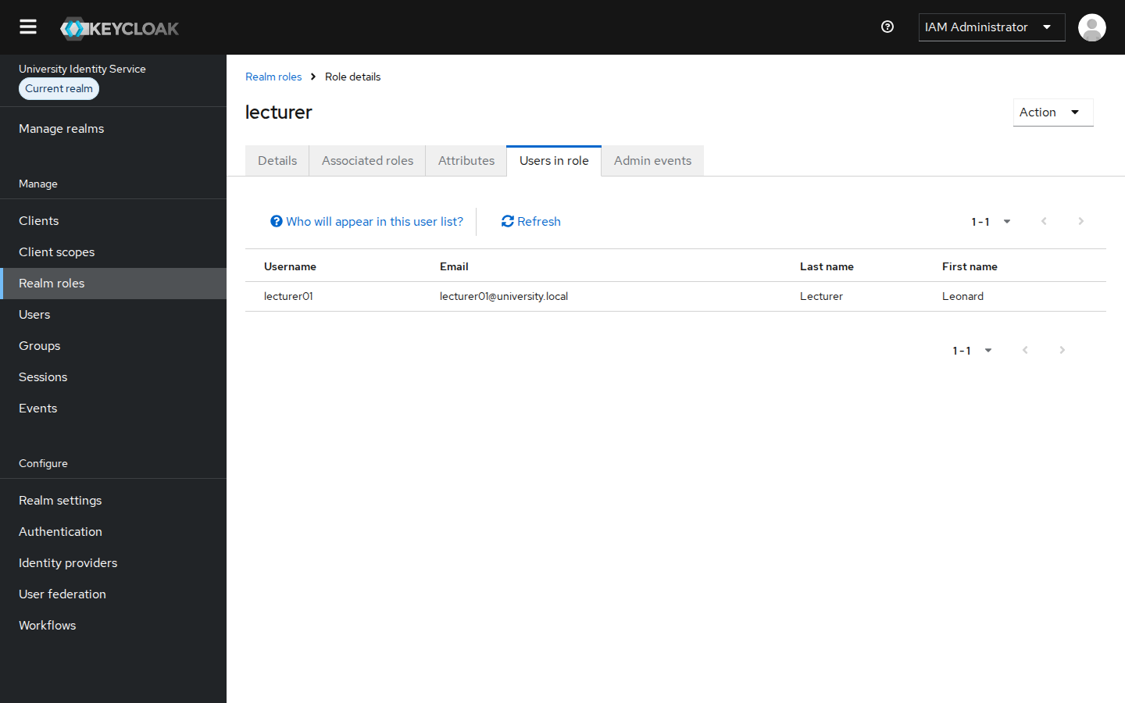
Figure 43: "Users in role" for lecturer: only lecturer01
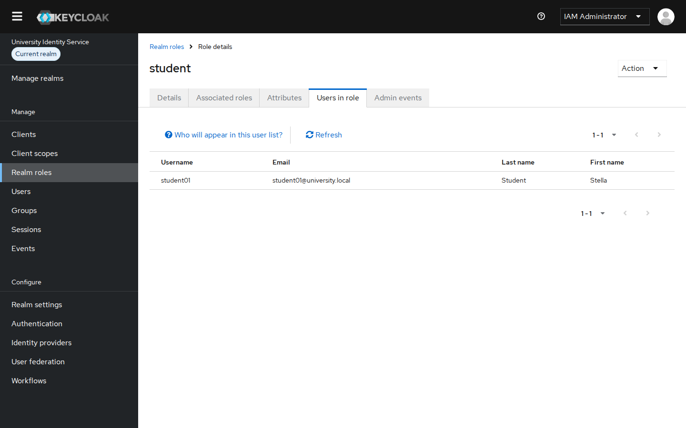
Figure 44: "Users in role" for student: only student01

5.3 How least privilege is applied
- One role per user, no composite roles. A user gets only the permissions their job needs. system-admin is deliberately not a composite of lecturer or student, so the administrator cannot read or change grades (demonstrated in section 5.4).
- Application administrator is not the IdP administrator. admin01 has no realm-management roles, so they cannot create users or change roles in Keycloak. Only iamadmin in the master realm can, which keeps IAM duties separate from application duties.
- Deny by default in the application. Every protected page checks for one specific role. If the role is missing, the application returns HTTP 403.
- Minimal client capabilities. student-portal has only the Standard (authorization code) flow. Implicit flow, direct password grants and service accounts are disabled.
- Short-lived credentials. Access tokens last 5 minutes and sessions expire after 30 idle minutes, so privileges that are removed or disabled take effect quickly.

5.4 Demonstrating different authorization privileges
Each user signed in to the Student Portal. The dashboard shows the roles Keycloak put in the token and which features are allowed. Each user was then sent directly to a page for another role, and the portal refused with 403 Access denied.
Page (required role) | admin01 | lecturer01 | student01
/admin (system-admin) | ALLOWED | DENIED 403 | DENIED
/lecturer/grades (lecturer) | DENIED 403 | ALLOWED | DENIED 403
/student/courses (student) | DENIED | DENIED | ALLOWED
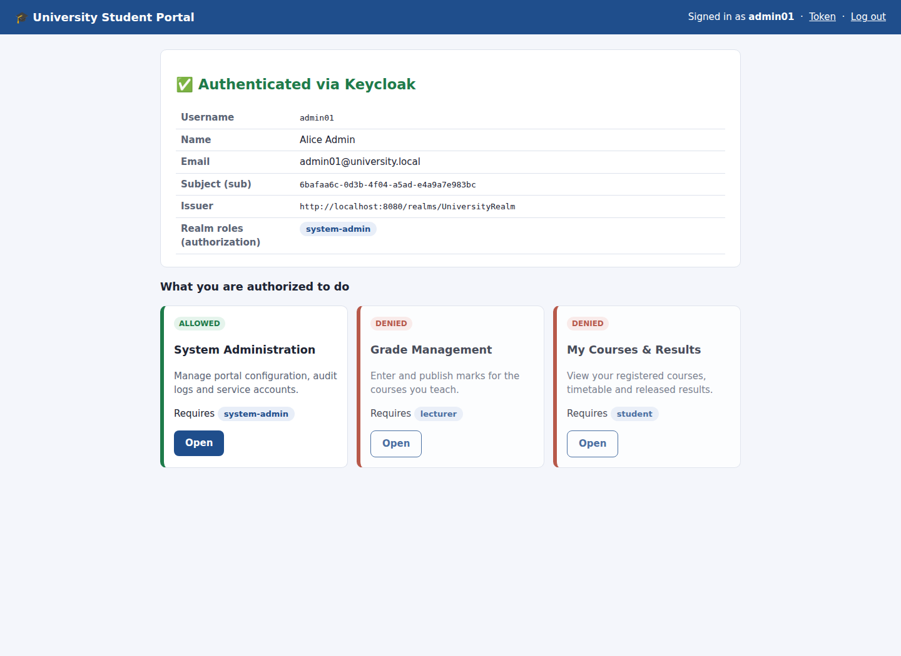
Figure 45: admin01 dashboard: role system-admin, only System Administration allowed
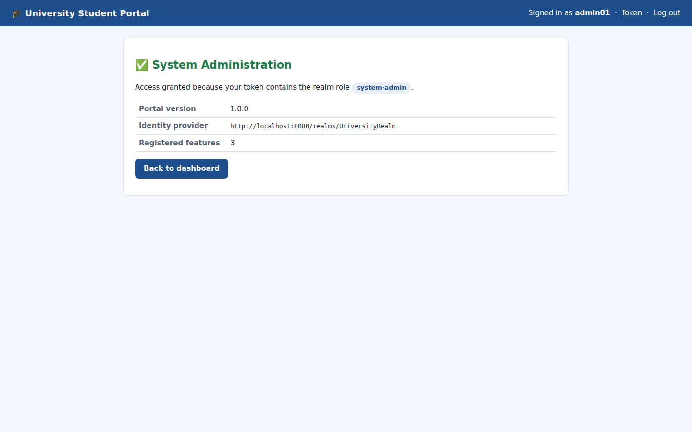
Figure 46: admin01 opens /admin: access granted
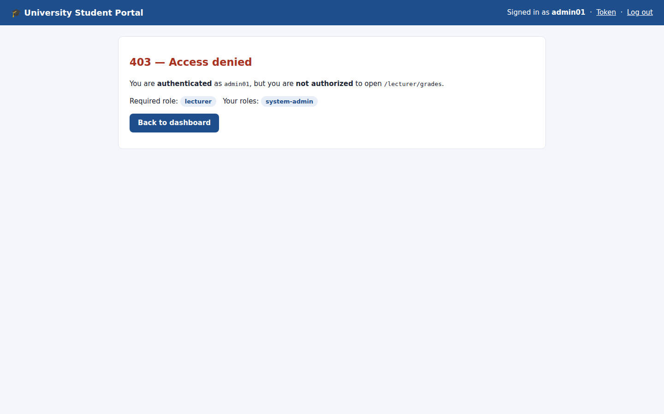
Figure 47: admin01 opens /lecturer/grades: 403, authenticated but not authorized
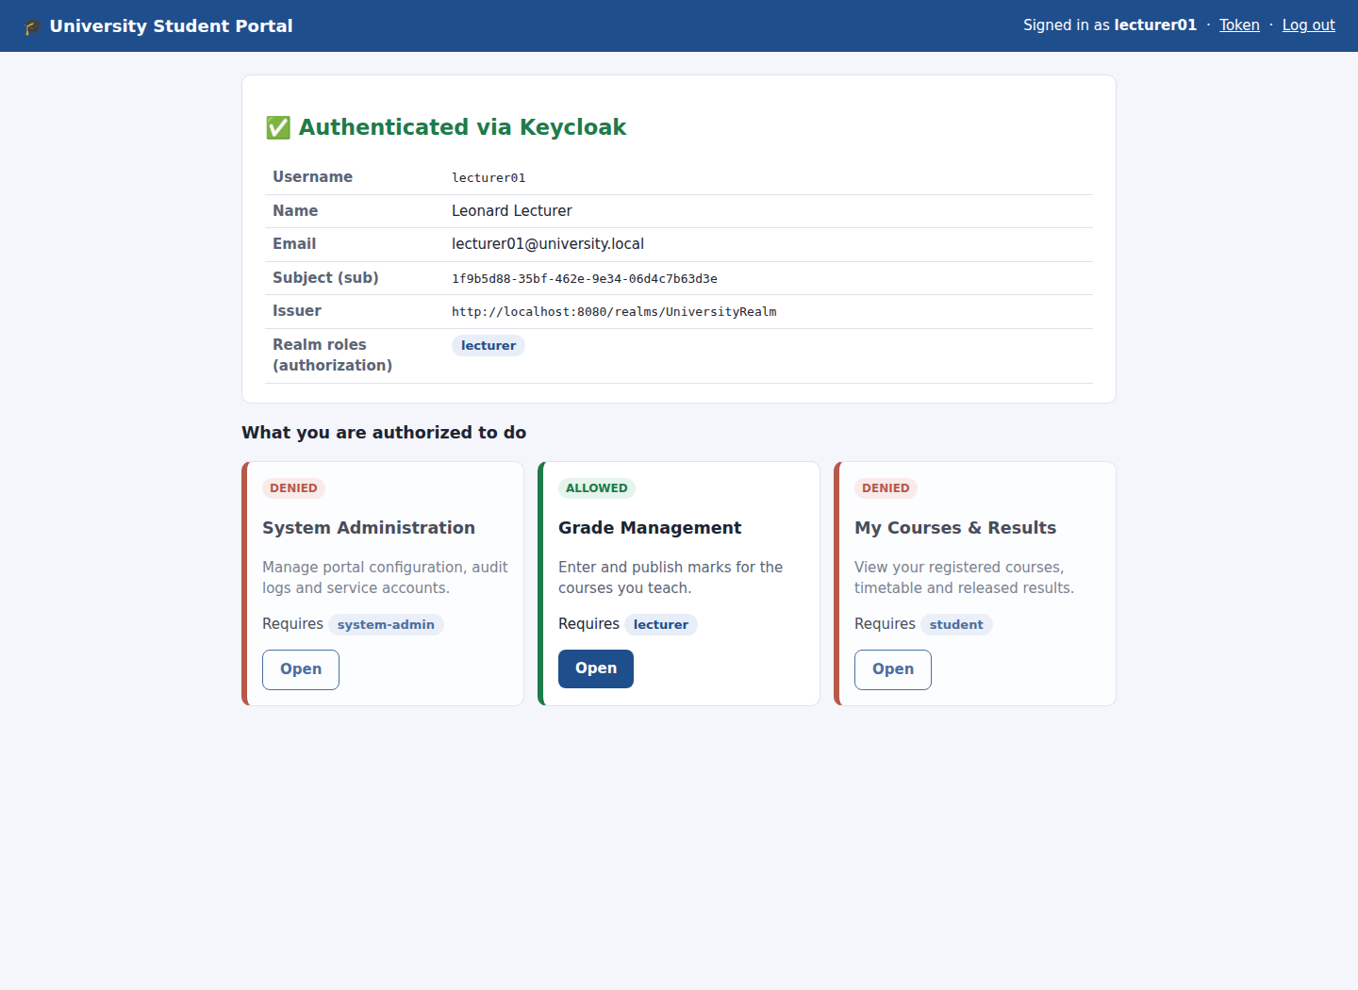
Figure 48: lecturer01 dashboard: role lecturer, only Grade Management allowed
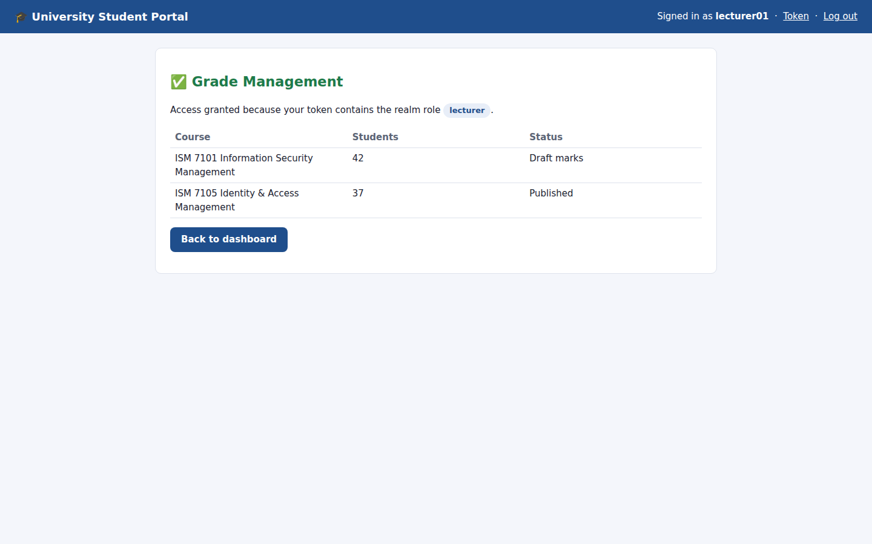
Figure 49: lecturer01 opens /lecturer/grades: access granted
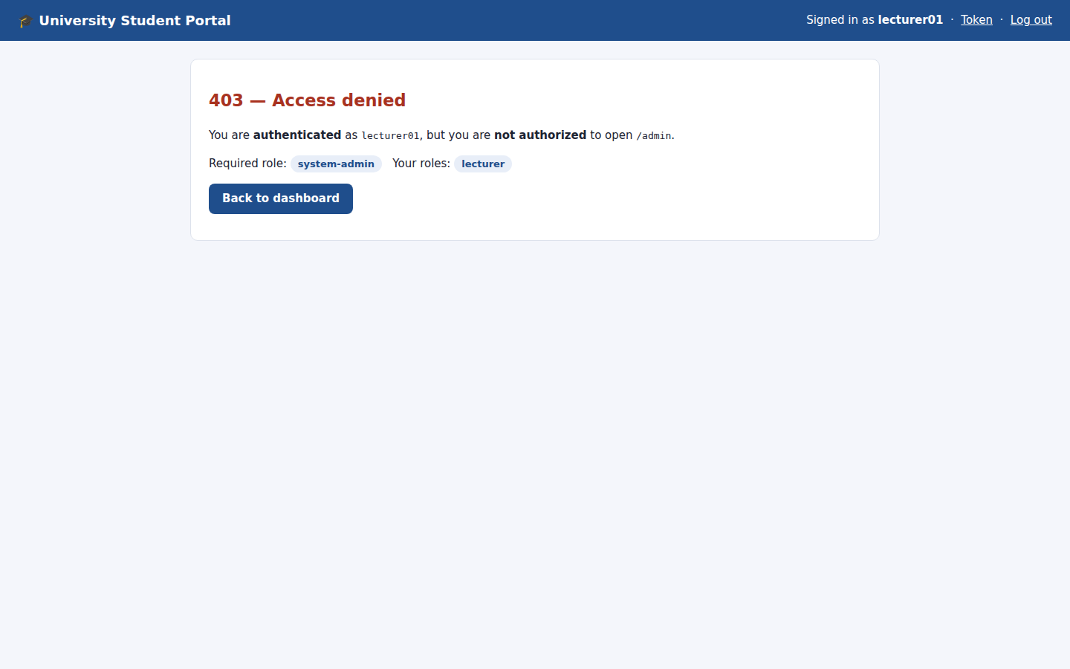
Figure 50: lecturer01 opens /admin: 403 denied
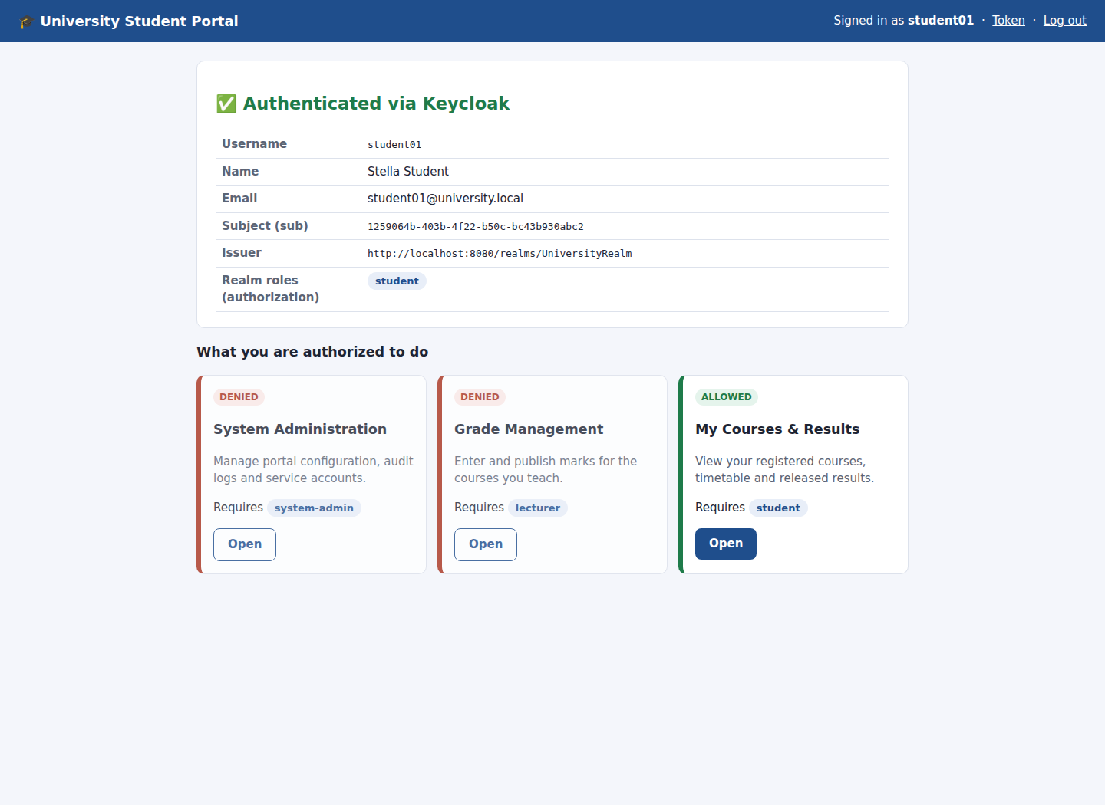
Figure 51: student01 dashboard: role student, only My Courses allowed
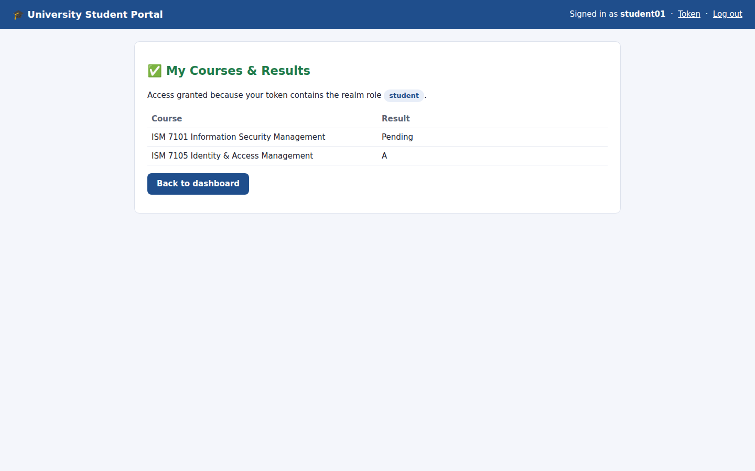
Figure 52: student01 opens /student/courses: access granted
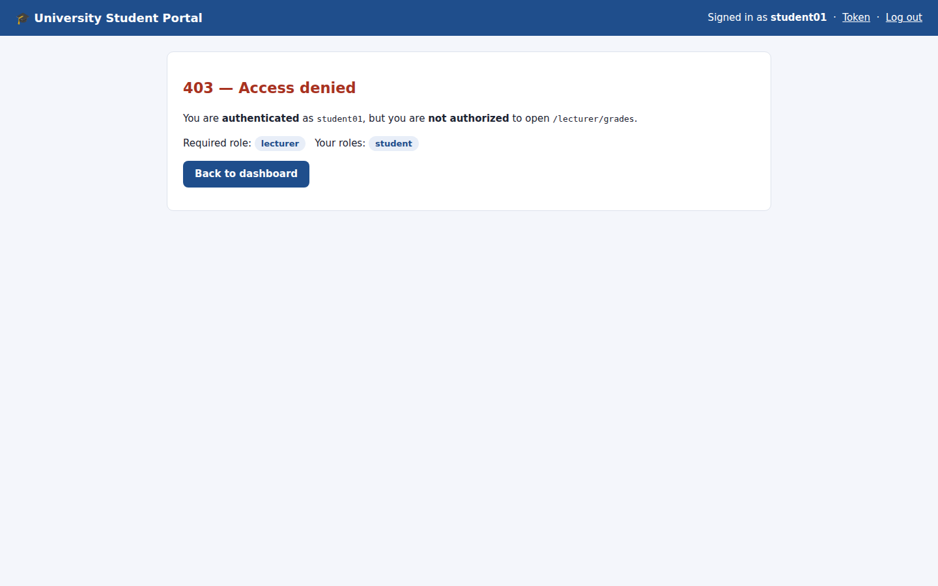
Figure 53: student01 opens /lecturer/grades: 403 denied

6. Client Configuration (Task 4)
A client in Keycloak is an application that delegates login to Keycloak. I created the client under Clients → Create client:
- General settings: Client type OpenID Connect, Client ID student-portal, Name "Student Portal".
- Capability config: Client authentication On (confidential client), Standard flow On; Direct access grants, Implicit flow and Service accounts Off; PKCE required with method S256.
- Login settings: Root URL http://localhost:3000, Home URL /, Valid redirect URIs http://localhost:3000/callback, Valid post-logout redirect URIs http://localhost:3000/, Web origins http://localhost:3000.
- Credentials tab: copy the generated client secret into the application's .env file. The secret is never committed to source control.

6.1 Authentication protocol: OpenID Connect
OIDC is an identity layer on top of OAuth 2.0. After login the application receives a signed ID token (a JWT) that proves who the user is, and an access token that carries the user's roles. I chose the Authorization Code flow with PKCE because it is the current best practice (OAuth 2.0 Security BCP / RFC 9700):
- the browser only ever sees a short-lived, one-time code, never the tokens;
- the code is exchanged server-to-server using the client secret and the PKCE code_verifier, so an intercepted code is useless;
- state protects against CSRF and nonce protects against ID-token replay;
- the application checks the token signature against Keycloak's published JWKS keys.

6.2 Redirect / allowed URLs
Redirect URIs are an exact match with no wildcards. Keycloak will only return an authorization code to http://localhost:3000/callback. This stops an attacker from building a login link that sends the code to their own site (open redirect / code theft). Web origins restricts cross-origin requests to the portal's origin, and the post-logout URI restricts where users land after signing out.
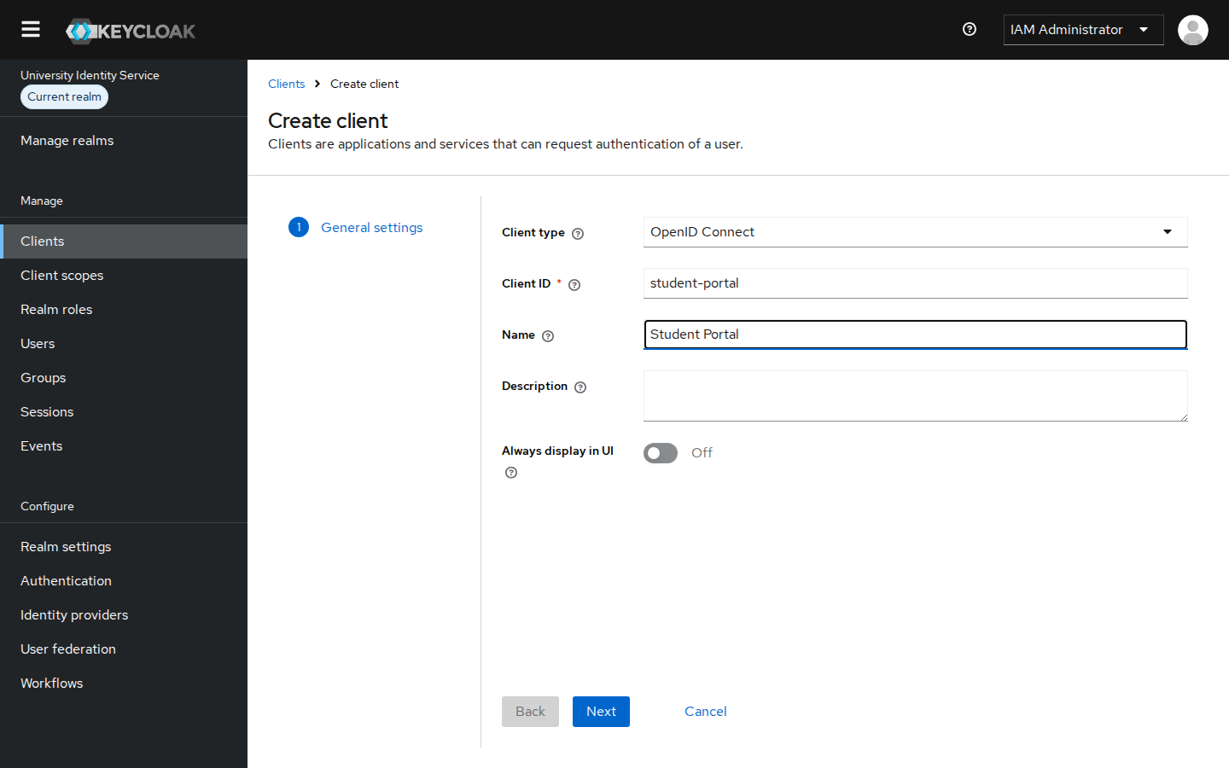
Figure 54: Clients → Create client, step 1: Client type OpenID Connect, Client ID student-portal
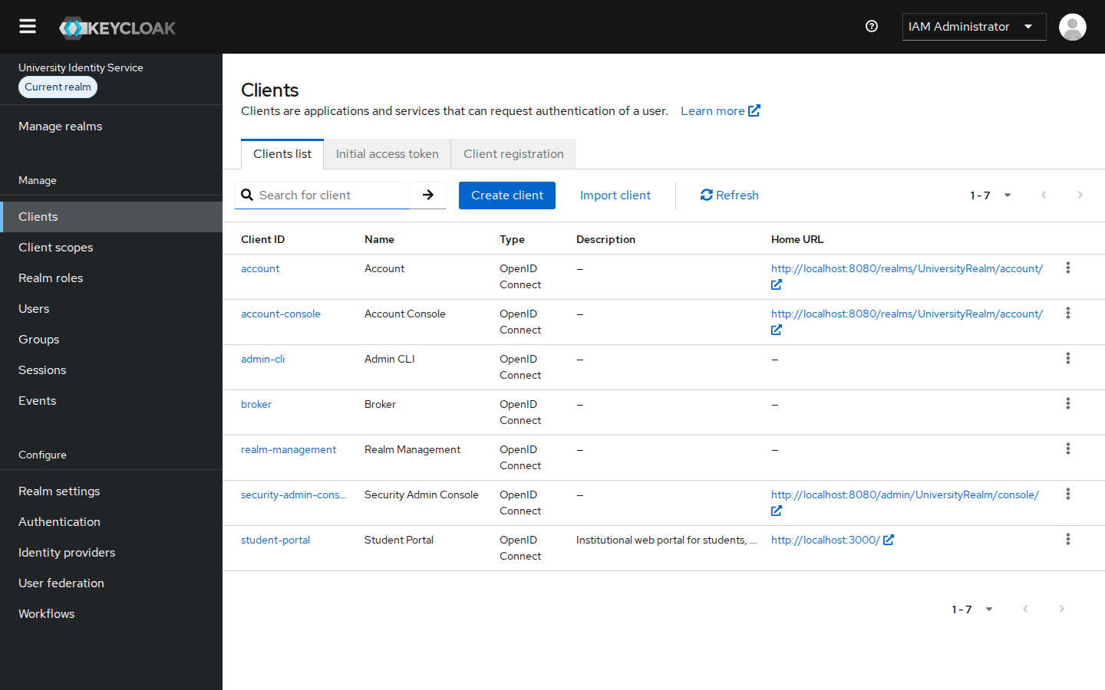
Figure 55: Clients list showing student-portal (OpenID Connect)
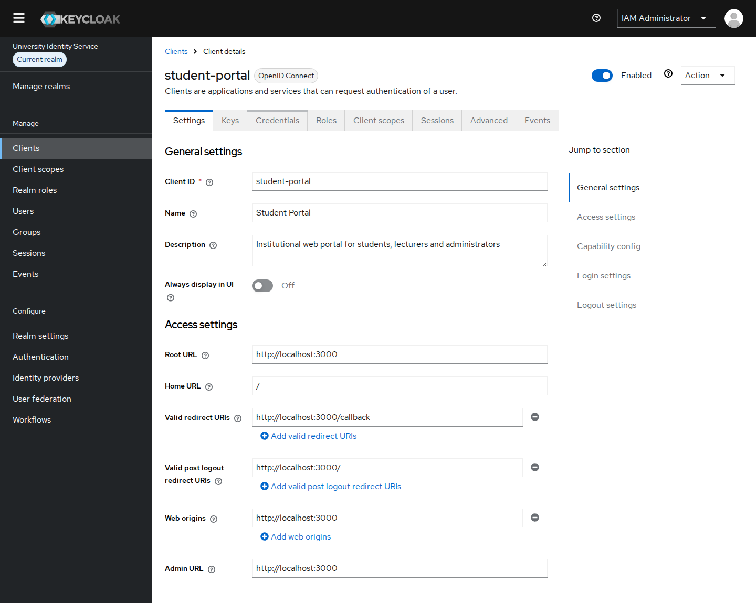
Figure 56: student-portal general and access settings: exact redirect URI, post-logout URI and web origin
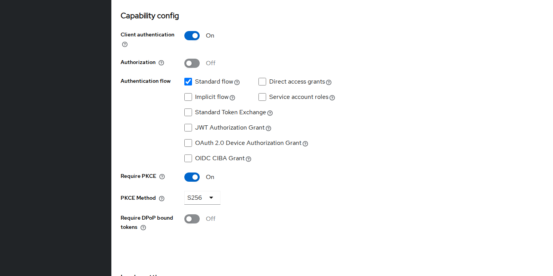
Figure 57: Capability config: client authentication On, Standard flow only, PKCE S256 required
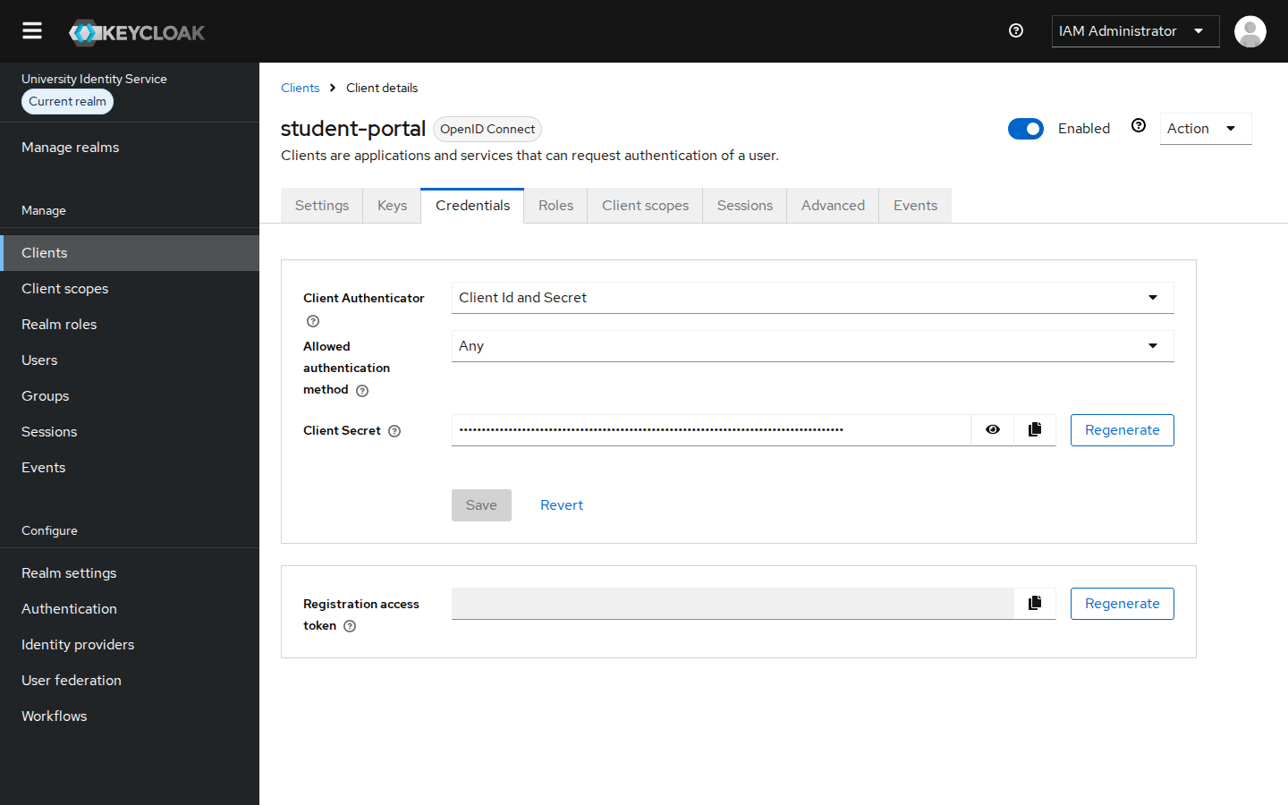
Figure 58: Credentials tab: Client Id and Secret authentication (secret masked)
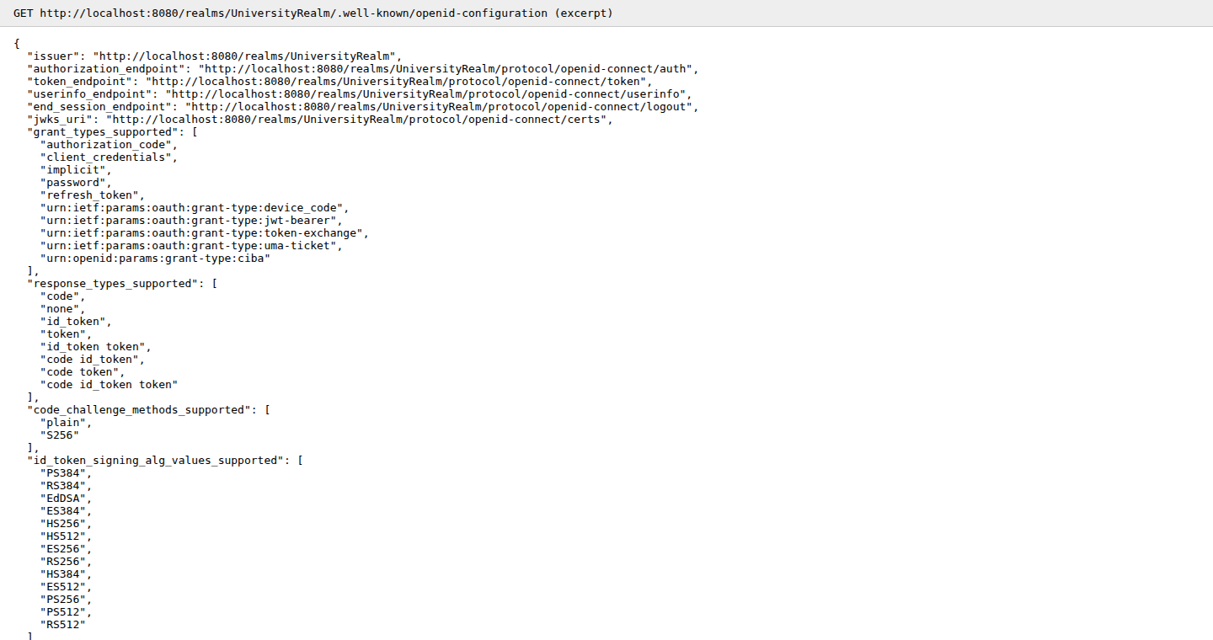
Figure 59: OIDC discovery document of UniversityRealm (issuer, endpoints, PKCE S256 support)

7. Authentication Demonstration (Task 4)
The flow below, User → Application → Keycloak → Login → Authentication → Application Access, was carried out with the Student Portal:
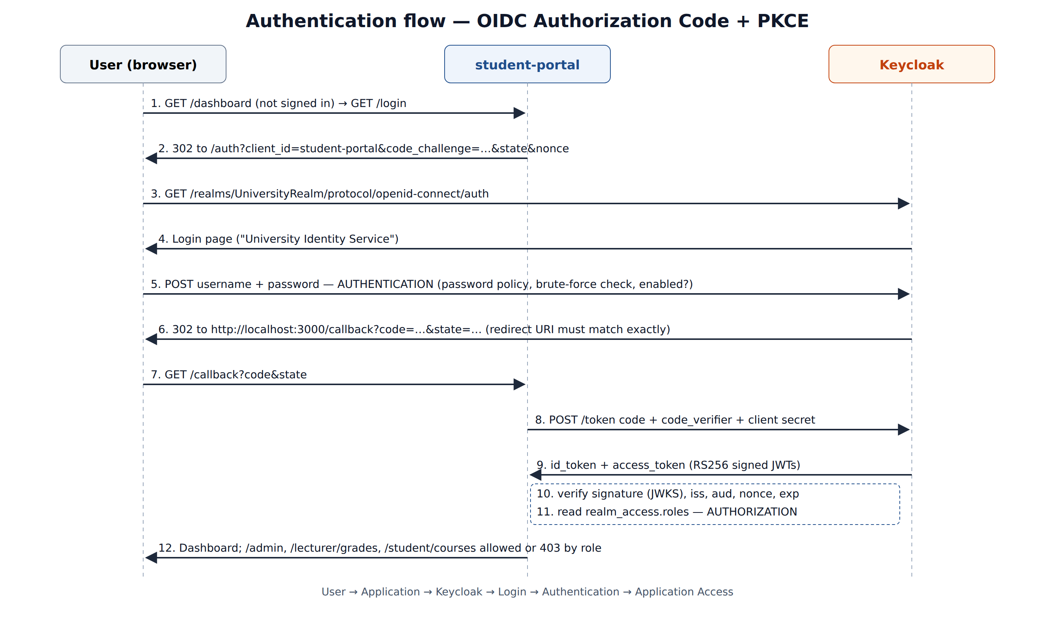
Figure 60: OIDC Authorization Code + PKCE sequence as implemented
- User → Application: the user opens http://localhost:3000 and clicks "Log in with University SSO".
- Application → Keycloak: the portal redirects the browser to the UniversityRealm authorization endpoint with client_id, redirect_uri, PKCE code_challenge, state and nonce.
- Login: Keycloak shows its own login page, branded "University Identity Service". The password is typed only into Keycloak.
- Authentication: Keycloak checks the password hash, whether the account is enabled, and the brute-force counters. It then sends the browser back to /callback with a one-time code.
- Token exchange: the portal swaps the code, client secret and code_verifier for signed ID and access tokens, and validates the ID token.
- Application access: the portal creates its session and shows the dashboard with the user's identity and roles.
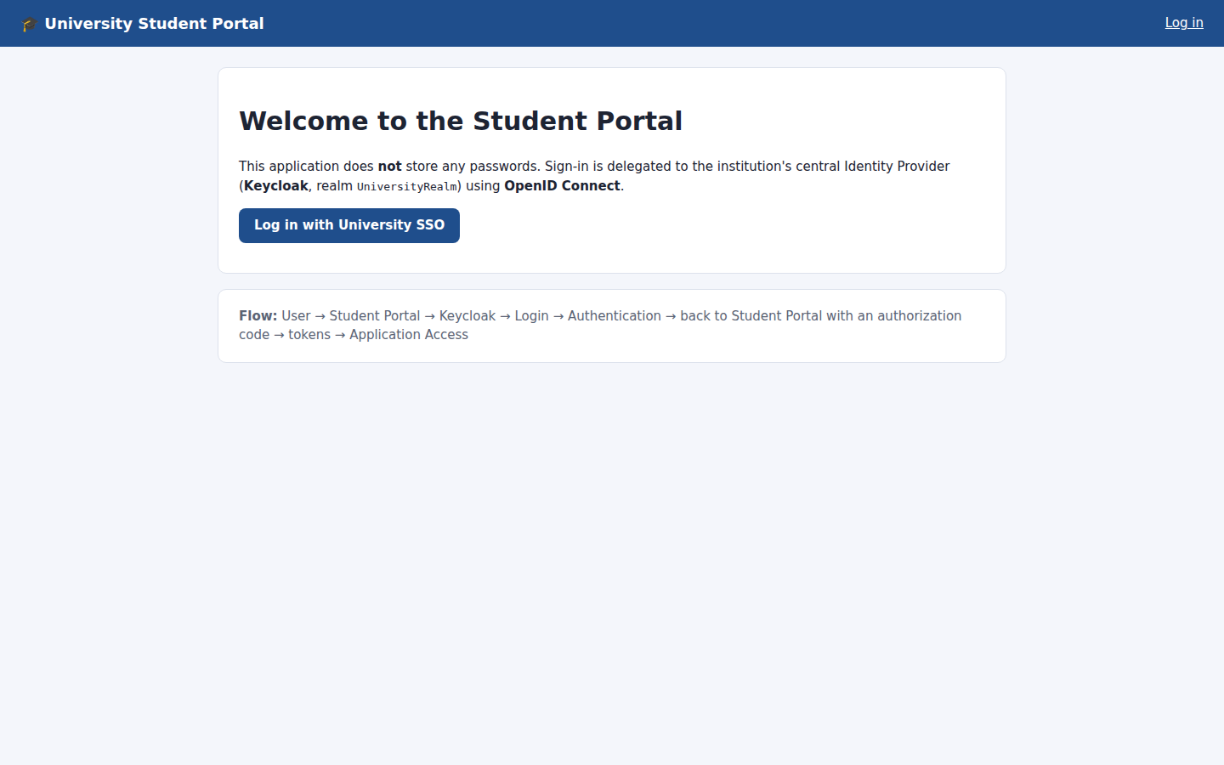
Figure 61: Step 1: Student Portal landing page (not signed in)
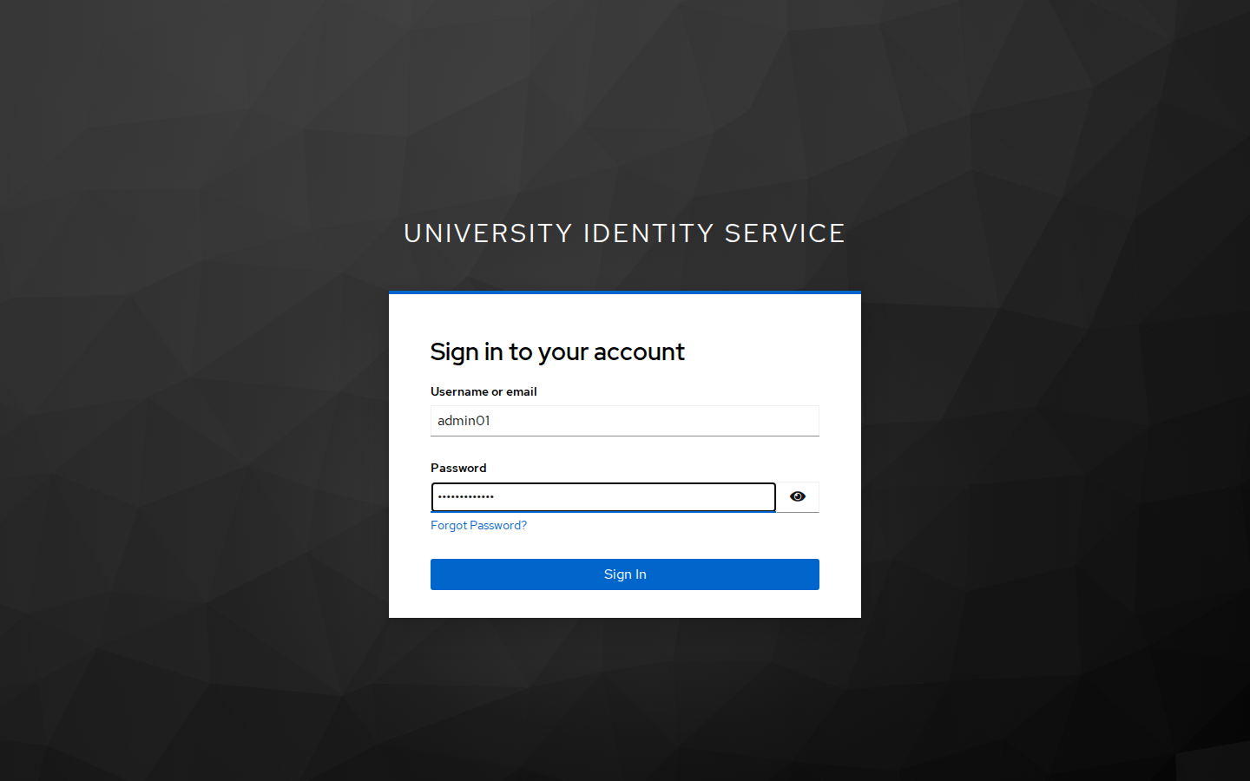
Figure 62: Step 3: redirected to the Keycloak login page for UniversityRealm
Figure 63: Step 6: successful authentication, identity claims issued by Keycloak shown in the application
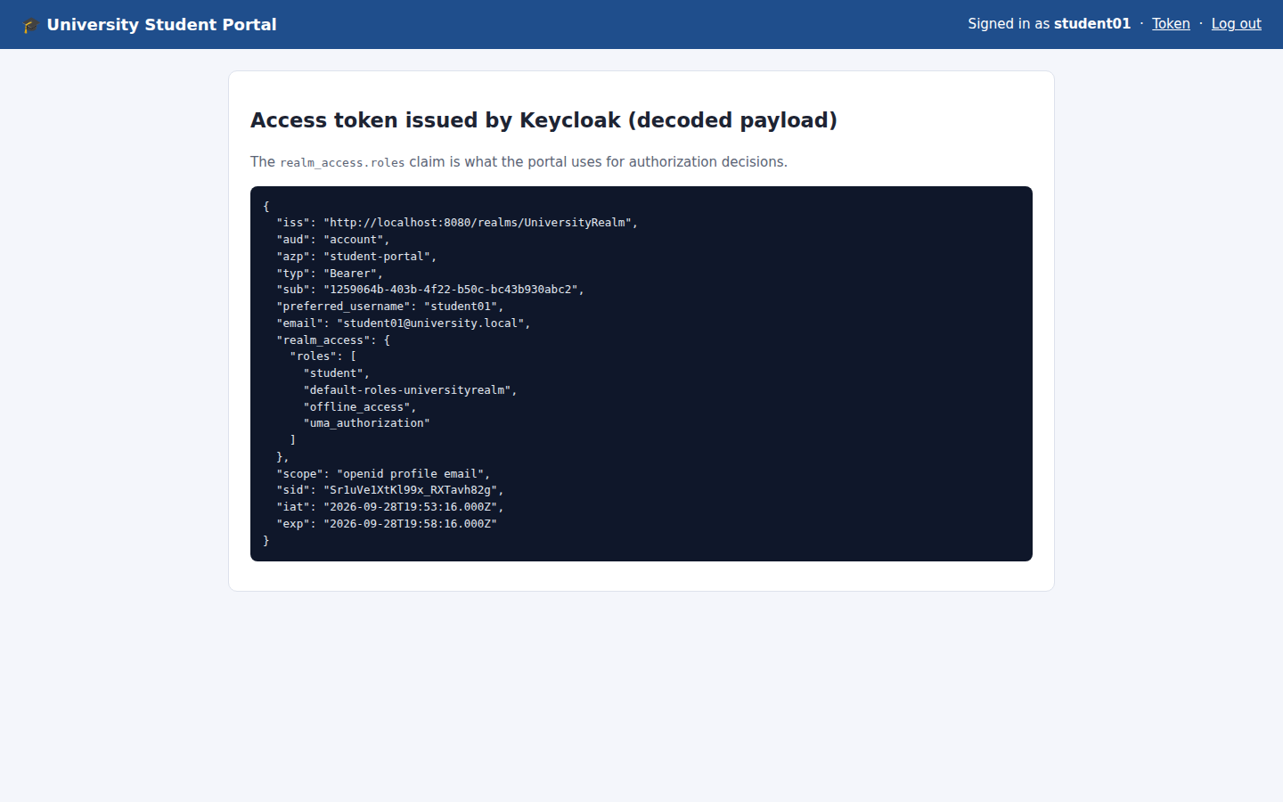
Figure 64: Decoded access token: issuer UniversityRealm, azp student-portal, realm_access.roles = [student, …]
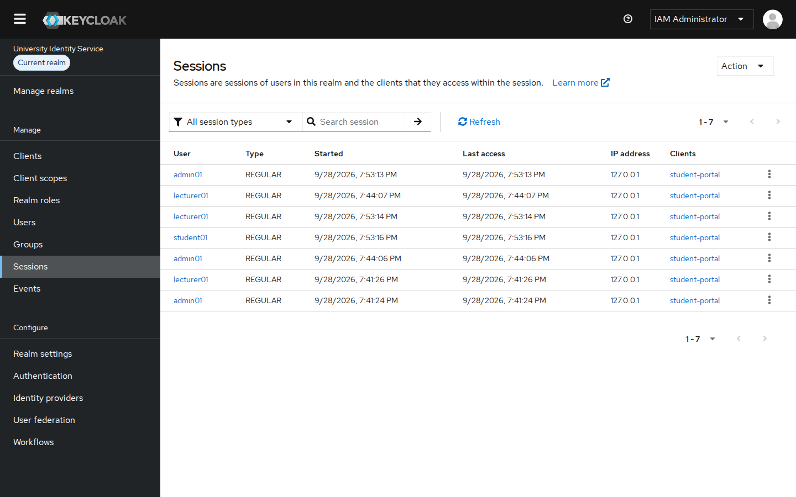
Figure 65: Keycloak Sessions: active SSO sessions of the three users for student-portal
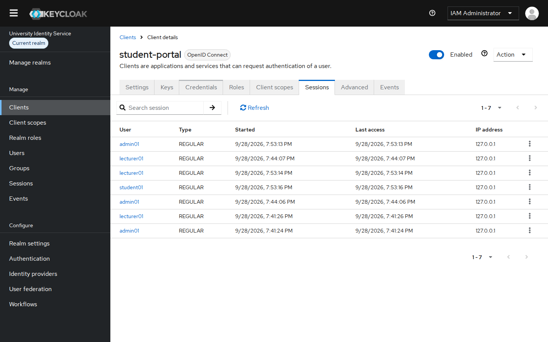
Figure 66: Client → Sessions for student-portal
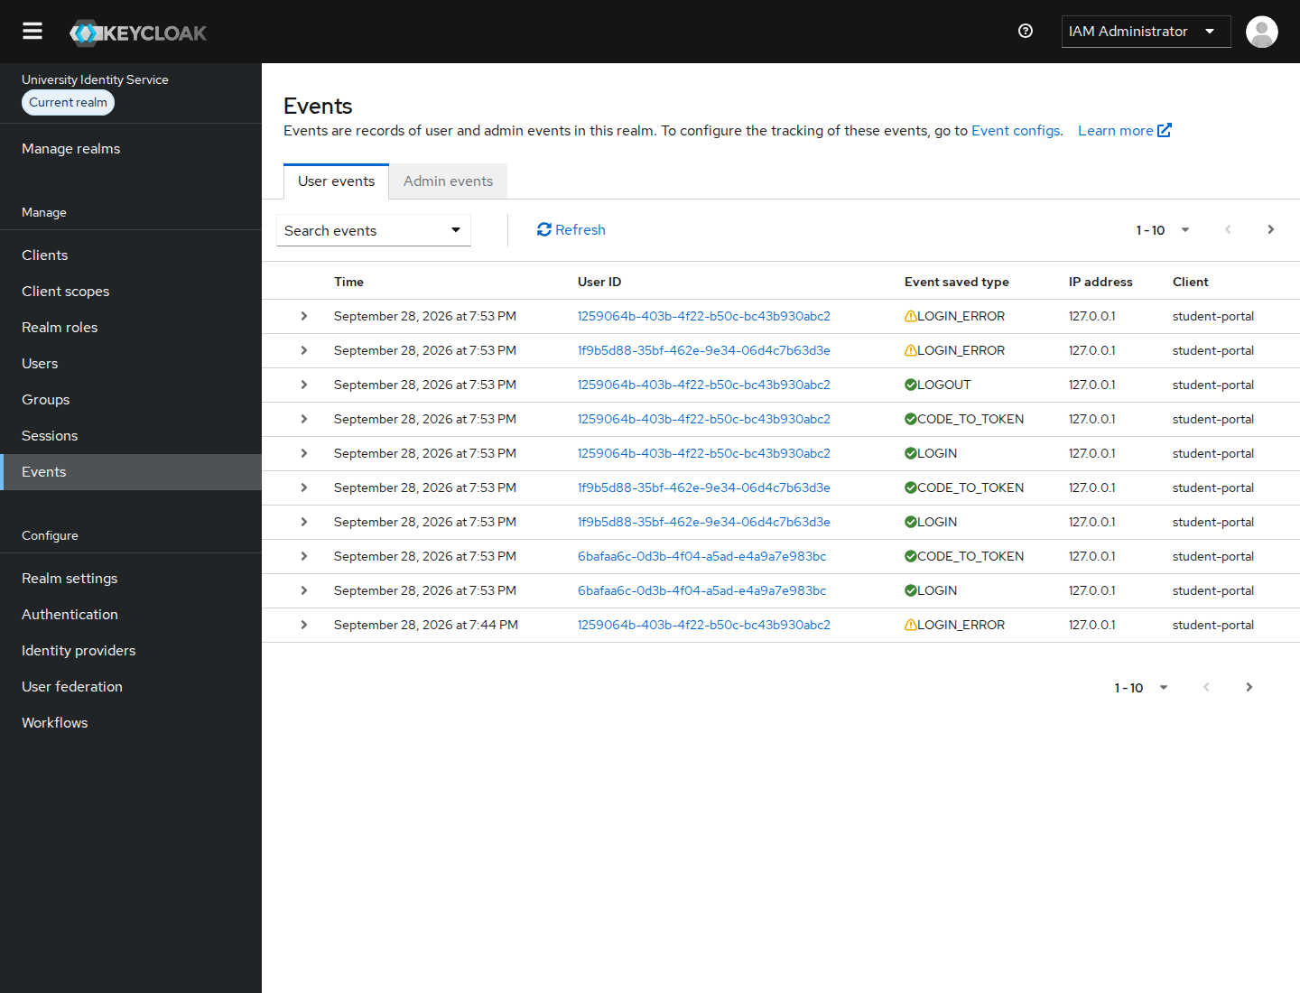
Figure 67: Realm Events: LOGIN, CODE_TO_TOKEN, LOGOUT and LOGIN_ERROR (wrong password, disabled user) recorded

Negative tests
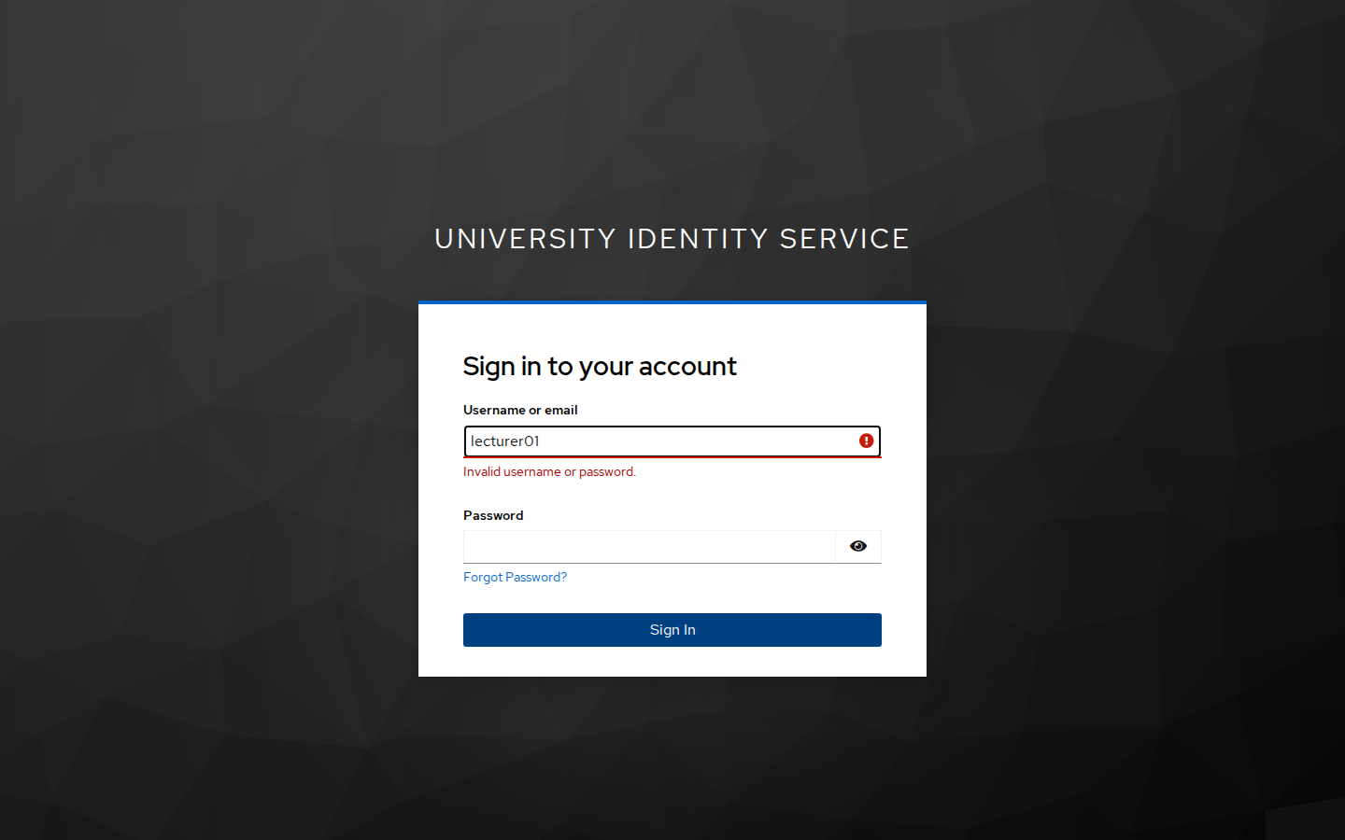
Figure 68: Wrong password: "Invalid username or password." (counted by brute-force detection)
Figure 69: After logout: the portal session and the Keycloak SSO session are ended (RP-initiated logout)

7.3 Authentication vs authorization in this implementation
 | Authentication | Authorization
Question answered | Who are you? | What are you allowed to do?
Performed by | Keycloak (UniversityRealm) | Student Portal (requireRole) using roles issued by Keycloak
Inputs | Username + password, account enabled, brute-force state | realm_access.roles claim in the access token
Output | Signed ID token (sub, preferred_username, email) | Allow the page, or HTTP 403 Access denied
Failure example | Wrong password / disabled account: Keycloak refuses login (Fig. 68, Fig. 21) | student01 is logged in but gets 403 on /lecturer/grades (Fig. 53)
Put simply: authentication proves identity once, at Keycloak. Authorization is checked on every request, in the application, using roles managed centrally in Keycloak. A user can be fully authenticated and still not be authorized, as the 403 pages show.

8. IAM Architecture Diagram (Task 5A)
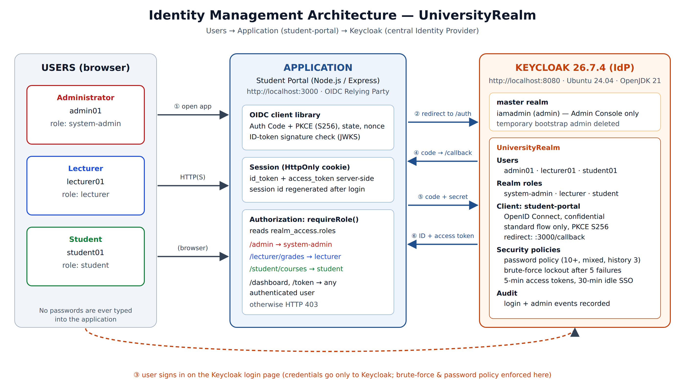
Figure 70: Identity Management Architecture: Users → Application (student-portal) → Keycloak (UniversityRealm)
- Users (Administrator, Lecturer, Student) use only a web browser. Their credentials go only to Keycloak.
- Application (student-portal) is an OIDC Relying Party. It redirects users for login, receives tokens over a back channel, and enforces role-based authorization per page.
- Keycloak is the central Identity Provider. The master realm is for administering Keycloak. UniversityRealm holds the users, roles, client, security policies and audit events.

9. Security Analysis (Task 5B)

Risk 1: Weak, reused or stolen passwords (credential compromise)
Risk. When every application manages its own passwords, users reuse weak passwords across systems. A leak in one system allows credential-stuffing and brute-force attacks on the others. Passwords typed into many applications can also be logged or stolen by any one of them.
How Keycloak mitigates it (as configured):
- Single sign-on: the password is entered only on Keycloak's login page. The portal never receives or stores it.
- Password policy: at least 10 characters with mixed classes, must not equal the username, and history of 3. Passwords are stored as salted hashes.
- Brute-force detection: after 5 failures the account is temporarily locked, with the wait growing to 15 minutes. Failures are recorded as LOGIN_ERROR events.
- Keycloak can require MFA (OTP or WebAuthn) and supports passkeys, so a stolen password alone is not enough (see Recommendation 1).

Risk 2: Excessive privileges and orphaned accounts (privilege creep)
Risk. Without central control, people pick up permissions as they change roles, and accounts of leavers stay active in some systems. An attacker or a former insider can then reach grades, personal data or admin functions they should not have. This is a common cause of data breaches and audit findings.
How Keycloak mitigates it (as configured):
- Central RBAC: roles are defined once in UniversityRealm and each user has exactly one role. "Users in role" gives an instant access review.
- One switch to revoke: disabling an account in Keycloak blocks login to every connected application at once (Fig. 21). Short token lifetimes make the change take effect within minutes.
- Separation of duties: the application administrator (admin01) cannot administer the IdP.
- Audit trail: login and admin events record who did what and when, for accountability and investigations.

10. Recommendations (Task 5C)

Recommendation 1: Enforce Multi-Factor Authentication (MFA), starting with privileged roles
Turn on OTP (authenticator app) or WebAuthn/passkeys in UniversityRealm. Make it mandatory for system-admin and lecturer using a conditional authentication flow based on role, and optional for students. Also require MFA for the master-realm iamadmin account. MFA stops most credential-stuffing and phishing attacks that a password policy alone cannot. Roll it out in stages: staff first, with communication and helpdesk procedures for lost devices (recovery codes).

Recommendation 2: Harden the production deployment and connect Keycloak to the authoritative directory
- Run Keycloak in production mode (kc.sh start) behind HTTPS with a valid TLS certificate. Set sslRequired=all, use a proper hostname, and use a PostgreSQL database with backups instead of the dev-mode H2 database. Use at least two nodes for availability.
- Move the User Federation proven in section 4.2 onto the university's production Active Directory over LDAPS, with a least-privilege, read-only bind account. Accounts are then created and disabled automatically from HR and admissions records (joiner/mover/leaver), which removes orphaned accounts.
- Send Keycloak login and admin events to the university SIEM, alert on repeated LOGIN_ERROR events and lockouts, and run quarterly access reviews of role membership.
- Rotate client secrets regularly, or move confidential clients to private_key_jwt. Keep Keycloak patched against published CVEs.

11. Conclusion
Keycloak 26.7.4 was installed and made the university's central Identity Provider. A dedicated realm, UniversityRealm, holds three users with full attributes. Each user has one of three realm roles, following least privilege. The student-portal application was registered as a confidential OpenID Connect client using the Authorization Code flow with PKCE and strict redirect URIs.
The demonstration showed the complete flow, User → Application → Keycloak → Login → Authentication → Application Access. It also showed the difference between authentication and authorization: every user signed in successfully, but each could only open the part of the portal their role allows. Disabling an account blocked access immediately, and failed logins were recorded and rate-limited.
Centralising identity in Keycloak gives the institution one place to manage, audit and revoke access. Adding MFA, production hardening and directory federation would make this lab setup ready for production.

12. References
- Keycloak Project (2026). Keycloak Server Administration Guide. https://www.keycloak.org/docs/latest/server_admin/
- Keycloak Project (2026). Getting started: OpenJDK / bare metal, and Configuring Keycloak for production. https://www.keycloak.org/guides
- Keycloak Project (2026). Securing Applications and Services Guide (OIDC clients). https://www.keycloak.org/docs/latest/securing_apps/
- Sakimura, N. et al. (2014). OpenID Connect Core 1.0. OpenID Foundation. https://openid.net/specs/openid-connect-core-1_0.html
- Hardt, D. (2012). RFC 6749: The OAuth 2.0 Authorization Framework. IETF.
- Sakimura, N., Bradley, J. and Agarwal, N. (2015). RFC 7636: Proof Key for Code Exchange (PKCE). IETF.
- Lodderstedt, T. et al. (2025). RFC 9700: Best Current Practice for OAuth 2.0 Security. IETF.
- Grassi, P. A. et al. (2017, rev.). NIST SP 800-63B: Digital Identity Guidelines, Authentication and Lifecycle Management. NIST.
- NIST (2020). SP 800-53 Rev. 5: Security and Privacy Controls, AC-2 Account Management, AC-6 Least Privilege. NIST.
- OWASP Foundation (2021). OWASP Top 10: A01 Broken Access Control; A07 Identification and Authentication Failures.

Appendix A: Reproducing the Configuration
The whole lab can be rebuilt from the project folder ISM-Keycloak-Assignment/:
# 1. start Keycloak (see section 2.2)
KC_BOOTSTRAP_ADMIN_USERNAME=temp-admin KC_BOOTSTRAP_ADMIN_PASSWORD=TempAdmin#2026 \
$KC_HOME/bin/kc.sh start-dev --http-port=8080

# 2. create iamadmin, UniversityRealm, roles, users, client (idempotent)
KC_HOME=/opt/keycloak-26.7.4 ./keycloak/setup-realm.sh

# 2b. optional: OpenLDAP directory + user federation (section 4.2)
sudo apt install slapd ldap-utils # domain university.local
./ldap/setup-ldap.sh && KC_HOME=/opt/keycloak-26.7.4 ./keycloak/setup-ldap-federation.sh

# 3. run the test application
cd student-portal && cp .env.example .env # paste client secret
npm install && npm start # http://localhost:3000
keycloak/UniversityRealm-realm-export.json contains a partial export of the realm (roles, client and policies, with secrets masked). It can be imported through Manage realms → Create realm → Resource file.

Appendix B: Marking-scheme cross-reference
Requirement | Marks | Evidence
Install & start; admin account | 2 | §2.2, Figs. 2–6
Version, OS, environment | 1 | §2.1, Fig. 1, Fig. 4
Screenshots of installation / console | 2 | Figs. 1–6
Create realm | 2 | §3.1, Figs. 8–9
Create three users | 3 | §4, Figs. 13–16
User attributes incl. password | 1 | §4 table, Figs. 14–17
Enable/disable + when | 1 | §4.1, Figs. 18–22
Screenshots realm & users | 1 | Figs. 8–22
Create three roles | 3 | §5.1, Figs. 35–38
Assign roles | 2 | §5.2, Figs. 39–44
Least privilege explained | 1 | §5.3
Different privileges demonstrated | 2 | §5.4, Figs. 45–53
Create client | 3 | §6, Fig. 55
OIDC protocol configured | 3 | §6.1, Figs. 57–59
Redirect / allowed URLs | 2 | §6.2, Fig. 56
Authentication demonstrated | 3 | §7, Figs. 60–69
Authentication vs authorization | 2 | §7.3
Architecture diagram | 2 | §8, Fig. 70
Two risks + mitigation | 2 | §9
Two recommendations | 2 | §10
Evidence: LDAP/AD configuration | – | §4.2, Figs. 23–33

