## **Install Nginx for Raspbian**

Assume Raspbian has been installed and configured using sudo rasp-config

1. Install Nginx: sudo sudo apt install nginx
2. Check Nginx version : $ nginx -v => nginx/1.14.2
3. $ sudo systemctl start nginx
4. Find out your Pi ip address: $ifconfig use the ip in your browser e.g., 192.1680.25 you can see “Welcome to nginx” page.

# Securing your Raspberry Pi

[Securing your Raspberry Pi - Raspberry Pi Documentation](https://www.raspberrypi.org/documentation/configuration/security.md)

1. Change your default password for user pi immediately

Sudo raspi-config

1. To add a new user: sudo adduser winter
2. To add user to the sudo group to give them sudo permissions as well as all of the other necessary permissions:

sudo usermod -a -G adm,dialout,cdrom,sudo,audio,video,plugdev, games,users,input,netdev,gpio,i2c,spi winter

1. Check if winter can use sudo: sudo su – winter
2. After the new sudo user created, you can delete the “pi” user:

* Sudo pkill -u pi - first close all processes by pi
* Sudo deluser pi - it only deletes user, but will leave /home/pi
* Sudo delused -remove-home pi

## **Ensure you have the latest security fixes**

Sudo apt install openssh-server - install the latest version

Install UFW

1. Sudo apt install ufw
2. Sudo ufw enable or sudo ufw disable
3. Sudo ufw allow 22/tcp
4. Sudo ufw allow 80/tcp
5. Sudo ufw allow 81/tcp
6. Sudo ufw allow 443/tcp
7. Sudo ufw status or sudo ufw status verbose
8. Sudo ufw status numbered

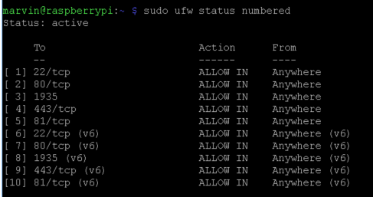

1. Sudo ufw delete [NUM]