In this task, you are required to write captions, and a caption is used to describe an image pair*. For each annotation instance, you will see 4 pairs of images, and you are supposed to write a caption **(in Turkish)** that is True for two pairs but False for each of the other two pairs.

* one image pair has two images in parallel: 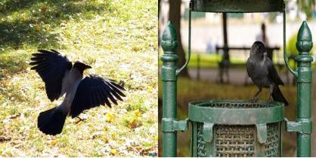

Below, we show you 5 concrete examples along with some tips. **Please spend sufficient time understanding the task.** And **it’s important to follow the tips as you are paid based on the number of qualified captions!** You will receive 0.6 GBP for each valid caption.

------------------------------------------------------------------------------------------------

Example 1:

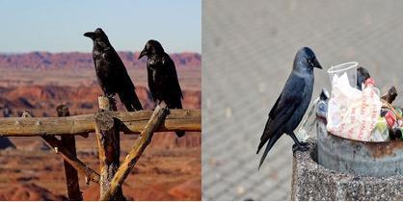 

./zh_images/2-crow/pair-1-b-2-8-2-9.jpg ./zh_images/2-crow/pair-1-a-2-6-2-5.jpg

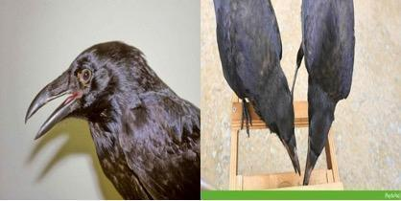 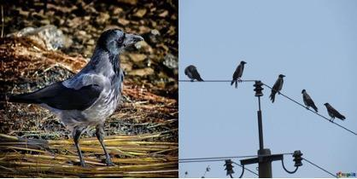

./zh_images/2-crow/pair-1-c-2-11-2-4.jpg ./zh_images/2-crow/pair-1-d-2-10-2-7.jpg

Caption: One of the images has exactly one crow while the other image has exactly two.

True pair1: ./zh_images/2-crow/pair-1-b-2-8-2-9.jpg

True pair2: ./zh_images/2-crow/pair-1-c-2-11-2-4.jpg

The caption is True for the upper-left and bottom-left pairs but False for the other two pairs. You should copy-paste the ids of the two True pairs to “True pair1” and “True pair2”.

------------------------------------------------------------------------------------------------

Example 2:

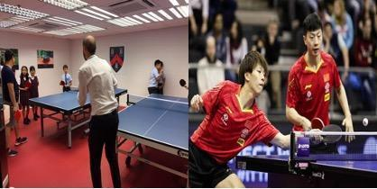 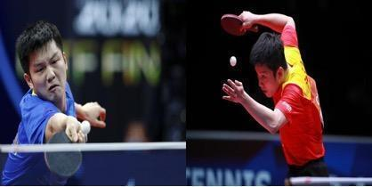

./zh_images/27-pingpong/pair-1-c-27-1-27-8.jpg ./zh_images/27-pingpong/pair-1-b-27-7-27-5.jpg

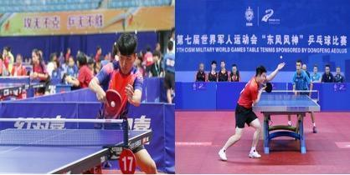 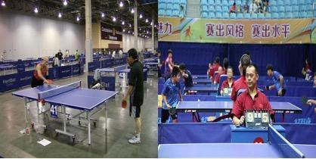

./zh_images/27-pingpong/pair-1-d-27-2-27-6.jpg ./zh_images/27-pingpong/pair-1-a-27-3-27-4.jpg

Caption: The man in the right image is serving a ball while the man in the left image is catching a ball.

True pair1: ./zh_images/27-pingpong/pair-1-b-27-7-27-5.jpg

True pair2: ./zh_images/27-pingpong/pair-1-d-27-2-27-6.jpg

Describe both images in a pair, if possible (but not required).

--------------------------------------------------------------------------------------------------

Example 3:

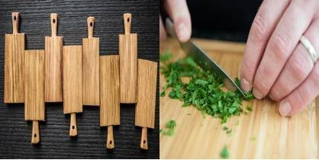 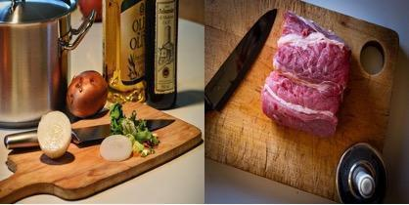

./zh_images/39-chopping_board/pair-1-c-39-4-39-7.jpg ./zh_images/39-chopping_board/pair-1-b-39-9-39-17.jpg

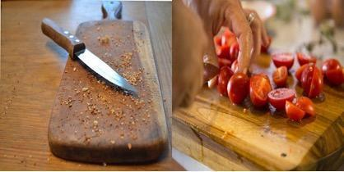 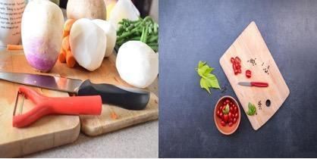

./zh_images/39-chopping_board/pair-1-a-39-1-39-8.jpg ./zh_images/39-chopping_board/pair-1-d-39-15-39-16.jpg

Caption: A knife and some food are sitting on the chopping board in both images.

True pair1: ./zh_images/39-chopping_board/pair-1-b-39-9-39-17.jpg

True pair2: ./zh_images/39-chopping_board/pair-1-d-39-15-39-16.jpg

The theme of the images can be seen in the ids( “chopping_board”, in this case) . Try to center your captions around the theme concepts if possible.

--------------------------------------------------------------------------------------------------

Example 4:  
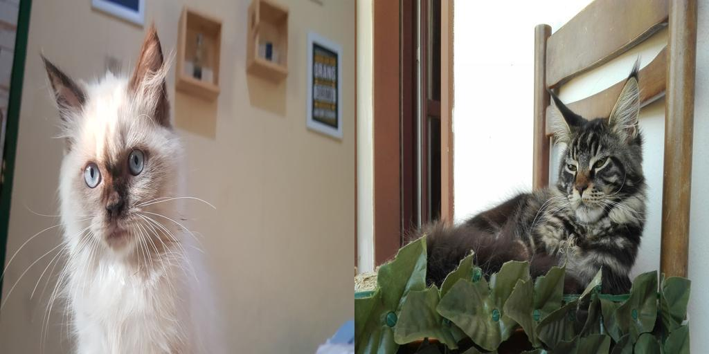 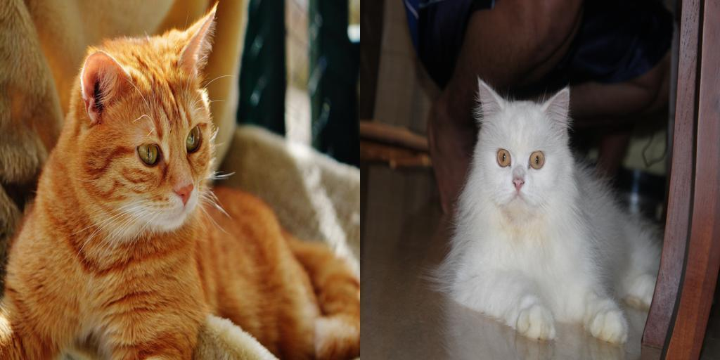  
./id_images/6-cat/pair-1-b-6-10-6-9.jpg ./id_images/6-cat/pair-1-d-6-1-6-5.jpg  
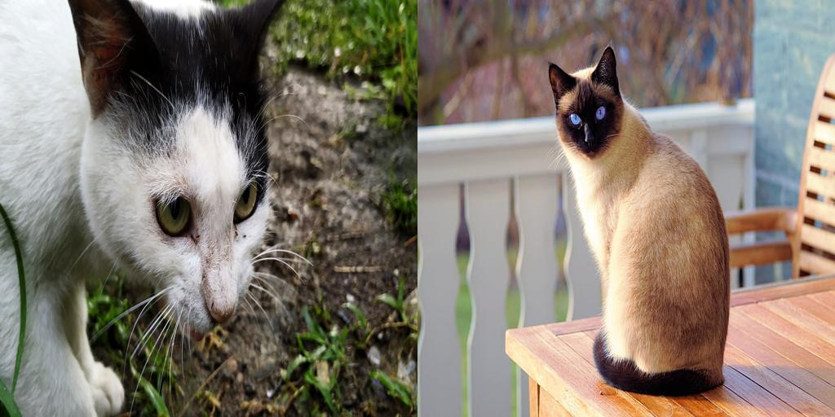 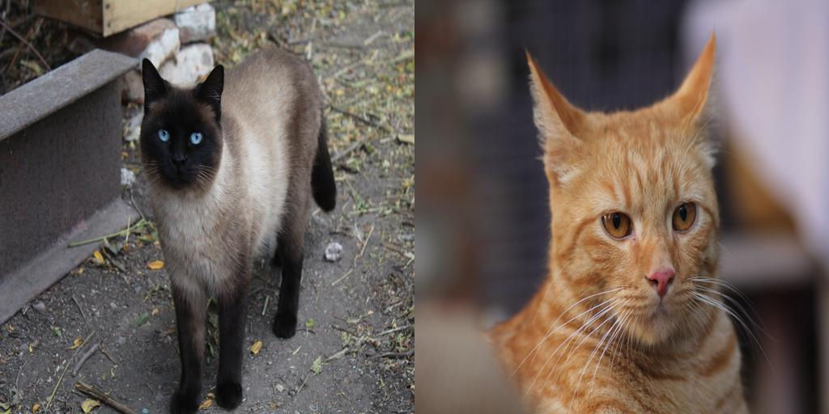  
./id_images/6-cat/pair-1-a-6-2-6-4.jpg ./id_images/6-cat/pair-1-c-6-7-6-3.jpg  
Caption: In the right image, a cat is sitting on a chair..  
True pair1: ./id_images/6-cat/pair-1-b-6-10-6-9.jpg  
True pair2: ./id_images/6-cat/pair-1-a-6-2-6-4.jpg

--------------------------------------------------------------------------------------------------

Example 5:

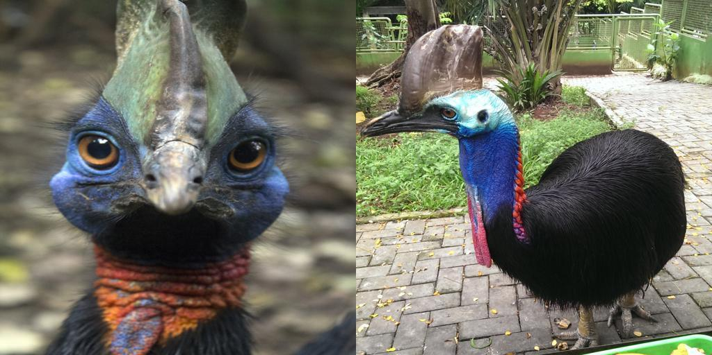 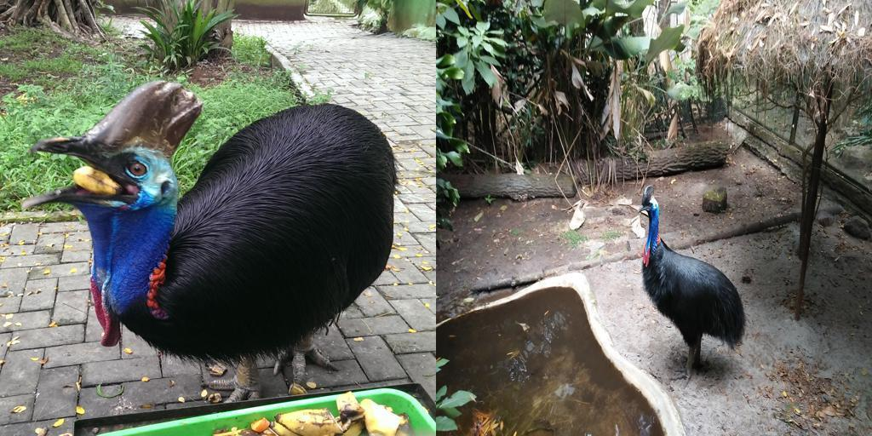  
./id_images/4-cassowary/pair-1-d-4-11-4-3.jpg ./id_images/4-cassowary/pair-1-c-4-4-4-6.jpg  
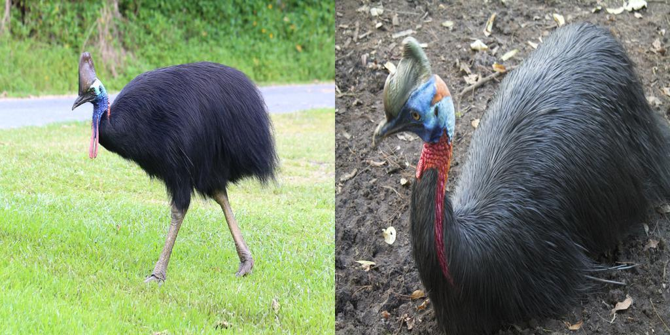 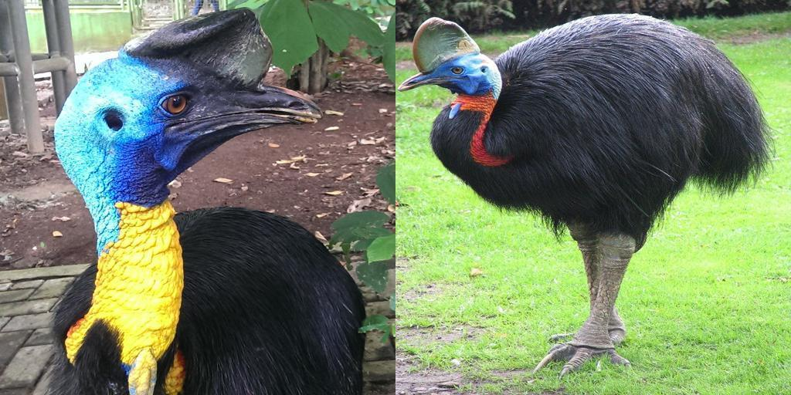  
./id_images/4-cassowary/pair-1-a-4-8-4-1.jpg ./id_images/4-cassowary/pair-1-b-4-9-4-0.jpg  
Caption: In both images, the cassowary is facing left.  
True pair1: ./id_images/4-cassowary/pair-1-c-4-4-4-6.jpg  
True pair2: ./id_images/4-cassowary/pair-1-a-4-8-4-1.jpg

--------------------------------------------------------------------------------------------------

**A few VERY IMPORTANT tips:**

* Avoid very simple captions (should have >8 words). Try to include a diverse set of objects/properties.
* The caption should describe one pair only without referring to any other pairs.
* It’s important to **concretely describe what is in the photo**. **Avoid speculations**.
* Be absolutely precise with the language used and avoid any ambiguity.
* Avoid describing only the colour of the objects, if possible.
* Write fluent captions. Ungrammatical captions don’t count.
* If you think you cannot write a valid caption, feel free to put “pass” in the caption and skip.
* If you think there is an error (e.g. duplicated images, images not belonging to the theme concept) in any examples, put “error” in the caption and skip.