**Network project**

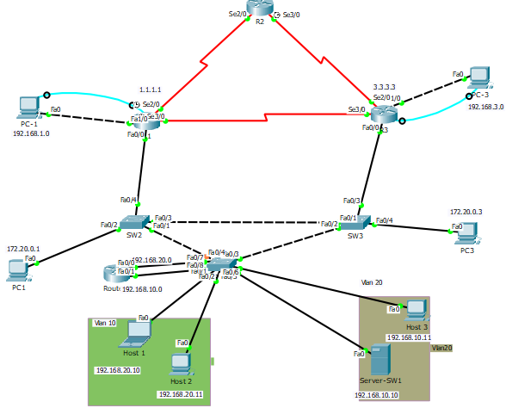

First, we set up the network topology and configured basic settings on the PC hosts, routers and switches.

***VLANS***:

Then we created 2 vlans:10 & 20 on SW1,

Such that ports fa0/1, fa0/2 belong to vlan 10

And ports fa0/5 fa0/6 belong to vlan 20.

And added a router and trunk port to let both vlans communicate.

SW1(config)#vlan 10

SW1 (config-vlan)#vlan 20

SW1 (config-vlan)#int ran fa0/1 -2

SW1 (config-if-range)#switchport mode access

SW1 (config-if-range)#switchport access vlan 10

SW1 (config-if-range)#spanning-tree portfast

SW1 (config-vlan)#int ran fa0/5-6

SW1 (config-if-range)#switchport mode access

SW1 (config-if-range)#switchport access vlan 10

SW1 (config-if-range)#spanning-tree portfast

Then we added ip addresses for both vlans and tested connectivity as shown below:

Ex1 : we send ping from host 3 of ip 192.168.10.10 of vlan 20 to host 1 of vlan 10 of ip 192.168.20.10

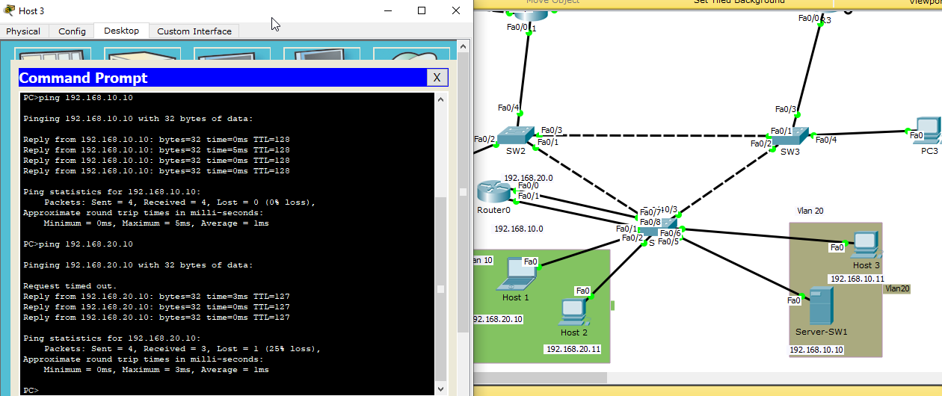

Ex2 : we send ping from host 1 of ip 192.168.20.10 of vlan 10 to host 1 of vlan 20 of ip 192.168.10.11

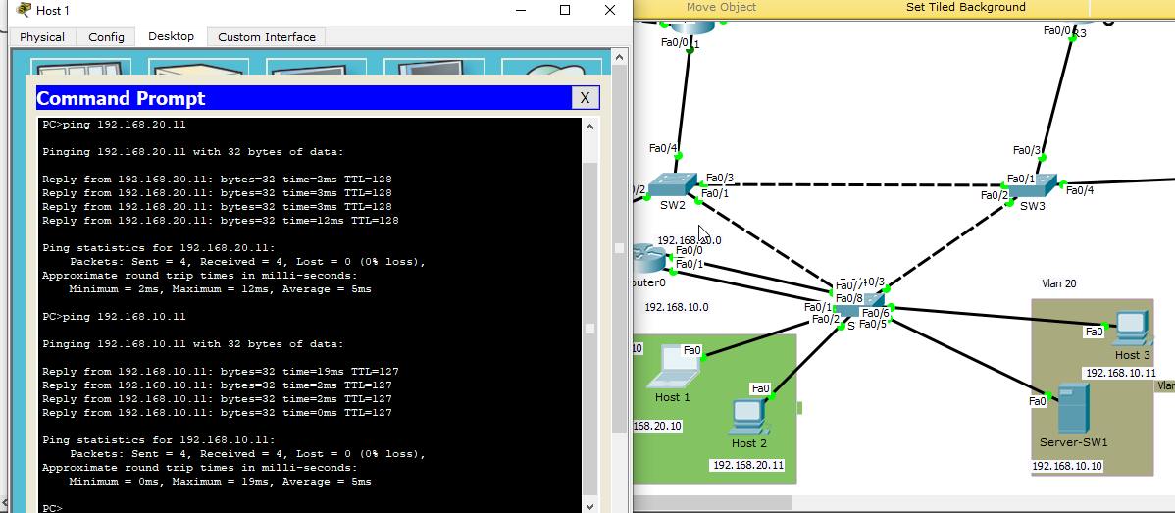

***STP:***

Check the spanning tree on each switch

SW1#sh spanning-tree

SW2#sh spanning-tree

SW3#sh spanning-tree

Fa0/4 is a blocking port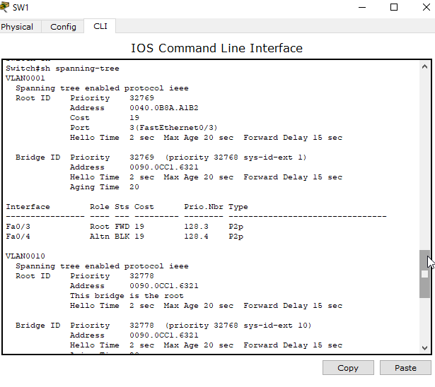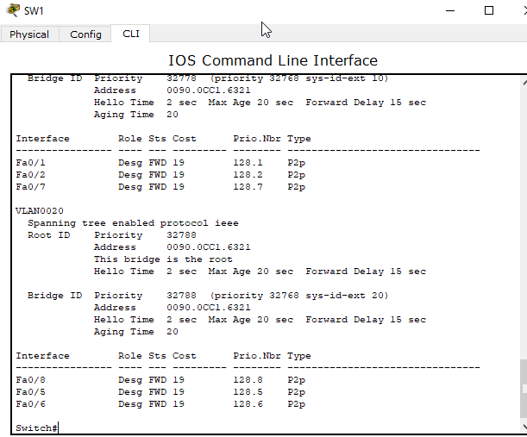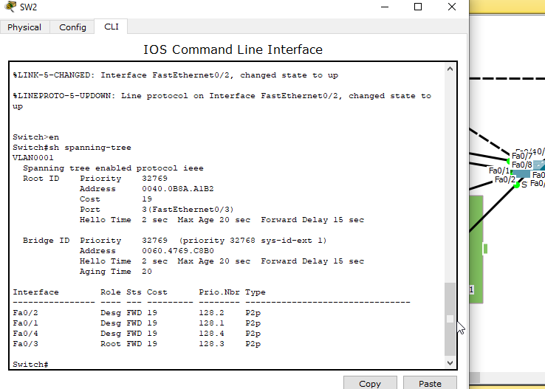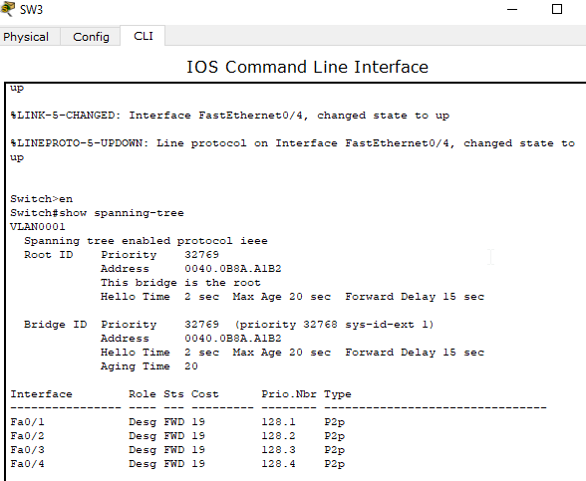Equal BIDs => we have a tie

fa0/3 on SW2 is the root port

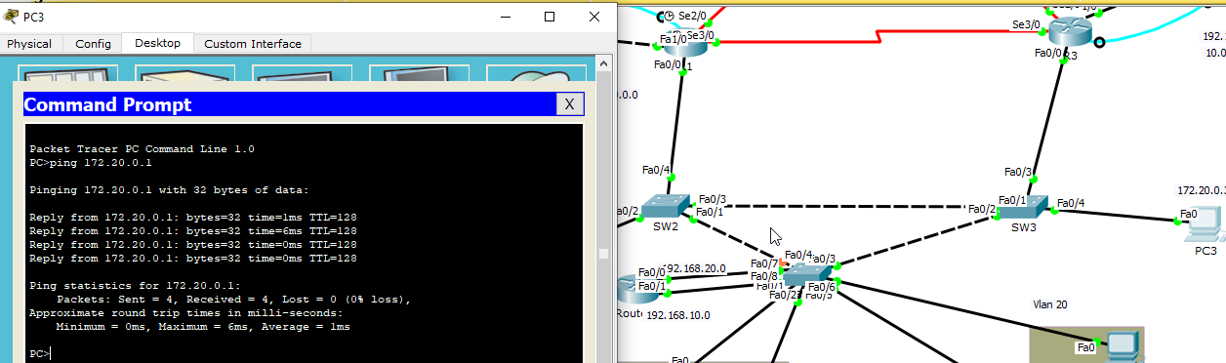ping from pc connected to SW3 to the pc connected to SW2

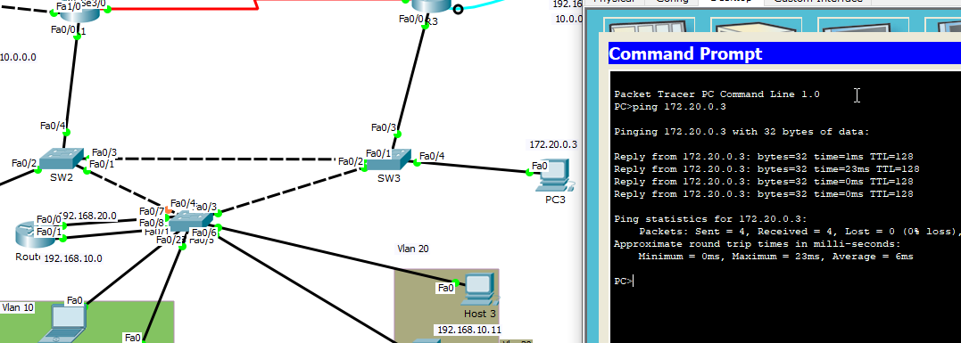

ping from pc connected to SW2 to the pc connected to SW3

***OSPF:***

We configure basic settings for each router by:

Disabling DNS lookup

Assigning **12345** as the privileged EXEC password.

Assigning **cisco** as the console and vty passwords.

Adding ip addresses.

Setting clock rate at 128000.

Copying the running configuration to the startup configuration using #copy run start.

Then we Tested the connectivity.

Then Configured OSPF on R1 by adding specific networks then on R2 & R3.

Then we verified OSPF neighbors and routing information as shown in the images

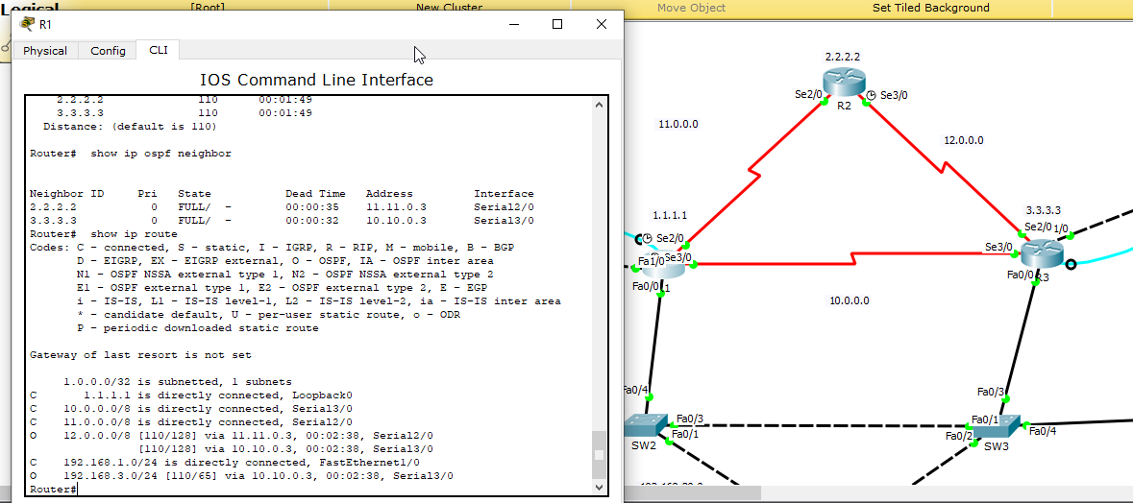

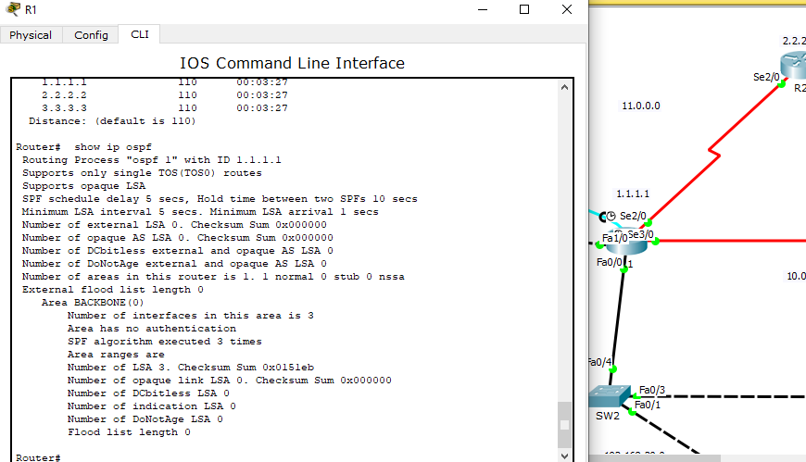 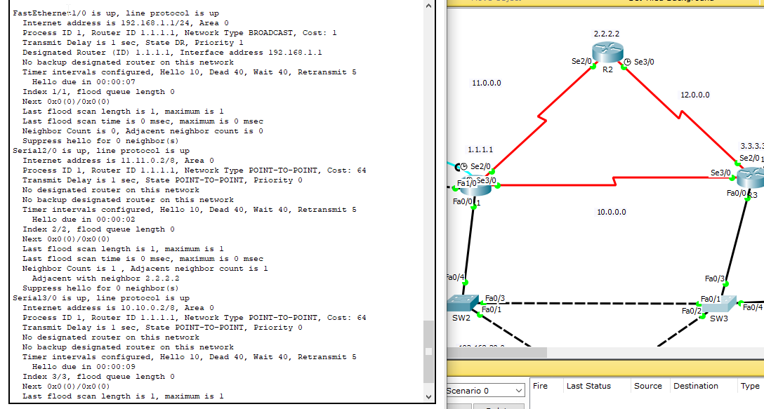

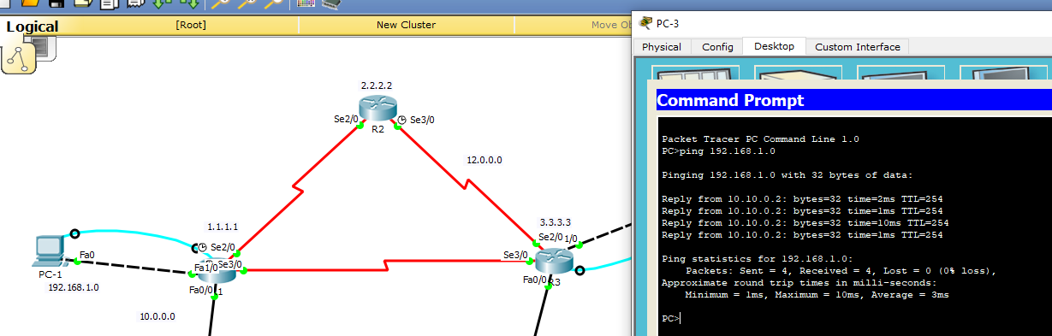testing connections between R1 and R3

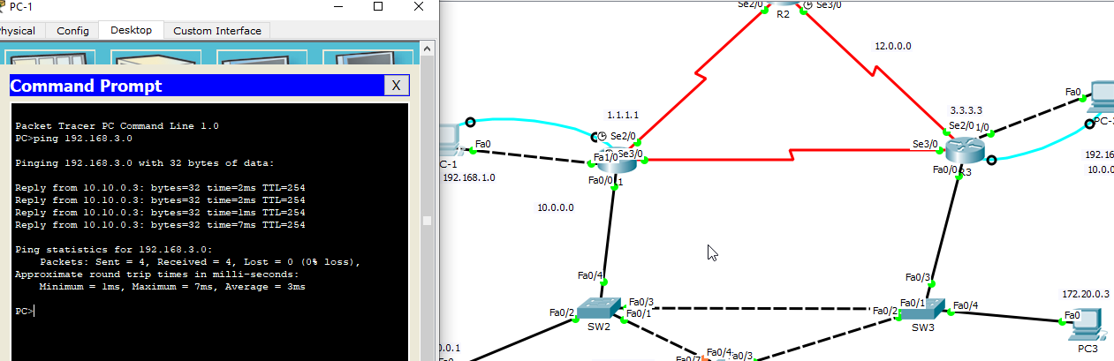

***RIP:***

Verifying the protocol

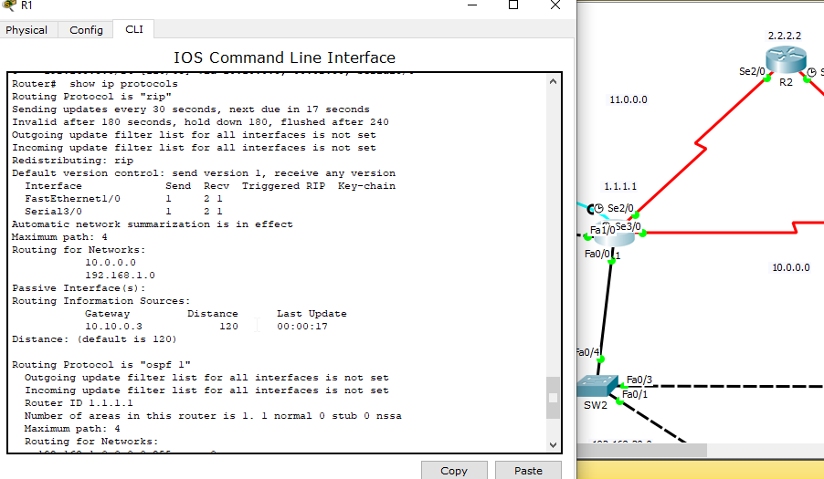Routing tables :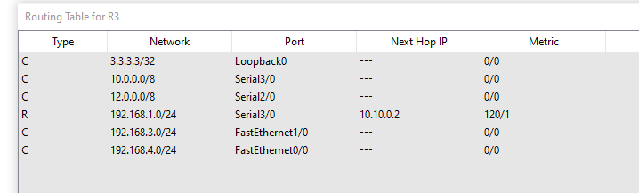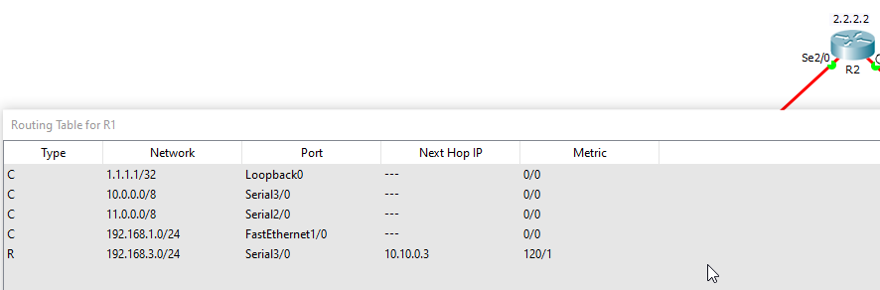

Verify connection between routers 