

**COMSATS UNIVERSITY ISLAMABAD**

**LAHORE CAMPUS**

Topics in Software Engineering I

CSE 350

**Submitted By :** Marwa Khalid FA19-BSE-083

Nimra Aftab FA19-BSE-031

Hamza Rana FA19-BSE-089

**Section** : A

**Submitted To**  : Dr. Fatima Sabir

**Date of submission** : Monday, December 26, 2022

**ASSIGNMENT:** REFACTORING STRATEGIES USED BY VISUAL STUDIO CODE

**Question 1: What refactoring strategies they use?**

Methods used by Visual Studio Code:

1. **Quick Fix**

Clicking on the Code Action lightbulb or using the **Quick Fix** command Ctrl+. will display Quick Fixes and refactoring options.

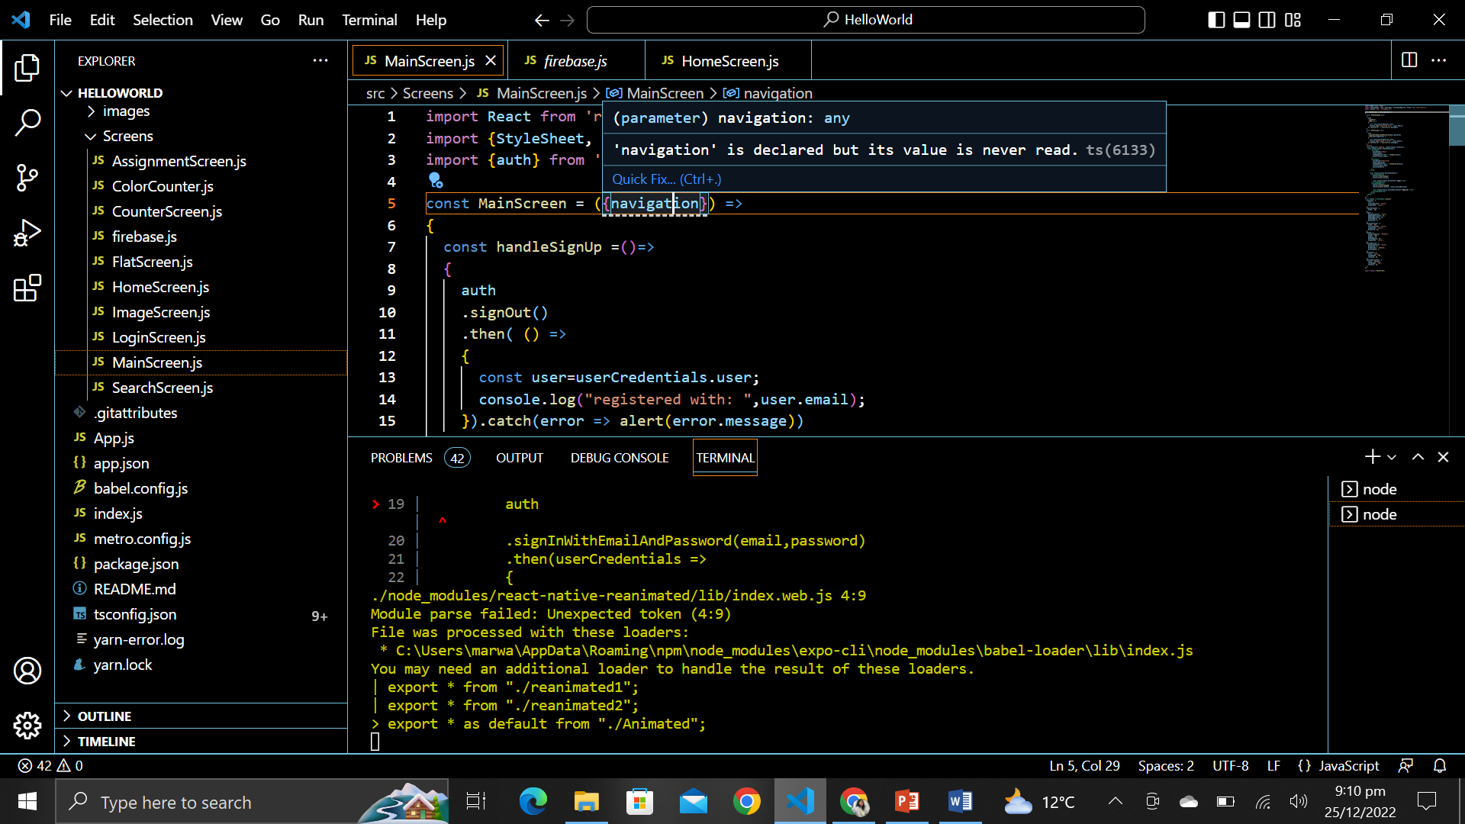

1. **Extract Method:**

Source code fragments can be extracted into a new method, or into a new function at various different scopes. During the extract refactoring, you will be prompted to provide a meaningful name.

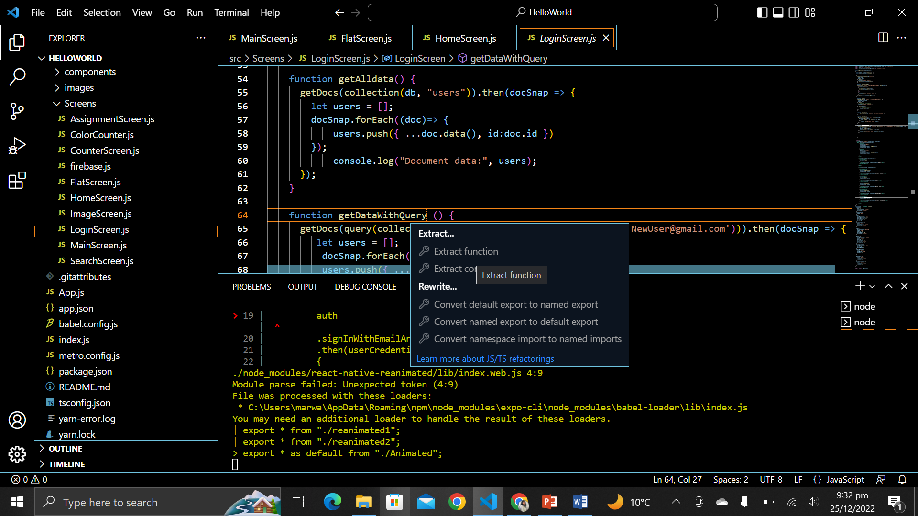

1. **Extract Variable:**

**Extract to constant** refactoring to create a new local variable

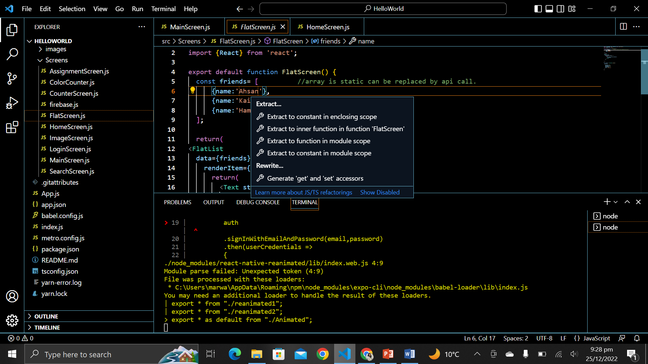 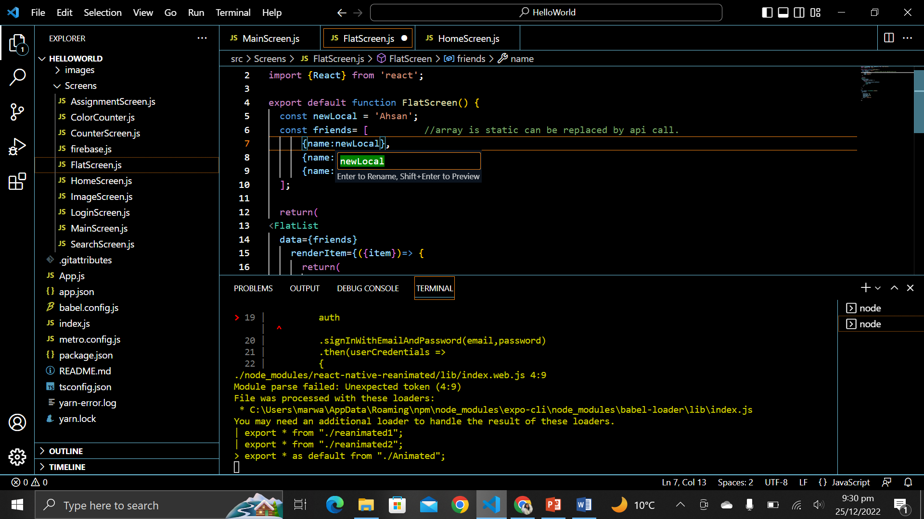

1. **Rename symbol:**

Renaming is a common operation related to refactoring source code and VS Code has a

separate **Rename Symbol**command (F2). Press F2 and then type the new desired name and press Enter. All usages of the symbol will be renamed, across files.

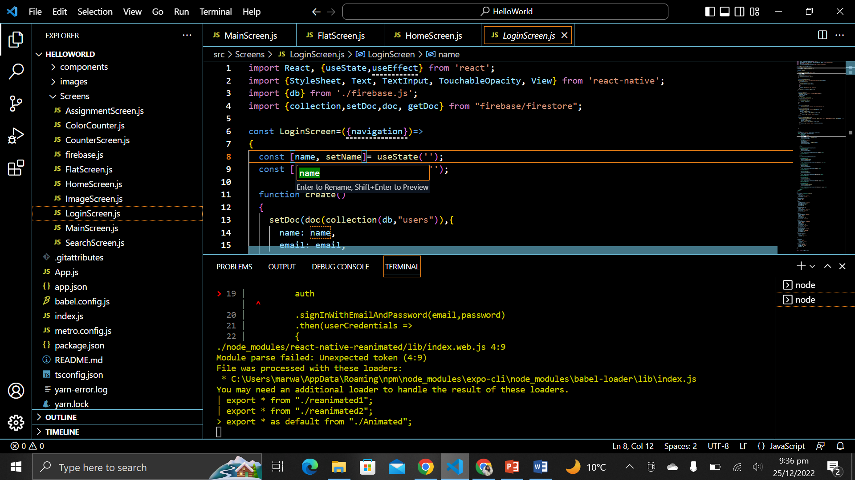

1. **Extensions with refactoring:**

Visual Studio Code provides extensions for refactoring. For Example:

* JS Refactoring Assistant
* PHP Refactoring
* SCSS Refactoring

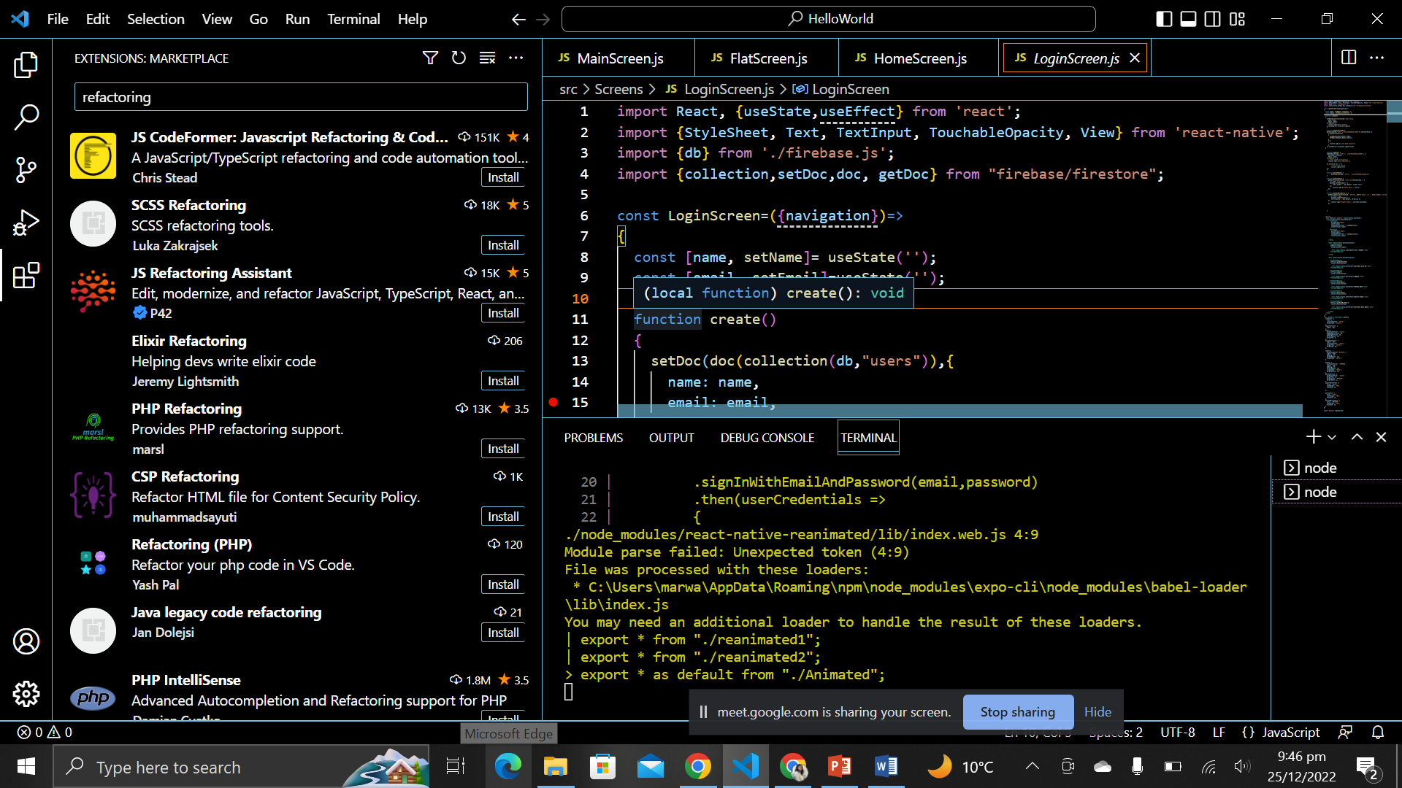

**Question 2: How they apply rewrite?**

By clicking (Ctrl+Shift+R), rewriting options will be shown. For example, I had an error on navigation in my MainScreen.js file. Following rewrite options are displayed after using the shortcut key.

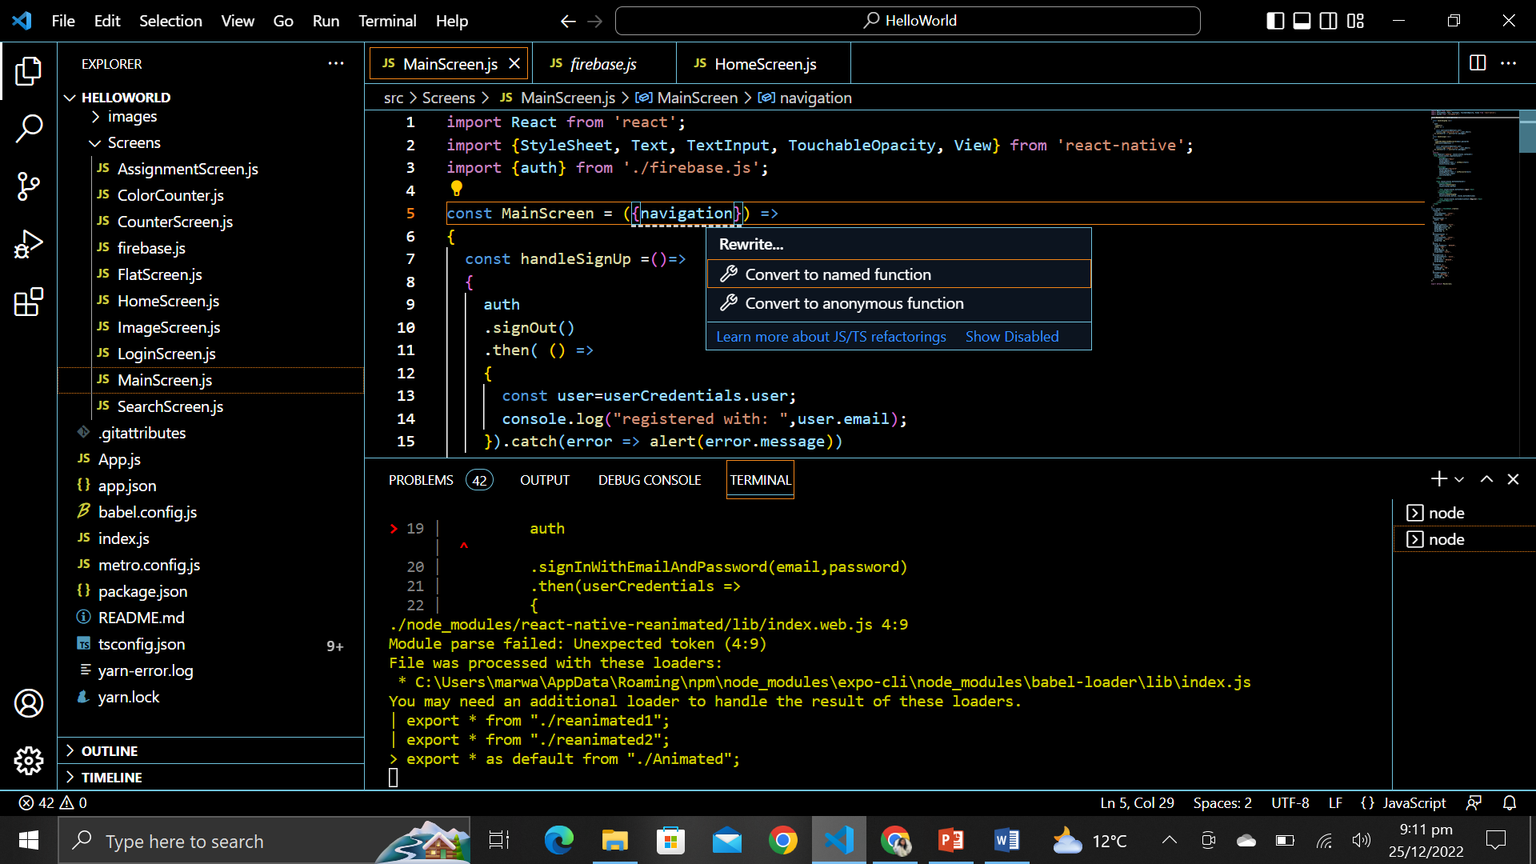

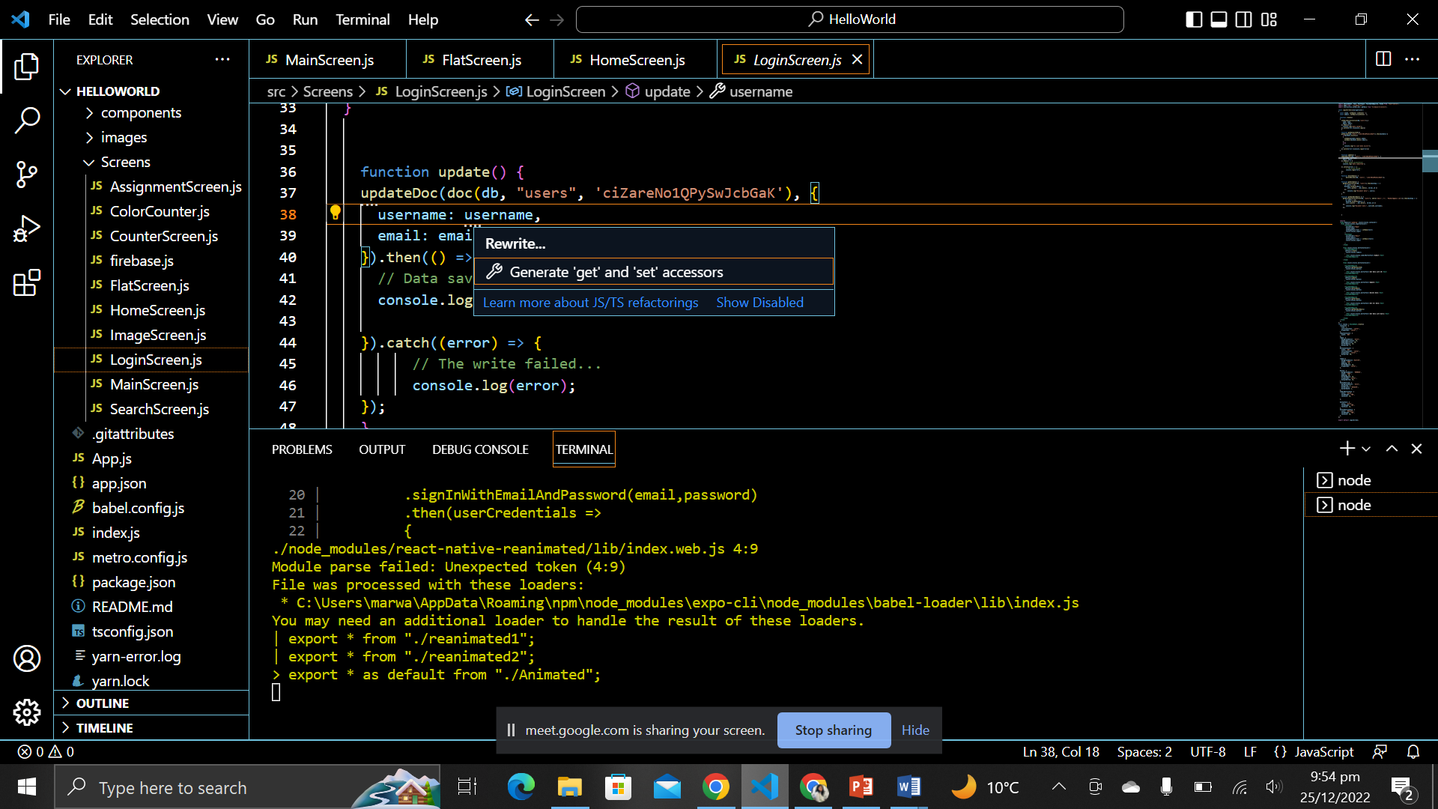

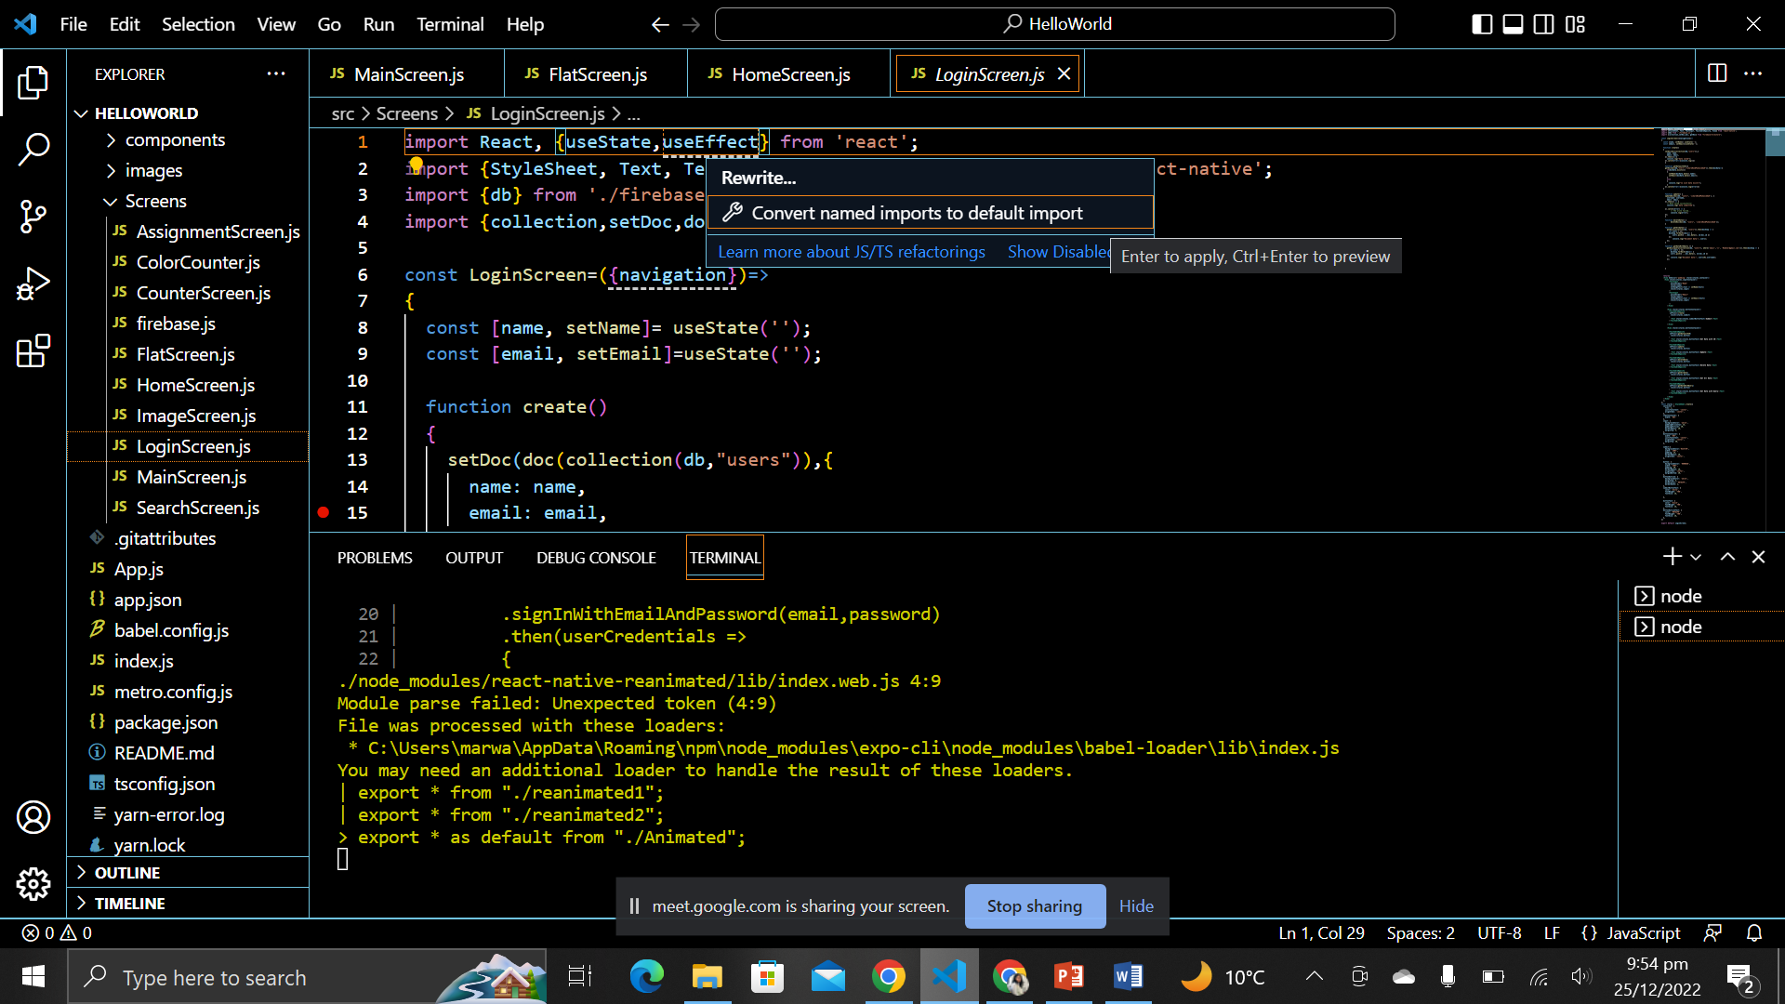

**Question 3: Difference in version November 2021 and November 2022:**

1. The Find control is now supported inside web views when VS Code is running in a browser

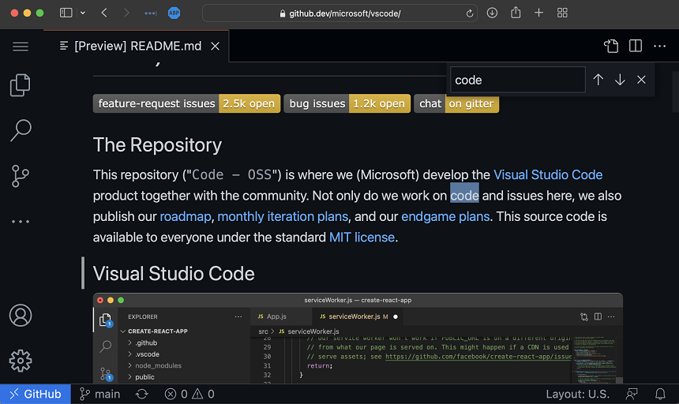

1. You can now choose to show command names as you trigger them via keyboard shortcuts in screencast mode. Use the Screencast Mode: Keyboard Shortcuts Format
2. These are the changes in different versions.

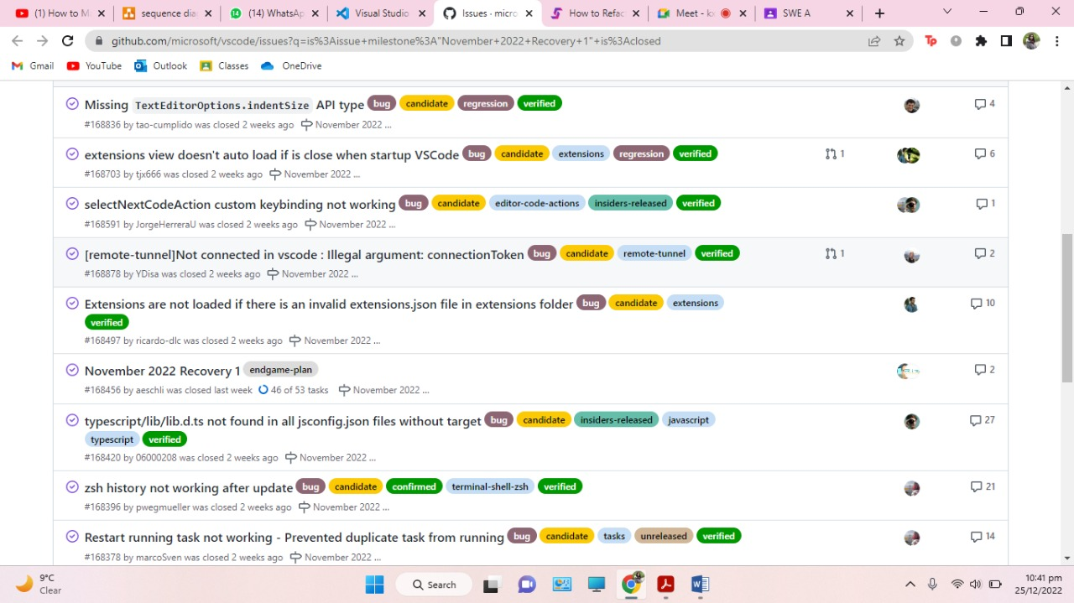

1. Merge Editor: User feedback indicated that checkboxes had some UX problems. The checkboxes weren't very discoverable and they caused confusion by not properly representing all possible states.

