

Blood Donation Database

Table of Contents
Creating Tables- 3
• Donors table 3
• Hospitals table 4
• Nurses Table 4
• Blood Bags Table 5
Insert Values- 6
• Donors Table 6
• Hospitals table 6
• Nurses Table 7
• Blood Bags Table 7
Nested functions- 8
• Donors table 8
• Hospitals table 8
• Blood Bags 8
Correlated Subquery- 9
Complex View- 9
NOSQL- 10
-Donors Table 10
• Create database- 10
• Insert Values- 10
• Update table- 10
• Delete record- 10
• Find record- 10

Creating Tables-

Donors table
--Create Donors table
CREATE TABLE DONORS (
D_NAME VARCHAR2(15) CONSTRAINT DONORS_NAME_NN NOT NULL, --Donor name and should not be null
D_ID NUMBER(5) CONSTRAINT DONORS_ID_PK PRIMARY KEY, --id should be unique and not null
D_AGE NUMBER(3) ,--Donor age
D_BLOODTYPE VARCHAR2(5) CONSTRAINT DONORS_BTYPE_NN NOT NULL, --Donor bloodtype
DONATION_DATE Date ,--Donor donation date
PHONE_NUMBER NUMBER(10), --Donor phone number
H_ID NUMBER(5), --ID of the hospital where donor donated
CONSTRAINT DONORS_AGE_CK CHECK(D_AGE>=18), --Donor age should be grater or equal to 18
CONSTRAINT DONORS_PN_UN UNIQUE(PHONE_NUMBER) ,--Each donor have different phone number
CONSTRAINT DONORS_HID_FK FOREIGN KEY (H_ID) REFERENCES HOSPITALS(H_ID) --Get hospital id from hospitals table
);
DESC DONORS;
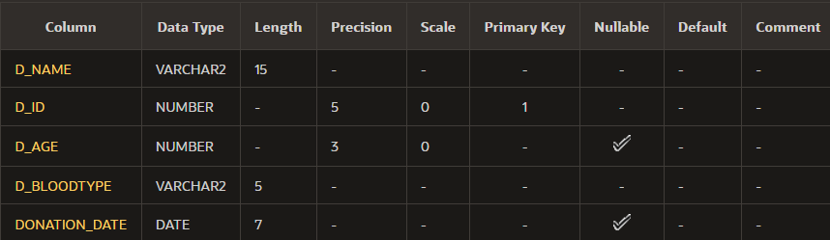

Hospitals table
CREATE TABLE HOSPITALS(
H_NAME VARCHAR2(30) CONSTRAINT HOSPITALS_NAME_NN NOT NULL,
H_ID NUMBER(5) CONSTRAINT HOSPITALS_HID_PK PRIMARY KEY,
H_LOCATION VARCHAR(50),
H_EMAIL VARCHAR2(50) CONSTRAINT HOSPITALS_EMAIL_NN NOT NULL,
H_PHONE NUMBER(10),
CONSTRAINT HOSPITALS_L_UN UNIQUE(H_LOCATION),
CONSTRAINT HOSPITALS_PN_UN UNIQUE(H_PHONE)
);
DESC HOSPITALS;
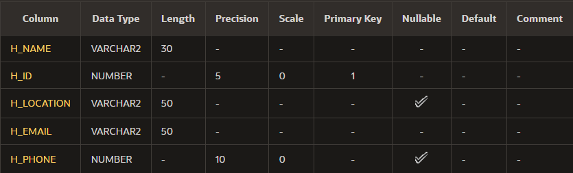

Nurses Table
CREATE TABLE NURSES (
N_ID NUMBER(5) CONSTRAINT NURSES_ID_PK PRIMARY KEY,
N_NAME VARCHAR2(30) CONSTRAINT NURSES_NAME_NN NOT NULL,
N_PHONE NUMBER(10) CONSTRAINT NURSES_PHONE_UN UNIQUE,
H_ID NUMBER(5) CONSTRAINT NURSES_HID_FK REFERENCES HOSPITALS(H_ID),
HIRE_DATE DATE CONSTRAINT NURSES_HIRE_NN NOT NULL );

DESC NURSES;
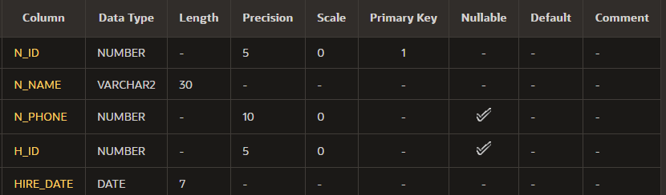

Blood Bags Table
CREATE TABLE BLOOD_BAGS (
BAG_ID NUMBER(5) CONSTRAINT BLOOD_BAGS_ID_PK PRIMARY KEY,
BLOOD_TYPE VARCHAR2(5) CONSTRAINT BLOOD_BAGS_TYPE_CK CHECK (BLOOD_TYPE IN ('O+', 'O-', 'A+', 'A-', 'B+', 'B-', 'AB+', 'AB-')),
DONATION_DATE DATE CONSTRAINT BLOOD_BAGS_DATE_NN NOT NULL,
D_ID NUMBER(5) CONSTRAINT BLOOD_BAGS_DID_FK REFERENCES DONORS(D_ID),
EXPIRY_DATE DATE CONSTRAINT BLOOD_BAGS_EXP_DATE_NN NOT NULL );

DESC BLOOD_BAGS;
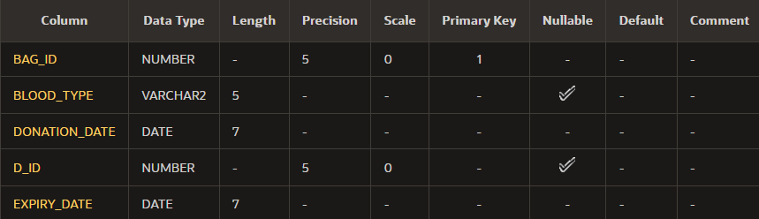

Insert Values-

Donors Table
INSERT INTO DONORS VALUES('Salim Ahmed',111,22,'AB+','14-Nov-2024',97966551,331);
INSERT INTO DONORS VALUES('Maryam Abdullah',112,40,'O+','03-Dec-2024',22366551,332);
INSERT INTO DONORS VALUES('Marwan Taher',113,33,'A+','01-Jan-2025',77666551,331);
INSERT INTO DONORS VALUES('Sara Mohammed',114,23,'B-','22-Nov-2024',79966551,333);
INSERT INTO DONORS VALUES('Mayar Saber',115,19,'O-','07-Feb-2025',98866551,334);

SELECT * FROM DONORS;
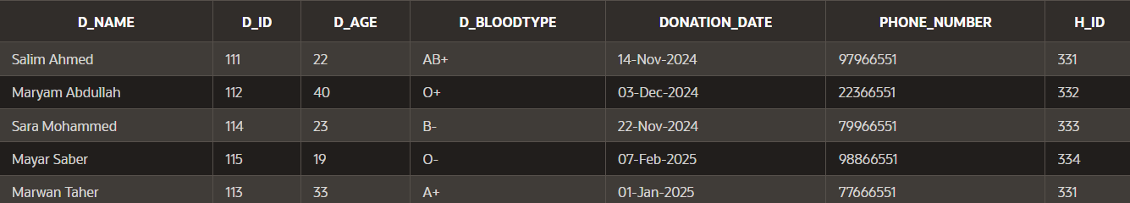

Hospitals table
INSERT INTO HOSPITALS VALUES('Khoula Hospital',331,' Al Wattayah, Muscat','khoula@moh.gov.om',24603555);
INSERT INTO HOSPITALS VALUES(' NMC Specialty Hospital',332,'Al Ghubra, Muscat',' muscat@nmc.ae',22091800);
INSERT INTO HOSPITALS VALUES('KIMS Oman Hospital',333,'Muscat, Oman',' info@kimsoman.com',24501888);
INSERT INTO HOSPITALS VALUES('Starcare Hospital',334,'Seeb, Muscat',' info@starcarehospital.com',24500000);

SELECT * FROM HOSPITALS;
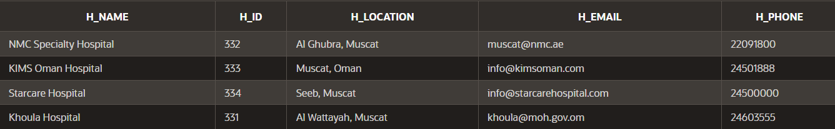

Nurses Table
INSERT INTO NURSES VALUES (101, 'Aisha Al Harbi', 99887766, 331,'01-May-2023');
INSERT INTO NURSES VALUES (102, 'Yusuf Al Balushi', 88776655, 332,'15-Oct-2022' );
INSERT INTO NURSES VALUES (103, 'Laila Al Zadjali', 77665544, 333, '25-Aug-2021');
INSERT INTO NURSES VALUES (104, 'Omar Al Hinai', 66554433, 334, '10-Dec-2020');
SELECT * FROM NURSES;
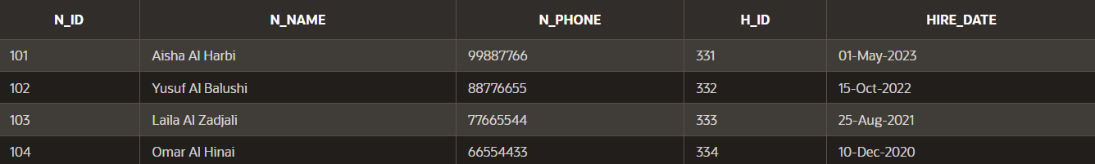

Blood Bags Table
INSERT INTO BLOOD_BAGS VALUES (201, 'O+', '21-Nov-2024', 112, '21-Feb-2025');
INSERT INTO BLOOD_BAGS VALUES (202, 'A+', '19-Nov-2024', 113, '19-Feb-2025');
INSERT INTO BLOOD_BAGS VALUES (203, 'B-', '20- Nov-2024'114, '20-Feb-2025');
INSERT INTO BLOOD_BAGS VALUES (204, 'O-', '21-Nov-2024'115, '18-Feb-2025');

SELECT * FROM BLOOD_BAGS;
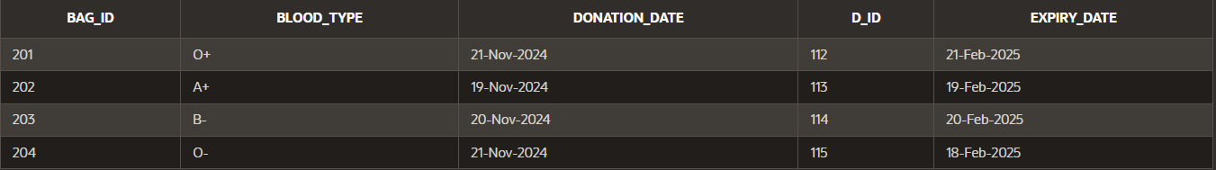

Nested functions-

Donors table

SELECT INITCAP(CONCAT(D_NAME,D_AGE))||' and the Blood type is '||D_BLOODTYPE AS "Donor Details" FROM DONORS;
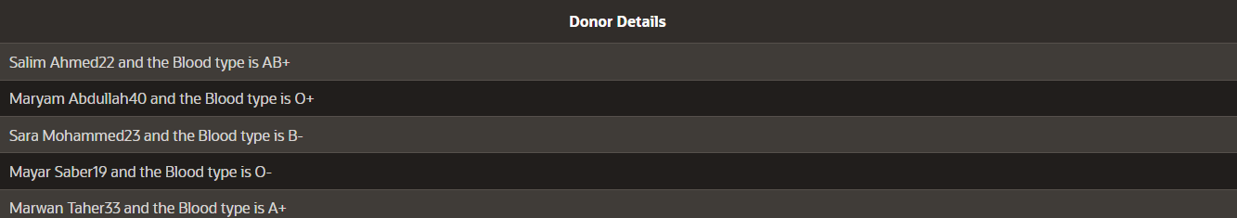

Hospitals table
SELECT H_NAME,REPLACE(LOWER(H_NAME),' ','_') "NEW NAME" FROM HOSPITALS;
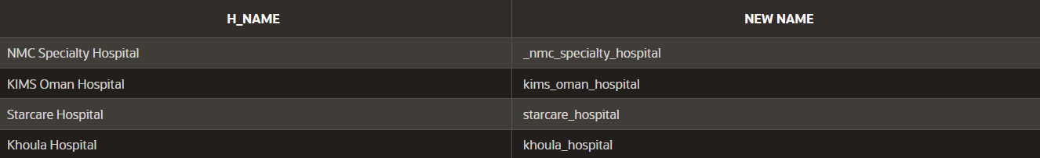

Blood Bags
-- CALCULATING THE DATS FOR THE BLOOD BAGS TO EXPIRE :
SELECT BAG_ID, EXPIRY_DATE, ROUND(EXPIRY_DATE - SYSDATE) AS "DAYS_TO_EXPIRE"
FROM BLOOD_BAGS;
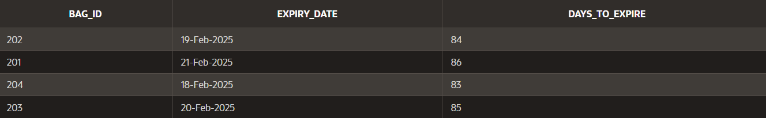

Correlated Subquery-

SELECT D_BLOODTYPE , DONATION_DATE FROM DONORS
WHERE D_ID > (SELECT D_ID FROM BLOOD_BAGS
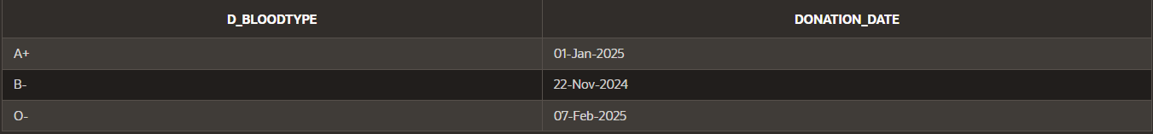
WHERE BAG_ID = 201);

Complex View-

CREATE OR REPLACE VIEW HIRE_VIEW
AS
SELECT UPPER(N_NAME) AS "Nurse Name",
TO_CHAR(HIRE_DATE,'DDSPTH "of" Mon YYYY') AS "Date of hiring"
FROM NURSES
WHERE N_ID IN (101,103,104)
ORDER BY N_NAME DESC;
--end of complex view code
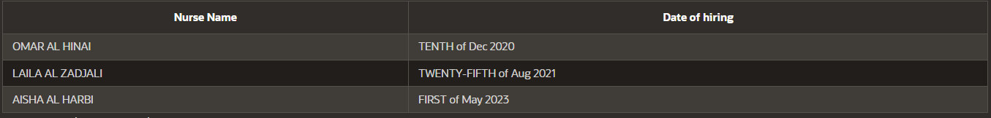
SELECT * FROM HIRE_VIEW;

NOSQL-
Note-(MongoDB)(Document-oriented database)

-Donors Table

Create database-
db.CreateCollection(“Donors”);

Insert Values-
db.Donors.insertMany([
{D_NAME: “Salim Ahmed”,D_ID: 111,D_AGE: 22,D_BLOODTYPE: “AB+”,DONATION_DATE: “14-Nov-2024”,PHONE_NUMBER: 97966551,H_ID:331}
{D_NAME: “Maryam Abdullah”,D_ID: 112,D_AGE: 40,D_BLOODTYPE: “O+”,DONATION_DATE: “03-Dec-2024”,PHONE_NUMBER: 22366551,H_ID: 332}
{D_NAME: “Marwan Taher”,D_ID: 113,D_AGE: 33,D_BLOODTYPE: “A+”,DONATION_DATE: “01-Jan-2025”,PHONE_NUMBER: 77666551,H_ID: 331}
]);

Update table-
db.Donors.updateOne(
{D_NAME: “Maryam Abdullah”},
{$set:{PHONE_NUMBER:77662233}}
);

Delete record-
db.Donors.deleteOne({D_AGE:{$lte: 22},});

Find record-
db.Donors.find(
{D_AGE:{$gte: 22},D_BLOODTYPE: “AB+”},
{D_NAME:1,D_AGE:1,D_BLOODTYPE:1,_ID:0}
);

