**Name**: marwa hasan hosni ali

**B.N**:880

**Topic**: Programming languages

**GitHub Link: https://github.com/marwa911/ece001**

**GitHub Pages:** **https://marwa911.github.io/ece001**

*Programming languages and its Applications:*

Programming can be defined as the process of writing instructions and commands for a computer or other device, to direct it and inform it about how to handle data or how to carry out a series of required actions.  
  
The programming process follows rules for the language chosen by the programmer.  
  
Each language has its own characteristics that distinguish it from the other and make it suitable in varying degrees for each type of program and the task required of this program.  
  
The programming languages ​​also have common characteristics and common borders, since all of these languages ​​are designed to deal with computers.  
Programming languages ​​evolve with the development of computers. When the electronic computer was invented in the forties and fifties of the last century (after the electrical calculation devices in the twenties) - and the computer was operating in large numbers of electronic valves - the programming language was also complicated, and it was a series of numbers and written in the form of long code codes these numbers are The numbers zero 0 and one 1 and this language is called bilingual or machine language, and this was difficult for programmers.

*Screenshots:*

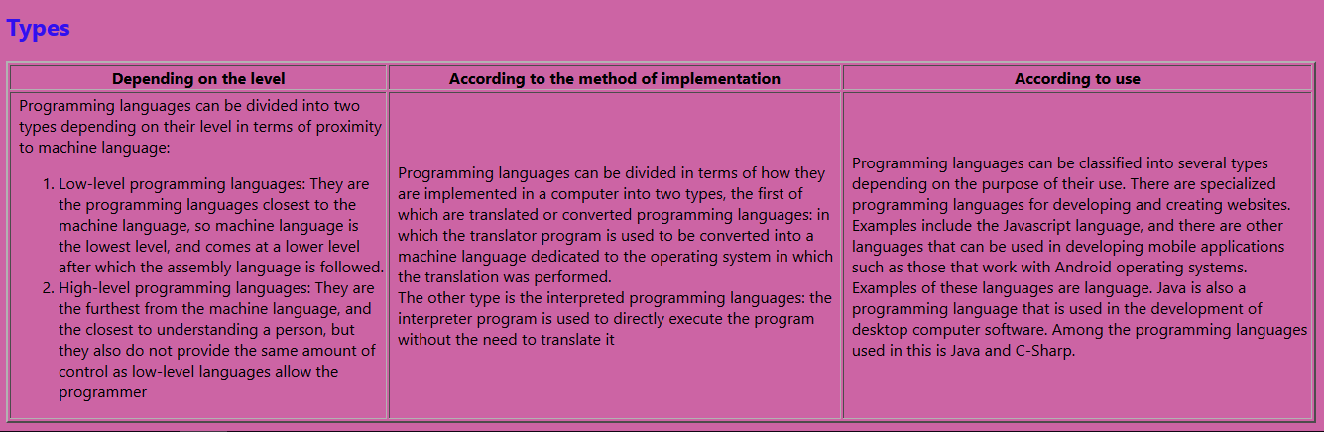

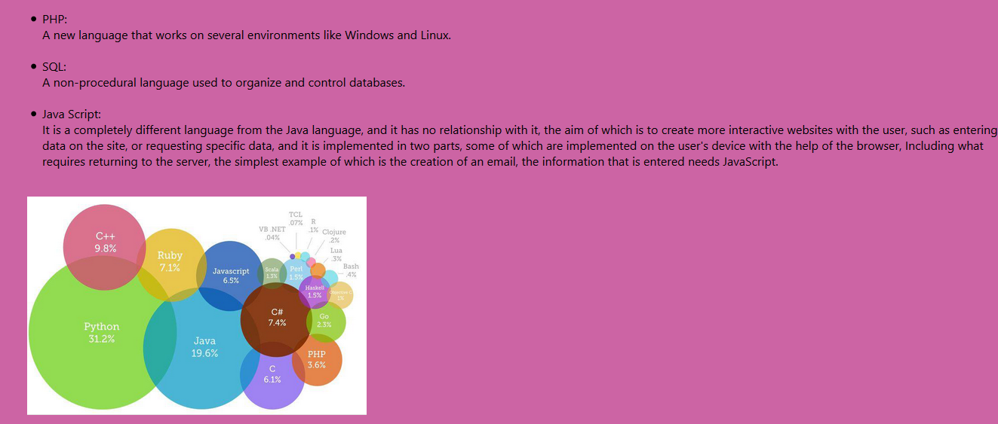

*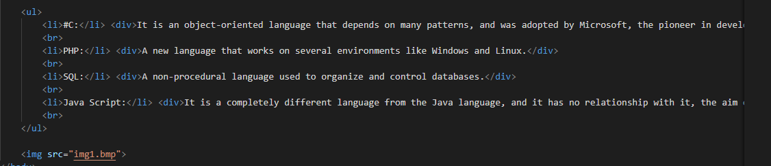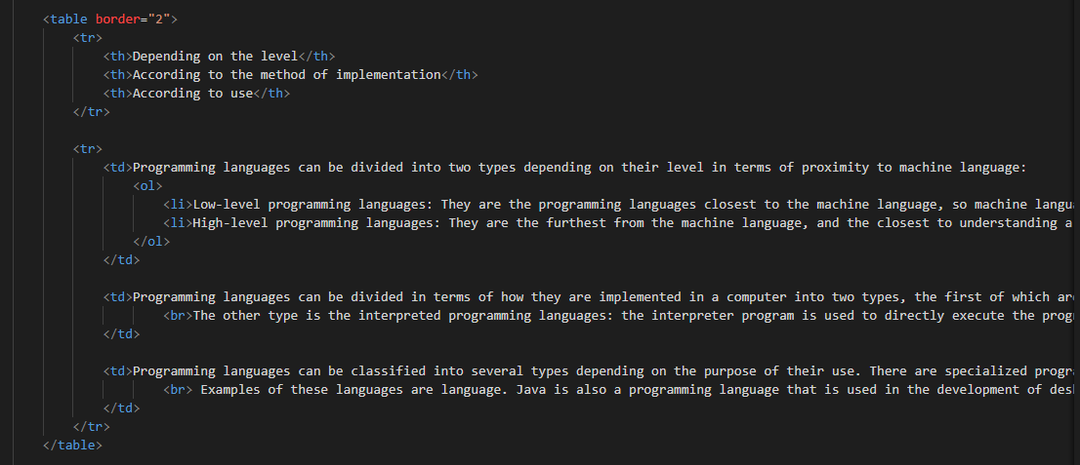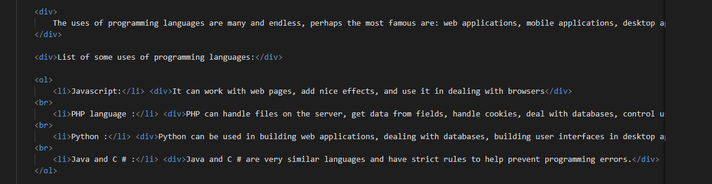Source Code:*