Object-Oriented Programming (OOP) Report

# 1. Introduction

# Object-Oriented Programming (OOP) is a way of writing code that’s based on objects, not just functions and logic. These objects hold both data and behavior, which makes it easier to manage and organize code. OOP is especially useful when working on big, complex, and long-term software projects. It helps reuse code, maintain programs easily, and keep everything more structured. Developers often use OOP when creating things like manufacturing systems, mobile apps, and games. In this report, I’ll go through the history of OOP, explain its key principles, compare it with procedural programming, highlight its benefits, and share real-life examples where OOP is used.

# 2. History and Background of OOP

OOP started as a new way to deal with the increasing complexity of software. Before that, programming was mostly done using methods based on math or logic, but those didn’t work well for large systems.

The idea of “Object-Oriented Programming” came from Alan Kay in the late 1960s. One early influence was Ivan Sutherland’s Sketchpad, a drawing tool that used reusable components and what we now call inheritance. The first language to include OOP features was Simula, created in 1965. It introduced important ideas like classes, objects, and inheritance. Later, Smalltalk came along in the 1970s and was one of the first full OOP languages, led by Kay and his team at Xerox PARC.

Since then, many popular languages like Java, C++, Python, and C# have used OOP as a main approach to building modern software.

# 3. Key Concepts of OOP

At the heart of Object-Oriented Programming are four key ideas: **Abstraction, Encapsulation, Inheritance**, and **Polymorphism**. These are the building blocks that help developers write clean and organized code. I explain them in detail in the next section.

# 4. OOP Principles (Encapsulation, Inheritance, Polymorphism, Abstraction)

**1. Abstraction**

Abstraction means showing only the important stuff and hiding the complex details. For example, when using a Vehicle class, you only need to know it has a method like startEngine()—you don’t need to know how it works inside. This helps make code simpler and easier to work with.

**2. Encapsulation**

Encapsulation means keeping data and the methods that work on that data inside a single class. It also means hiding the internal details and only letting other parts of the program interact through public methods. For example, a BankAccount class might have a private balance and public methods like deposit() or withdraw() to safely change it.

**3. Inheritance**

Inheritance lets one class get the features of another class. It saves time and avoids repeating code. For instance, if you have an Animal class, a Dog class can inherit from it, reusing common features like name and age while adding new ones like bark().

**4. Polymorphism**

Polymorphism lets the same method or object act differently depending on the situation. A function that works on a Shape can also work on a Circle or Rectangle because they inherit from the same class but behave in their own way.

These four principles make OOP powerful. They help create software that’s easier to update, understand, and grow over time.

Together, these principles empower developers to create software that is easier to understand, extend, and maintain, laying a solid foundation for robust application development.

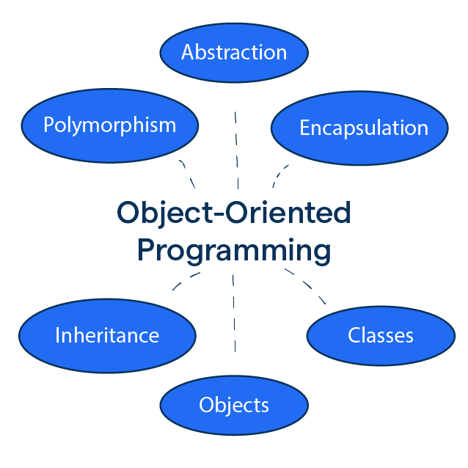

# 5. Benefits of Using OOP

# OOP has become very popular because it offers a modular, flexible, and scalable way to program. It organizes code into objects, which makes it easier to understand and manage, especially in large projects. By creating classes and objects, you can reuse code, saving time since you don’t have to rewrite the same things again and again. Grouping related data and functions together also makes fixing bugs and updating features simpler. Moreover, OOP lets programmers design software that models real-world things like cars, animals, or bank accounts, making the programs more intuitive. Because the code is organized and modular, multiple developers can work on different parts of the program at the same time without causing problems.

# 6. OOP vs Procedural Programming

Procedural programming is a way of writing code by creating functions that do tasks step by step. It focuses on the sequence of actions and uses separate data and functions. It’s like following a recipe.

On the other hand, Object-Oriented Programming (OOP) organizes code around objects that hold both data and actions. It models real-world things, like a car or a bank account, making it easier to understand and work with.

Some main differences are:

* Procedural programming uses functions to do tasks, while OOP groups data and functions together in objects.
* OOP lets you reuse code better through things like inheritance, but in procedural programming, you often have to write similar code again.
* OOP is easier to maintain and change, especially for big programs, while procedural code can get messy as the project grows.
* OOP models real-life things, so it feels more natural when designing complex software.

# 7. Real-World Applications of OOP

# OOP is used in many areas because it makes programming easier to manage and update. Here are some places where OOP is really helpful:

# Game Development: Games have many things like players, enemies, and items. OOP helps organize these things, so the game works well.

# Mobile Apps: Apps on phones use OOP to keep the code clean and easy to fix or improve.

# Websites and Web Apps: Websites use OOP languages like Java or Python to handle lots of different tasks smoothly.

# Banking Systems: Banks use OOP to manage accounts, customers, and transactions safely and reliably.

# Simulations: Programs like flight simulators or factory software use OOP to represent real parts and processes.

# Basically, OOP helps create software that is easy to understand, maintain, and expand

# .8. Conclusion

# To sum it up, Object-Oriented Programming is a useful and powerful way to write code. It helps make programs more organized, easier to understand, and simpler to fix or update. By using objects, classes, and principles like encapsulation and inheritance, developers can build software that’s flexible and easier to manage. OOP is used in many real-life applications, from games to banking systems, and it’s a skill that’s important for anyone learning to code today

# .9. References

-TechTarget. (n.d.). Object-oriented programming (OOP). Retrieved from

<https://www.techtarget.com/searchapparchitecture/definition/object-oriented-programming-OOP>

-Abrams, M. (2017). The forgotten history of OOP. Medium. Retrieved from  
<https://medium.com/javascript-scene/the-forgotten-history-of-oop-88d71b9b2d9f>

- ProgrammingKnowledge. (2016). Fundamental concepts of object-oriented programming [Video]. YouTube.  
<https://www.youtube.com/watch?v=m_MQYyJpIjg&t=5s>

-OpenAI ChatGPT. (2025). Assistance with Object-Oriented Programming concepts and report writing. Retrieved [Date], from <https://chat.openai.com/>

-