**Chemical Engineering 141 2nd Midterm**

H = U + PV

A = U – TS

G = H – TS

dU = TdS – PdV ${(\frac{∂T}{∂U})}_{S}=-{(\frac{∂P}{∂S})}_{V}$

dH = TdS + VdP ${(\frac{∂T}{∂P})}_{S}={(\frac{∂V}{∂S})}_{P}$

dA = -PdV – SdT ${(\frac{∂P}{∂T})}_{V}={(\frac{∂S}{∂V})}_{T}$

dG = VdP – SdT ${(\frac{∂V}{∂T})}_{P}=-{(\frac{∂S}{∂P})}_{T}$

Enthalpy as a function of T and P $dH=C_{P}dT+\left[V-T{\left(\frac{∂V}{∂T}\right)}_{P}\right]dP dH=C_{P}dT+\left(1-βV\right)VdP$

Entropy as a function of T and P $dS=C_{P}\frac{dT}{T}-{\left(\frac{∂V}{∂T}\right)}_{P}dP$ $dS=C_{P}\frac{dT}{T}-βVdP$

Internal Energy as a function of P ${(\frac{∂U}{∂P})}_{T}=-T{\left(\frac{∂V}{∂T}\right)}_{P}-P{\left(\frac{∂V}{∂P}\right)}_{T}$

Idealgas ${dH}^{ig}={C_{P}}^{ig}dT {dS}^{ig}={C_{P}}^{ig}\frac{dT}{T}-R\frac{dP}{P}$

Alternative forms for liquids ${(\frac{∂S}{∂P})}_{T}=-βV {\left(\frac{∂H}{∂P}\right)}_{T}=\left(1-βT\right)V$

**Internal Energy as function of T and V**

$${\left(\frac{∂S}{∂T}\right)}_{V}=\frac{C_{V}}{T} {\left(\frac{∂U}{∂V}\right)}_{T}=T{\left(\frac{∂P}{∂T}\right)}_{V}-P$$

$$dU=C_{V}dT+\left[T{\left(\frac{∂P}{∂T}\right)}_{V}-T\right]dV dU=C_{V}dT+\left[T\frac{β}{K} -P\right]dV$$

$$dS=C_{V}\frac{dT}{T}+{\left(\frac{∂P}{∂T}\right)}_{V}dV dS= \frac{C_{V}}{T}dT+\frac{β}{K}dV$$

**The Gibbs Energy as a Generating Function**

$$dG=VdP-SdT$$

$$d\left(\frac{G}{RT}\right)=\frac{1}{RT}dG-\frac{G}{RT^{2}}dT=\frac{V}{RT}dP-\frac{H}{RT^{2}}dT$$

$$\frac{V}{RT}={[\frac{∂(\frac{G}{RT})}{∂P}]}_{T} \frac{H}{RT}=-T{[\frac{∂\left(\frac{G}{RT}\right)}{∂T}]}_{P}$$

**Residual properties**

MR = M-Mig

|  |  |  |
| --- | --- | --- |
|  | Virial EOS | Cubic EOS |
| $$\frac{G^{R}}{RT}$$ | $$\int_{0}^{ρ}{\left(Z-1\right)\frac{dρ}{ρ}}+Z-1-\ln{Z}$$ | $$Z-1-\ln\left(Z-β\right)-qI$$ |
| $$\frac{H^{R}}{RT}$$ | $$-T\int_{0}^{ρ}{{(\frac{∂Z}{∂T})}_{ρ}\frac{dρ}{ρ}}+Z-1$$ | $$Z-1+[\frac{d\ln{α(T_{r}})}{d\ln{T_{r}}}-1]-qI$$ |
| $$\frac{S^{R}}{R}$$ | $$\ln{Z}-T\int_{0}^{ρ}{{(\frac{∂Z}{∂T})}_{ρ}\frac{dρ}{ρ}}-\int_{0}^{ρ}{(Z-1)\frac{dρ}{ρ}}$$ | $$\ln{(Z-β)}+[\frac{d\ln{α(T_{r}})}{d\ln{T_{r}}}]-qI$$ |

$$I=\int_{0}^{ρ}{\frac{d\left(ρb\right)}{(1+ϵρb)(1+σρb)}}$$

**Two Phase Systems**

$$\ln{P^{sat}}=A-\frac{B}{T+C} \ln{{P_{r}}^{sat}}=\frac{Aτ+Bτ^{1.5}+Cτ^{3}+Dτ^{6}}{1-τ} τ=1-T_{r}$$

Liquid/Vapor Systems

$$M=\left(1-x^{v}\right)M^{l}+x^{v}M^{v}=M^{l}+x^{v}∆M^{lv} M represents V, U, H, S$$

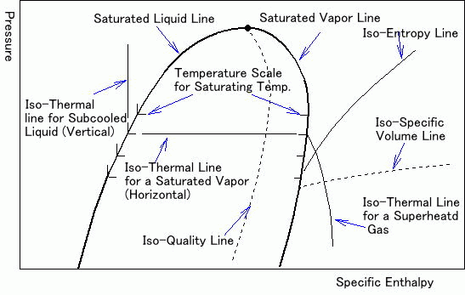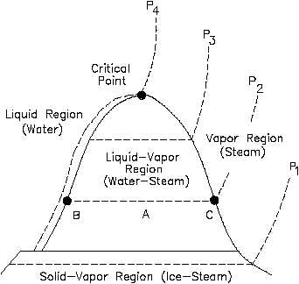

**Generalized property correlations for gases**

$$\frac{H^{R}}{RT_{c}}=\frac{{{(H}^{R})}^{0}}{RT_{c}}+ω\frac{{{(H}^{R})}^{1}}{RT_{c}} \frac{S^{R}}{R}=\frac{{{(S}^{R})}^{0}}{R}+ω\frac{{{(S}^{R})}^{1}}{R}$$

$$∆H={C_{P}^{ig}}_{H}\left(T_{2}-T_{1}\right)+H_{2}^{R}-H_{1}^{R}$$

$$∆S={C_{P}^{ig}}_{S}\ln{\frac{T_{2}}{T_{1}}}-R\ln{\frac{P_{2}}{P_{1}}}+S_{2}^{R}-S_{1}^{R}$$

**Equations of Balance**

|  |  |  |
| --- | --- | --- |
| General equations | Steady-flow | Single-stream steady-flow |
| $$\frac{{dm}_{CV}}{dt}+∆{(\dot{m})}_{fs}=0$$ | $$∆{(\dot{m})}_{fs}=0$$ | $${\dot{m}}_{1}={\dot{m}}_{2}={\dot{m}}_{3}$$ |
| $$\frac{{d(mU)}_{CV}}{dt}+∆{[(H+\frac{1}{2}u^{2}+zg)\dot{m}]}_{fs}=\dot{Q}+\dot{W}$$ | $$∆{[(H+\frac{1}{2}u^{2}+zg)\dot{m}]}_{fs}=\dot{Q}+\dot{W}$$ | $$∆H+\frac{{∆u}^{2}}{2}+∆zg=\dot{Q}+\dot{W}$$ |
| $$\frac{{d(mS)}_{CV}}{dt}+∆{(S\dot{m})}_{fs}-\sum{\frac{{\dot{Q}}_{j}}{T_{σ,j}}=\dot{S_{G}}≥0}$$ | $$∆{(S\dot{m})}_{fs}-\sum{\begin{aligned}\frac{{\dot{Q}}_{j}}{T_{σ,j}} \\ =\dot{S_{G}}≥0\end{aligned}}$$ | $$∆S-\sum{\frac{Q_{j}}{T_{σ,j}}=\dot{S_{G}≥0}}$$ |

**Throttling process**

$$∆H=H_{2}-H_{1}=0$$

**Joule/Thomson coefficient**

$$μ={(\frac{∂T}{∂P})}_{H}=\frac{RT^{2}}{C_{P}P}{(\frac{∂Z}{∂T})}_{P} { ( \frac{∂H}{∂P} )}_{T}=V-T{(\frac{∂V}{∂T})}_{P}$$

**Turbines (expanders)**

$$\dot{W_{s}}=\dot{m}∆H=\dot{m}\left(H_{2}-H_{1}\right) W_{s}=∆H=H_{2}-H_{1}$$

$$η=\frac{W_{s}}{W_{s}(isentropic)}=\frac{∆H}{{(∆H)}_{S}}$$

**Compression processes**

$$η=\frac{W_{s}(isentropic)}{W}=\frac{{\left(∆H\right)}_{S}}{∆H}$$

$$W_{s}\left(isentropic\right)=C_{P}T_{1}\left[{\left(\frac{P_{2}}{P_{1}}\right)}^{\frac{R}{C_{P}}}-1\right]$$

$$T_{2}=T_{1}+\frac{∆H}{{C_{P}}_{H}}=T_{1}+\frac{T_{1}\left[{\left(\frac{P_{2}}{P_{1}}\right)}^{\frac{R}{C_{P}}}-1\right]}{η}$$

**Pumps**

$$dH=C_{P}dT+V\left(1-βT\right)dP ∆H=C_{P}∆T+\left(1-βT\right)∆P$$

$$dS=C_{P}\frac{dT}{T}-βVdP ∆S=C_{P}\frac{T_{2}}{T_{1}}-βV∆P$$

**Rankine Cycle**

|  |  |
| --- | --- |
| File:Rankine cycle Ts.png | 1-2: reversible, adiabatic (isentropic) pumping of the saturated liquid to the pressure of the boiler, producing compressed (subcooled) liquid. $∆T is small$ 2-3: heating of subcooled liquid water to its saturation temperature, vaporization at constant temperature and pressure, and superheating of the vapor to a temperature well above its saturation temperature  3-4: reversible, adiabatic (isentropic) expansion of vapor in a turbine to the pressure of the condenser.  4-1: constant-pressure, constant temperature process in a condenser to product saturated liquid |

 \eta_{therm}=\frac{\dot{W}_{turbine}-\dot{W}_{pump}}{\dot{Q}_{in}} \approx \frac{\dot{W}_{turbine}}{\dot{Q}_{in}}.

\frac{\dot{Q}_{in}}{\dot{m}}=h_3-h_2 \frac{\dot{Q}_{out}}{\dot{m}}=h_4-h_1 \frac{\dot{W}_{pump}}{\dot{m}}=h_2-h_1 \frac{\dot{W}_{turbine}}{\dot{m}}=h_3-h_4

Otto cycle

|  |  |
| --- | --- |
| http://upload.wikimedia.org/wikipedia/commons/thumb/c/cf/P-V_otto.png/300px-P-V_otto.pnghttp://upload.wikimedia.org/wikipedia/commons/thumb/6/6d/Otto2.png/300px-Otto2.png | * 1. intake stroke   A mass of air (working fluid) is drawn into the cylinder, from 0 to 1, at atmospheric pressure (constant pressure) through the open intake valve  1-2 compression stroke  Isentropic compression, compression ratio V1/V2  2-3 ignition  Isochoric, heat is added, pressure rises, temperature increases, pressure ratio P3/P2  3-4 expansion stroke  Fluid expands isentropically, expansion ratio, V4/V3  4-1 heat ejection  Isochoric, heat is removed, pressure drops, temperature decreases |

Diesel cycle

|  |  |
| --- | --- |
| File:DieselCycle PV.svg | 1-2 isentropic compression  2-3 isobaric expansion  3-4 isentropic expansion  4-1 isochoric cooling |

Brayton Cycle / Gas Turbine Engine

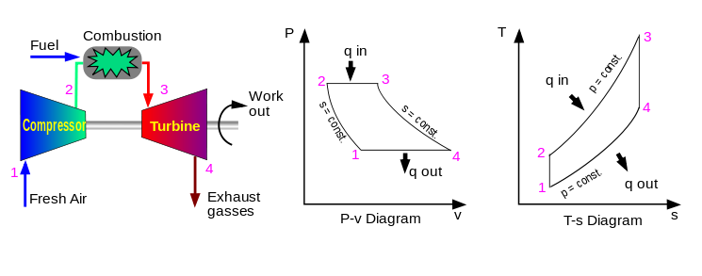

$$Q_{23}=C_{P}\left(T_{3}-T_{2}\right) {|W}_{34}|=C_{P}\left(T_{3}-T_{4}\right) \frac{T_{2}}{T_{1}}={\left(\frac{P_{2}}{P_{1}}\right)}^{\frac{γ-1}{γ} } \frac{T_{4}}{T_{3}}={\left(\frac{P_{4}}{P_{3}}\right)}^{\frac{γ-1}{γ} }={\left(\frac{P_{1}}{P_{2}}\right)}^{\frac{γ-1}{γ} }$$

$$η=\frac{\left|W_{net}\right|}{Q_{23}}=\frac{{\left|W_{34}\right|-W}_{12}}{Q_{23}}=1-\frac{T_{4}-T_{1}}{T_{3}-T_{2}}=1-{\left(\frac{P_{1}}{P_{2}}\right)}^{\frac{γ-1}{γ} }$$

1-2 isentropic compression

2-3 isobaric expansion/heating

3-4 isentropic expansion/cooling

4-1 isobaric compression

**Refrigeration**

|  |  |  |
| --- | --- | --- |
| http://www.qrg.northwestern.edu/thermo/design-library/refrig/Ts.gif | | simple refrigeration cycle |
|  | |  |
| **Claude liquefaction process** | [http://lh4.ggpht.com/_YOjepBEvjc8/TF7iAo6HfVI/AAAAAAAAD9I/tyNbNHVQWGk/s400/Linde_simple_process.GIF](http://lh4.ggpht.com/_YOjepBEvjc8/TF7iAo6HfVI/AAAAAAAAD9I/tyNbNHVQWGk/s800/Linde_simple_process.GIF)  **Linde liquefaction process** | |

|  |  |
| --- | --- |
|  |  |

**Phase Rule**: $F=2-π+N$

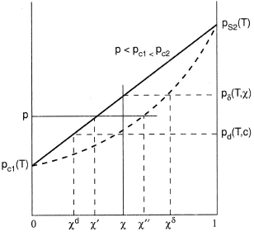 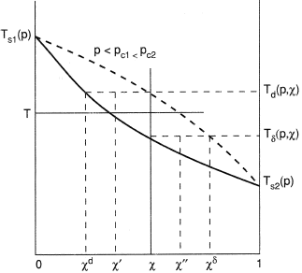

P-x diagram T-x digram

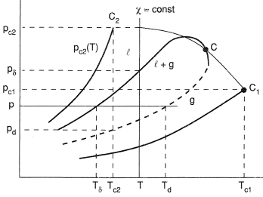 PT diagram

|  |  |
| --- | --- |
| http://readysleep.files.wordpress.com/2008/04/henrys-law.png | |
| Modified Raoult’s law $$y_{i}P=x_{i}{γ_{i}P}_{i}^{sat}$$ $$P=\sum_{i}{x_{i}{γ_{i}P}_{i}^{sat}=\frac{1}{\sum_{i}{y_{i}/γ_{i}P_{i}^{sat}}}}$$ y is vapor phase  x is liquid phase $$\sum_{i}{y_{i}}=\sum_{i}{x_{i}}=1$$ $$K_{i}=\frac{y_{i}}{x_{i}} \sum_{i}{{K_{i}x}_{i}=}\sum_{i}{\frac{y_{i}}{K_{i}}=}1$$ | $$y_{i}P=x_{i}H_{i}$$ |

Antoine equation $\ln{P_{i}^{sat}=A-\frac{B}{T+C}}$

|  |  |
| --- | --- |
| **Bubble point {xi}, T, given**   1. get {Pisat} by T | **Dew point {yi}, T, given**   1. get {Pisat} by T |
| **Bubble point {xi}, P, given**   1. Plug P into Antoine equation as the Pisat to calculate Tisat. As an initial guess 2. Calculate {Pisat} at this T. 3. Choose one species k as a reference:      1. Plug in P1sat or P2sat in Antoine equation to get a new value for T. 2. Go back to step 2 until T converges. | **Dew point {yi}, P, given**   1. Plug P into Antoine equation as the Pisat to calculate Tisat. As an initial guess 2. Calculate {Pisat} at this T. 3. Choose one species k as a reference:   ) )   1. Plug in P1sat or P2sat in Antoine equation to get a new value for T. 2. Go back to step 2 until T converges. |