**Chemical Engineering 141 Notes**

H = U + PV

ΔH = ΔU + Δ(PV)

$$C_{V}={\left(\frac{∂U}{∂T}\right)}_{V}$$

$$C_{P}={\left(\frac{∂H}{∂T}\right)}_{P}$$

**Mass balance in open system**

$\frac{dm}{dt}$ or $\frac{dn}{dt}$ = uAp u is the velocity, A is the area, and u is the mass density or the molar density

**Energy balance in open system**

$$\frac{{d(mU)}_{CV}}{dt}+ {Δ\left[\left(H+ \frac{1}{2}u^{2}+zg\right)\dot{m}\right]}_{fs}=\dot{Q}+\dot{W}$$

Usually, $\frac{1}{2}u^{2}+zg$ are neglected

$$\frac{{d(mU)}_{CV}}{dt}+Δ{(H\dot{m)} }_{fs}=\dot{Q}+\dot{W}$$

In a closed system where there is no flow stream, $Δ{(H\dot{m)} }_{fs}$ is neglected.

$$\frac{{d\left(mU\right)}_{CV}}{dt}=\dot{Q}+\dot{W}$$

$$ΔU^{t}=Q+W$$

Energy balance on filling up an empty gas tank

$$\frac{{d(mU)}_{tank}}{dt}-H'\dot{m'}=0$$

$$m^{'}=\frac{{dm}_{tank}}{dt}$$

$$\frac{{d\left(mU\right)}_{tank}}{dt}-H^{'\frac{{dm}_{tank}}{dt}}=0$$

$$m_{2}U_{2}-m_{1}U_{1}=H^{'}\left(m_{2}-m_{1}\right)$$

$$U_{2}=H^{'}$$

V = V(T,P)

$$dV={(\frac{∂V}{∂T})}_{P}dT+{(\frac{∂V}{∂P})}_{T}dP$$

$$β= \frac{1}{V}{\left(\frac{∂V}{∂T}\right)}_{P}$$

$$γ= -\frac{1}{V}{\left(\frac{∂V}{∂P}\right)}_{T}$$

$$\frac{dV}{V}= βdT- γdP$$

$$ln\frac{V_{2}}{V_{1}}=β\left(T_{2}-T_{1}\right)+γ(P_{2}-P_{1})$$

$${(\frac{∂P}{∂T})}_{V}=\frac{β}{γ}$$

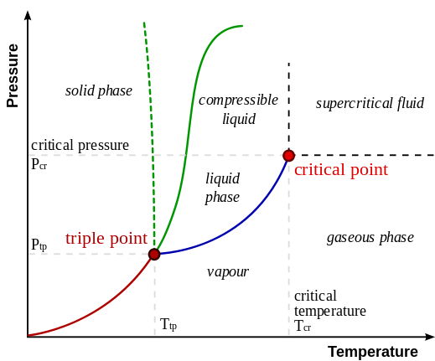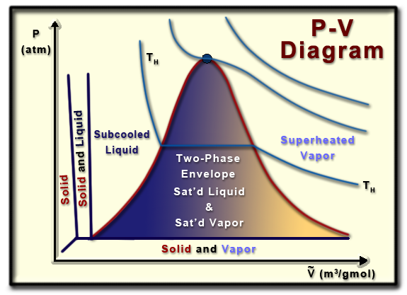

**Virial equations of state**

$$PV = a + bP + cP^{2}+…$$

if b = aB’, c = aC’

$$PV = a (a+B’P + C’P^{2}+D’P^{3}+…)$$

$$Z =\frac{PV}{RT}$$

$$Z =1+B^{'}P+C^{'}P^{2}+D^{'}P^{3}+…=1+\frac{B}{V}+\frac{C}{V^{2}}+\frac{D}{V^{3}}+…$$

$$γ=\frac{C_{P}}{C_{V}}$$

|  |  |  |  |  |
| --- | --- | --- | --- | --- |
|  | Q | W | U | H |
| Isothermal | $$RTln\frac{V_{2}}{V_{1}}=-RTln\frac{P_{2}}{P_{1}}$$ | $$-RTln\frac{V_{2}}{V_{1}}=RTln\frac{P_{2}}{P_{1}}$$ | 0 | 0 |
| Isobaric | $$\int{C_{P}dT}$$ | $$-R (T_{2}-T_{1})$$ | $$\int{C_{V}dT}$$ | $$\int{C_{P}dT}$$ |
| Isochoric | $$\int{C_{V}dT}$$ | 0 | $$\int{C_{V}dT}$$ | $$\int{C_{V}dT}$$ |
| Adiabatic | 0 | $\frac{P_{1}V_{1}}{γ-1}{[(\frac{P_{2}}{P_{1}})}^{\frac{γ-1}{γ}}-1]$ = $\frac{RT_{1}}{γ-1}{[(\frac{P_{2}}{P_{1}})}^{\frac{γ-1}{γ}}-1]$ | Same as W |  |

**Van der Waals EOS**

$$P= \frac{RT}{V-b}-\frac{a}{V^{2}}$$

**Critical parameters**

$$V_{c}= \frac{3RT_{C}}{8P_{c}} a=\frac{27}{64}\frac{R^{2}T_{c}^{2}}{P_{c}} b=\frac{1}{8}\frac{RT_{c}}{P_{c}}$$

$$Z_{c}=\frac{P_{c}V_{c}}{RT_{c}}=\frac{3}{8}$$

**Reduced temperature and pressure**

$$T_{r}=\frac{T}{T_{c}} P_{r}=\frac{P}{P_{c}}$$

**Redlich/Kwong EOS**

P={\frac  {R\,T}{V_{m}-b}}-{\frac  {a}{{\sqrt  {T}}\;V_{m}\,(V_{m}+b)}}, a={\frac  {0.4275\,R^{2}\,T_{c}^{{5/2}}}{P_{c}}},\qquad b={\frac  {0.08664\,R\,T_{c}}{P_{c}}},

**Carnot engine**

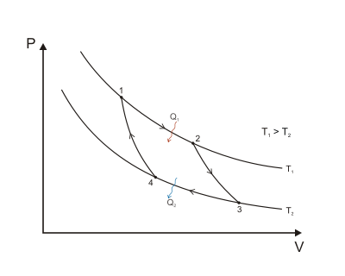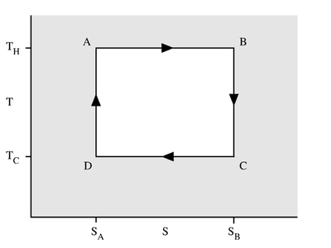

Reversible [isothermal](http://en.wikipedia.org/wiki/Isothermal) expansion of the gas at the "hot" temperature, 1🡪2, A🡪 B

\Delta S=Q_1/T_1

[Isentropic](http://en.wikipedia.org/wiki/Isentropic_process) ([reversible adiabatic](http://en.wikipedia.org/wiki/Reversible_adiabatic_process)) expansion of the gas (isentropic work output). 2🡪3, B🡪 C

$$∆S=0$$

Reversible isothermal compression of the gas at the "cold" temperature, *T2*. 3🡪4, C🡪 D

\Delta S=Q_2/T_2

Isentropic compression of the gas (isentropic work input). 4🡪1, D🡪 A

W = \oint PdV = 

                            (T_H-T_C)(S_B-S_A)



S = k_{\mathrm{B}} \ln \Omega \, ,

H = U + PV

A = U – TS

G = H – TS

dU = TdS – PdV ${(\frac{∂T}{∂U})}_{S}=-{(\frac{∂P}{∂S})}_{V}$

dH = TdS + VdP ${(\frac{∂T}{∂P})}_{S}={(\frac{∂V}{∂S})}_{P}$

dA = -PdV – SdT ${(\frac{∂P}{∂T})}_{V}={(\frac{∂S}{∂V})}_{T}$

dG = VdP – SdT ${(\frac{∂V}{∂T})}_{P}=-{(\frac{∂S}{∂P})}_{T}$

Enthalpy as a function of T and P $dH=C_{P}dT+\left[V-T{\left(\frac{∂V}{∂T}\right)}_{P}\right]dP dH=C_{P}dT+\left(1-βV\right)VdP$

Entropy as a function of T and P $dS=C_{P}\frac{dT}{T}-{\left(\frac{∂V}{∂T}\right)}_{P}dP$ $dS=C_{P}\frac{dT}{T}-βVdP$

Internal Energy as a function of P ${(\frac{∂U}{∂P})}_{T}=-T{\left(\frac{∂V}{∂T}\right)}_{P}-P{\left(\frac{∂V}{∂P}\right)}_{T}$

Idealgas ${dH}^{ig}={C_{P}}^{ig}dT {dS}^{ig}={C_{P}}^{ig}\frac{dT}{T}-R\frac{dP}{P}$

Alternative forms for liquids ${(\frac{∂S}{∂P})}_{T}=-βV {\left(\frac{∂H}{∂P}\right)}_{T}=\left(1-βT\right)V$

**Internal Energy as function of T and V**

$${\left(\frac{∂S}{∂T}\right)}_{V}=\frac{C_{V}}{T} {\left(\frac{∂U}{∂V}\right)}_{T}=T{\left(\frac{∂P}{∂T}\right)}_{V}-P$$

$$dU=C_{V}dT+\left[T{\left(\frac{∂P}{∂T}\right)}_{V}-T\right]dV dU=C_{V}dT+\left[T\frac{β}{K} -P\right]dV$$

$$dS=C_{V}\frac{dT}{T}+{\left(\frac{∂P}{∂T}\right)}_{V}dV dS= \frac{C_{V}}{T}dT+\frac{β}{K}dV$$

**The Gibbs Energy as a Generating Function**

$$dG=VdP-SdT$$

$$d\left(\frac{G}{RT}\right)=\frac{1}{RT}dG-\frac{G}{RT^{2}}dT=\frac{V}{RT}dP-\frac{H}{RT^{2}}dT$$

$$\frac{V}{RT}={[\frac{∂(\frac{G}{RT})}{∂P}]}_{T} \frac{H}{RT}=-T{[\frac{∂\left(\frac{G}{RT}\right)}{∂T}]}_{P}$$

**Residual properties**

MR = M-Mig