**Chemical Engineering 150A Final Review Sheet**

**Fluid statics**

|  |  |  |  |  |
| --- | --- | --- | --- | --- |
| mano | | 2 points connected in same fluid at the same height, pressure is equal | | |
|  | |  |

**Compressible fluid**

**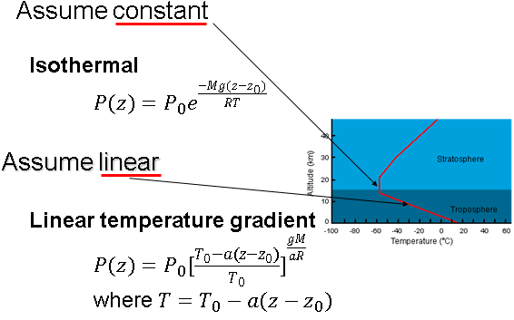**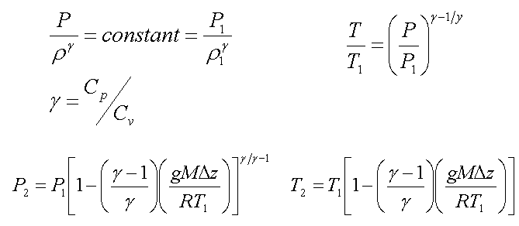

**Momentum Balance**

**Straight tube**:

**U tube**:

**Velocity entering the fitting**- push the fitting in the direction of velocity

**Velocity leaving the fitting**- push the fitting in the opposite direction of velocity

**Energy Balance**

|  |  |  |  |  |  |  |
| --- | --- | --- | --- | --- | --- | --- |
| Turbulent flow | | | |  | | |
| Laminar flow | | | |  | | |
| Terms | + | | | | | - |
|  | Work done on the system | | | | | Work done by the system |
|  | Inlet > outlet, start with high pressure | | | | | Inlet < outlet, end with high pressure |
|  | Start with high velocity, decelerating | | | | | Turn into high velocity, accelerating |
|  | Start at higher point, going into low point | | | | | Start with low point, elevation is raised |
|  | Always **positive**, work is dissipated as friction | | | | | |
|  | | | **Laminar** | | **Turbulent** | |
| **Newtonian** | | |  | | Churchill’s correlation (more accurate)  Colebrook equation (easier) | |
| **Power law fluid** | | | | | | | | |
|  | | |  | | | | | |
| **Laminar** | | |  | | | | | |
| **Turbulent** | | | PLf_turb | | | | | |

L is the length of the tube

D is the diameter of the tube

µ is the viscosity of the fluid

k is the roughness factor

|  |  |
| --- | --- |
| **Bingham Plastic** |  |
| **Laminar** |  |
| **Turbulent** | BP_f |

Flow through non-circular conduits

RH = hydraulic radius S = cross-sectional area Lp = wetted perimeter

Bernoulli

|  |  |
| --- | --- |
| Total friction = Skin friction + Fitting drag + Unit drag  Ke = 1 for filling the tank  Kc = 0.4 for emptying the tank  Pumps  Cavitation occurs when Pinlet < Pvap. To pump efficiently, Pinlet > Pvap |  |

Flow around immersed objects

Particles reach terminal velocity when

Cd is the drag coefficient; A is the projected area of the particle

|  |  |
| --- | --- |
| Stoke | Newton |
| Re<1 | 1000<Re<200000 |
|  |  |
|  |  |
|  |  |
| K < 2.6 | K > 68.9 |



**Fixed and fluidized bed**

**Minimum fluidization velocity**

**Compressible flow**

|  |  |
| --- | --- |
| Isothermal flow | Isentropic flow |
|  |  |
| If flow is subsonic (normal), then pressure will drop from Pinlet to Pexit in pipe  Check that u2 (end of pipe) < usound to make sure flow is subsonic  If flow goes sonic (choked), pressure will not be able to drop to Pexit at the end  Check sonic flow [P2 (end of pipe) > Pexit]: | With enough a fluid can go sonic at the throat, and supersonic in diverging nozzle.  The maximum velocity at the throat is NMa = 1, there is a maximum flow rate |

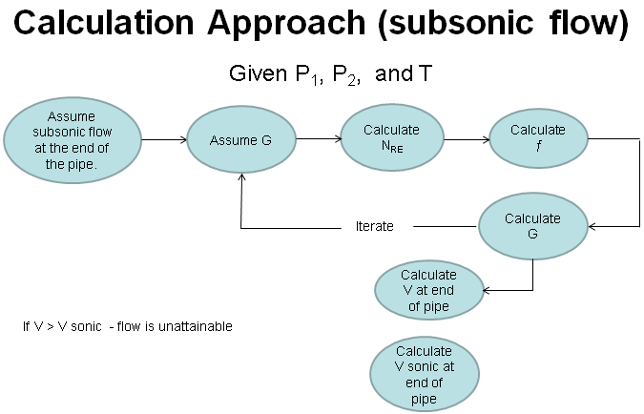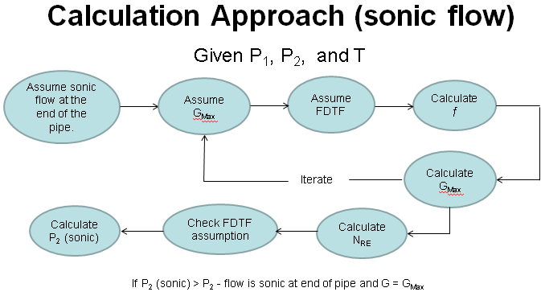

|  |  |
| --- | --- |
|  | Due to imperfections in nozzle, flow can drop off the isentropic pathway as it decelerates to v < vsound.  Normal shock tables relate conditions before and after a shock.   * Find Ma on isentropic table for the given shock location * Look up Ma as Ma1 on normal shock table, record ratios of post shock values Ma2, P2, and T2 relative to P1 and T1 before shock.   After normal shock, fluid will continue to travel on a new isentropic pathway   * Use isentropic flow table to find fictional A\*, T0, and P0 that would have given you the same conditions as the post-chock conditions. * Use isentropic flow table to find conditions further down the nozzle relative to those A\*, T0, and P0 values |

Compressors

**Determine number of required centrifugal compressor stages:**

o Guideline (1) max compression ratio/stage ~3

o Guideline (2) max discharge temperature ~350°F

**Method for using chart:**

1) Find starting point using initial P and T

2) Read off H at that point

3) Follow a line of constant S from starting point to ending P (of that stage)

4) Read off T and H at that end point

5)

6) Repeat for multiple stages, assuming perfect intercooling

**Calculate final temperature**

Chart: start at Pend, Tend, go right by to get T2, actual

**Polytropic compression**

**Navier-Stokes**

**Equation of continuity**

|  |  |  |
| --- | --- | --- |
| \begin{align}   r:\ &\rho \left(\frac{\partial u_r}{\partial t} + u_r \frac{\partial u_r}{\partial r} +                    \frac{u_{\phi}}{r} \frac{\partial u_r}{\partial \phi} + u_z \frac{\partial u_r}{\partial z} - \frac{u_{\phi}^2}{r}\right) = {}\\       &-\frac{\partial p}{\partial r} + \mu \left[\frac{1}{r}\frac{\partial}{\partial r}\left(r \frac{\partial u_r}{\partial r}\right) +         \frac{1}{r^2}\frac{\partial^2 u_r}{\partial \phi^2} + \frac{\partial^2 u_r}{\partial z^2} - \frac{u_r}{r^2} -         \frac{2}{r^2}\frac{\partial u_\phi}{\partial \phi} \right] + \rho g_r \\   \phi:\ &\rho \left(\frac{\partial u_{\phi}}{\partial t} + u_r \frac{\partial u_{\phi}}{\partial r} +                       \frac{u_{\phi}}{r} \frac{\partial u_{\phi}}{\partial \phi} + u_z \frac{\partial u_{\phi}}{\partial z} + \frac{u_r u_{\phi}}{r}\right) = {}\\          &-\frac{1}{r}\frac{\partial p}{\partial \phi} + \mu \left[\frac{1}{r}\frac{\partial}{\partial r}\left(r \frac{\partial u_{\phi}}{\partial r}\right) +            \frac{1}{r^2}\frac{\partial^2 u_{\phi}}{\partial \phi^2} + \frac{\partial^2 u_{\phi}}{\partial z^2} + \frac{2}{r^2}\frac{\partial u_r}{\partial \phi} -            \frac{u_{\phi}}{r^2}\right] + \rho g_{\phi} \\   z:\ &\rho \left(\frac{\partial u_z}{\partial t} + u_r \frac{\partial u_z}{\partial r} + \frac{u_{\phi}}{r} \frac{\partial u_z}{\partial \phi} +                u_z \frac{\partial u_z}{\partial z}\right) = {}\\       &-\frac{\partial p}{\partial z} + \mu \left[\frac{1}{r}\frac{\partial}{\partial r}\left(r \frac{\partial u_z}{\partial r}\right) +         \frac{1}{r^2}\frac{\partial^2 u_z}{\partial \phi^2} + \frac{\partial^2 u_z}{\partial z^2}\right] + \rho g_z. \end{align} | | **Equation of continuity**  \frac{\partial\rho}{\partial t} + \frac{1}{r}\frac{\partial}{\partial r}\left(\rho r u_r\right) +   \frac{1}{r}\frac{\partial (\rho u_\phi)}{\partial \phi} + \frac{\partial (\rho u_z)}{\partial z}     = 0. |
| **Assumptions** | **Implications** | | |
| Flow is steady, d/dt = 0 |  | | |
| Plates are infinite in   1. x/y direction 2. x/z direction 3. y/z direction   Parallel flow |  | | |
| Incompressible, Newtonian, laminar, constant properties |  | | |
| No pressure gradient |  | | |
| 2D | 1. , , 2. , , 3. , , | | |
| Gravity acts in the –x,-y, or -z direction |  | | |
| No slip at wall |  | | |
| At the free surface (*x =* *h*), there is negligible shear |  | | |
| The pipe is infinitely long in the z-direction, parallel flow |  | | |
| The velocity field is axisymmetric with no swirl | *u*θ = 0 and all partial derivatives with respect to θ are zero | | |

**Conduction**

k – thermal conductivity, in units of power per distance per temperature (Btu / (hr ft F)

α – thermal diffusivity, in units of area per time (ft^2 / hour)

Thermal Resistance

Plane: Cylinder: Sphere:

Series resistance: Parallel resistance:

**Non-steady state conduction**

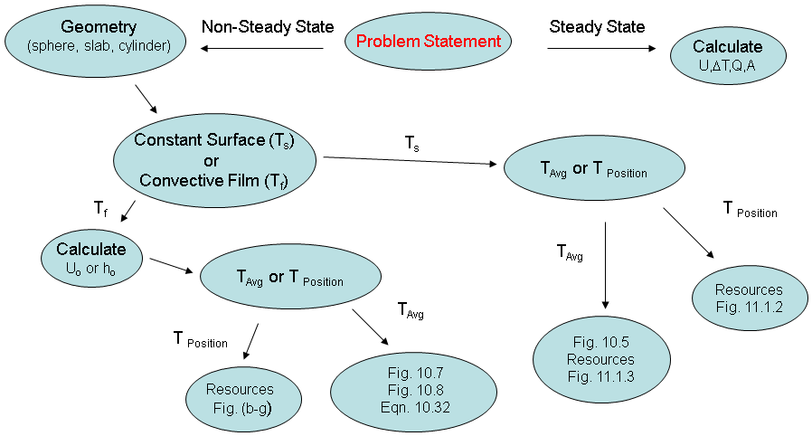

Ts – constant average temperature of surface

Tb – average temperature of the slab/sphere at time t or at position r

Ta – initial temperature of the slab/sphere

**Figure 10.5** Average temperatures during unsteady-state heating or cooling of a large slab, and infinitely long cylinder, or a sphere.

|  |  |
| --- | --- |
|  | For infinitely long (no end effects) cylinder:  For a sphere: |

Biot number:

**For constant surface**

**To get time, based on all temperatures**

Get θ 🡪 Fig 10.5 to Get F0 🡪 Get time

**To get average temperature, based on time**

Based on time, get F0 🡪 Fig 10.5 t go get θ

**For convective film**

**To get time, based on all temperatures**

Calculate Re and Pr 🡪 Get Nu 🡪 Get h 🡪 Get Bi && Get θ 🡪 Fig 10.7/10.8 to Get F0 🡪 Get time

**To get average temperature, based on time**

Calculate Re and Pr 🡪 Get Nu 🡪 Get h 🡪 Get Bi && Get F0 🡪 Fig 10.7/10.8 to get θ based on F0 and Bi

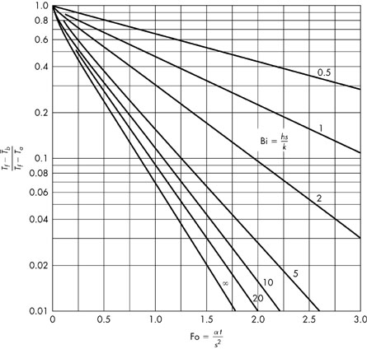

**Figure 10.7** Change with time of the average temperature of a slab with external convective resistance.

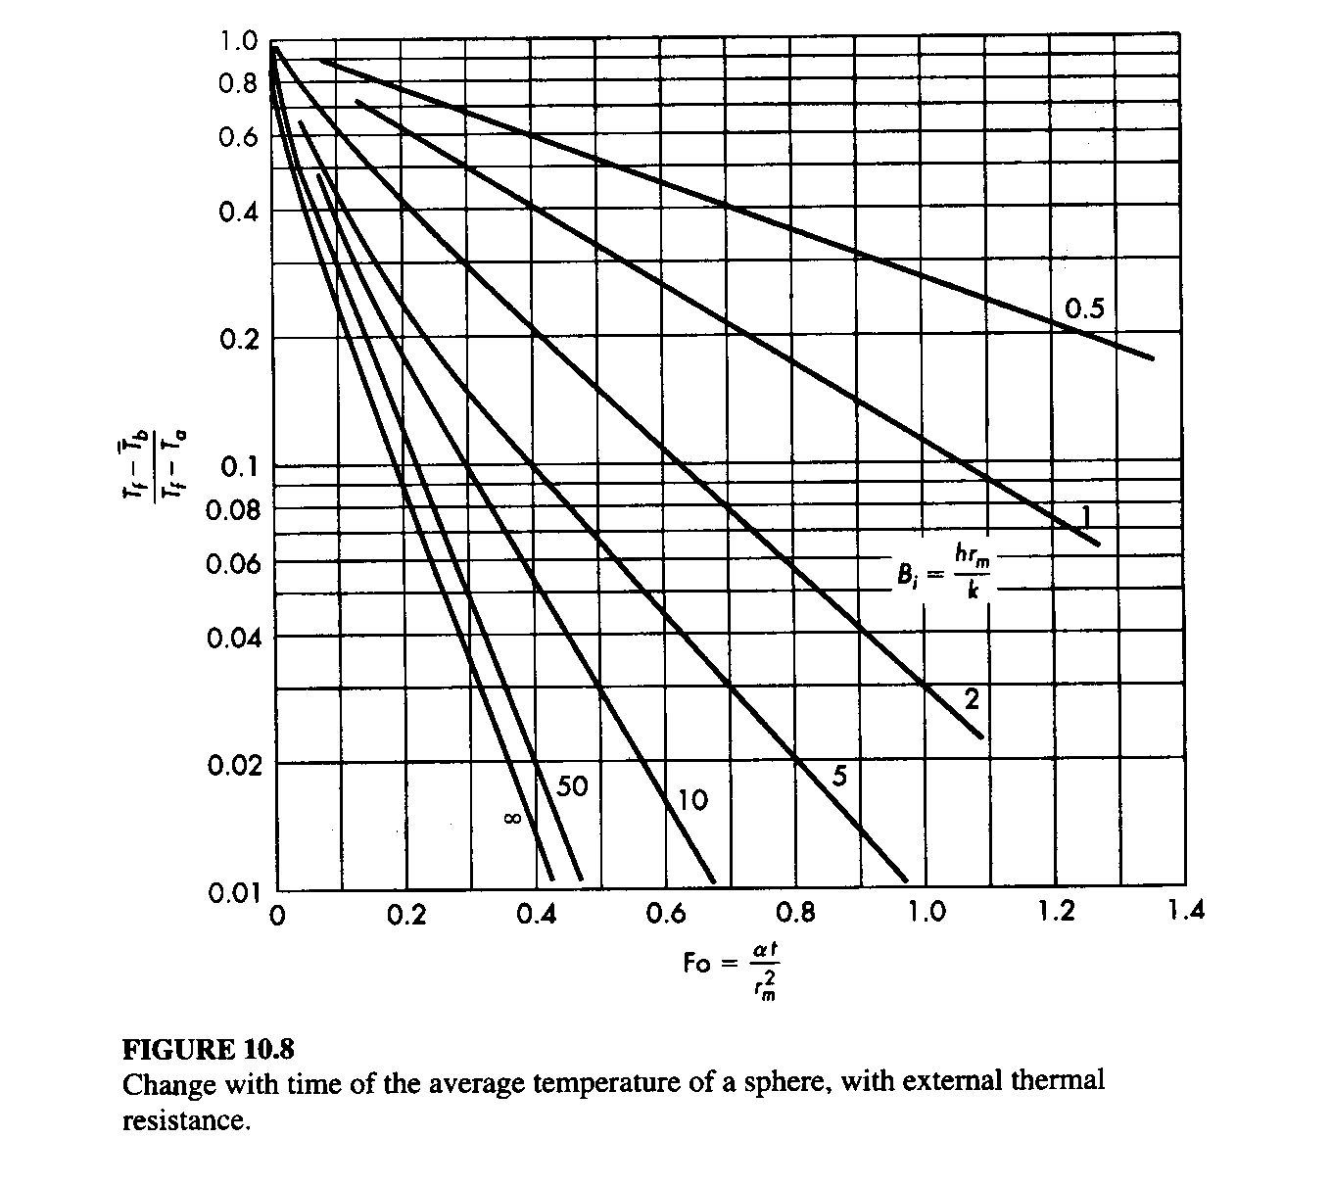

**Convection**

h is the individual heat transfer coefficient, obtained from empirical methods, power per area per temperature

For flow in pipes, 0.6<NPr<16700

|  |  |
| --- | --- |
|  | External forced convection normal to tubes |
|  | Flow past single sphere |

Where kw is the thermal conductivity of the pipe wall and is the wall thickness xw

**Concentric pipe**

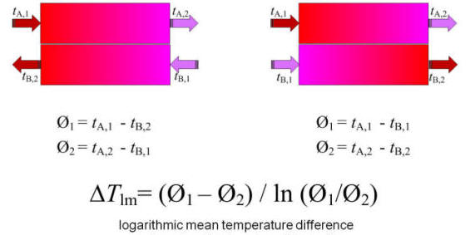

If

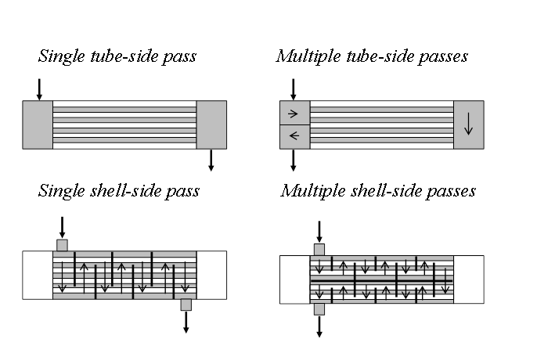

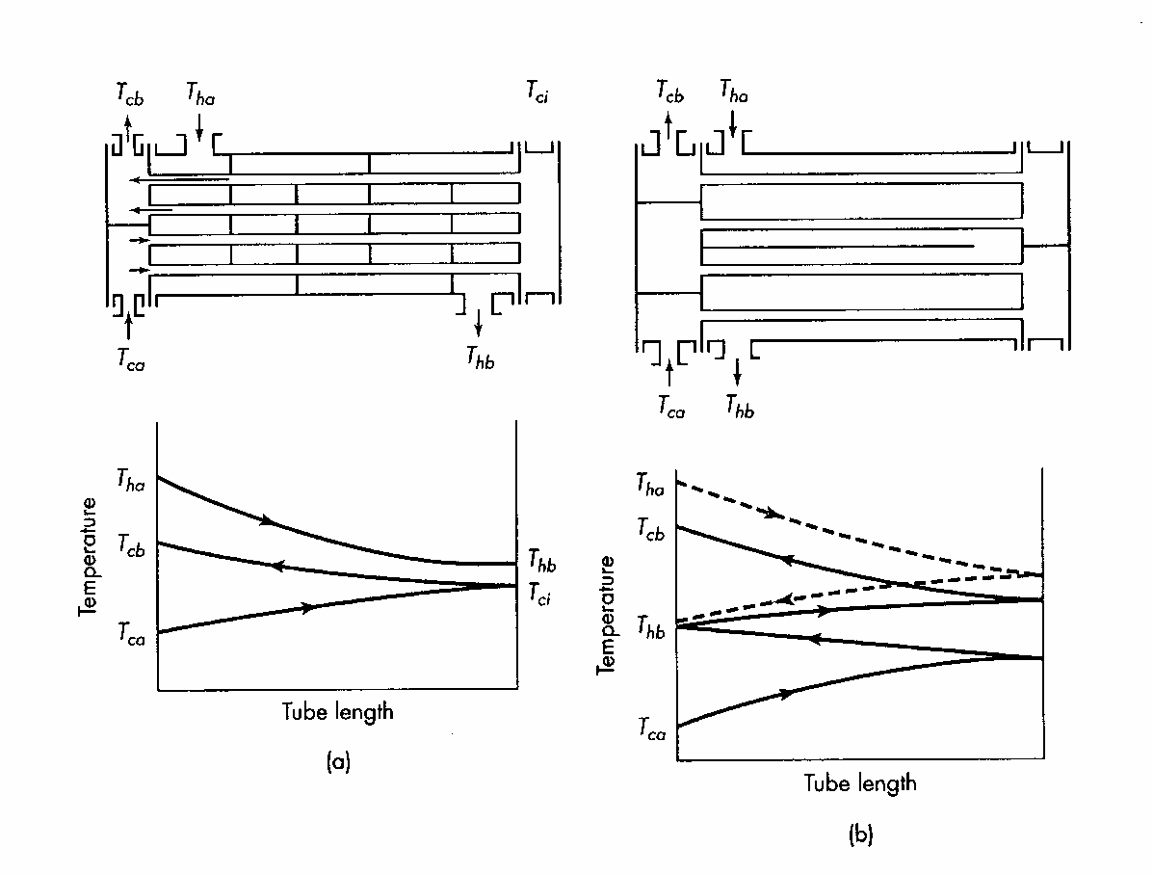

h- shell

c- tube

a- in

b- out

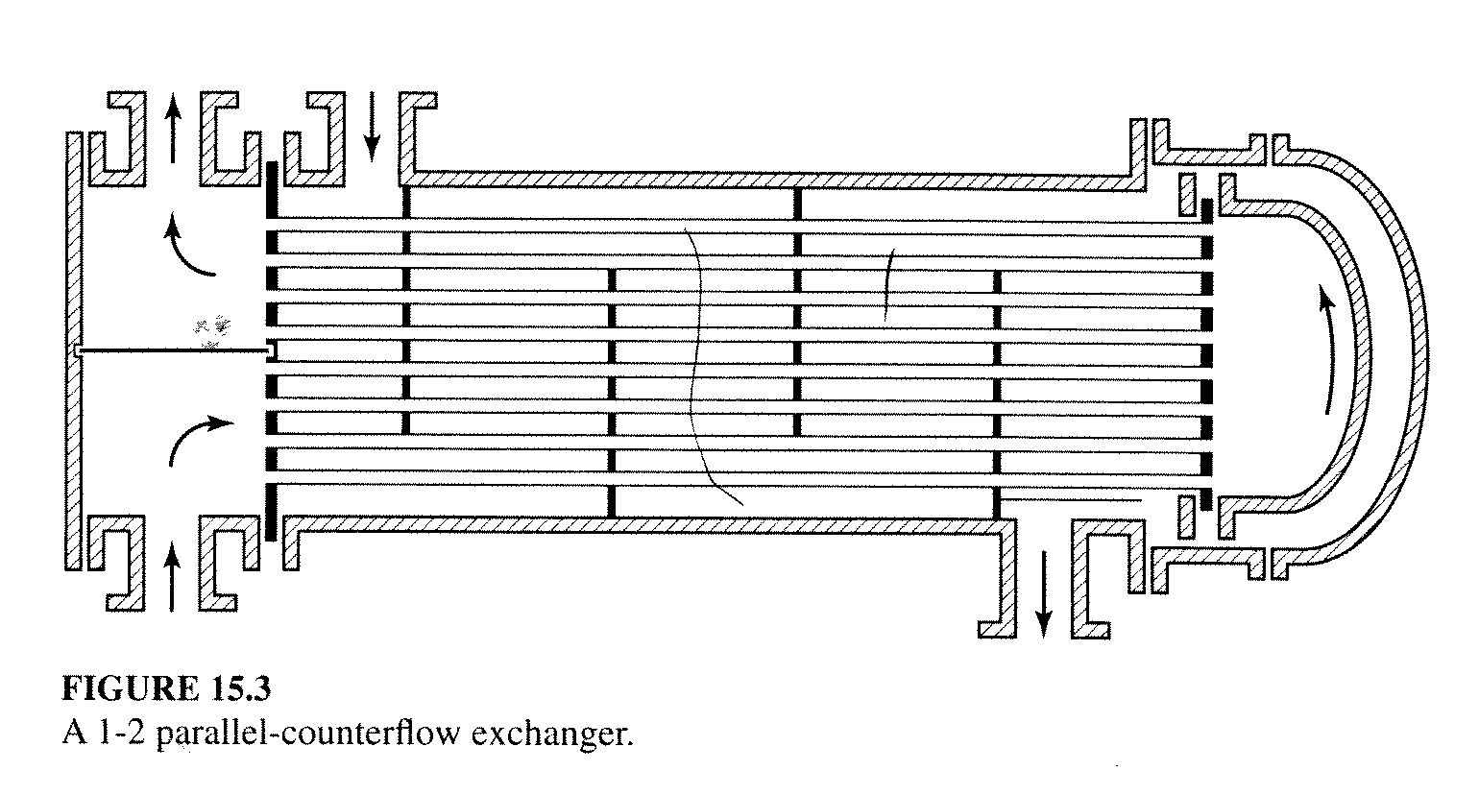

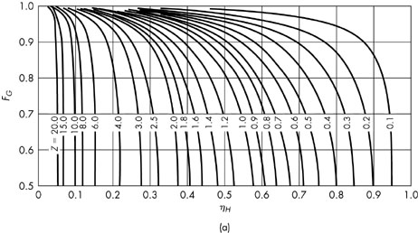

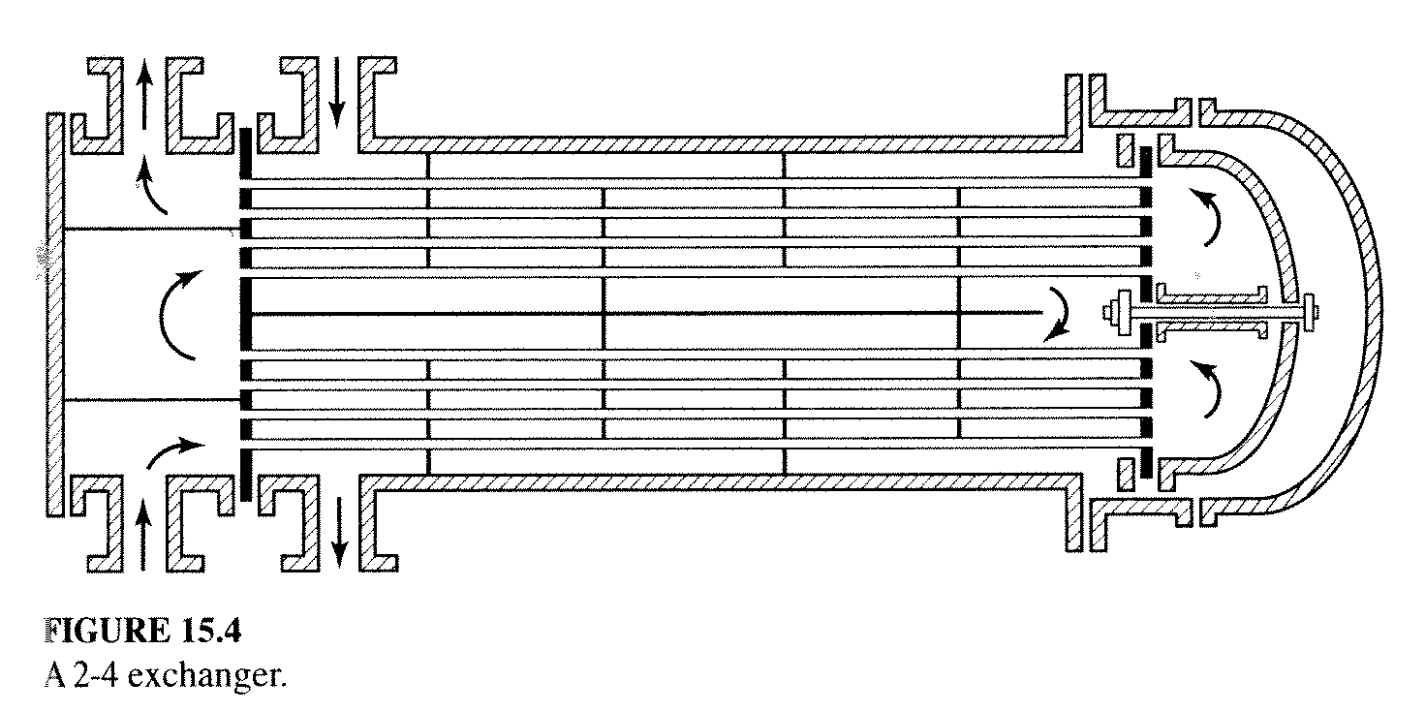

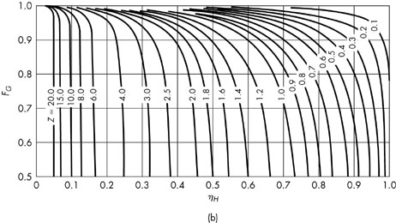

Radiation

Kirchoff’s law of thermal radiation at thermal equilibrium

for blackbody

Energy input Energy output

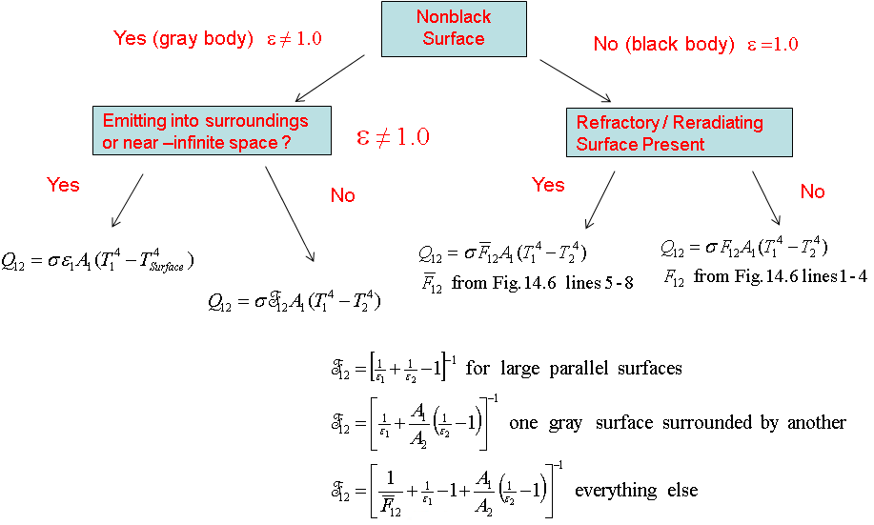

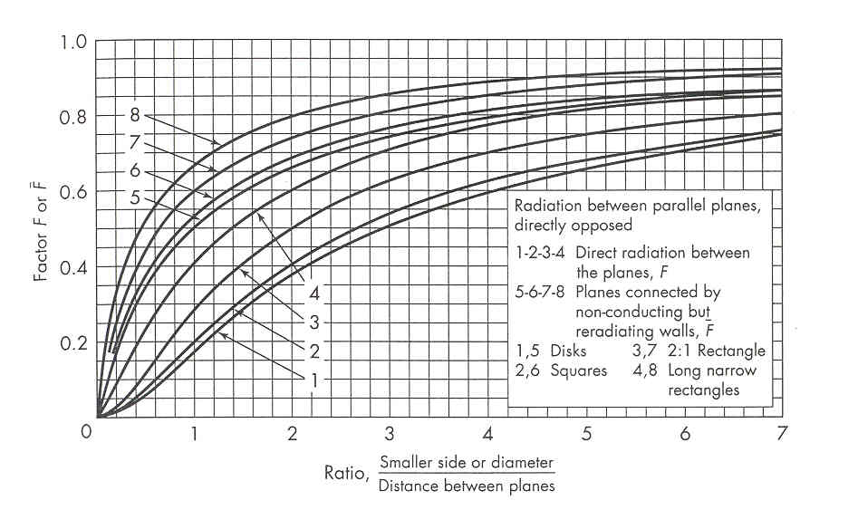

Conversion