Chemical Engineering 150A Second Midterm Review Sheet

Bernoulli

|  |  |
| --- | --- |
| $$h_{f}=4f\frac{l}{D}+\sum{K_{f}\frac{v^{2}}{2}}+\sum{\frac{∆P_{unit}}{ρ}}$$ Total friction = Skin friction + Fitting drag + Unit drag  Ke = 1 for filling the tank  Kc = 0.4 for emptying the tank  Pumps  Cavitation occurs when Pinlet < Pvap. To pump efficiently, Pinlet > Pvap |  |

Flow around immersed objects

Particles reach terminal velocity when $\sum{F}=F_{g}+F_{k}+F_{g}+F_{B}=0$

$$F_{g}=m_{p}g=V_{p}ρ_{p}g$$

$$F_{k}=\frac{C_{d}Aρu_{0}^{2}}{2}$$

$$F_{B}=A\left(P_{2}-P_{1}\right)=Aρ_{f}gh=V_{p}ρ_{f}$$

$$u_{t}=\sqrt{\frac{4g\left(ρ_{p}-ρ_{p}\right)D_{p}}{3C_{d}ρ_{f}}}$$

Cd is the drag coefficient; A is the projected area of the particle

$$Re=\frac{Du_{0}ρ}{μ}$$

|  |  |
| --- | --- |
| Stoke | Newton |
| Re<1 | 1000<Re<200000 |
| $$F_{k}=3πμDu_{0}$$ | $$F_{k}=0.055πμDu_{0}$$ |
| $$C_{d}=\frac{24}{Re}$$ | $$C_{d}≅0.44$$ |
| $$u_{t}=\frac{D_{p}^{2}\left(ρ_{p}-ρ_{f}\right)}{18μ}$$ | $$u_{t}=1.75\sqrt{\frac{gD_{p}\left(ρ_{p}-ρ_{f}\right)}{ρ_{f}}}$$ |
| $K={\left(\frac{gρ_{f}\left(ρ_{p}-ρ_{f}\right)}{μ^{2}}\right)}^{\frac{1}{3}}$ K < 2.6 | K > 68.9 |



**Fixed and fluidized bed**

$${∆P}_{Ergun}=\frac{150μv_{0}L_{b}}{∅_{s}^{2}D_{p}^{2}}\frac{{\left(1-ε\right)}^{2}}{{ ε}^{3}}+\frac{1.75ρv_{0}^{2}L_{b}}{∅_{s}D_{b}}\frac{\left(1-ε\right)}{ε^{3}}$$

$$h_{f}=\frac{{∆P}_{Ergun}}{ρ} L_{b}:bed length D_{p}: equivalent spherical particle diameter$$

$$D_{p}={\left(\frac{{6V}_{particle}}{π}\right)}^{\frac{1}{3}} ∅_{s}=\frac{a_{sphere}}{a_{particle}}=\frac{\frac{6}{D_{p}}}{\frac{S_{particle}}{V_{particle}}} ε=1-\frac{ρ_{bulk}}{ρ_{p}}$$

**Minimum fluidization velocity**

$$\left(ρ_{p}-ρ_{f}\right)g=\frac{ρ_{f}v_{mf}^{2}}{∅_{s}D_{p}ε_{mf}^{3}}\left[\frac{150\left(1-ε_{mf}\right)μ}{∅_{s}D_{p}ρ_{f}v_{mf}}+1.75\right]$$

$$∅_{s}ε_{mf}^{3}≅\frac{1}{14} L_{b,mf}=\frac{M_{p}}{A_{b}\left(1-ε_{mf}\right)ρ_{p}}$$

**Compressible flow**

|  |  |
| --- | --- |
| Isothermal flow | Isentropic flow |
| $$u_{sound}=\sqrt{\frac{zRT}{M}}$$ | $$u_{sound}=\sqrt{\frac{γRT}{M}}$$ |
| If flow is subsonic (normal), then pressure will drop from Pinlet to Pexit in pipe $$G^{2}=\frac{\frac{M}{RT}\left(P_{1}^{2}-P_{2}^{2}\right)}{4f\frac{L}{D}-{\ln\left[\frac{P_{2}}{P_{1}}\right]}^{2}}$$ Check that u2 (end of pipe) < usound to make sure flow is subsonic  If flow goes sonic (choked), pressure will not be able to drop to Pexit at the end $${G_{max}}^{2}=\frac{ρ_{1}P_{1}}{1+4f\frac{L}{D}+ln⁡(\frac{{ρ_{1}P}_{1}}{{G_{max}}^{2}})}$$ Check sonic flow [P2 (end of pipe) > Pexit]: | With enough $∆P$ a fluid can go sonic at the throat, and supersonic in diverging nozzle. $$N=\frac{v}{v_{sound}} γ=\frac{C_{P}}{C_{V}}$$ $$\frac{A}{A^{*}}=\frac{1}{Ma}{\left[\frac{2+\left(γ-1\right)N^{2}}{γ+1}\right]}^{\frac{γ+1}{2\left(γ-1\right)}}$$ $$\frac{T}{T_{0}}={\left[1+\frac{γ-1}{2}N^{2}\right]}^{-1}$$ $$\frac{P}{P_{0}}={\left[1+\frac{γ-1}{2}N^{2}\right]}^{\frac{γ}{1-γ}}$$ $$\frac{ρ}{ρ_{0}}={\left[1+\frac{γ-1}{2}N^{2}\right]}^{\frac{1}{1-γ}}$$ The maximum velocity at the throat is NMa = 1, there is a maximum flow rate |

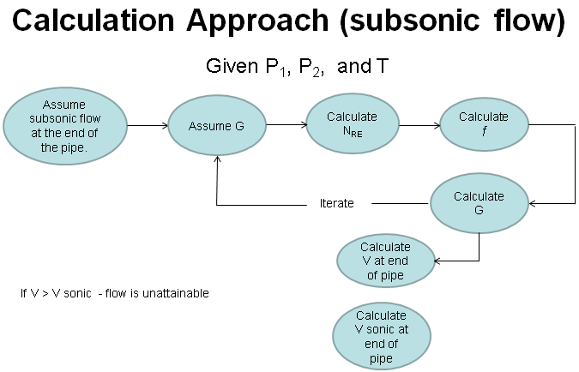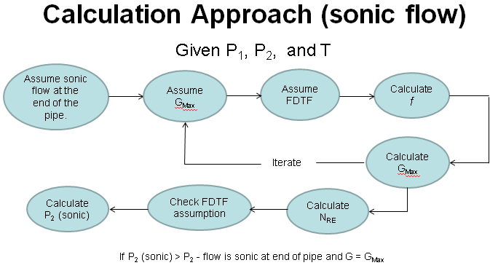

|  |  |
| --- | --- |
|  | Due to imperfections in nozzle, flow can drop off the isentropic pathway as it decelerates to v < vsound.  Normal shock tables relate conditions before and after a shock.   * Find Ma on isentropic table for the given shock location * Look up Ma as Ma1 on normal shock table, record ratios of post shock values Ma2, P2, and T2 relative to P1 and T1 before shock.   After normal shock, fluid will continue to travel on a new isentropic pathway   * Use isentropic flow table to find fictional A*, T0, and P0 that would have given you the same conditions as the post-chock conditions. * Use isentropic flow table to find conditions further down the nozzle relative to those A*, T0, and P0 values |

Compressors

$$Compressor ratio (C.R.)=\frac{P_{discharge}}{P_{suction}}$$

**Determine number of required centrifugal compressor stages:**

o Guideline (1) max compression ratio/stage ~3

o Guideline (2) max discharge temperature ~350°F

$${C.R.}_{total} ={\left({C.R.}_{stage}\right)}^{n}$$

$$Work per stage= \hat{W}=\frac{P_{1}γ}{ρ_{1}\left(γ-1\right)}\left[{\left(\frac{P_{2}}{P_{1}}\right)}^{\frac{γ-1}{γ}}-1\right]$$

$$P=\frac{n\hat{W}\dot{m}}{η}$$

**Method for using chart:**

1) Find starting point using initial P and T

2) Read off H at that point

3) Follow a line of constant S from starting point to ending P (of that stage)

4) Read off T and H at that end point

5)

6) Repeat for multiple stages, assuming perfect intercooling

**Calculate final temperature**

$$T_{2}=T_{1}{\left(\frac{P_{2}}{P_{1}}\right)}^{\frac{γ-1}{γ}}$$

$$\frac{\hat{W}}{η}=C_{P}∆T$$

Chart: start at Pend, Tend, go right by $∆H_{actual}-∆H_{ideal}$ to get T2, actual

**Polytropic compression**

$$Work per stage= \hat{W}=\frac{P_{1}n}{ρ_{1}\left(n-1\right)}\left[{\left(\frac{P_{2}}{P_{1}}\right)}^{\frac{n-1}{n}}-1\right]$$

$$P=\frac{j\hat{W}\dot{m}}{η} j is the number of stages$$

$$n=\frac{ηγ}{1+ηγ-γ}$$

Conversion

$$1 lb=453.6 g$$

$$1 in=2.54 cm$$

$$1 {ft}^{3}=7.48 gallon=28.32 L=0.02832 m^{3}$$

$$1 ft=0.3048 m=30.48 cm 1 m=3.28 ft$$

$$1 atm=1013250 \frac{dyn}{{cm}^{2}}=14.696 psi$$

$$1 dyn={10}^{-5}N= {10}^{-5}\frac{kg*m}{s^{2}}=1 \frac{g*cm}{s^{2}}=2.248*{10}^{-6}lbf$$

$$1 lbf=1 lbm*32\frac{ft}{s^{2}}$$

$$1 P= 0.100 \frac{kg}{m*s}=1 \frac{g}{cm*s}= 0.06720\frac{lb}{ft*s}$$

$$1 cP= 0.01 P=0.0006720\frac{lb}{ft*s}$$

$$1=32\frac{lbm*ft}{lbf*s^{2}}$$

$$^{o}R= ^{o}F+459.7$$

$$R=8.3145\frac{J}{mol*K}=1545.3\frac{ft*lbf}{ ^{o}R lb mol}$$

$$ρ_{H_{2}O}=1 \frac{g}{{cm}^{3}}=62.4 \frac{lbm}{{ft}^{3}}$$

$$1 Hp=745.7 W=550 \frac{ft*lbf}{s}$$

$$g=9.8 \frac{m}{s^{2}}=32.17 \frac{ft}{s^{2}}$$

$$1 Btu=1055.05 J 1\frac{Btu}{s}=1055.05 W=1.41485 Hp$$