**Navier-Stokes**

$$ρ\left(\frac{∂v_{x}}{∂t}+v_{x}\frac{∂v_{x}}{∂x}+v_{y}\frac{∂v_{x}}{∂y}+v_{z}\frac{∂v_{x}}{∂z}\right)=-\frac{∂p}{∂x}+μ\left(\frac{∂^{2}v_{x}}{∂x^{2}}+\frac{∂^{2}v_{x}}{∂y^{2}}+\frac{∂^{2}v_{x}}{∂z^{2}}\right)+ρg_{x}$$

$$ρ\left(\frac{∂v_{y}}{∂t}+v_{x}\frac{∂v_{y}}{∂x}+v_{y}\frac{∂v_{y}}{∂y}+v_{z}\frac{∂v_{y}}{∂z}\right)=-\frac{∂p}{∂y}+μ\left(\frac{∂^{2}v_{y}}{∂x^{2}}+\frac{∂^{2}v_{y}}{∂y^{2}}+\frac{∂^{2}v_{y}}{∂z^{2}}\right)+ρg_{y}$$

$$ρ\left(\frac{∂v_{z}}{∂t}+v_{x}\frac{∂v_{z}}{∂x}+v_{y}\frac{∂v_{z}}{∂y}+v_{z}\frac{∂v_{z}}{∂z}\right)=-\frac{∂p}{∂z}+μ\left(\frac{∂^{2}v_{z}}{∂x^{2}}+\frac{∂^{2}v_{z}}{∂y^{2}}+\frac{∂^{2}v_{z}}{∂z^{2}}\right)+ρg_{z}$$

**Equation of continuity**

|  |  |  |
| --- | --- | --- |
| \begin{align}   r:\ &\rho \left(\frac{\partial u_r}{\partial t} + u_r \frac{\partial u_r}{\partial r} +                    \frac{u_{\phi}}{r} \frac{\partial u_r}{\partial \phi} + u_z \frac{\partial u_r}{\partial z} - \frac{u_{\phi}^2}{r}\right) = {}\\       &-\frac{\partial p}{\partial r} + \mu \left[\frac{1}{r}\frac{\partial}{\partial r}\left(r \frac{\partial u_r}{\partial r}\right) +         \frac{1}{r^2}\frac{\partial^2 u_r}{\partial \phi^2} + \frac{\partial^2 u_r}{\partial z^2} - \frac{u_r}{r^2} -         \frac{2}{r^2}\frac{\partial u_\phi}{\partial \phi} \right] + \rho g_r \\   \phi:\ &\rho \left(\frac{\partial u_{\phi}}{\partial t} + u_r \frac{\partial u_{\phi}}{\partial r} +                       \frac{u_{\phi}}{r} \frac{\partial u_{\phi}}{\partial \phi} + u_z \frac{\partial u_{\phi}}{\partial z} + \frac{u_r u_{\phi}}{r}\right) = {}\\          &-\frac{1}{r}\frac{\partial p}{\partial \phi} + \mu \left[\frac{1}{r}\frac{\partial}{\partial r}\left(r \frac{\partial u_{\phi}}{\partial r}\right) +            \frac{1}{r^2}\frac{\partial^2 u_{\phi}}{\partial \phi^2} + \frac{\partial^2 u_{\phi}}{\partial z^2} + \frac{2}{r^2}\frac{\partial u_r}{\partial \phi} -            \frac{u_{\phi}}{r^2}\right] + \rho g_{\phi} \\   z:\ &\rho \left(\frac{\partial u_z}{\partial t} + u_r \frac{\partial u_z}{\partial r} + \frac{u_{\phi}}{r} \frac{\partial u_z}{\partial \phi} +                u_z \frac{\partial u_z}{\partial z}\right) = {}\\       &-\frac{\partial p}{\partial z} + \mu \left[\frac{1}{r}\frac{\partial}{\partial r}\left(r \frac{\partial u_z}{\partial r}\right) +         \frac{1}{r^2}\frac{\partial^2 u_z}{\partial \phi^2} + \frac{\partial^2 u_z}{\partial z^2}\right] + \rho g_z. \end{align} | | **Equation of continuity**  \frac{\partial\rho}{\partial t} + \frac{1}{r}\frac{\partial}{\partial r}\left(\rho r u_r\right) +   \frac{1}{r}\frac{\partial (\rho u_\phi)}{\partial \phi} + \frac{\partial (\rho u_z)}{\partial z}     = 0. |
| **Assumptions** | **Implications** | | |
| Flow is steady, d/dt = 0 | $$\frac{∂v_{x}}{∂t}, \frac{∂v_{y}}{∂t}, \frac{∂v_{z}}{∂t},\frac{∂v_{r}}{∂t},\frac{∂v_{∅}}{∂t}=0$$ | | |
| Plates are infinite in   1. x/y direction 2. x/z direction 3. y/z direction   Parallel flow | $v_{z}=0$ $v_{y}=0$ $v_{x}=0$ | | |
| Incompressible, Newtonian, laminar, constant properties |  | | |
| No pressure gradient |  | | |
| 2D | 1. , , 2. , , 3. , , | | |
| Gravity acts in the –x,-y, or -z direction | $$g_{x} or g_{y} or g_{z}= -g$$ $$The other two g components are therefore 0$$ | | |
| No slip at wall | $$v_{x}=v_{y}=v_{z}=0$$ | | |
| At the free surface (*x =* *h*), there is negligible shear | $\frac{∂v_{y}}{∂x}=0$ $\frac{∂v_{z}}{∂x}=0$ $\frac{∂v_{z}}{∂y}=0$ | | |
| The pipe is infinitely long in the z-direction, parallel flow | $$u_{r}=0 \frac{∂{(ru}_{r})}{∂r}=0$$ | | |
| The velocity field is axisymmetric with no swirl | *u*θ = 0 and all partial derivatives with respect to θ are zero | | |

**Conduction**

k – thermal conductivity, in units of power per distance per temperature (Btu / (hr ft F)

α – thermal diffusivity, in units of area per time (ft^2 / hour)

Thermal Resistance

$$q=\frac{∆T}{R}$$

Plane: $R=\frac{∆x}{kA}$ Cylinder: $R=\frac{∆r}{kA_{LM}}$ Sphere: $R=\frac{∆r}{kA_{GM}} A_{GM}=\sqrt{A_{1}A_{2}} A_{LM}=\frac{A_{2}-A_{1}}{\ln{\frac{A_{2}}{A_{1}}}}$

Series resistance: $R_{total}=\sum{R}$ Parallel resistance: $\frac{1}{R_{total}}=\sum{\frac{1}{R}}$

**Non-steady state conduction**

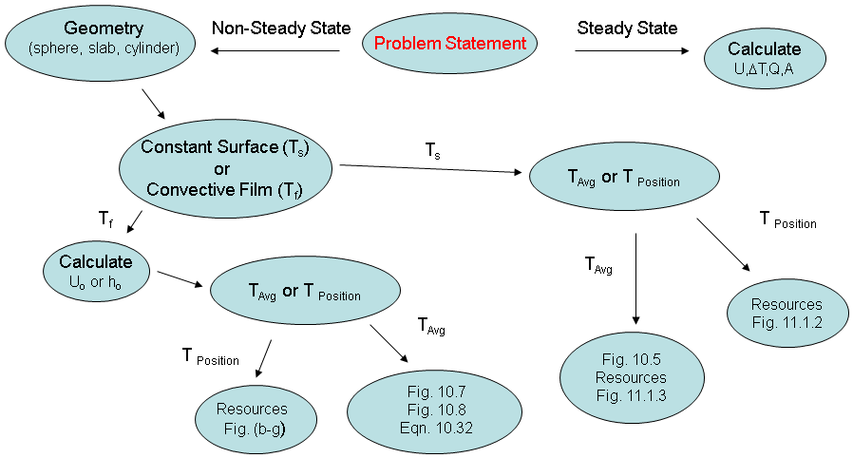

$$α=\frac{k}{ρC_{p}} F_{a}=\frac{αt_{T}}{r^{2}} (unitless)$$

Ts – constant average temperature of surface

Tb – average temperature of the slab/sphere at time t or at position r

Ta – initial temperature of the slab/sphere

**Figure 10.5** Average temperatures during unsteady-state heating or cooling of a large slab, and infinitely long cylinder, or a sphere.

|  |  |
| --- | --- |
|  | For infinitely long (no end effects) cylinder: $$θ=\frac{T_{s}-T_{b}}{T_{s}-T_{a}}$$ $$=0.692e^{-5.78F_{a}}+0.131e^{-30.5F_{a}}+0.0534e^{-74.9F_{a}}$$ For a sphere: $$θ=\frac{T_{s}-T_{b}}{T_{s}-T_{a}}$$ $$=0.608e^{-9.87F_{a}}+0.152e^{-39.5F_{a}}+0.0676e^{-88.8F_{a}}$$ |

Biot number: $B_{i}=\frac{convection}{conduction}=\frac{hs}{k} for a flat plate, where s is half of the thickness$

$$B_{i}=\frac{hr}{k}, for a sphere, where r is the radius$$

**For constant surface**

**To get time, based on all temperatures**

Get θ 🡪 Fig 10.5 to Get F0 🡪 Get time

**To get average temperature, based on time**

Based on time, get F0 🡪 Fig 10.5 t go get θ

**For convective film**

**To get time, based on all temperatures**

Calculate Re and Pr 🡪 Get Nu 🡪 Get h 🡪 Get Bi && Get θ 🡪 Fig 10.7/10.8 to Get F0 🡪 Get time

**To get average temperature, based on time**

Calculate Re and Pr 🡪 Get Nu 🡪 Get h 🡪 Get Bi && Get F0 🡪 Fig 10.7/10.8 to get θ based on F0 and Bi

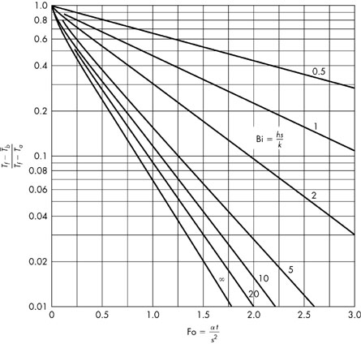

**Figure 10.7** Change with time of the average temperature of a slab with external convective resistance.

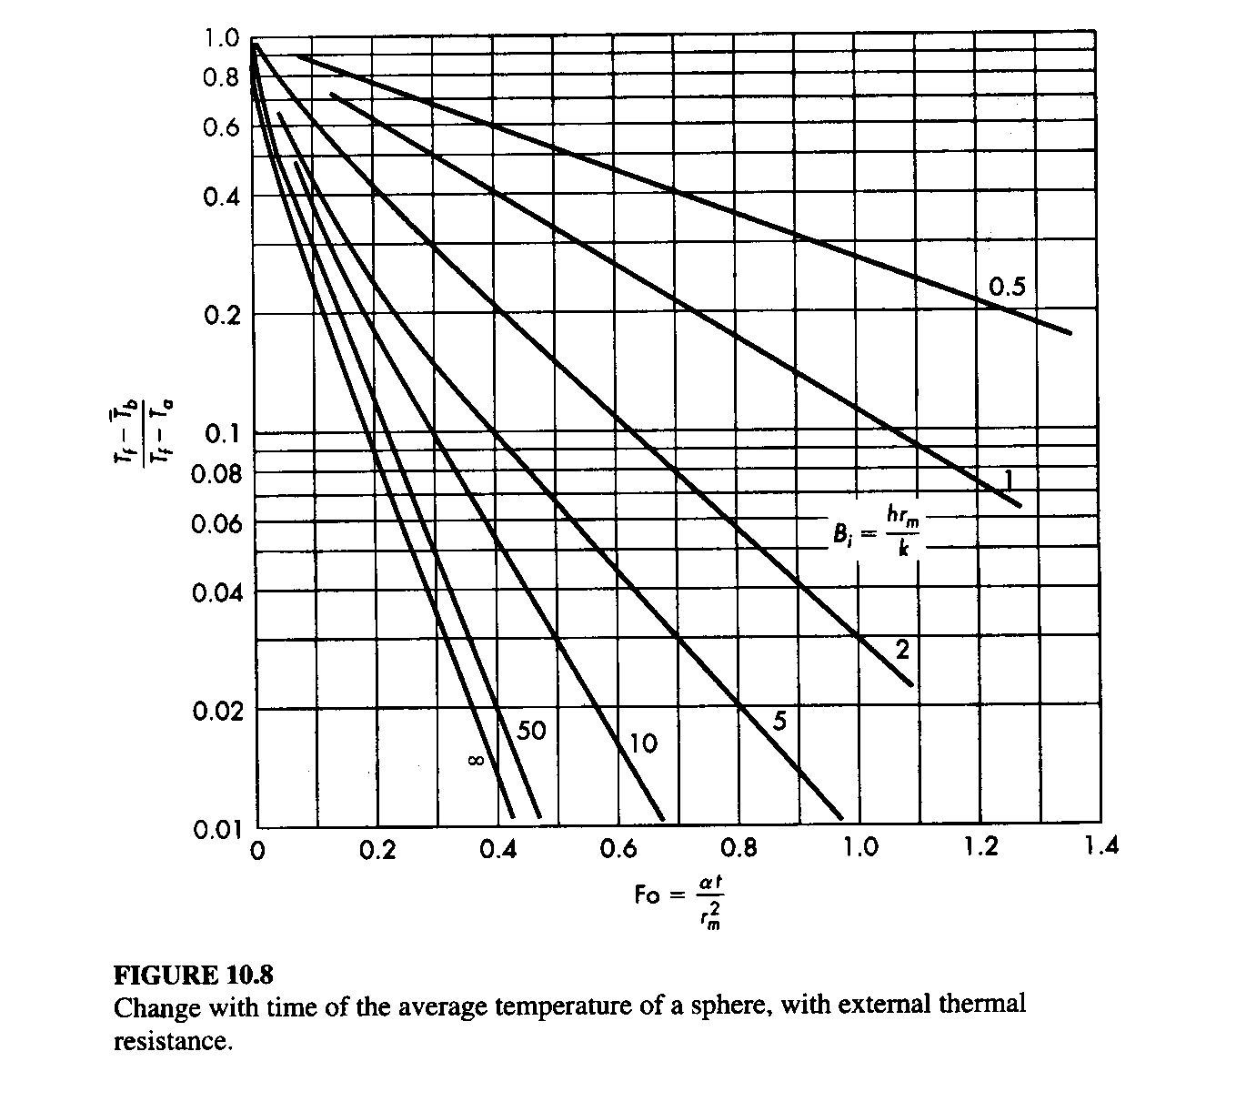

**Convection**

$$q=hA∆T$$

h is the individual heat transfer coefficient, obtained from empirical methods, power per area per temperature

$$N_{Nu}=\frac{hD}{k}=0.023N_{Re}^{0.8}N_{Pr}^{0.333}∅^{0.14}=0.023{\left(\frac{Dρv}{μ}\right)}^{0.8}{\left(\frac{C_{p}μ}{k}\right)}^{0.333}{\left(\frac{μ}{μ_{w}}\right)}^{0.14}$$

For flow in pipes, 0.6<NPr<16700

$$N_{St}N_{Pr}^{2/3}∅^{0.14}=\left(\frac{h}{C_{p}ρv}\right){\left(\frac{C_{p}μ}{k}\right)}^{2/3}{\left(\frac{μ}{μ_{w}}\right)}^{0.14}=0.023{\left(\frac{Dρv}{μ}\right)}^{-0.2}$$

$$j=0.023{\left(\frac{Dρv}{μ}\right)}^{-0.2}=\frac{f}{2}$$

|  |  |
| --- | --- |
|  | External forced convection normal to tubes $$N_{Pr}^{0.333}N_{Nu}=0.35+0.56N_{Re}^{0.52}$$ |
|  | Flow past single sphere $$N_{Nu}=2.0+0.6N_{Re}^{0.50}N_{Pr}^{0.333}$$ |

$$\frac{1}{U_{0}A_{0}}=\frac{1}{h_{0}A_{0}}+\frac{{∆r}_{insul}}{A_{lm}k_{insul}}+\frac{{∆r}_{pipe}}{A_{lm}k_{pipe}}+\frac{1}{h_{i}A_{i}}$$

$$\frac{1}{U_{0}}=\frac{D_{0}}{D_{i}h_{i}}+\frac{D_{0}ln⁡(D_{0}/D_{i)}}{2k_{w}}+\frac{1}{h_{0}}=\frac{D_{0}}{D_{i}h_{i}}+\frac{D_{0}(D_{0}-D_{i})}{D_{LM}2k_{w}}+\frac{1}{h_{0}}$$

Where kw is the thermal conductivity of the pipe wall and $\frac{D_{0}-D_{i}}{2}$ is the wall thickness xw

**Concentric pipe**

$$Q=UA∆T_{LM}$$

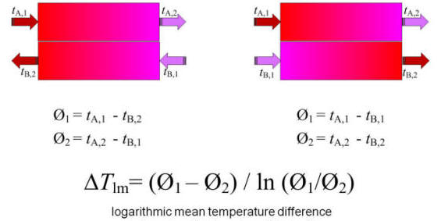

If $∅_{1}=∅_{2}, then ∆T_{LM}=∅_{1}$

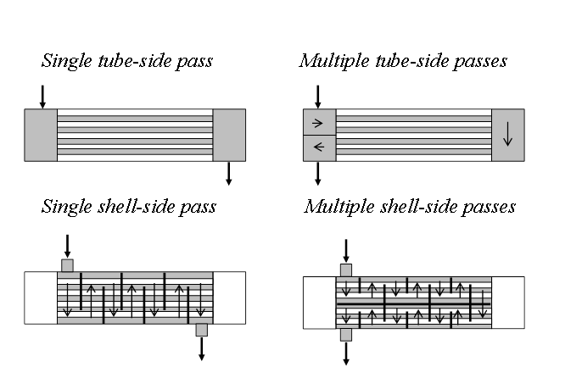

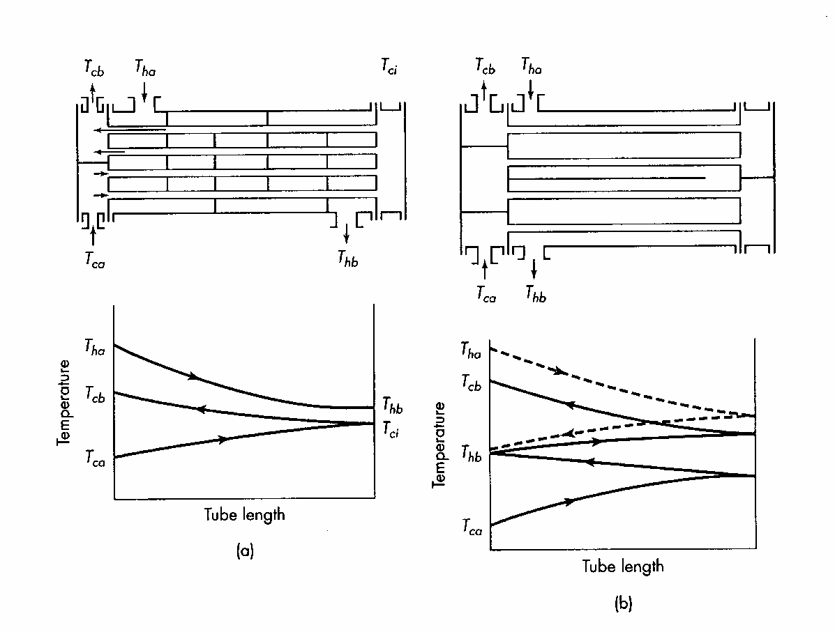

$$Z=\frac{T_{ha}-T_{hb}}{T_{cb}-T_{ca}} η=\frac{T_{ca}-T_{ca}}{T_{ha}-T_{ca}}$$

h- shell

c- tube

a- in

b- out

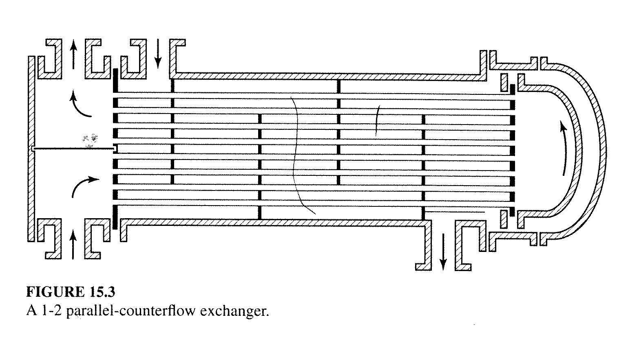

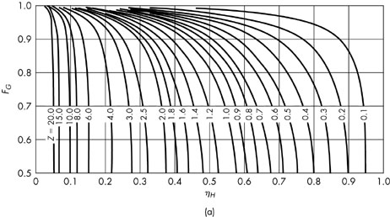

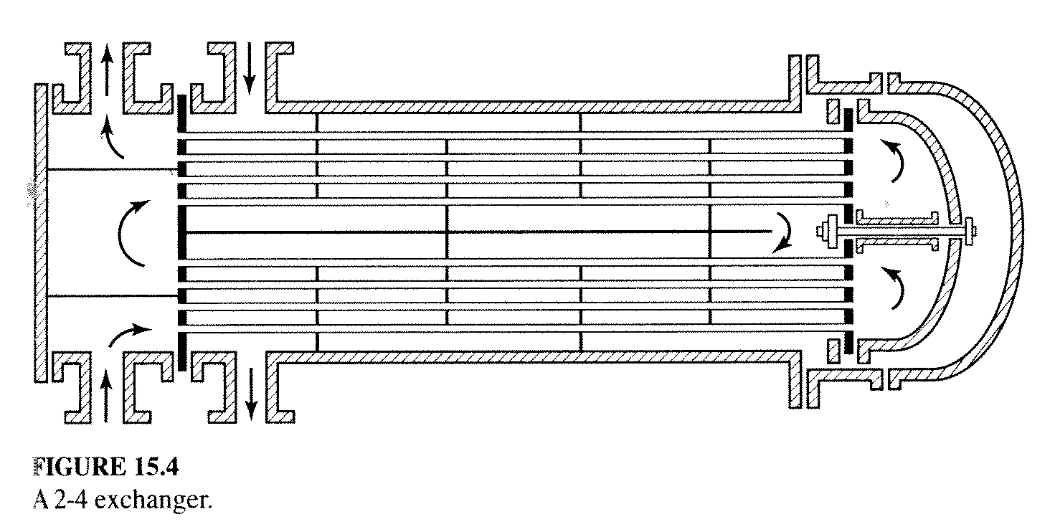

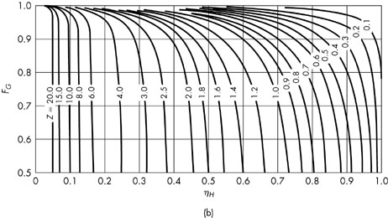

$$Q = U_{0}A_{0}F_{G}∆T_{LM}$$