|  |  |
| --- | --- |
| Liquid or solid mixture | Gas mixture |
|  |  |

**Fick’s law for molecular diffusion**

**Convection**

**Equimolar counterdiffusion in gases**

**If A is diffusing in stagnant, nondiffusing B,**

**Diffusion from a sphere**

**Diffusion through a conduit of nonuniform cross-sectional area**

Sherwood number

**Equation for diffusion in liquids**

**Diffusion in solids**

|  |  |
| --- | --- |
| Heat transfer | Mass transfer |
|  |  |

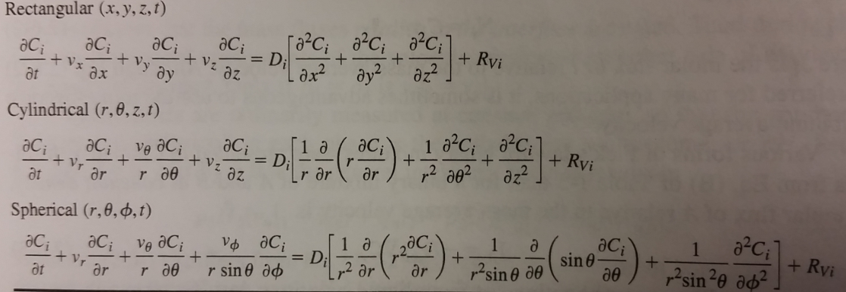

Initial conditions (IC)

Boundary conditions (BC)

Boundary conditions (BC)

Different types of fluxes

|  |  |  |
| --- | --- | --- |
|  | Mass flux (kg/s/m^2) | Molar flux (kg/s/m^2) |
| Relative to fixed coordinates |  |  |
| Relative to molar average velocity vm |  |  |
| Relative to mass average velocity v |  |  |
| Relations between the fluxes above | | |
|  |  |  |
|  |  |  |
|  |  |  |

General mole balance

**Spherical coordinates** (typical 1D transport)

If dilute or if counterdiffusive

If no reaction,

If steady state with reaction, if steady state without reaction,

Typical ICs, t=0, Typical BCs, r=R,

**Cartesian coordinates** (can be any dimension)

If dilute or if counterdiffusive

If no reaction,

If steady state with reaction, if steady state without reaction,

Typical ICs, t=0,

Typical BCs, z=something,

**Cylindrical coordinates** (can be 1D radial, or 2D axial)

If no reaction,

If steady state with reaction, if steady state without reaction,

Typical ICs, t=0,

Typical BCs, z or r=something,

**Equimolar counterdiffusion**

|  |  |
| --- | --- |
| If m’ small, gas phase controlling. | If m’’ big, gas phase controlling. |

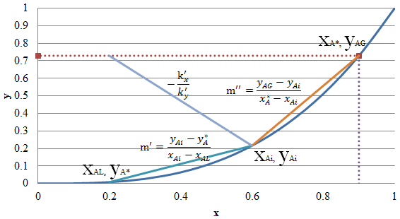

**A diffusing through stagnant B**

|  |  |
| --- | --- |
|  |  |

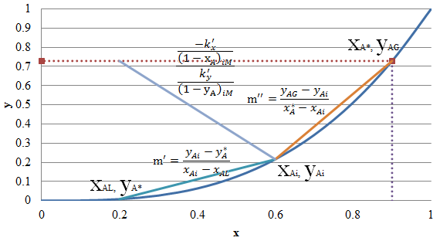

|  |  |
| --- | --- |
|  | Stripping (transfer of solute from L to V) |
|  | Absorption (transfer of solute from V to L) |

Plate absorption towers Packed column

For stripping (transfer of solute from L to V)

For absorption (transfer of solute from V to L)

a is the interfacial area in m2 per m3 volume of packed section S is the cross-sectional area of the tower.

if dilute

Concentrated solutions, stagnant B

Dilute solutions

Vapor-liquid separation

|  |  |
| --- | --- |
| http://upload.wikimedia.org/wikipedia/commons/thumb/4/47/Raoultov_zakon.png/220px-Raoultov_zakon.png | Raoult’s law |

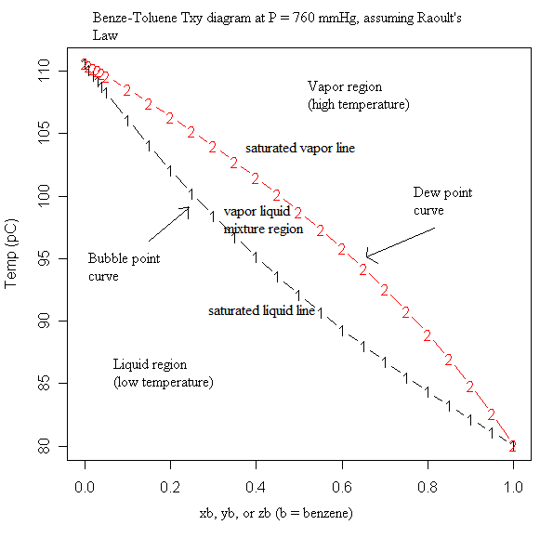

[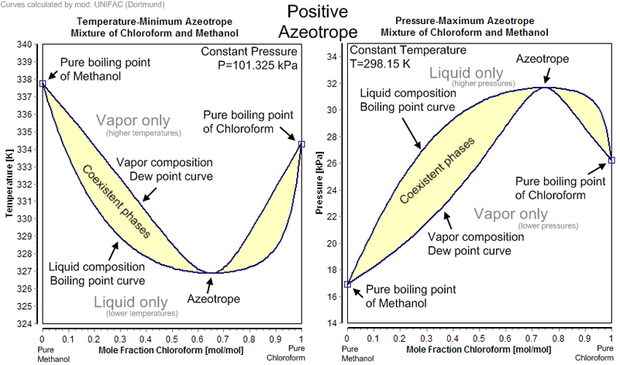](http://upload.wikimedia.org/wikipedia/commons/7/76/Positive_Azeotrope.png)

[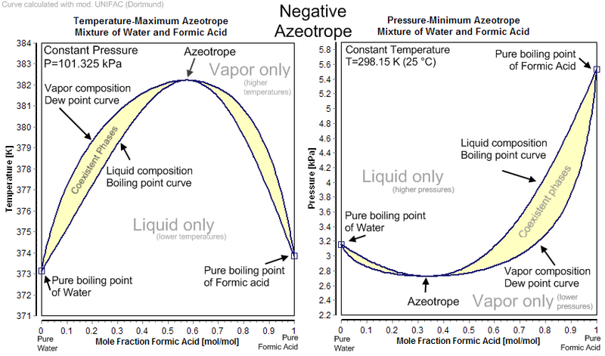](http://upload.wikimedia.org/wikipedia/commons/3/37/Negative_Azeotrope.png)

Relative volatility

**Flash distillation**

|  |  |  |  |  |  |  |  |  |  |  |
| --- | --- | --- | --- | --- | --- | --- | --- | --- | --- | --- |
|  | McCabe-Thiele Method   |  |  |  | | --- | --- | --- | |  |  | n-1 | |  | ↑ ↓  ↑ ↓ | n | |  | ↑ ↓  ↑ ↓ | n+1 | |
| Enriching section  **Enriching line will intersect y=x line at xD, y=xD**  Draw from xD, y=xD with the slope | Stripping section  **Enriching line will intersect y=x line at xW, y=xW**  Draw from xD, y=xD with the slope |

Two lines intersect at a point, connect that point to xF, y=xF to form q line

|  |  |
| --- | --- |
| http://upload.wikimedia.org/wikipedia/commons/d/d1/Q-line_slopes.png | H- enthalpy of feed  **q line will intersect y=x line at xF, y=xF** |
| 1. H at entrance condition > H at bubble point (and dew point), q < 0, slope < 1 2. H at entrance condition = H at dew point, q = 0, slope = 0 3. H at entrance condition < H at bubble point, 0<q<1, slope < 0 4. H at entrance condition = H at bubble point q=1, slope = infinite 5. H at entrance condition < H at dew point, q>1, slope > 1 |

|  |  |
| --- | --- |
| Reboiler is an equilibrium stage where there is both liquid and vapor leaving. Condenser is not because full condensation occurs. | x’ and y' represent pinch point, where the number of stages required becomes infinite, . Typically want R = 1.2 Rm ~ 1.5 Rm  R = infinity, slope of the enriching section = 1  Overall efficiency  Murphree tray efficiency  if the operating line is straight with slope m |

**Liquid-liquid and fluid-solid separations**

**Equilibrium relationships - 3 isotherms for adsorption**

|  |  |  |  |
| --- | --- | --- | --- |
| https://dl.sciencesocieties.org/images/publications/vzj/6/3/407fig1.jpeg | | | Freundlich is favorable, Langmuir is strongly favorable. |
|  |  |  |

Washing

Analogous to stripping where U (underflows) 🡪 O (overflows)

|  |  |  |  |
| --- | --- | --- | --- |
| V1, x1  ←  →  L0, N0, y0, B |  | | V2, x2  ←  →  L1, N1, y1, B |
|  | | | |
|  | |  | |

