**Chemical Engineering 162 First Midterm Review**

Formulating a control strategy

**Control objectives**

**Manipulated input**- one that can be adjusted by the control system

**Disturbance input**- one that affects the process outputs but that cannot be adjusted by the control system

**Output**- measured or unmeasured

**Constraints**- soft or hard

**Operating characteristics**- continuous, batch, semicontinuous/semibatch

**Safety, environmental, and economic considerations**

**Control structure**

**Positive gain**- an increase in a process input leads to an increase in the process output

**Negative gain**- an increase in a process input leads to a decrease in the process output

**Fail-closed / air-to-open**- if signal is lost, valve will close

**Fail-open / air-to-close**- if signal is lost, valve will open

**Feedforward**- measures disturbance variable and sends this value to a controller, which adjusts the manipulated variable

**Feedback**- measures the output variable, compares the value to the desired output value, and uses this information to adjust the manipulated variable

**Setpoint**- desired value of the measured process output

**Mass balances**

$$\frac{dV}{dt}=F_{1}-F_{2} \frac{dh}{dt}=\frac{F_{1}-F_{2}}{A}$$

$$\frac{dM}{dt}=\dot{m_{in}}-\dot{m_{out}}$$

$$\frac{dn}{dt}=q_{i}-q=\frac{V}{RT}\frac{dP}{dt} \frac{dP}{dt}=\frac{RT}{V}\left(q_{i}-q\right) q=β(P-P_{h})$$

$$\dot{x}=f\left(x,u,p\right) \dot{y}=g\left(x,u,p\right)$$

x is the vector of state variables, u is the vector of input variables, p is the vector of parameters, y is the vector of output

**Energy balances**

$$\frac{dT}{dt}=\frac{F_{i}}{V}\left(T_{i}-T\right)+\frac{Q}{VρC_{P}}$$

$$u=Q-Q_{s} y=T-T_{s}$$

$$τ_{p}\frac{dy}{dt}=-y+k_{p}u$$

$$\frac{dx}{dt}=f\left(x\right) f\left(x\right)=f\left(x_{s}\right)+{\left.\frac{∂f}{∂x}\left(x-x_{s}\right)\right|}_{x_{s}}$$

$$f\left(x,u\right)=f\left(x_{s},u_{s}\right)+{\left.\frac{∂f}{∂x}\left(x-x_{s}\right)\right|}_{x_{s}}+{\left.\frac{∂f}{∂u}\left(u-u_{s}\right)\right|}_{u_{s}}$$

$${\dot{x}}^{'}=Ax^{'}+Bu^{'}$$

$${\dot{y}}^{'}=Cx^{'}+Du^{'}$$

$$A_{ij}=\frac{∂f_{i}}{∂x_{j}} B_{ij}=\frac{∂f_{i}}{∂u_{j}} C_{ij}=\frac{∂g_{i}}{∂x_{j}} D_{ij}=\frac{∂g_{i}}{∂u_{j}}$$

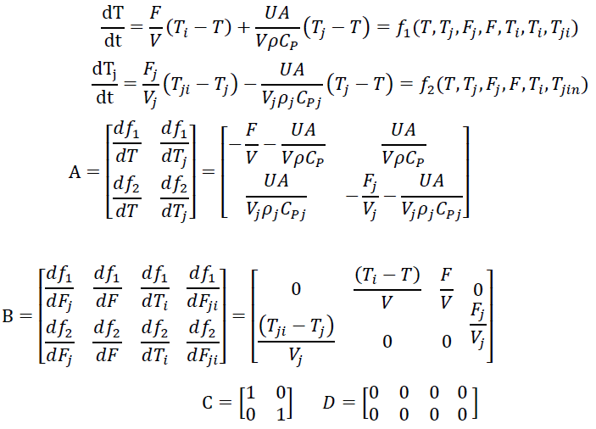

Eigenvalue

$$\det\left(λI-A\right)=0 λ=\frac{a_{11}+a_{22}±\sqrt{{\left(a_{11}+a_{22}\right)}^{2}-4\left(a_{11}a_{22}-a_{12}a_{21}\right)}}{2}$$

Laplace Transform

$$L\left[f\left(t\right)\right]=F\left(s\right)=\int_{0}^{∞}{f\left(t\right)e^{-st}dt}$$

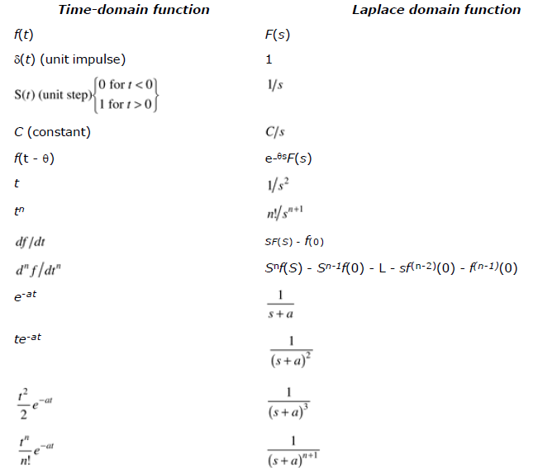

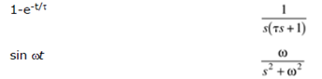

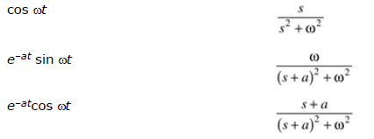

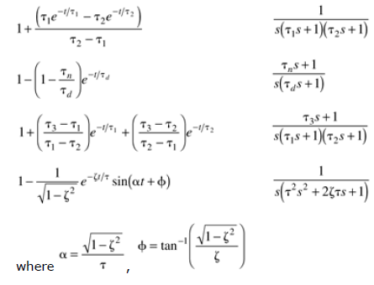

$$final value theorem: \lim_{t→∞}{f\left(t\right)}=\lim_{s→0}\left[sF\left(s\right)\right]$$

$$initial value theorem: \lim_{t→0}{f\left(t\right)}=\lim_{s→∞}\left[sF\left(s\right)\right]$$

$$\frac{d^{n}y}{dt^{n}}+a_{n-1}\frac{d^{n-1}y}{dt^{n-1}}+…+a_{0}y=b_{n-1}\frac{d^{n-1}u}{dt^{n-1}}+…+b_{0}u$$

$$L\left[\frac{d^{n}y}{dt^{n}}\right]=s^{n}Y\left(s\right)$$

$$Y\left(s\right)=\frac{N\left(s\right)}{D\left(s\right)}=\frac{C_{1}}{s-a}+\frac{C_{2}}{s-b}+… y\left(t\right)=C_{1}e^{-at}+C_{2}e^{-bt}+…$$

$$Y\left(s\right)=\frac{C_{1}}{s-a}+\frac{C_{2}}{{\left(s-a\right)}^{2}}+… y\left(t\right)=C_{1}e^{-at}+C_{2}te^{-at}+\frac{C_{3}}{2}t^{2}e^{-at}…$$

Transfer functions

$$Y\left(s\right)=g\left(s\right)U\left(s\right) g\left(s\right)=\frac{Y\left(s\right)}{U\left(s\right)}$$

The roots of numerator are zeroes.

The roots of denominator are poles.