* DNA: information, RNA:info or operation, proteins: operation, glycans (carbs)
* fxn of distance 🡪 pairwise interxns b/w molecules in 2 substances
* covalent bond (sharing elecs) stronger than noncovalent, which det energy of interxn
* any 2 neutral atoms – induced dipole, VdW interxn (+=London)
* **VdW** contact: dist=added VdW radii; stabilization energy assoc.
* O:1.5Å,Cl:1.9Å,N:1.6Å,S:1.8Å,C:1.7Å,P:1.8Å,H:1.2Å
* VdW repulsion 🡪 steric effects
* ion pair=salt bridge
* 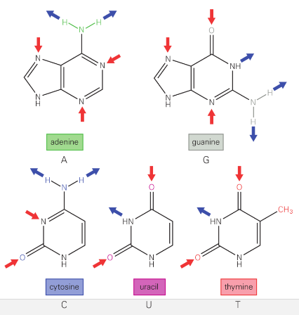vacuum->H2O: 80xreduced ES E
* vacuum->protein:2xred,but v high E penalty from sep. ion+H2O
* DNA&RNA:nucleotide polymers
* 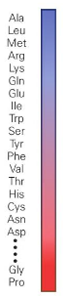sugar is a pentose
* phosphodiester linkage
* DNA primarily stabilized by base stacking: ES + VdW
* -&+ areas overlap, 3.4Å rise/BP

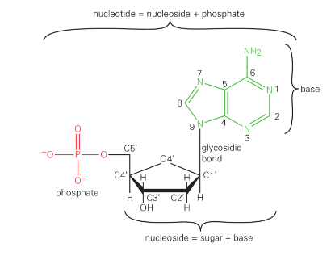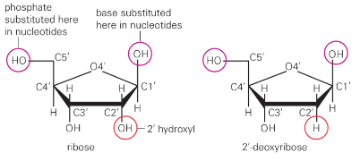

* N w/LP outside plane of ring = e- pair donor = Lewis *base*
* purine: fused 5-6 ring, pyrimidine 5 mem
* DNA: AC, GT; RNA: AC, G
* sugar H1’ and base C6, C8 (pyrimidine/purine) in trans around glycosidic bond = anti conf of base. If cis, ‘syn’
* in some ZDNA and RNA loops, syn is better stacking
* C5, out of plane of ring: if on the same side as out of plane atom on 5-mem ring (sugar)
* protein: 3 mRNA nucleotides->1 AA
* His ½ chance of protonation (+chg)
* glycine containing chains v flexible
* h/e backbone hydrophilic
* α: RH twist; H-bonds b/w CO and NH of 2 residues; compensate for H2O bonds
* β: bonds across strands
* antiparallel β: narrowly spaced H bonds alt w widely spaced
* RNA can also form double helix
* energetic penalty for base mismatch in DNA
* **major groove**: wider, accessible; regulatory proteins access nucleotide fxnl grps on edge of groove.
* Narrow **minor groove**: fxnl groups inside groove
* double helix ppl strxr for DNA/RNA
* polarization of pbases increase stacking interxn strength
* ribose ring has alt conf by sugar pucker;
* DNA only has A form (C3’ endo) and B form (C2’ endo)
* RNA **can’t** adopt C2’ endo sugar pucker b/c OH group on C2’ and phosphate on C3’; does C3’ endo
* Watson-Crick: B-form: HP are perp to axis of helix; major/minor grv
* B-form helix rises 34Å/turn, 10-11 bp/turn; favorable VdW interxns, tight packing
* RNA polymerase (initiates transcriptions) – **transcription factors** – recognize target sites on DNA by finding edges of bp in major/minor grooves. 4 types of interxn: H-bond donors, acceptors, hydrophobic groups, NP hydrogen atoms
* **major** groove: proteins binding to sequence specific regions of DNA in major grooves
* RNA forms A-form helix: different stxr. bp away from perpendicular and center of helix; major groove is deeper and narrower than B-form counterpart, and vv for minor groove
* genetic info in DNA, better chem stability with better sequence specific protein accessibility d/t H sub for OH and B-form strxr
* Z-form is a left-handed helix (unlike A,B)
* W-C pairing, but A can sub G, and T for C, but can still make **Z-form work**
* 12 bp/turn in Z-form, alternating pucker (2’ and 3’ endo)
* G (or A) in syn, and C (or T) in anti
* B form not strictly required; can change locally while preserving double helix: e.g. b/c of small molecules, via intercalation (molec goes b/w bp of DNA and stacks w bases)
* DNA **supercoiling** when ends are constrained (over/underwound)
* W=L-T
* RNA polymerase-local supercoiling
* W-C standard BP: width, angle
* noncoding RNA: nonstandard ok
* used as recognition elts for proteins, ligands, ion binding, nucleic acids
* G-U wobble BP most common non-WC bp

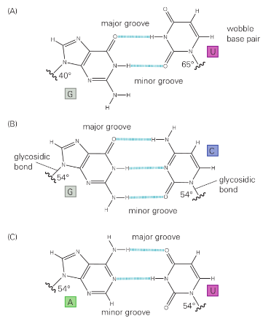

* codon/anticodon interxns; RNA in all organisms has GU wobble bp
* Hoogsteen bp: H0bond b/w WC base pairing (central) edge of one base, major groove edge of another
* Hoogsteen bp form when ssDNA or RNA enter major groove of dsDNA/RNA; results in triple helix.
* **hairpin loops**: RNA strand folds back in on itself, stabilized by complementary base pairing
* GNRA tetraloop: G=guanine,N=(any) nucleotide,R=purine,A=adenine
* GNRA: recognition elt (3 bases outside)
* metal ion interxns help fold RNA
* interxns like Hoogsteen bp, A-minor motif stabilize RNA tertiary strxr
* A-minor motif: using minor groove edge of adenine-incoming strand can stack its own bases favorably
* 2 classes of proteins: water-soluble or membrane.
* Water-soluble include *globular proteins (hydrophobic sidechains inside, hydrophilic outside), fibrous, and intrinsically disordered; *ch 4
* 1o strxr: AA sequence. 2o: local strxr, α and β strands w loops connecting. 3o: protein fold. 4o: subunit association
* 2o strxrs aren’t stable b/c of hydrophobic effect

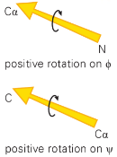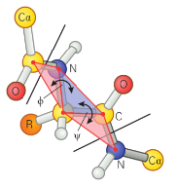

* Ramachandran diagram: VdW repulsion>>>H-bonding

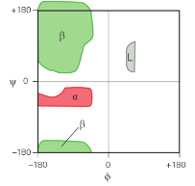

* α=phi,psi values which when repeated form this helix,β,L=left-handed helix, rare in proteins
* generally, for α helix, φ≈ -60ᵒ,ψ≈ -40ᵒ
* β sheet: φ≈ -120ᵒ,ψ≈ +120ᵒ
* ideal **α helix** has 3.6 residues/turn; H-bonds b/w C=O on 1st residue n and NH of n+4 (positions)- just pts in diag
* **π**=n+5, big enough for a hole
* **310**=n+3, too tightly packed backbone; 3 residues/turn, 10 atoms b/w H-bond donor and acceptor
* both of 2 above only on ends and rare
* LH α helix for L AA’s unfavorable b/c sidechains close to C=O
* 3-5 res ^ can occur
* loop region can have mix of angle combinations in α,β regions; not necessarily either strxr tho
* β hairpin loop=reverse turn=4-6 residues differing by phi,psi angles of the two central residues in the turn
* have specific pattern b/c backbone isn’t completely flexible; use Ramachandran conf while turning 180
* α helices usually on outside of protein; 1 side in soln, other hydrophobic
* If 1 side -phobic, 1 –philic: amphipathic
* but α helix can be buried or completely exposed or have hydrophobic side facing out
* β sheet on surface of proteins usually has amphipathic β strands
* dist bw alternate Cα atoms in β strand about 6.5Å
* typical protein domain ~20Å wide
* some AA pref in α helix (diff in E of contacts bw sidechain and backbone); alanine best. Leucine>valine.
* Glycine (stability issue bc flexible) & proline (prevents N from H-bonding and steric hindrance to helix) bad
* some AAs preferred at ends of helices to help w NH and C=O H-bonding requirements-glycine.
* β sheet: local interxns bw neighboring sidechains > stability
* combine few 2ᵒ strxrs🡪motifs: packing sidechains of adjacent α/β near e/o
* **helix-turn-helix** motif: often used to recognize specific sequences; insert into major groove of DNA
* **helix-loop-helix** motif: EF hand; calcium binding (calmodulin)
* antiparallel β strands: **Greek key** motif; hairpin turn
* **β-α-β motif**: in parallel β sheets
* amphipathic α helices🡪coiled coils when separate from other strxrs
* coiled coil=supercoil=superhelix
* LH superhelical structure
* ^of 2 RH α helices: effective residues/turn now 3.5🡪heptad repeat, a-g. a,d hydrophobic (leucine, valine, isoleucine)
* d res sidechain against every 2nd turn of α helices; a also hydrophobic
* can have polar residues- salt bridges
* antiparallel: a on one interxt w d on other; parallel: a<->a, d<->d

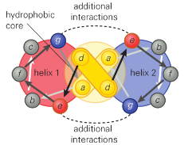

* also 4 helix bundle, globin fold
* ridges into grooves pattern: surface det
* α/β strxr: parallel/mixed β sheet surrounded by α helices
* ^where twisted parallel β strands in a barrel, α on outside: TIM barrel
* Other: open β sheet, e.g. Rossman fold
* α on both sides of β: open sheet strxr
* catalytic sites often inside core of fold
* binding sites at interfaces bw domains
* membrane proteins have transmembrane segment
* 25 res to span lipid bilayer 35Å thick
* β sheet spanning membrane always forms closed barrels w no loose edge w uncompensated H bonds
* loss H bond partner destabilize protein
* hydrophobic res in clear majority in transmemberane helices
* hydrophobicity scale: water/octanol; partition H2O->water; txfer free E
* **thermodynamic hypothesis** in protein folding: native strxr (folding in physio condn) based on optimized intrinsic molec properties: seq det strxr
* i.e. ea protein can fold spontaneously
* first est by **Anfinsen** experiment
* ribonuclease A catalyzes breakdown of RNA. Only when in native strxr
* 8 cysteines. Break w reducing agent, like mercaptoethanol, then unfold w denaturing agent like urea
* urea-v polar, affect balance of H bonds in water & thus hydrophobic effect
* Works: 1.add urea,mercapt. 2. remove urea,add O2 (disulfide)
* Doesn’t (1% activity required, which makes sense w 105 possible disulfide bond combos & 1 right): 1. add urea, mercapt. 2. add O2. 3. remove urea
* globin fold: myoglobin’s 8 α helices
* ^preserved across species w diff seq
* AA subst **BLOSUM matrix**
* Sij: freq w which ith replaced by jth type of AA; +=more than random, i.e. favored by evolution
* if too similar, artificially high scores

; ;

;

ea col, #i,j together: ; add for fij

2 in Sij ensure that Lij=2🡪Sij=2

* Sij is additive
* tryptophan: 45x more likely to be conserved than if random;lg aromatic ring useful for hydrophobic core
* selected against subst w evolution
* arginine on surface of proteins, can be replaced; likely sub by lysine, rare Trp
* proteins evolve w common stxrl core
* rms deviation in posn of Cα bw common cores
* proteins >50% ID have <1Å rms
* changes in protein strxr rel to drift in AA sequence
* catalysts p similar
* sequence comparison only useful when length is >50 residues; stxr similar for >25% sequence identity w such seg
* AA have pref for certain enviro in folded proteins
* fold-recognition algorithm: uses known 3d info of proteins against new AA + properties
* 3D-1D profile method is 1 such alg
* 1D: environmental class. 3D: axes

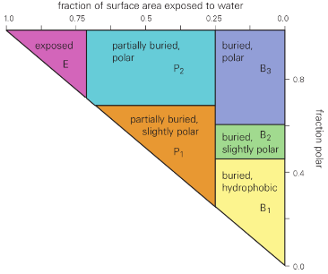

* enviro scores result: Sij = log(Pij)
* matches based on strxr
* CATH by folds; topology class broad
* highest populated family: Rossman fold
* protein change ok in core:λ repressor
* probabilistic binding:

 ; 

* if change in entropy/multiplicity:



* **dU = dq + dw**
* **dw=-Pext dV=F dx**
* isobaric, not isovolumetric: H = U + PV
* dH = dU + Pdv + VdP = dU + PdV + 0
* Since dU = dq + dw = dq – PdV: dH = dq
* H is E w correction for PV work under benchtop (isobaric) conditions
* Morse potential





* Hooke’s law (treat like spring)

accurate 4 sml Δr

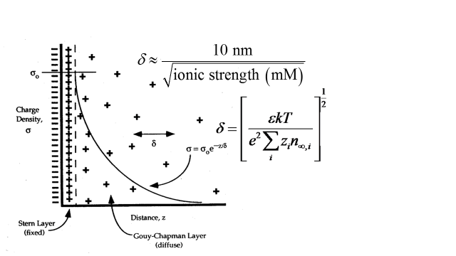

* Gaussian distrib: 
* ES



* Statistical defn of entropy/multiplicity



* ergodic sys: max work gradual release of P, rev (unlike sudden expansion)



isothermal process:



* binary mixture:



* constant pressure:



* chemical potential

; pdt (CD)-reactants (AB)

* distrib among states; bw levels
* Surface potential &equilib

* flood w ligand so free L ~ total

y-int: [P]tot/KD

slope: -1/ KD

* rate eqns

; intg:

* Michaelis Menton:
* steady state:

; ;

* equilib: [S]=[KD]; slow pdt formation