**Chem 4B Final Exam Review Sheet**



**Systematic error-** arises from a flaw in equipment or the design of an experiment

**Random error**- arises from controlled variables in the measurement

**Accuracy**- nearness to the truth **Precision**- agreement with one another

**Propagation of error**

Uncertainty in addition and subtraction 

Uncertainty in multiplication and division 

**Chromatography-** one type of extraction where one phase is held in place while the other moves past it

The **mobile** **phase** (the solvent moving through the column) is either a liquid or a gas, and the **stationary** **phase** (the one that stays in place inside the column) is most commonly a viscous liquid chemically bonded to the inside of a capillary tube or onto the surface of solid particles packed in the column.

Fluid entering the column is called **eluent**, and emerging from the end of the column is called **eluate**. The process of passing liquid or gas through a chromatography column is called **elution**.

Ion-exchange chromatography

Ion exchange resins are insoluble materials that contain cations or anions that can be exchanged. The resins typically consist of a framework held together by strong chemical bonds. Positively or negatively charged functional groups are attached to this framework and each of these groups carries an oppositely charged ion, called a counter ion, which is held by electrostatic attraction. When an ion exchange resin is placed in contact with a solution containing ions, the counter ions on the resin can be replaced by an equivalent number of ions from the solution. The most common resins contain sulfonic acid groups (––SO3.H+), which are strongly acidic, or quaternary ammonium groups (––NR3 +Cl.), which are strong bases. When the sulfonated polystyrene cation exchange resin is placed in contact with a solution containing metal cations M+, the M+ ions compete with H+ for a seat on the SO3– functional groups of the resin. The ion which has the strongest attraction for the functional group will be favored in this competition reaction. The equilibrium constant for exchanging H+ with M+ depends on a number of factors, but most notably on the size and charge of the hydrated cation M+.



For an anion exchange column, the extra anions in solution will compete with eluent for sites on the stationary phase. Consequently, the eluent will not be retained very well and will elute.

**Retention** **time**- the time that elapses between injection of mixture onto the column and the arrival of that component at the detector

**Adjusted retention time**- additional time required to travel the length of the column, beyond that required by solvent

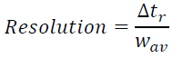 **number of plates on column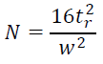**

**Standard solutions**- solutions that contain known concentrations of analyte

**Blank solutions**- solutions that contain all reagents and solvents used in the analysis, but no deliberately added analyte

**Matrix**- everything in the sample other than analyte

**Matrix** **effect**- change in the analytical signal caused by anything in the sample other than analyte

**Standard** **addition**- known quantities of analyte are added to the unknown; from the increase in signal, we deduce how much analyte was in the original unknown

Concentration of analyte in initial solution = signal from initial solution

Concentration of analyte plus standard in final solution signal from final solution

Standard addition graph

|  |  |
| --- | --- |
| constant volume  Rs+x = k [S]i / Vf  \* Vs + k [X]i/Vf \* Vx  y     =       m       \*  x  +   b  plot Rs+x vs Vs [X]i / [S]i \* Vx = - x-intercept | constant volume  Rs+x = Rx / [X]i \* [X]f + Rx / [X]i \* [S]f  y     =       b            +    m     \*  x  plot Rs+x vs Sf [X]f = - x-intercept |
| non-constant volume  Vf/Vx Rx+s = Rx / [X]i \* [S]i \* Vs/Vx + Rx      y          =     m     \*      x          + b  [X]i = - x-intercept | |

**Internal standards**- a known amount of a compound, different from analyte, that is added to the unknown. Signal from analyte is compared with signal from the internal standard to find out how much analyte is present.

**In standard addition, the standard is the same substance as the analyte. An internal standard is different from the analyte.** Internal standard is useful for analyses in which the sample analyzed or the instrument response varies from run to run.

Metal-Chelate complexes

**Metal ions** are **Lewis acids**, accepting electron pair from **ligands** which are **Lewis** **bases**

**Ligand**- atom or group attached to a central atom in a molecule

**Monodentate ligand**- one that binds to a metal ion through only one atom

**Multidentate ligand**- one that binds to a metal ion through more than one atom

**Chelating ligand**- a ligand that binds to a metal through more than one atom

**Chelate effect**- the observation that a single multidentate ligand forms metal complexes that are more stable than those formed by several individual ligands with the same ligand atoms

**Complexometric titration**- one in which the reaction between analyte and titrant involves complexes formation

**Formation constant**, Kf = [MYn-4]

[Mn+] [Y4-]

**Conditional formation constant**, Kf’ = [MYn-4]

[Mn+] [EDTA]

**Direct titration**- analyte is titrated with standard EDTA

**Back titration**- a known excess of EDTA is added to the analyte and is then titrated with a standard solution of a second metal ion. (necessary if analyte precipitates in the absence of EDTA, if it reacts too slowly with EDTA, or if it blocks the indicator)

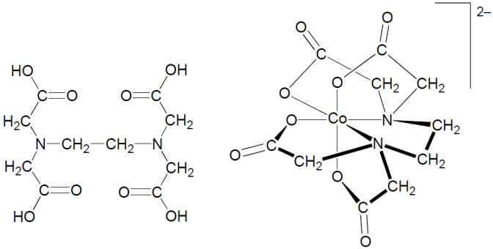 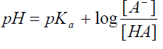

AAS/AES

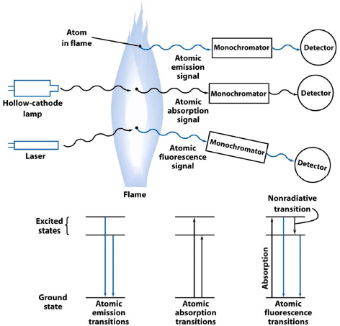

**Atomic absorption spectroscopy**- absorption of the light

**Atomic emission spectroscopy**- emission of the light

**Atomic fluorescence spectroscopy**- electronic transitions of atoms

Samples are vaporized as free atoms into the light path of the spectrometer by drawing a solution into a flame. In a typical flame atomizer, all or part of the solution is sprayed as a fine mist and spread throughout the flame. A monochromator is adjusted to allow only the wavelength of an atomic line of the element for which you are analyzing onto the detector.

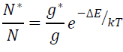

According to the trends in particle‐in‐a‐box, the larger the pi system the lower energy it takes to excited electrons into a higher energy state.

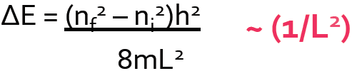

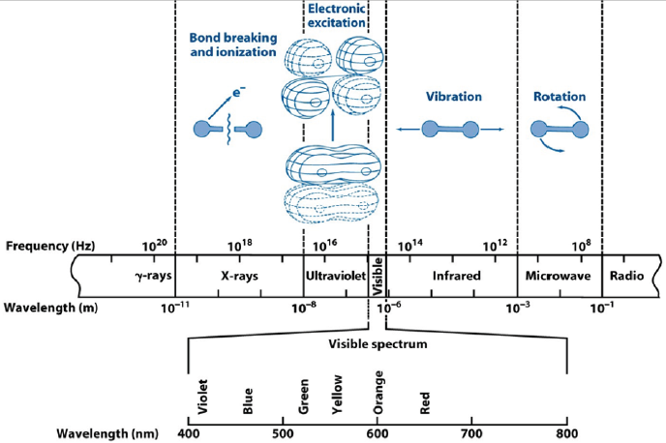

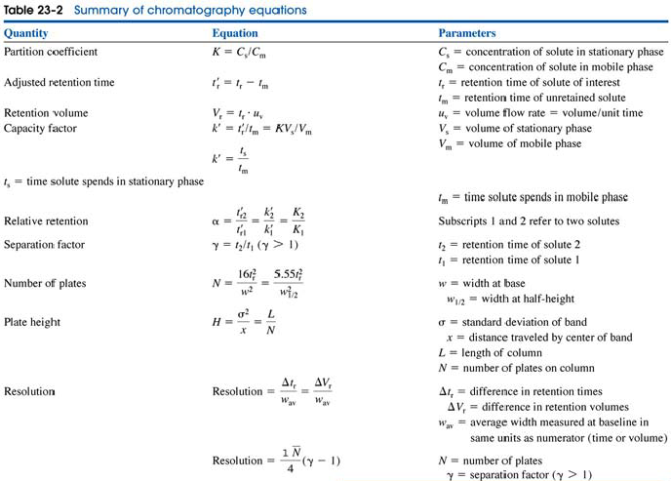

**A resolution of > 1.5 is desirable. And the one with the shortest elution time is the best**

|  |  |  |  |
| --- | --- | --- | --- |
|  | Conditions of analytes | Mobile phase | Detector |
| GC | Vaporized | Gas | Mass spectrometry |
| HPLC | Dissolved | Liquid | UV-Vis |

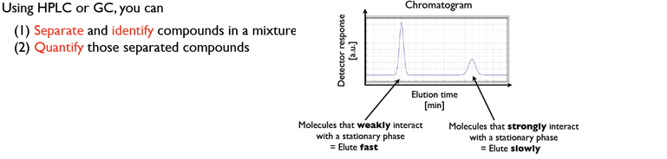

Gas chromatography

With a longer column, resolution goes up, peak height goes down, peak width goes up, peak area stays the same.

**Selected ion monitoring**- mass to charge ratio can help to determine what species of ion is present.

Factors that affect the retention time:

* **boiling** **point** (**mainly**), compounds with LOWER bp elute faster; BP is affected by
  + higher molecular weight 🡪 higher BP
  + higher polarity 🡪 higher BP
* **stationary phase**- polar has longer retention time because of induced dipole, compound with LESS affinity to the column elute faster

HPLC

**Eluent strength** is increased by making the mobile phase more like the stationary phase. The more the eluent strength of the solvent, the more easily it displaces the solute.

|  |  |  |  |
| --- | --- | --- | --- |
|  | Normal phase | Reverse phase | Anion-exchange |
| Stationary phase | Polar  Silica particles | Nonpolar  Silica particles coated with long alkyl chains | Resin with cationic surfaces |
| Mobile phase | Nonpolar intermediate  Organic solvent | Polar  Buffer, methanol, water | Polar (acidic)  Aqueous acid |
| Interaction between stationary phase and analytes | Hydrophilic | Hydrophobic | Electrostatic |
| Order of elution | Less polar first, more polar last | More polar first, less polar last | Less ionic first, more ionic last |

Criteria for choosing a method

* Analytes must be soluble in a mobile phase
* Affinity between a stationary phase and analytes should not be too strong

*f*sample x *A*standard / [standard] = *A*sample /[sample]

**Effects of changing the mobile phase in normal phase**

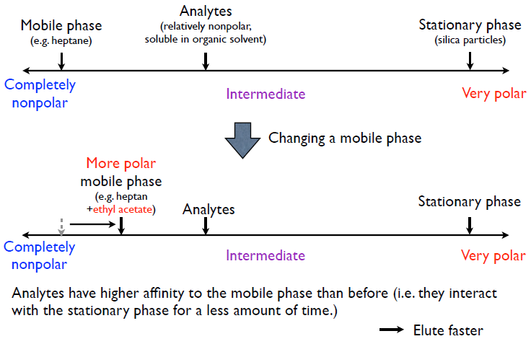

**Effects of changing the mobile phase in normal phase**

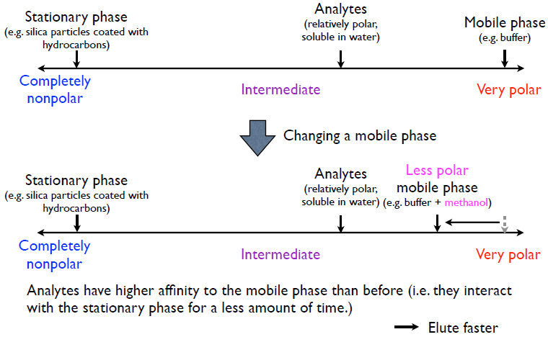

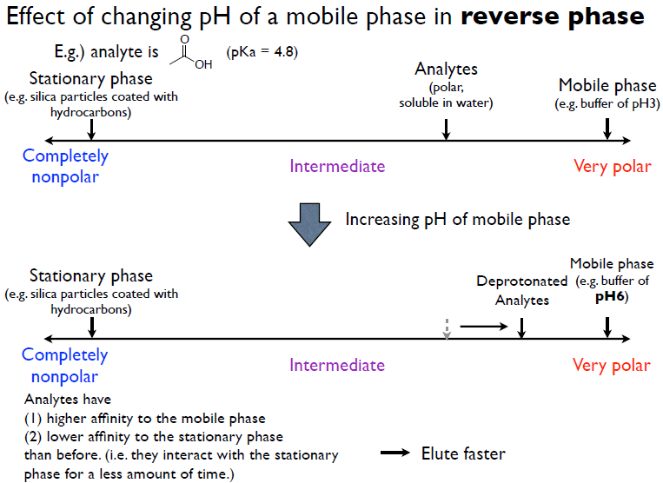

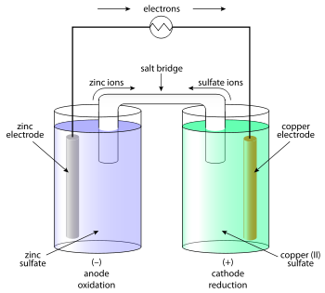A **redox** reaction involves transfer of electrons from one species to another.

**Oxidation**- loss of electrons (something is oxidized)

**Reduction**- gain of electrons (something is reduced)

**Oxidizing agent (oxidant)-** gains electrons, becomes reduced

**Reducing agent (reductant)-** loses electrons, becomes oxidized

q (charge, C) = n (mol) \* F (Faraday’s constant, C/mol) Work = E (volts) \* q (charge)

Δ G = - work = -n F E I (current) = E (voltage) / R (resistance)

M*n*+ (oxidized species) + *n*e- is in equilibrium withM (reduced species)

*m* A + *n* B*m*+ is in equilibrium with*n* B + *m* A*n*+

A (s) | An+ (aq) || Bm+ (aq) | B (s)

\ln K= \frac{nFE^0}{RT}

E_{\text{half-cell}} = E^0 - \frac{RT}{nF}\ln_e Q 

E_{\text{half-cell}} = E^0 - 2.303 \frac{RT}{nF} \log_{10} \{ M^{n+}\}

E_{\text{half-cell}}= E^0 - \frac{0.05918 V}{n} \log_{10} [ M^{n+}] (298K)

Platinum electrode is inert, it doesn’t participate in the redox chemistry except as a conductor of electrons.

**Standard hydrogen electrode (SHE)-** H2 bubbling over a catalytic Pt surface immersed in aqueous H+

Larger ions have larger mobility in water because it is less surrounded by water molecules. Hydrogen has the highest mobility.

|  |  |
| --- | --- |
|  |  |

Michaelis-Menten kinetics

v asymptotically approaches vmax KM is [S] when v = vmax/2

Noncovalent interactions between amino acids

|  |  |  |  |
| --- | --- | --- | --- |
|  | H-bond | Electrostatic interaction | vdW |
| Interactions | Between H donor and acceptor | Between charged molecules | Between all atoms |
| Only proximity | Yes | No | Yes |
| Strength | Strong | Strong | Weak |

Tripeptides with ionic functional groups: ion-ion, ion-dipole, dipole-dipole, H-bond, vdW

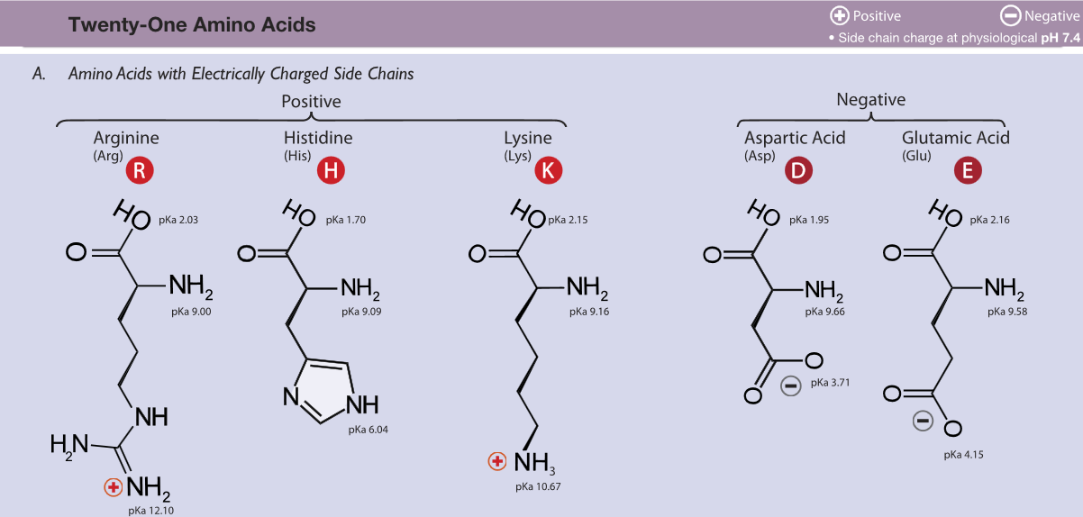

Protonated at neutral/physiological pH Deprotonated at neutral/physiological pH

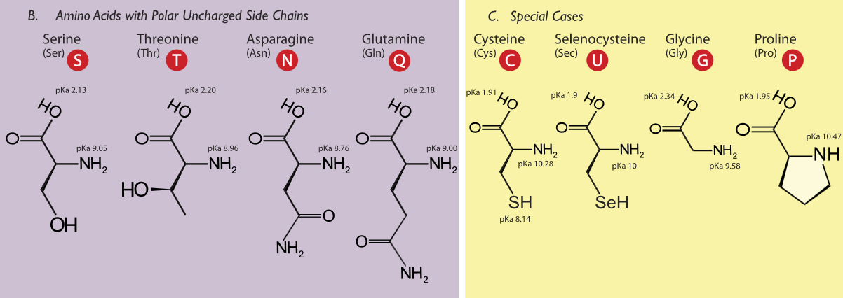

Alcohols Amides

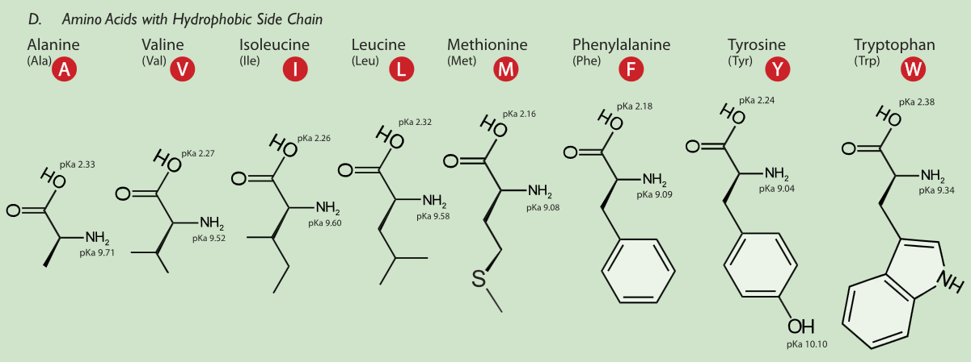

**Very polar**

* Charged functional groups
* Hydroxyl (OH) and amino (NH2) groups
* Other functional groups containing a heteroatom (N, S)
* Aromatic rings
* Aliphatic chains

**Nonpolar**

The probability of finding a particular N (number of) amino sequence in a protein is **1 in 20N**

**Protein folding**

**HOW DOES THE PROTEIN STRUCTURE FORM?**

Most proteins function in the body when they are in an aqueous solution, so we will restrict our discussion to water soluble proteins. In this case, perhaps the most important thing occurring is not an interaction, but the lack of an interaction. Water, the solvent, is not able to form hydrogen bonds or dipole interactions with the ‘oily’ residues. Because of the lack of strong interactions, the ‘oily’ amino acids get pushed away from the water, and they end up inside the protein structure. On the other hand, the amino acids which can strongly interact with the water end up on the outside of the protein structure where they are partially surrounded by water molecules. Because of the lack of interactions with water, the ‘oily’ residues are said to be **hydrophobic** or water hating. They really don’t ‘hate’ water; water just prefers to interact with more polar molecules, so the ‘oily’ residues are excluded from water. The amino acids which can form dipole-dipole interactions or hydrogen bonds are called **hydrophilic,** or water loving. In general, hydrophobic amino acids are found inside the protein structure and hydrophilic amino acids are found on the outside of the protein structure; this is called the **hydrophobic effect** in protein folding. The ‘oily’ amino acids will interact with other ‘oily’ amino acids to give some structure to the protein. The polar and charged amino acids will interact with other polar and/or charged amino acids along with individual water molecules to build the rest of the protein structure. Once the protein has assumed its three dimensional structure (native structure), it is ready to carry out its function.

**IS THERE ANY WAY WE CAN AFFECT THE PROTEIN STRUCTURE?**

First, we could add a small molecule in large quantitywhich will tie up all the water in hydrogen bonding. In this case, the amino acids on the outside of the protein won’t have their normal interactions with water, and they may move to interact with an amino acid which they would normally ignore. Second, we could add a detergent to our solution. A detergent is a molecule that has an ‘oily’ end and a polar end. The ‘oily’ end could interact with the ‘oily’ amino acids which are normally buried inside the protein and pull them out. The protein structure can also be altered by increases in temperature (thermal motion interferes with intermolecular interactions), changes in pH (charges are lost or gained at different parts of the protein), or mechanical shock. One example of permanently changing a protein structure by mechanical shock is beating egg whites to form the fluffy white foam. The clear liquid is actually a solution of albumin, a protein. The albumin is mechanically shocked or beaten until its structure changes and it is no longer water soluble. Conversely, we can stabilize the three dimensional structure of the protein by adding ions such as sulfate or phosphate. The way these anions stabilize the structure isn’t entirely understood, but it appears to be due to an increase in surface tension. You can imagine that to make a protein dissolve in solution, you need to make a tiny cavity in the water for the protein. If it is relatively easy to make the cavity in the solution, the protein doesn’t need to be as tightly folded. On the other hand, if it is hard to make the cavity, such as in a solution of sulfate or phosphate ions, the cavity will be very small and the protein has to be folded very tightly to fit inside.

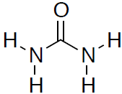Urea can have multiple H bonds with amino acids

It disrupts alpha helices and beta sheets in a protein.

It also affects interactions between side chains, between water and a side chain.

But it’s not an acid/base; it is **not** ionic.

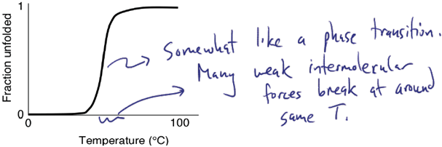

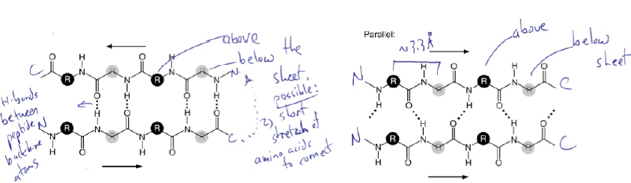

**Interaction strength is dependent on the environment:**

* In the **core** of a protein, there is electrostatic interaction and hydrogen bonds
* But on the **surface** of a protein, water competes with hydrogen bonds between amino acids and reduces electrostatic force

Polymerase Chain Reaction

95 C: This temperature \melts" the double stranded template DNA to form ssDNA, thus exposing the base pair sequence to solution and making them accessible to the primers. DNA polymerase does not synthesize DNA at this stage because there are no paired strands.

58 C: The solution is now cool enough that primers can bind to the template DNA. At this point, the temperature is too low for DNA polymerase to function. Reformation of the double stranded template DNA is prevented by keeping primers in excess.

72 C: Perfect temperature for DNA polymerase to function. At this stage, get DNA synthesis.

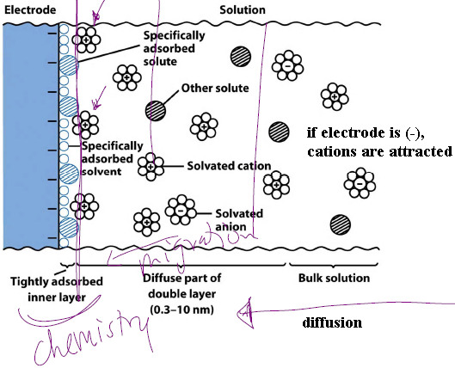

Cyclic voltammetry

* Electrochemical probe for redox reactions
* Vary voltage with time, measure current between 2 electrodes
* Redox reactions show up as peaks

|  |  |
| --- | --- |
|  |  |
| Irreversible electron transfer current response  Voltammogram of irreversible reaction |

RNA Cleavage

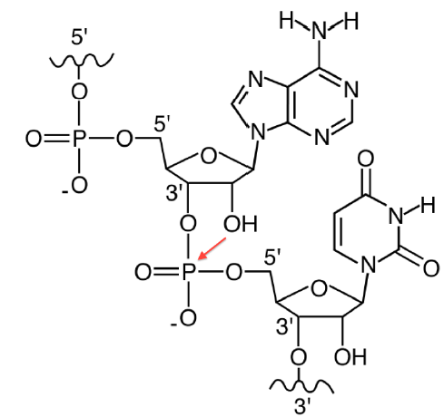RNA has an OH group at the 2' position which places it in a good position to attack the phosphodiester and break the P{5'O bond. Since DNA does not have a 2'-OH, the phosphodiester bond can only be cleaved by another species (e.g. water).

If RNA cleavage proceeds more quickly at higher pH, then the self reaction can be written as:

2'-RO- + phosphodiester 🡪 cleaved RNA

Mg2+ could coordinate to the 2'-OH, thus dropping the pKa from ~16 to ~11 and increasing the concentration of the deprotonated state. By Le Chatlier's principle, increasing the reactant concentration will drive a reaction towards products (in this case, cleaved RNA).

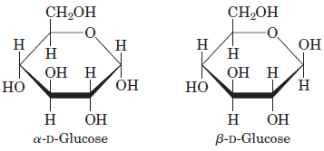

The two forms differ at the **hemiacetal** carbon (C-1; anomeric carbon; asymmetric)

A fresh solution of the alpha or beta form of glucose undergoes mutarotation to an equilibrium mix containing both alpha and beta forms.

|  |  |
| --- | --- |
| The aldehyde group on monosaccharides is a reducing agent. | For polysaccharides, the end of a chain with a free anomeric carbon (one not involved in a glycosidic bond) is commonly called the reducing end |

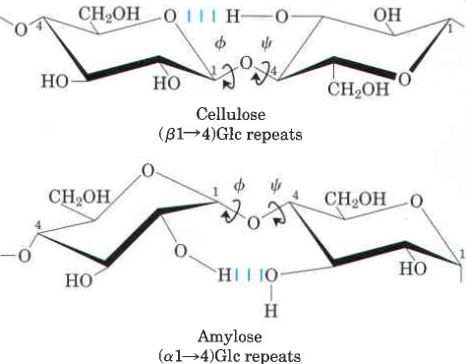Cellulose and cellulase

Humans cannot break down cellulose to its monosaccharides because they lack cellulases, a family of enzymes, produced chiefly by fungi, bacteria, and protozoans, that catalyze the hydrolysis of cellulose to glucose. In ruminant animals (such as cows and sheep), the rumen (one of four stomach compartments) acts as an anaerobic fermenter in which bacteria and protozoa degrade cellulose, making its glucose available as a nutrient to the animal.

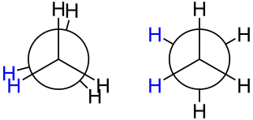Newman projection, left is eclipsed, right is staggered (favored due to steric repulsion).

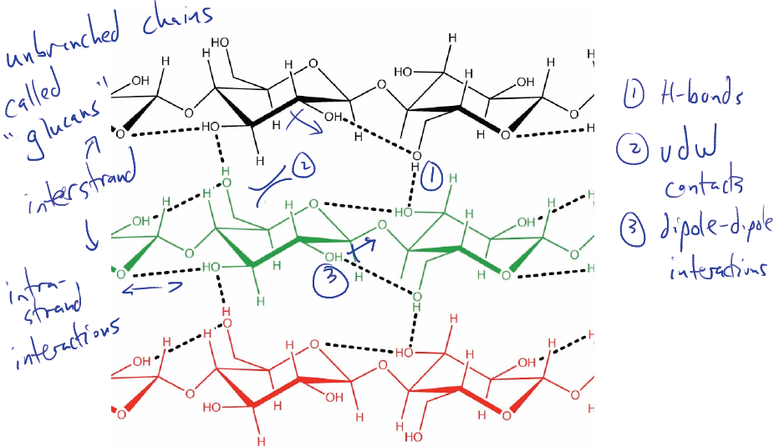

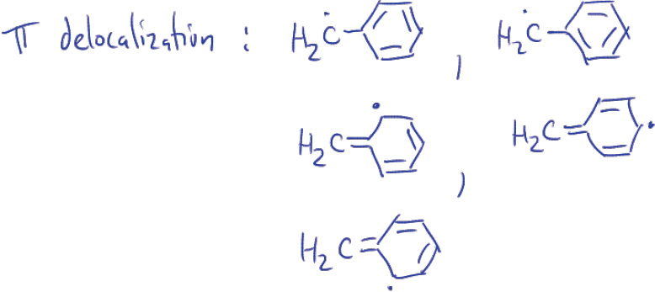Molecules that can stabilize a radical can moderate the kinetics of the resulting combustion reaction (i.e. to prevent an explosive rate that results in “knock”).

A straight-chain alkane has more surface area available for packing. It packs better, and has a higher boiling point and density, so it is a better SUMMER blend fuel additive. Branched alkane doesn’t pack as well; WINTER blend.

|  |  |  |  |  |
| --- | --- | --- | --- | --- |
|  | **Base** | **Nucleoside** | **Nucleotide** | **Nucleic acid** |
| **Purines** | | | |
| Adenine | Adenosine | Adenylate | RNA |
|  | Deoxyadenosine | Deoxyadenylate | DNA |
| Guanine | Guanosine | Guanylate | RNA |
|  | Deoxyguanosine | Deoxyguanylate | DNA |
| **Pyridines** | | | |
| Guanine | Cytidine | Cytidylate | RNA |
|  | Deoxycytidine | Deoxycytidylate | DNA |
| Thymine | Thymidine or deoxythymidine | Thymidylate or deoxythymidylate | DNA |
| Uracil | Uridine | Uridylate | RNA |

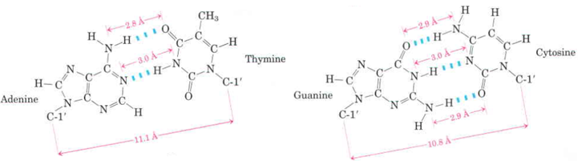

**The amino groups on exocyclic amines rotate very slowly, due to the pi bond, compared to the amino groups on primary amines, due to the sigma bond.**

Arsenic based life

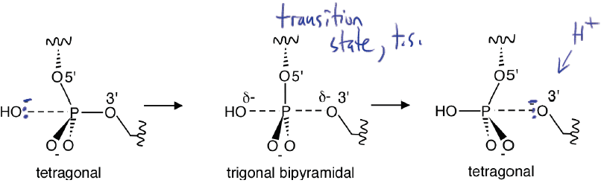

Phosphomonoesters have a **pKa of around 6.5**.

Phosphodiesters have **a low pKa** and are **charged** at neutral/physiological pH.

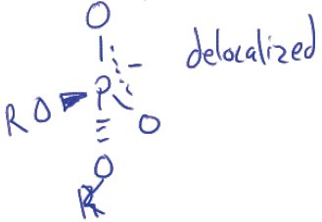 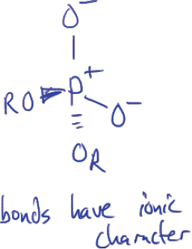

expanded octet illustration of phosphodiester the correct illustration of phosphodiester

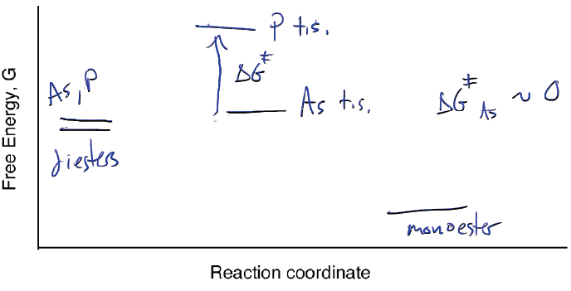

Energy diagram of the hydrolysis of phosphodiester and arsenodiester